UNITED NATIONS EDUCATIONAL, SCIENTIFIC

AND CULTURAL ORGANIZATION

CONVENTION FOR THE SAFEGUARDING OF THE INTANGIBLE CULTURAL HERITAGE

INTERGOVERNMENTAL COMMITTEE FOR THE

SAFEGUARDING OF THE INTANGIBLE CULTURAL HERITAGE

Bureau Meeting

UNESCO Headquarters, Paris

7 May 2009

Item 3 of the Provisional Agenda: Evaluation of International Assistance requests less than USD 25.000

Decision required: paragraph 8

- As provided in Article 20 of the Convention, International Assistance may be granted for the safeguarding of the heritage inscribed on the List of Intangible Cultural Heritage in Need of Urgent Safeguarding, the preparation of inventories in the sense of Articles 11 and 12, support for programmes, projects and activities carried out at the national, subregional and regional levels aimed at the safeguarding of the intangible cultural heritage and any other purpose the Committee may deem necessary.
- At its second session, the General Assembly adopted the Operational Directives of the Convention (Resolution 2.GA 5) which provide in paragraph 73 an overview of the kinds of international assistance. In its Resolution 2.GA 8, the General Assembly approved the plan for the use of the resources of the Fund and allocated the sum of 1,347,396 US dollars for international assistance in the period of 1 July 2008 to 31 December 2009 and 449,132 US dollars for the period January to June 2010.
- In conformity with paragraph 73 of the Operational Directives, requests less than 25,000 US dollars can be submitted at any time (except for requests for preparatory assistance, which have an annual deadline of 1 September). The Operational Directives provide that requests for international assistance less than 25,000 US dollars will be evaluated by the Bureau of the Committee. Between the last Bureau meeting (17 December 2008) and now, the Secretariat received five requests for international assistance less than 25,000 US dollars.
- In conformity with paragraphs 65 and 68 of the Operational Directives adopted by the General Assembly of the States Parties to the Convention for the Safeguarding of the Intangible Cultural Heritage, only States Parties are eligible to request international assistance. The Secretariat received three requests which were not submitted by a State Party.
  - From an Indian NGO, Rural Entrepreneurship for Art and Cultural Heritage, to implement a project entitled “The Vanishing Voices Festival” for an amount of 25,000 US dollars. The Secretariat informed the NGO, by e-mail and regular mail, with copies to the Permanent Delegation of India and the Indian National Commission, that the request does not clearly show whether Rural Entrepreneurship for Art and Cultural Heritage is entitled to submit such a request on behalf of the Government of India, and invited them to clarify this question. The Secretariat received no information subsequently to indicate that this request should be considered as an official request from the State Party.
  - From a private person, Mr Achim Bovellet, for a project entitled “Dialect Preservation Project” to be based in the Netherlands, for an amount of 11,500 US dollars. The Secretariat informed the requester, by e-mail and regular mail, with copy to the Permanent Delegation of the Netherlands (non State Party to the Convention), that his request does not clearly show that it is submitted on behalf of any State Party of the Convention. The Secretariat received no information subsequently to indicate that this request should be considered as an official request from any State Party.
  - From the Barrouallie Whalers Project Inc, located in the United States of America, for a project entitled “Whalers Heritage Performances from Barrouallie, St. Vincent and the Grenadines”, for an amount of 11,024 US dollars. The Secretariat informed the requester, by e-mail and regular mail on 28 April 2009, with copy to the Permanent Delegations of St. Vincent and the Grenadines (non State Party to the Convention) and the United States of America (non State Party to the Convention), as well as the respective National Commissions for UNESCO, that his request does not clearly show that it is submitted on behalf of any State Party of the Convention and invited them to clarify this question.

- The Secretariat received two requests submitted by States Parties, respectively Mongolia and the Seychelles. After receipt of the requests the Secretariat, in conformity with paragraph 71 of the Operational Directives, assessed the completeness of the requests, asked for additional information and informed the requesting State Party about the evaluation date of the request by the Bureau (7 May 2009).
- The complete requests of the Seychelles (file number 00296) and Mongolia (file number 00298) are annexed to this document in the language received by the Secretariat (English), for evaluation by the Bureau, followed by a recommendation, in English and French, prepared by the Secretariat in conformity with the previous instructions of the Bureau.
- In conformity with the Operational Directives, the Secretariat shall communicate the decision of the Bureau concerning the granting of assistance to the requesting party(ies) within two weeks following the decision.
- The Bureau of the Intergovernmental Committee may wish to adopt the following decision:

DRAFT DECISION 4.COM 2.BUR 3
The Bureau,
1. Recalling Article 20 of the Convention;
2. Further recalling chapter 2.2 of the Operational Directives related to International Assistance;
3. Having examined the requests for International Assistance no. 00296 from the Seychelles on “Inventory of Intangible Cultural Heritage in Seychelles” and no. 00298 from Mongolia for the “Elaboration of the Inventory of the Representative List and List in need of urgent safeguarding of Intangible Cultural Heritage in Mongolia”;
4. Approves, as authorized body, the following request for International Assistance:
[State, Name of the element, amount]
[State, Name of the element, amount]
5. Requests the Secretariat to reach agreement with the requesting parties on the technical details of the assistance.
ANNEX A.1 – The Seychelles (00296): Request Form
Request for International Assistance from the Intangible Heritage Fund
Cover Sheet
A. Project title:
Not to exceed 200 characters
Inventory of Intangible Cultural Heritage in Seychelles
B. Submitting State Party:
Seychelles
C. Beneficiary community, group, or if appropriate, individuals:
National Heritage Research Section ( NHRS)
D. Is this an emergency request that might receive expedited processing?
emergency request
non-emergency request
If this is an emergency request, the information required in sections 4, 5 and 6 can be submitted at a later stage, if required.
E. Purpose of request (check one):
safeguarding heritage inscribed on the Urgent Safeguarding List
safeguarding heritage being nominated for inscription on the Urgent Safeguarding List
elaboration of inventories
implementation of programmes, projects and activities for safeguarding
F. Scope of the project (check one):
local
national
sub-regional
regional
international (including geographically non-continuous areas)
G. Location of the project:
Seychelles
H. Proposed implementing organization or body:
National Heritage Research Section ( NHRS)
I. Budget overview (in US dollars):
Amount requested from the Fund: USD9,862.61
State Party contribution: Salary and infrastructures for researchers
J. Time frame:
The whole project will run from February 2010 to December 2012. * See time table for details regarding duration of fieldworks, meetings with stakeholders and the designing and printing of the small publication.
K. Summary project description:
The project “Inventory of Intangible Cultural Heritage in Seychelles” aims at not only ratifying the UNESCO convention but also carrying out the mission of the NHRS (National Heritage Research Section) which is to research, document, preserve and promote the cultural heritage of Seychelles. The project will give a detailed description of different intangible practices in Seychelles and include photographs, audio recordings and videos where appropriate. This will serve as an important reference tool as a complete inventory of intangible heritage has never been carried out in Seychelles. Such a project will help with the dissemination, promotion and protection of the ‘indigenous knowledge’ and practices.
The Inventory will include a series of fieldworks on four islands in Seychelles; Mahe, Praslin , La Digue and Silhouette and it will involve the participation of the local community through a series meetings with stakeholders. The gathered information will be compiled into a small coloured publication of a hundred pages. This publication will serve as reference for researchers as well as policy makers.
Application
1. Background and rationale
Not to exceed 500 words
The project is in line with articles 11 and 12 of the 2003 UNESCO convention for the safeguarding of the Intangible Cultural Heritage, which states that “each state party shall draw up, in a manner geared to its own situation, one or more inventories of the intangible cultural heritage present in its territory”. Although several small inventories on various aspects of ICH have been conducted throughout the years by the National Heritage Research Section ( NHRS) of Seychelles whose mission is to research, document, preserve and promote the cultural heritage of Seychelles through the implementation of various cultural related activities and research projects, a full detailed inventory is yet to be completed. Moreover, specific structures, policies and funds for the safeguarding of ICH is currently lacking.
The project ‘Inventory of Intangible Cultural Heritage of Seychelles’ will run for a period of 3 years, from February 2010 to December 2012. Without any doubt, such a long project will require several human and material resources. While the human resources are readily available, the material resources are currently insufficient. This is the main reason behind our request for financial assistance. The National Heritage Research Section (NHRS) which is the implementing institution has budget constraints due to the various programmes it has running on a yearly basis (see 4.b.).
The much needed financial assistance will allow the conducting of fieldworks, purchasing of equipments and meetings with stakeholders which are all vital to the success of the project. Finally, the financial assistance will fund the publication of a book; a compilation of the complete inventory.

2. Objectives and expected results
Not to exceed 250 words
OBJECTIVES
- To collect and document updated data in the aim of safeguarding and dissemination.
- To compile a document (small publication) on ICH in Seychelles which will serve as a reference tool for researchers and visitors of the local research institutions as well as a working tool for teachers in our educational institutions.
- To create greater public awareness in regards to the richness of our local intangible cultural heritage and the need for their protection, valorization and revitalization.
- To showcase areas were safeguarding measures needs to be reinforced and thus allow policy makers to establish specific policies for the protection and preservation of local ICH.
- To establish a data base of local Knowledge Holders and practitioners in the field of ICH.
EXPECTED RESULTS
- A small coloured publication of a hundred pages portraying the variety and diversity of the Seychelles’ Intangible Cultural Heritage. This will serve as a point of reference for researchers and visitors.
- The research in general will point out the elements of the Seychelles’ ICH that are in urgent need of preservation and revitalization. This will hopefully get policy/decision makers to introduce measures such as apprenticeship with the practitioners for the youth so that those knowledge gets passed down through the generations.
- The Publication and audio visual recordings will enrich the collection/ data base of the NHRS’ documentation centre which is a much visited research institution. It will also aid in the NHRS’ future dissemination programmes with partners such as the local Television and Radio station ( SBC) and the Ministry of Education where they could be used as tools in presentations and exhibitions for students of all ages and the general public.

3. Activities
Not to exceed 500 words
1. Fieldworks

The fieldworks will be conducted on four islands of the Seychelles archipelago: the main island of Mahe and the 3 inner islands of Praslin, LaDigue and Silhouette. These will be done after a preliminary identification of all forms of IHC in Seychelles through literature review, reference to existing data and consulting key knowledge holders. This list will include elements such as dance, music (songs/musical instruments), traditional economic activities, craftsmanship, culinary art, performance, arts, traditional medicines, rituals, celebrations, legends, anecdotes, riddles, beliefs…
The scheduled fieldworks will allow us to interview key practitioners and Knowledge holders. These will include experts in the local cultural field from the Ministry of Community Development, Youth, Sports and Culture, cultural institutions such as the National History Museum, the National Archives, the ‘Kreol’ Institute ( See 4.c.), NGOs such as the Association of Promoters of Complementary Health in Seychelles ( APOCHIS), herbalists, carftmen, performers, storytellers, anthropologists, researchers, elder members of our community…
The fieldworks will also allow us to record and collect audio visual materials. This will include recordings of interviews, music, stories… filming of practices and taking photographs.
There will be two series of fieldworks (see 6. Timetable). The first series is to research and document identified elements before presenting the findings to stakeholders. The second series is to allow the research of elements that have been overlooked in the first series of fieldworks, for inclusion in the inventory.

2. Meetings with Stakeholders

Two series of meetings will be held with local stakeholders on all the four Islands where fieldworks and research will be conducted. The first series of meetings will allow the researchers to present the preliminary findings. This will enable stakeholders o discuss and point out any discrepancies and deficiencies. The second series will allow the researchers to present the final document to the stakeholders for approval before publishing and submission to UNESCO.

3. Publication

A 100 A4 pages book of the whole inventory will be published. The book will be coloured .50 copies will be printed. Some will be donated to research institutions such as the National Library, National Archives, National History Museum and the Documentation Centre of the Ministry of education. The rest will be sold to generate fund for future editions.
4. Project management and implementation
4.a. Community involvement:
Not to exceed 250 words
To carry out the inventory itself we will require the assistance of the whole Seychelles Community. We will need to go to knowledge from various levels of the community i.e. specialist in various cultural fields, anthropologists, historians, archivist, storytellers, the elderly citizens…It is through interviews with them that we will be able to compile information for the inventory. Two series of meetings will also be conducted with stakeholders on Mahe , Praslin, La digue and Silhouette Islands. These meetings will allow the whole Seychellois community to make their suggestions and finally approve the complete inventory. The final published document that will be submitted to UNESCO will be the contribution of the whole Seychellois community.

4.b. Implementing organization:
National Heritage Research Section
The National Heritage Research Section (NHRS), formerly known as the Oral Tradition Section, was created in 1980. It is a Section within the Ministry of Community Development, Youth, Sports and Culture of Seychelles.
The Section initially focused on the collection and documentation of the oral tradition and folklore of Seychelles. It has now evolved into 3 major sub-units: The Oral Tradition sub-unit, the Cultural Site Management sub-unit and the Copyright sub-unit
The NHRS has researched extensively in most fields of the Seychellois cultural heritage. This includes Seychellois habitat, traditional medicine, traditional fishing, traditional industries, Seychellois folklore, (songs, dances, folklores, riddles, legends, myths), the cultural sites and built heritage of Seychelles, the traditional culinary art of Seychelles, the traditional musical instruments of Seychelles, as well as the maritime heritage of Seychelles.
The NHRS organizes various types of programmes. This includes public lectures, cultural site management programmes, media programmes, and publications, including collaborative research programmes with international agencies from the USA, France, UK, Mauritius, Germany, Italy, Kenya, and Madagascar.
The NHRS also acts as a consultancy agency in cultural matters such as the National Monuments Board of Seychelles, traditional medicine of Seychelles, and the Kreol language.
It provides a considerable amount of information to the public (both national and international) pertaining to cultural matters. Finally, the National Heritage is the executive arm of the National Monuments Board of Seychelles, and it also registers copyrights on behalf of, and in affiliation with, the office of the Registrar General.
Mission
The NHRS has the mission of collecting, researching, documenting, disseminating and promoting the Seychelles tangible and intangible heritage. The programme is aimed at the general public both local and international, so as to perpetuate the traditional knowledge of the Seychellois people.

Human Resources
The NHRS has to date 9 research staff and 4 support staff. Two of the research staff (Research Officer/Research Assistant) specifically falls under the Oral Tradition and Anthropology Unit which is mostly responsible for research in Intangible aspects of the Seychelles’ cultural heritage.

4.c. Partners:
The project will involve the partnership of the NHRS with the following institutions/companies:
1. District Administrations on Mahe Island, Praslin Island and La Digue Island :
There are 22 districts on Mahe Island, 2 on Praslin Island and 1 on La Digue Island. A partnership with the District Administrations will facilitate networking with knowledge holders, practitioners and stakeholders. As all 25 district administrators are well acquainted with the people within their community they will be able to provide us the contact details as well as guides. They will also assist us in organizing meetings with stakeholders.
2. Seychelles Broadcasting Cooperation ( SBC) :
This is our national television and radio station. The SBC audio-visual archive has a good collection of documented elements of ICH. Their 6 staff will be able to assist us in conducting our research.
3. Island Development Company ( IDC) :
The IDC is the company responsible for the management of Silhouette Island. Through them, we will be able to gain access to the island and its community. The
Island administrator will be able to organize guides to take us to the stakeholders; knowledge holders, practitioners, story tellers….
4. The Seychelles National Archives
The Seychelles National Archives is a centre for academic research and the ‘memory bank’ of our people. The Seychelles National Archives was officially established with the promulgation of the 1964 Archives Law. It was given the mandate for the collection and preservation of all government records and to make these accessible to the general public. The mission of the Seychelles National Archives is to collect, preserve, and make accessible to the general public and depositors, the archival documents in its care.
Its rich collection of historical documents/records and even its collection of newspaper will assist us in our literature review. Its audio and visual archives will also be vital in our research for the inventory. To date, the National Archives have 20 staff, which will be able to assist us.
- ‘Kreol’ (Creole) Institute of Seychelles
Established in 1981, the Kreol Institute of Seychelles has served to promote Kreol, the maternal language of Seychelles, as a national language in both oral and written form, as a language of instruction in education, and also as a means of encouraging the development of a Seychellois Kreol Literature. The mission of the Kreol Institute is to research into and promote Seychellois Kreol in particular, and world Kreols in general, with a view to developing Kreol as a mother tongue and national language through, education, literature, cultural manifestations and information communication technology (ICT). Throughout the years, The Kreol Institute has a wide collection of Seychelles literature (stories, poems, proverbs, riddles, legends….) some of which has been published. These documents will serve as reference when we are conducting our research. They will also be able to help us to establish contact with Seychelles which knowledge in these specific areas. To note, the Kreol Institute has a total of 13 staff which will be able to assist us in our research.
4.d. Monitoring, reporting and evaluation:
Not to exceed 250 words
The members of the Oral Tradition and Anthropology Unit within the HRPS will have to report to the Principal Research Officer of the Section on their progress and any problems they are encountering on a fortnightly basis or whenever deemed necessary. The Principal Research Officer will be responsible of monitoring the project and will accordingly serve as advisor.
5. Capacity-building, sustainability and long-term impacts of the project
5.a. Capacity-building:
Not to exceed 250 words
The identification of all elements of ICH in Seychelles and the scheduled meetings with stakeholders will point out areas where safeguarding measures needs to be reinforced or introduced. It will help policy makers within the Seychelles’ Ministry of Community Development, Youth, Sports and Culture, the parent Ministry of the implementing organization to establish specific measures /policies regarding the protection and preservation of ICH in Seychelles. The resulting publication will serve as a reference material for future projects related to ICH to be conducted by the NHRS or other cultural and educational institutions. With the inventory, contact of knowledge holders and the equipments (digital camera, tape recorder…) gained through the project, the NHRS research staff will have more resources to work with in conducting and implementing future ICH related research projects.
5.b. Sustainability:
Not to exceed 250 words
The small publication resulting from the project will serve as reference tools for additional research in Seychelles’ intangible cultural heritage by the NHRS and other cultural and educational institutions. It could also be used as a working tool for educational institutions such as the Seychelles Tourism Academy and even primary and secondary level education where elements of ICH are taught to students. The sale of the books will generate fund for the publishing of more editions of the same or new publications related to ICH. Through the project the NHRS’ research staff will have also establish contact with various knowledge holders/stakeholders will be able to assist us when conducting future research projects. The publication and collection of audio visual materials obtained through the project will enable the NHRS to create more awareness of ICH through exhibitions, presentations and radio and television programmes. The NHRS also has a policy of lending materials (documents, videos, cassettes, exhibitions…) to educational and other cultural institutions for the purpose of dissemination, upon their request. The same could be done to the materials gathered during the project.
5.c. Multiplier effects:
Not to exceed 250 words
-
6. Timetable and budget
6.a. Timetable:
ACTIVITY | LOCATION | DATE | DETAILS
1ST SERIES OF FIELDWORK | Mahe Island | 1st March 2010-30th April 2010 | 15 fieldworks will be conducted in the 22 districts of Mahe Island.
1ST SERIES OF FIELDWORK | Praslin Island | 1st July 2010-31st August 2010 | 10 fieldworks will be conducted in the 2 districts of Praslin Island.
1ST SERIES OF FIELDWORK | La Digue Island | 1st February 2011- 31st August 2011 | 15 fieldworks will be conducted on this Island rich in knowledge holders and where certain elements of the Seychelles’ ICH are still part of the daily lives of the community.
1ST SERIES OF FIELDWORK | Silhouette Island | 1st June 2011- 29th July 2011 | 10 fieldworks will be conducted on this island which is again rich in knowledge holders.
1ST SERIES OF MEETINGS WITH STAKEHOLDERS | Mahe Island | October 2011 | The general public and key stakeholders will be invited to these meetings where the preliminary report of the first series of fieldwork and other researches will be presented.
1ST SERIES OF MEETINGS WITH STAKEHOLDERS | Praslin Island | October 2011
1ST SERIES OF MEETINGS WITH STAKEHOLDERS | La Digue Island | November 2011
1ST SERIES OF MEETINGS WITH STAKEHOLDERS | Silhouette Island | November 2011
2ND SERIES OF FIELDWORKS  (These fieldworks are necessary to include elements that have been overlooked in the first report and identified with the meetings with stakeholders. | Mahe Island | 1st February – 29th February 2012 | 5 Fieldworks will be conducted
 | Praslin Island | 1st March – 30th March 2012 | 5 Fieldworks will be conducted
 | La Digue Island | 2nd April - 30th April 2012 | 5 Fieldworks will be conducted
 | Silhouette Island | 1st May -31st May 2012 | 5 Fieldworks will be conducted
2ND SERIES OF MEETINGS WITH STAKEHOLDERS | Mahe Island | September 2012 | These series of meetings will allow the researchers to present the final document to the stakeholders for submission to UNESCO.
2ND SERIES OF MEETINGS WITH STAKEHOLDERS | Praslin Island | September 2012
2ND SERIES OF MEETINGS WITH STAKEHOLDERS | La Digue Island | September 2012
2ND SERIES OF MEETINGS WITH STAKEHOLDERS | Silhouette Island | September 2012
DESIGNING AND PRINTING OF SMALL PUBLICATION | AI creations ltd  Victoria  Mahe  Seychelles | November 2012 | This small publication will be of a hundred pages and coloured.
6.b. Budget
Exchange rates ( Barclays Bank of Seychelles 15/04/09)
1 US Dollar ( USD) = 16.028 Seychelles Rupees.(SR)
PARTICULARS | DETAILS | COST IN SR | COST IN USD
1) Material Resources | -Digital Video Recorder  -1 Digital Audio Recorder  -1 External Hard Drive  -1 Printer  -1 Pen Drive  -4 Rechargeable Batteries and Charger  -10 A4 Paper Realms  -1 Computer Set | SR 53, 978 | USD 3,367.73
2) Publication | -Designing and layout  -Printing of 50 copies | -RS 22,000 | -USD 1,372.59
3) Total Fieldwork to be conducted Mahe, Praslin, La Digue and Silhouette islands | -Ferry fares for 2 staff  -Accommodations  -Fieldwork Allowance | - SR 8,200  -SR 31,800  -SR 20,500 | - USD 511.60  - USD1, 984.02  - USD 1,279.01
4) Meetings with Stakeholders ( 2 series of meetings on Mahe, Praslin, La Digue and Silhouette islands) | -Ferry fares for 4 staff  - Tea Breaks | -SR5,600  SR16,000 | -USD 349.38  -USB 998.25
GRAND TOTAL |  | SR158,078 | USD9,862.61

7. Contact information
7.a. Submitting State Party:
Seychelles
7.b. Contact person for correspondence:
Miss Sophia Thelermont
Research Officer
National Heritage Research Section
PO Box 573
Tel: +248 32133 ext 8164
Fax: +248 322531
Email: sophiathelermont@hotmail.co.uk
7.c. Organization or body responsible for implementation:
National Heritage Research Section
8. Signature
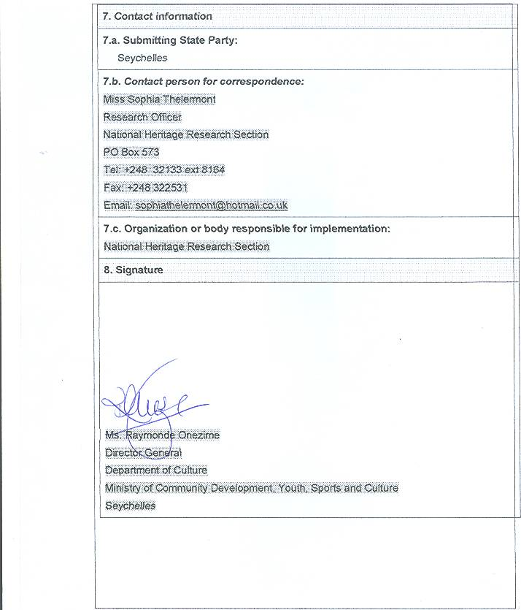

ANNEX A.2 – The Seychelles (00296): recommendation by the Secretariat
Request for International Assistance less than 25,000 US dollars
Request Number 00296
Recommendation by the Secretariat

STATE PARTY: The Seychelles
PROJECT TITLE: Inventory of the Intangible Cultural Heritage in Seychelles
AMOUNT REQUESTED: US$ 9,862.61
TIME FRAME: February 2010 to December 2012
- The Government of the Seychelles requests assistance for a project that will give a detailed description of different intangible practices in Seychelles and include photographs, audio recordings and videos where appropriate. This will serve as an important reference tool as a complete inventory of intangible heritage has never been carried out in Seychelles. Such a project will help with the dissemination, promotion and protection of the ‘indigenous knowledge’ and practices. The Inventory will include fieldwork on four islands in Seychelles (Mahe, Praslin, La Digue and Silhouette) and will involve the participation of the local community through a series of meetings with stakeholders. The gathered information will be compiled into a small publication of a hundred pages.
- The project will be implemented by the National Heritage Research Section (NHRS), formerly known as the Oral Tradition Section, created in 1980. NHRS is a Section within the Ministry of Community Development, Youth, Sports and Culture of Seychelles. It involves as well a partnership with district administrations, Seychelles Broadcasting Corporation, Island Development Corporation, the Seychelles National Archive and the Kreol Institute of the Seychelles, The amount of assistance is modest and appropriate to the scale of the activity, aimed primarily at providing certain technical capacities that staff will use in their ongoing inventory activity. The primary costs of personnel are borne by the State, and only added costs for equipment and travel are requested. The assistance aims at strengthening local capacities and supporting the future implementation of safeguarding activities. Community involvement and participation are built into the project through stakeholder workshops at key stages.
- The project timetable and budget foresee activities extending until 2012, and UNESCO's financial procedures do not permit a contract to extend for such a long period. For a small project and budget of this size, it is impractical to separate the work into two or more shorter contracts. It would thus be necessary that the Secretariat work with the requesting State to define more focused work that may be completed within a shorter time period.
- Request no. 00296 appears to satisfy the criteria and procedures for international assistance requests in amounts less than 25,000 US dollars, as laid out in paragraphs 61-75 of the Operational Directives.
ANNEX B.1 - Mongolia (00298): Request Form
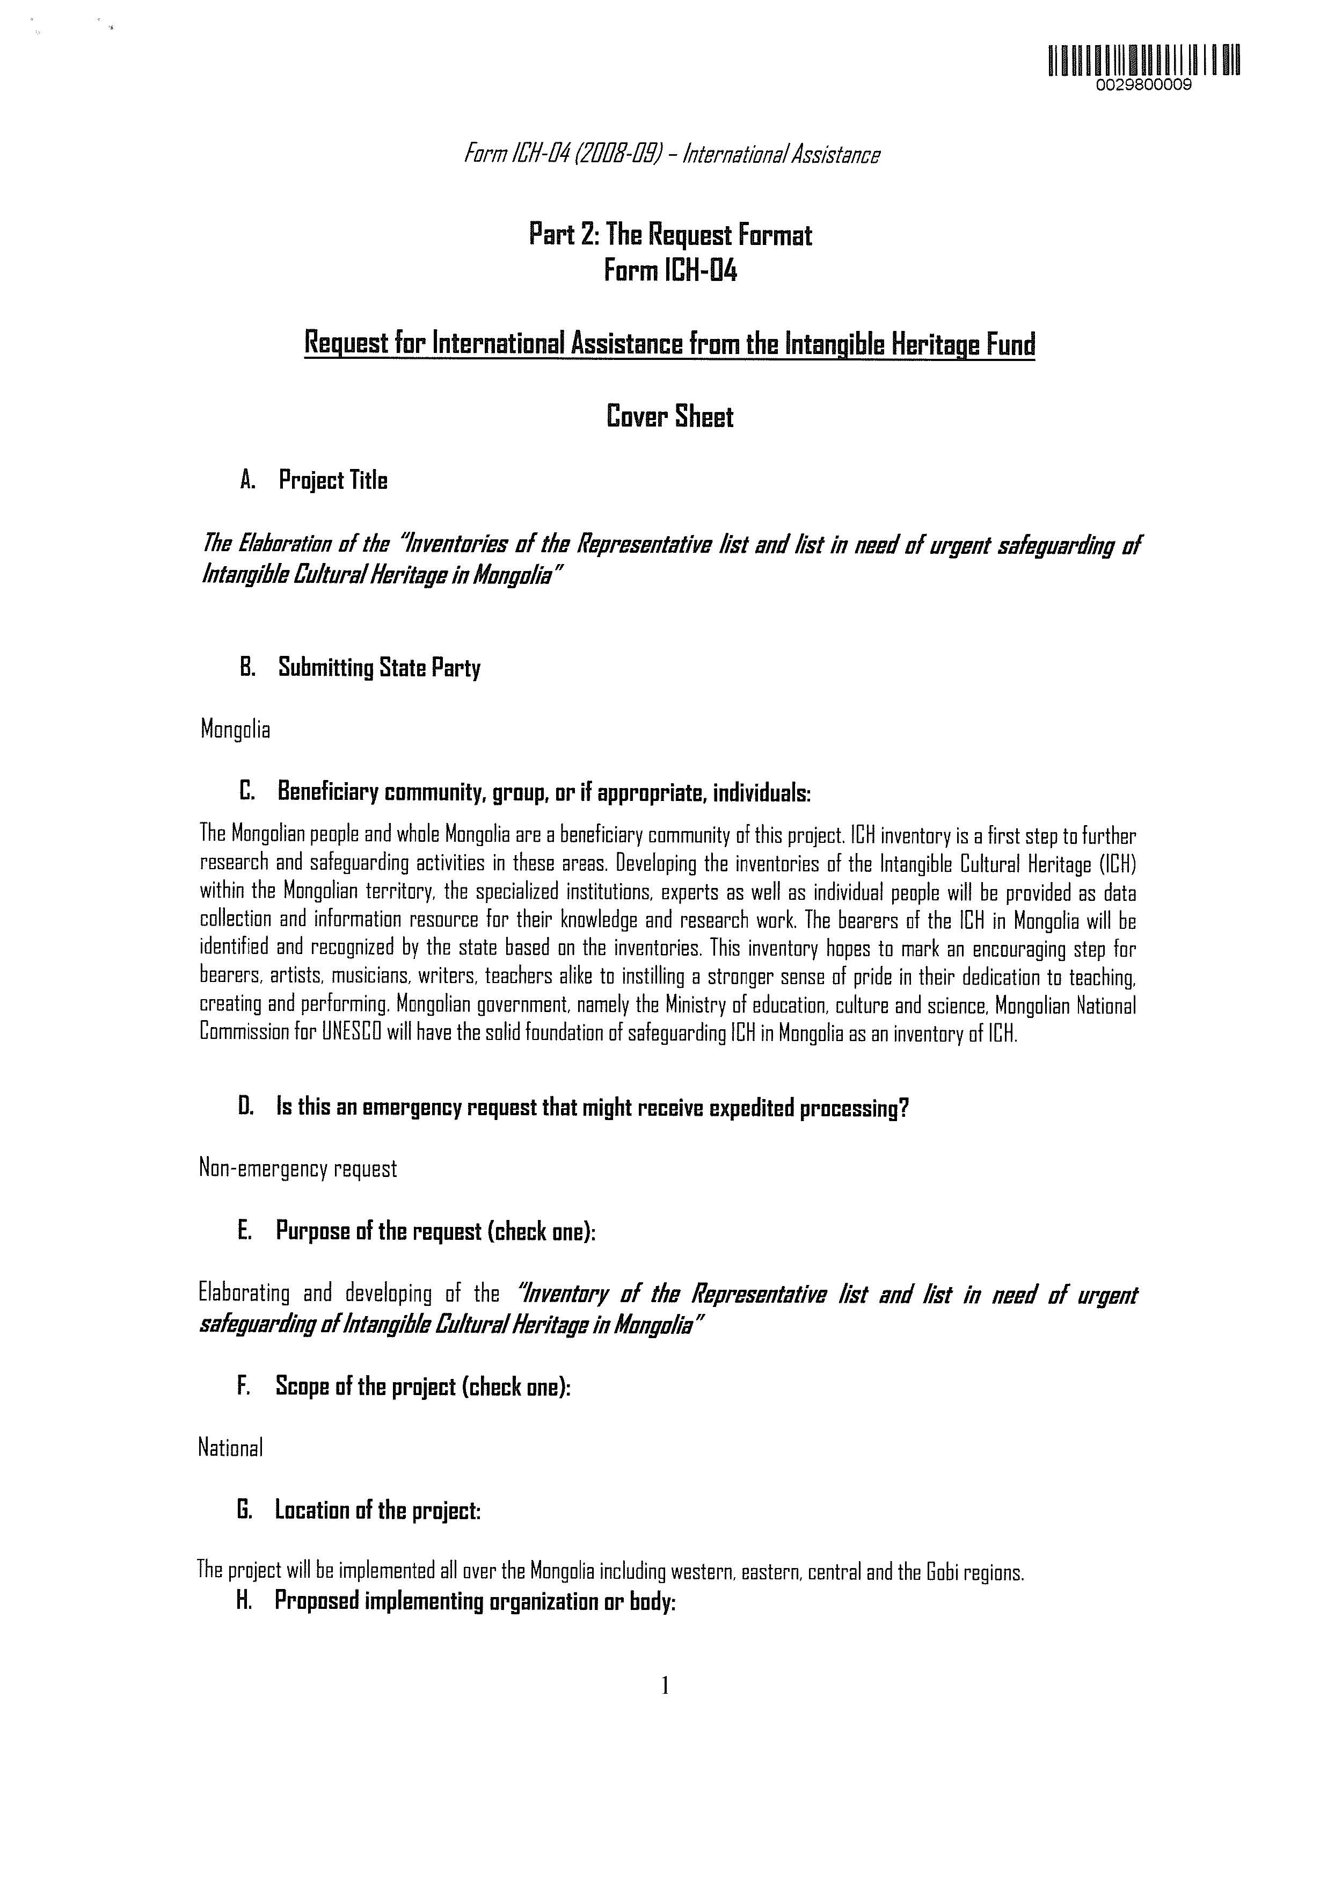

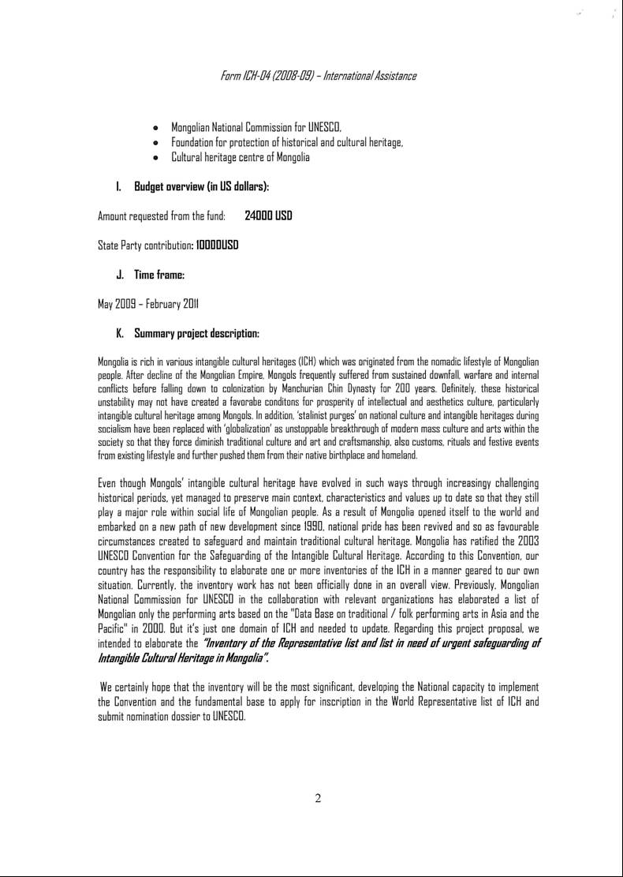
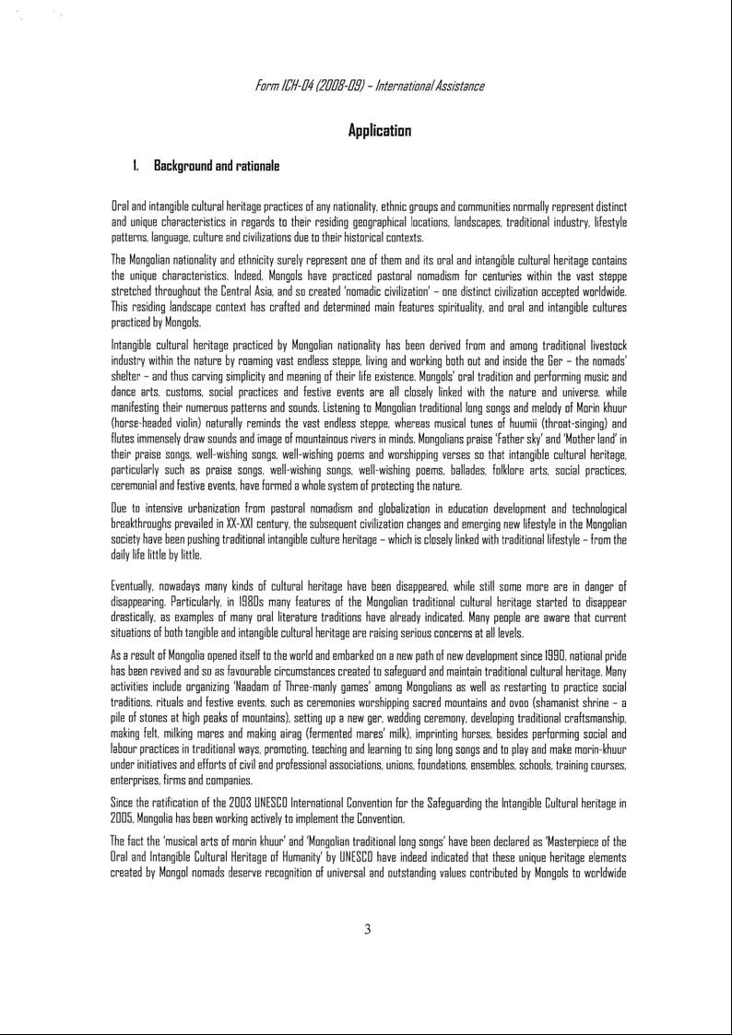
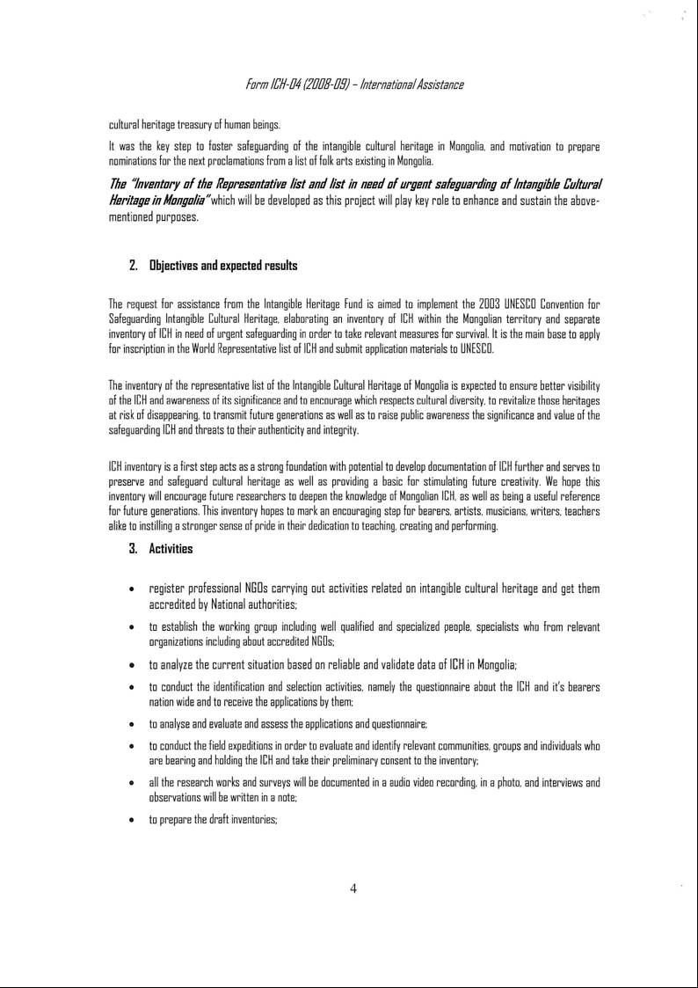
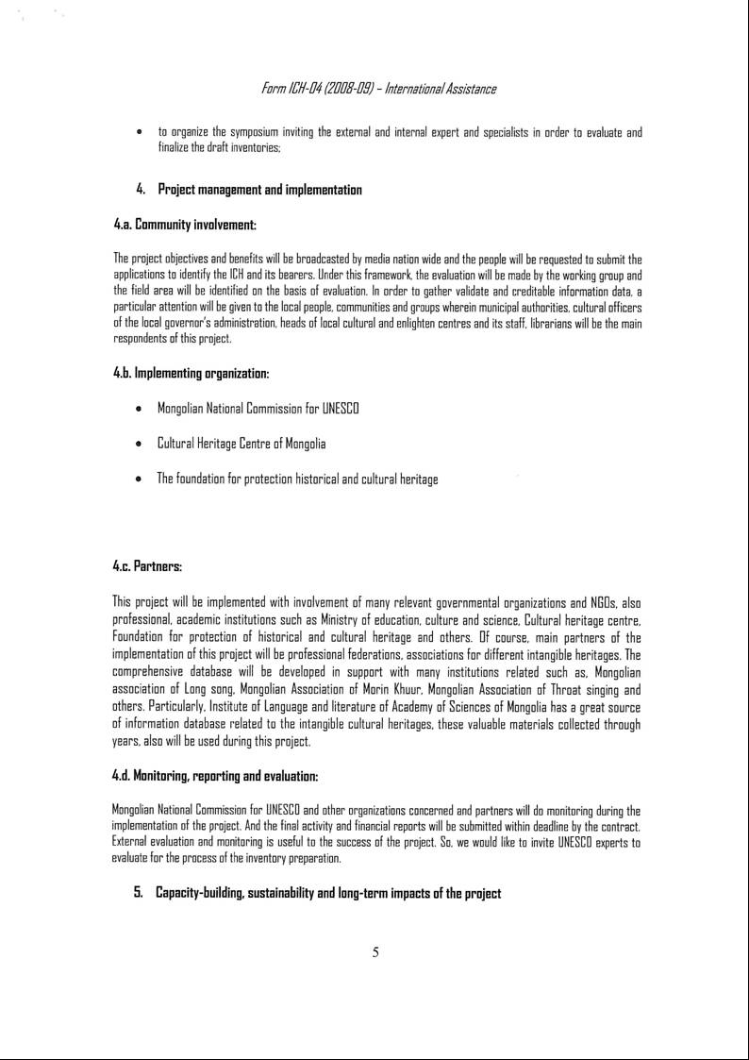
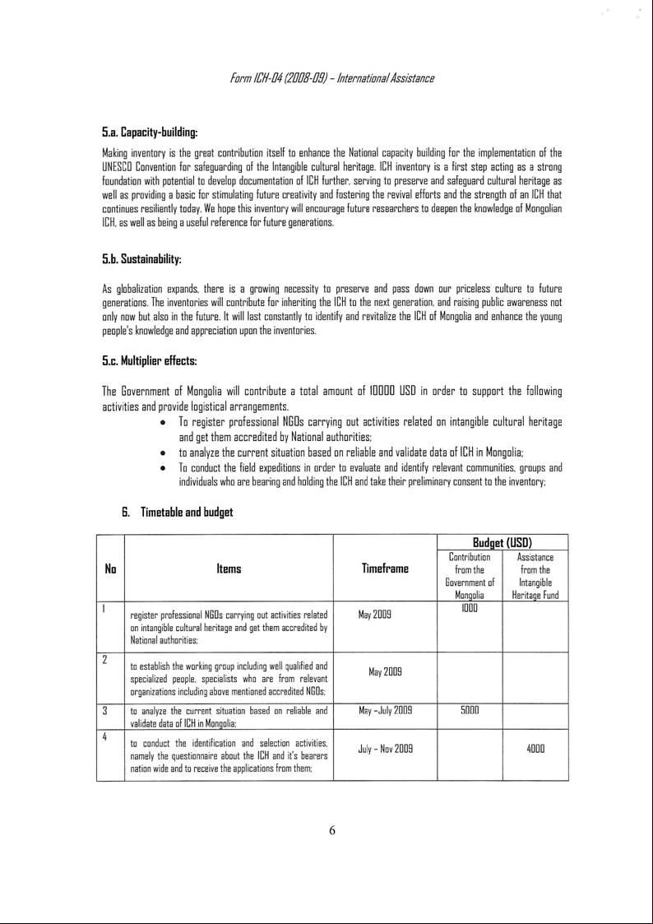
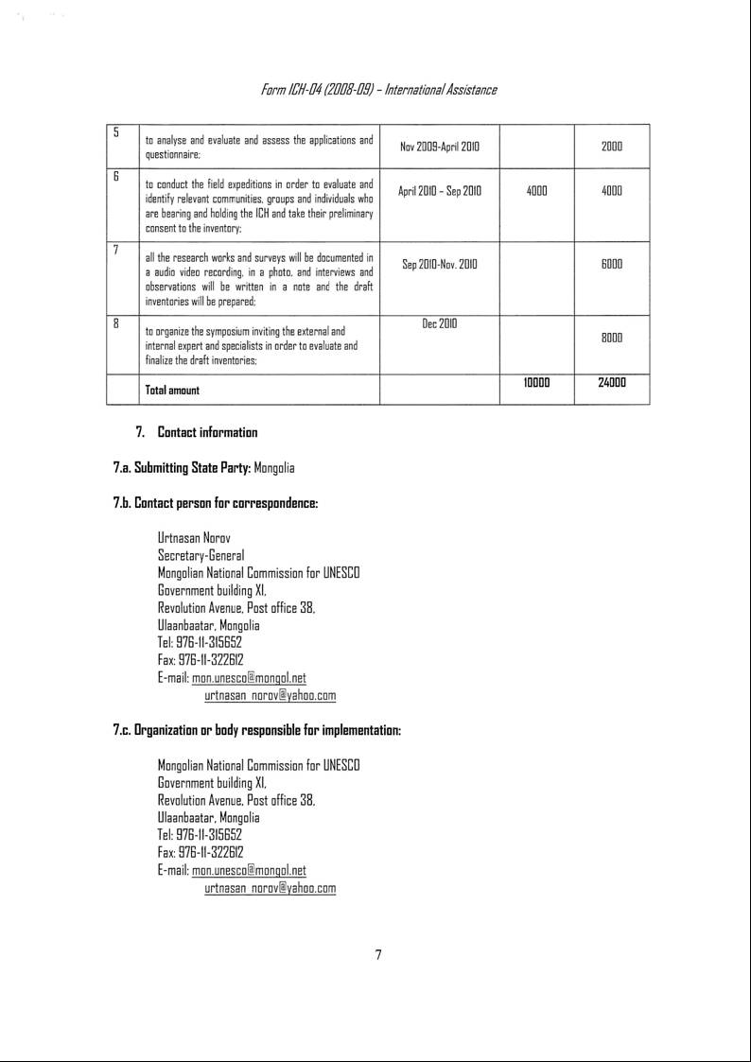
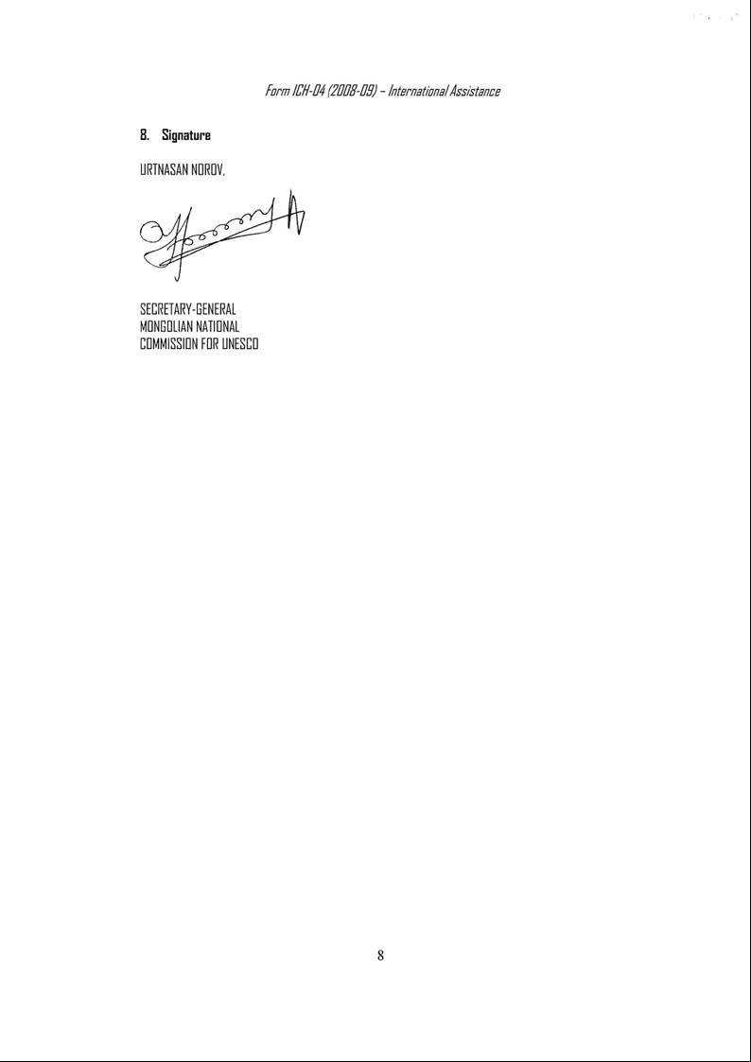

ANNEX B.2 – Mongolia (00298): recommendation by the Secretariat
Request for International Assistance less than 25,000 US dollars
Request Number 00298
Recommendation by the Secretariat

STATE PARTY: Mongolia
PROJECT TITLE: Elaboration of the “Inventories of the Representative List and list in need of urgent safeguarding of Intangible Cultural Heritage in Mongolia”
AMOUNT REQUESTED: US$ 24,000
TIME FRAME: May 2009 – February 2011

- The Mongolian Government seeks funds to support its work of inventorying the intangible cultural heritage present on the territory of Mongolia, as required under Articles 11 and 12 of the Convention. Mongolia's initiative builds upon its previous experience conducting an inventory of Mongolian performing arts in 2000; the scope would now be broadened to the wider range of intangible heritage expressions and practices. The inventorying project, to be carried out with full participation of Mongolian communities and ICH practitioners, will produce a two-tiered inventory, identifying representative elements of Mongolian heritage and those in need of urgent safeguarding.
- The inventorying project will be coordinated by the Mongolian National Commission for UNESCO and Cultural Heritage Centre and involve both governmental partners (namely, the Ministry of Education, Culture and Science and the Institute of Language and Literature of the Mongolian Academy of Sciences) and civil society partners (Foundation for Protection of Historical and Cultural Heritage, Mongolian Association of Long Song, Mongolian Association of Morin Khuur and other practitioner associations). The project is oriented towards community-based inventorying, in the spirit of Articles 11, 12 and 15 of the Convention, and combines the inventory work that is essential to the implementation of the Convention with a broad public awareness campaign. It is designed to reinforce Mongolian capacities, both institutional and individual, in safeguarding intangible cultural heritage. The beneficiary State Party is committing a substantial share of funds towards the project; the budget is appropriate to the expected results. The Mongolian National Commission has implemented previously financed activities in line with all regulations, having received preparatory assistance funds for two nominations to the Urgent Safeguarding List.
- Request no. 00298 appears to satisfy the criteria and procedures for international assistance requests in amounts less than 25,000 US dollars, as laid out in paragraphs 61-75 of the Operational Directives.

