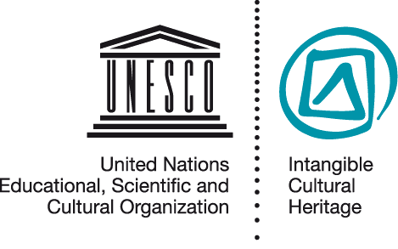
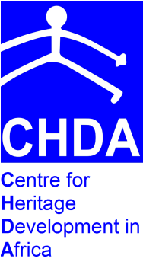

WORKSHOP ANNOUNCEMENT
Strengthening capacities of African Universities in intangible cultural heritage
18-22 June 2012
Mombasa Kenya
RATIONALE
African universities play a critical role in training future decision-makers and professionals in the field of heritage studies and sustainable development. Traditionally the focus of heritage-related studies was tangible cultural heritage, encompassing the protection and promotion of sites, monuments and objects. However, with the adoption of the UNESCO Convention for the Safeguarding of the Intangible Cultural Heritage (2003) and its rapid ratification by 142 State Parties to date, a new vision of cultural heritage is gaining prominence. Indeed the more recent international legal framework developed over the years by UNESCO is closing an important gap in the field of cultural heritage: it addresses a type of heritage that contributes to the well-being and development of communities and societies, to their livelihoods and their sense of belonging. In other words, the rich array of knowledge systems, practices and rituals that communities wish to keep alive, recreate and pass on to future generations, is at the heart of what has been called, after long and thorough debates at the international level, ‘intangible cultural heritage’.
While in some parts of the world, notably in Asia, intangible cultural heritage is already well integrated in courses for students of heritage studies, there is a great need for strengthening this component in the teaching and curricula of universities in Africa. Operational Directive 107 (k) of the Intangible Heritage Convention states that “[States Parties are encouraged in particular, to implement measures and policies aimed at …] teaching about intangible cultural heritage in universities and fostering the development of interdisciplinary scientific, technical and artistic studies, as well as research methodologies, (l) providing vocational guidance to youth by informing them about the value of intangible cultural heritage for personal and career development, (m) training communities, groups or individuals in the management of small businesses dealing with intangible cultural heritage. University teaching faculty needs to have a profound knowledge of the concepts and mechanisms of safeguarding intangible cultural heritage foreseen in the Intangible Heritage Convention. They need to be aware and understand the different roles of academia, as one of the different stakeholder groups in implementing the Convention at national level, and how safeguarding intangible cultural heritage is critical for the success of national strategies for sustainable development. They in particular need to know how to best train future heritage actors in the field of intangible cultural heritage safeguarding.

- OBJECTIVES OF THE WORKSHOP
The workshop aims at raising the level of knowledge of African university teaching faculty in the field of intangible cultural heritage safeguarding, enabling them to incorporate the issue in their teaching and provide guidance for their future courses and programs on heritage and sustainable development. More specifically it intends to:
- familiarize academics who train future decision-makers, community heritage workers, researchers and heritage professionals in Africa with the concepts and mechanisms of the UNESCO Convention for the Safeguarding of the Intangible Cultural Heritage and its implementation process;
- discuss the key role of universities in contributing to the implementation of the Convention, notably as trainers of future heritage actors and with reference to the text of the Convention and the Operational Directives;
- develop ideas and proposals of how to integrate training on intangible cultural heritage safeguarding for sustainable development in heritage studies, with respect to training approaches;
- promote networking of African academics teaching and training in the field of intangible cultural heritage.

II PARTICIPANTS
This training is addressed to teaching faculty of African Universities who:
- teach graduate and undergraduate studies to students who wish to become actors within the heritage sector;
- focus in their teaching and field research on issues raised within the Convention for the Safeguarding of the Intangible Cultural Heritage, including community involvement in heritage safeguarding and the articulation between intangible cultural heritage and sustainable development;
- collaborate with different stakeholder groups, such as government officials, community heritage workers, heritage bearers, communities of practice and other stakeholders.
III WORKSHOP PRESENTERS
The workshop will be co-facilitated by Deirdre Prins-Solani and Harriet Deacon who are both part of the network of 65 facilitators trained by UNESCO to use the dedicated workshop materials on implementing the Convention for the Safeguarding of the Intangible Cultural Heritage.
Ms Deirdre Prins-Solani currently serves as the Director for the Centre for Heritage Development in Africa. She has been instrumental in the development of academic programs in Heritage Management, such as the African Program for Museums and Heritage Studies a collaborative post graduate diploma offered by the Universities of Cape Town, Western Cape and Robben Island Museum and has co-facilitated workshops on implementing the Intangible Heritage Convention for NGOs in Libreville and government officials in Mombasa.
Ms Harriet Deacon is a historian with interests in tangible and intangible heritage management, public policy on heritage, and the intersection between culture and health. Her publications include the Subtle Power of Intangible Heritage (HSRC Press, 2004; available free online). She has been involved in the preparation and delivery of training materials for the implementation of the Intangible Heritage Convention since April 2010 and co-facilitated related training of trainers’ workshops in Havana, Harare and Beijing.

IV APPLICATION PROCESS
- Kindly submit a letter of application which outlines your reasons for applying to come to the workshop.
- State your current teaching responsibilities, your course topics and teaching methods. Include any relevant course outlines for courses that you teach.
- Include profiles of your students stating whether they come from National, Regional, or sub regional catchments, and what sectors/fields they have entered on graduation.

V BURSARIES
Limited bursaries are available. Kindly indicate in the application letter whether a bursary is required
Applications/Enquiries should be sent to:
chda@heritageinafrica.org AND diana.onkoba@heritageinafrica.org
Contact Number: +254 707701761
THE WORKSHOP SHALL BE CONDUCTED IN ENGLISH. ENGLISH PROFICIENCY IS A REQUIREMENT

See Operational Directives for the Implementation of the Convention for the Safeguarding of the Intangible Cultural Heritage. Adopted by the General Assembly of the States Parties to the Convention at its second ordinary session (Paris, France, 16 to 19 June 2008), amended at its third session (Paris, France, 22 to 24 June 2010)
For more information see: http://www.unesco.org/culture/ich/index.php?lg=en&pg=00326

