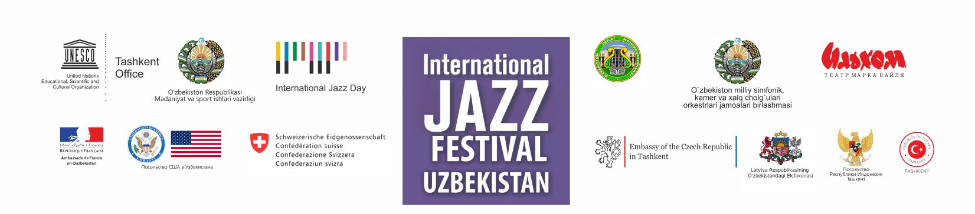
INTERNATIONAL JAZZ FESTIVAL IN UZBEKISTAN 2016. LIST OF EVENTS
DATE | TIME | VENUE | EVENT | TICKET INFORMATION
Thursday,  7 April | 10:00 -12:00 | Pop and Circus College, Tashkent | Master class for the students of Pop and Circus College, vocal group "The Exchange" (USA)
Thursday,  7 April | 14:00 -15:30 | Uzbekistan State Conservatory | Master Class for students of the State Conservatory, vocal group "The Exchange" (USA)
Thursday,  7 April | 16:00 - 17:30 | National Library of Uzbekistan | Meeting with audience “New Generation Music - Vocal in Pop”; vocal group "The Exchange" (USA) | http://www.natlib.uz/ru-RU/Announcement/ReadMore/9 (in Russian)
Friday,  8 April | 18:30 | Grand Hall, Uzbekistan State Conservatory | Joint Concert of the Jazz orchestra named after Batir Zakirov and the vocal group "The Exchange" (USA) | Tel. 289-57-95, 185-89-55, 988-61-73, Union of National symphony, chamber and folk instruments orchestras communities of Uzbekistan
Saturday,  9 April | 18:00 | Turkistan Concert Hall | Concert, vocal group  "The Exchange" (USA) | Please contact the USA Embassy in Tashkent for further information Tashkent-Program@state.gov, https://www.facebook.com/usdos.uzbekistan, http://uzbekistan.usembassy.gov/
Sunday,  10 April | 10:30 | Samarkand Music College | Master Class, vocal group  "The Exchange" (USA)
Tuesday,  12 April | 18:30 | Grand Hall, Uzbekistan State Conservatory | Concert of  Uzbek Jazz Bands | For invitations please call the Conservatory at  (90) 988 61 73, (94) 660 45 60
Saturday, 16 April | 18:30 | Grand Hall, Uzbekistan State Conservatory | Concert of the Jazz Band of  the State Conservatory | For invitations please call the Conservatory at  (90) 988 61 73, (94) 660 45 60
Thursday, 21 April | 18:30 | Grand Hall, Uzbekistan State Conservatory | Joint Concert of Michal Wroblewski, saxophone  (Czech Republic) and the Jazz orchestra named after Batir Zakirov | Tel. 289-57-95, 185-89-55, 988-61-73, Union of National symphony, chamber and folk instruments orchestras communities of Uzbekistan
Thursday, 21 April | 18:30 | Samarkand Music College | Concert, Latvian Radio Big Band (Latvia) | Embassy of Latvia  (+998) 71 237 22 15, embassy.uzbekistan@mfa.gov.lv
Friday,  22 April | 10:00 | Pop and Circus College | Master Class,  Michal Wroblewski, saxophone  (Czech Republic)
Friday,  22 April  ATTENTION  CHANGE OF DATE | 18:30 | Turkistan Concert Hall | Concert, Latvian Radio Big Band (Latvia) | For invitations please contact the Embassy of Latvia at (+998) 71 237 22 15, embassy.uzbekistan@mfa.gov.lv
Sunday,  24 April | 18:30 | Grand Hall, Uzbekistan State Conservatory | Concert of Dwiki Dharmawan  and his group (Indonesia) | For invitations please call the Conservatory at  (90) 988 61 73, (94) 660 45 60
Tuesday, 26 April | 11:00 | Uspensky Academic Mu-sical Lyceum | Master Class,  “Noisy Minority” (Switzerland)
Tuesday,  26 April | 18:30 | Grand Hall, Uzbekistan State Conservatory | Batir Zakirov's Birthday concert with the participation of the Jazz orchestra named after Batir Zakirov,  Ahmet Berker – Gokhan Somel Band (Turkey),  “Noisy Minority” (Switzerland), Dwiki Dharmawan and his group (Indonesia) | Tel. 289-57-95, 185-89-55, 988-61-73, Union of National symphony, chamber and folk instruments orchestras communities of Uzbekistan
Wednesday, 27 April | 18:30 | Grand Hall, Uzbekistan State Conservatory | Concert, Ahmet Berker – Gokhan Somel Band (Turkey) | For invitations please call the Conservatory at  (90) 988 61 73, (94) 660 45 60
Thursday, 28 April | 19:00  ATTENTION  CHANGE OF TIME | Grand Hall, Uzbekistan State Conservatory | Concert, “Noisy Minority” (Switzerland) | For invitations please call the Conservatory at  (90) 988 61 73, (94) 660 45 60
Thursday, 28 April |  | Samarkand Music College | Concert of Dwiki Dharmawan  and his group (Indonesia)
Friday,  29 April | 18:30 | Grand Hall, Uzbekistan State Conservatory | Joint Concert of pianist  Hervé Sellin (France) and the Jazz orchestra named after Batir Zakirov | Tel. 289-57-95, 185-89-55, 988-61-73, Union of National symphony, chamber and folk instruments orchestras communities of Uzbekistan;  http://www.ambafrance-uz.org/,  https://www.facebook.com/culturefranceouzbekistan/?fref=ts, https://www.facebook.com/ambafrancetachkent/?fref=ts
Saturday, 30 April | 18:30 | Grand Hall, Uzbekistan State Conservatory | International Jazz Day Concert | For invitations please call the Conservatory at  (90) 988 61 73, (94) 660 45 60

Please follow the updated information on http://www.unesco.org/new/en/tashkent/; https://www.facebook.com/UNESCO.Tashkent/ and the websites of the embassies, participating in the festival.

