CONVENTION FOR THE SAFEGUARDING OF THE
INTANGIBLE CULTURAL HERITAGE
INTERGOVERNMENTAL COMMITTEE FOR THE
SAFEGUARDING OF THE INTANGIBLE CULTURAL HERITAGE
Twelfth session
Jeju Island, Republic of Korea
4 to 9 December 2017
Item 7 of the Provisional Agenda:
Draft plan for the use of the resources of the
Intangible Cultural Heritage Fund in 2018-2019
Summary
Part I of the document reports on the use of the Intangible Cultural Heritage Fund and presents, in Annex II, the Financial Report for the period 1 January 2016 to 30 June 2017 established by the Bureau of Financial Management (BFM).
Part II presents the draft plan for the use of the resources of the Intangible Cultural Heritage Fund for the period 1 January 2018 to 31 December 2019 and the first semester of 2020, included in its Annex I, to be submitted to the General Assembly for its approval.
Decision required: paragraph 38

REPORT ON THE EXECUTION OF THE PLAN FOR THE USE OF THE RESOURCES OF THE INTANGIBLE CULTURAL HERITAGE FUND FOR THE PERIOD 1 JANUARY 2016 TO 30 JUNE 2017
- In accordance with Article 25.3 of the Convention, the income of the Intangible Cultural Heritage Special Account (hereafter the Fund) consists of: a) contributions made by States Parties to the Convention; b) funds appropriated for this purpose by the General Conference of UNESCO; c) contributions, gifts or bequests that may be made by other States, organizations and programmes of the United Nations system, particularly the United Nations Development Programme, as well as other international organizations and public or private bodies or individuals; d) any interest due on the resources of the Fund; e) funds raised through collections, and receipts from events organized for the benefit of the Fund; f) any other resources authorized by the regulations of the Fund, to be drawn up by the Committee. Those regulations are found in the Financial Regulations of the Special Account for the Fund for the Safeguarding of the Intangible Cultural Heritage, adopted by the Committee at its first extraordinary session (Decision 1.EXT.COM 9). Expenditures of non-earmarked contributions are governed by the Plan for the use of the resources of the Fund, which is adopted each biennium by the General Assembly according to Article 7 (c) of the Convention. In accordance with Article 25.5 of the Convention, the Committee approves earmarked contributions made to the Fund and their use does not follow the two-yearly accounting period.
- The Financial Report in Annex II covers the period from 1 January 2016 to 30 June 2017, during which the Fund was used according to the Plan approved by the sixth session of the General Assembly in June 2016 (Resolution 6.GA 9). According to Article 7.5 of the Financial Regulations, a financial report for the entire biennium (1 January 2016 to 31 December 2017) will be submitted to the General Assembly of the States Parties at its seventh session.
- Income (financial statement I)
- During the reporting period, the income of the Fund consisted of:
- Compulsory and voluntary assessed contributions from States Parties
Compulsory contributions of 167 States Parties to the Convention, as described in Article 26.1 of the Convention. | US$3,554,720
Voluntary contributions received from four of the five States Parties, which, at the time of their ratification, had recourse to Article 26.2 of the Convention. | US$308,056
- Voluntary supplementary contributions
Contributions made for specific purposes relating to specific projects approved by the Committee, in accordance with Article 25.5 of the Convention
From the Netherlands for the implementation of ongoing projects supporting the capacity-building programme in the Dutch Caribbean islands and Suriname (Decision 9.COM 7).  From the People’s Republic of China to support an open-ended intergovernmental working group on developing an overall results framework for the Convention (Decision 10.COM 9).  From the Republic of Korea in support of improving the periodic reporting mechanism of the Convention (Decision 11.COM 6). | US$510,375
Sub-fund created within the Intangible Cultural Heritage Fund and intended exclusively to strengthen the human capacities of the Secretariat
(Resolution 3.GA 9)
From Azerbaijan, Monaco and the United Arab Emirates | US$108,494
- Interest due on the resources of the Funds | US$178,588
TOTAL | US$4,660,233
- The total income as at 30 June 2017 is 15% lower than in the previous biennium for the period 1 January 2014 to 31 August 2015. This fall is mainly due to the reduction in the amount of voluntary supplementary contributions received, which decreased from US$1,581,353 to US$618,868; this situation affected both the funds dedicated to specific activities approved by the Committee and the Sub-fund for enhancing the human capacities of the Secretariat. The fall in the total income received is partially compensated by the increase in the interest generated, which grew from US$51,642 to US$178,588. As at 30 June 2017, the total unpaid represents 71% of the value of 2017 compulsory contributions.
- Voluntary Contributions
- Annex II (a) of the present report contains the list of voluntary supplementary contributions paid between January 2016 and June 2017 for specific purposes, as stipulated in Article 25.5 of the Convention, following a decision of the Committee. On the other hand, the list attached to document ITH/17/12.COM/6 presents all the voluntary contributions received in support of the 2003 Convention, with all modalities combined, since the eleventh session of the Committee. Annex II (b) shows the total expenditure incurred for each earmarked project, from its beginning until 30 June 2017.
- Annex II (c) shows the forecasts as of 30 June 2017, based on the Secretariat’s estimation, for the future use of the funds allocated to ongoing projects based on funds not committed at that date and budgets approved by the Committee. In cases where the donor has already confirmed that the outstanding contribution will not be paid (marked with an asterisk), forecasts are based on the actual funding received to date.
- Schedule of appropriations and expenditure for the period 1 January 2016 to 30 June 2017 (Financial Statement I, page 12-13)
- By its Resolution 6.GA 9, the General Assembly approved a budget of US$7,977,920 for the period 1 January 2016 to 31 December 2017, as shown by the schedule of appropriations and expenditure. This corresponds to the balance of the Fund on 1 January 2016 (US$8,953,730) less the Reserve Fund accumulated up to that date (US$975,810).
- Financial Statement I shows a total expenditure of US$2,769,000 as of 30 June 2017, that is, 35% of the approved budget. Explanations for each budget line of the schedule of appropriations and expenditure are provided below.
- In line with the priorities set by the Guidelines for the use of the resources of the Fund in Chapter II.1 of the Operational Directives, the General Assembly once again decided that the majority of the resources (budget line 1, 59%) be allocated to the provision of International Assistance to States Parties to supplement their national efforts to safeguard intangible cultural heritage. Expenses under this line correspond to International Assistance granted by the Committee or its Bureau to thirteen projects. In line with past trends, the majority of the projects approved (nine) belong to Electoral Group 5a: Africa. During the reporting period, three other projects – two granted by the Bureau that met in May 2017 (Decisions 12.COM 2.BUR 4.2 and 12.COM 2.BUR 4.4) and one by the last Committee (Decision 11.COM 10.a.6) – have not yet materialized into a contract and are, therefore, not reflected in this Financial Statement. Thus, while it remains low, the expenditure rate of International Assistance (19.7%) is expected to rise to 26% at the end of the biennium when the above-mentioned contracts are established, marking an increase of around 13% compared to the expenditure rate of the last biennium.
- During the reporting period, the Secretariat received only one preparatory assistance request for a nomination to the List of Intangible Cultural Heritage in Need of Urgent Safeguarding and no preparatory assistance requests for proposals for the Register of Good Safeguarding Practices. The Bureau examined the preparatory assistance after the reporting period. Expenditures reflected in budget line 2 correspond to the provision of technical assistance to four States Parties for their International Assistance requests, in accordance with Decision 8.COM 7.c.
- The use of the budget for ‘other functions of the Committee’ (budget line 3) is decided by the Bureau on the basis of specific proposals prepared by the Secretariat (Decision 10.COM 8). According to the plan approved by the Bureau in its Decision 11.COM 2.BUR 1, these funds were dedicated to: capacity building and guidance on safeguarding measures and good practices (51.38%); knowledge-management services (24.32%); awareness raising and outreach (21.15%); and monitoring the implementation of the Convention (3.15%). Some 62.9% of the funds approved for the current biennium were obligated as of 30 June 2017. A detailed report on the progress of implementation of these funds can be found in document ITH/17/12.COM/5.b, ‘Report by the Secretariat on its activities’.
- Following the Internal Oversight Service’s recommendation in its audit of the working methods of the culture conventions (IOS/AUD/2013/06), the Committee requested, by its Decision 8.COM 11, that the Secretariat apply the cost recovery policy consistently when using the resources of the Fund. Consequently, and as provided in Article 5.2 of the Financial Regulations of the Fund, budget lines 1 to 3 were charged with all direct expenses. Decision 8.COM 11 is systematically applied and will continue to be applied in future cycles.
- Budget line 4, which is used to finance the participation of experts representing developing States Members of the Committee, its Bureau and subsidiary bodies in its sessions, shows an expenditure rate of 64.8%, including the foreseeable costs that are already committed for the participation of such experts in the twelfth session of the Committee. As in previous biennia, this rate is likely to remain almost unaltered until the end of the year, meaning an increase of around 5% compared to the previous biennium.
- The expenditure rate of budget line 5 reaches almost 100%. Disbursements include the participation costs of eligible experts from developing States Parties non-members of the Committee serving on the Evaluation Body in 2016 and 2017 and the participation costs of experts in the eleventh session of the Committee. Unliquidated obligations are mainly provisioned for covering the participation costs of experts from developing States Parties non-members of the Committee in the twelfth session of the Committee.
- Budget Line 6 shows an expenditure rate of 65.7%, which reflects the participation costs of the six accredited non-governmental organizations (NGOs) serving on the Evaluation Body in 2016 and 2017 and the participation of twenty-three NGOs in the eleventh session of the Committee. It also reflects unliquidated obligations provisioned for the participation of accredited NGOs from developing countries in the twelfth session of the Committee.
- Budget line 7 shows an expenditure rate of 51.4%, corresponding to the fees of the eligible members of the Evaluation Body (ten in 2016 and eleven in 2017) and the fees paid to the Chairperson and the Rapporteur of the Body for the additional tasks they perform. This rate remains relatively low due to the need to establish the contract of the members of the Evaluation Body at the beginning of the evaluation cycle, when only one fourth of the total budget is still available. Therefore, it is necessary to overestimate the total percentage allocated, to have enough funds until the final approval of the General Assembly (the first June of the biennium).
- The Reserve Fund (budget line 8) was created in accordance with the Financial Regulations of the Special Account of the Fund for the Safeguarding of the Intangible Cultural Heritage to meet requests for International Assistance in cases of extreme urgency and in the event that the funds allocated to International Assistance (budget line 1) are exhausted. The total allocation of the Reserve Fund reached the amount of US$1,000,000 – achieving the objective set by the Committee (Decision 10.COM 8 and Resolution 6.GA 9) – when US$24,190 was transferred to it following the approval of the Plan for the use of the resources of the Fund by the sixth session of the General Assembly in June 2016.
- Trends
- The low expenditure rate of the latest plan approved by the General Assembly is not an exception and continues to be directly linked to the insufficient use of the International Assistance mechanisms. The graph below (Figure 1) clearly demonstrates that the Fund is systematically underutilized, with expenditure that continues to be significantly lower than the approved budget (35% for the 38 C/5) and indeed lower than the amount of assessed contributions due (72% for the 38 C/5). As a result, the approved budget increases notably from one biennium to the next as unspent balances are added to the assessed contributions due for the following biennium. The budget also increases due to the growing number of States Parties to the Convention. For example, the budget for the spending plan approved by General Assembly for the 38 C/5 biennium (US$7,977,920) was 18% higher than the amount approved for the 37 C/5 biennium. Thus, the expenditure rate for the 38 C/5 remains at similar levels to that of the 37 C/5, despite an increase of 13% in the total expenditure at the time of this report.

Figure 1: expenditure rate of the Fund
- Figure 2 demonstrates clearly that States Parties make low use of the International Assistance mechanisms, corresponding to budget lines 1 and 2. During the 38 C/5 biennium, considering only the budget corresponding to the assessed contributions due each biennium, the expenditure rate increased to 53%, compared to the 21% of the 37 C/5. This positive result was due mainly due to: 1) the increase in the ceiling of International Assistance requests that can be presented to the Bureau from US$25,000 to US$100,000 (Resolution 6.GA 7) and 2) the 40% increase (compared to previous biennia) of the requests examined by the Bureau, with the corresponding recommendations prepared by the Secretariat. Despite this intense effort, the total expenditure rate under these two budget lines remains proportionally low (26%) as shown in Figure 2. This is due to the persisting increase in the total budget approved each biennium. If this trend continues, the budget will continue to increase in future cycles, making it even more difficult for expenditures to follow. A detailed report on the progress of implementation of the funds dedicated to International Assistance can be found in document ITH/17/12.COM/8.a, ‘Reports of State Parties on the use of International Assistance’.

Figure 2: expenditure rate: International and Preparatory Assistance
- The underutilization of the funds dedicated to International Assistance and the inadequate monitoring mechanism is particularly unfortunate at a time when other financial sources to support the Convention and, in particular, its implementation at the national and local levels are diminishing, while developing States are in need of resources and support to safeguard their intangible cultural heritage.

PROPOSED DRAFT PLAN FOR THE USE OF THE RESOURCES
OF THE INTANGIBLE CULTURAL HERITAGE FUND FOR THE PERIOD 2018-2019
- Article 7 (c) of the Convention requests that the Committee ‘prepare and submit to the General Assembly for approval a draft plan for the use of the resources of the Fund’. Article 25.4 of the Convention further provides that the use of the resources of the Fund by the Committee ‘shall be decided on the basis of guidelines laid down by the General Assembly’. Those guidelines were adopted by the General Assembly of the States Parties in its second session in 2008 and are found in Chapter II.1 of the Operational Directives for the implementation of the Convention. The draft plan proposed as Annex I to this document was prepared in conformity with those guidelines and based on the experience of implementing the current plan for the 2016-2017 period.
- The General Assembly of the States Parties to the Convention meets in ordinary session in even years, about six months after the start of UNESCO’s financial period. At its seventh session in June 2018, the General Assembly will therefore be requested to approve a draft plan for the use of the resources of the Fund that covers twenty-four months, from 1 January 2018 to 31 December 2019, and, on a provisional basis, the first six months of the next financial period, i.e. from 1 January to 30 June 2020, preceding the eighth session of the General Assembly. The provisional budget for the first semester of 2018 that was adopted by the sixth session of the General Assembly (Resolution 6.GA 9) will in turn be superseded by the present plan once it has been adopted by the seventh session of the General Assembly.
- The total amount of funds available for the next financial period cannot be known until early 2018, after the closure of the 2017 accounts. The budget presented in the draft plan below (Annex I) is thus expressed in percentages of the total amount that will be available. The document to be submitted to the General Assembly will specify the amounts allocated for each purpose. As was done in the current plan, the Committee may wish to propose provisionally allocating to the first semester of 2020 one fourth of the amount established for the two-year period from 1 January 2018 to 31 December 2019. It is therefore proposed that the Committee submit to the General Assembly a spending plan based on the total amount of unrestricted and unencumbered funds available as of 31 December 2017, which is estimated to be approximately US$8.33 million.
- The spending plan proposed below takes into account this systematic underutilization of International Assistance mechanisms and seeks to redress the absence of an appropriate follow-up and monitoring in its implementation and proposes measures to help States Parties benefit from the resources available in the Fund. It also considers the reduction in the resources of the Secretariat – staff members have decreased by 20% since 2010 – the increasing number of States members of the Convention – a 30% increase since 2010 – and other mechanisms requiring more resources within the Secretariat that are coming into operation (e.g. periodic reporting, NGO evaluation and accreditation and support for the capacity-building facilitators’ network).
- Currently there are eight professional and four general fixed term staff working at the Intangible Cultural Heritage Section, including the Secretary of the Convention and the Chiefs of the two units (Programme Implementation Unit and a Capacity-building and Heritage Policy Unit). These numbers are not even sufficient to allow the Secretariat to respond to all its core statutory obligations (such as preparing statutory meetings including drafting documents, supporting the Evaluation Body with its work, treating nominations and non-governmental organizations requests for accreditation and reviewing and following-up on periodic reporting) and other vital functions (regional officer roles and capacity building programme). As a result, many of these core obligations and functions are currently undertaken by temporary staff. Under the current situation, the work on international assistance is divided among a number of staff over and above their primary responsibilities. However, in order to redress the underutilization of the international assistance mechanisms and the ever growing balance of the Fund it is imperative to have a small, dedicated team to the implementation on International Assistance. The current staffing situation simply does not allow for that.
- Therefore, compared to the current Plan for the use of the resources of the Fund, it is proposed that a new budget line be created (budget line 1.1), which will cover the biennial costs of two extra-budgetary fixed-term posts (one P3 and one G5) in order to fully activate the International Assistance mechanisms and effectively monitor and evaluate its implementation. Furthermore, slight percentage reductions or increases are proposed in certain lines to absorb the creation of the new budget line and taking into account past experience. Considering that the balance that will serve as the basis for the Plan is expected to increase, the reductions in those lines will be minimal and the real allocations will be significantly above what was spent in the past. It is worth mentioning that due to the existing unspent balances, the Fund is generating an increasing amount of interest each biennium that, in fact, will cover around 40% of the expenditures related to the posts during the next exercise.
- In line with the priorities set by the Guidelines for the use of the resources of the Fund in Chapter II.1 of the Operational Directives, it is once again proposed that the majority of the resources – 54.85% – be allocated to providing International Assistance to States Parties to supplement their national efforts to safeguard intangible cultural heritage (budget line 1). The slight decrease (4.15%) compared to the current biennium will serve to cover most of the costs of the newly created budget line 1.1, keeping budget line 1 provisions above its 37 C/5 level, when there were still allocations to the Reserve fund.
- It is proposed that 4.5% of the funds be budgeted for granting preparatory assistance (budget line 2). In addition to preparatory assistance for nomination files for the List of Intangible Cultural Heritage in Need of Urgent Safeguarding and for proposals for the Register of Good Safeguarding Practices, the Committee decided to use this line to provide technical assistance to States Parties for preparing International Assistance requests (Decision 8.COM 7.c). Considering that States have required technical assistance much more than preparatory assistance in its traditional format, it is proposed that funds available under this line continue to be used for the provision of experts, as described in Article 21 of the Convention. The one percentage point decrease in funds assigned to this budget line, compared to the previous biennium, will contribute to covering the costs of the two new posts.
- Budget line 3, ‘other functions of the Committee’, will be maintained at 20%. The Secretariat will use these funds primarily for promoting the objectives of the Convention and encouraging and monitoring its implementation (Article 7 [a]). To this end, funds allocated to this budget line will continue to provide essential support for a number of cross-cutting needs of the capacity-building programme and the new initiative to incorporate intangible cultural heritage into formal and non-formal education. Similarly, this budget line will be vital to ensure the steady improvement in the management of knowledge, information and monitoring, including the website of the Convention and the continuation of the work already started on the overall results framework. Funds allocated to this budget line will also contribute to the integration of intangible cultural heritage into development plans, policies and programmes, through the establishment of partnerships with educational institutions and cooperation with other United Nations agencies, in line with the 2030 Agenda. Finally, these funds will be used to promote the objectives of the Convention though awareness raising and outreach.
- The participation in statutory meetings of experts in intangible cultural heritage representing developing States Parties is covered either by budget line 4 when they are members of the Committee or by budget line 5 when they are not. The participation of experts in intangible cultural heritage representing accredited NGOs from developing countries in the sessions of the Committee is covered by budget line 6. It proposed that 2%, 3.25% and 4%, respectively, be dedicated to the above-mentioned lines.
- It is proposed that budget line 7 be maintained at 6% as the allocation approved for the 38 C/5 exercise proved sufficient to cover the cost of the advisory services provided at the request of the Committee. Furthermore, according to Decision 10.COM 8 of the Committee, it is proposed that no budget be allocated to budget line 8.
- The International Assistance mechanisms of the Convention provide a unique opportunity for States to assume leadership in developing and implementing projects according to their own needs, goals and priorities in safeguarding the intangible cultural heritage in their territories. However, as demonstrated above, despite the efforts made by the governing bodies and the Secretariat to improve the use of those mechanisms, such as the increase in the ceiling of files that can be examined by the Bureau from US$25,000 to US$100,000, the increase in requests presented to the Bureau, the development of capacity-building materials on International Assistance, and the provision of technical assistance for specific projects, the progress achieved so far remains insufficient. It is therefore proposed, as already mentioned in paragraph 26, that two extra-budgetary fixed-term posts (one P3 and one G5) be created. These posts will be covered by a new budget line (budget line 1.1) that, if approved, will be part of the current and future Plans for the use of the Fund. The funds needed to cover the cost of the two posts for the 39 C/5 biennium are estimated at US$446,000 that is 5.4% of the total estimated budget.
- One of the purposes of creating two extra-budgetary fixed-term posts is to increase the quality and quantity of International Assistance requests, the target being to reach an optimum level when the budget equals assessed contributions and expenditure. Based on a steadily increasing level of assessed contributions (3% every biennium) and an estimated 40% increase in the use of budget lines 1 and 2 during the 39 C/5 and 40 C/5, remaining stable thereafter, this target will be reached by the 45 C/5 biennium (Figure 3). When the budget stabilizes to the amount of the assessed contributions, around 9.5% of the overall budget will be needed to cover the cost of the two fixed-term posts (budget line 1.1).
- The creation of the two posts will also allow for a thorough project monitoring and evaluation process. This monitoring process will help to assess the impact of projects supported by the Fund, identifying best practices and lessons learned that would help to enhance the efficiency of projects in the future. Such information could also serve as a communication tool and provide inspiration to other States to engage in the safeguarding of their intangible culture heritage in line with the spirit of the Convention, and may trigger more requests. Monitoring is becoming crucial following the development of the overall results framework as well as the approval of the increase in the ceiling of International Assistance requests that can be presented to the Bureau from US$25,000 to US$100,000 (Resolution 6.GA 7), leading to projects of a more complex nature and a wider scope and impact.

Figure 3: Forecast trends: Fund, if the new Draft Plan for the use of the resources is approved
- As in the current and preceding Plans for the use of the Fund, the present draft decision proposes that the Committee again delegate to its Bureau the authority to decide upon the utilization of the funds allocated under budget line 3, on the basis of specific proposals to be prepared by the Secretariat. It is also proposed in the draft decision that the Committee authorize the Secretariat to make transfers between activities within budget line 3 up to a cumulative amount equivalent to 2% of the initial total allocation likely to be proposed for this purpose to the General Assembly, which should fluctuate around US$30,000, as authorized by previous decisions of the Committee (Decisions 6.COM 20, 8.COM 11, and 10.COM 8). Such authorization is similar to that by which the General Conference authorizes the Director-General to make transfers between appropriation lines of UNESCO’s regular programme up to an amount of 2% of the initial appropriation. The Secretariat would inform the Bureau in writing, at the session following such action, of the details and reasons for these transfers; any transfers larger than that amount would require the Bureau’s prior approval of a revised spending plan.

PROSPECTS FOR FUTURE BUDGET CYCLES
- With its current 175 States Parties, the Fund shall receive some US$3.9 million in assessed contributions from States Parties in 2018–2019, depending on the Resolutions on UNESCO’s regular budget to be adopted by the General Conference at its 39th session. As of 30 June 2017, the 174 States Parties were responsible for more than 63.5% of the total assessed budget of UNESCO, with the rates for assessed contributions to the Convention established at 1% of each State’s contribution to UNESCO.
- The Committee may consider that the low utilization rate, which in particular affects the use of budget line 1 (International Assistance) and budget line 2 (preparatory assistance), will be corrected with the new measures proposed in this Plan. The global capacity-building strategy and in particular efforts to strengthen the capacities of developing States Parties to formulate solid International Assistance requests will continue to be implemented in the coming years. However, the significant decrease in extra-budgetary support from Funds-in-Trust and earmarked contributions to the Fund, as reflected in document ITH/17/12.COM/6, should be noted, creating a greater need for other measures.
- The Committee may wish to adopt the following decision:
DRAFT DECISION 12.COM 7
The Committee,
- Having examined Document ITH/17/12.COM/7,
- Recalling Article 7(c) of the Convention and Resolution 6.GA 9 of the General Assembly,
- Decides to base the draft plan for the use of the resources of the Fund for the periods of 1 January 2018 to 31 December 2019 and 1 January to 30 June 2020 on the total unrestricted operating reserves available as of 31 December 2017, including any unused balance;
- Submits for approval to the General Assembly the plan for the use of the resources of the Fund, as included in Annex I of document ITH/17/12.COM/7, and proposes to the General Assembly that one fourth of the amount established for the two-year period from 1 January 2018 to 31 December 2019 be provisionally allocated to the first semester of 2020;
- Takes note of the need to enhance the human resources of the Secretariat for the implementation of the International Assistance mechanisms of the Fund, including their effective monitoring, and welcomes the proposal for the creation of two new extra-budgetary fixed-term posts;
- Delegates to its Bureau the authority to decide upon the utilization of the funds allocated under budget line 3 of the Plan, ‘Other functions of the Committee’, on the basis of specific proposals to be prepared by the Secretariat;
- Authorizes the Secretariat, when utilizing the funds allocated under budget line 3 of the Plan, to make transfers between activities included within the specific proposals approved by the Bureau up to a cumulative amount equivalent to 2% of the initial total allocation proposed to the General Assembly for this purpose, informing the Members of the Bureau in writing, at the session following such action, of the details and reasons for these transfers.

ANNEX I
Draft plan for the use of the resources of the Fund
For the period 1 January 2018 to 31 December 2019, as well as for the period  1 January to 30 June 2020, the resources of the Intangible Cultural Heritage fund may be used for the following purposes: |  | % of the total amount | 2016–2017 Plan
1. | International Assistance, comprising the safeguarding of the heritage inscribed on the List of Intangible Cultural Heritage in Need of Urgent Safeguarding, the preparation of inventories and support for other safeguarding programmes, projects and activities; | 54.85% | 59.00%
1.1 | Enhancing human resources to improve the implementation of the International Assistance mechanisms through the creation of two extra-budgetary fixed-term posts (one P3 and one G5); | 5.4% | n/a
2. | Preparatory assistance for International Assistance requests, as well as for nomination files for the Urgent Safeguarding List and for proposals for the Register of Good Safeguarding Practices; | 4.50% | 5.50%
3. | Other functions of the Committee as described in Article 7 of the Convention, aimed at promoting the objectives of the Convention and encouraging and monitoring its implementation, in particular by strengthening capacities to effectively safeguard intangible cultural heritage, raising awareness of the importance of such heritage, providing guidance on good safeguarding practices and updating and publishing the Lists and the Register of Good Safeguarding Practices; | 20.00% | 20.00%
4. | Participation in the sessions of the Committee, its Bureau and subsidiary bodies of experts in intangible cultural heritage representing developing States Members of the Committee; | 2.00% | 2.25%
5. | Participation in the sessions of the Committee and its consultative bodies of experts in intangible cultural heritage representing developing states that are Parties to the Convention but not Members of the Committee; | 3.25% | 2.75%
6. | Participation in the sessions of the Committee, its Bureau and consultative bodies of public or private bodies, private persons, notably members of communities and groups, that have been invited by the Committee to advise it on specific matters, as well as experts in intangible cultural heritage representing accredited NGOs from developing countries; | 4.00% | 4.50%
7. | The costs of advisory services to be provided at the request of the Committee, including support to developing States whose representatives have been appointed to the Evaluation Body; | 6.00% | 6.00%
8 | Building up the Reserve Fund referred to in Article 6 of the Financial Regulations of the Fund; | 0% | U$24,190
 | Subtotal | 100% | 100%
Funds that have not been committed at the end of the period of this Plan are carried over to the next financial period and shall be allocated in accordance with the Plan approved by the General Assembly at that time.

ANNEX II
Statement I
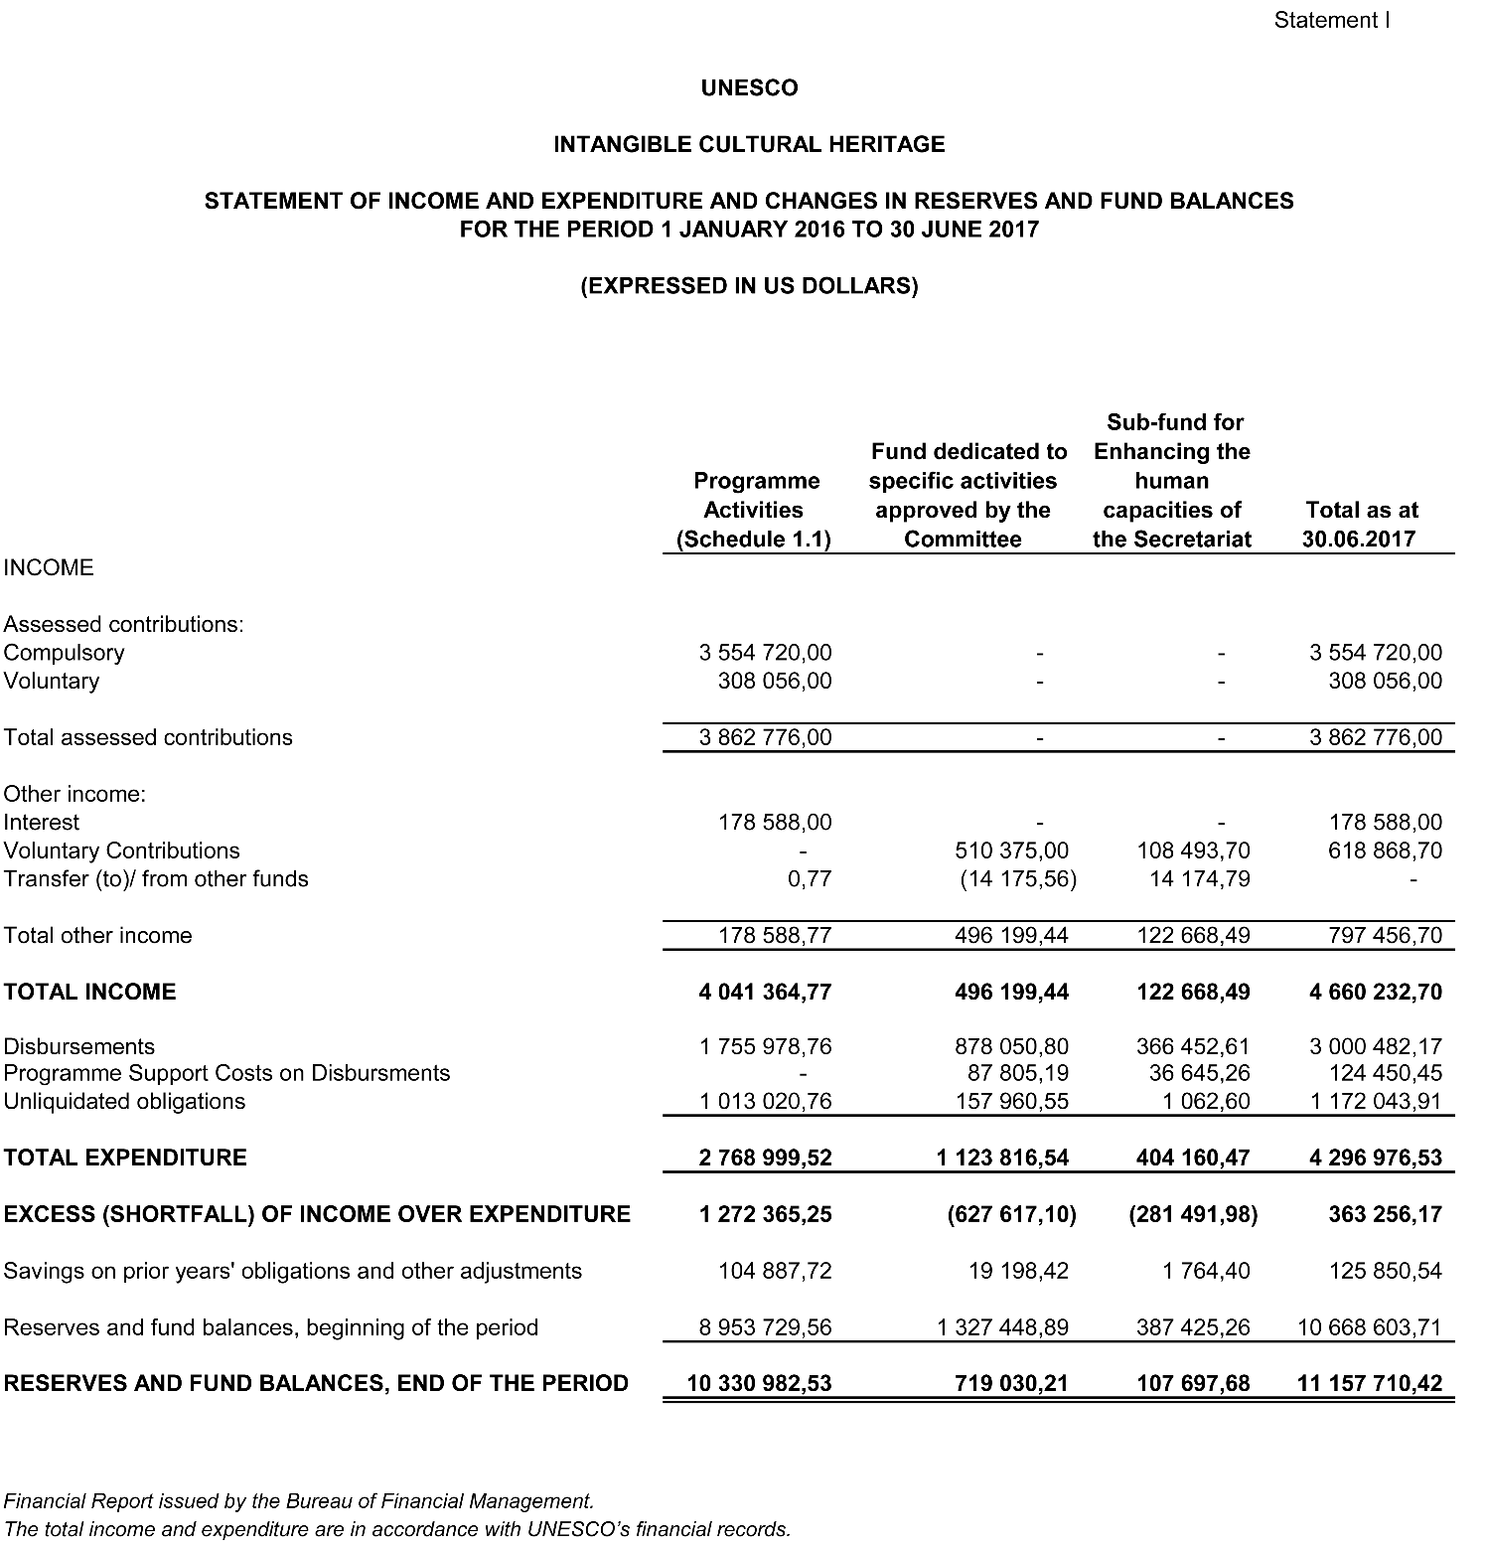

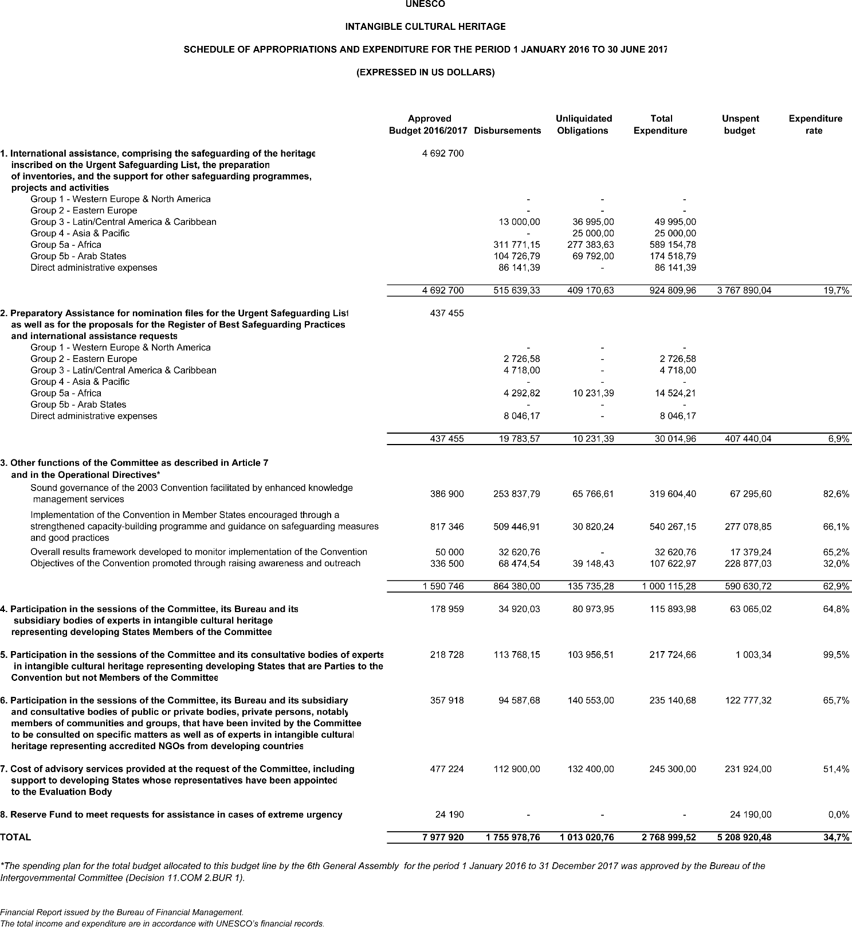

Statement II
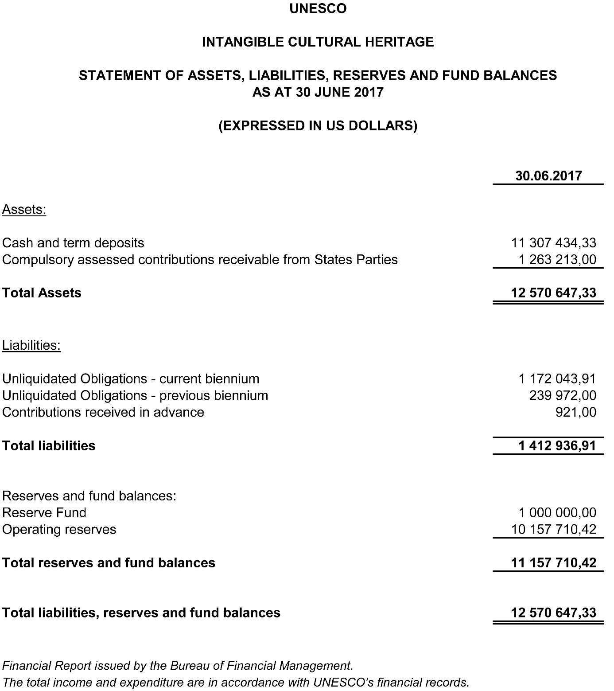

Statement III
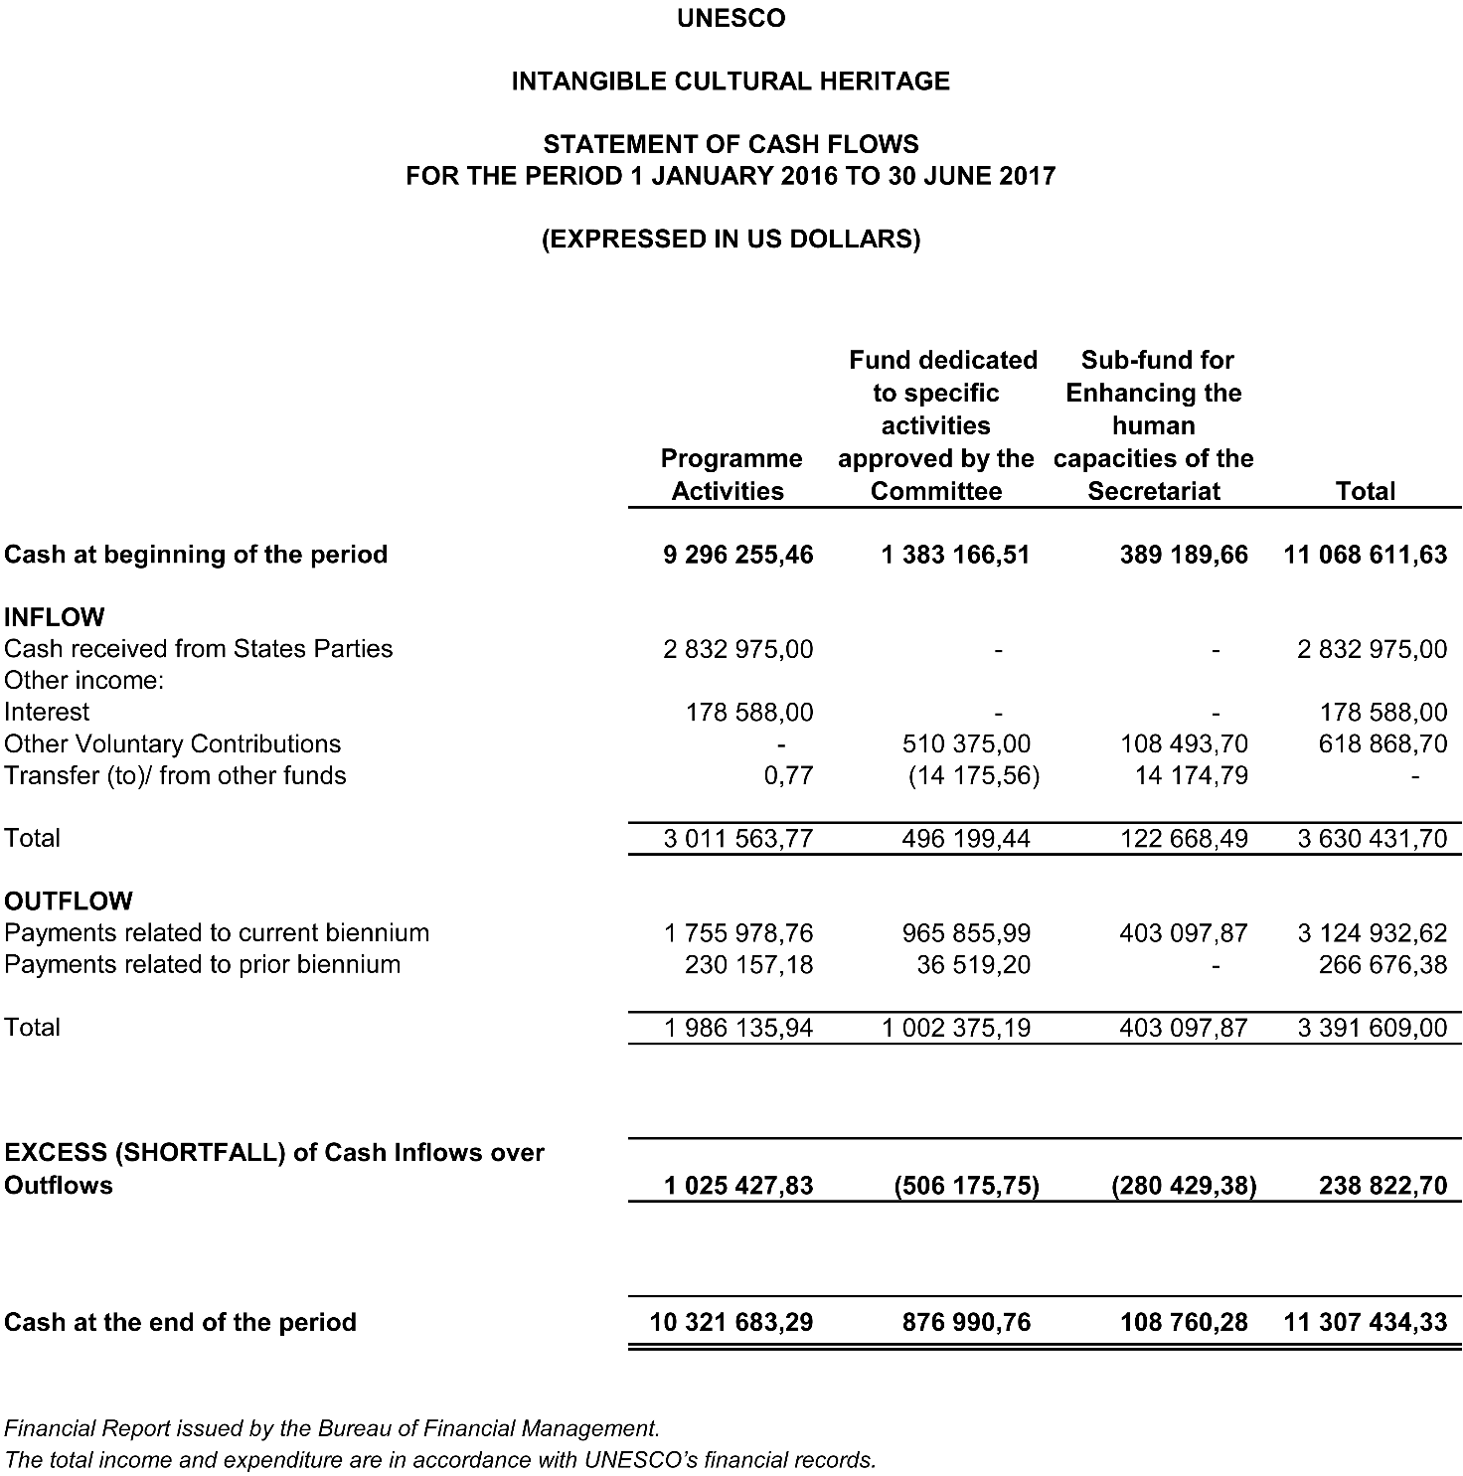

ANNEX II (a)
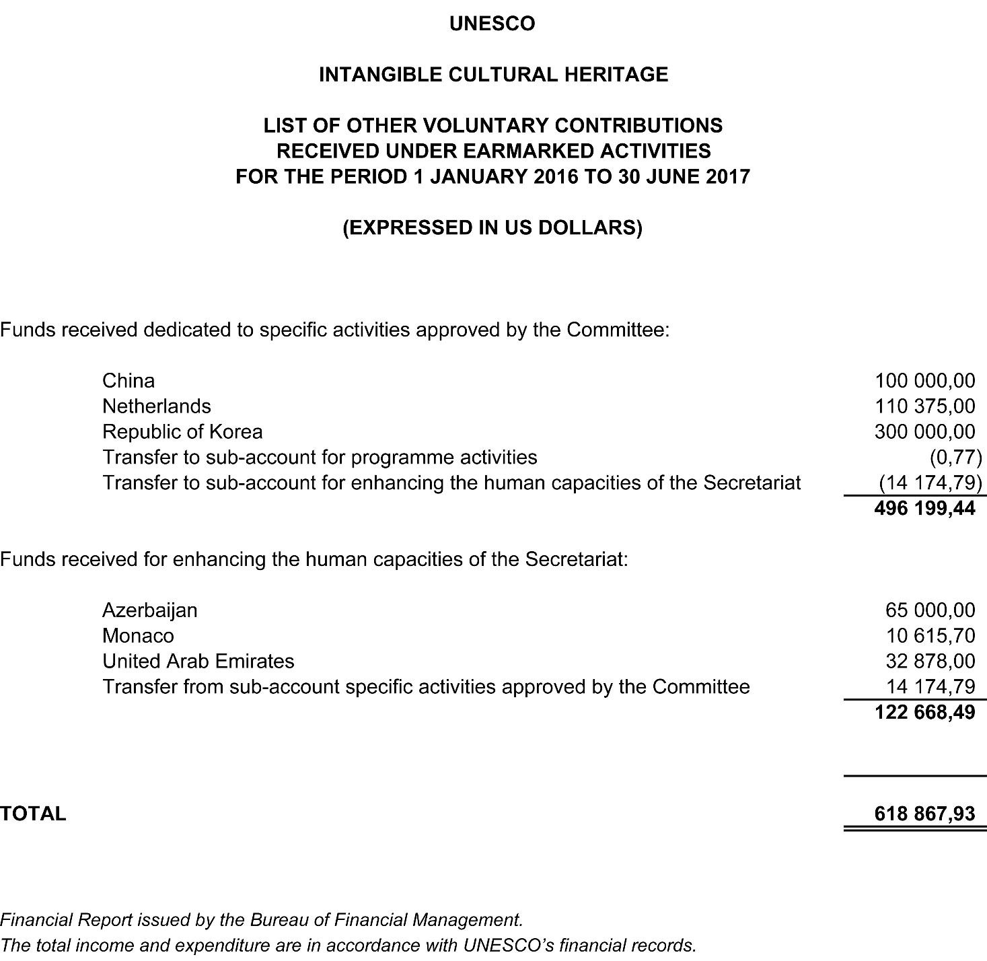

ANNEX II (b)
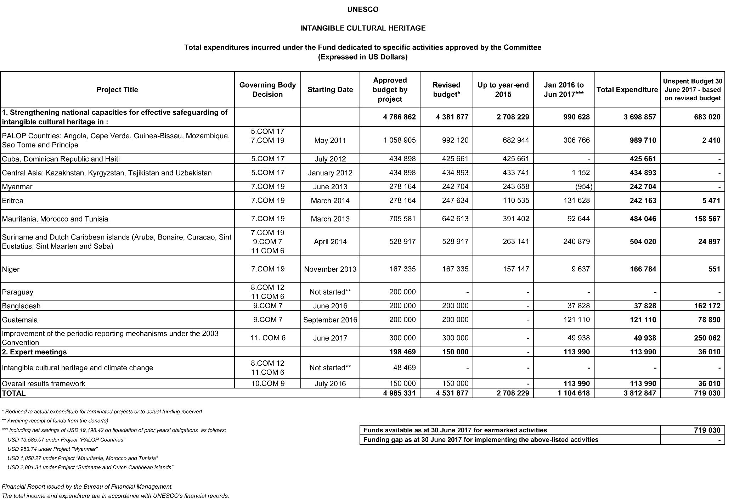
ANNEX II (c)
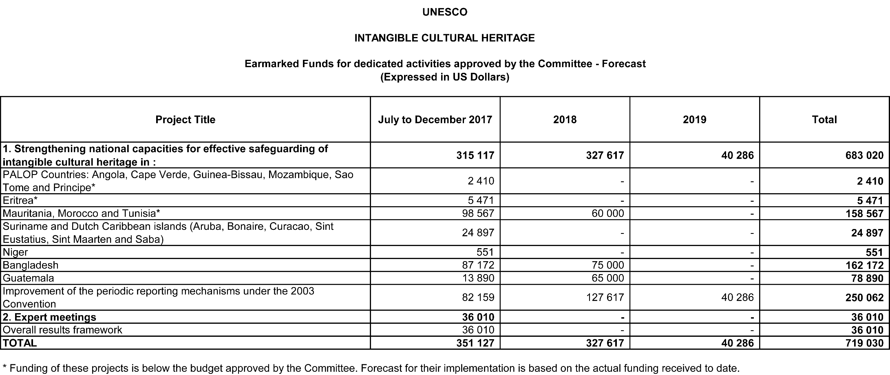

. Figures rounded up to the next highest dollar compared to the Financial Statement I, pages 12-13.
. In Financial Statement I, the assessed compulsory contributions for the period 2016 to 2017 are shown as income, whether they have been received or not; in Financial Statement II, the unpaid amount from States Parties due on 30 June 2017 was US$1,263,213. The assessed voluntary contributions appear as income only on the date when they are received.
. Since its creation in 2010, as of 30 June 2017 the sub-fund – intended exclusively to strengthen the human capacities of the Secretariat – had received contributions amounting to a total of US$1,488,409 as per SAP records.
. Figures rounded up to the next highest dollar compared to that in Financial Statement I, pages 12-13.
. The charts prepared by the Intangible Cultural Heritage Section are based on the financial reports issued at the end of each biennium, except for the current 38 C/5, which considers the financial report issued at 30 June 2017.
. Considering the three IAS projects already approved (and Decision 11.COM 10.a.6) but yet not materialized into contracts, as mentioned in paragraph 9.
. This calculation is based on the forecasted assessed contributions due for the 39 C/5 and possible remaining balance from the current Plan.
. Percentages were applied to the balance of the Fund as of 31 December 2015 less the amount that the Committee proposed to transfer to the Reserve Fund (US$24,190) in order to set its total amount at US$1 million.

