World Makers Gathered at Shenzhen Polytechnic

Maker Faire Shenzhen 2017, a very important international event for makers all over the world, had its grand opening at Shenzhen Polytechnic (SZPT) on 10th November, 2017. The event was hosted by Shenzhen Polytechnic and Chaihuo Makers, which is a well-known booming up company for makers in China and a close cooperator of SZPT. 667 makers from nearly 30 countries and 200 exhibitors with over 1000 projects attended the Maker Faire.

The theme of the Faire 2017 is “Maker Go Pro”, aiming at promoting professional new ideas and products that closely reflect the current transformation of the industries. In the three-day event, 5 sub-activities were organized, i.e. Makers’ Forum, Maker Market, Maker Show, Workshop and Maker Pro.

Ms. Sherry Huss, Mr. PAN Hao, famous Maker and founder of Chaihuo Makers and Mr. Zeng Dejun, Hi-Fi Audio expert and Founder of Muzen Audio together with other 20 top Makers from 8 countries present themselves at the Faire and shared their vision and expertise at the Forum.

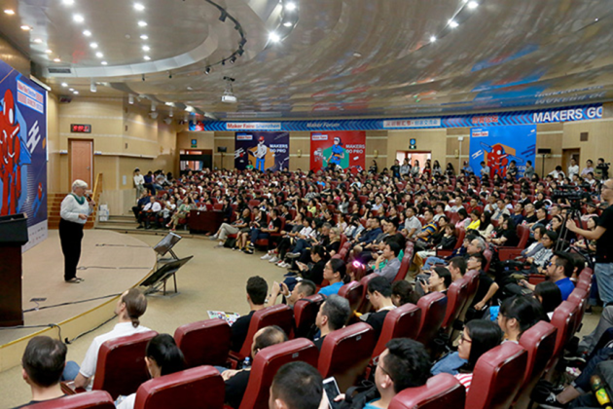
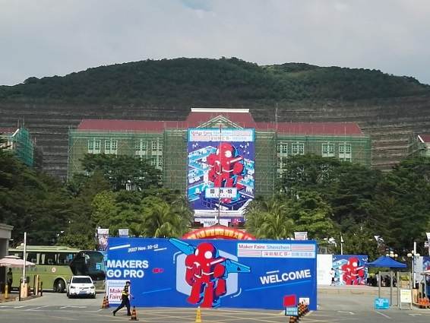
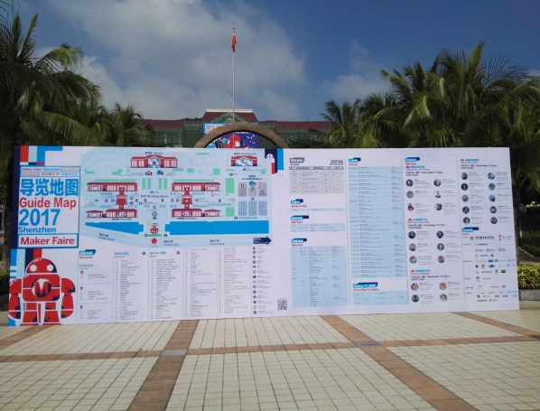
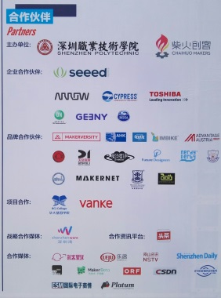
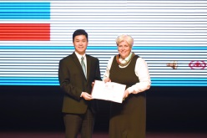
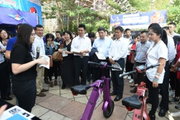
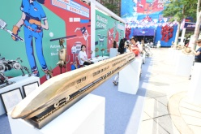
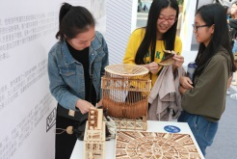
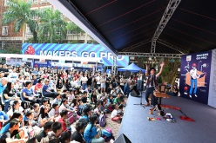

- Fair on the Campus
- Makers’ Forum
- Guide Map of the Fair
- Partners of the Fair
- 6.7.8.9. Activities

1
2
3
4
5
6
7
8
9

For more photos of the event, one can click the following linkage.
http://mmbiz.qpic.cn/mmbiz_gif/ZDuUu69osn3J7GHrIQ6wCszibeDJND3fMfC6xKWULricU2KWjKXTAmf9aKib9xjITrn1hc6vMdkoPkjYDa9uSEqpw/0?wx_fmt=gif&tp=webp&wxfrom=5&wx_lazy=1

At the opening ceremony, Mr. Chen Qiuming, Party Secretary General of SZPT, awarded Honorary Professor Certificate to Ms. Sherry Husss, Vice President of Maker Media and co-creator of the Maker Faire. Mr. MA Xiaoming, Vice President of SZPT singed a School-Enterprise Strategic Cooperation Agreement with Mr. Tomas Diez, the Co-Founder of Fab Lab Barcelona and Instigator at Fab City Research Laboratory. According to the agreement, the two sides will undertake a series of cooperation on education, incubator and exchange of resources and communication.

At the Maker show, 26 international leading companies exhibited their latest maker products and AI and VI technology. More than 20 companies from SZPT Students Entrepreneurship Incubator and 300 SZPT student makers bring their 86 products to the Faire.

Shenzhen, a pioneer for reform and Opening up policy in China, has also been called a Chinese Silicon Valley. It brings about a superb supporting environment for SZPT entrepreneurship education. SZPT has made a lot efforts in construction its creative education, formulated its systematic entrepreneurship educational and practice system, has been running 16 entrepreneurial practice bases for years, including Students Entrepreneurship Incubator, IT Maker Center, and Electronic Elite Creator Space etc. In terms of students' skills development and entrepreneurship curriculum system, the school has also set up a 600-person scale innovation and entrepreneurship education mentor team composed of experts and scholars both inside and outside the school, well-known entrepreneurs, successful entrepreneurs and outstanding alumni.

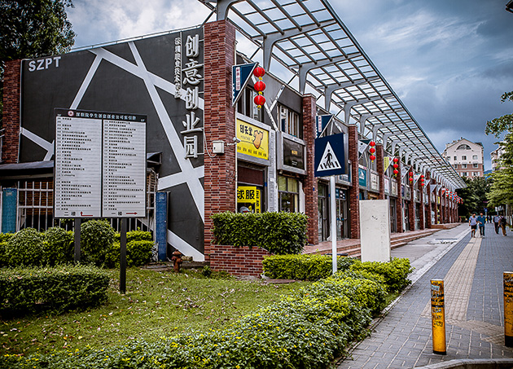
Shenzhen Polytechnic’s Student Entrepreneurship Incubator Area

If one wants to know more information about the Fair, he/she can visit the following address: http://www.shenzhenmakerfaire.com/

(UNESCO UNEVOC SHENZHEN POLYTECHNIC)

