Seventh Annual Regional meeting
on Intangible Cultural Heritage
in South East Europe

“New strategies for sustainable development, tourism and partnerships”

Sofia, Bulgaria, 27-28 May 2013

A meeting organized within the initiative
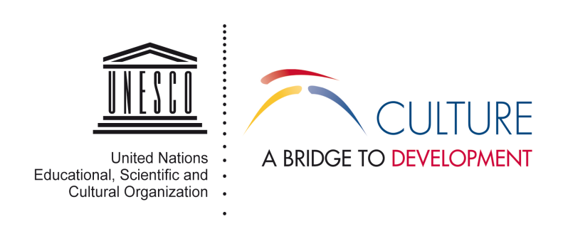

LIST OF PARTICIPANTS

 | NAME of EXPERT | TITLE | CONTACT DETAILS
ALBANIA | Ms Eranda Bedalli | Head of ICH section - Directorate of Cultural Heritage, Ministry of Tourism, Culture, Youth and Sports | eranda.bedalli@mtkrs.gov.al
BOSNIA AND HERZEGOVINA | Ms. Marija Radakovic | Senior Curator at Museum of Kozera in Prijedor | marija.radakovic3@gmail.com
CROATIA | Ms. Mirela Hrovatin | Senior Advisor, Section for Movable and Intangible Cultural Heritage, Directorate for the Protection of Cultural Heritage, Ministry of Culture | mirela.hrovatin@min-kulture.hr
CYPRUS | Ms. Thekla Papantoniou | Officer  Cyprus National Commission  for UNESCO  Officer  Cyprus National Commission  for UNESCO | tpapantoniou@culture.moec.gov.cy
THE FORMER YUGOSLAV REPUBLIC OF MACEDONIA | Ms. Velika Stojkova Serafimovska | Expert for intangible cultural heritage from National Institute for folklore "Marko Cepenkov" | lika73@yahoo.com
GREECE | Mrs Stavroula Fotopoulou | Head of Department of Museums of Modern Cultural Heritage Hellenic Ministry of Education, Religious Affairs, Culture and Sports | vilifotopoulou@gmail.com
ROMANIA | Mr. Cristian - George Iscru | Counsellor, Directorate for Cultural Heritage/Intangible Heritage Compartment, Ministry of Culture of Romania | cristian.iscru@cultura.ro  iscru.cristian@yahoo.com
 | Mrs. Mirela Cretu | Director of the ASTRA National Museum Complex in Sibiu. | mirelacretuastra@yahoo.com mirela.cretu@muzeulastra.com
 | Mr. Andreea Gruitoiu | ASTRA Film Festival
 | Mr. Dumitru Budrala | Director of the ASTRA Film Festival
 | Mr. Mihai Dragomir | Director, Mioritics Association | mihai@mioritics.ro
SERBIA | Mr. Sasa Sreckovic | Head of the national committee for intangible cultural heritage in Serbia | sasasrec@gmail.com
 | Ms. Biljana Djordjević | Archeologist, operative director of National Museum of  Serbia - Member of Serbian national committee for ICH | opdir@narodnimuzej.rs  biljana-djordjevic@hotmail.com
TURKEY | Ms. Seçil Çoşkun | Expert Intangible Cultural Heritage Department - Republic of Turkey Ministry of Culture and Tourism | secil.coskun@kulturturizm.gov.tr
 | Ms Ahu Uçar Sever | Expert Intangible Cultural Heritage Department - Republic of Turkey Ministry of Culture and Tourism | ahu.ucar@kulturturizm.gov.tr
UNESCO Venice Office | Mr. Anthony Krause | Head of Culture Unit, Programme Specialist, Culture Unit | a.krause@unesco.org
 | Mr. Matteo Rosati | Programme Officer, CLT Unit | m.rosati@unesco.org

BULGARIA | Ms. Lyudmila Dimitrova | Chairperson of Executive Board  Regional Centre for the Safeguarding of the Intangible Cultural Heritage in South-Eastern Europe under the auspices of UNESCO in Sofia | ldimitrova@mfa.government.bg
 | Ms. Oli Grueva | Executive Director Regional Centre for the Safeguarding of the Intangible Cultural Heritage in South-Eastern Europe under the auspices of UNESCO in Sofia | grueva.oli@gmail.com
 | Assoc.Prof. Nikolai  Vukov Ph.D. | Institute of Ethnology and Folklore Studies with Ethnographic Museum with Bulgarian Academy of Science | nikolai.vukov@gmail.com
BULGARIA | Mr. Anguel Goev | Director of Architectural-Ethnographic Complex ETAR- Gabrovo | etar_gabrovo@abv.bg
 | Ms. Petya Boneva | Architectural-Ethnographic Complex ETAR- Gabrovo | etar_gabrovo@abv.bg

