CONVENTION FOR THE SAFEGUARDING OF THE
INTANGIBLE CULTURAL HERITAGE
GENERAL ASSEMBLY OF THE STATES PARTIES TO THE CONVENTION
Seventh session
UNESCO Headquarters, Room II
4 June to 6 June 2018
Financial statement for the period
1 January 2016 – 31 December 2017
Summary
In conformity with Article 7.5 of its Financial Regulations, the accounts of the Special Account for the Fund for the Safeguarding of the Intangible Cultural Heritage ‘shall be submitted by the Director-General to the General Assembly of the States Parties to the Convention’. The present document includes the Financial Report for the Intangible Cultural Heritage Fund for the period 1 January 2016 to 31 December 2017, preceded by a brief explanatory note.
Explanatory Note
- In conformity with Article 7.5 of its Financial Regulations, the accounts of the Special Account for the Fund for the Safeguarding of the Intangible Cultural Heritage (hereafter ‘the Fund’) ‘shall be submitted by the Director-General to the General Assembly of the States Parties to the Convention’. The present document includes the Financial Report for the Fund for the period 1 January 2016 to 31 December 2017, preceded by a brief explanatory note. During the reporting period, the resources of the Fund were utilized according to the Plan for the use of the resources of the Fund approved by the sixth session of the General Assembly in June 2016 (Resolution 6.GA 9).
Income
- In accordance with Article 25.3 of the Convention, the income of the Fund consists of the following categories, which are reflected in Statements I, II and III annexed to this document:
- contributions made by States Parties to the Convention;
- funds appropriated for this purpose by the General Conference of UNESCO;
- contributions, gifts or bequests which may be made by other States, organizations and programmes of the United Nations system, particularly the United Nations Development Programme, as well as other international organizations and public or private bodies or individuals;
- any interest due on the resources of the Fund;
- funds raised through collections, and receipts from events organized for the benefit of the Fund;
- any other resources authorized by the regulations of the Fund, to be drawn up by the Committee.
- During the reporting period, income to the Fund consisted of:
- Compulsory and voluntary assessed contributions by States Parties
Compulsory contributions by 170 States Parties to the Convention, as described in Article 26.1 of the Convention | US$3,554,993
Voluntary contributions of four of the five States Parties, which had recourse to Article 26.2 of the Convention, at the time of their ratification | US$308,056
- Voluntary supplementary contributions
Earmarked contributions for specific purposes relating to specific projects approved by the Committee, in accordance with Article 25.5 of the Convention
From the Netherlands for the implementation of ongoing projects supporting the capacity-building programme in the Dutch Caribbean islands and Suriname (Decision 9.COM 7).  From the People’s Republic of China to support an open-ended intergovernmental working group on developing an overall results framework for the Convention (Decision 10.COM 9).  From the Republic of Korea in support of improving the periodic reporting mechanism of the Convention (Decision 11.COM 6). | US$582,756
Sub-fund created within the Intangible Cultural Heritage Fund and intended exclusively to strengthen the human capacities of the Secretariat (Resolution 3.GA 9)
Azerbaijan, Monaco and the United Arab Emirates | US$135,013
- Interest earned on the resources of the Fund | US$277,238
TOTAL | US$4,858,056
- Compared to the preceding biennium, the total income during the reporting period was 15.6% lower; this was primarily due to a considerable decrease in the voluntary supplementary contributions received (from US$1,811,268 to US$717,769). This decrease impacted both the funds dedicated to specific activities approved by the Committee (earmarked) and the Sub-fund for enhancing the human capacities of the Secretariat. At the same time, the interest generated grew from US$79,953 to US$277,238, thus partially compensating the decrease in the income as a whole. Finally, the total unpaid balance represented 25.5% of the value of the 2017 compulsory contributions as at 31 December 2017.
Schedule of appropriations and expenditure for the period 1 January 2016 to 31 December 2017
- The amount approved by the sixth session of the General Assembly for the operational budget in the schedule of appropriations and expenditure (US$7,977,920) corresponds to the balance of the Fund on 1 January 2016 (US$8,953,729) minus the accumulated Reserve Fund (US$975,810) at the same date. This Reserve Fund was created, in accordance with the Financial Regulations of the Fund, to grant International Assistance in cases of extreme urgency and in the event that the funds allocated to International Assistance (budget line 1) are exhausted. As shown in Annex I/ Statement II, following the last transfer made at the beginning of the reporting period (US$24,190), the Reserve Fund reached an allocation of US$1,000,000 – achieving the objective set by the Committee (Decision 10.COM 8 and Resolution 6.GA 9).
- The Financial Report shows a total expenditure of US$3,609,488 as of 31 December 2017, that is, 45.2% of the operational budget approved by the General Assembly – excluding funds provided for the Reserve Fund. Even though the expenditure increased by 47.8% compared to the preceding biennium (US$2,441,884), this rate remains low as the total budget approved also increased in relation to the preceding biennium. Explanations for each budget line of the schedule of appropriations and expenditure are provided below.
- The low implementation of the Fund continues to be directly linked to the insufficient use States Parties make of the International Assistance mechanisms (budget lines 1 and 2). As at 31 December 2017, budget line 1 (International Assistance) presented an implementation rate of only 27.4%. It is worth mentioning that during the reporting period the Committee or its Bureau approved seventeen projects for an amount of over US$1.7 million. However, the financial reports only reflect those projects for which contracts had been established during the reporting period.
- Concerning budget line 2 (Preparatory Assistance), only two Preparatory Assistance requests for preparing a nomination to the Urgent Safeguarding List were submitted and subsequently approved by the Bureau. This line was used additionally, and in the sense of the decision of the Committee taken at its eighth session in 2013 (Decision 8.COM 7.c), to provide technical assistance ‘to States Parties wishing to elaborate requests for International Assistance’. Such assistance was provided through the provision of experts - both external consultants and the Secretariat - upon specific requests from States Parties. During the reporting period, technical assistance was provided to five requesting States; two of these requests were presented to the Bureau and received assistance under the Fund.
- Based on specific proposals prepared by the Secretariat, the Bureau decided upon the utilization of resources in budget line 3, ‘other functions of the Committee’ (Decision 8.COM 11 and Decision 11.COM 2.BUR 1). These resources were dedicated to capacity building (51.4%), knowledge-management services (24.3%), the development of an overall results framework to monitor the implementation of the Convention (3.1%) and communication and outreach tools (21.2%). 92.8% of the funds were spent and obligated as of 31 December 2017. The level of execution represents an increase of 2.6% compared to previous biennium, thus maintaining the high expenditure rate once again. More details on the progress made in the implementation of these funds can be found in document ITH/18/7.GA/7, ‘Report of the Secretariat on its activities’.
- Following the Internal Oversight Service’s recommendation in its audit of the working methods of the culture conventions (IOS/AUD/2013/06), the Committee requested that the Secretariat apply the cost recovery policy consistently when using the resources of the Fund (Decision 8.COM 11). Consequently, and as provided in Article 5.2 of the Financial Regulations of the Fund, budget lines 1 to 3 were charged with direct expenses related to their implementation.
- Budget line 4 was used to finance the participation of twenty-nine experts representing developing States Members of the Committee, its Bureau and subsidiary bodies in its sessions. The expenditure rate for this line is 58.6%, maintaining the rate of recent exercises. In turn, the expenditure rate of budget line 5 reached almost 100%. Expenditure includes the participation costs of nine eligible experts from developing States Parties non-members of the Committee serving on the Evaluation Body in 2016 and 2017 and the participation costs of forty-nine experts in the eleventh and twelfth sessions of the Committee. Budget Line 6 shows an expenditure rate of 65.7%, which reflects the participation costs of the six accredited non-governmental organizations (NGOs) serving on the Evaluation Body in 2016 and 2017 and the participation of twenty-three NGOs in the eleventh and twelfth sessions of the Committee, respectively.
- Noting the unequal use of the resources in budget lines 4, 5 and 6, at its twelfth session the Committee proposed that the General Assembly authorize the Secretariat to make transfers between those lines in the future up to an equivalent of 30% of their total allocation. This decision is expected to improve the use of the resources and the expenditure rate of these three lines by allowing the Secretariat a certain flexibility in responding to the specific requirements of each biennium.
- Lastly, budget line 7 shows an expenditure rate of 51.4%, corresponding to the fees of the eligible members of the Evaluation Body (ten in 2016 and eleven in 2017) and the fees paid to the Chairperson and the Rapporteur of the Body for the additional tasks they perform. This rate remains relatively low due to the need to establish the contracts of the members of the Evaluation Body at the beginning of the evaluation cycle, when only one fourth of the total budget is available. Therefore, it is necessary to overestimate the total percentage allocated, to have enough funds until the final approval of the General Assembly (during the month of June of the first year of the biennium).
Additional reports
- According to Article 25.5 of the Convention, Annexes II (a) and II (b) to this document present the list of voluntary supplementary contributions received for specific purposes, for the period 1 January 2016 to 31 December 2017, as well as other forms of support provided by State Parties and other entities during the same reporting period. In conformity with paragraph 77 of the Operational Directives, an updated list of donors can be found on the website of the Intangible Cultural Heritage Convention.
- Annex II (c) presents the total expenditure incurred for each project financed through earmarked contributions from its beginning until 31 December 2017. Finally, Annex II (d) shows the forecasts as of 31 December 2017, based on the Secretariat’s estimation, for the future use of the funds allocated to ongoing projects based on funds not committed at that date and budgets approved by the Committee. In cases where the donor has already confirmed that the outstanding contribution will not be paid (marked with an asterisk), forecasts are based on the actual funding received to date.

ANNEX I
Statement I
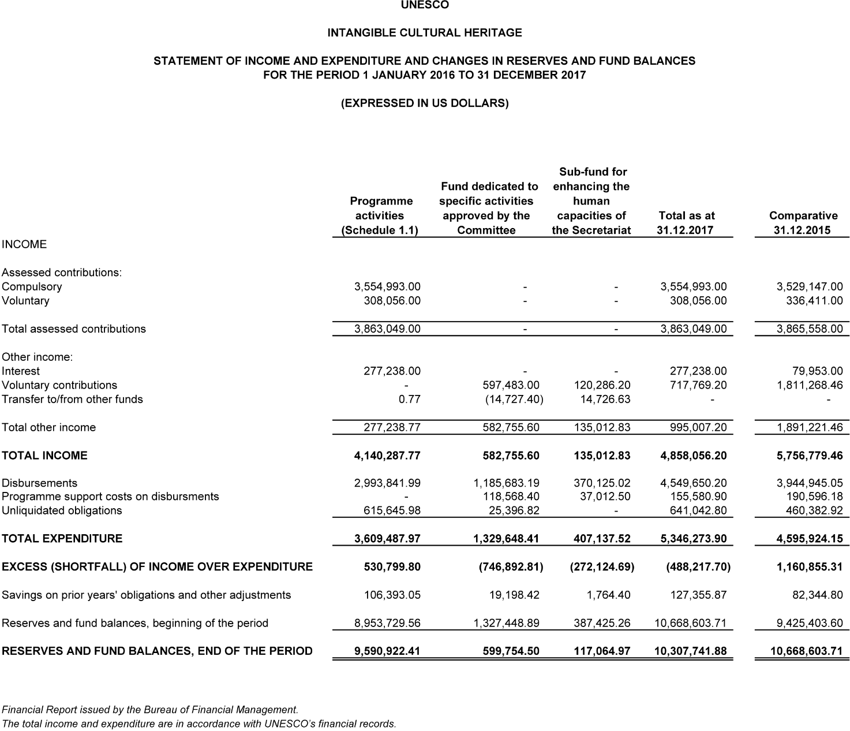
Schedule 1.1
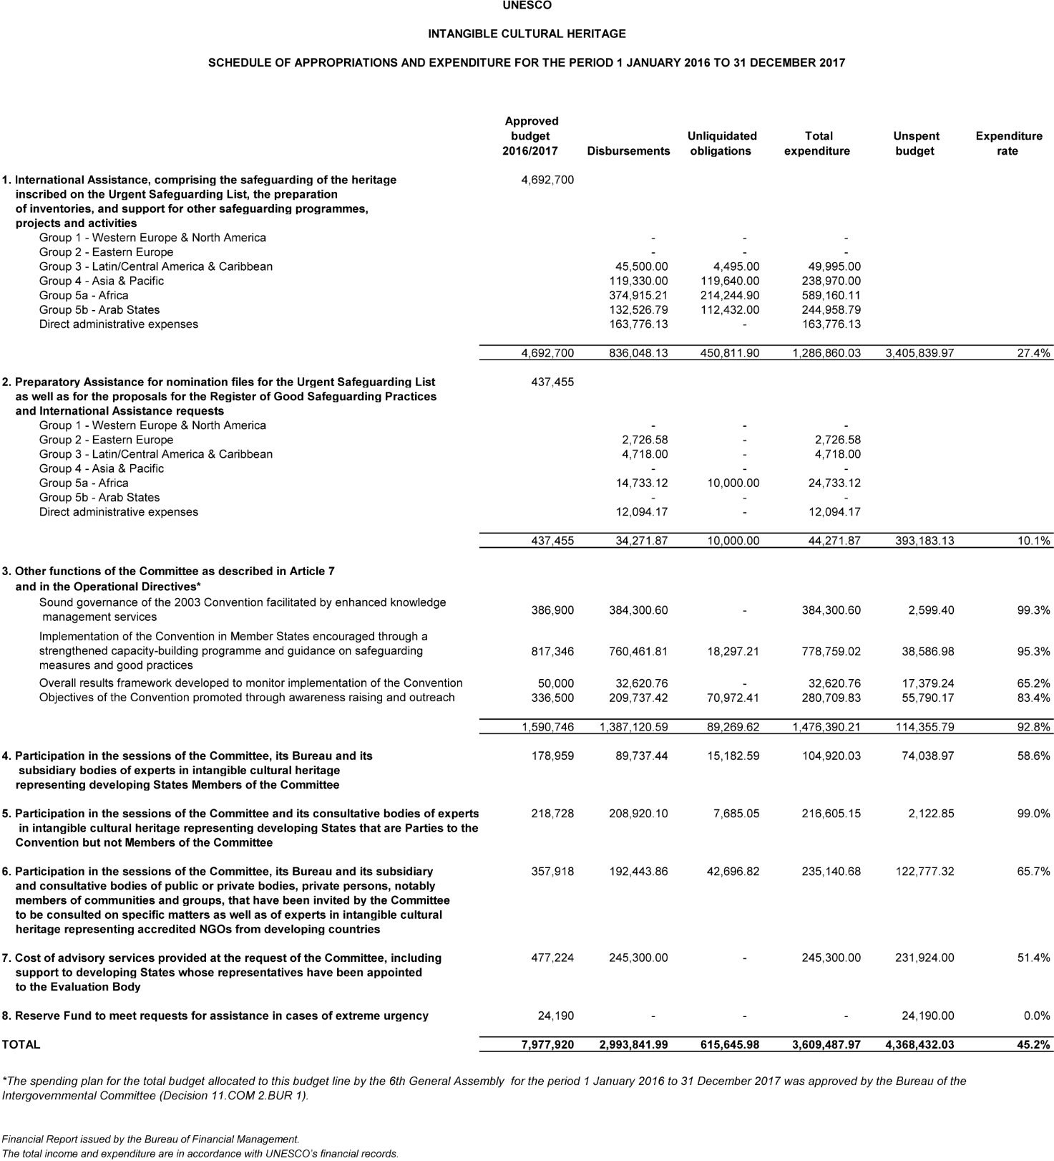
Statement II
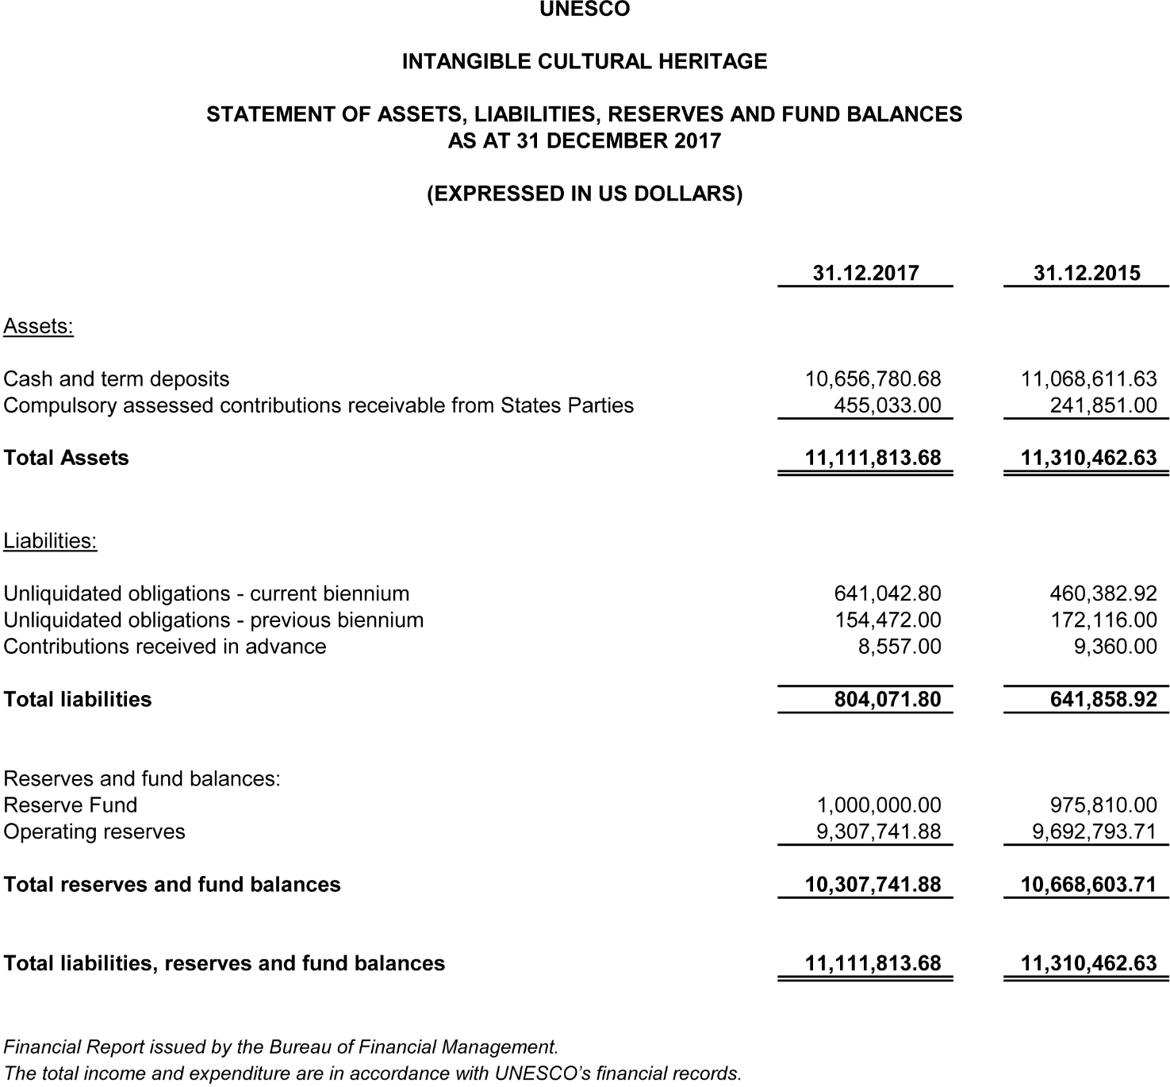
Statement III
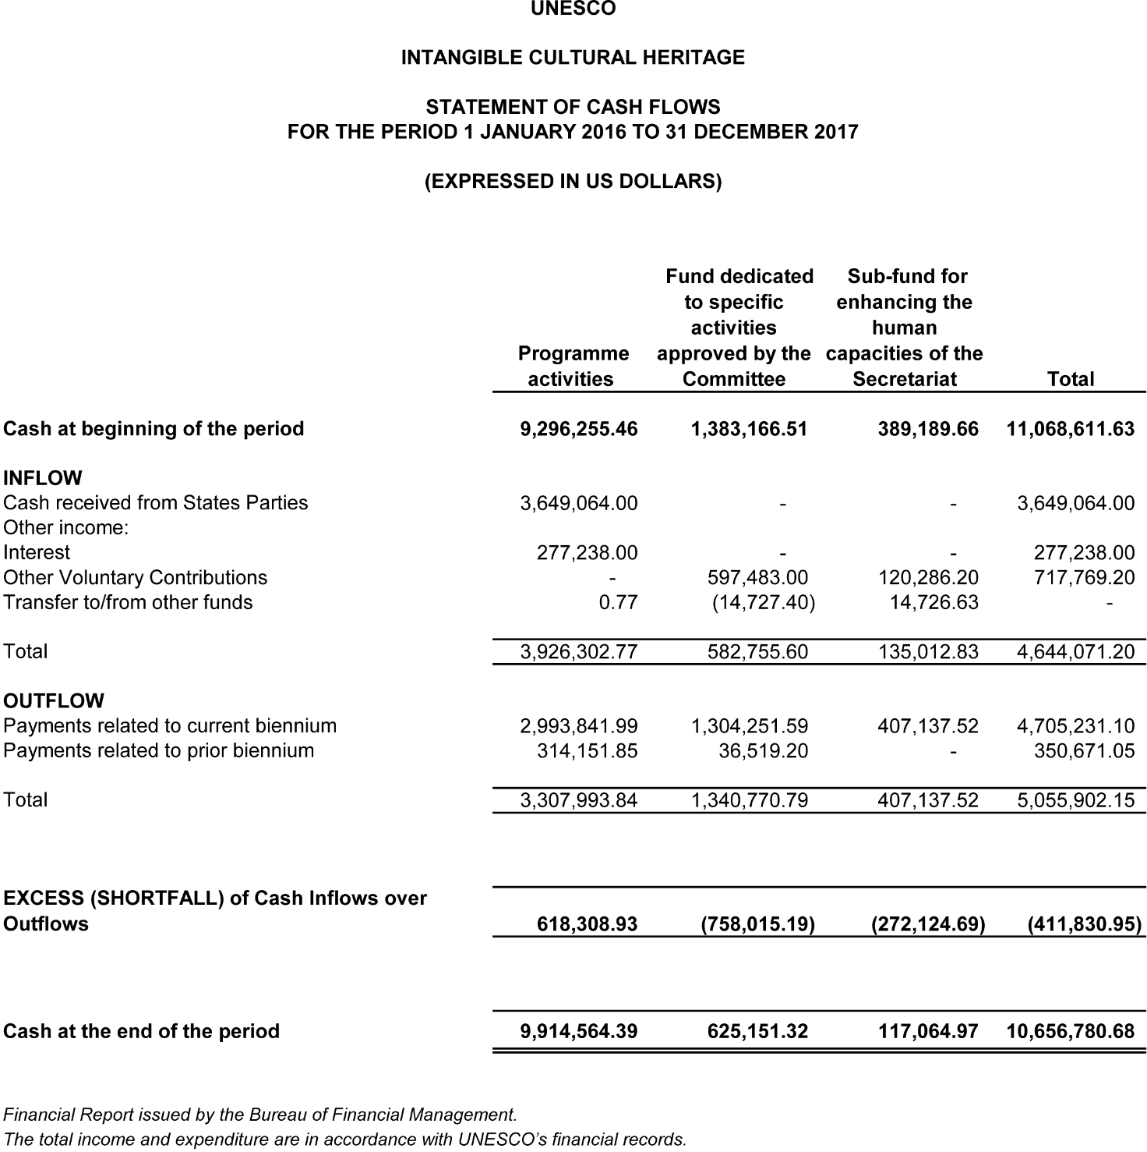
ANNEX II (a)
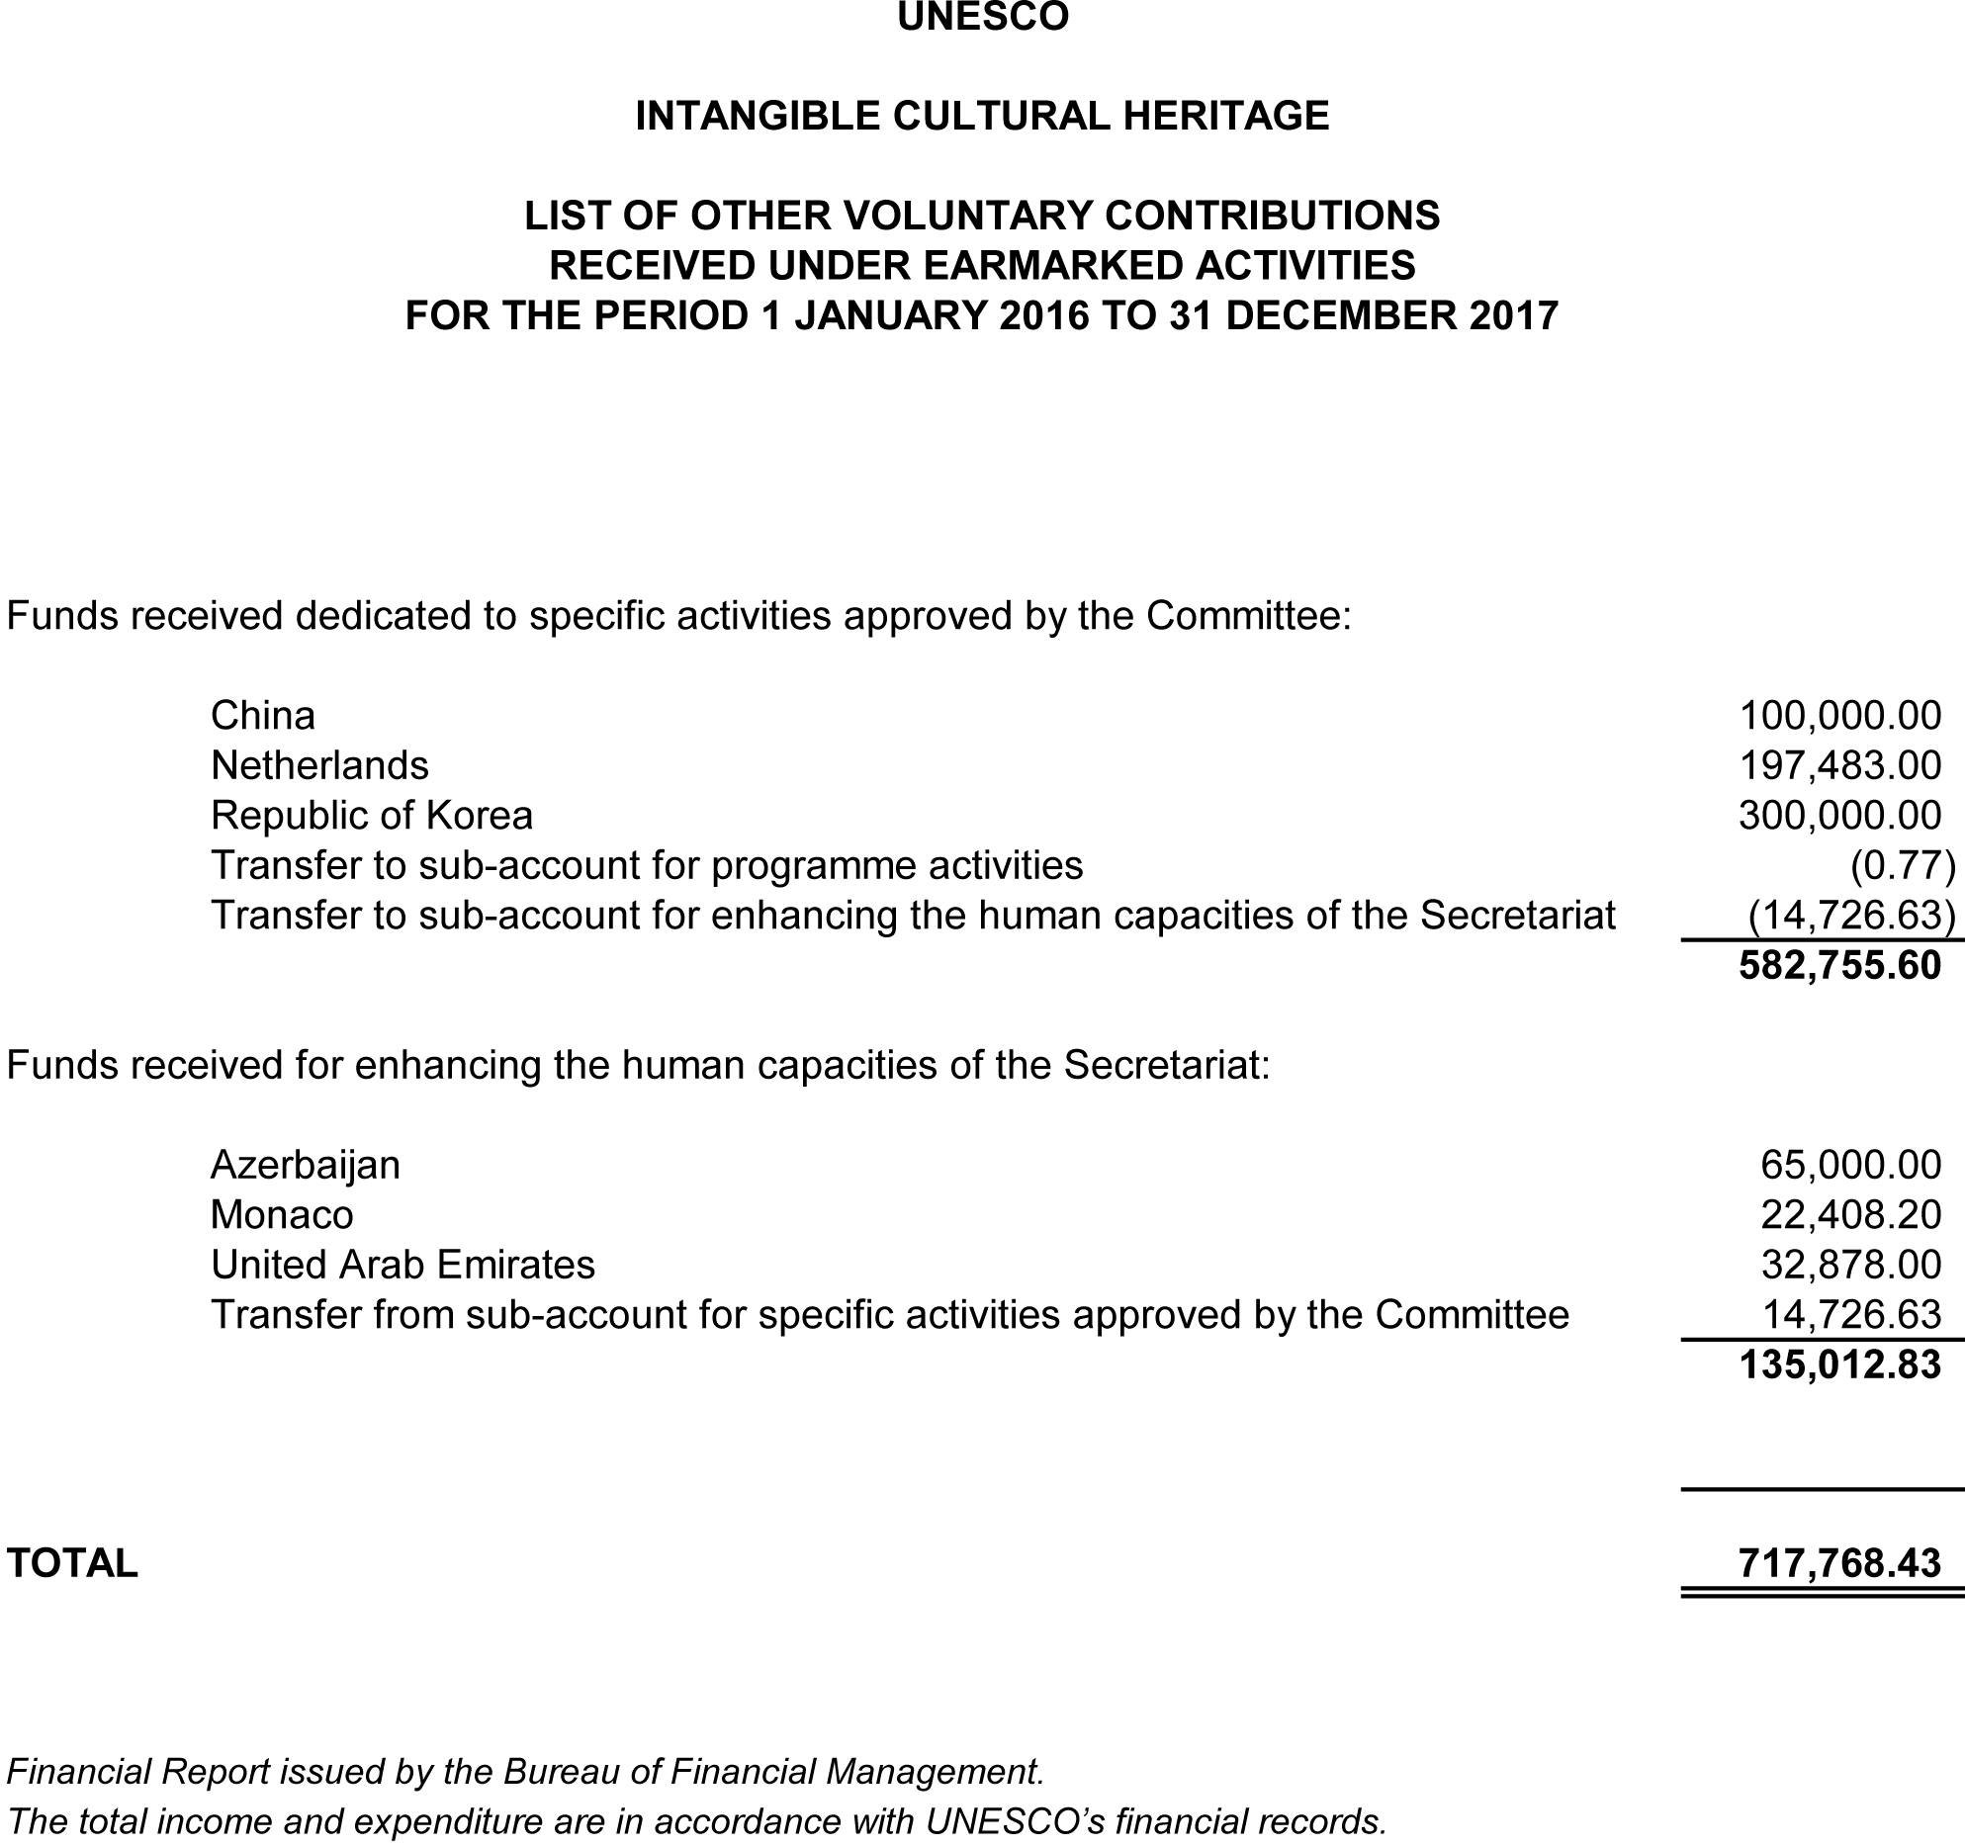
ANNEX II (b)
Other kinds of voluntary contributions in support of the 2003 Convention for the Safeguarding of the Intangible Cultural Heritage for the period 1 January 2016 to 31 December 2017

Funds-in-Trust
Flanders (Belgium) | US$250,000
Japan | US$102,409
United Arab Emirates (Abu Dhabi Tourism & Culture Authority) | US$1,227,257

Loans and Secondments
China | 24 months at P-2 level
Japan | 24 months at P-2 level
United Arab Emirates (Abu Dhabi Tourism & Culture Authority) (Project Appointment) | 16 months at P-2 level

ANNEX II (c)
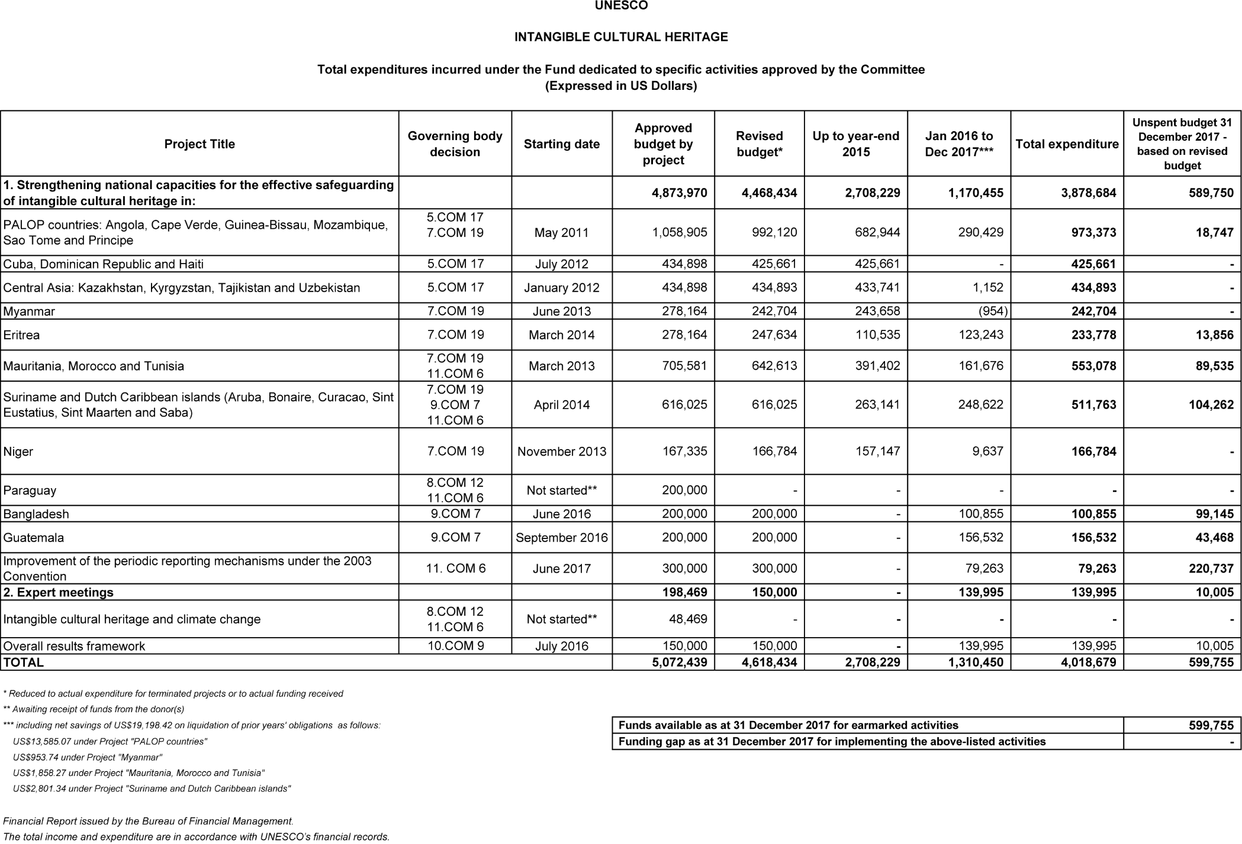
ANNEX II (d)
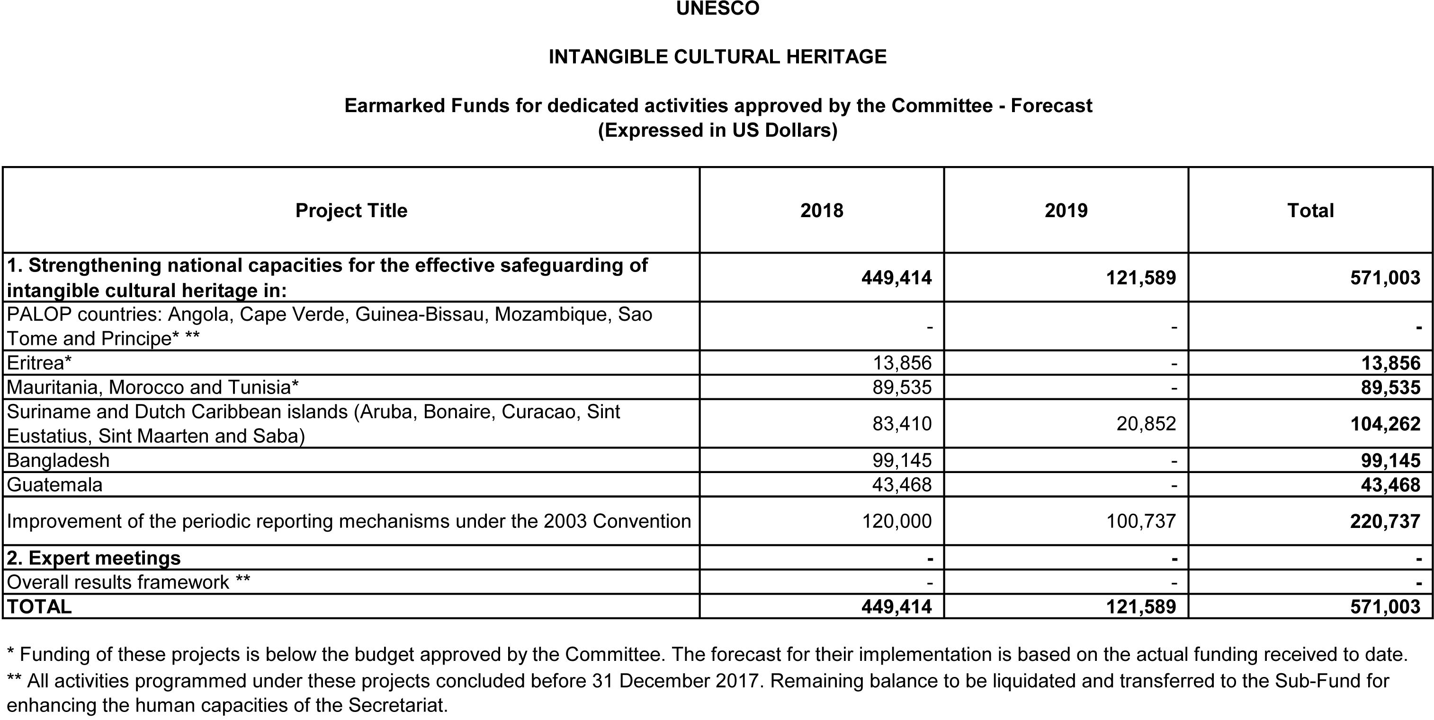

. Figures rounded up to the next highest dollar compared to that in Statement I.
. In Annex I/Statement I, the compulsory assessed contributions for the period 2016-2017 are shown as income, whether or not they have been received; Annex I/Statement II shows that the amount still unpaid and receivable from States Parties as of 31 December 2017 was US$455,033. Voluntary assessed contributions are shown as income only at the time cash is received.
. Annex II(b) issued by the Intangible Cultural Heritage section (ITH) as a complement to the financial report issued by the Bureau of Financial Management (BFM)
. Financial contributions received during the reporting period.
. Staff in office during the reporting period.

