CONVENTION FOR THE SAFEGUARDING OF THE
INTANGIBLE CULTURAL HERITAGE
INTERGOVERNMENTAL COMMITTEE FOR THE
SAFEGUARDING OF THE INTANGIBLE CULTURAL HERITAGE
Eleventh session
Addis Ababa, Ethiopia
28 November to 2 December 2016
Item 6 of the Provisional Agenda:
Voluntary supplementary contributions to the Intangible Cultural Heritage Fund
Summary
In accordance with Article 25.5 of the Convention, the Committee may accept contributions to the Fund for specific purposes relating to specific projects, provided that those projects have been approved by the Committee. The present document reports on such contributions since the Committee’s tenth session and presents an offer by the Government of the Republic of Korea in support of specific project provisionally entitled ‘Improving the periodic reporting mechanism of the 2003 Convention for the Safeguarding of the Intangible Cultural Heritage’.
Decision required: paragraph 13
- Chapter VI of the Convention concerning the Intangible Cultural Heritage Fund states that States Parties may wish to provide voluntary supplementary contributions (Article 27) in addition to their assessed contributions as defined in Article 26. Article 25.5 also provides for the possibility that such contributions can be made in favour of specific projects, ‘provided that those projects have been approved by the Committee’.
- At its ninth session, the Committee approved the Concept Note for the 2014-2017 Complementary Additional Programme entitled ‘Strengthening capacities to safeguard intangible cultural heritage for sustainable development’ (Decision 9.COM 7) developed by the Secretariat to extend the reach and effectiveness of that global capacity-building strategy and to inform donors of the funding requirements of this programme. Indeed, in order to ensure that the Committee – as the Convention’s governing body deciding on the use of the resources of the Intangible Cultural Heritage Fund – and the General Conference of Member States – as UNESCO’s governing body that determines the policies and the main lines of work of the Organization – shared the same vision of UNESCO’s action priorities in the field of intangible cultural heritage, the Committee considered it appropriate to endorse the programmatic framework described in the Complementary Additional Programme insofar as it is strictly aligned with the Regular Programme. By extension, the Committee accepted, in that same decision, any future voluntary supplementary contributions that might be made to support capacity-building activities within the scope of that programmatic framework between two Committee sessions, authorized the Secretariat to make immediate use of them and requested it to report on the progress of implementation of any voluntary supplementary contributions it may have received since its last session.
- Since its last session, the Intangible Cultural Heritage Fund has received two contributions within the scope of the programmatic framework laid in the Complementary Additional Programme. As noted by the Committee at its tenth session (Decision 10.COM 9), the Government of Catalonia (Spain) contributed US$131,868 to further support a multi-year capacity-building programme in Mauritania, Morocco and Tunisia.
- A supplementary voluntary contribution of €100,000 in support of this programme was also received into the Intangible Cultural Heritage Fund from the Government of the Netherlands on 28 October 2016. It will be used to build on the results of the capacity-building programme that reached an end in September 2016 in Suriname and the Dutch Caribbean Islands and will complement the significant efforts that the concerned beneficiaries have made in recent years to take full ownership of the Convention as an operational tool to safeguard intangible cultural heritage present in their territories. This second phase should enable to test the framework and methodology for inventorying intangible cultural heritage developed during the first phase with pilot inventorying activities in each territory.
- The Cultural Heritage Administration of the Republic of Korea also expressed its wish to support the Convention by contributing to the Intangible Cultural Heritage Fund. The low rate of submission of reports on the legislative, regulatory and other measures taken for the implementation of the Convention (hereafter ‘periodic reports’) continues to be of concern to States Parties and the Convention’s governing bodies. The overview of periodic reports provided in document ITH/16/11.COM/9.a confirms this trend. During the sixth session of the General Assembly in June 2016, many States regretted the high number of States Parties whose reports were overdue while acknowledging the difficulties faced by some of them to fulfil this statutory obligation. The Republic of Korea, in particular, shared this concern and recalled, on that occasion, that it is the overall monitoring of the Convention which is suffering from this dysfunction. Moreover, the Republic of Korea announced its will to offer financial support to help build mechanisms to encourage the submission of periodic reports. Therefore, the Committee is asked at the present session to approve the Republic of Korea’s offer – as set out in the letter from the Cultural Heritage Administration presented in Annex I of the present document – to support the Secretariat in improving the periodic reporting mechanism under the Convention.
- In its Decision 7.COM 20.1, the Committee took note that States make use of different forms of support, financial and in-kind, to the 2003 Convention for the Safeguarding of the Intangible Cultural Heritage and not only of the voluntary supplementary contributions to the Intangible Cultural Heritage Fund set out in Article 25.5 of the Convention. It requested the Secretariat to report at each session of the Committee on the receipt of all forms of contributions since its previous session. Accordingly, the list of contributions in support of the 2003 Convention since the tenth session of the Committee can be found in Annex II of the present document.
- Since most of the support received by the Convention benefits the global capacity-building programme and, to a significantly lesser extent, the strengthening of human resources of the Secretariat, it seems appropriate to provide an overview of the evolution of this support to the Committee through the last three biennia. Figure 1 confirms a general trend to the decline in the amount of resources mobilized for the capacity-building programme.

Figure 1: Evolution of resources mobilized in support of the global capacity-building programme
- The 35 C/5 biennium saw the launch of the global capacity-building programme, which drew significant enthusiasm from donors. The 36C/5 biennium was marked by the implementation of resources mobilized during the previous biennium and attracted comparable donor interest. The 37C/5 biennium experienced renewed funding, coinciding with the Committee’s endorsement of the Concept Note for the 2014-2017 Complementary Additional Programme, and funds reached its mid-term objective. However the situation for the 38C/5 is alarming as, at the time this document is written, mobilized resources have reached only 12% of the mid-term objective, making it virtually impossible to achieve the fixed target for the 2014-2017 quadrennium.
- Recognizing that the Secretariat’s ability to provide quality services to Member States depends largely on its human resources, many and various donors have provided support in this direction by making use of several modalities. Yet, the graph below shows an overall decrease of such support, with again an alarming drop during the current biennium. In particular, support to the sub-fund of the Intangible Cultural Heritage Fund to enhance the human resources of the Secretariat is far from reaching the annual target of US$1.1 million set by the General Assembly (Resolution 3.GA 9). More precisely, it is worth noting that since the tenth session of the Committee, the sub-fund received voluntary contributions totalling US$114,522 for the period of October 2015 to October 2016, only a fourth of the amount received into the sub-fund between its ninth and tenth session.

Figure 2: Evolution of resources mobilized in support of human resources
- The two figures above show an undeniable decline in support to the Convention through the Intangible Cultural Heritage Fund, in terms of earmarked contributions for the capacity-building programme and of contributions to the sub-fund for enhancing human resources of the Secretariat. For the former, the underutilization of this modality is unfortunate since it has proven to be particularly suited to the spirit of the capacity-building strategy as it allows effective use of resources by UNESCO, from a thorough needs assessment and consultation with national counterparts to project implementation. For the latter, it is equally unfortunate since, without discrediting the merits of the other modalities, the sub-fund is the only mechanism that can secure a sustainable workforce adapted to the statutory functions that the Secretariat must perform.
- Other unfortunate circumstances need to be brought to the attention of the Committee regarding support to the Convention on a voluntary basis. At its eight session, the Committee approved two projects to be supported by earmarked contributions to the Intangible Cultural Heritage Fund: a contribution of US$200,000 from Brazil to support a two-year programme for strengthening national capacities for safeguarding intangible cultural heritage in Paraguay and a contribution of US$48,469 from Viet Nam to support a category VI expert meeting on the links between intangible cultural heritage and climate change (Decision 8.COM 12). Following the Committee’s invitation to these two countries to inform the Secretariat of the status of their respective outstanding contributions (Decision 10.COM 9), Brazil informed the Secretariat by diplomatic note on 22 February 2016 of its inability to comply with that decision due to legal and budgetary issues. Concerning the outstanding contribution of Vietnam, the Secretariat was informed on 18 November 2016 that, due to the budgetary difficulties faced by Vietnam, the country will not be able to pay the voluntary contribution approved by the Committee in 2013.
- Voluntary supplementary contributions to the Intangible Cultural Heritage Fund are also the condition laid by the Committee to cover the costs of organizing two open ended intergovernmental working groups on two different themes. Indeed, at its ninth session, the Committee decided to ‘convene an open ended intergovernmental working group during the course of 2016 to examine preliminary recommendations of possible directives’ (Decision 9.COM 13.e) concerning an overall results framework for the Convention while, at its tenth session, it decided to convene a similar working group on the procedure on the transfer of an element from one List to the other and the removal of an element from a List (Decision 10.COM 19). At the time of writing, the Secretariat is in consultation with a State Party which has expressed interest in hosting the open ended working group on the overall results framework. In addition to the unfeasibility of organizing both working groups in the same year, the Secretariat will only be in a position to organize them if the required respective contributions are received at least six months before the possible date of their holding.
- The Committee may wish to adopt the following decision:
DRAFT DECISION 11.COM 6
The Committee,
- Having examined document ITH/16/11.COM/6 Rev. and its annexes,
- Recalling Article 25.5 of the Convention and Chapter II of the Operational Directives,
- Further recalling Decisions 8.COM 12, 9.COM 7, 9.COM 13.e and 10.COM 9,
- Commends the Republic of Korea for its generous offer of a voluntary supplementary contribution to the Intangible Cultural Heritage Fund to improve the periodic reporting mechanisms under the Convention;
- Accepts with gratitude the generous contribution of the Republic of Korea, approves its specific purpose and requests the Secretariat to ensure its proper planning and implementation;
- Expresses its concern on the small number of new voluntary supplementary contributions to the Intangible Cultural Heritage Fund to support the programmatic framework of the 2014-2017 Complementary Additional Programme entitled ‘Strengthening capacities to safeguard intangible cultural heritage for sustainable development’ since its last session;
- Thanks Brazil for the information concerning the outstanding voluntary supplementary contribution to the Intangible Cultural Heritage Fund, regrets that Brazil will not be able to honour its previous offer and invites other contributors to support the two-year programme for strengthening national capacities for safeguarding intangible cultural heritage in Paraguay that it approved in 2013;
- Also thanks Viet Nam for the information concerning the outstanding voluntary supplementary contribution to the Intangible Cultural Heritage Fund, regrets that Viet Nam will not be able to honour its previous offer and invites other donors to consider the possibility of supporting initiatives to further explore the links between intangible cultural heritage and climate change, as well as other sustainable development issues;
- Further takes note that no supplementary voluntary contributions to the Intangible Cultural Heritage Fund have yet been received to cover all of the costs of organizing two open ended intergovernmental working groups to be devoted to, respectively, the development of an overall results framework for the Convention and the procedure for removal of an element from a List and the transfer of an element from one list to the other;
- Thanks all the contributors that have generously supported the Convention and its Secretariat, since its last session, namely Azerbaijan, Belgium (Flanders), China, Japan, the Netherlands, Norway, Spain (Government of Catalonia) and the United Arab Emirates (Abu Dhabi Tourism & Culture Authority and Hamdan Bin Mohammed Heritage Centre) as well as the Norwegian Centre for Traditional Music and Dance;
- Encourages other contributors to consider the possibility of supporting the Convention, in particular through the Intangible Cultural Heritage Fund, while inviting them to disburse their contribution on time and therefore shorten as much as possible the time lapse between their offer and the payment of the announced contributions, allowing for smooth and timely implementation of activities;
- Requests the Secretariat to report, at its twelfth session, on the progress of implementation of any voluntary supplementary contributions it may have received since its last session.

ANNEX I
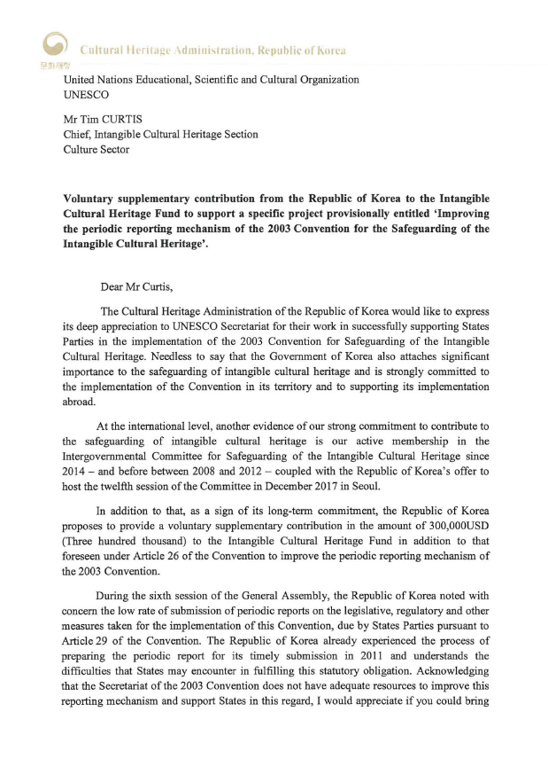
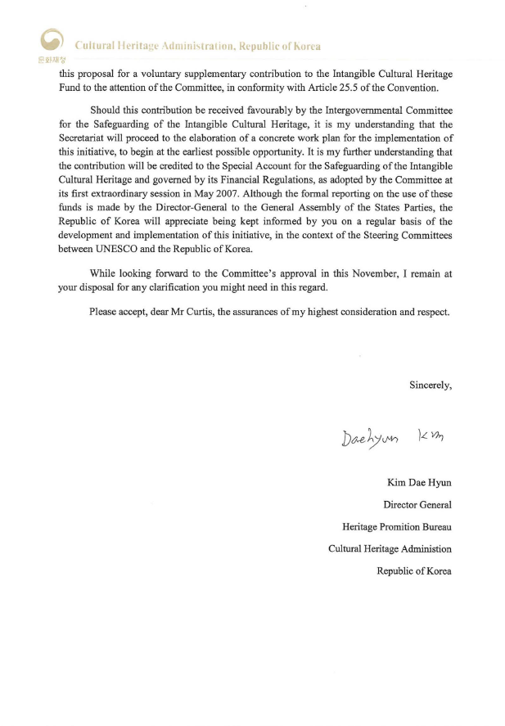

Annex II
Financial/In-kind support to the 2003 Convention for the Safeguarding
of the Intangible Cultural Heritage since the ninth session of the Committee,
for the period October 2015 to October 2016
Voluntary supplementary contributions to the Intangible Cultural Heritage Fund
Earmarked for capacity-building programmes
Netherlands | US$110,375
Spain (Government of Catalonia) | US$131,868
Expert meeting on developing an overall results framework for the Convention
China | US$50,000
Sub-fund for enhancing the human capacities of the Secretariat
Azerbaijan | US$65,000
Norwegian Centre for Traditional Music and Dance (Norway) | US$2,470
United Arab Emirates (Hamdan Bin Mohammed Heritage Centre) | US$32,878
Funds-in-trust
Belgium (Flanders) | US$250,000
Loans and Secondments
United Arab Emirates (Abu Dhabi Tourism & Culture Authority) | 12 months at P-2 level
China | 12 months at P-2 level
Japan | 12 months at P-2 level

. The Concept Note for the 2014-2017 Complementary Additional Programme endorsed by the Committee foresees an overall need during the quadrennium of US$6 million to carry out activities in some 20 countries worldwide.
. Based on cash received.
. Based on approved projects.

