Expert meeting on a model code of ethics for intangible cultural heritage
Valencia, Spain, 30 March to 1 April 2015
Practical information
Documents
- Background note and agenda
ITH/15/EXP/1: English|French|Spanish
- Towards codes of ethics for intangible cultural heritage?
ITH/15/EXP/2: English|French|Spanish
- List of participants
ITH/15/EXP/3: English/French
Webpage
http://www.unesco.org/culture/ich/index.php?meeting_id=00463
Languages
The meeting will be conducted in English, French and Spanish.
Travel and transport
Valencia Airport is located eight kilometres to the west of the capital. A member of the staff will be waiting for the participants at the airport.
All the travelling expenses and transfers in Spain and accommodation allowances shall be borne by the Ministry of Foreign Affairs and Cooperation and the Ministry of Education, Culture and Sports of the Kingdom of Spain.
Location and venue
Meeting venue will be at the Palau de les Arts Reina Sofia (http://www.lesarts.com/) (Avenida del Professor López Piñero, 1, 46006 València).
Accommodation
Hotel Barceló Valencia. Av. de França, 11, 46023, Valencia (http://www.barcelo.com/barcelohotels/en_gb/hotels/spain/valencia/hotels-valencia.aspx).
Tel. +963 30 63 44
N.B. Minibar, spa, laundry or telephone charges are not included in your half board accommodation.
Meals
For all participants:
- Your half board accommodation includes breakfast and dinner at the hotel. Bars and restaurants in Hotel Barceló Valencia:
- Buffet Breakfast
From 07.00 to 10.30 on weekdays and from 08.00 to 11.00 on bank holidays and weekends. Enjoy the best breakfast in Valencia with views of the City of Arts and Sciences. Diet corner with special products for celiac disease sufferers, hot buffet, cold buffet, fine rolls and buns: the perfect choice to start the day.
- A-la-carte restaurant ‘Senyoret’, where dinners will take place
Specialized in Mediterranean cuisine with menu and daily set menu service. Open for dinner from 20.30 - 23.00.
- Lobby Bar ‘El Gotet’
Informal cuisine and light meals. Daily set menu. Open from 11.00 - 00.30
- Dinners include water, wine and soft drinks. Other drinks will be paid by the own consumer.
During the three days of the meeting (30 March-1 April) lunch will be provided at the meeting venue.
For those who arrive on Saturday 28 or Sunday 29 morning and participants who leave on Thursday 2 April in the evening:
Lunch Sunday 29 March:
- Restaurant PANORAMA DEL PUERTO, Marina Real Juan Carlos I.
- Second option: BLACK SHEEP, Gourmet hamburger, Plaza. Porta de la Mar, 6.
Lunch Thursday 2 April:
- Restaurant PANORAMA DEL PUERTO, Marina Real Juan Carlos I.
(find attached a map with the location of the restaurants)
Side events
Monday 30 March (Day 1)
18.00 - 20.00 Visit to the Silk Exchange, with display of clothing and traditional Valencian music.
20.00 - 23.00 Dinner
Tuesday 31 March (Day 2)
20.00 - 22.45 Performance of the opera “Norma” by Vincenzo Bellini, Palau de les Arts.
23.00 Dinner
Thursday 2 April (free day)
12.00 Public session of the Water Tribunal of the plain of Valencia. Plaza de la Virgen, Catedral de Valencia, Puerta de los Apóstoles
Weather information
Valencia has a subtropical Mediterranean climate.
Valencia has one of the mildest winters in Europe, owing to its southern location on the Mediterranean Sea and the Foehn phenomenon. March is transitional: the temperature often exceeds 20° C (68° F), with an average temperature of 19° C (66° F) during the day and 10° C (50° F) at night.
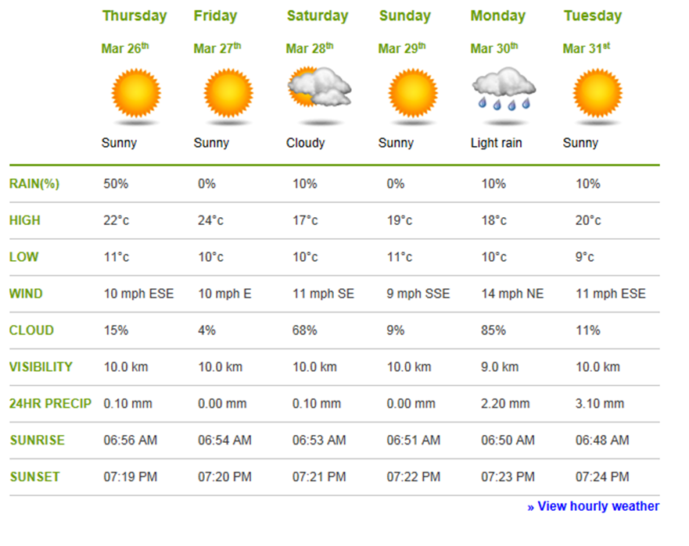
Annex – location of restaurants for lunches on Sunday 29 March and Thursday 2 April
A. BARCELÓ HOTEL - B. RESTAURANT PANORAMA DEL PUERTO
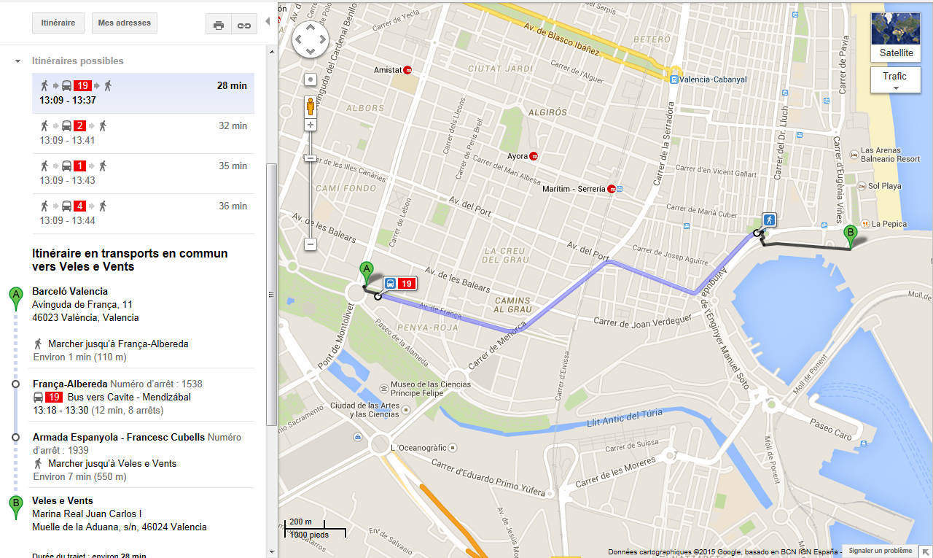
A. BARCELÓ HOTEL - B. RESTAURANT BLACK SHEEP 