CONVENTION FOR THE SAFEGUARDING OF THE
INTANGIBLE CULTURAL HERITAGE
INTERGOVERNMENTAL COMMITTEE FOR THE
SAFEGUARDING OF THE INTANGIBLE CULTURAL HERITAGE
Fourteenth session
Bogotá, Republic of Colombia
9 to 14 December 2019
Item 7 of the Provisional Agenda:
Draft plan for the use of the resources of the
Intangible Cultural Heritage Fund in 2020–2021
Summary
Part I of this document examines the trends in the use of the Intangible Cultural Heritage Fund until the 2018–2019 period. Part II presents a draft plan for the use of the resources of the Intangible Cultural Heritage Fund for the period 1 January 2020 to 31 December 2021 and the first semester of 2022, to be submitted to the General Assembly for its approval.
Decision required: paragraph 28

- Article 7(c) of the Convention requests that the Committee ‘prepare and submit to the General Assembly for approval a draft plan for the use of the resources of the Fund’. Article 25.4 of the Convention further provides that the use of the resources of the Fund by the Committee ‘shall be decided on the basis of guidelines laid down by the General Assembly’. Those guidelines were adopted by the General Assembly of the States Parties in its second session in 2008 and can be found in Chapter II.1 of the Operational Directives for the implementation of the Convention. The draft plan proposed as Annex I to this document was prepared in conformity with those guidelines on the basis of the 2018–2019 plan.
- The General Assembly of the States Parties to the Convention meets in ordinary session in even years, about six months after the start of UNESCO’s financial period. At its eighth session in June 2020, the General Assembly will therefore be requested to approve a draft plan for the use of the resources of the Fund that covers twenty-four months, from 1 January 2020 to 31 December 2021, and, on a provisional basis, the first six months of the following financial period, i.e. from 1 January 2022 to 30 June 2022, preceding the ninth session of the General Assembly. The provisional budget for the first semester of 2020 that was adopted by the seventh session of the General Assembly (Resolution 7.GA 8) will in turn be superseded by the present plan once it has been adopted by the eighth session of the General Assembly.
- The total amount of funds available for the next financial period cannot be known until early 2020, after the closure of the 2019 accounts. The budget presented in the draft plan (Annex I) is thus expressed in percentages of the total amount that will be available. The document to be submitted to the General Assembly will specify the amounts allocated for each purpose. As was the case in the current plan, the Committee may wish to propose provisionally allocating to the first semester of 2022 one fourth of the amount established for the two-year period from 1 January 2020 to 31 December 2021. It is therefore proposed that the Committee submit to the General Assembly an expenditure plan based on the total amount of unrestricted and unencumbered funds available as of 31 December 2019, which is estimated to be approximately US$7 million.
- In order to better understand the context of the proposed draft plan for the use of the resources of the Intangible Cultural Heritage Fund for the period 2020–2021 (Part II), the present document first provides an overview of the present status of the Fund and of current trends (Part I). The third section describes the future perspectives of the Fund for the coming biennia (Part III). Finally, the document brings to the attention of the Committee a decision from UNESCO’s Executive Board concerning the Financial Regulations of Special Accounts, which affects the Financial Regulations of the Fund (Part IV).
- STATUS AND TRENDS
- Based on the financial report included in document LHE/19/14.COM/INF.7 for the period 1 January 2018 to 30 June 2019 and following the analysis of trends outlined in document ITH/17/12.COM/7, this section describes the evolution of the income and expenditures of the Intangible Cultural Heritage Special Account (hereafter ‘the Fund’) until 30 June 2019.
- During the present 2018–2019 biennium, income has further decreased compared to the previous biennium, which confirms the worrying trend of the previous biennium in which a 15.6% decrease had already been witnessed. The total income as at 30 June 2019 is 4.6% lower than in the previous biennium for the same period. This represents even more of a concern since this fall – mainly due to the 87.4% reduction in the amount of voluntary supplementary contributions received since the previous biennium – is only slightly compensated by the increase in the interest credited to the Fund.
- Meanwhile, the expenditure rate of the latest plan approved by the General Assembly is on the increase, reaching 47.2% as at 30 June 2019, with another six months still remaining in the current biennium. According to the latest forecast, the expenditure rate at the end of the biennium may exceed 60%, which would represent the highest expenditure rate of the Fund since 2010 (42.6% on average between 2010 and 2017).
- The graph below (Figure 1) shows that during the current biennium, the expenditures have, for the first time, surpassed US$4 million and represents 112% of the compulsory assessed contributions due for 2018-2019. The increase in expenditure is linked to the improvement in the capacity to deliver. It is worth noting that this will lead to a decrease of the reserve which in turn will lead to a decrease in the amount available in the budget in the future. As a result, the overall approved budget is expected to decrease for the 40 C/5 biennium (2020-2021) from US$ 8.6 million to US$ 7 million.
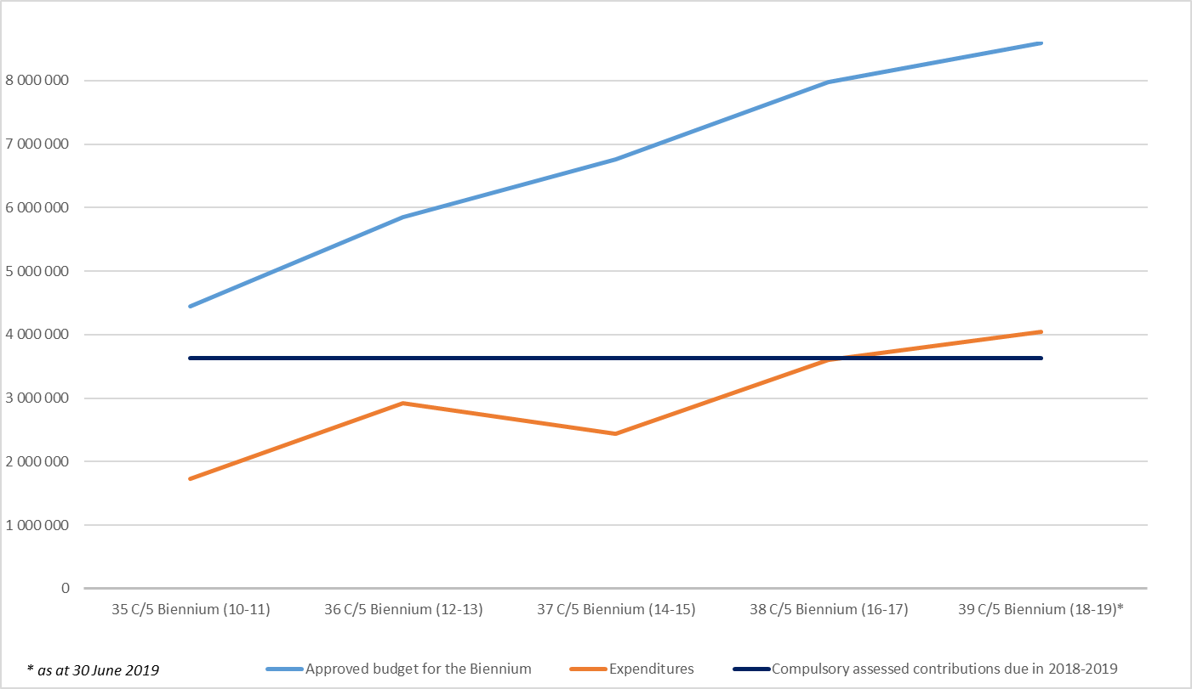
Figure 1: Evolution of expenditures of the Fund
- It should be recalled that the payment of contributions is an obligation incumbent on all States Parties that have ratified the Convention, in accordance with Article 26. As States Parties exercise rights and enjoy benefits conferred on them under the Convention, they are also expected to fulfil their corresponding commitments in return. It is worth noting that the lack of cash availability caused by late payments of assessed contributions might delay and thus jeopardize the implementation of activities foreseen in the budget.
- With regards to the compulsory assessed contributions by States Parties to be paid in accordance with Article 26.1 of the Convention, the evolution of the payment of assessed compulsory contributions in the past six years shows a continuous trend of around 13% unpaid contributions each year. The amounts paid were slightly higher than the amounts due in 2014 and 2018, which meant that some States Parties settled arrears or made payments in advance. As at 30 June 2019, the payments are lower than the amounts due and the arrears amount to US$1.43 million (against US$1.26 million at 30 June 2017), US$347,465 of which correspond to unpaid contributions of previous years. As of 30 June 2019, 111 States Parties (64%) have not yet paid their contribution for 2019. Amongst them, 55 States Parties (32%) have also not paid their contribution for 2018, and in a number of cases for preceding years as well (see Annex II).
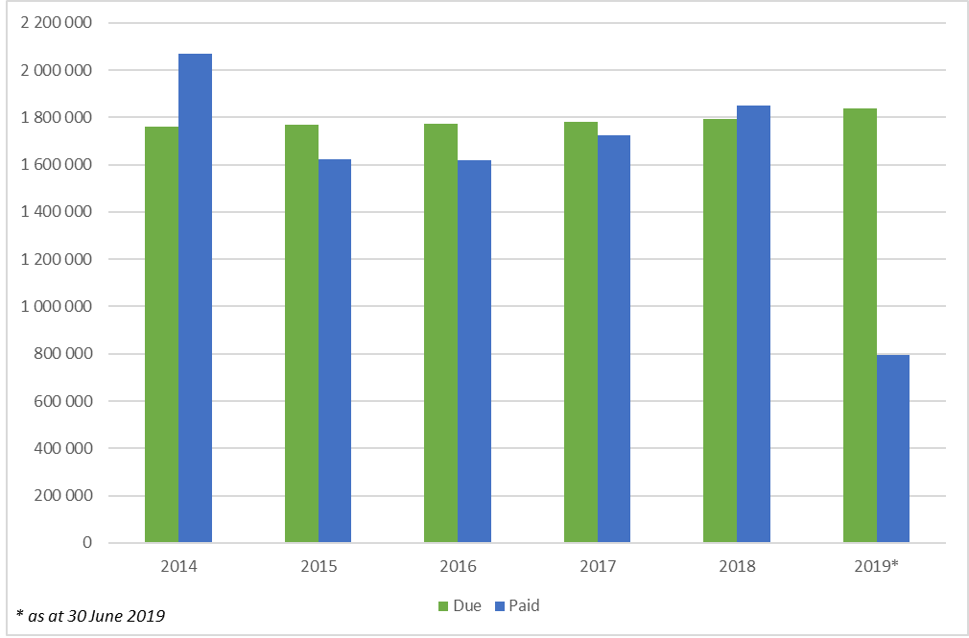
Figure 2: Evolution of assessed compulsory contributions
- With regards to the voluntary assessed contributions by States Parties to be paid in accordance with Article 26.2 of the Convention, a comparison over the past six years shows that the payments of voluntary assessed contributions remain on average at 58% of the expected amounts.
- Figure 3 clearly demonstrates that States Parties have been making a significantly higher use of the International Assistance mechanisms, corresponding to budget lines 1 and 2. During the 39 C/5 biennium (2018-2019), expenditures under these two budget lines increased by 78%. As for the expenditure rate, it reached 49% as at 30 June 2019. This positive result is mainly thanks to: 1) the increase in the ceiling of International Assistance requests that can be presented to the Bureau from US$25,000 to US$100,000 (Resolution 6.GA 7); 2) the 20% increase (compared to the previous 2016-2017 biennium) in the number of requests examined by the Bureau, with the corresponding recommendations prepared by the Secretariat and 3) the continuation of a relatively high proportion of requests approved by the Bureau (65.5% of requests examined by the Bureau since January 2018 have been approved), demonstrating the overall satisfactory quality of the requests received by the Secretariat. A detailed report on the progress of the implementation of the funds dedicated to International Assistance can be found in document LHE/19/14.COM/9.b, ‘Reports of State Parties on the use of International Assistance from the Intangible Cultural Heritage Fund’.
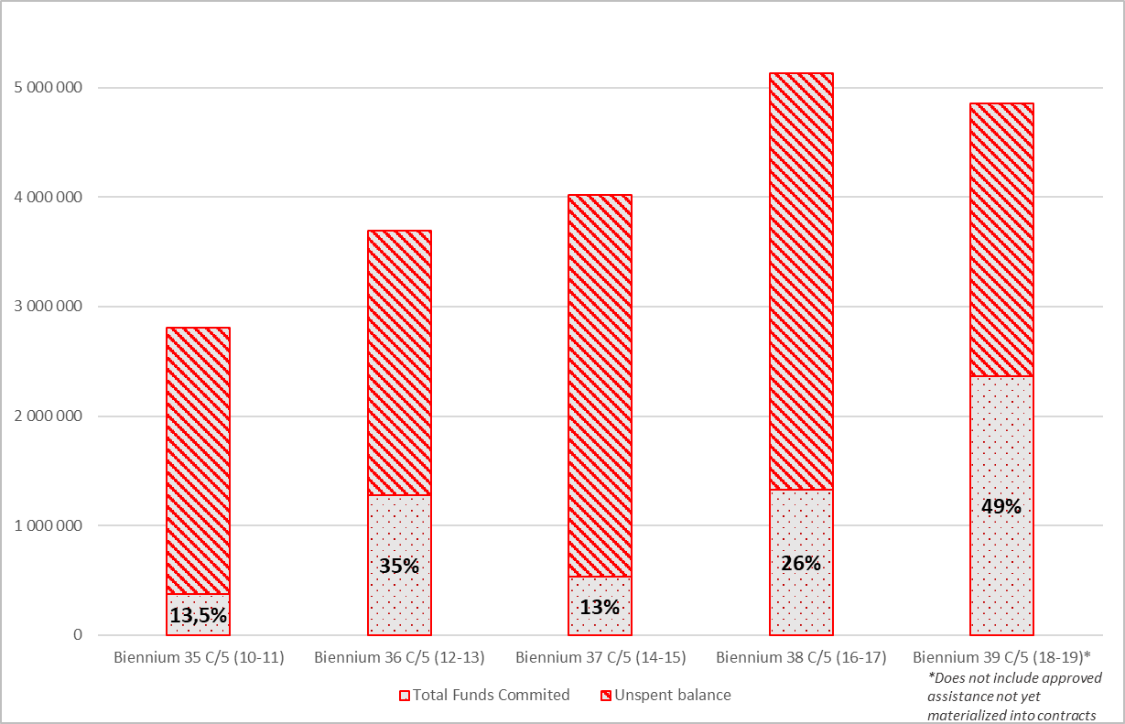
Figure 3: Expenditure rate: International and Preparatory Assistance

PROPOSED DRAFT PLAN FOR THE USE OF THE RESOURCES OF THE INTANGIBLE CULTURAL HERITAGE FUND FOR THE PERIOD 2020–2021
- The draft plan proposed below is based on an estimated total budget of approximately US$7 million corresponding to the amount forecasted as available as at 31 December 2019. This would represent a 19% drop in the overall budget of the Fund, which would in turn have an impact on the budget distribution among budget lines, as some of the expenditures proposed in the 2020–2021 plan (in particular budget lines 1.1 and 4) need to be maintained at their nominal amount.
- In line with the priorities set by the Guidelines for the use of the resources of the Fund in Chapter II.1 of the Operational Directives, it is proposed that the majority of the resources be allocated to providing International Assistance to States Parties to supplement their national efforts to safeguard intangible cultural heritage (budget lines 1, 1.1 and 2). The combined percentage of these three lines (64.75%) remains the same as during the previous biennium.
- 51.96% is foreseen for the support provided to States, through the International Assistance mechanisms, for the safeguarding of heritage inscribed on the List of Intangible Cultural Heritage in Need of Urgent Safeguarding, the preparation of inventories and support for other safeguarding programmes (budget line 1). Despite the foreseen decrease in the nominal amount, due to the decrease in the overall budget (see paragraph 7), this allocation should still allow the Fund to maintain the current level of support to States through International Assistance, should the number of requests received remain stable during the 2020–2021 period.
- At its seventh session in June 2018, the General Assembly approved the creation of three extra-budgetary fixed-term posts (Resolution 7.GA 8) to form a dedicated team to operationalize the implementation of the International Assistance mechanisms, in particular through a thorough project monitoring and evaluation process that will help assess the impact of projects supported by the Fund, identifying best practices and lessons learned that would help enhance the efficiency of projects in the future. Some 10.79% of the resources of the Fund are proposed to be allocated to cover the costs of these three posts (budget line 1.1). The 2.59% increase in budget line 1.1 – to maintain the nominal amount needed to cover the costs of the three extra-budgetary fixed-term posts – is proposed to be offset by a slight percentage decrease in budget lines 1 and 2.
- Furthermore, it is proposed that 2% of the funds be budgeted for granting preparatory assistance (budget line 2). In addition to preparatory assistance for nomination files, the Committee decided to use this line to provide technical assistance to States Parties for preparing International Assistance requests. Considering that preparatory assistance is rather underutilized (9% of the allocation in the current biennium – as at 30 June 2019) and that States have required technical assistance much more often than preparatory assistance in its traditional format, it is proposed that funds available under this line continue to be used for the provision of experts, as described in Article 21 of the Convention. The two percentage point decrease in funds assigned to this budget line, compared to the previous biennium, will contribute to covering the costs of the three posts, while remaining in a position to respond to requests for preparatory assistance and technical assistance at the same level as during the current biennium.
- Budget line 3, ‘other functions of the Committee’, will be maintained at 20% in order to strengthen the work initiated during the current biennium. While the percentage level is proposed to remain at the same percentage, the nominal amount allocated to this line will significantly decrease. This will require the Secretariat to adjust and reduce the scope of its activities supported by the Fund. Taking this decrease into consideration, the Secretariat intends to use these funds primarily for promoting the objectives of the Convention at the global level and encouraging and monitoring its implementation (Article 7 [a]). To this end, funds allocated to this budget line will continue to provide essential support for a number of upstream and cross-cutting needs of the capacity-building programme and the initiative to promote the integration of intangible cultural heritage into formal and non-formal education. Similarly, this budget line will be vital for ensuring the steady improvement in the management of knowledge, information and monitoring, including the website of the Convention. Funds allocated to this budget line will also contribute to the integration of intangible cultural heritage into development plans, policies and programmes, through the establishment of partnerships with educational institutions, the continuation of the work on safeguarding intangible cultural heritage in emergencies and cooperation with other United Nations agencies, in line with the 2030 Agenda. Finally, these funds will also be used to promote the objectives of the Convention through awareness raising and outreach.
- As in the current and preceding Plans for the use of the Fund, the present draft decision proposes that the Committee continue to delegate to its Bureau the authority to decide upon the utilization of the funds allocated under budget line 3, on the basis of specific proposals to be prepared by the Secretariat. As authorized by previous decisions of the Committee (Decisions 6.COM 20, 8.COM 11, 10.COM 8 and 12.COM 7), it is also proposed in the draft decision that the Committee authorize the Secretariat to make transfers between activities within budget line 3 up to a cumulative amount equivalent to 2% of the initial total allocation likely to be proposed for this purpose to the General Assembly. Such authorization is similar to that by which the General Conference authorizes the Director-General to make transfers between appropriation lines of UNESCO’s regular programme up to an amount of 2% of the initial appropriation under the 39 C/5. The Secretariat would inform the Bureau in writing, at the session following such action, of the details and reasons for these transfers; any transfers larger than that amount would require the Bureau’s prior approval of a revised spending plan.
- The participation in statutory meetings of experts in intangible cultural heritage representing developing States Parties is covered either by budget line 4 when they are members of the Committee or by budget line 5 when they are not. The participation of experts in intangible cultural heritage representing accredited NGOs from developing countries in the sessions of the Committee is covered by budget line 6. It is proposed that 2.63%, 3.31% and 3.31%, respectively, be dedicated to the above-mentioned lines. The slight increase in budget line 4 – to be compensated by the decrease in budget line 6 – would allow for a sufficient nominal allocation of funds despite the decreasing amount of the overall budget of the Fund. Furthermore, the slight increase in budget line 5 – to be also offset by the decrease in budget line 6 – would balance the support given to States Parties and accredited NGOs, taking into account the increasing number of ratifications in recent years.
- Budget line 7 is proposed to be maintained at 6% to cover the cost of the advisory services provided at the request of the Committee from January 2020 to December 2021.
- The Reserve Fund was created in accordance with the Financial Regulations of the Special Account of the Fund for the Safeguarding of the Intangible Cultural Heritage to meet requests for International Assistance in cases of extreme urgency and in the event that the funds allocated to International Assistance (budget line 1) are exhausted. The total allocation of the Reserve Fund reached the amount of US$1,000,000 – achieving the objective set by the Committee and the General Assembly (Decision 10.COM 8 and Resolution 6.GA 9) at the end of the previous biennium. Therefore, it is proposed that no budget be allocated to budget line 8.
- At its seventh session (Resolution 7.GA 8), the General Assembly recommended that the Secretariat be authorized to make transfers between budget lines 4, 5 and 6, up to 30% of their initial total allocation. While no transfer has been necessary during the reporting period, the intention is still to make efficient use of the funds in accordance with the necessities of each cycle. Furthermore, it has been observed that the use of the funds allocated to budget line 7 can significantly vary from one year to another, as expenditures depend on the country of residence of members of the Evaluation Body. Therefore, to enhance efforts to respond to as many requests for financial assistance as possible across the different categories of participants, it is proposed that the Committee recommend to the General Assembly to also authorize the Secretariat to make transfers between budget lines 4, 5, 6 and 7, up to an equivalent of 30% of their initial total. Should such a transfer be necessary, the Secretariat would be requested to inform the Committee and the General Assembly in writing, at the session following such action, of the details of and reasons for these transfers.

PROSPECTS FOR FUTURE BUDGET CYCLES
- With its current 178 States Parties, US$3.9 million in assessed contributions is estimated for 2020–2021, depending on the Resolutions on UNESCO’s appropriated regular budget to be adopted by the General Conference at its fortieth session in November 2019. Currently, the rate for assessed contributions to the Convention is established at 1% of each State’s contribution to UNESCO’s regular budget.
- While it is worth noting that the financial situation of the Fund is sound a number of considerations will need to be taken into account in the future to continue ensuring the efficient and equitable use of the budget allocations, in particular those dedicated to International Assistance (budget lines 1, 1.1 and 2). In this regard, in its future sessions the Committee may consider it useful, notwithstanding the sovereignty of each State to submit International Assistance requests, to discuss whether measures may need to be implemented to ensure that all States Parties do indeed have equitable access to the Fund. Such measures may include the possibility of establishing criteria to determine different levels of priority among International Assistance requests received and/or limit the amount that can be granted to a single country (see document ITH/18/13.COM/12 for an initial reflection on this subject).
- The forecast trend is a positive sign from an operational and administrative point of view. It reflects States’ increased capacity to access funds that support programmes and projects that contribute to the safeguarding of living heritage and the improved ability of the governing bodies of the Convention and of the Secretariat to respond to their requests. However, this trend also means that the amount of financial resources available to support State efforts to safeguard intangible cultural heritage may diminish in the future, although this is not an immediate concern. Combined with the significant decrease in voluntary supplementary contributions through Funds-in-Trust arrangements and earmarked contributions to the Fund, as reflected in document LHE/19/14.COM/6, the situation for the coming years is however not without preoccupations. On the other hand now that the Fund is in a healthier operational situation, the Convention is in a better position to pursue voluntary supplementary contributions. In this regard, some promising signs have been observed during the reporting period as a series of concept notes and projects were developed for review by prospective donors who have expressed an interest in making voluntary supplementary contributions to the Fund.

ALIGNMENT OF FINANCIAL REGULATIONS OF SPECIAL ACCOUNTS
- At its 200th session in 2016, UNESCO’s Executive Board approved Standard Financial Regulations for all types of Special Accounts including those related to conventions, as set out in Annex IV of document 200EX/19 (200 EX/Decision 19). At its following session in 2017, the Executive Board requested the Director-General to propose to the relevant governing body of each Special Account, a realignment of the Financial Regulations of their respective Special Account with the abovementioned Standard Financial Regulations (201 EX/Decision 24). In conformity with both decisions, the Secretariat of the 2003 Convention will prepare draft revisions to the Financial Regulations of the Special Account for the Fund for the Safeguarding of the Intangible Cultural Heritage. As the Fund already operates under comprehensive Financial Regulations, revisions are not expected to bring major changes to the functioning of the Fund.
- The Committee may wish to adopt the following decision:
DRAFT DECISION 14.COM 7
The Committee,
- Having examined documents LHE/19/14.COM/7 and LHE/19/14.COM/7.INF,
- Recalling Article 7(c) of the Convention and Resolution 7.GA 8 of the General Assembly,
- Further recalling 200 EX/Decision 19 and 201 EX/Decision 24,
- Takes note of the statement of accounts of the Fund for 2018–2019 as of 30 June 2019, recalls that the payment of compulsory and assessed voluntary contributions is, as per Article 26 of the Convention, an obligation incumbent on all States Parties which have ratified the Convention and calls upon all States Parties which have not yet paid the totality of their assessed contributions for 2019 or previous years, including voluntary contributions, to ensure that their contributions are paid at the earliest opportunity;
- Welcomes the recent positive trends in the implementation of the Fund, commends the Secretariat for its efforts to intensify the operationalization of the International Assistance mechanisms, further takes note that a dedicated team has been established with three new extra-budgetary fixed-term posts and looks forward to observing the improved monitoring of the impact of projects supported by the Fund;
- Notes that, as a consequence of the intensification of the implementation of the Fund, the allocation of funds dedicated to providing International Assistance to States Parties will decrease in 2020–2021 and therefore further calls upon all States Parties to consider making voluntary contributions to complement the support already provided through the Fund;
- Decides to base the draft plan for the use of the resources of the Fund for the periods 1 January 2020 to 31 December 2021 and 1 January to 30 June 2022 on the total unrestricted operating reserves available as of 31 December 2019;
- Submits for approval to the eighth session of the General Assembly the plan for the use of the resources of the Fund, as included in Annex I of Document LHE/19/14.COM/7, and proposes to the General Assembly that one fourth of the amount established for the two-year period from 1 January 2020 to 31 December 2021 be provisionally allocated to the first semester of 2022;
- Delegates to its Bureau the authority to decide upon the utilization of the funds allocated under budget line 3 of the Plan, ‘Other functions of the Committee’, on the basis of specific proposals to be prepared by the Secretariat;
- Authorizes the Secretariat, when utilizing the funds allocated under budget line 3 of the Plan, to make transfers between activities included within the specific proposals approved by the Bureau up to a cumulative amount equivalent to 2 per cent of the initial total allocation proposed to the General Assembly for this purpose, and requests that, in such cases, the Secretariat inform the Members of the Bureau in writing, at the session following such action, of the details and reasons for these transfers;
- Recommends that the General Assembly authorize the Secretariat to make transfers between budget lines 4, 5, 6 and 7, up to an equivalent of 30 per cent of their initial total allocation approved by the General Assembly, and requests that the Secretariat inform the Committee and the General Assembly in writing, at the session following such action, of the details of and reasons for these transfers;
- Further requests that the Secretariat propose, for examination by the General Assembly at its eighth session in 2020, draft revisions to the Financial Regulations of the Special Account for the Fund for the Safeguarding of the Intangible Cultural Heritage in order to align them with UNESCO’s Standard Financial Regulations.

ANNEX I
Draft plan for the use of the resources of the Fund
For the period 1 January 2020 to 31 December 2021, as well as for the period  1 January to 30 June 2022, the resources of the Intangible Cultural Heritage Fund may be used for the following purposes: |  | % of the total amount | 2018–2019 Plan
1. | International Assistance, comprising the safeguarding of the heritage inscribed on the List of Intangible Cultural Heritage in Need of Urgent Safeguarding, the preparation of inventories and support for other safeguarding programmes, projects and activities; | 51.96% | 52.55%
1.1 | Enhancing human resources to improve the implementation of the International Assistance mechanisms through three extra-budgetary fixed-term posts (one P3, one P2 and one G5); | 10.79% | 8.20%
2. | Preparatory assistance for International Assistance requests, as well as for nomination files for the Urgent Safeguarding List and for proposals for the Register of Good Safeguarding Practices; | 2.00% | 4.00%
3. | Other functions of the Committee, as described in Article 7 of the Convention, aimed at promoting the objectives of the Convention and encouraging and monitoring its implementation, in particular by strengthening capacities to effectively safeguard intangible cultural heritage, raising awareness of the importance of such heritage, providing guidance on good safeguarding practices and updating and publishing the Lists and the Register of Good Safeguarding Practices; | 20.00% | 20.00%
4. | Participation in the sessions of the Committee, its Bureau and subsidiary bodies of experts in intangible cultural heritage representing developing States that are Members of the Committee; | 2.63% | 2.00%
5. | Participation in the sessions of the Committee and its consultative bodies of experts in intangible cultural heritage representing developing States that are Parties to the Convention but not Members of the Committee; | 3.31% | 3.25%
6. | Participation in the sessions of the Committee, its Bureau and consultative bodies of public or private bodies, private persons, notably members of communities and groups, that have been invited by the Committee to advise it on specific matters, as well as experts in intangible cultural heritage representing accredited NGOs from developing countries; | 3.31% | 4.00%
7. | The costs of advisory services to be provided at the request of the Committee, including support to developing States whose representatives have been appointed to the Evaluation Body; | 6.00% | 6.00%
8 | Building up the Reserve Fund referred to in Article 6 of the Financial Regulations of the Fund. | 0% | 0%
 | Subtotal | 100.00% | 100.00%
Funds that have not been committed at the end of the period of this Plan are carried over to the next financial period and shall be allocated in accordance with the Plan approved by the General Assembly at that time.

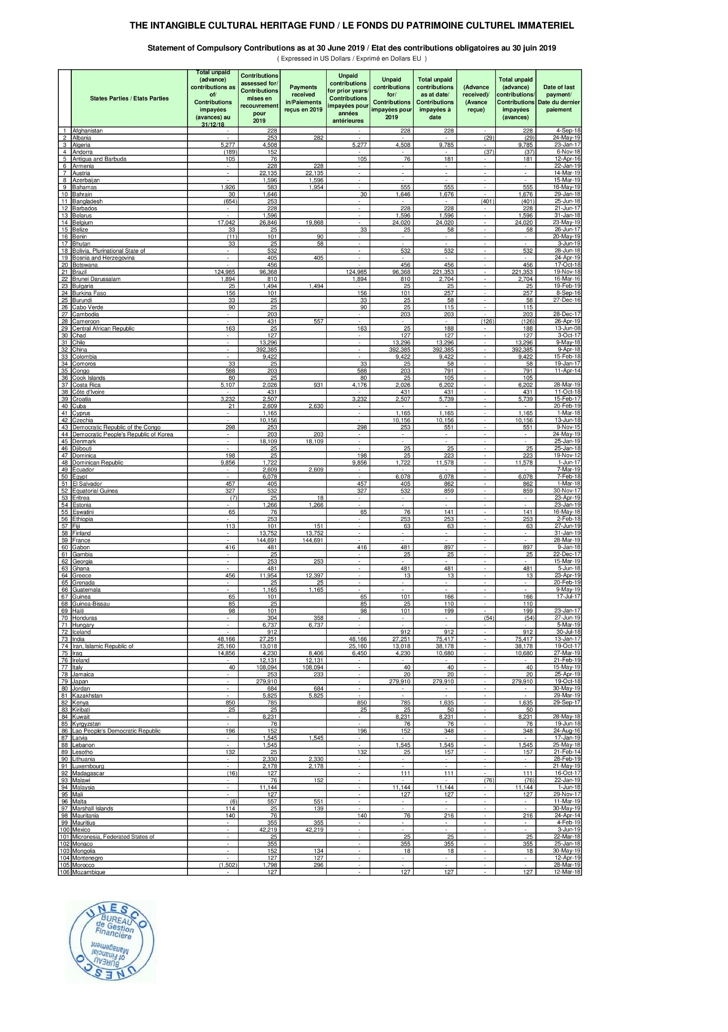
ANNEX II
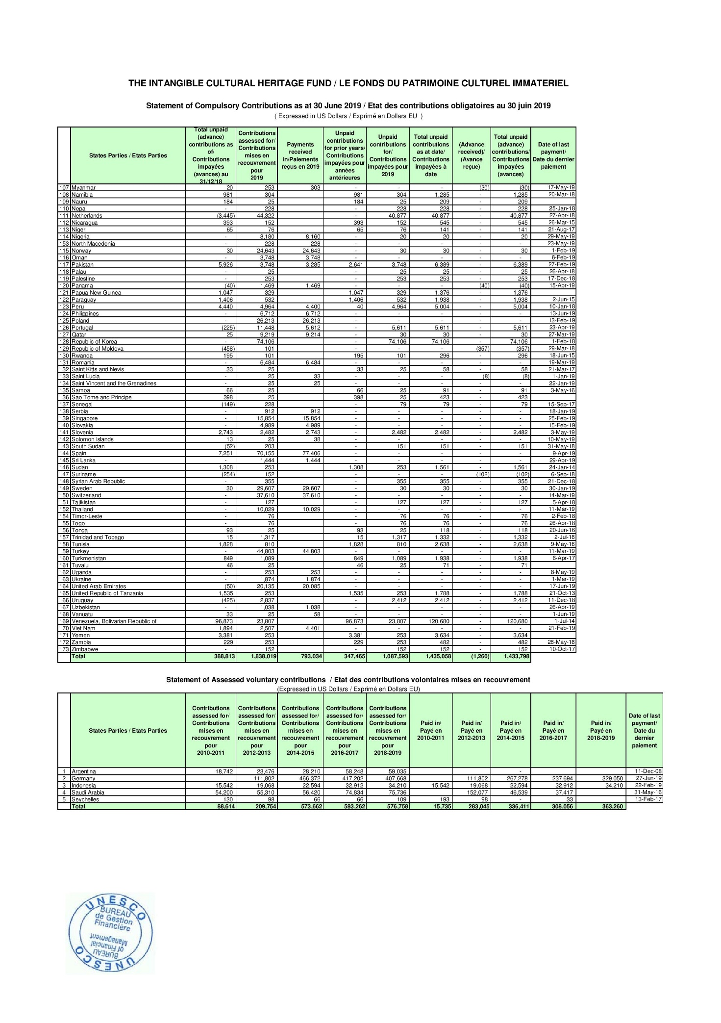

. This estimate is based on the Fund balance as at 30 June 2019 (excluding the Reserve Fund of US$1,000,000) and does not take into account assessed contributions due for the 40 C/5.
. See documents LHE/19/14.COM/6 and LHE/19/14.COM/INF.7
. The latest Statement of compulsory contributions is available at: http://www.unesco.org/eri/cp/factsheets/ICH-Status-of-Contributions.pdf
. The latest Statement of compulsory contributions is available at: http://www.unesco.org/eri/cp/factsheets/ICH-Status-of-Contributions.pdf
. Compared with the 2014–2015 biennium (37C/5), the number of requests examined by the Bureau has increased by 142%. This increased rate does not take into account the International Assistance requests that have been examined by the Bureau in the second half of 2019.
. ‘Preparatory assistance’ corresponds to the assistance that States Parties can request for developing nominations to the List of Intangible Cultural Heritage in Need of Urgent Safeguarding or proposals for the Register of Good Safeguarding Practices (paragraph 21 of the Operational Directives). ‘Technical assistance’ refers to the provision of experts, as described in Article 21 of the Convention, to States Parties wishing to develop requests for International Assistance (Decision 8.COM 7.c).

