CONVENTION FOR THE SAFEGUARDING OF THE
INTANGIBLE CULTURAL HERITAGE
INTERGOVERNMENTAL COMMITTEE FOR THE
SAFEGUARDING OF THE INTANGIBLE CULTURAL HERITAGE
Open ended intergovernmental working group
on developing an overall results framework for the Convention
Chengdu, People’s Republic of China
11 to 13 June 2017
Item 3 of the Agenda:
Towards an overall results framework for the Convention:
progress to date and objectives of the present meeting
Summary
At its eighth session, the Committee decided to develop an overall results framework for the Convention. The topic was further discussed by the Committee at its ninth and tenth sessions. At its eleventh session, the Committee welcomed the results of a preliminary expert meeting, held in Beijing, China, from 7 to 9 September 2016. The Committee reaffirmed the necessity for an inclusive process of consultation and discussion in the development of such a framework and reiterated its call for an open ended intergovernmental working group to that end (Decision 11.COM 14).

Background of the meeting
- In its 2013 evaluation of the standard-setting work of UNESCO’s Culture Sector, UNESCO’s Internal Oversight Service (IOS) noted that the Committee’s task of monitoring the implementation of the Convention – one of its functions as set out in Article 7 of the Convention – was impeded by the lack of an overall results framework agreed by its States Parties. As IOS noted, ‘capturing and reporting on results (outputs and outcomes) is only possible if it is clear what results are to be achieved. This is not the case right now. […] Drawing conclusions about the progress made with regard to the implementation of the Convention is difficult in the absence of objectives, indicators and benchmarks’. After debate at its eighth session, the Committee therefore decided to ‘develop an overall results framework for the Convention including clear objectives, time-frames, indicators and benchmarks’ (Decision 8.COM 5.c.1).
- When the Committee debated this issue, States Members emphasized that the process of developing an overall results framework should be led by States Parties and should be one in which they were fully involved. In response, the Secretariat invited the ninth session of the Committee to discuss a process and timetable by which a results framework for the Convention could be developed. Recognizing ‘the necessity for an inclusive process of consultation and discussion in the development of such a framework’, the Committee decided to convene an intergovernmental working group to that end, on the condition that adequate extrabudgetary resources were mobilized (Decision 9.COM 13.e).
- Although it was not possible to organize such a meeting in 2016 as the Committee had hoped, the National Commission of the People’s Republic of China for UNESCO offered to support a smaller meeting of experts that could elaborate a preliminary framework, for submission to a subsequent intergovernmental working group. In its Decision 10.COM 9, the Committee ‘Accept[ed] with gratitude the generous contribution of the National Commission of the People’s Republic of China, approve[d] its specific purpose and request[ed] the Secretariat to ensure the proper organization of the expert meeting.’
- As a consequence, from 7 to 9 September 2016 in Beijing, China, UNESCO organized a category VI meeting; that is, a meeting of a non-representative character of experts appointed by the Director-General who served in their private capacity. The meeting brought together 21 experts from different UNESCO Member States and Associate Members, working in governmental and non-governmental institutions, in communities or practitioner groups, as well as five members of the Intangible Cultural Heritage Section and three staff members from the UNESCO Office in Beijing. A number of Chinese experts were present as observers. The working papers for the meeting are available on a dedicated web page and its report to the Committee is found in Document ITH/16/11.COM/14.
- At its eleventh session, the Committee expressed its satisfaction with the outcomes of the expert meeting, taking particular note of the results map that the experts had produced (Decision 11.COM 14). The Committee deemed that this results map (annexed to its decision) ‘reflects a vision of success for the implementation of the Convention placing outcomes and impacts on a logical sequence and constitutes a thinking tool for developing an overall results framework’. It further requested ‘the Secretariat to continue developing an overall results framework building on the discussions of the preliminary expert meeting and the initial debate by the States Parties in the eleventh session’. Reiterating its call for an open ended intergovernmental working group, it welcomed an expression of interest from China to host such a meeting. The present meeting, made possible through the generous contribution of Centre for Safeguarding Intangible Cultural Heritage in Chengdu, thus constitutes the next major landmark on the road towards an overall results framework for the Convention.

Getting started on the Results-Based Management cycle
- The Committee’s efforts to develop an overall results framework are in line with the Results-Based Management (RBM) approach adopted by the United Nations and understood as a cyclical ‘management strategy by which all actors, contributing directly or indirectly to achieving a set of results, ensure that their processes, products and services contribute to the achievement of desired results (outputs, outcomes and longer-term goals or impact). The actors in turn use information and evidence on actual results to inform decision making on the design, resourcing and delivery of programmes and activities as well as for accountability and reporting.’ This framework represents a life cycle based on continuous improvement that includes planning, monitoring and evaluation phases where the results of evaluation feed into decision making for the next planning cycle; see Figure 1 below.
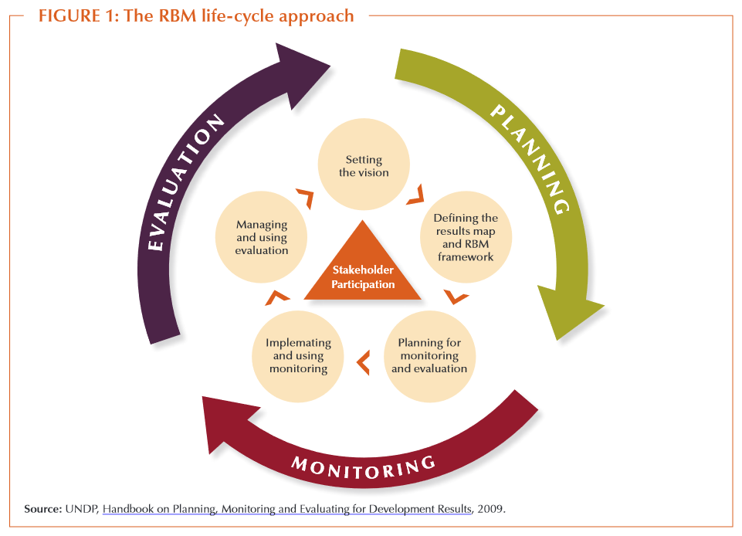
- In the case of the Convention, its vision is already determined by its text, so the Committee’s work begins with the second part of the planning phase: ‘Defining the results map and RBM framework’. However, specific challenges arise from developing an overall results framework for an international normative instrument such as the 2003 Convention, which is atypical of the kind of organizations and programmes on which monitoring and evaluation work typically focuses. Like much of the United Nations’ normative work, the Convention ‘involves numerous actors, many potential causes and just as many possible effects’
- A results map sets out the logical sequence of main steps in achieving the vision agreed (inputs, activities, outputs, outcomes and impacts); see Figure 2.

Figure 2: The logical sequence of a results map
- The results map must also be accompanied by suitable qualitative or quantitative indicators for measuring progress towards achieving the vision. Together, the map and the respective indicators constitute the overall results framework (‘RBM framework’ in Figure 1), completing the planning phase of the cycle. As the RBM cycle continues, an ongoing process of monitoring (phase 2) collects and compiles information that can then be used for evaluation (phase 3). That process of evaluation in turn feeds back into possible revisions of the results map, aiming at achieving the Convention’s vision more effectively or efficiently. Given the cyclical nature of this process, effective indicators must be defined both in relation to the outputs, outcomes and impacts they are intended to measure and in relation to the sources of information that will reliably and sustainably be available during monitoring.
- The discussions in the September 2016 expert meeting were consequently wide-ranging, touching upon all parts of the RBM cycle. The left side of the cycle (i.e. implementing a monitoring system and using its results for evaluation) nevertheless received less attention than the right side (defining the results map, with an eye to the future elaboration of indicators and a monitoring plan). The expert group submitted a rich report to the eleventh session of the Committee (Document ITH/16/11.COM/14), and agreed upon a results map that was annexed to that report and to the present document. The report and results map in turn met with the satisfaction of the Committee, which determined, as noted above, that it placed outcomes and impacts on a logical sequence and constituted a thinking tool for developing an overall results framework (Decision 11.COM 14).

Objectives of the present meeting
- The primary goal of the open ended working group will be to reach consensus on a set of indicators capable of effectively measuring the outputs, outcomes and impacts identified in the results map; this will enable the draft overall results framework to be completed for examination by the Committee at its twelfth session (Jeju Island, Republic of Korea, December 2017) and, if the Committee so agrees, for the results framework to be submitted to the General Assembly at its seventh session (Paris, June 2018). The Secretariat will provide a draft set of indicators for the working group’s examination, revision and adoption (Document ITH/17/12.COM WG/4), based upon the debates of the expert meeting and the comments of Committee members during its eleventh session.
- The expert group’s reflections on the topic of indicators are summarized in its aforementioned report to the Committee, and will be further extended and expanded in the working group document introducing the draft set of indicators. It may nevertheless be useful at this point to mention that the working group will be asked to consider the appropriateness and effectiveness of each indicator, according to the following criteria:
- Will it adequately describe the result or condition in clear terms?
- Will it provide sufficient information?
- Will data be available?
- Will data collection be feasible and reliable (consistently measurable over time, in the same way by different observers)?
- Will data collection be cost effective?
- Will data be comparable, both over time and in relation to others?
- Will it be gathered at time intervals that are relevant?
- In its report to the twelfth session of the Committee, the working group will thus integrate the set of indicators it has adopted, together with the existing results map, into an overall results framework. Working group members will also be invited to examine two sample guidance notes. A guidance note will later be elaborated for each indicator, so that the diverse stakeholders who will be involved in the long-term monitoring and evaluation of the Convention will share a common understanding of essential terminology and apply the indicators in a comparable way.
- As noted above, indicators cannot be elaborated without careful consideration of where, when and how information will be collected as part of a monitoring process (here, too, the report of the expert meeting offers rich reflections). As emphasized by Committee Members during its eleventh session, it is therefore essential that there be the closest possible harmony between the Convention’s overall results framework and the process of periodic reporting by States Parties ‘on the legislative, regulatory and other measures taken for the implementation of this Convention’, as set out in Article 29 of the Convention. Another task of the open ended working group will therefore be to look at the periodic reporting mechanism with a view to offering recommendations for reform that can make that process one that is more useful to States, informative to them and to others, and more efficient in gathering information relevant to the overall results framework, without imposing an additional burden on State capacities that are often already stressed or limited. Document ITH/17/12.COM WG/5 will review the Convention’s experience to date with periodic reporting, summarize the challenges States have faced with the existing system, and offer possible paths towards improving the periodic reporting system that the working group will be invited to discuss.
- Even if periodic reporting will be the principle source of information to support the monitoring and evaluation of the Convention’s implementation, it will not be the only possible source. For instance, States Parties benefitting from International Assistance must also submit implementation reports (Article 24), and specific reports are required for elements inscribed on the Urgent Safeguarding List. In addition, the Convention’s global capacity-building programme has an ongoing monitoring and evaluation process that generates information that will be relevant to several indicators. Moreover, much of the information gathered about the implementation of the Convention may also be relevant to other State-level or international efforts to monitor progress in specific areas, such as the systems for monitoring achievements for the Sustainable Development Goals (SDGs). The working group will therefore be asked to consider how the Convention’s monitoring can best be designed so that it can integrate information from complementary information sources and so that the Convention’s system can contribute effectively to parallel and complementary monitoring exercises such as those mentioned above (see Document ITH/17/12.COM WG/6).
- The open ended intergovernmental working group is thus intended to advance the work initiated by the Committee in its deliberations during several sessions, and to build upon the groundwork laid by the September 2016 expert meeting. Its results – in the form of a set of indicators and other related recommendations – will be provided to the Committee for its twelfth session in December 2017. If the Committee so wishes, it can then offer concrete recommendations for amended Operational Directives to the seventh session of the General Assembly in June 2018.
ANNEX
Results map presented to the Committee by the expert group
and considered by the Committee to be a thinking tool for developing
an overall results framework for the Convention (see Decision 11.COM 14)
Inputs |  | Resources needed to safeguard intangible cultural heritage identified and agreed by relevant stakeholders
Activities  (cf. Article 2.3) |  | Actions to safeguard intangible cultural heritage identified and agreed by relevant stakeholders such as:  - identification  - documentation  - research  - preservation  - protection  - promotion  - enhancement  - transmission, particularly through formal and non-formal education  - revitalization  - …
Outputs  (cf. Articles 11-18; 23) |  | Identified and agreed actions implemented by relevant stakeholders such as:  - inventories  - policies  - institutional frameworks  - scientific, technical and artistic studies  - educational, training, awareness-raising and information programmes  - capacity-building programmes  - participation in the international mechanisms of the Convention  - …
Short-term Outcomes |  | Improved capacities to support the safeguarding of intangible cultural heritage in general |  |  |  | Improved capacities to implement safeguarding measures or plans for specific elements of intangible cultural heritage
Mid-term Outcomes |  | Effective relationships built among a diversity of communities, groups and individuals and other stakeholders for safeguarding intangible cultural heritage |  |  |  | Dynamic development and implementation of safeguarding measures or plans for specific elements of intangible cultural heritage led by a diversity of communities, groups and individuals
Long-term Outcomes  (cf. Article 1) |  | Continued practice and transmission of intangible cultural heritage ensured |  | Diversity of intangible cultural heritage respected |  | Recognition and awareness of the importance of intangible cultural heritage and its safeguarding ensured |  | Engagement and international cooperation for safeguarding enhanced among all stakeholders and at all levels
Impacts |  | Intangible cultural heritage is safeguarded by communities, groups and individuals who exercise active and ongoing stewardship over it, thereby contributing to sustainable development for human well-being, dignity and creativity in peaceful and inclusive societies

. ‘Evaluation of UNESCO’s Standard‐setting Work of the Culture Sector: Part I – 2003 Convention for the Safeguarding of the Intangible Cultural Heritage’ available in English|French|Spanish|Arabic.
. http://www.unesco.org/culture/ich/en/events/expert-meeting-on-developing-an-overall-results-framework-for-the-2003-convention-00581
. United Nations Development Group Results-based Management (RBM) Handbook (2011), https://undg.org/wp-content/uploads/2015/01/UNDG-RBM-Handbook-2012.pdf.
. UNEG Handbook for Conducting Evaluations of Normative Work in the UN System, 2013, para. 70, http://www.uneval.org/document/detail/1484 (available in English, French and Spanish).
. http://www.unesco.org/culture/ich/en/Decisions/11.COM/14

