CONVENTION FOR THE SAFEGUARDING OF THE
INTANGIBLE CULTURAL HERITAGE
INTERGOVERNMENTAL COMMITTEE FOR THE
SAFEGUARDING OF THE INTANGIBLE CULTURAL HERITAGE
Thirteenth session
Port Louis, Republic of Mauritius
26 November to 1 December 2018
General Information

TABLE OF CONTENTS
1. THIRTEENTH SESSION 4
2. HOST COUNTRY CONTACTS 4
3. REGISTRATION 5
4. ACCOMMODATION 5
5. PASSPORTS, VISAS AND OTHER TRAVEL INFORMATION 5
5.1 Immigration/Visa 5
5.2 Formalities 5
5.3 Customs in the Republic of Mauritius 6
5.4 Health requirements 7
5.5 Medical insurance and services 7
5.6 Travelling to and from the Republic of Mauritius 7
6. LOCAL TRANSPORTATION 7
7. VENUE OF THE SESSION 8
7.1 Meeting venue 8
7.2 Official opening, meetings and related events 8
7.3 Interpretation 8
7.4 Documentation 8
7.5 Meeting registration and information desk 8
7.6 Security badges 8
7.7 Participants’ lounge 8
7.8 Conference venue 8
7.9 Meals 9
8. MEDIA 9
8.1 Media centre 9
8.2 Press conference room 9
8.3 Press releases 9
9. OPENING DINNER AND RELATED EVENTS 9
10. COUNTRY INFORMATION 9
10.1 The Republic of Mauritius 9
10.2 Government structure 9
10.3 Geography and climate 10
10.4 The Republic of Mauritius and its culture 10
10.5 Fauna and flora 10
10.6 The capital city, Port Louis 10
10.7 Currency 10
10.8 Electricity supply 10
10.9 Time zone 10
10.10 Banking services 11
10.11 Emergency telephone numbers of major hospitals 11
ANNEX A REGISTRATION FORM FOR THE THIRTEENTH SESSION OF THE COMMITTEE 12
ANNEX B VISA REQUIREMENT BY COUNTRY 13
ANNEX C VISA APPLICATION FORM 19
ANNEX D RECOMMENDED HOTELS 20

- THIRTEENTH SESSION
The Thirteenth Session of the Intergovernmental Committee for the Safeguarding of the Intangible Cultural Heritage will be held in Port Louis, Republic of Mauritius, at the Swami Vivekananda International Convention Centre (SVICC) from 26 November to 1 December 2018, hosted by the Republic of Mauritius:
Address: Port Louis, Republic of Mauritius
Tel: (+230) 2060500
Fax: (+230) 2060501
Website: http://www.svicc.mu
All the relevant information is also available at the following address: https://ich.unesco.org/en/13COM/. The logistical information contained in this document was provided by the host country. The Intergovernmental Committee for the Safeguarding of the Intangible Cultural Heritage consists of twenty-four representatives of States Parties to the Convention for the Safeguarding of the Intangible Cultural Heritage, elected by the General Assembly of the States Parties to the Convention.
The current composition of the Committee is: (Group I) Austria, Cyprus, Netherlands; (Group II) Armenia, Azerbaijan, Poland; (Group III) Colombia, Cuba, Guatemala, Jamaica; (Group IV) China, Japan, Kazakhstan, Philippines, Sri Lanka; (Group V(a)) Cameroon, Djibouti, Mauritius, Senegal, Togo, Zambia; and (Group V(b)) Kuwait, Lebanon, Palestine.
The elected members (Decision 12.COM 20) of the Bureau of the thirteenth session of the Committee are:
Chairperson: H.E. Hon Prithvirajsing Roopun
Minister of Arts and Culture
Republic of Mauritius
Vice-Chairs: Cyprus, Armenia, Guatemala, Philippines and Lebanon
Rapporteur: Ms Gabriele Detschmann (Austria)
The working languages are English and French.
- HOST COUNTRY CONTACTS
Host Administration:
Ministry of Arts and Culture
Address: 7th Floor, Renganaden Seeneevassen Building,
Cnr Pope Henessy and Maillard Streets, Port Louis, Republic of Mauritius
Tel: (+230) 2122112
Contact pesons:
Ms Rajwantee Ramrukheea, Permanent Secretary
Tel: (+230) 2125848 Email: rramrukheea@govmu.org
Fax: (+230) 2129366
Mr Islam Bhugan, Director of Culture
Tel: (+230) 2115713 Email: ibhugan@govmu.org /
Fax: (+230) 2100442 ibhugan@gmail.com
Ms Deepti Dabee, Assistant Permanent Secretary
Tel: (+230) 2016269 Email: dedabee@govmu.org
Fax: (+230) 2129366
Ms Sohar Urvashi, Assistant Permanent Secretary
Tel: (+230) 2116930 Email: usohar@govmu.org /
Fax: (+230) 2129366 sohar.urvashi@gmail.com
- REGISTRATION
The main participants of the thirteenth session of the Intergovernmental Committee are the twenty-four members of the Committee. All participants, delegates, observers and those wishing to attend the thirteenth session of the Committee are strongly advised to register by no later than 29 October 2018. This is to allow the organizers sufficient time to process all the relevant information and to ensure that all the logistical arrangements are in place before the opening of the session. Please register online on the website of the thirteenth session of the Committee: https://ich.unesco.org/en/13COM/.
If you are not able to register online, please use the registration form in Annex A and return it by email to: ichmeetings@unesco.org.
All registered participants, delegates and observers are requested to inform the UNESCO Intangible Cultural Heritage Section of any subsequent changes to their travel arrangements. This will ensure that logistical arrangements are attended to in a smooth manner.
- ACCOMMODATION
Participants are responsible for booking their own accommodation and for covering all costs incurred during their stay in the Republic of Mauritius. It is strongly recommended that all participants book their own accommodation by 15 September 2018. A list of designated hotels is available at the end of this document (Annex D). Please note that shuttle services will be provided to participants only to and from these designated hotels.
- PASSPORTS, VISAS AND OTHER TRAVEL INFORMATION

5.1 Immigration/Visa
All participants, delegates and observers are required to present a passport that is valid for at least six months from the day of their arrival in the Republic of Mauritius.
Participants are kindly advised to check details regarding entry requirements into the Republic of Mauritius, with particular reference to nationality and the type of passport they hold with the nearest Embassy or Consulate of the Republic of Mauritius.
Details on visa requirements and the application process are also available on the website as follows:
http://passport.govmu.org/English/Passport%20and%20Visa%20Requirement%20in%20Mauritius/Pages/Visa-Requirements-in-Mauritius.aspx
If you are travelling to the Republic of Mauritius via other countries, please familiarize yourself with the transit requirements of those countries before you travel to the Republic of Mauritius.

5.2 Formalities
Please note that visas and extensions for the Republic of Mauritius are issued free of charge.
For countries who receive visa on arrival, delegates shall submit the following documents to the Immigration Officer on arrival at the airports of Mauritius:
- passport;
- return ticket;
- details where they are residing; and
- an invitation letter (if any).
For countries requiring visa prior to travel, delegates shall submit the following documents to Ms Sohar Urvashi (usohar@govmu.org OR sohar.urvashi@gmail.com), Assistant Permanent Secretary, Ministry of Arts and Culture at least 6 weeks prior to travelling to Mauritius:
- copy of passport; and
- visa application form (Annex C), dully filled with passport size photo affixed.
* Please refer to visa requirement by country (Annex B)
Categories of persons who do not require visas:
- Citizens of Mauritius;
- Persons who are residents of Mauritius under the Immigration Act;
- The Spouse of a citizen of Mauritius;
- The child or step child or lawfully adopted child of persons referred to at (a) and (b) above;
- Holders of Diplomatic Passports other than those issued by the Government of Afghanistan, Iran, Iraq, Libya, Somalia, South Sudan, Sudan, and Yemen;
- Crew of a vessel travelling on duty or in transit to join another vessel;
- Holders of Laissez-passer issued by the United Nations, SADC or from other internationally recognized organizations, and;
- Persons who intend to remain in Mauritius only during the stay of a vessel by which they arrive and depart.
- Countries under visa waiver agreements (refer to Annex B)

5.3 Customs in the Republic of Mauritius
On arrival to Mauritius, passengers on international flights must declare the following items to customs:
- goods that may be prohibited or restricted, such as weapons, agricultural products, articles, wildlife products, pharmaceutical products or illicit drugs (import restrictions);
- goods in excess of the normal allowance of 30,000 rupees or 15,000 rupees as the case may be and the tobacco and alcoholic beverages in excess of the allowances (allowances);
- goods for commercial, business, or trade purposes (merchandise of sale);
- Currency exceeding 500,000 rupees or its equivalent in any currency or bearer negotiable instruments including bearer traveller’s cheque, cheques, promissory notes and money orders.
Passengers do not have to declare their clothing, footwear or toiletries. These are regarded as personal effects if they are intended solely for your own use.
Red/Green Channel/Way-Out
To expedite clearance of incoming passengers, the Red and Green Channel system has been devised at the Airport and Port, and this is a self-elective system.
Red Channel
Incoming passengers with:
- Controlled or Restricted items;
- Taxable or dutiable items exceeding duty free allowance;
- Merchandise of sale;
- Items in excess of allowances;
- Currency or bearer negotiable instruments exceeding 500,000 rupees in value.
Incoming Passengers who are unsure which channel to use, shall proceed to the Red Channel.
Green Channel
Incoming passengers who have nothing to declare may proceed to the Green Channel. It is to be noted that this channel is also subject to Customs control.
By selecting the Green Channel, any passenger shall be deemed to have declared that he has no prohibited or restricted goods or any goods in excess of the allowance and liable to duties, excise duties and taxes or currency / bearer negotiable instruments exceeding 500,000 rupees in value in his possession. Any passenger intercepted in the Green Channel and found to be in possession of such goods shall commit an offence and the goods may be liable to payment of duty, excise duty and taxes, penalty / fine and/or seizure / forfeiture.
Baggage Search
The baggage of any traveller may be searched by the proper Customs Officers at the Port or Airport.

5.4 Health requirements
Medical and dental care in the Republic of Mauritius is usually of a very good standard. Public health services are free of cost while private clinics offering a wide range of services are also available across the island. Make sure you have adequate travel health insurance and accessible funds to cover the cost of any medical treatment abroad and repatriation. If you need emergency medical assistance during your trip, dial SAMU (‘Service d’Aide Médicale Urgente’) on 114 (toll free) from a local phone (landline or mobile) and ask for an ambulance. You should contact your insurance/medical assistance company promptly if you are referred to a medical facility for treatment.

5.5 Medical insurance and services
First-aid services will be provided at the meeting venue. Directions to the first-aid room can be obtained from the reception. Participants are, however, expected to assume responsibility for the medical costs of other treatments that they might receive in private clinics. It is strongly recommended that participants purchase medical insurance in their home countries to cover medical costs.

5.6 Travelling to and from the Republic of Mauritius
Sir S. Ramgoolam International Airport is the only international arrival and departure point in Mauritius. A welcome desk will be set up from 24 to 27 November for arrivals and from 1 to 4 December 2018 for departures, and a dedicated team will be at the airport for assistance.
To ensure timely airport transportation arrangements, all participants are kindly requested to submit their expected date and time of arrival and departure by email to: usohar@govmu.org OR sohar.urvashi@gmail.com. Any subsequent changes should be communicated through the same email address.
It is kindly requested that the confirmed flight details of all participants, especially participating Heads of State/Government, Ministers and Heads of Delegations, be provided at least thirty working days prior to the meeting.
- LOCAL TRANSPORTATION
The Ministry of Arts and Culture will make transportation arrangements for participants from the airport to the designated hotels, as indicated in Annex D, and from the designated hotels to the conference venue in the morning.
Shuttle bus services will be provided for participants in the afternoon after the sessions and to venues for planned activities as per the conference programme. Please note that, participants who are not staying at the officially designated hotels will be responsible for arranging their own transportation to and from the airport, to and from their respective hotels and to and from the conference venue, as well as to venues for planned activities as per the meeting programme.
- VENUE OF THE SESSION

7.1 Meeting venue
The meeting venue will be at the Swami Vivekananda International Convention Centre (SVICC) Main Hall.
For a general overview of the venue, please visit the website: http://www.svicc.mu.

7.2 Official opening, meetings and related events
The official opening ceremony of the thirteenth session of the Committee will take place on 25 November 2018. More details will be communicated in due course regarding the time and venue.
The session of the Committee meeting will be held daily from 9.30 a.m. to 12.30 p.m. and from 2.30 p.m. to 5.30 p.m. from 26 November to 1 December 2018. For more information on the programme of work, please refer to the provisional agenda, which can be retrieved from the UNESCO Secretariat’s website at: https://ich.unesco.org/en/13COM/.

7.3 Interpretation
Simultaneous interpretation will be provided in the working languages of the Committee, namely English and French.

7.4 Documentation
For environmental reasons and in order to reduce costs, printed copies of the documents will only be provided on request. All the documents for the thirteenth session can be downloaded from https://ich.unesco.org/en/13COM/. During the meetings, participants are advised to bring their laptops to consult the relevant working documents.

7.5 Meeting registration and information desk
A registration and information desk will be set up at the SVICC between 8.00 a.m. and 8.00 p.m. from 25 to 27 November 2018. Registration will be possible as from 25 November 2018 and will remain open till 27 November 2018. Every participant, delegate and observer must register prior to the beginning of the session on the following website: https://ich.unesco.org/en/13COM/. An information package on the meeting will be available at that time.

7.6 Security badges
Badges will be presented to the participants, delegates and observers at the registration and information desk. Participants must wear the badges at all times when entering the conference venue.

7.7 Participants’ lounge
A space will be available to serve as a lounge for participants during the session. A number of computers with internet access and printing facilities will be provided. The technical staff will be on-site to assist participants.

7.8 Conference venue
A free Wi-Fi connection is available at the meeting venue. The log-in information will be provided.

7.9 Meals
During the meeting, a continuous refreshment/coffee service will be available at the conference venue, located on the ground floor. Lunch will be offered within the conference venue at a reasonable price.
- MEDIA

8.1 Media centre
A media centre will be provided to the press to cover the thirteenth session of the Committee. The press will also have access to the internet and a fax machine.

8.2 Press conference room
A press conference room will be provided, the details of which will be communicated in due course. Only registered media will have access to this room. The schedule outlining press events will be available upon registration.

8.3 Press releases
Press releases and photographs of the meeting will be posted on the meeting website. Press releases will be posted on the media room page and photographs will be displayed in the photo gallery.
- OPENING DINNER AND RELATED EVENTS
Registered participants, delegates and observers will be invited to opening ceremony and other events during the thirteenth session of the Intergovernmental Committee for the Safeguarding of the Intangible Cultural Heritage.
The programme will be available on the webpage of the Convention: https://ich.unesco.org/en/13COM/.
- COUNTRY INFORMATION

10.1 The Republic of Mauritius
The Republic of Mauritius is in the Indian Ocean, 350 km from the western coast of Madagascar and eleven hours flight to Europe and five hours flight to Dubai. The nearest African International Airport is South Africa. It is a tropical island and November/December is summer time. Its people hailed from the three major continents of the world- Africa, Asia and Europe. English is the official language while French is widely spoken and written. Ancestral languages from other countries of origin are also spoken and taught in schools.
Land Size: 2,000 km²
Population: 1.2 million
Capital: Port Louis
Language: Creole / Bhojpuri / English / French
Political system: Free democracy with a President as Head of State and
Prime Minister as Head of Government
Currency: Mauritian Rupee and Cents (Rs)
Dialing code: +230
Detailed information about tourism on: http://www.tourism-mauritius.mu/

10.2 Government structure
The Republic of Mauritius has adopted a presidential system wherein the President is nominated by the ruling majority in Parliament for a seven-year term. It is a democracy based on West ministerial principles of the separation of powers for the Executive, Legislative and Judiciary.

10.3 Geography and climate
The Republic of Mauritius is a tropical island with only two seasons, summer and winter. Highest temperature being 35°C and lowest in winter 10°C.

10.4 The Republic of Mauritius and its culture
The Republic of Mauritius is populated with people from the main continents of the world – Africa, Asia and Europe. The Republic of Mauritius is a multicultural, multi-linguistic and multi-ethnic country. Its success is an outcome of its policy of mutual sharing, understanding and caring. It is a united nation in miniature. Creole is the language of communication as well as Bhojpuri. Other languages are also used such as Hindi, Urdu, Arabic, Tamil, Telugu, Marathi, Italian, English, French, etc. The island was previously inhabited by the Dodo, which is an extinct bird today.
Traditional foods in the Republic of Mauritius
Rice, curry, bread, roti, dholl-puri, noodles are the main staple food of the Mauritian population. It includes European and African food. Food is easily accessible at reasonable price.
UNESCO heritage in Mauritius
The Republic of Mauritius has three elements inscribed on the Representative List of the Intangible Cultural Heritage of Humanity, namely the ‘Sega tipik’, the ‘Geet Gawai’ and the ‘Sega Tambour Rodrigues’; two elements on the World Cultural and Natural Heritage List, namely ‘Aapravasi Ghat’ and ‘Le Morne Cultural Landscape’ and two elements on the Memory of the World Register, namely ‘Records of the French Occupation of Mauritius’ and ‘The Records of Indentured Immigration.

10.5 Fauna and flora
Fauna
No large mammals as tigers, lions and elephants can be found in the forest of Mauritius but can be seen at national adventure parks. Only domestic animals as cats, dogs, horses, cattle, etc. are present in Mauritius. Horse racing being one of the main attractions in Mauritius, its season usually starts in March and ends in the first weekend of December.
Flora
The Trochetia Boutoniana is the national flower. Mauritius boast itself of a rich variety of trees, flowers, and decorative plants, with a high proportion of endemic species occurring nowhere else in the world

10.6 The capital city, Port Louis
Port Louis is the capital of Mauritius and is the main business centre of the island where the Port and Parliament are both located. It has a population of around 200,000 inhabitants.

10.7 Currency
The official currency is the Mauritian Rupee and Cents. Foreign exchange services are available at all banks and money-changers. The official exchange rate as at 23 July 2018 is 1 US$ = Rs 34.25.

10.8 Electricity supply
The voltage in the Republic of Mauritius is 220-240 volts and the power sockets used are the British 3 pin standard. An adaptor will be required if you bring electrical appliances along.

10.9 Time zone
The Republic of Mauritius is four hours ahead of Greenwich Mean Time (GMT+4).

10.10 Banking services
Banking hours are from 9.00 a.m. to 4.00 p.m. from Monday to Friday. Most banks and hotels accept international credit cards. ATMs are available throughout Port Louis.

10.11 Emergency telephone numbers of major hospitals
- A.G. Jeetoo Hospital, Port-Louis ……………………………………… 2031001
- Princess Victoria Hospital, Candos …………………………………… 4020800
- SSR National Hospital, Pamplemousses …………………………….. 2434670
- J. Nehru Hospital, Rose Belle …………………………………………. 6037000
In case of an emergency, please call the hospital for an ambulance. Participants are encouraged to buy travel insurance before departing for the Session.

ANNEX A REGISTRATION FORM FOR THE THIRTEENTH SESSION OF THE COMMITTEE
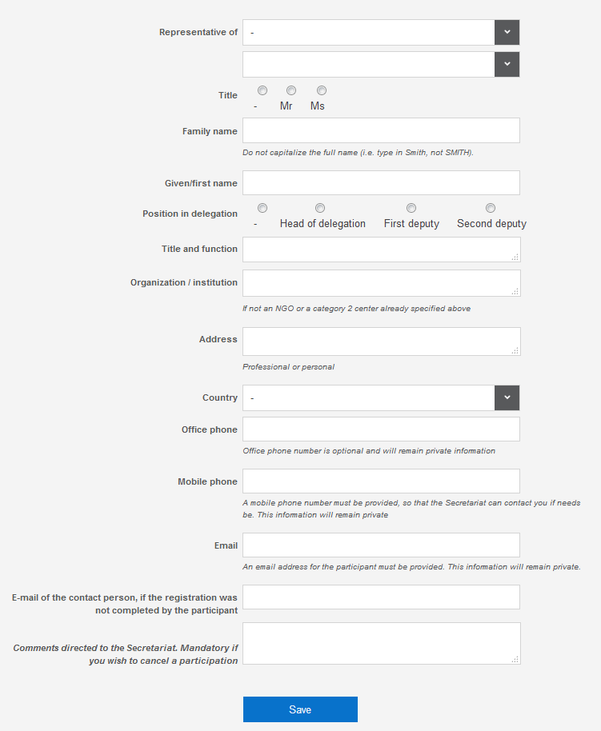

ANNEX B VISA REQUIREMENT BY COUNTRY
S/No | Country | Requirement
1 | Afghanistan | Visa required prior to travel.
2 | Albania | Visa for sixty days on arrival.
3 | Algeria | Visa for two weeks on arrival.
4 | Andorra | Visa for sixty days on arrival.
5 | Angola | No visa required.
6 | Antigua and Barbuda | No visa required.
7 | Argentina | No visa required.
8 | Armenia | Visa for sixty days on arrival.
9 | Australia | No visa required.
10 | Austria | No visa required.
11 | Azerbaijan | Visa for sixty days on arrival.
12 | Bahamas | No visa required.
13 | Bahrain | No visa required.
14 | Bangladesh | Visa required prior to travel.
15 | Barbados | No visa required.
16 | Belarus | Visa for sixty days on arrival.
17 | Belgium | No visa required.
18 | Belize | No visa required.
19 | Benin | No visa required.
20 | Bhutan | Visa for sixty days on arrival.
21 | Bolivia (Plurinational State of) | Visa for sixty days on arrival.
22 | Bosnia and Herzegovina | Visa for sixty days on arrival.
23 | Botswana | No visa required.
24 | Brazil | No visa required.
25 | Brunei Darussalam | No visa required.
26 | Bulgaria | No visa required.
27 | Burkina Faso | Visa for sixty days on arrival.
28 | Burundi | No visa required.
29 | Cambodia | Visa for sixty days on arrival.
30 | Cameroon | Visa for sixty days on arrival.
31 | Canada | No visa required.
32 | Cape Verde | No visa required.
33 | Chad | No visa required.
34 | Chile | No visa required.
35 | China | No visa required.
36 | Colombia | Visa for sixty days on arrival.
37 | Comoros | Visa for two weeks on arrival.
38 | Congo | No visa required.
39 | Central African Rep. | Visa for sixty days on arrival.
40 | Democratic Rep. of the Congo | No visa required.
41 | Costa Rica | Visa for sixty days on arrival.
42 | Cote D’Ivoire (Ivory Coast) | Visa for sixty days on arrival.
43 | Croatia | No visa required.
44 | Cuba | Visa for sixty days on arrival.
45 | Cyprus | No visa required.
46 | Czechia | No visa required.
47 | Denmark | No visa required.
48 | Djibouti | Visa for sixty days on arrival.
49 | Dominica | No visa required.
50 | Dominican Republic | Visa for sixty days on arrival.
51 | Ecuador | Visa for sixty days on arrival.
52 | Egypt | No visa required.
53 | El Salvador | Visa for sixty days on arrival.
54 | Equatorial Guinea | Visa for sixty days on arrival.
55 | Eritrea | Visa for sixty days on arrival.
56 | Estonia | No visa required.
57 | Eswatini | No visa required.
58 | Ethiopia | Visa for sixty days on arrival.
59 | Fiji | No visa required.
60 | Finland | No visa required.
61 | France | No visa required.
62 | Gabon | No visa required.
63 | Gambia | No visa required.
64 | Georgia | No visa required
65 | Germany | No visa required.
66 | Ghana | No visa required.
67 | Greece | No visa required.
68 | Grenada | No visa required.
69 | Guatemala | Visa for sixty days on arrival.
70 | Guinea | Visa for sixty days on arrival.
71 | Guinea Bissau | Visa for sixty days on arrival.
72 | Guyana | No visa required.
73 | Haiti | Visa for sixty days on arrival.
74 | Honduras | Visa for sixty days on arrival.
75 | Hungary | No visa required.
76 | Iceland | No visa required.
77 | India | No visa required.
78 | Indonesia | Visa for sixty days on arrival.
79 | Iran (Islamic Republic of) | Visa required prior to travel.
80 | Iraq | Visa required prior to travel.
81 | Ireland | No visa required.
82 | Israel | No visa required.
83 | Italy | No visa required.
84 | Jamaica | No visa required.
85 | Japan | No visa required.
86 | Jordan | Visa for sixty days on arrival.
87 | Kazakhstan | Visa for sixty days on arrival.
88 | Kenya | No visa required.
89 | Kiribati | No visa required.
90 | Korea (Republic of) | No visa required.
91 | Korea (Democratic People’s Republic of) | Visa required prior to travel.
92 | Kuwait | No visa required.
93 | Kyrgyzstan | Visa for sixty days on arrival.
94 | Lao People’s Democratic Republic | Visa required prior to travel.
95 | Latvia | No visa required.
96 | Lebanon | Visa for sixty days on arrival.
97 | Lesotho | No visa required.
98 | Liberia | Visa for sixty days on arrival.
99 | Libya | Visa required prior to travel.
100 | Liechtenstein | No visa required.
101 | Lithuania | No visa required.
102 | Luxemburg | No visa required.
103 | Macedonia (The former Yugoslav Rep. of) | Visa for sixty days on arrival.
104 | Madagascar | Visa for two weeks on arrival.
105 | Malawi | No visa required.
106 | Malaysia | No visa required.
107 | Maldives | No visa required.
108 | Mali | Visa required prior to travel.
109 | Malta | No visa required.
110 | Marshall Island | Visa for sixty days on arrival.
112 | Mauritania | Visa for sixty days on arrival.
113 | Mexico | No visa required.
114 | Micronesia | Visa for sixty days on arrival.
115 | Moldova (Republic of) | Visa for sixty days on arrival.
116 | Monaco | No visa required.
117 | Mongolia | Visa for sixty days on arrival.
118 | Montenegro | Visa for sixty days on arrival.
119 | Morocco | Visa for sixty days on arrival.
120 | Mozambique | No visa required.
121 | Myanmar | Visa for two weeks on arrival.
122 | Namibia | No visa required.
123 | Nauru | No visa required.
124 | Nepal | Visa for sixty days on arrival.
125 | Netherlands | No visa required.
126 | New Zealand | No visa required.
127 | Nicaragua | Visa for sixty days on arrival.
128 | Niger | Visa for sixty days on arrival.
129 | Nigeria | Visa for two weeks on arrival.
130 | Norway | No visa required.
131 | Oman | No visa required.
132 | Pakistan | Visa required prior to travel.
133 | Palau | Visa for sixty days on arrival.
134 | Palestine | Visa required prior to travel.
135 | Panama | Visa for sixty days on arrival.
136 | Papua New Guinea | No visa required.
137 | Paraguay | No visa required.
138 | Peru | Visa for sixty days on arrival.
139 | Philippines | Visa for sixty days on arrival.
140 | Poland | No visa required.
141 | Portugal | No visa required.
142 | Qatar | No visa required.
143 | Romania | No visa required.
144 | Rwanda | No visa required.
145 | Russian Federation | No visa required.
146 | Saint Kitts and Nevis | No visa required.
147 | Saint Lucia | No visa required.
148 | Saint Vincent and the Grenadines | No visa required.
149 | Samoa | No visa required.
150 | San Marino | No visa required.
151 | Sao Tome and Principe | Visa for sixty days on arrival.
152 | Saudi Arabia | No visa required.
153 | Senegal | Visa for sixty days on arrival.
154 | Serbia | Visa for sixty days on arrival.
155 | Seychelles | No visa required.
156 | Sierra Leone | No visa required.
157 | Singapore | No visa required.
158 | Slovakia | No visa required.
159 | Slovenia | No visa required.
160 | Solomon Islands | No visa required.
161 | Somalia | Visa required prior to travel.
162 | South Africa | No visa required.
163 | South Sudan | Visa required prior to travel.
164 | Spain | No visa required.
165 | Sri Lanka | Visa for sixty days on arrival.
166 | Sudan | Visa required prior to travel.
167 | Suriname | No visa required.
168 | Sweden | No visa required.
169 | Switzerland | No visa required.
170 | Syrian Arab Republic | Visa required prior to travel.
171 | Tajikistan | Visa for sixty days on arrival.
172 | Tanzania (United Republic of) | No visa required.
173 | Thailand | Visa for sixty days on arrival.
174 | Timor Leste | Visa for sixty days on arrival.
175 | Togo | Visa for sixty days on arrival.
176 | Tonga | No visa required.
177 | Trinidad and Tobago | No visa required.
178 | Tunisia | No visa required.
179 | Turkey | No visa required.
180 | Turkmenistan | Visa for sixty days on arrival.
181 | Tuvalu | No visa required.
182 | Uganda | No visa required.
183 | Ukraine | No visa required.
184 | United Arab Emirates | No visa required.
185 | United Kingdom | No visa required.
186 | United States of America | No visa required.
187 | Uruguay | Visa for sixty days on arrival.
188 | Uzbekistan | Visa for sixty days on arrival.
189 | Vanuatu | No visa required.
190 | Vatican | No visa required.
191 | Venezuela | Visa for sixty days on arrival.
192 | Vietnam | Visa for sixty days on arrival.
193 | Yemen | Visa required prior to travel.
194 | Zambia | No visa required.
195 | Zimbabwe | No visa required.

ANNEX C VISA APPLICATION FORM (Click to download the form)
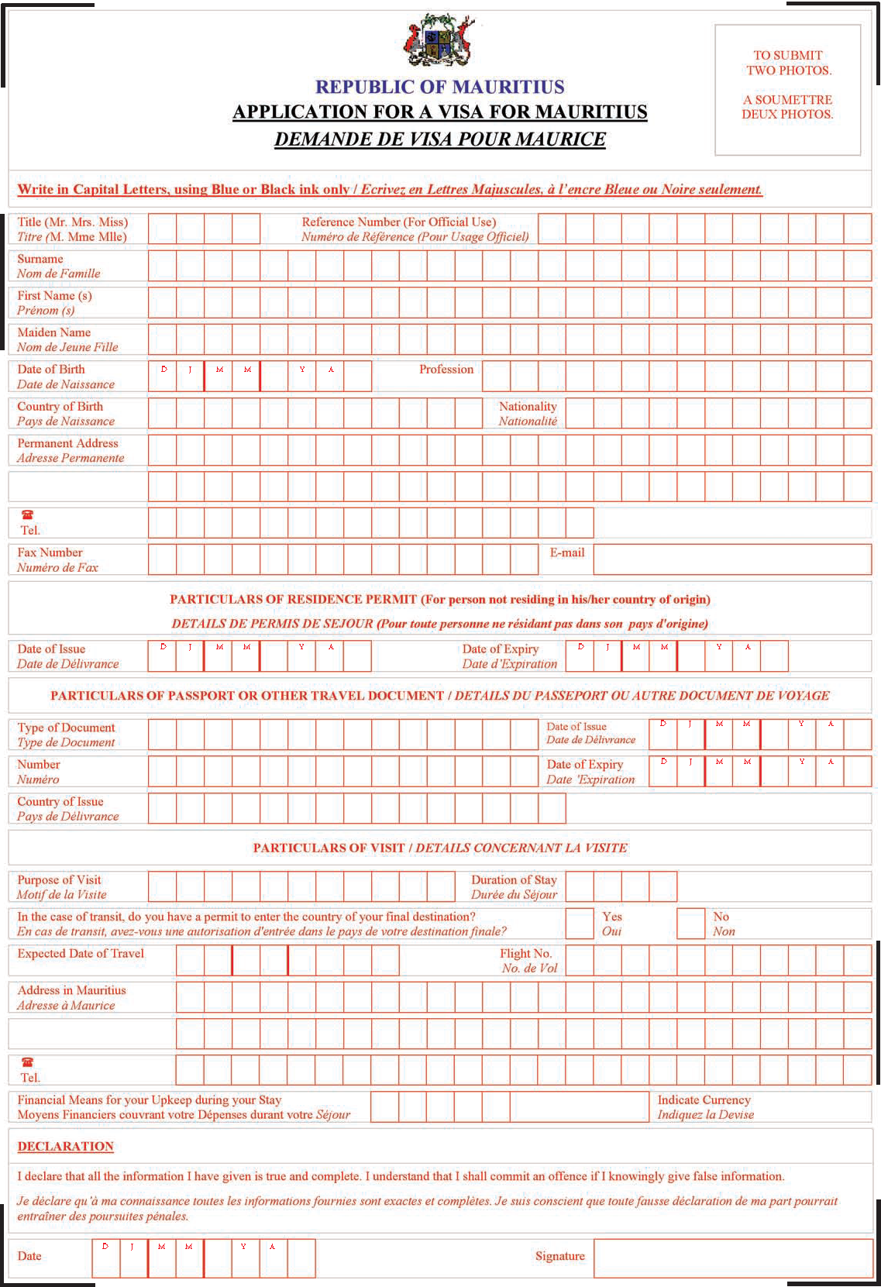

ANNEX D RECOMMENDED HOTELS
Please note that shuttle busses to and from the Swami Vivekananda International Convention Centre (SVICC) will be provided only at the hotels included in the list below. Any delegate wishing to seek alternative accommodation options will have to make their own transport arrangements.
NORTH
LE MERIDIEN – 4*
265 rooms. Overlooking Andes Mountains and the Indian Ocean, the unique 4-star Le Meridien Ile Maurice Hotel offers a tennis court, a sauna and a nightclub. Founded in 1998, the hotel underwent a renovation in 2003.The property lies within 11 km from Caudan Waterfront. The venue is near to the sandy beach with parasols and sun loungers. There are shopping centers and commercial centers in the proximity of the hotel.
14.2 km from the Swami Vivekananda International Convention Centre
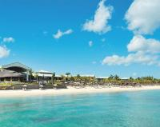 | Address: Village Hall Lane, Pointe aux Piments  Tel: (230) 204 3333  Website: http://www.lemeridien-mauritius.com/  Sale Specialist: Ms Kavita Ramchurn  E-mail: kavitaramchurn@starwoodhotels.com  Tel: (230) 204 3360 / (230) 5973 4719
THE WESTIN TURTLE BAY RESORT AND SPA – 5*
190 rooms. Facing the Turtle Bay marine park, this luxury resort is 10 km from the Mauritius National Botanical Garden and 13 km from the capital city Port Louis. Spread over 10 hectares, The Westin Turtle Bay Resort & Spa Mauritius is replete with captivating views and sparkling amenities. The resort offers a number of activities to guide you on your path towards rejuvenation.
12.4 km from the Swami Vivekananda International Convention Centre
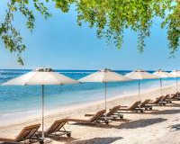 | Address: Balaclava, Turtle Bay  Tel: (230) 204 1400  E-mail: westin.mauritius@westin.com  Website: http://www.westinturtlebaymauritius.com/  Sales Specialist: Ms Kavita Ramchurn  E-mail: kavitaramchurn@starwoodhotels.com  Tel: (230) 204 3360/ (230) 5973 4719
ZILWA ATTITUDE – 4*
214 rooms. In the Creole language Zilwa means an “islander”. Zilwa Attitude is the first hotel boasting a Creole name in Mauritius. Zilwa Attitude is different and unique with its Mauritian concept and invites all guests to discover the legendary genuineness of this little paradise. Situated on the north coast of Mauritius, in Kalodyne, close to the fishermen’s village of Grand Gaube, this 4* hotel is a “hymn” to Mauritius.
32.6 km from the Swami Vivekananda International Convention Centre
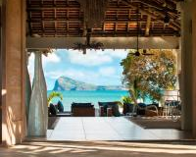 |  | Address: Calodyne sur Mer, Grand Gaube  Tel: (230) 204 8800  Email: info@hotels-attitude.com  Website: https://hotels-attitude.com/en/zilwa-attitude/  Key Accountant Manager: Ms Sheetal Kalisaran  E-mail: sheetal.kalisaran@hotels-attitude.com  Tel: (230) 204 3800
RÉCIF ATTITUDE – 3*
70 rooms. Situated in the north-west of Mauritius, Récif Attitude is an adult exclusive hotel, a must if you want to go back to essentials, to recharge your batteries, to spend time together as a couple or with friends. Nested in a white sandy creek overlooking a beautiful natural marine reserve, Récif Attitude is an invitation to farniente.
22.6 km from the Swami Vivekananda International Convention Centre
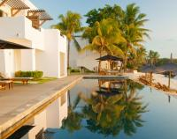 |  | Address: Calodyne sur Mer, Grand Gaube  Tel: (230) 261 0444  Email: info@hotels-attitude.com  Website: https://hotels-attitude.com/en/recif-attitude/  Reservation Manager: Ms Sheetal Kalisaran  E-mail: sheetal.kalisaran@hotels-attitude.com  Tel: (230) 261 0444 / (230) 204 3800
SENSIMAR LAGOON MAURITIUS – 4*
182 rooms. Situated along the north coast of Mauritius, Sensimar Lagoon, nestled in a beautiful tropical garden, overlooks the very wide lagoon of Anse la Raie and the northern islands. Its typically Mauritian architecture merges harmoniously into the surrounding nature.
33.3 km from the Swami Vivekananda International Convention Centre
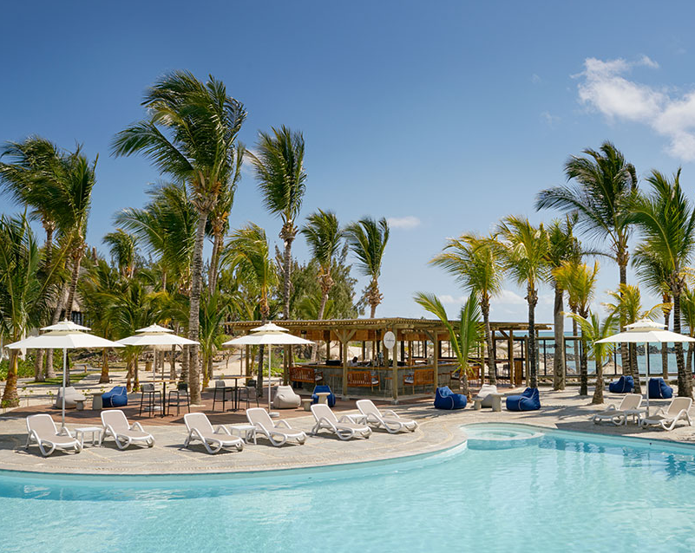 |  | Address: Coastal Road, Saint-François  Tel: (230) 204 8800  E-mail: admin@sensimar-mauritius.com  Website: http://sensimar-mauritius.com/en  Key Accountant Manager: Ms Sheetal Kalisaran  E-mail: sheetal.kalisaran@hotels-attitude.com  Tel: (230) 204 3800
THE RAVENALA ATTITUDE – 4*
272 rooms. In Balaclava, on the north-west coast of Mauritius, nicely tucked away between sea and river in the middle of a luxuriant and exotic garden, the 4-star hotel The Ravenala Attitude is an invitation to a dream voyage. A good mix of colonial heritage and contemporary design with tropical accents and genuine Mauritian art de vivre. No boundaries, inside and outside flow harmoniously into each other.
12.8 km from the Swami Vivekananda International Convention Centre
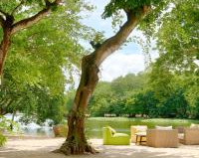 | Address: Turtle Bay, Balaclava  Tel: (230) 204 3000  E-mail: info@hotels-attitude.com  Website: https://hotels-attitude.com/en/the-ravenala-attitude/  Key Accountant Manager: Ms Sheetal Kalisaran  E-mail: sheetal.kalisaran@hotels-attitude.com  Tel: (230) 204 3800
LUX* Grand Gaube – 5*
186 rooms. Amidst lush tropical gardens, LUX* Grand Gaube is enveloped by undulating coves, the calmest of lagoons and is blessed with two tranquil beaches and two spectacular swimming pools. A global culinary journey leads to live cooking stations at the Palm Court, Peruvian and Argentinian cuisine at INTI, authentic Creole flavours at Banyan and a Turkish twist at Bodrum Blue.
35.1 km from the Swami Vivekananda International Convention Centre
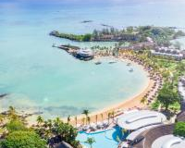 |  | Address: Coastal Road, Grand Gaube 30617  Tel: (230) 204 9191 Fax: (230) 288 2828  Email: reservation@luxresorts.com  Website: https://www.luxresorts.com/en/hotel-mauritius/luxgrandgaube  Head of sales & Marketing: Ms Jenna Perrier  E-mail: jenna.perrier@luxgrandgaube.com  Tel: (230) 5 258 04 03/ (230) 204 91 91
MERVILLE BEACH, Grand Baie – 3*
169 rooms. On a private white sand beach, this hotel is less than one kilometer from Grand Baie. It has an outdoor pool with lagoon views, and offers air-conditioned guest rooms with balconies.
23.7 km from the Swami Vivekananda International Convention Centre
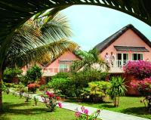 |  | Address: Grand Baie  Tel: (230) 209 2200 Fax: (230) 263 8146  E-mail: reservation@luxresorts.com  Website: http://www.mervillebeach.com/  Head of sales & Marketing: Ms Jenna Perrier  E-mail: jenna.perrier@luxgrandgaube.com  Tel: (230) 5 258 04 03/ (230) 204 91 91
LABOUDONNAIS WATERFRONT HOTEL – 5*
105 rooms. As the only 5-star business hotel in Mauritius, the Labourdonnais Waterfront Hotel exudes refinement and exclusivity. With its precise service and luxurious comfort, the Labourdonnais Waterfront Hotel combines a subtle blend of timeless elegance with Mauritian art de vivre. The Hotel has a total of 105 elegant, chic and luxurious guest rooms including and suites with gorgeous harbour and marina views.
4 km from the Swami Vivekananda International Convention Centre
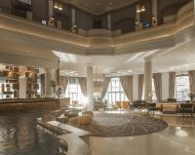 | Address: Caudan Waterfront, PO Box 91, Port Louis  Tel: (230) 202 4000 Fax: (230) 202 4040  E-mail: reservations@indigohotels.com  Website: http://www.labourdonnais.com/  Sales executive: Ms Isabelle Boissezon  E-mail: sales@indigohotels.com  Tel: (230) 202 4003
LE SUFFREN HOTEL & MARINA – 4*
102 rooms. Le Suffren Hotel & Marina, offers both business travellers and holiday makers alike a sparkling and dynamic 4-star hotel in the capital city of Mauritius. Le Suffren is perfectly positioned on the Waterfront to take full advantage of everything that Mauritius has to offer, whether it’s taking care of business in Port Louis, or taking time out to discover the unspoilt beauty of our island.
4 km from the Swami Vivekananda International Convention Centre (SVICC)
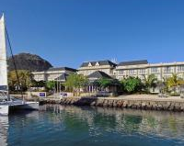 | Address: Le Caudan, PO Box 91, Port Louis  Tel: (230) 202 4900 Fax: (230) 211 9411  E-mail: reservations@lesuffrenhotel.com  Website: http://www.lesuffrenhotel.com/  Sales executive: Ms Isabelle Boissezon  E-mail: sales@indigohotels.com  Tel: (230) 202 4003
THE ADDRESS BOUTIQUE HOTEL – 4*
42 rooms. The Address Boutique Hotel is a 4 star venue, offering business travelers and vacationers alike, an atypical cosy ‘pied à terre’ with cosmopolitan experience. In keeping with its “boutique” spirit, the atmosphere is warmly welcoming and casual. The service, thoughtful and personalized, makes each client the center of privileged attention.
10.1 km from the Swami Vivekananda International Convention Centre
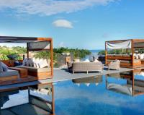 | Address: Terre Rouge, Port Chambly  Tel (230) 405 3000 Fax (230) 405 3001  E-mail: reservations@addressboutiquehotel.com  Website: http://www.addressboutiquehotel.com/  Sales executive: Ms Isabelle Boissezon  E-mail: sales@indigohotels.com  Tel: (230) 202 4003
MARITIM RESORT & SPA MAURITIUS – 5*
212 rooms. Exhibiting all the pleasures of a tropical island hotel resort, each of our 212 stylish rooms, suites and exclusive villa has a private sea view balcony or terrace on the Turtle Bay coastline. Inviting, modern, spacious and yet cozy, Maritim Resort & Spa Mauritius boasts a choice of rooms and suites, meticulously designed to the highest standards both aesthetically and in terms of soothing comfort equipped to suit the needs of leisure or business travelers.
12.4 km from the Swami Vivekananda International Convention Centre
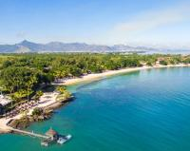 | Tel: (230) 204 1000 Fax: (230) 204 1020  E-Mail: info.mau@maritim.com  Website: http://www.maritimresortandspa.mu/  Senior Reservation Manager: Ms Chitra Mungra  E-mail: revervierung.mau@maritim.com/ maunotes.mau@maritim.com  Tel: (230) 204 1009 / (230) 204 1010
INTERCONTINENTAL MAURITIUS RESORT BALACLAVA FORT – 5*
210 rooms. Nestled in tropical gardens on the shores of the Bay Balaclava, InterContinental Mauritius Resort Balaclava Fort offers accommodation alongside a white-sand beach. Overlooking the Indian Ocean, InterContinental Mauritius Resort Balaclava Fort features a spa and 2 swimming pools.
11.6 km from the Swami Vivekananda International Convention Centre
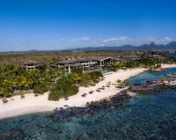 | Address: Balaclava Fort, Coastal Road, Balaclava  Tel: (230) 261 1200 Fax: (230) 261 1201  E-mail: info.icmauritius@ihg.com / reservations.icmauritius@ihg.com  Website: http://mauritius.intercontinental.com/  Director of Marketing &Sales: Mr Jiri Benes  E-mail: jiri.Benes@ihg.com  Tel: (230) 5252 7918 / (230) 261 1165
BEACHCOMBER (Trou Aux Biches) – 5*
306 rooms. Accommodation is housed in lavish chalet-style suites built in crescents while private villas are tucked among the lush tropical gardens. With an emphasis on environmental preservation, Trou aux Biches Beachcomber Golf Resort & Spa is the first eco-friendly resort in Mauritius, while providing the latest in luxury focusing on privacy, space and diversity.
19.2 km from the Swami Vivekananda International Convention Centre
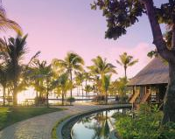 | Address: Royal Trou aux Biches, Triolet 22302  Tel: (230) 204 6800 Fax: (230) 204 6900  E-mail: trouauxbiches@beachcomber.com  Website: https://www.beachcomber-hotels.com/en/hotel/trou-aux-biches-golf-resort-spa  Mice Coordinator: Ms Marie-Christine Constantin  E-mail: incentives@beachcomber.com  Tel: (230) 601 9286 Fax: (230) 601 9090
BEACHCOMBER (Victoria) – 4*
254 rooms. Renowned for its spacious sea-facing rooms, a laid-back atmosphere and a wide range of activities for both children and teenagers, the hotel encompasses a lifestyle to appeal to all ages.
22 km from the Swami Vivekananda International Convention Centre
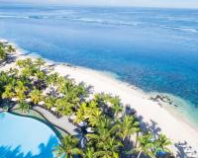 |  | Address: Pointe aux Piments 21304  Tel: (230) 204 2000  Fax: (230) 204 2200  E-mail: victoria@beachcomber.com  Website: https://www.beachcomber-hotels.com/en/hotel/victoria-resort-spa  Mice Coordinator: Ms Marie-Christine Constantin  E-mail: incentives@beachcomber.com  Tel: (230) 601 9286 Fax: (230) 601 9090
BEACHCOMBER (Canonnier) – 4*
284 rooms. Bearing testimony to the island’s historical past are ruins of a lighthouse and fortress blending seamlessly into the tropical gardens. A wide variety of land and water sports is on offer. A unique feature of the resort is its Spa built in the branches of a banyan tree where therapists soothe body and mind.
27.9 km from the Swami Vivekananda International Convention Centre
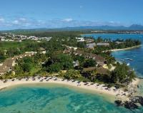 |  | Address: Coastal Road, Pointe aux Canonniers, Grand Baie 30522  Tel: (230) 209 7000 Fax: (230) 209 7900  E-mail: canonnier@beachcomber.com  Website: https://www.beachcomber-hotels.com/en/hotel/canonnier-golf-resort-spa  Mice Coordinator: Ms Marie-Christine Constantin  E-mail: incentives@beachcomber.com  Tel: (230) 601 9286 Fax: (230) 601 9090
BEACHCOMBER (Mauricia) – 4*
237 rooms. Mauricia Beachcomber Resort & Spa also features a lovely spa. Evoking a serene oasis, it has cabins designed to resemble nomadic tents, cleverly designed around a shaded pool. A range of land and water sports is on hand.
22.8 km from the Swami Vivekananda International Convention Centre
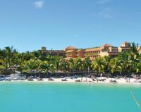 |  | Address: Royal Road, Grand Baie 30512  Tel: (230) 209 1100 Fax: (230) 209 1600  E-mail: mauricia@beachcomber.com  Website: https://www.beachcomber-hotels.com/en/hotel/mauricia-resort-spa  Mice Coordinator: Ms Marie-Christine Constantin  E-mail: incentives@beachcomber.com  Tel: (230) 601 9286 Fax: (230) 601 9090
WEST
LE PALMISTE RESORT & SPA – 3*
81 rooms. Located in the North West of Mauritius, Le Palmiste features an exotic garden, only 150 m away from the beach. It offers an outdoor pool, spa facilities, and free Wi-Fi. Le Palmiste Resort & Spa has air-conditioned rooms with wooden furniture. All rooms have tiled floors and balconies overlooking the garden or the pool.
18.5 km from the Swami Vivekananda International Convention Centre
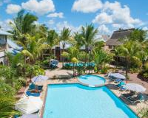 | Address: Route Cotière, Trou-aux-Biches  Tel: (230) 265 6815 Fax: (230) 265 6811  Email: info@hotel-lepalmiste.mu  Website: http://www.hotel-lepalmiste.mu/  Kajal Rampol, Reservation Clerk  E-mail: info@hotel-lepalmiste.mu / resa2@hotel-lepalmiste.mu / reservation@hotel-lepalmiste.mu  Tel: (230) 265 6815
CENTRAL PLATEAU
PALMS HOTEL (Quatre Bornes) – 3*
48 rooms. Located within 1.1 km of Trianon Shopping Park, Palms Hotel in Quatre Bornes has a number of amenities including a bar. Among the facilities of this property are a restaurant, a 24-hour front desk and an ATM, along with free WiFi. Guests can enjoy city views.
7.6 km from the Swami Vivekananda International Convention Centre
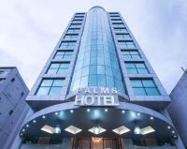 | Address: 66, St Jean Road, Quatre Bornes 742CU001  Tel: (230) 465 7575  Fax: (230) 467 7912  E-mail: info@palmshotelmauritius.com  Website: http://www.palmshotelmauritius.com  Karishma Ramlochun, Hotel Manager  E-mail: finance@palmshotelmauritius.com  reservations@palmshotelmauritius.com  Tel: (230) 465 7581 Mob: (230) 5256 4216
HENNESSY PARK HOTEL – 4*
108 rooms. The Hennessy Park Hotel, located in the heart of the bustling Ebene City is emerging with a brand new soul that pervades the whole place right from the lobby, social spaces, accommodation to the dining facilities. Art has always been a hallmark of the Hennessy Park Hotel with a variety of events and happenings all year round.

5.1 km from the Swami Vivekananda International Convention Centre
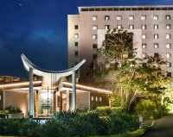 | Address: 65, Ébène Cybercity, Ébène  Tel: (230) 403 7200  Fax: (230) 403 7201  E-mail: reservations@hennessyhotel.com  Website: http://www.hennessyhotel.com/  Sales executive: Ms Isabelle Boissezon  E-mail: sales@indigohotels.com  Tel: (230) 202 4003
VOILA BAGATELLE – 3*
118 rooms. The 3-star Voila Bagatelle Hotel offers fine accommodation in Mauritius. The budget hotel in Mauritius attracts guests with its art deco architecture. The hotel is set in a convenient location 7 km away from Port Louis. Voila Bagatelle Hotel is connected with other parts of Mauritius due to a port located nearby.
3.1 km from the Swami Vivekananda International Convention Centre
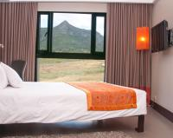 | Address: Bagatelle Mall of Mauritius, PO Box 30, Réduit  Tel: (230) 4068000  E-mail: hello@voilahotel.mu  Website: http://www.voilahotel.mu/  Sales Marketing Manager: Ms Beatrice Fabre  E-mail: bfabre@voilahotel.mu  Tel: (230) 406 8024 / (230) 5499 3860

