Case study 39

Indonesian batik

Batik
Inscribed in 2009 on the Representative List of the Intangible Cultural Heritage of Humanity

What is batik-making?
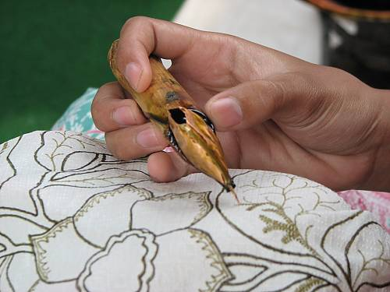
Batik-making represents an element of ICH in Indonesia (as well as other countries in the region). Artisans draw designs on fabric using dots and lines of hot wax, which resists vegetable and other dyes. This technique allows selective colouring by soaking the cloth in one colour, removing the wax with boiling water and repeating if multiple colours are desired. For centuries, batik fabrics have been made using the traditional method of ‘writing’ on the fabric with wax using special pens – this technique is now known as batik tulis. In the industrial age, new ways of making batik such as batik cap (using copper plate stamps) and batik print have emerged.
© Batik Museum Institute, Pekalongan, 2008
Designs and motifs show regional variation, but also reflect a variety of influences, incorporating Arabic calligraphy, European bouquets and Chinese phoenixes to Japanese cherry blossoms and Indian or Persian peacocks.
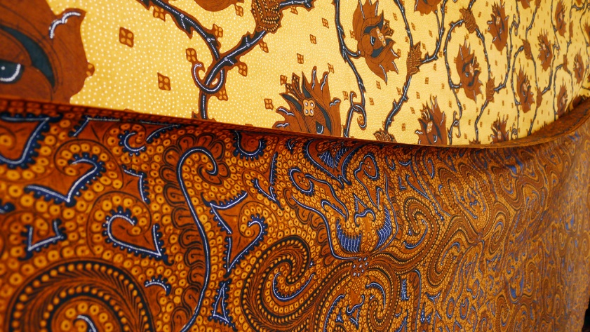
In Indonesia, traditionally, batik was sold in 2.25-metre lengths used for kain panjang or sarong for kebaya dress. It can also be worn by wrapping it around the body, or made into a hat known as blangkon.
Whereas until recently batik was mainly worn by older people for formal occasions, after the inscription of the element on the Representative List, it has become increasingly popular as every day and office wear. Policies in government and some private companies require employees to wear batik outfits every Friday. This has resulted in increased demand both for traditionally-made batiks and for cheaper printed versions.
Stephen Kennedy, 2011

What does batik mean to the communities concerned?
The craft and use of batik is intertwined with the cultural identity of many groups of Indonesians, expressing their creativity and spirituality. The symbolism and cultural practices surrounding batik permeate their lives: infants are carried in batik slings decorated with symbols designed to bring luck, and the dead are shrouded in funerary batik. Clothes with everyday designs are worn regularly in business and academic settings, while special items are incorporated into celebrations of marriage and pregnancy, into puppet theatre and other art forms. The garments also play a central role in local rituals, such as the reported ceremonial casting of royal batik into a volcano.

How is the viability of batik-making threatened and how is it best safeguarded, now and in the future?
The market for traditionally-made batik cloth has been affected by commercial printing processes, and many of these skills are being lost. Some batik patterns are now simply printed onto fabric in a factory. New formal and informal methods of teaching batik and raising awareness about it have revived interest in learning the skill.
There is not a large demand for the special tools used for making batik. Efforts have been made to support craftspeople who make these tools, such as the canting, and to provide them with a market for their products.
Batik craftspeople traditionally hand down their knowledge and skills within families. Today, although they make many of the traditional designs, batik craftspeople have been unable to reproduce all the batik designs used in the past. Batik museums can showcase older designs that can be copied by craftspeople today and they can also serve as venues for the teaching of batik-making skills.
Some batik heritage campaigners have suggested that making products such as handbags using vintage cotton batik tulis destroys batik heritage. Batik cloth glued to products such as bags wears out very quickly, and the products do not do justice to it because they show only one side of the fabric (traditional batik is printed on both sides). Designer bags usually combine the cotton fabric of the batik with other materials such as leather, which pucker the cotton, and glue used in the production process also spoils the fabric. The campaigners suggest using industrially-produced batik for such products. Others go further, saying that it is better to purchase, display and use batik tulis only in their ‘whole long-cloth glorious 2 meters x 1 meter form’.

Questions
- What different kinds of policies in the culture sector would promote the following actions: (a) conserving old batik cloth, (b) developing new products from batik and (c) safeguarding batik-making skills?
- What is the most important aspect of batik from the perspective of museums, cultural industries, and ICH safeguarding policies?
- What might be the tensions between these policy approaches? Consider for example the following:
- Traditionally-made royal batik has to be thrown into a volcano as part of a ritual: this destroys the cloth: how does it affect batik-making as ICH?
- How does making new products from old batik cloth affect conservation strategies for vintage cloth, and safeguarding strategies for ICH associated with batik-making?
- What synergies could be found between approaches that prioritise conservation of old batik cloth, the promotion of cultural industries around batik, and the safeguarding of the ICH associated with batik-making?

Further information
  - Inscription on the Representative List http://www.unesco.org/culture/ich/RL/00170
  - Wikipedia article on Batik https://en.wikipedia.org/wiki/Batik
  - ‘Save the batik’ website http://extinctbatiktulis.blogspot.co.nz/
  - Marshall Clark, Juliet Pietsch, Indonesia-Malaysia Relations: Cultural Heritage, Politics and Labour Migration. Routledge: 2014.
Photos
- © Batik Museum Institute, Pekalongan,2008 https://ich.unesco.org/en/RL/indonesian-batik-00170
- "Batik” [https://www.flickr.com/photos/shkizzle/5948832135/in/photolist-a4Fjxi-9dHG2p-bMf4Da-5dWkzi-3zER6-9D9S21-5ukxZx-2cdQsf-DKo4jF-767e-65ShX-a7x4yx-yzULW-6yyeo3-yzV2J-EfCWvo-EfDyk9-37JSFY-azygSX-4A6L4U-95Fvqb-4hF3D3-34dLZq-7iWJgS-7JECFH-7yysoV-92N84n-8Uw5r-5AK2u1-8ykjFZ-4mVsJv-7PgEWm-sgCAv-7Hq9Fb-8ykjNF-7HmeZ6-cHUrS-4RoN77-iKpjs-bqASnZ-aZb51i-bqATwT-8FRJu-7Hqaz3-4ZSEMu-dQefta-5ow8QW-47x3Vb-7VFnff-21qrA2m] by Stephen Kennedy [https://www.flickr.com/photos/shkizzle/] is licensed under CC BY 2.0 [https://creativecommons.org/licenses/by/2.0/]

