UNIt 61

filling out the online form
Published in 2019 by the United Nations Educational, Scientific and Cultural Organization, 7, place de Fontenoy, 75352 Paris 07 SP, France
© UNESCO 2019
This publication is available in Open Access under the Attribution-ShareAlike 3.0 IGO (CC-BY-SA 3.0 IGO) license (http://creativecommons.org/licenses/by-sa/3.0/igo/). By using the content of this publication, the users accept to be bound by the terms of use of the UNESCO Open Access Repository (http://www.unesco.org/open-access/terms-use-ccbysa-en).
The images of this publication do not fall under the CC-BY-SA licence and may not be used, reproduced, or commercialized without the prior permission of the copyright holders.
The designations employed and the presentation of material throughout this publication do not imply the expression of any opinion whatsoever on the part of UNESCO concerning the legal status of any country, territory, city or area or of its authorities, or concerning the delimitation of its frontiers or boundaries.
The ideas and opinions expressed in this publication are those of the authors; they are not necessarily those of UNESCO and do not commit the Organization.

Lesson Plan

DURATION
3 hours 25 minutes

Objectives:
Familiarize participants with the online form for periodic reporting, how to navigate it and how to fill out the different sections. Provide participants practical experience of using the online form, including the various question forms, selection of questions to respond to, and how to identify national baselines and targets.

Description:
This unit presents the ‘architecture’ of the online form and its different sections. It introduces the various question types and prompts, providing advice on how each section can be filled out. In view of the vast differences between the realities and experiences in each country and region, this is not prescriptive but rather offers guidance on the possible responses that may be provided. Participants will have the opportunity to work on each section of the form in a group exercise and will then discuss and evaluate their performance, noting potential challenges and ways of addressing these. If time permits, participants will also practice filling out different examples from each section in plenary on the computer.

SEQUENCE OF SESSIONS:
Session 1: Architecture of the online form (20 minutes): This session comprises a short overview by the facilitator on the architecture of the form, which is reinforced by providing a summary version of the form in Handout 1.
Session 2: Different question types and how to answer them (40 minutes): This session presents the different types of questions asked in the form and the nature of the responses required. Some representative questions from form ICH-10 are used as the basis for discussion. The participants will have the opportunity to practice answering each question type and share their ideas.
Session 3: Hands-on experience of filling out the form (1) (40 minutes): The participants will work in groups to respond to one or two questions from each section of form ICH-10. They will share and analyse their experiences and suggest useful strategies and potential pitfalls in plenary.
Session 4: Hands-on experience of filling out the form (2) (1 hour and 45 minutes): The participants will work in plenary with the facilitator on one or two further questions from each section of the form. If possible, this can be done using a computer and projector so that the responses can be filled out in real time.

Supporting documents:
- Facilitator’s notes Unit 61
- PowerPoint presentation Unit 61
- Participant’s text Unit 61
- Handout 1 Unit 61 Question types in the periodic reporting form
- Glossary found in Participants Text Unit 57
- Guidance notes

Facilitator’s Narrative

Session 1: architecture of the online form
Estimated time: 20 minutes
The facilitator presents a brief overview of the architecture of the form, which is reinforced by providing a summary version of the online form in the participants’ notes.

SLIDE 2

Overview of the online periodic reporting tool - Section A:
Section A of the online reporting tool asks for more general information concerning the reporting State Party (including the national Focal Point), the overall institutional arrangements for ICH safeguarding, internationally inscribed elements (Urgent Safeguarding List/Representative List) and programmes (Register of Good Safeguarding Practices), programmes benefiting from international assistance, national inventories and synergies between implementation of the 2003 Convention with other UNESCO programmes and treaties.
A.3: Institutions and organizations involved in the preparation of the periodic report: It should be noted that the range of non-governmental actors and stakeholders mentioned here is broader than those mentioned in the ODs and include, for example, universities, museums, NGOs, municipalities, local governments, charitable bodies, and private sector entities. It also leaves open the possibility of others not listed that may be relevant in the reporting country, which could be religious institutions or tribal councils, for example; States Parties are requested to specify these.
A.6: Inventories: It is important also to note that questions relating to the process of inventorying that can be found in Section B (Indicators 7 & 8). With regard to information on national inventories, this is designed to retain the useful information set that used to be provided in Section B.2 of the original form ICH-10 and in recognition of the fundamental importance of inventorying as a safeguarding measure. In some cases, further detail is requested in Section B (Indicators 7 & 8) regarding the existence of a specialized inventory or an inventory of specific scope (further detail in section 7.2); whether access to the inventory is facilitated while respecting customary practices governing access to specific aspects of ICH (section 7.4); whether communities, groups and NGOs participate inclusively in the inventorying process (section 8.1); if the inventory respects the diversity of ICH and its practitioners, including the practices and expressions of all sectors of society and all regions (section 8.2); and whether the inventory includes the practices and expressions of all genders (8.2).
A.7: Synergies with other programmes/Conventions of UNESCO: These questions are solely concerned with relevant UNESCO programmes and treaties, in particular the Man and Biosphere (MAB) and Local and Indigenous Knowledge Systems (LINKS) programmes and the 1972 and 2005 Conventions. Cooperation with other international and intergovernmental bodies is dealt with under question 25.3 (relating to Indicator 25 ‘Percentage of States Parties actively engaged in international networking and institutional cooperation’).

SLIDES 3 – 5

Overview of the online periodic reporting tool - Section B (1), (2) & (3):
These slides present the different sections of Section B of the online periodic reporting tool, which solicit responses to questions based on the assessment factors for each indicator of the overall results framework. Participants should be reminded that the overall results framework is given in part 6 of the participant text to Unit 58.
Each of the eight parts of Section B corresponds to one of the thematic areas of the overall results framework, with the levels of the core indicators and assessment factors retained. The wording of the 26 indicators has not been changed, but the assessment factors have been re-worded to serve as questions for an online tool and have, in some cases, been broken up into two or more sub-sections. The next section of this unit explains how the questions were constructed and how the responses should be provided. It should also be noted that responses to questions 22 and 26 are not provided by the State Party, but that the related indicators will be monitored and reported at the global level (on the basis of data available to the UNESCO Secretariat).
The online tool automatically creates baselines for each indicator, according to the responses provided for the questions related to that indicator and the weightings accorded to them (as explained in Unit 59).

Session 2: Different question types and how to answer them
Estimated time: 40 minutes
The online questionnaire is a ‘dynamic tool’ that contains a number of different question forms, depending on the type of information sought. In the first part of this session, the facilitator presents the different types of questions asked in the form and the nature of the responses required.
Please note that Handout 1 provides the different question type examples, which is to be given out to participants in the session following this brief presentation and will form the basis for a hands-on practical exercise later in the session.

SLIDE 6

Question types in the online periodic reporting tool:
Slides (7-11) show examples of the main types of question used in the online form. The question numbers given in parentheses in the explanations for slides 7-11 are for the facilitator’s information at this stage, and participants are given experience of these questions types later on in the unit.
Open comment type questions involve providing some explanation, examples and/or detail in text format. This type of question is used throughout Section A.6 on inventorying. In addition, most questions in Section B include a pop-up box of the open comment type (see examples below) requesting further detail, mostly for ‘yes’ responses to the preceding question. These often seek information on how a measure is carried out or a result is achieved, and contain word limits to avoid over-lengthy responses.

SLIDE 7

Yes/No questions:
If ‘yes’ is clicked, then a box opens requesting more detail. In some case, if ‘no’ is clicked, then a box opens requesting the reason why this is the case. In some questions, there is a further follow-up question that pops up (e.g. 4.2), while, in others, two boxes will appear simultaneously that require further information on different aspects of the initial question (e.g. 4.3). Others, such as question 2.1 take an even more complex form (e.g. 2.1).

SLIDE 8

Check boxes questions:
Choosing the relevant answers (multiple answers possible) and/or filling in the ‘Other’ field where applicable. Again, these are followed by a box to provide further detail, specifying that this should be included for each box ticked above (e.g. 6.1, 13.2).

SLIDE 9

Rating scale questions:
Rating the given statement based on the corresponding scale in the table (e.g. Not at all-Minimally-Partially-Largely-Fully or Not applicable-Not at all-Limited-Some-High) (e.g. questions sections 8 and 10, 18.4)

SLIDES 10 & 11

Combined questions (1) & (2)
In a few cases these are combined such that: in question 19.2, there is a ‘yes/no’ type question combined with a check box question; and in question 21.1, there is a rating scale question combined with two pop up boxes requesting further information on two different aspects of the question (assuming that the statement is applicable to some degree).

SLIDES 12

Some more complex question types (1) & (2):
A few other question types take a somewhat complex form, as in the examples shown on these two slides.

SLIDE 14

Indicator 4 – General Question:
In the case of indicator 4, there is a general question asked at the top of the section before question 4.1 is introduced. This aims to identify the wider educational context for transmitting ICH and/or using it as a teaching medium in formal and non-formal education.
The above examples show that the revised ICH-10 seeks to benefit from the targeted information that a results-based questionnaire can provide. It includes very specific questions often requiring a simple ‘yes’ or ‘no’ response while, at the same time, allowing for States Parties to provide further explanation and examples. This is in order not to lose the contextual information that can be very informative.
To recap: It is worth reminding the participants that, when embarking on the process of revising the periodic reporting system, some of the aims and objectives were to:
- Provide information on how the Convention is being implemented, serving as a national planning tool, capturing lessons and experience, and identifying emerging issues, trends and challenges, etc.
- Allow States Parties to develop baselines for measuring their performance in implementing the Convention and targets for the future, based on their own priorities, resources, and capacities
- Give rise to targeted Action Plans at national and regional levels in response to the needs, challenges, threats, strengths and opportunities identified
- Seek both qualitative and quantitative information and the ‘how, why, when and with what impact’ relating to policies and measures
- Standardise information (tick-boxes, predefined answers, rating scales, etc.) alongside freer narrative boxes (with word limits) that can allow both for regional and even international comparison as well as more country-specific experiences
- Address cross-cutting issues (age, gender, minority and/or indigenous status, etc.)
- Encourage deeper NGO/CSO involvement with the reporting process, allowing this to develop naturally over time

Session 3: Hands-on experience of filling out the form (1)
Estimated time: 40 minutes

SLIDE 15

Exercise (40 minutes)
Learning objective: Familiarity with the various question types and the nature of the data/data sources required for these; developing strategies for filling out the online reporting form and how to use the Guidance Notes as a supporting material.
Participants should be divided into groups and asked to refer to the copy of Handout 1 that they were given in Session 1 of this unit. They should work together on filling out the various question types included in the handout. While they are doing this, they should be asked to bear in mind how and from whom/where they can find the relevant information required to fill out these sections. Of course, the participants do not have access during the workshop to the sources of information they will need. The purpose of this exercise is to familiarize them with the different question types and to make them aware of the multiple information sources they will need to complete the form.
Participants should be encouraged to use the Guidance Notes that are available for each core indicator as a reference material for this workshop. They may use these as a support, focusing mainly on the second section aimed at periodic reporting.
After they have had sufficient time to consider each question type, participants will then return to the plenary to share and analyse their experiences and suggest useful strategies and potential pitfalls. Participants can also be asked to give their comments on how helpful they found the Guidance Notes in this exercise, and what comments they may have about these and how they should be used both in filling out the form but also in training national team members.

Session 4: Hands-on experience of filling out the form (2)
Estimated time: 1 hour 45 minutes
This session starts by taking participants through each part of Section A of the form, with the facilitator providing detailed explanations for each one. After this, participants will have the opportunity for a hands-on experience filling out parts of Section B of the form.

SLIDES 16 to 23

Section A:
The facilitator should take the participants through the process of filling out the various sections of Section A, reminding them of the following points:
Name of State Party and date of ratification: It is important that the State Party’s name be given according to the form that it is recognized in UNESCO and that the date of ratification is accurate. The facilitator can remind the participants that this can be checked on the UNESCO website at: http://www.unesco.org/eri/la/convention.asp?KO=17116&language=E.
Slide 16: A.1 – Executive summary: The purpose of this is to provide a snapshot of the information provided in the form and so should be as representative as possible of all sections of the form, with the information provided in summary form. A common error here is to focus on one part of the form to the detriment of others. Participants should note the word limit of 600-800 words.
Slide 17: A.2 – Contact information for the Focal Point: This should be fairly obvious, but it is worth mentioning that all details need to be filled out. If they are not sure about what is required (e.g. for “Institution/position”) the facilitator and other participants can help. The “Other relevant information” part is not obligatory.
Slide 18: A.3 - Institutions and organizations involved in the preparation of the report: It is important that participants note that the phrase ‘involved in’ suggests having an active role and not simply being asked to approve a completed form, although the level of engagement will differ according to the actor(s). The comment box allows the State Party to explain how different actors were involved in the process and also to mention other actors who do not figure in this list but are important in their national context. The facilitator should check that participants all understand who the different actors mentioned are (giving examples if necessary) and ask if there are other actors that need to be included to take account of national/regional circumstances.
Slide 19: A.4 – Accredited NGOs: It is important to remind participants that this relates only to NGOs that have been accredited by the Committee. Details can be found on the website of the Convention (NGO Forum).
Slide 20: A.5 - Participation in international mechanisms: Here, the facilitator should go through each element and check that participants understand the information being requested, reminding them that they should be careful to enter the correct name of USL and RL elements and RGSP programmes and projects as they have been inscribed. The comment boxes are not obligatory, and it is useful to discuss what type of information they may wish to put in these boxes (e.g. if a multinational element has been re-inscribed with new member countries, if an element has been moved from one list to another, etc.)
Slide 21 and 22: A.6 – Inventories: First, it should be pointed out that some countries do not yet have inventories and, in such a case, they just leave the page blank. Questions (a) to (j) repeat those that have been previously asked in Section B.2 of the previous version of the periodic reporting form and so should not cause any difficulty. However, it is worth checking this. It is also important to point out that, for question (e), further detail will be asked for in question 7.3. At the bottom of the section, there is a box that allows the State Party to add another inventory.
The term ‘specialized inventory or inventory of specific scope’ in (n) may need explanation, referring as it does to (a) inventories for particular classes of ICH (e.g. musical instruments) and (b) inventories covering a particular geographic area, ethnic group, etc. Questions (o) to (r) elicit only ‘yes/no’ responses, but States Parties are given the opportunity to provide more detail in questions 7.4, 8.1 and 8.2 in Section B. This reminds us that Section A.6 is aimed more at introducing all the inventories existing in the country and giving an overview of each one. Details concerning the inventorying process are covered in Section B. The idea of inclusivity expressed in (p) should be understood to mean ‘inclusive of all sectors and strata of society, including indigenous peoples, migrants, immigrants and refugees, people of different ages and genders, persons with disabilities and members of vulnerable groups’ (cf. Operational Directives 174 and 194). The notion of diversity expressed in (q) refers to diversity in terms of cultural and social groups, sex and gender, ethnicity, language, etc. that exists within the national society and across the different regions of a given country (including overseas territories).
Slide 23: A.7 – Synergies with other UNESCO programmes/Conventions: This is concerned with UNESCO relevant programmes and treaties, in particular the Man and Biosphere (MAB) and Local and Indigenous Knowledge Systems (LINKS) programmes and the 1972 and 2005 Conventions. Cooperation with other international and intergovernmental bodies is dealt with under question 25.3 (relating to Indicator 25 ‘Percentage of States Parties actively engaged in international networking and institutional cooperation’).

Exercise
For the next part of this session, participants are given hands-on experience filling out the form, working in plenary with the facilitator on the following questions (which are representative of different question types) and then in break out groups.
If possible, this can be done using a computer and projector so that the responses can be entered in ‘real time’ and the participants can see how certain responses lead to specific follow-up questions/pop-up boxes. It is advisable also for the facilitator to show participants the different outcomes of positive and negative responses. Participants may refer to the Guidance Notes (available online) during this exercise.
The following questions (shown below as screenshots from the online reporting tool) should be completed online, first in plenary and then in break-out groups.

Indicator 2:
To illustrate how the responses feed into developing baselines and targets, all three questions relating to indicator 2 “Extent to which programmes support the strengthening of human capacities to promote safeguarding and management of ICH” are presented first. It is worth drawing the participants’ attention to the fact that these three questions are similar in their appearance, but are seeking information on very different types of institutions/bodies, namely tertiary education institutions (2.1), governmental institutions, centres and other bodies (2.2) and community-based or NGO initiatives (2.3). As a result, the focus of the brief description requested in the first pop-up box is different for each.
These three questions (2.1, 2.2 and 2.3) are the combined or complex form of ‘yes’/’no’ questions in which: (1) a ‘yes’/’no’ question with a pop-up box (if ‘yes’ is given) in which a brief description with examples of the courses is requested; followed by (2) a further ‘yes’/’no’ question with a pop-up box. The first pop-up box and the subsequent follow-up question and pop-up box only appear if ‘yes’ is clicked. It is worth noting that, at the second stage, the pop-up box appears irrespective of whether ‘yes’ or ‘no’ is clicked. This suggests that, if ‘no’ is clicked it may be appropriate to give a short explanation as the main question in 2.1 itself mentions ‘on an inclusive basis’. The idea of ‘inclusive’ and ‘inclusivity’ is explained in the glossary included in the participants’ text for Unit 57, and given in the online form.
Question 2.1: The first pop-up box requires (i) a brief description, (ii) some examples as supporting evidence and (iii) should have a specific focus, namely on the course content relevant to ICH and its safeguarding. This question form is designed to avoid extraneous information being provided and aims for extremely targeted responses.
Question 2.2 : This takes a similar form to question 2.1, though the information sought in (iii) is on the nature of the training offered and what type of body offers it.
Question 2.3 : The comments to be made about this question are similar to those for question 2.2.
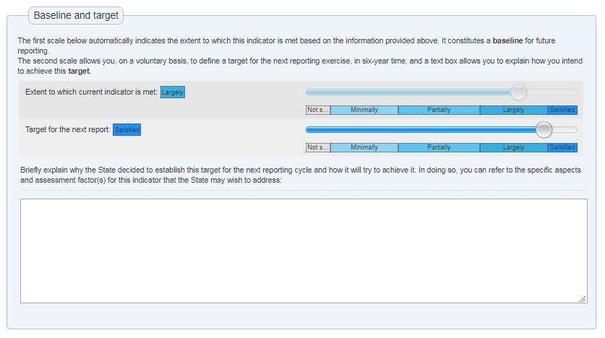
Once all three questions have been answered, the baseline for this periodic reporting cycle for indicator 2 will be calculated automatically by the online tool. Then, the reporting State Party may, if they wish, set their target for the next report in the box below, giving an explanation in the final box as to why this target has been set and how the State will try to achieve it, using the assessment factors for the indicator as a guide.
It may be a useful exercise for the facilitator to demonstrate here the different baselines provided by ticking all ‘no’ answers and a different balance of ‘yes’ and ’no’ responses.

OPTIONAL: SLIDE 24

Exercise (30 minutes):
Learning objective: Reinforce familiarity with using the online reporting tool, with issues concerning the required data and information, how baselines are calculated and how targets can be set.
The facilitator can judge, on the basis of the responses from participants, how many of the following questions are to be completed together in plenary, and how many can be left to participants to complete in break-out groups.
Once the participants have been divided into break-out groups of 2-3 people in such a manner that they are all able to see the PPT screen, they should be asked to respond to each of the remaining questions in the online reporting tool. While they do this, they should be instructed to bear in mind issues relating to the gathering of appropriate data and related statistical information and how you would seek to manage this process. They can also consider giving a ‘no’ response to some of these questions. They should consider how this will affect the information you need to provide and the setting of the baseline (and associated target) for this indicator. Participants are reminded that they can refer to the Guidance Notes while considering each indicator.
If working in plenary (with a single computer for the online form), participants in their break-out groups should be given a few minutes for each question type shown below and then the question can be filled out on screen with contributions from all the participants. If there are sufficient computers available for filling out the form, an alternative approach would be for each group to fill out the questions independently, with the facilitator checking their progress. In this latter scenario, the break-out groups then share their experiences in plenary.
This discussion should give rise to some issues that will merit further discussion in the plenary.

Thematic Area II: Transmission and education - Indicator 5, Q 5.1:
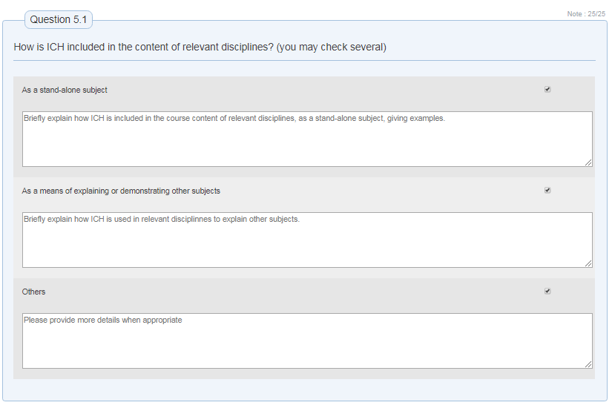This question seeks to identify (i) if ICH is included in relevant primary and secondary education disciplines and (ii) how this is done (e.g. as a subject on its own, as a medium for imparting information, both of these, or in some other way). It is, of course, possible that two boxes may be ticked. When a box is ticked, a pop-up box appears asking for a brief explanation of how this happens, with examples that relate to each box ticked. It would, of course, be helpful to make it clear which box a particular example relates to.

Thematic Area II: Transmission and education - Indicator 5, Q 6.1:
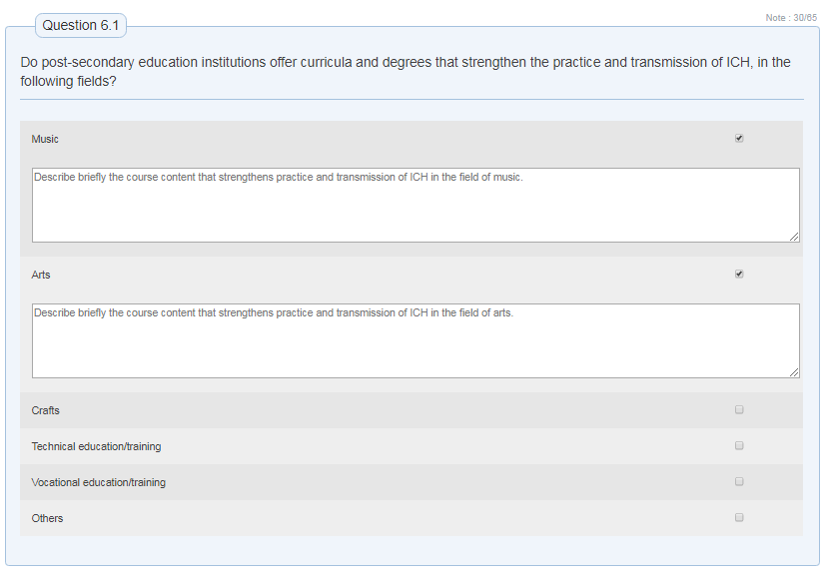This question refers only to education that takes place after secondary school is completed and may, but not exclusively, covers technical and vocational education and training. In the case of this question, a separate box pops up for each box ticked asking for a brief description of the course content.

Thematic Area III: Inventorying and research - Indicator 7, Q 7.1a:
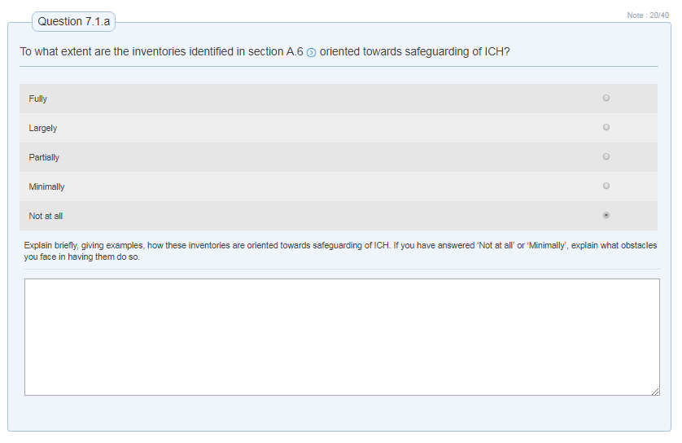In responding to questions relating to indicators 7 and 8, it is important to bear in mind the inter-relationship between these and question A.6 (on inventories). Hence, question 7.1a explicitly mentions the inventories cited in A.6, seeking further information about them. Of course, if no inventories are mentioned, responses cannot be provided for this and other questions concerning inventorying. The rating scale used here runs from ‘not at all’ to ‘fully’, although most responses probably lie in between. Note that, as much as the pop-up box asks for a brief explanation with examples as to how this is achieved, it also asks States Parties who responded ‘not at all’ and ‘minimally’ to explain what obstacles have prevented a better outcome.

Thematic Area III: Inventorying and research - Indicator 8, Q 8.1:
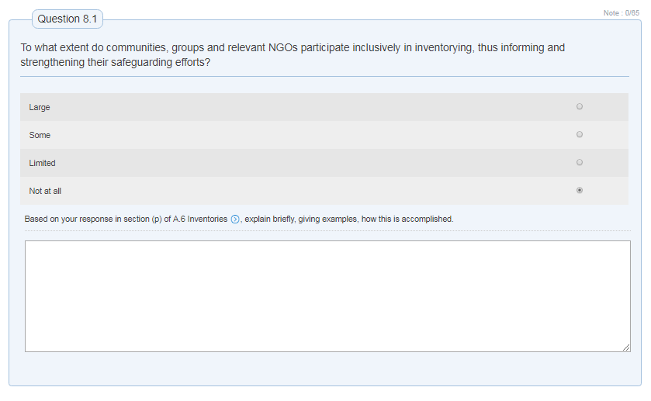This question is shown, in part, to show a different rating scale from the previous one and it is worth briefly discussing why they are different. It also relates to the question of ‘inclusive’ participation and, with the Unit B glossary to hand, it is useful to consider what this implies for the nature of the response given.

Thematic Area III: Inventorying and research - Indicator 10, Q 10.1:
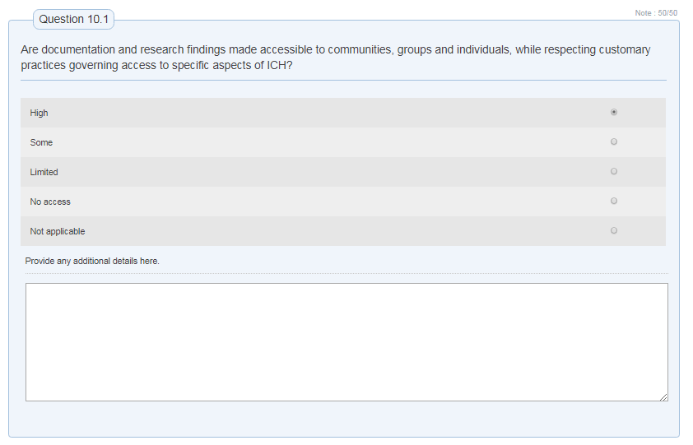Again, we have a further example of a different rating scale.

Thematic Area III: Inventorying and research - Indicator 11, Q 11.1:
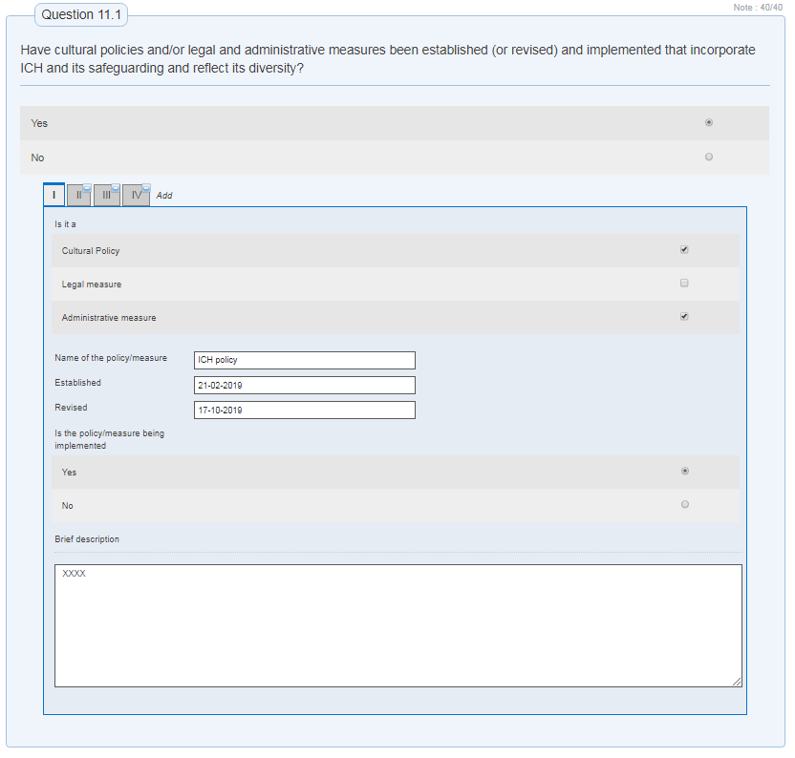Here, we have one of the more complex question types (dealing with a complex issue of policy-making and legal and administrative measures introduced). It is a two-step question where there is, first, a simple ‘yes/no’ question. If ‘yes’ is clicked, then a fairly detailed pop-up box appears which it is worth taking participants through in order to check their understanding of this. First, they have to be sure whether it is a policy or a legal or administrative measure – all in the field of culture in question 11.1 – and give its name. They must also be aware of the fact that it has been established or if it has been revised, and if it is currently being implemented; this suggests that policies and measures that are no longer being implemented that reflected the diversity of ICH and the importance of its safeguarding can be relevant here. Finally, a brief description of the policy or measure is required. Once this has been completed, the option exists to repeat the same process for another policy/measure. The meaning of ‘diversity’ can be checked in the Unit 58 glossary if needed.
Question 12.1 which related to policies and/or legal and administrative measures in the field of education follows the same format.

Thematic Area IV: Policies, as well as legal and administrative measures - Indicator 13, Q 13.2:
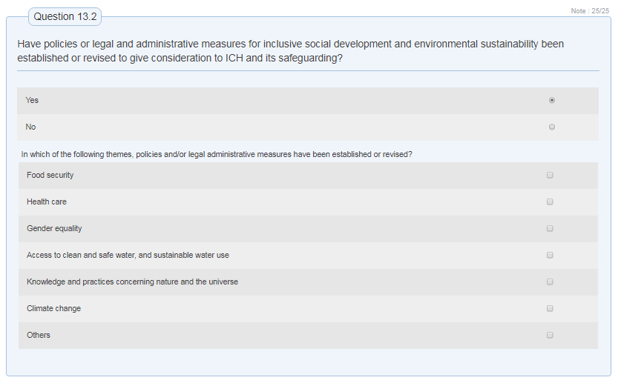However, when we reach policies and/or legal and administrative measures in fields other than culture or education, we see a different format in question 13.2 where the emphasis is on those that relate to inclusive social development (see Unit 58 Glossary) and environmental sustainability. A similar question is asked in relation to policies and/or legal and administrative measures for inclusive economic development (see Unit 58 Glossary) at 13.4. The form itself is straightforward, and the main difficulty in responding to this question probably relates to identifying policies and/or legal and administrative measures that are relevant for each of the areas mentioned (including the possibility of ‘other’).

Thematic Area IV: Policies, as well as legal and administrative measures - Indicator 14, Question 14.1:
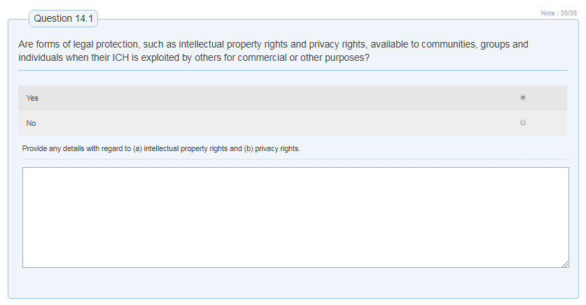This is a fairly straightforward ‘yes/no’ question form, but it is worth checking the participants’ understanding of the intellectual property rights and privacy rights mentioned here (see Unit 58 glossary).

Thematic Area V - Indicator 15, Question 15.1:
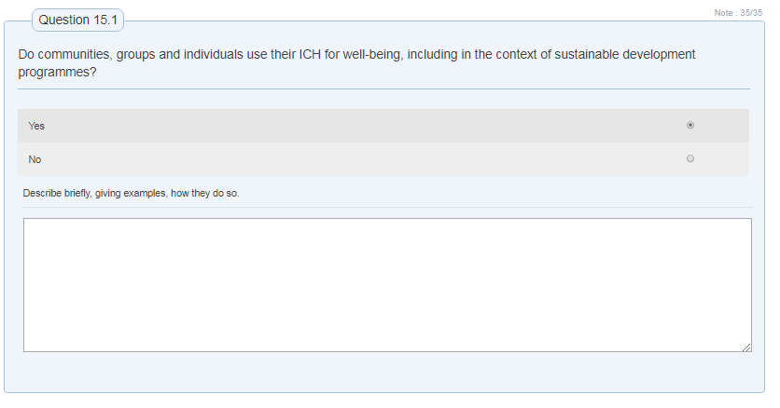Here, the idea of ‘well-being’ may need explanation: It is a human rights-oriented notion that relates to having a reasonable quality of life, not only from the economic point of view but also in terms of its social, cultural, political, environmental and psychological dimensions. As for the context of sustainable development programmes, participants can be encouraged to check Chapter VI of the ODs for further guidance.

Thematic Area V: Role of ICH and its safeguarding in society – indicator 16, Question 16.1:
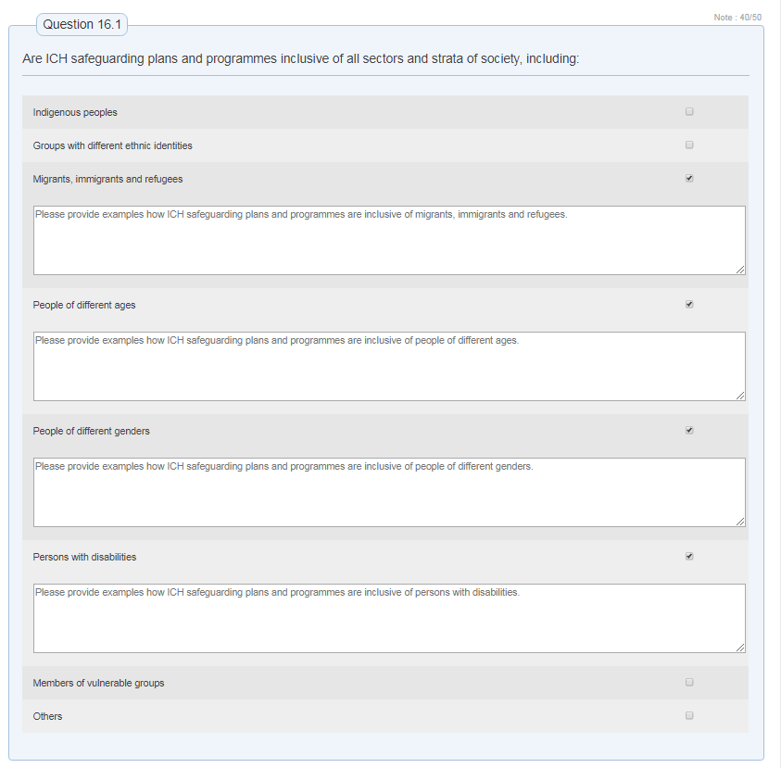Question 16.1 is specifically focused on plans and programmes related to aspects of development, including infrastructural plans, and how far these are inclusive of different sectors and strata (levels) of society. The social groups mentioned here all constitute different, often vulnerable and/or marginalized, groups. Most of the terms used here are defined in the Unit 58 glossary.

Thematic Area VI: Awareness-raising - Indicator 17, question 17.4:
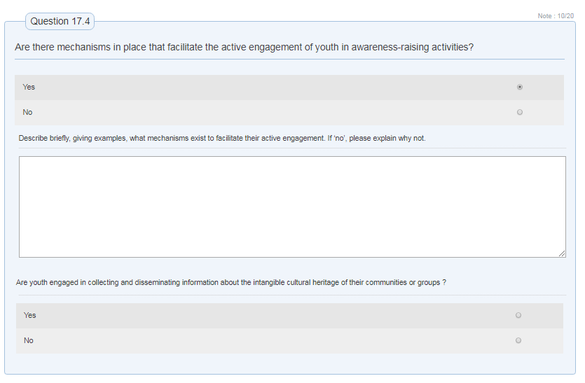This question is useful to test due to its relative complexity of two layers of ‘yes/no’ questions. The structure of this question is that it first asks a general question concerning youth engagement in awareness-raising activities and, following this, a second more targeted question concerning their involvement in disseminating information about the ICH of communities and groups. In addition, relatively little attention has been given to this question of youth engagement in periodic reporting up until now. It should be noted that this is one of the few cases (in the first pop-up box) where a ‘no’ question solicits further explanation as to why this is the case.

Thematic Area VII: Engagement of stakeholders - Indicator 21, question 21.1:
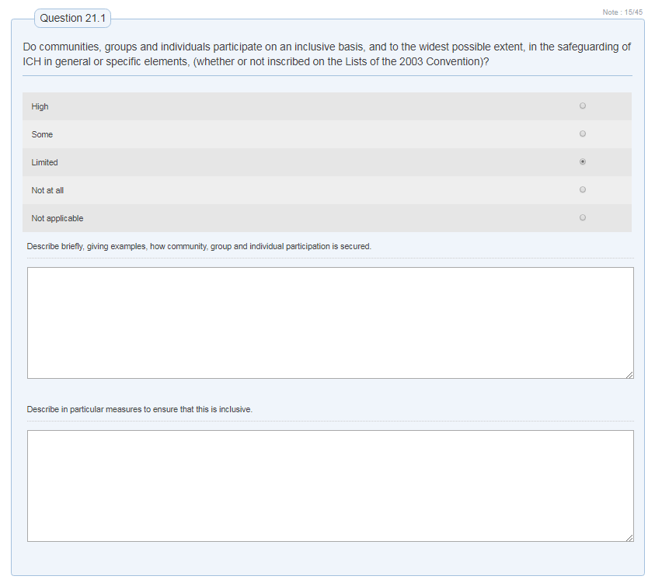The first point to note about question 21.1 is that it has a fairly complex structure of: a rating scale plus two pop-up boxes in which the first seeks a description of what has been done and the second one focuses on how far the process has been inclusive. This serves (a) to break the question down into manageable elements and (b) to give a stronger focus to inclusivity than would otherwise be the case (as is appropriate to Thematic Area VII). It should also be pointed out that the wording of question 21.1 is such as to include all categories of ICH: general, specific elements, inscribed and non-inscribed elements.

Thematic Area VIII: International engagement - Indicators 23 and 26:
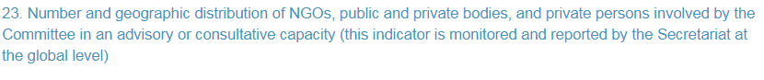
When introducing Thematic Area VIII, participants should be reminded that indicators 23 and 26 are not filled out by responding States Parties, but are monitored and reported on by the Secretariat at the global level. Their purpose, then, is not to evaluate performance in implementing by individual States Parties as much as to provide a global picture of how the Convention is operating at the supra-national level.

Thematic Area VIII: International engagement - Indicator 24, question 24.1:
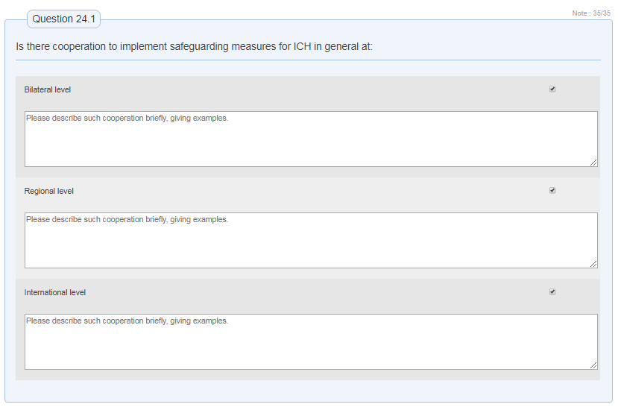This set of questions (for indicator 24) should be shown mainly to illustrate the way in which they are constructed, i.e. that the same question is asked for the different levels of engagement (bilateral, regional and international). These questions should be answered separately for each instance of such cooperation, with the option of ticking the box at the bottom right to give information on a further example of such cooperation. With regard to that box, the term ‘international’ is an umbrella one that includes the ideas of ‘bilateral’ and ‘regional’. It needs to be clarified also that, for the separate questions, ‘bilateral’ usually refers to county-to-country arrangements (but this might include a trilateral arrangement between three countries), ‘regional’ refers to arrangements made between a number of countries across a single region and ‘international’ implies several countries from different regions cooperating in some way.

Thematic Area VIII: International engagement - Indicator 25, question 25.3:
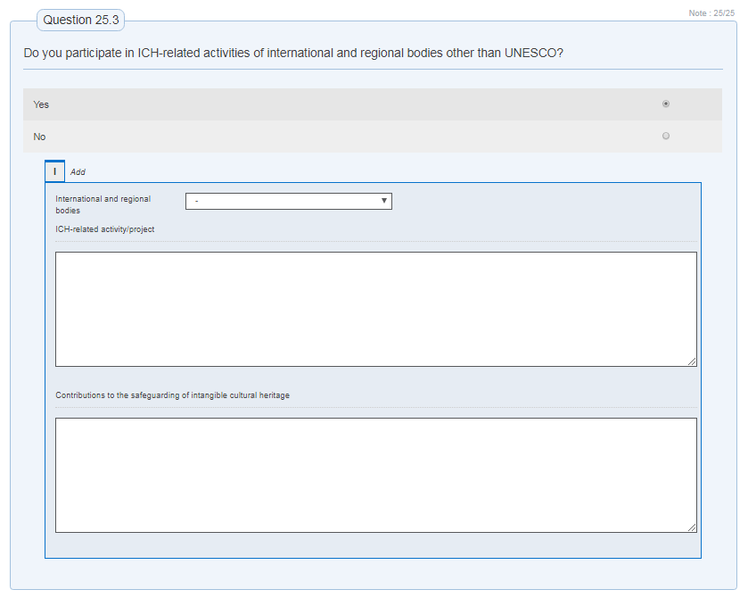Here, it is worth explaining that the online form is seeking to learn about any participation by the State Party in activities of international bodies (including those with a regional basis) other than UNESCO that relate to ICH in some way. The bodies that can be mentioned are included in the dropdown list to the left, and there are columns where the State Party can describe (1) the activity or project in question and (2) what contributions it makes to ICH safeguarding. This second column recognizes the fact that such activities may only be partly relevant to ICH, for example environmental protection activities.

Information on these is available online at : https://en.unesco.org/mab and https://en.unesco.org/links, respectively.

