CONVENTION FOR THE SAFEGUARDING OF THE
INTANGIBLE CULTURAL HERITAGE
INTERGOVERNMENTAL COMMITTEE FOR THE
SAFEGUARDING OF THE INTANGIBLE CULTURAL HERITAGE
Twelfth session
Jeju Island, Republic of Korea
4 to 9 December 2017
General Information

TABLE OF CONTENTS
1. TWELFTH SESSION 4
2. HOST COUNTRY CONTACTS 4
3. REGISTRATION 5
4. ACCOMMODATION 5
5. PASSPORTS, VISAS AND OTHER TRAVEL INFORMATION 5
5.1 Immigration/Visa 5
5.2 Formalities 5
5.3 Customs in the Republic of Korea 6
5.4 Health requirements 6
5.5 Medical insurance and services 6
5.6 Travelling to and from Jeju Island, Republic of Korea 6
6. LOCAL TRANSPORTATION 6
7. VENUE OF THE SESSION 6
7.1 Meeting venue 6
7.2 Official opening, meetings and related events 7
7.3 Interpretation 7
7.4 Documentation 7
7.5 Meeting registration and information desk 7
7.6 Security badges 7
7.7 Participants’ lounge 7
7.8 Conference venue 7
7.9 Meals 7
8. MEDIA 7
8.1 Media centre 7
8.2 Press conference room 8
8.3 Press releases 8
9. RECEPTION PROGRAMME AND RELATED EVENTS 8
10. COUNTRY INFORMATION 8
10.1 The Republic of Korea at a glance 8
10.2 Government structure 8
10.3 Geography and climate 8
10.4 The Republic of Korea and its people 9
10.5 The Republic of Korea and its culture 9
10.6 Fauna and flora 10
10.7 The capital city, Seoul, and the host city, Jeju 10
10.8 Currency 11
10.9 Electricity supply 11
10.10 Time zone 11
10.11 Banking services 11
10.12 Emergency telephone numbers of major hospitals 11
ANNEX A REGISTRATION FORM FOR THE TWELFTH SESSION
OF THE COMMITTEE 12
ANNEX B LIST OF PARTIES TO THE VISA WAIVER AGREEMENT 13
ANNEX C DESIGNATED VISA-FREE ENTRY 19
ANNEX D RECOMMENDED HOTELS 20

- TWELFTH SESSION
The twelfth session of the Intergovernmental Committee for the Safeguarding of the Intangible Cultural Heritage will take place in Jeju Island, Republic of Korea, at the International Conference Centre (ICC Jeju) from 4 to 9 December 2017, hosted by the Republic of Korea:
Address: 224 Jungmungwangwang-ro, Seogwipo, Jeju Special Self-Governing Province, Republic of Korea
Tel: (+82) 64 735 1036
Fax: (+82) 64 35 1098
Website: http://www.iccjeju.co.kr
All the relevant information is also available at the following address: https://ich.unesco.org/en/12COM/. The logistical information contained in this document was provided by the host country.
The Intergovernmental Committee for the Safeguarding of the Intangible Cultural Heritage consists of twenty-four representatives of States Parties to the Convention for the Safeguarding of the Intangible Cultural Heritage, elected by the General Assembly of the States Parties to the Convention.
The current composition of the Committee is: (Group I) Austria, Cyprus, Turkey; (Group II) Armenia, Bulgaria, Hungary; (Group III) Colombia, Cuba, Guatemala, Saint Lucia; (Group IV) Afghanistan, India, Mongolia, Philippines, Republic of Korea; (Group V(a)) Congo, Côte d’Ivoire, Ethiopia, Mauritius, Senegal, Zambia; and (Group V(b)) Algeria, Lebanon, Palestine.
The elected members (Decision 11.COM 17) of the Bureau of the twelfth session of the Committee are:
Chairperson: H.E. Mr Byong-hyun Lee (Republic of Korea)
Vice-Chairs: Turkey, Bulgaria, Colombia, Côte d’Ivoire, Palestine
Rapporteur: Mr Gábor Soós (Hungary)
The working languages are English and French.
- HOST COUNTRY CONTACTS
Host Administration:
Cultural Heritage Administration of Republic of Korea
Address: 189, Cheongsa-ro, Seo-gu, Daejeon, Republic of Korea
Tel: +82(0)424813185/+82(0)424813186
Fax: +82(0)424813199
Email: 12com.cha@gmail.com
Contact pesons:
Mr Hyungbin Park – The Cultural Heritage Administration
Tel: +82-42-481-3185 Fax: +82-42-481-3199
Email: bihn@Korea.kr / bihn9403@gmail.com
Ms Eunseon Jeong – The Cultural Heritage Administration
Tel: +82-42-481-3186 Fax: +82-42-481-3199
Email: ejeong@Korea.kr / ejeong101@gmail.com
Ms Hansol Kwak – Permanent Delegation of the Republic of Korea to UNESCO
Tel: +33 (0) 1 44 10 24 09
Fax: +33 (0) 1 43 3538 24
Email: hs.kwak.kr@unesco-delegations.org
- REGISTRATION
The main participants of the twelfth session of the Intergovernmental Committee are the twenty-four members of the Committee. All participants, delegates, observers and those wishing to attend the twelfth session of the Committee are strongly advised to register by no later than 10 November 2017. This is to allow the organizers sufficient time to process all the relevant information and to ensure that all the logistical arrangements are in place before the opening of the session. Please register online on the website of the twelfth session of the Committee: https://ich.unesco.org/en/12COM/.
If you are not able to register online, please use the registration form in Annex A and return it by email to: ichmeetings@unesco.org.
All registered participants, delegates and observers are requested to inform the UNESCO Intangible Cultural Heritage Section of any subsequent changes to their travel arrangements. This will ensure that logistical arrangements are attended to in a smooth manner.
- ACCOMMODATION
Participants are responsible for booking their own accommodation and for covering all costs incurred during their stay in the Republic of Korea. It is strongly recommended that all participants book their own accommodation by 10 November 2017. A list of designated hotels is available at the end of this document (Annex D). Please note that shuttle services will be provided to participants only to and from these designated hotels.
- PASSPORTS, VISAS AND OTHER TRAVEL INFORMATION

5.1 Immigration/Visa
All participants, delegates and observers are required to present a passport that is valid for at least six months from the day of their arrival in the Republic of Korea.
Participants are kindly advised to check details regarding entry requirements into the Republic of Korea, with particular reference to nationality and the type of passport they hold with the nearest Embassy or Consulate of the Republic of Korea.
Details on visa requirements and the application process are also available on the website as follows:
- Korea Visa Portal
http://www.visa.go.kr (Korean, English, Chinese)
- Korea Immigration Service
http://www.immigration.go.kr (Korean, English)
- Hi Korea (e-government for foreigners)
http://www.hikorea.go.kr (Korean, English, Japanese, Chinese)
If you are travelling to the Republic of Korea via other countries, please familiarize yourself with the transit requirements of those countries before you travel to the Republic of Korea.

5.2 Formalities
Please note that visa costs for the Republic of Korea differ according to countries. Details on visa fees are available on the website at: http://www.visa.go.kr
Categories of persons who do not require visas:
* Countries under visa waiver agreements (Annex B)
* Designated visa-free entry (Annex C)
* Re-entry permit holders
* Holders of passports issued by recognized international organizations (LAISSEZ-PASSER)

5.3 Customs in the Republic of Korea
While it is not illegal to carry large sums of cash when you enter the Republic of Korea, you must declare any amount above US$10,000, and keep all receipts of currency exchanges while you are in the country. Please ask for the appropriate in-flight declaration forms or ask an immigration officer after landing.

5.4 Health requirements
Medical and dental care in the Republic of Korea is usually of a good standard but can be expensive. Make sure you have adequate travel health insurance and accessible funds to cover the cost of any medical treatment abroad and repatriation. If you need emergency medical assistance during your trip, dial 119 and ask for an ambulance. You should contact your insurance/medical assistance company promptly if you are referred to a medical facility for treatment.

5.5 Medical insurance and services
First-aid services will be provided at the meeting venue. Directions to the first-aid room can be obtained from the reception. Participants are, however, expected to assume responsibility for the medical costs of other treatments that they might receive while in the Republic of Korea. It is strongly recommended that participants purchase medical insurance in their home countries to cover medical costs while in the Republic of Korea or in transit.

5.6 Travelling to and from Jeju Island, Republic of Korea
Incheon International Airport, Gimpo Airport, and Jeju Airport are the main international arrival and departure airports to the Republic of Korea. A welcome desk will be set up at all three airports from 2 December to 5 December and from 8 December to 10 December 2017 to assist arriving and departing participants.
To facilitate airport transportation arrangements, all participants are kindly requested to submit their expected date and time of arrival in the Republic of Korea (Incheon, Gimpo, and Jeju) and flight details to the Cultural Heritage Administration (Mr Park or Ms Jeong) by email to: 12com.cha@gmail.com. Any subsequent changes should be communicated through the same email address.
It is requested that the confirmed flight details of all participants, especially participating Heads of State/Government and Heads of Delegations, be provided at least thirty working days prior to the meeting.
- LOCAL TRANSPORTATION
The Cultural Heritage Administration and Jeju Special Self-Governing Province will make transportation arrangements for participants from the airport to the designated hotels, as indicated in Annex D, and from the designated hotels to the conference venue in the morning.
Shuttle bus services will be provided for participants in the afternoon after the sessions and to venues for planned activities as per the conference programme.
Please note that participants who are not staying at the officially designated hotels will be responsible for arranging their own transportation to and from the airport, to and from their respective hotels and to and from the conference venue, as well as to venues for planned activities as per the meeting programme.
- VENUE OF THE SESSION

7.1 Meeting venue
The meeting venue at the ICC JEJU will be in Tamna Hall, which is located on the fifth floor.
For a general overview of the venue, please visit the website: http://www.iccjeju.co.kr.

7.2 Official opening, meetings and related events
The official opening ceremony of the twelfth session of the Committee will take place at 6 p.m. on 3 December 2017 at the Event Hall, ICC Jeju.
The session of the Committee meeting will be held daily from 9.30 a.m. to 12.30 p.m. and from 2.30 p.m. to 5.30 p.m. from 4 to 9 December 2017. The ICH NGO Capacity Building Workshop will also take place from 1 to 3 December 2017 at the ICC Jeju (Halla Hall). For more information on the programme of work, please refer to the provisional agenda, which can be retrieved from the UNESCO Secretariat’s website at: https://ich.unesco.org/en/12COM/.

7.3 Interpretation
Simultaneous interpretation will be provided in the working languages of the Committee, namely English and French. Arabic and Korean interpretation will also be generously provided by Saudi Arabia from 5 to 8 December 2017 and by Republic of Korea throughout the session, respectively.

7.4 Documentation
For environmental reasons and in order to reduce costs, printed copies of the documents will only be provided on request. All the documents for the twelfth session can be downloaded from https://ich.unesco.org/en/12COM/. During the meetings, participants are advised to bring their laptops to consult the relevant working documents.

7.5 Meeting registration and information desk
A registration and information desk will be set up at the ICC Jeju between 8 a.m. and 8 p.m. from 3 to 6 December 2017 and from 8 a.m. to 6 p.m. from 7 to 9 December 2017. During the afternoon of 3 December 2017, registration will also be possible at the ICC Jeju registration desk during the opening ceremony. Every participant, delegate and observer must register prior to the beginning of the session on the following website: https://ich.unesco.org/en/12COM. An information package on the meeting will be available at that time.

7.6 Security badges
Badges will be presented to the participants, delegates and observers at the registration and information desk. Participants must wear the badges at all times when entering the conference venue.

7.7 Participants’ lounge
A space will be available to serve as a lounge for participants during the session. A number of computers with internet access and printing facilities will be provided. The technical staff will be on-site to assist participants.

7.8 Conference venue
A free Wi-Fi connection is available at the meeting venue. The log-in information will be provided upon arrival.

7.9 Meals
During the meeting, a continuous refreshment/coffee service will be available at the conference venue, located on the fifth floor, and lunch will be offered within the conference venue (Delizia, Kraze Burger, and Dunkin Donuts) at a reasonable price.
- MEDIA

8.1 Media centre
A media centre will be provided for the media to cover the twelfth session of the Committee. The Press will also have access to the internet and a fax machine.

8.2 Press conference room
A press conference room will be provided, the details of which will be communicated in due course. Only registered media will have access to this room. The schedule outlining press events will be available upon registration.

8.3 Press releases
Press releases and photographs of the meeting will be posted on the meeting website. Press releases will be posted on the media room page and photographs will be displayed in the photo gallery.
- RECEPTION PROGRAMME AND RELATED EVENTS
Registered participants, delegates and observers will be invited to receptions and other events during the twelfth session of the Intergovernmental Committee for the Safeguarding of the Intangible Cultural Heritage.
The programme will be available on the webpage of the Convention: https://ich.unesco.org/en/12COM/.
- COUNTRY INFORMATION

10.1 The Republic of Korea at a glance
The Republic of Korea sits in the north-eastern part of the Asian continent and enjoys four distinctive seasons in spring, summer, autumn and winter. It is known for its green, hilly countryside dotted with cherry trees and centuries-old Buddhist temples, its shining coastal villages, tropical islands and high-tech cities such as Seoul.
Land Size: 223,433 km² (including the Democratic People’s Republic of Korea)
South Korea only: 100,295 km²
Population: 51.07million (2016)
Capital city: Seoul (since 1394)
Language: Korean; Hangeul
Political system: free democracy; presidential system
Currency: Korean Republic Won (KRW)
Dialing code: +82
Detailed information about tourism in the Republic of Korea can be found on the following website: http://english.visitkorea.or.kr/enu/index.kto

10.2 Government structure
The Republic of Korea has adopted a presidential system wherein the President is elected by the direct vote of the people for a five-year term. The government is composed of three independent branches: the Executive branch; the Legislative branch, which comprises 300 four-year term members of the National Assembly; and the Judiciary branch, which includes fourteen six-term Supreme Court justices. There are seventeen regional local governments and 226 basic local governments. The heads of the local governments and the members of the local councils are each elected for a four-year term.

10.3 Geography and climate
The Korean peninsula is located between 33° 7′ and 43° 1′ in north latitude, and between 124° 11′ and 131° 53′ in east longitude at the edge of the Northwestern Pacific, sharing a border with China and Russia to the north and lying near the Japanese archipelago to the south. It extends about 960km southward and is about 170km wide from east to west. It is surrounded by three oceans and nearly 70 per cent of its terrain is mostly mountainous, so its terrestrial and marine ecosystems include a variety of species with a high level of biodiversity.
The Korean peninsula encompasses 221,000km², 45 per cent of which makes up the Republic of Korea. About 20 per cent of the total land area in the Republic of Korea is used for agriculture while forests cover 64 per cent. The Korean peninsula lies in the east and is characterized by distinct seasonal temperatures and precipitation levels.
The Republic of Korea has a temperate climate characterized by four distinct seasons. The seasons change gradually but each has significant seasonal characteristics. Spring and autumn are relatively short while summer and winter are rather long. With high temperatures and humidity, summer begins in June and lasts until August and is accompanied by monsoon typhoons and rains. Winter is dry and cold due to the northwesterly winds sweeping down from Siberia. The average annual temperature is 12-14°C in the central region and 3-20°C in the northern region. In particular, the average temperature in Jeju Island in December is 8-10°C.

10.4 The Republic of Korea and its people
Archaeologists think that people settled in the Korean peninsula around 700,000 B.C., during the Paleolithic Age. Koreans, like many other Asian people, are descendants of the Mongolian Tungus stock.
Korean belongs to the Altaic language family, and its written form uses Hangeul, a writing system commissioned by King Sejong (1397-1450) during the Joseon Dynasty. Koreans are very proud of this remarkable achievement, and Hangeul is a very efficient and easy script to learn and use.
Hangeul is composed of fourteen consonants and ten vowels. It can express virtually all the sounds produced by nature and humans. Every year, UNESCO presents the King Sejong Literacy Prize to people who have made a distinguished contribution to the elimination of illiteracy.

10.5 The Republic of Korea and its culture
<Korean Language; Hangeul>
Hangeul, one of the most indigenous and unique creations of the nation, was introduced in 1443 by King Sejong (1418-1450), the fourth king of the Joseon Dynasty. In order to help all commoners to easily read and write this new alphabet, Hunminjeongeum (meaning “proper sounds to instruct the people” in Korean) was created.
Hangeul is a series of creative and scientifically designed characters. The alphabet is composed of basic consonants and vowels with a set sound each, with a dot or a line added to form more sounds. Originally composed of seventeen consonants and eleven vowels, only fourteen consonants and ten vowels are now used in modern Hangeul.
As a written language, Hangeul was not influenced in any way by pre-existing writing systems. The language is very easy for all to learn, as is evidenced by the fact that the Republic of Korea’s illiteracy rates are among the lowest in the world. Of all of the Republic of Korea’s cultural assets, its citizens are most proud of Hangeul and have thus designated every 9 October as Hangeul Day, to memorialize and celebrate the invention of the alphabet. In addition, Hunminjeongum: the Hanguel Manuscript, was inscribed on the Memory of the World Register in 1997.
<Traditional foods in the Republic of Korea>
Hansik refers to traditional Korean food, centred around rice, served alongside a bowl of soup and a variety of side dishes. Hansik’s most outstanding feature is the fermented foods, which are beneficial for improving digestion, as well as preventing cancer. The most well-known fermented foods are Kimchi (fermented cabbage), ganjang (soy sauce), doenjang (soybean paste) and gochujang (Korean chilli paste).
Popular dishes among international eaters include bulgogi, bibimbap and royal cuisine. Bulgogi is a marinated beef or sometimes pork dish that is sweet and tender in texture. In particular, the soy sauce seasoning is not spicy, thus making it a great introduction dish to hansik. Bibimbap, on the other hand, is a complete meal in and of itself, mixing rice with all kinds of condiments of one’s choice, topped with gochujang for an extra kick. Royal cuisine, the ultimate in Korean culinary arts, is a full course meal, including at least twelve different sides and desserts in addition to soup, steamed foods and hot pots.
<The Republic of Korea’s traditional costume, Hanbok>
Hanbok is the traditional attire of the people of the Republic of Korea. Worn daily up until just a hundred years ago, these days it is only worn on festive occasions or special anniversaries. It is a formal dress and most Koreans keep a hanbok for special times in their lives.
A special feature of hanbok is its shape, with a slim top and wide bottom, similar to a bell. The jacket should be tight and fitted while the skirt is relaxed. The tightly fitting jacket attractively reflects the shape of the upper body. The wide sleeves and flexible skirt flatter the wearer’s gracefulness by hiding the movements of the lower body, so the wearer appears to be floating on air.
Hanbok fabric is coloured using natural dyes. The colours of nature are imbued in the cloth, giving hanbok a depth and richness not found from artificial dyes.
<UNESCO heritage in the Republic of Korea>
The Republic of Korea has nineteen elements inscribed on the Representative List of the Intangible Cultural Heritage of Humanity, twelve elements on the World Cultural and Natural Heritage List, and thirteen elements on the Memory of the World Register.

10.6 Fauna and flora
<Fauna>
Large mammals such as tigers, bears and lynx were once abundant throughout the Korean peninsula. However, many have disappeared due to human settlement, the loss of forest habitats and over-hunting. The Siberian tiger has hardly been sighted in the Republic of Korea, but bears and wildcats can still be found in the more remote areas, such as Jiri-san and Seorak-san.
The Republic of Korea also has several indigenous species of deer, including the roe deer and the Siberian musk deer. Wild boars have been growing more common in recent years. One of the most interesting things about the Korean environment is the demilitarized zone, a strip of land between the Democratic People’s Republic of Korea and the Republic of Korea. As it has been untouched since 1953, it has become a haven for wildlife, particularly migrating birds.
<Flora>
The Korean peninsula has three forest zones; warm temperate forest, cool temperate forest and sub-boreal forest. In the warm temperate forest zone, evergreen broad-leaved trees and Camellia japonica are widely present. In the cool temperate forest, mostly pine forests as well as a few broad-leaved deciduous forests can be observed. Spruce trees and Korean pines grow in the sub-boreal forest zone.

10.7 The capital city, Seoul, and the host city, Jeju
<The capital city, Seoul>
Seoul, the capital of the Republic of Korea, is geographically located at 37.34 N, 126.59 E, putting it in close proximity to the Yellow Sea. The Hangang (River) flows horizontally across Seoul, dividing the city into two sections lying north and south of the river. There are twenty-five autonomous districts and 423 administrative “dong” units in Seoul. The city covers 0.28 per cent of the entire peninsula (or 0.61 of the Republic of Korea), and spans an area 30.30 km north-to-south and 34.78 km west-to-east. The population of Seoul in 2017 is approximately 10.92 million.
Seoul is an important part of the Republic of Korea’s cultural heritage and the most popular attraction among overseas visitors to the Republic of Korea. Although it is now one of the very largest modern metropolises in the world, its downtown area is enclosed by historic walls that were originally built over 600 years ago and contains a number of valuable historical heritage sites including Royal Palaces, fortress gates and the old residential district.
<The host city, Jeju>
Jeju Island, the biggest island in the Republic of Korea, is located in the southwest of the Korean peninsula. The island is a volcanic island covered with basalt rocks and is oval-shaped, with Halla Mountain in the centre stretching 73 km from east to west and 41 km from north to south. With its abundant marine and natural heritage, the island was designated as a World Biosphere Reserve, UNESCO Natural Heritage Site and a Global Geopark. This island is home to 9,500 Haenyeo (women divers), 77 types of mammals, 198 types of birds, 8 types each of reptiles and amphibians, 873 types of insects and 74 types of spiders.

10.8 Currency
The official currency of the Republic of Korea is the Korean Republic Won (KRW). Foreign exchange services are available at all banks. The official exchange rate as of 21 August 2017 is 1USD=1,139KRW (1,000KRW=0.88USD) and 1EUR=1,338KRW (1,000KRW=0.75EUR).

10.9 Electricity supply
The voltage in the Republic of Korea is 220 volts AC, 60Hz with a round two-pin plug (plug type: C, F).

10.10 Time zone
The Republic of Korea is nine hours ahead of Greenwich Mean Time (GMT+9).

10.11 Banking services
Banking hours are from 9 a.m. to 4 p.m. from Monday to Friday. A bank in the ICC Jeju (Level 1) is open from 9 a.m. to 4 p.m. from Monday to Friday. A currency exchange (USD, EURO, CNY, and JPY) and money transfer service and Automatic Teller Machines (ATMs) are available. Most banks and hotels accept international credit cards. ATMs are available throughout the city.

10.12 Emergency telephone numbers of major hospitals
<Seogwipo Medical Centre>
1530-2, DongHeung-dong, Seogwipo-si, Jeju Special Self-Governing Province
Tel: 82-64-730-3001~3
In case of an emergency, please call the hospital for an ambulance. Participants are encouraged to buy travel insurance before departing.

ANNEX A REGISTRATION FORM FOR THE TWELFTH SESSION OF THE COMMITTEE
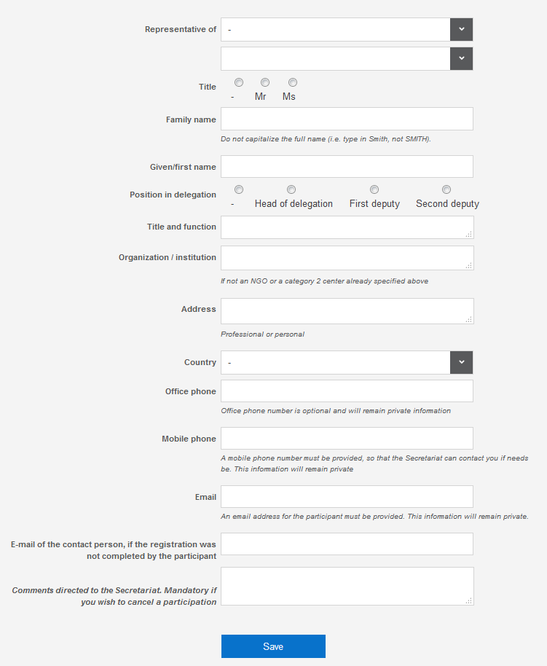

ANNEX B LIST OF PARTIES TO THE VISA WAIVER AGREEMENT
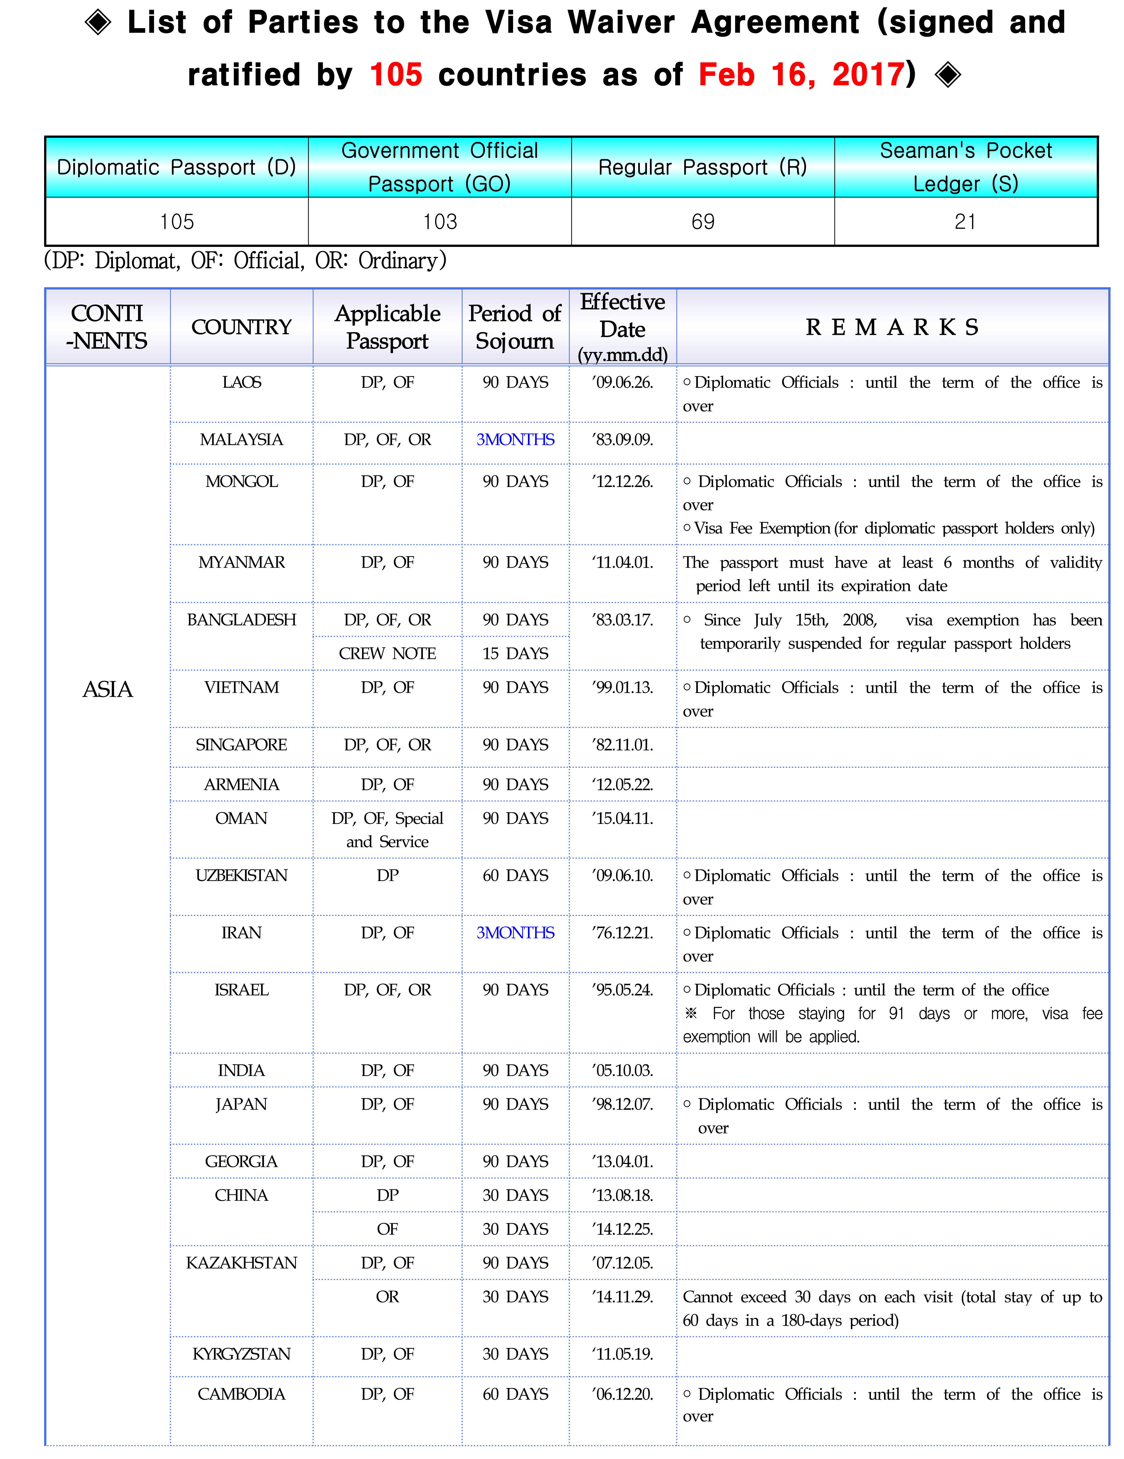
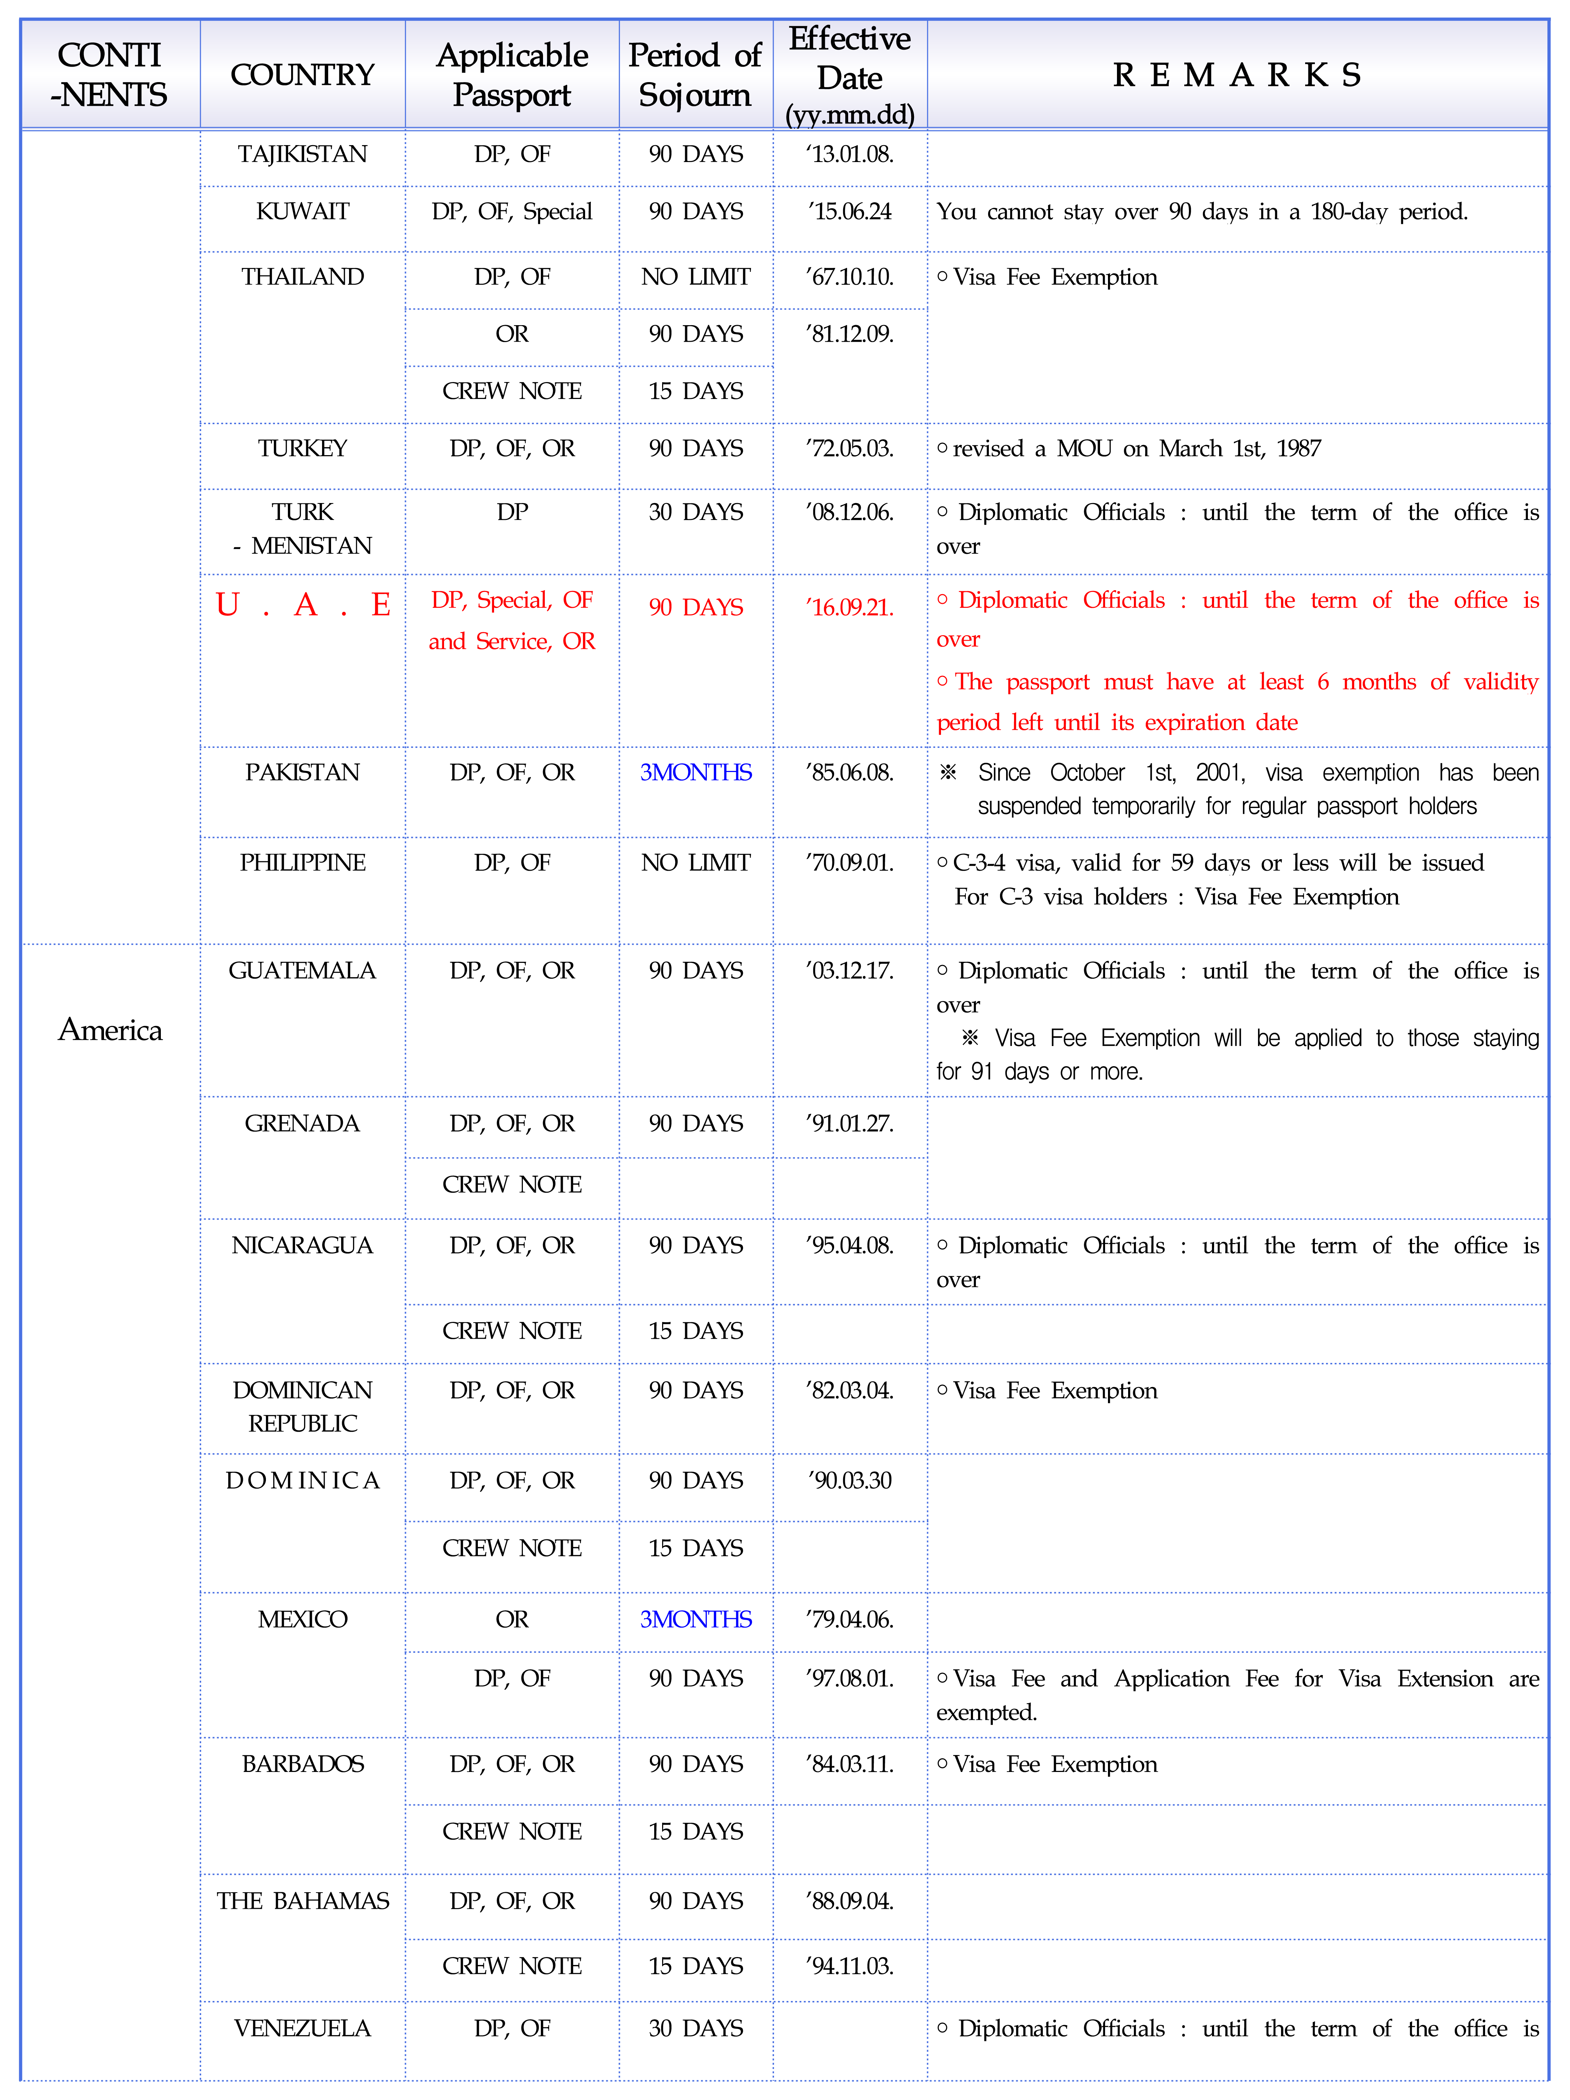
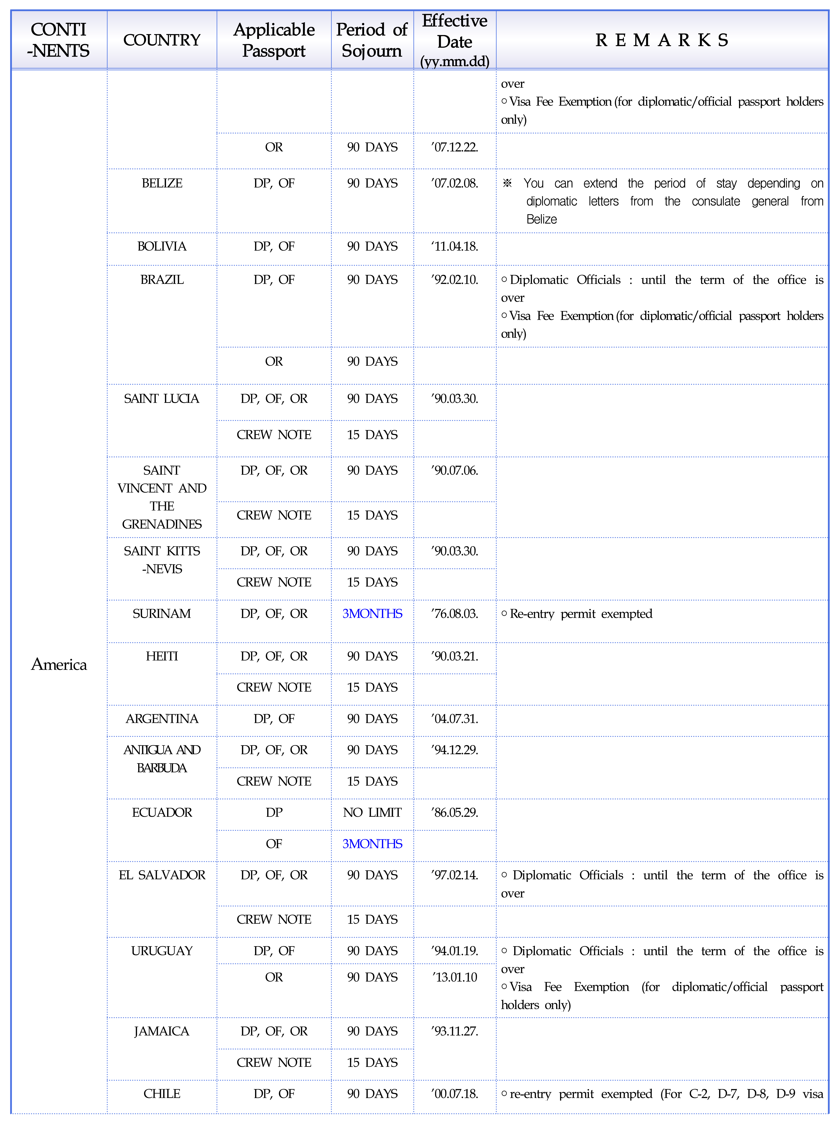
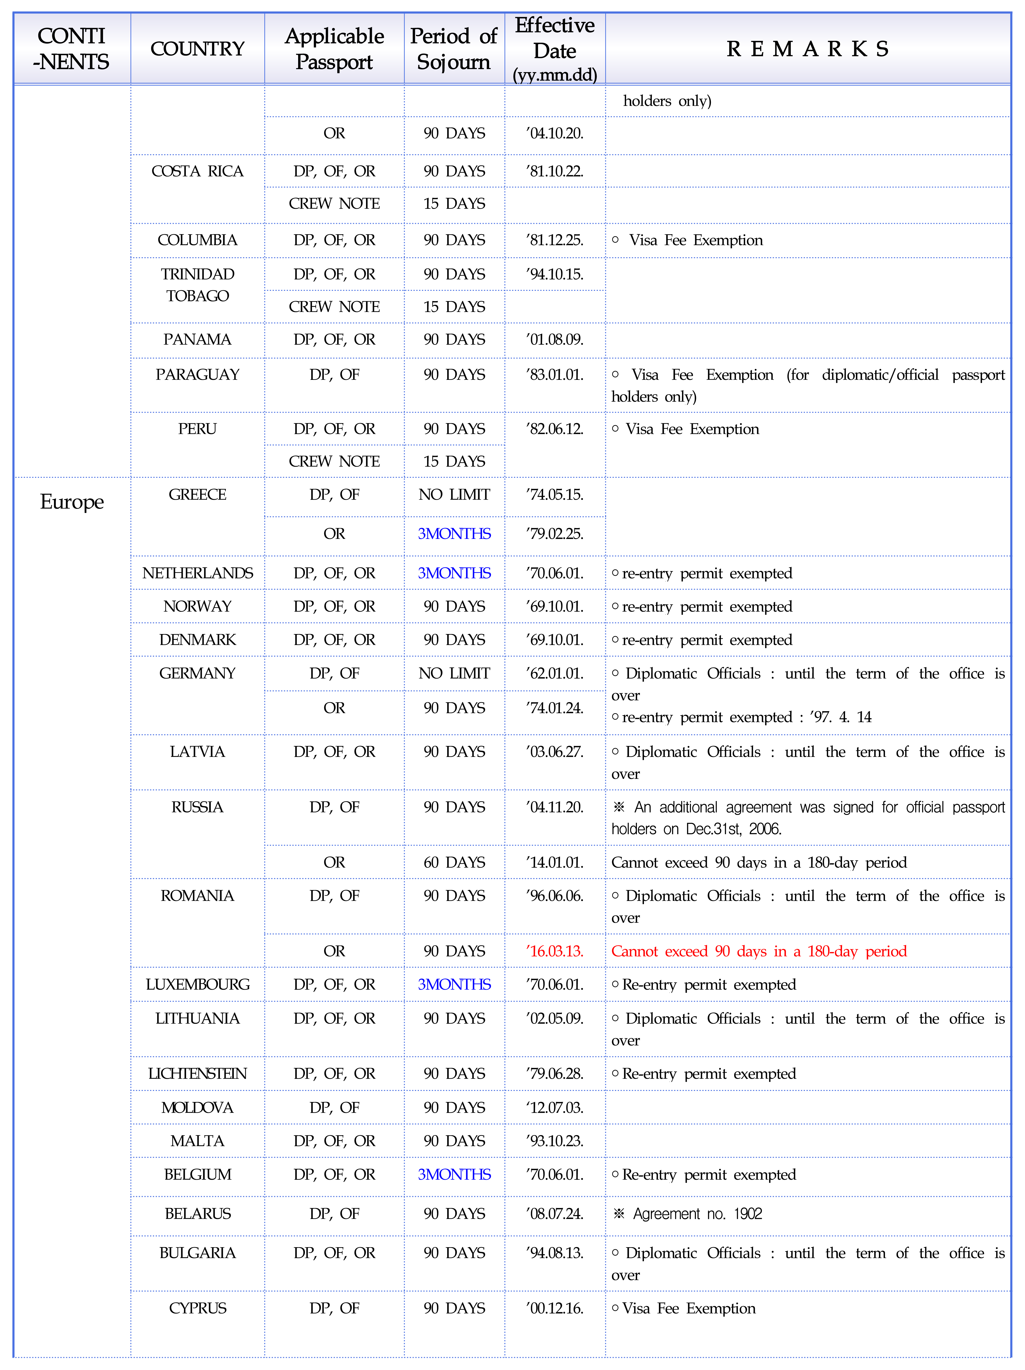
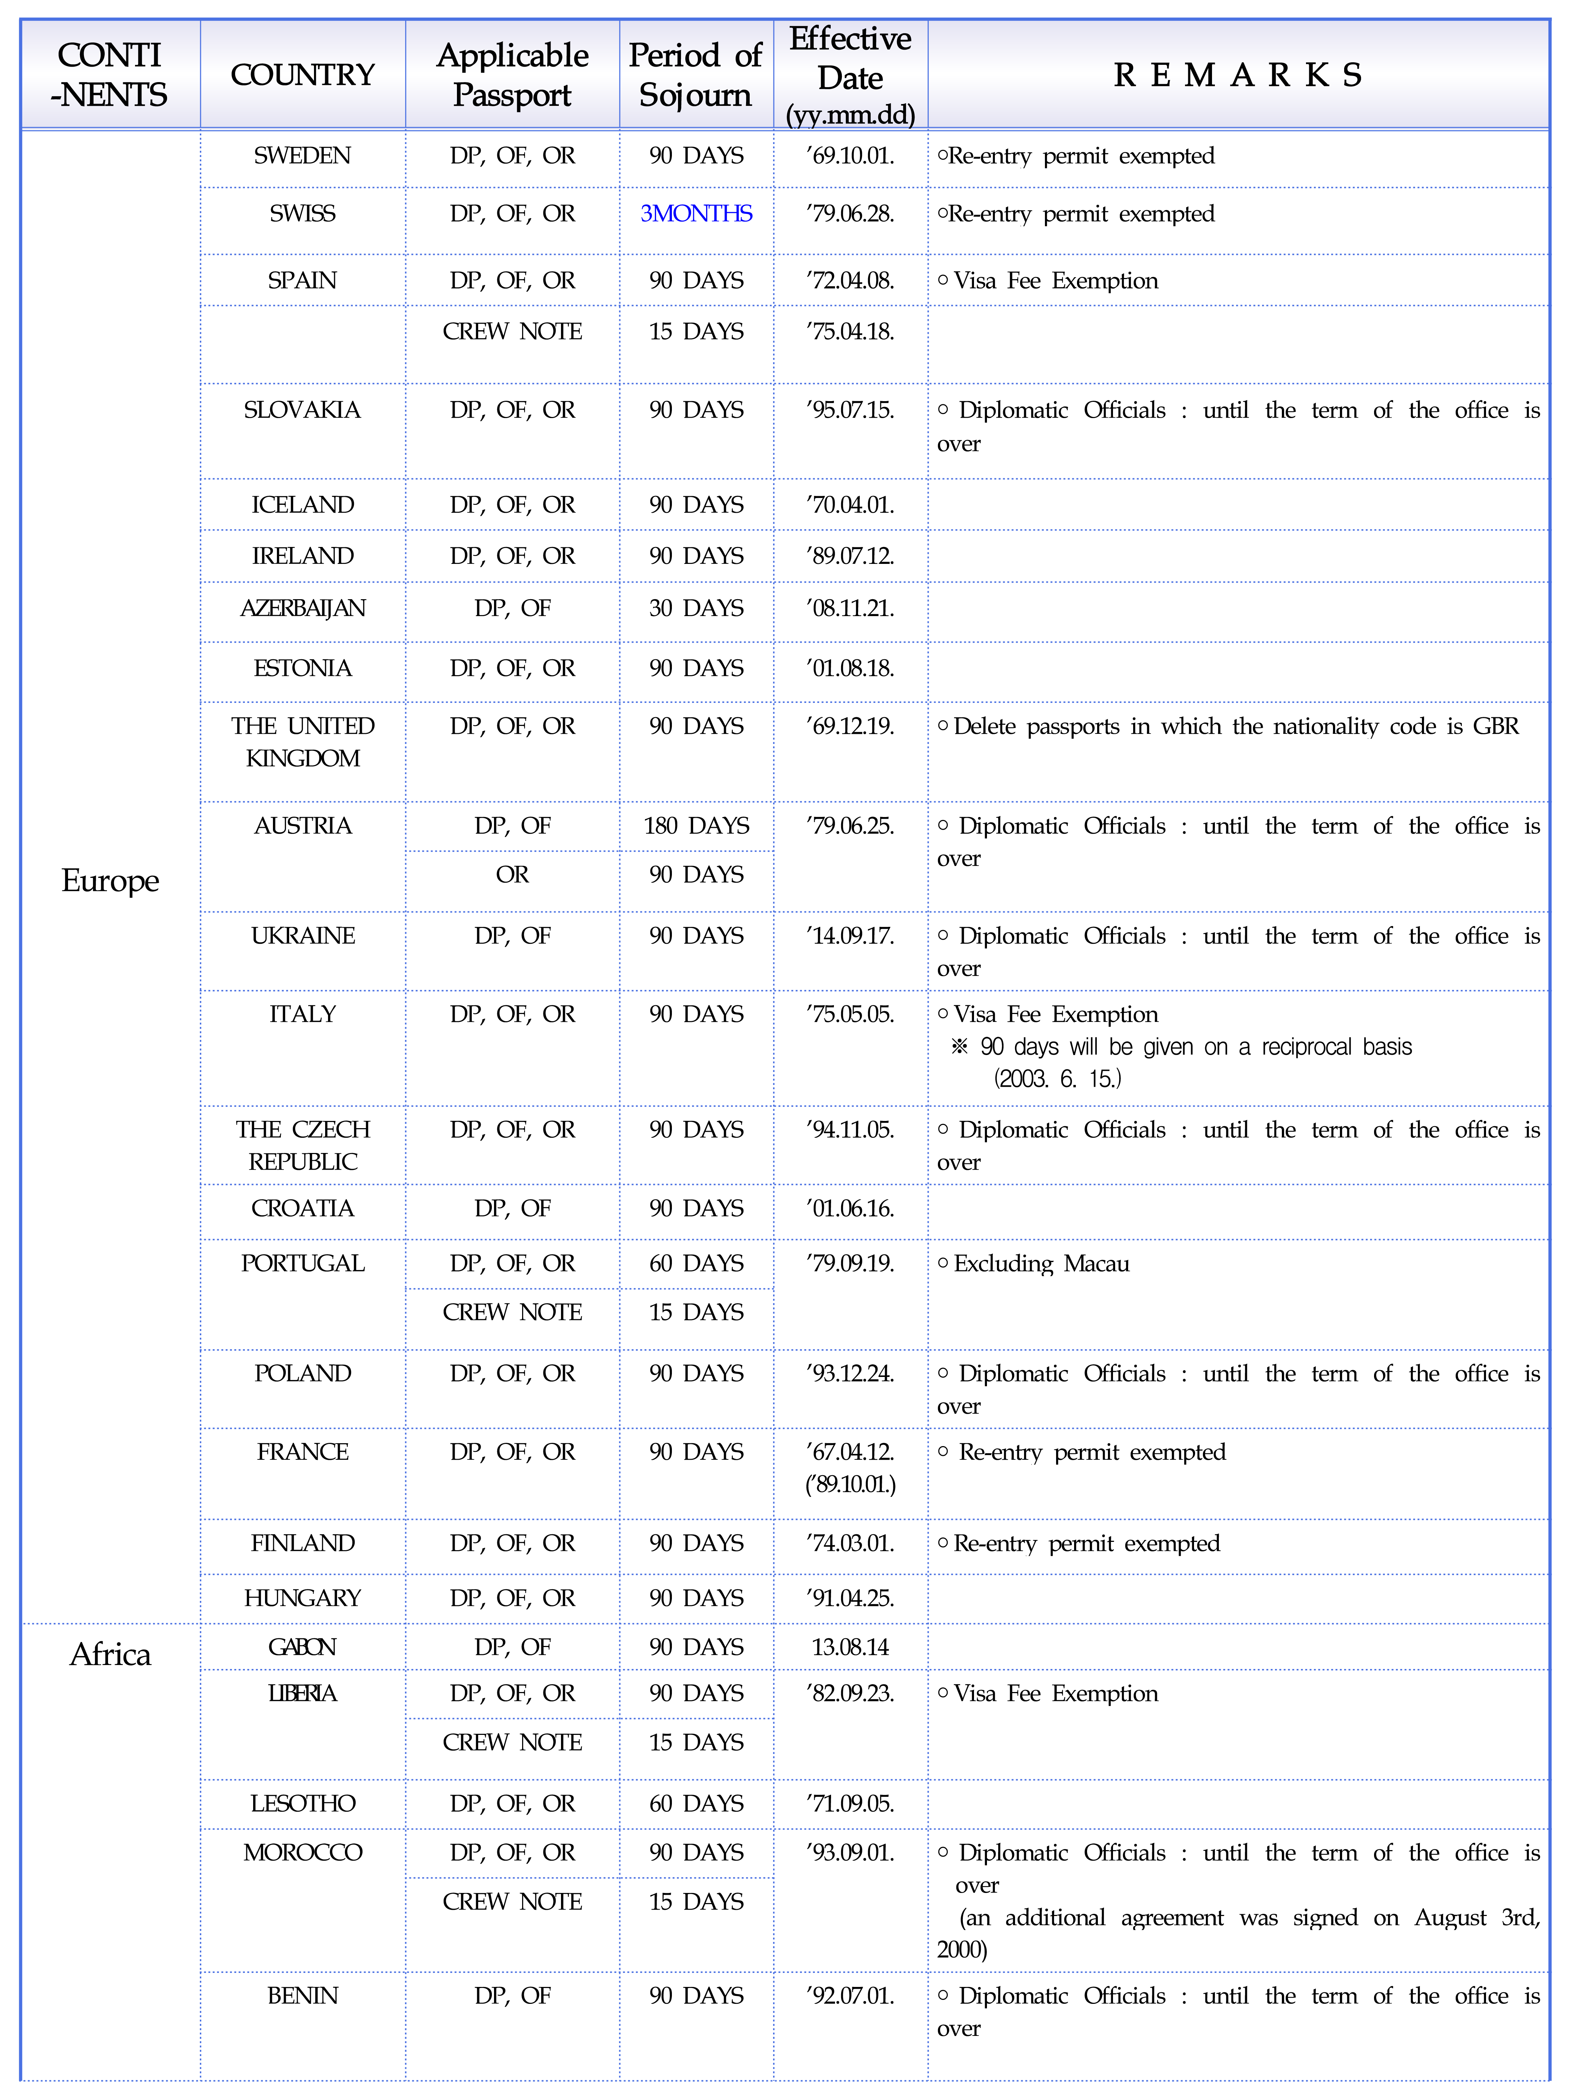
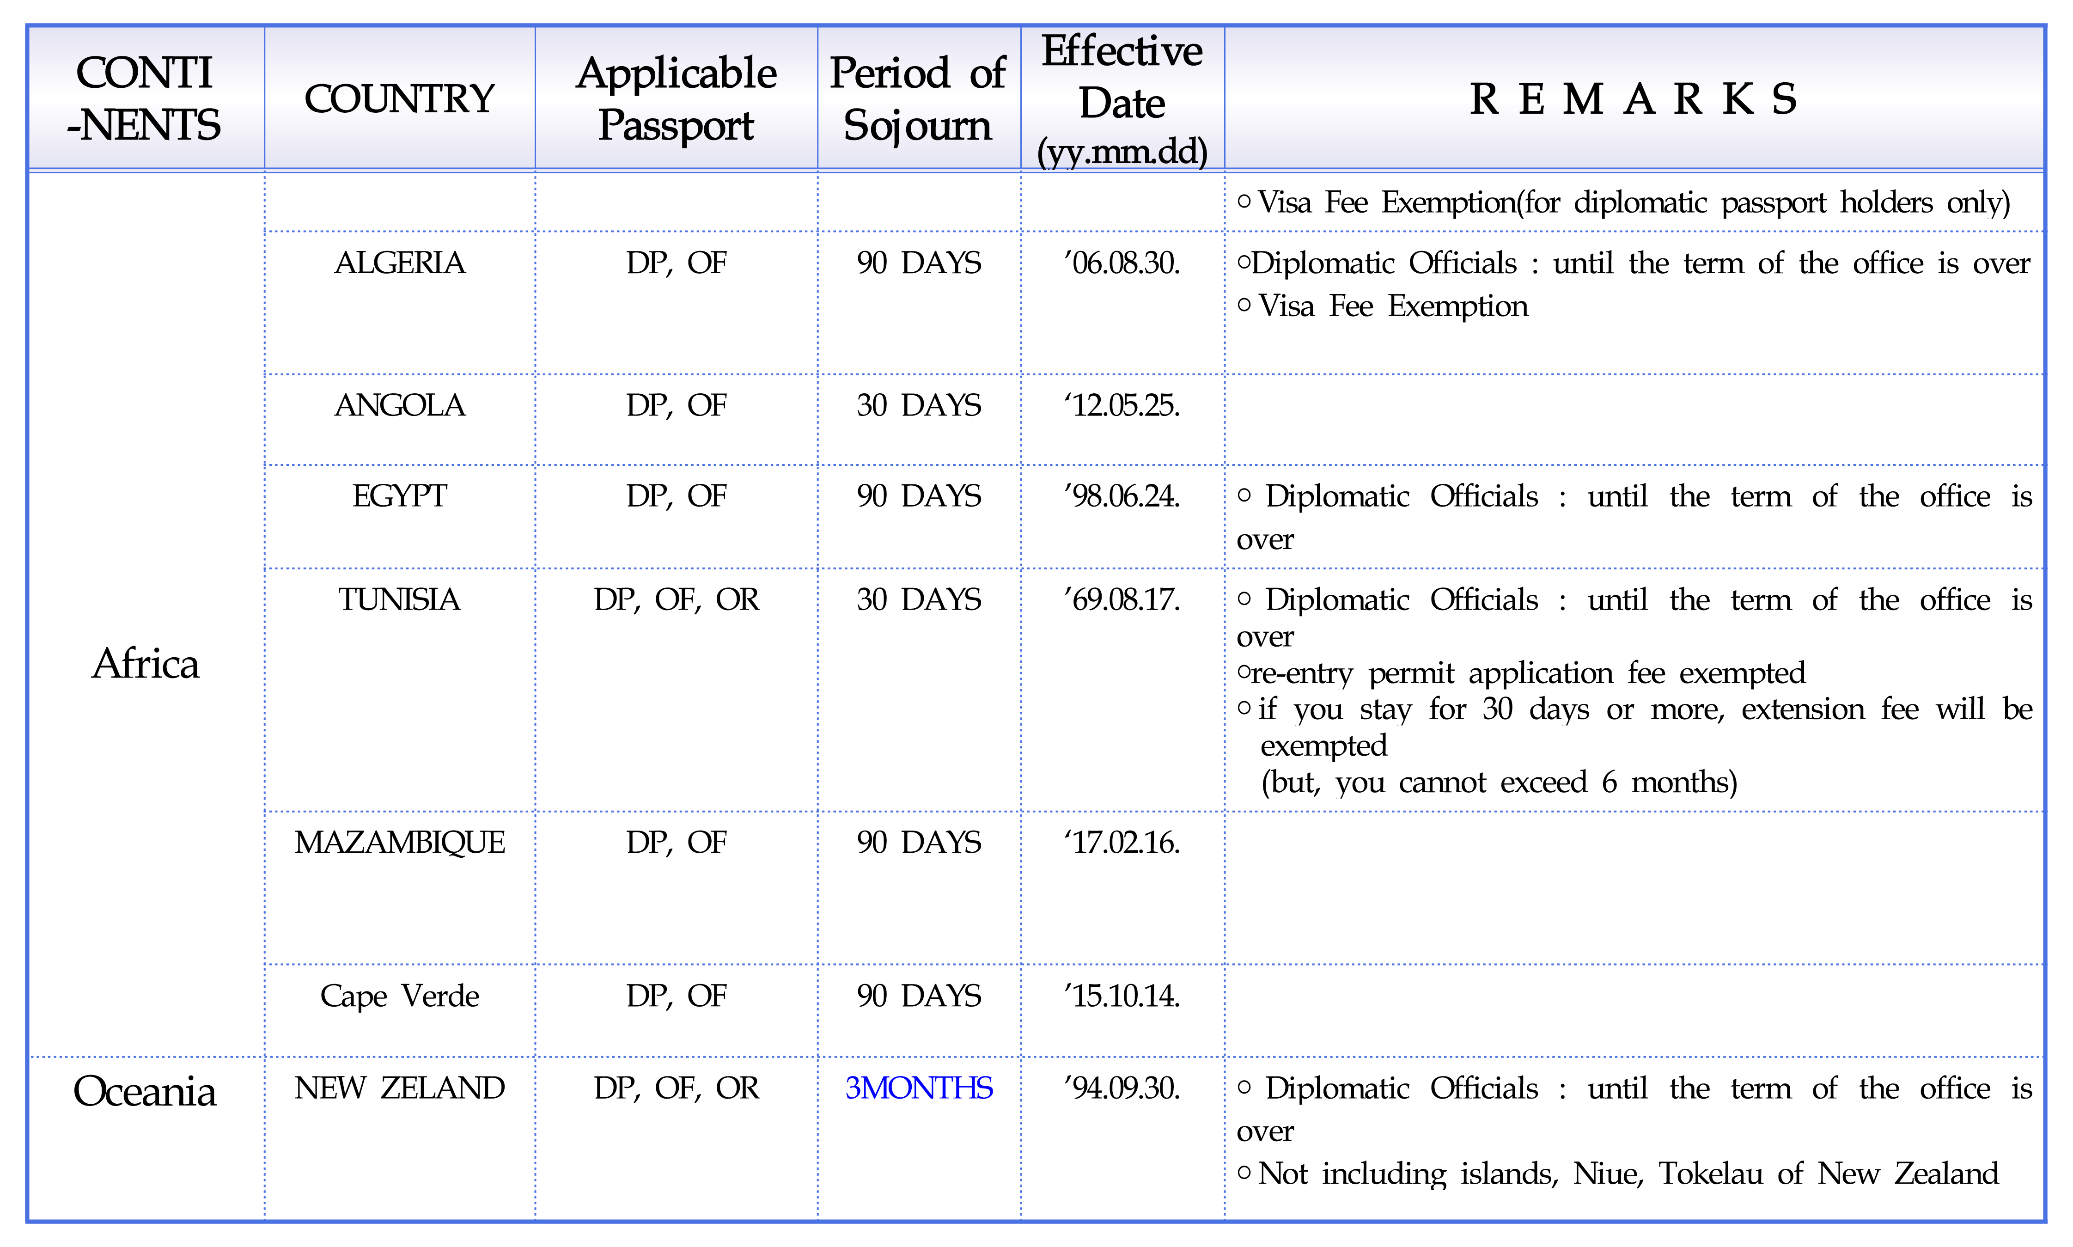

ANNEX C DESIGNATED VISA-FREE ENTRY
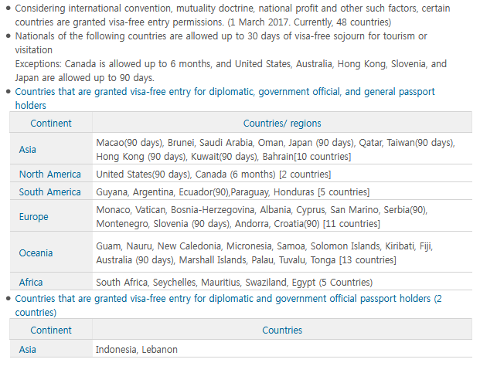

ANNEX D RECOMMENDED HOTELS
Please book your hotel room through the link: http://www.hntjeju.co.kr/?mid=KR02&miceId=38
Five-star hotels
LOTTE HOTEL JEJU*****
500 rooms. Lotte Hotel Jeju is a luxury resort of Lotte Hotels & Resorts, which opened in 2000 in the heart of the Jungmun Tourism Complex. The hotel features a total of 500 rooms, 9 restaurants, 6 banquet halls, a fitness centre, a casino reserved for foreigners, a duty-free shop, and diverse convenience facilities. The hotel buildings are mostly spread across sloping land, granting the majority of the rooms a spectacular view of the charming gardens and the open sea.
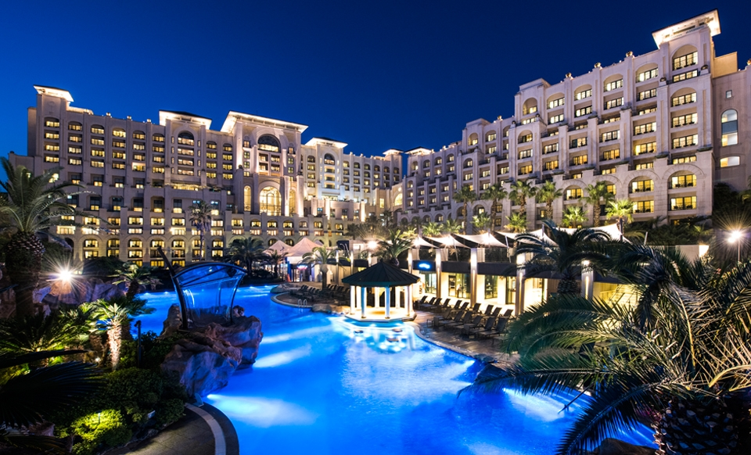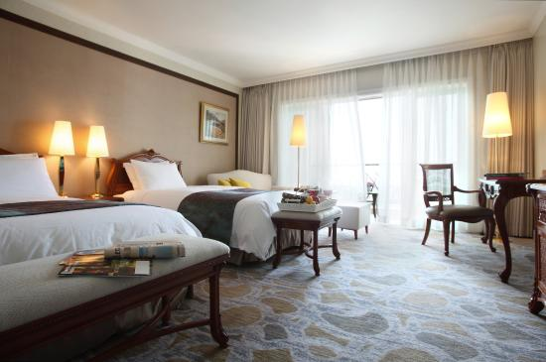 | Tel: (82) 64 731 1000/ Fax: (82) 64 738 7305  http://www.lottehotel.com/jeju/en
THE SHILLA HOTEL*****
429 rooms. The Shilla Jeju is the Republic of Korea’s best resort hotel harmonized with world-famous artworks, a tropical garden, and refined, wonderful services. The hotel has six restaurants, eight banquet halls, a casino, spa, and fitness center.
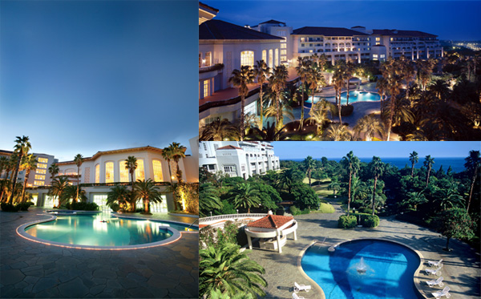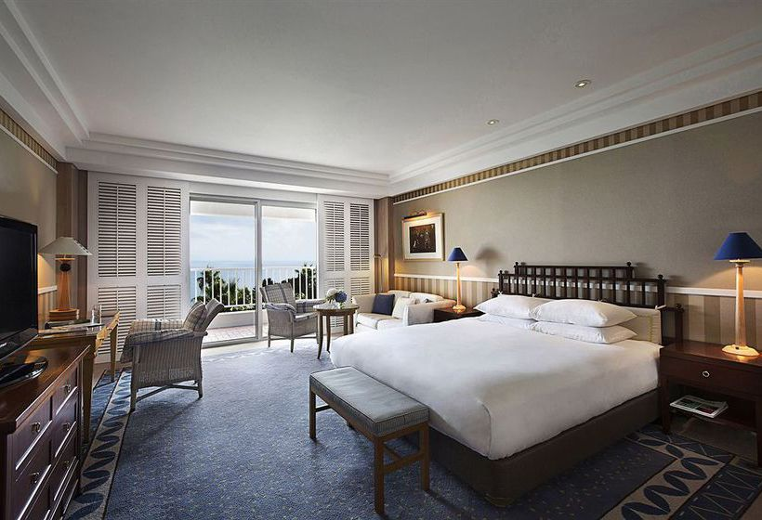 | Tel: (82) 64 735 5114/ Fax: (82) 64 735 5415  http://www.shilla.net/jeju
JEJU BOOYOUNG HOTEL & RESORT*****
449 rooms. As the largest convention hotel in the Jeju area, the hotel has four restaurants, six banquet halls, a fitness center, and a beach path for walks as well as a good view of the emerald-colored sea. 262 hotel rooms and 187 resort rooms are available. It is located right next to the ICC Jeju.
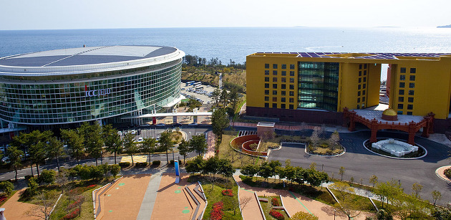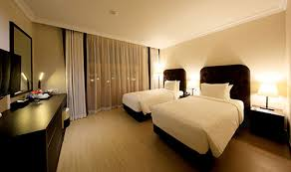 | Tel: (82) 64 731 5500  http://www.booyoungjejuhotel.com
SEAES HOTEL & RESORT*****
27 rooms. Located in the Jung-mun resort, in beautiful Jeju Island, SEAES Hotel & Resort covers a space of 43,000 m², immersed in nature, with rooms that are at once modern and traditional in an exclusive villa. Rooms with a direct ocean view, including ten traditional, elegant rooms with Jeju stone walls and thatched roofs, beautiful gardens, pond fountains and an outdoor bath.
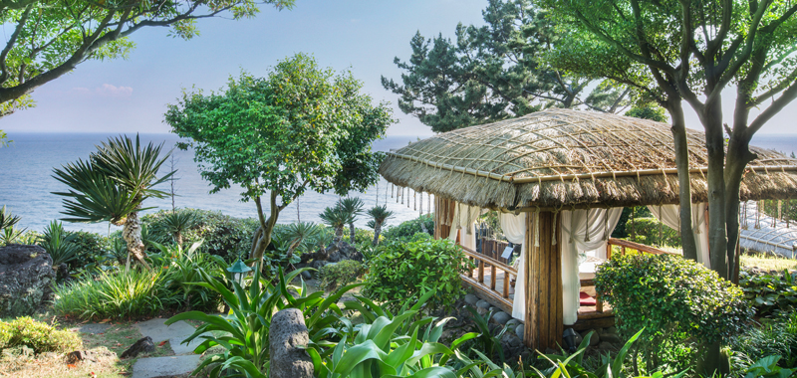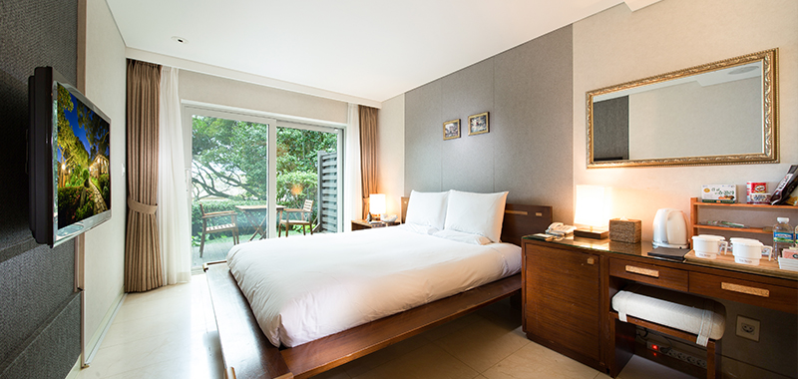 | Tel: (82) 64 735 3000/ Fax: (82) 64 735 3003  http://www.seaes.co.kr
HIDDEN CLIFF HOTEL & NATURE*****
250 rooms. Hidden Cliff Hotel and Nature, opened in 2016, offers a pristine experience thanks to its location within the Yere ecological conservation area, which embraces the vitality of a natural reserve. The hotel provides three restaurants, an infinity pool, a L’OCCITANE spa and a fitness center.
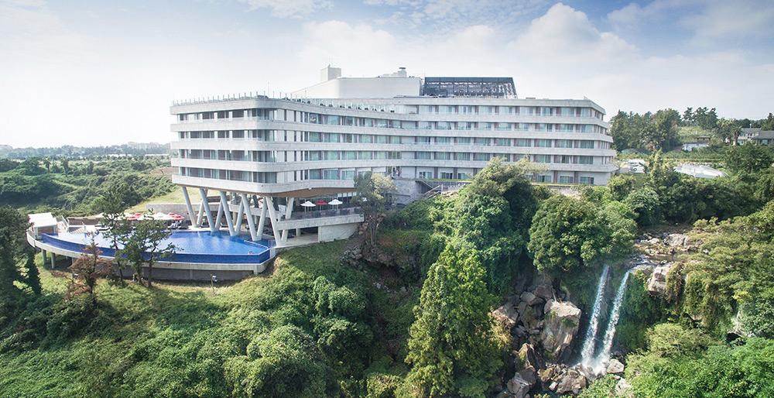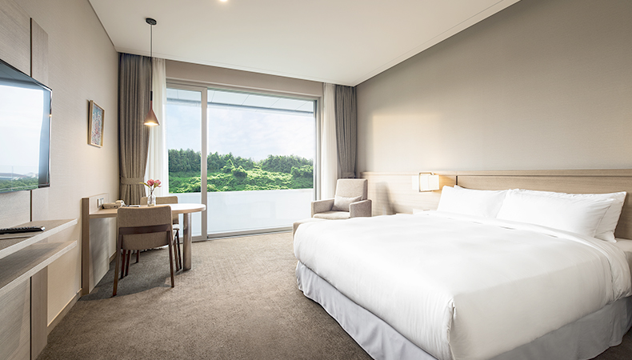 | Tel: (82) 64 752 7777  Reservation: (82) 2 2277 9999  Email: info@hiddencliff.kr  http://www.hiddencliff.kr
HYATT REGENCY HOTEL*****
222 rooms. Hyatt Regency Jeju is a luxury resort hotel located in the Jungmun Tourism Complex of Seogwipo City, near the ICC Jeju, which makes it ideal for business and leisure guests alike. In addition, all guestrooms have private balconies offering panoramic views of Jeju’s natural surroundings.
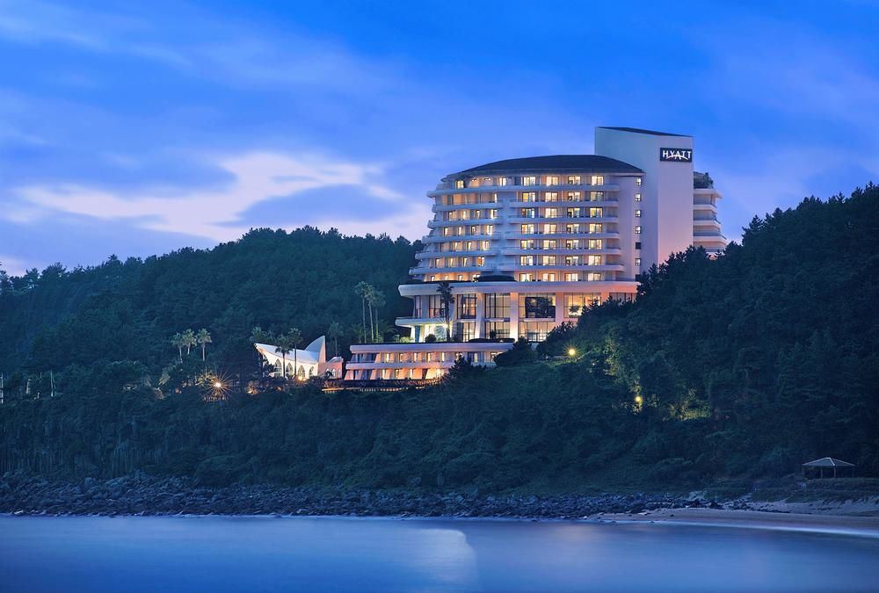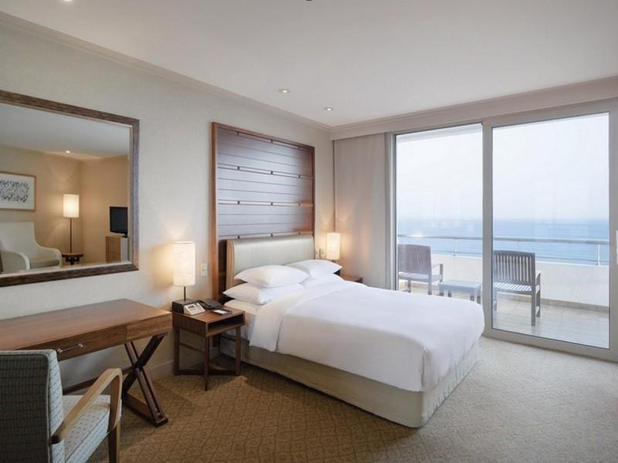 | Tel: (82) 64 733 1234/ Fax: (82) 64 735 8635  Email: jeju.regency@hyatt.com  https://jeju.regency.hyatt.com/en/hotel/home.html
THE SUITES HOTEL JEJU*****
90 rooms. A European-style building and cozy yet modern interior make the Suites Hotel a unique and elegant choice for your stay. Located in the Jungmoon Tourism Complex in Jeju, the Suites Hotel Jeju offers you easy access to all the magnificent attractions in Jeju Island. Our hotel rooms are refreshing and spacious.
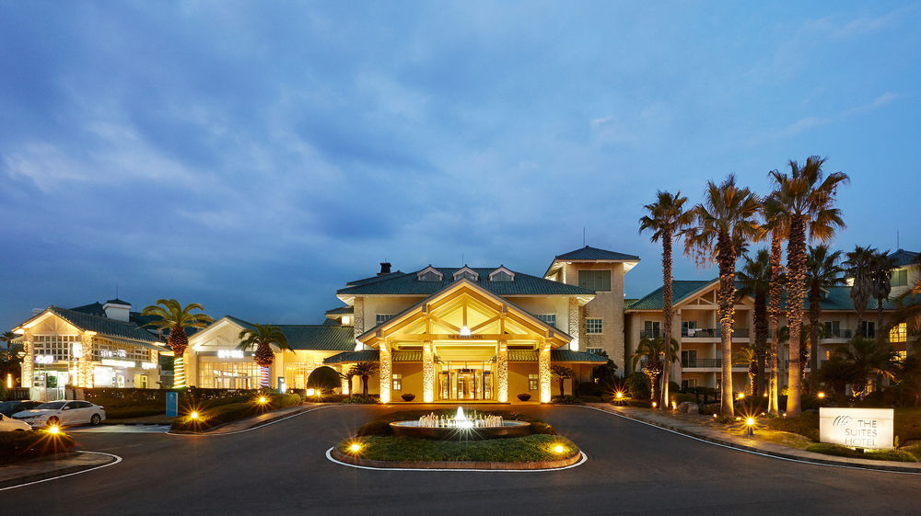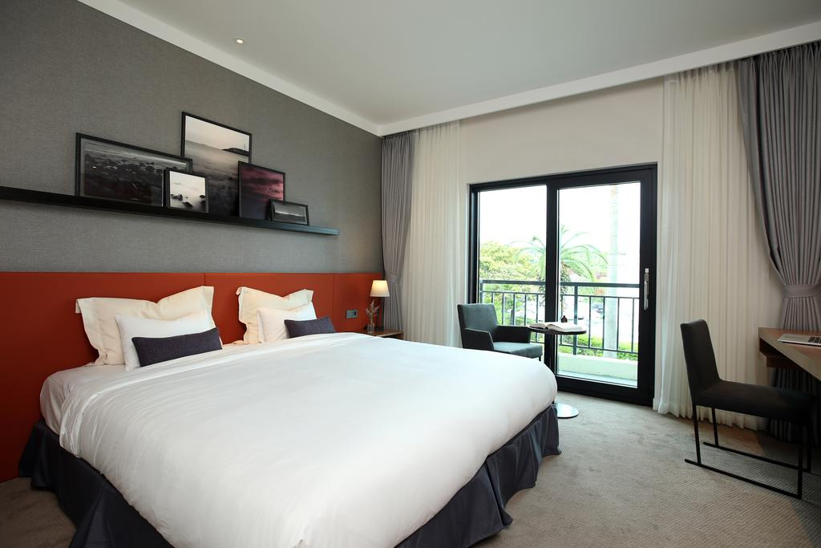 | Tel: (82) 64 738 3800/ Fax: (82) 64 738 8080  jeju@suites.co.kr  http://www.suites.co.kr/Jeju/eng/indexE
KENSINGTON HOTEL*****
221 rooms. Kensington Jeju Hotel is famous for its rooftop infinity pool (Skyfinity) and its ‘Four Seasons Garden’. The hotel facilities include three conference halls, eight restaurants, a sauna, fitness club, spa by Thalgo, and a duty-free-style shop.
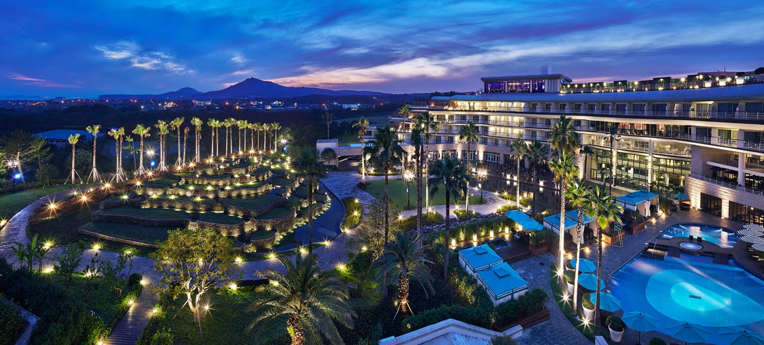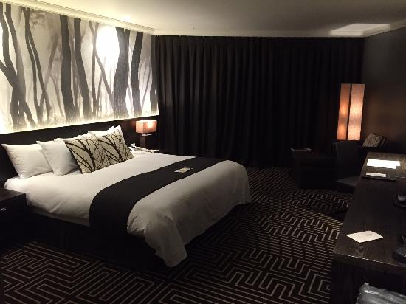 | Tel: (82) 64 735 8900/ Fax: (82) 64 735 8940  http://www.kensingtonjeju.com/En

Four-star hotels
RAMADA ENCORE JEJU****
243 rooms. The hotel was opened in 2015. It boasts an ideal location in the heart of the Seogwipo area, and within easy reach of government offices and exquisite sightseeing places in Jeju Island. The hotel provides a fitness center, high-speed internet, a free shuttle service to and from the airport, 24-hour room service, and parking space.
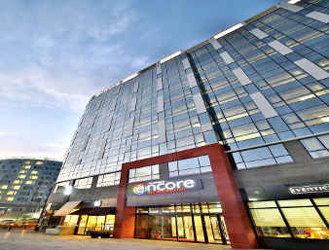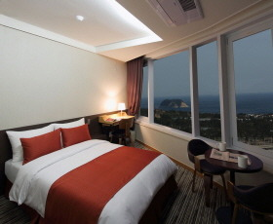 | Tel: (82) 64 735 2000/ Fax: (82) 64 735 2020  http://www.ramadaencorejejuseogwipo.com
BAREVE HOTEL JEJU****
204 rooms. This hotel opened in 2014 and is located in the centre of the Seogwipo area. It provides 204 rooms, a fitness center, a therapy service and high-speed internet.
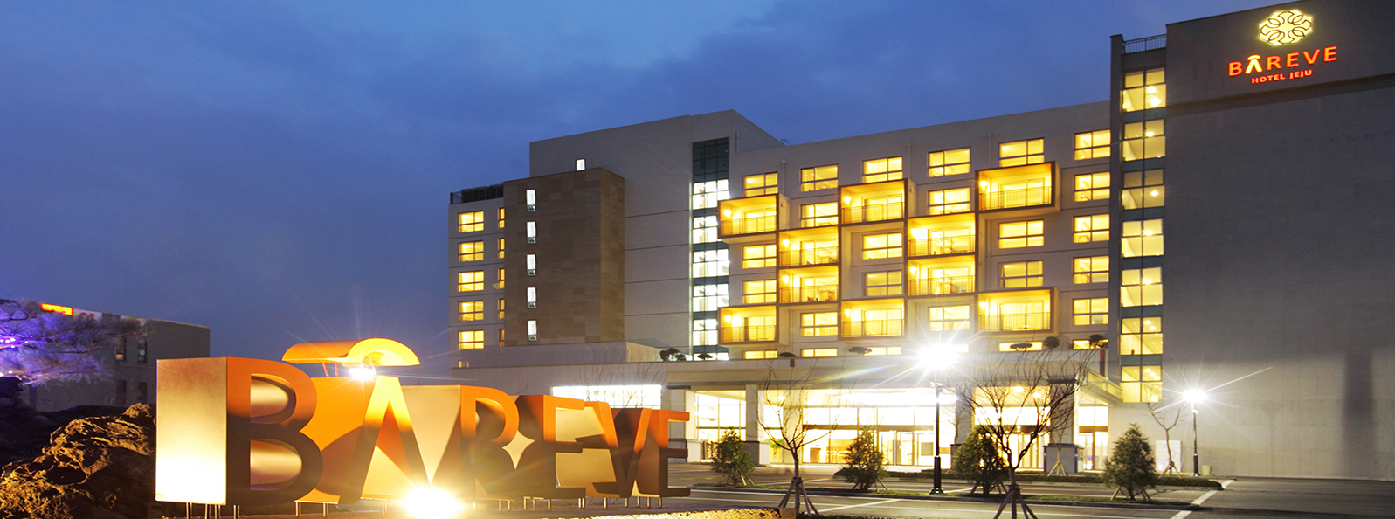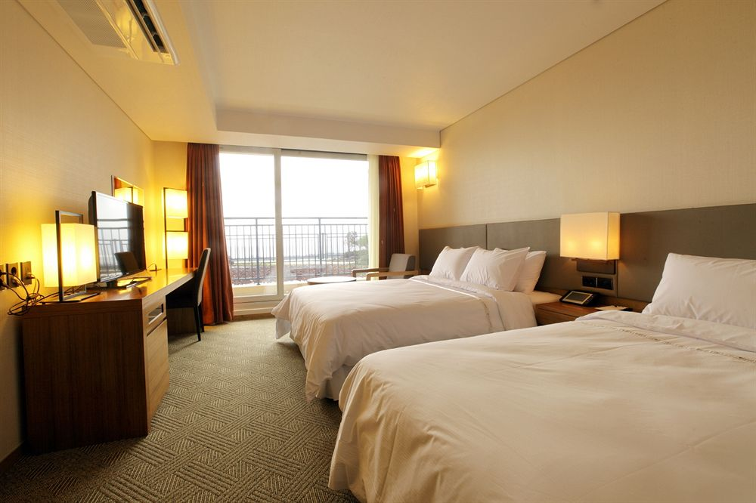 | Tel: (82) 64 735 8899/ Fax: (82) 64 735 8888  http://www.barevhotel.com
HOTEL THE BORN****
139 rooms. Hotel The Born Jeju is located north of the Jungmun Tourist Complex. It provides both western and traditional Korean-style guest rooms. Each room comes with Wi-Fi, air conditioning and a flat-screen TV.
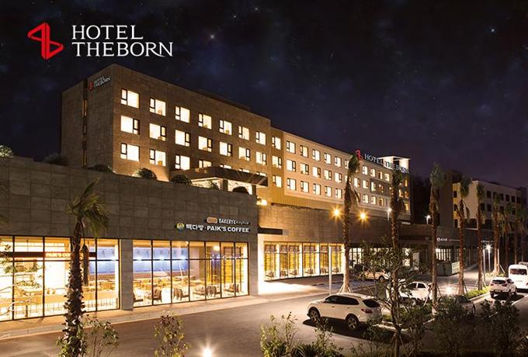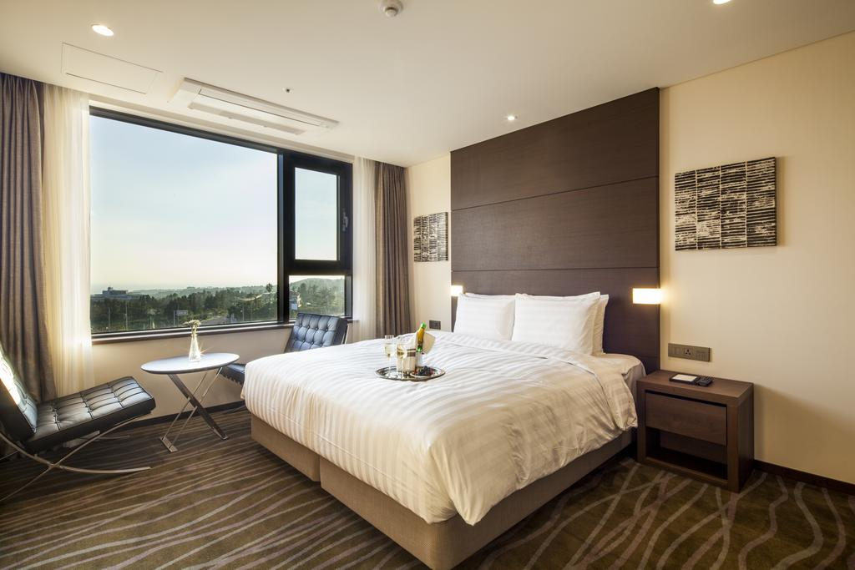 | Tel: (82) 64 766 8903~4/ Fax:(82) 64 766 8989  http://www.hoteltheborn.com

