Unit 28

Participatory mapping in inventorying
Published in 2016 by the United Nations Educational, Scientific and Cultural Organization, 7, place de Fontenoy, 75352 Paris 07 SP, France

© UNESCO 2016

This publication is available in Open Access under the Attribution-NonCommercial-ShareAlike 3.0 IGO (CC-BY-NC-SA 3.0 IGO) license (http://creativecommons.org/licenses/by-nc-sa/3.0/igo/). By using the content of this publication, the users accept to be bound by the terms of use of the UNESCO Open Access Repository (www.unesco.org/open-access/terms-use-ccbyncsa-en).

The designations employed and the presentation of material throughout this publication do not imply the expression of any opinion whatsoever on the part of UNESCO concerning the legal status of any country, territory, city or area or of its authorities, or concerning the delimitation of its frontiers or boundaries.

The ideas and opinions expressed in this publication are those of the authors; they are not necessarily those of UNESCO and do not commit the Organization.

Lesson plan

Duration:
3 hours

Objective(s):
Participants will be able to describe, differentiate and conduct ground and sketch mapping, as well as explain the characteristics, strengths, weaknesses, opportunities and risks of both.

Description:
This unit introduces different kinds of mapping, including ground and sketch mapping, and the potential uses of these techniques as effective tools for exploring the spatial and territorial aspects of a community’s intangible cultural heritage (ICH). It analyses concrete examples of why and how mapping can be used in community-based inventorying and includes relevant exercises.
Proposed sequence:
- Ground mapping
- Sketch mapping
- Map legend
- Transect walk
- Mental map analysis
- Stengths
- Weaknesses
- Exercise 1: Map your neighbourhood
- Exercise 2: Mental map analysis
- Exercise 3: SWOR (strengths, weaknesses, opportunities and risks) analysis

Supporting documents:
- Unit 28 PowerPoint presentation
Notes and suggestions
This unit is adapted from CTA. 2010. Training Kit on Participatory Spatial Information Management and Communication. CTA, The Netherlands and IFAD, Italy (ISBN: 978-92-9081-446-7):
Exercise 1: Map your neighborhood and Exercise 2: Mental map analysis are adapted from Pretty, J. N., Guijt I., Thomposon J., and Scoones, I. Participatory Learning and Action: A traininer’s guide. IIED Participatory Methodology Series. International Institute for Environment and Development, London 1995. http://pubs.iied.org/6021IIED/

Unit 28

Participatory mapping in inventorying

Facilitator’s narrative

Slide 1.
Participatory mapping in inventorying
This unit introduces the participant to the basics of participatory mapping.
Participatory mapping is a process and tool used to visually convey the spatial relationships related to a particular ICH element. Maps are powerful tools that make it easier to identify and define ICH elements, and to present them in a simple and visually realistic way to a broad range of stakeholders.

Slide 2.
In this presentation…
This unit introduces different kinds of participatory mapping, including ground and sketch mapping, and presents the potential uses of these techniques as effective tools for exploring the spatial and territorial aspects of a community’s ICH. It analyses concrete examples of why and how mapping can be used in inventorying and includes relevant exercises.
- Ground mapping
- Sketch mapping
- Map legend
- Transect walk
- Mental map analysis
- Strengths
- Weaknesses

Slide 3.
Introduction
Participatory mapping first emerged as a tool used in participatory rural appraisal (PRA) methodology. However, its emphasis on transparency and the involvement of whole social networks and multiple voices in map-making makes it quite applicable to inventorying. Maps can also be used to help communities find new ways to manage the intergenerational transfer of knowledge and culture.
Some communities have long been engaged with map-making in relation to their ICH. For example, the Aboriginal peoples of Australia have a long tradition of producing ICH maps that reflect their understanding of their landscapes through the movement of ancestors and mythical creatures. Their maps are related to songs, family territories, and to nature and spiritual resources etched on and under the landscape.
In South Africa, for example, the South African San Institute (SASI) has worked in cooperation with Strata360 and Open Channels to assist the ‡Khomani San community to map land relevant to their land claim and the revival of their cultural heritage. One aspect of the mapping is the identification of individual trees and landscape features relevant to understanding the cultural heritage and occupancy of the area. Although there are quite a few trees in the Southern Kalahari, they are nonetheless deemed precious in the desert environment. Each tree is an ecological zone of its own. It creates much-needed shade and traps moisture that can be used by animals, insects and even humans. But each tree is also a cultural space. Through recollections and memories, each tree carries with it stories of burials, child rearing, food gathering, love affairs and so on. For these hunter-gatherers, there is no formal separation into natural spaces and cultural spaces. The natural world is imbued with stories, myths, values, dreams and rituals. The artists are community elders and though the canvases have survived for generations they can also be easily lost.
To be participatory a mapping exercise must meet the inventorying needs of a community and be driven by their culture and priorities. A mapping facilitator helps to explain the techniques involved and foresees potential problems or the need for adjustments during the process.
More broadly, participatory mapping provides an opportunity not only for greater recognition of oral cultural and intangible heritage, but also a medium to explain the relationship between different cultural heritages and the territory and natural resource contexts in which they arise, survive and are passed on to future generations. Participatory mapping can strengthen the ability of communities to manage their ICH, while also encouraging respect and understanding from dominant groups.
Note to facilitator:
The facilitator may wish to share a major theme that emerged during the Nessuit case relative to cultural and participatory mapping. The facilitators noted that the majority of community participation was male. The women elders tended to watch the process, comment among themselves, indicate to their husbands when they did something wrong, and when the men went to eat, the women would approach the map and modify it. It was suggested that the women have their own space and time for mapping. Women’s knowledge may overlap with men’s knowledge, but in certain domains they are exclusive knowledge holders. However, in another case, having women work on the models alone created conflict within the community and the women suffered as a result. Community dynamics must always be taken into consideration. The topic of participation could also be returned to during the slides on strengths, weaknesses, opportunities and risks (SWOR).

Slide 4.
Ground and sketch mapping
Ground and sketch maps are powerful tools that make it easier to identify and analyse place-based patterns and communicate those patterns in a simple and visually realistic way to a broad range of stakeholders. Ground and sketch maps offer local communities a means of spatially visualizing their knowledge and perceptions of ICH. This stimulates exchange of information and helps to equalize opportunities for all community members to participate in inventorying their ICH.
These methods are characterized by limited accuracy in scaling and geo-referencing. They do, however, offer the simplest approach for local communities wanting to depict their mental maps and perceptions. Because sketch mapping uses large sheets of craft paper and ground mapping uses soil, these methods are low-cost, not technologically dependent, and easily facilitated and appropriated by the participants.
Ground and sketch mapping, unlike other mapping methods such as aerial photography, global positioning systems (GPS) and participatory 3D modelling (P3DM), do not offer any prior information cues to guide participants in locating data; they start with blank media.

Slide 5.
Ground mapping (1)
Ground mapping is the most basic map-making method. Informants use raw materials such as soil, pebbles, sticks and leaves, depending on availability, to create maps on the ground. The choice of materials may be influenced by culture, religion and geographic location. For example, some communities will not use certain parts of plants because of cultural barriers.

Slide 6.
Ground mapping (2)
Ground maps allow participants to store acquired knowledge as mental maps, and then mentally recompose it as needed. They can be used to map physical and cultural landscapes as the local communities perceive them to be, and may be used as a first step towards creating a sketch map.
Note to facilitator:
Physical landscape refers to topographic and natural features. Topographic features include hills, valleys, plains and shores. Natural features include soils, water (e.g. rivers, lakes), plants and animals. Cultural landscape refers to features that shape the social values, norms, practices and spirituality of a community. These include sacred sites, dancing sites and circumcision sites.

Slide 7.
Sketch mapping
Sketch mapping is more elaborate than ground mapping: it uses portable media (i.e. paper) and requires that information be written.
Natural features can be depicted on the map using items from nature (e.g. leaves, twigs and stone). Community members have a range of choices regarding the materials to use for the sketch map and the symbols to use to visualize desired features. The size of each feature may also reflect the importance that community members attach to it. This is the case for both ground and sketch mapping.
If properly facilitated, the process is documented and features are recorded on a legend necessary for interpreting depicted symbols. Since data are not scaled consistently or geo-referenced, there is room for subjective interpretation of the final output.
In sketch mapping, and to some extent, ground mapping, technical preparation requires that the facilitator assemble and confirm the adequacy of mapping materials, orientate the participants with respect to direction, and ensure agreement on mapping extent and the corresponding size of the map.
Logistical preparation requires that the facilitator help select the mapping venue, determine a suitable number of participants and the composition of the group (e.g. gender, professional experience and knowledge of the ICH element), identify the mapping space and suggest ways for the participants to arrange themselves (e.g. sitting in circle, etc.).

Slide 8.
The map legend
Participants are invited to sketch their mental maps and perceptions on the ground or on craft paper. The space-related features they visualize may vary depending on the type of participants (e.g. men or women, young or older members).
An accompanying legend is created that uses agreed-upon symbols, which represent various themes (e.g. land cover/use, infrastructure, aspects related to the ICH element) and features (e.g. lines, points and areas).
Using the symbols in the legend, participants depict their mental maps and perceptions on the medium (i.e. soil surface or craft paper) with cartographic themes and features. The idea, however, is to keep sketch and ground maps relatively simple by limiting the legend variables to a minimum.
The map legend can be a stand-alone document or can be drawn within the map.

Slide 9.
Transect walk
Once the participants have completed the mapping process, they can undertake a transect walk to observe whether actual features match those marked on the sketch map. This is sometimes known as ‘groundtruthing’. Transect walks are also a means of facilitating in-depth discussion. With the aid of a completed sketch map (this is not possible for ground maps), participants take a few cross-sectional directions that best represent the ICH element under consideration in the mapped area. The transect walk may also aid in developing a narrative or pictorial description of the cross-sectional findings.
Transect walks may help to:
- harmonize stakeholders’ understanding of the mapping context;
- elicit observations and confirm the field realities of mapping outputs;
- elicit a reality-based discussion about the ICH element, constraints on mapping and inventorying, and the potential for addressing such issues;
- map ICH features and related issues; and
- monitor ICH.
Communities can incorporate the results of their transect walks back into the sketch maps, or design new maps based on the information collected concerning the ICH element.

Slide 10.
Mental map analysis
Everyone has biases in visualizing maps. Good facilitation requires listening to the community members who are doing the mapping and facilitating the transposition of their ICH element onto the map.
Once the map is complete, participants can perform a mental map analysis to determine such characteristics as position, patterns, trends and relationships. Mental map analysis helps to answer key questions such as ‘What else is in the area?’, ‘Where is the ICH element located in the area?’, ‘What are the attributes of the ICH element?’, ‘How are the various ICH elements spatially related?’ and ‘What are the time and space-related trends?’
These questions may be answered through facilitated discussions aided by the mapped features. The group can then present its findings during a plenary session. Discussions of such questions can assist the successful inventorying of ICH elements.

Slide 11.
Strengths of mapping
- Local communities take a leading role in:
- generating local and indigenous knowledge, and
- visualizing spatial perceptions of ICH elements
- Engages non-expert users;
- Stakeholders can relate to mapping products;
- Low-cost approaches to mapping;
- Not technologically dependent; and
- Easily facilitated because of their tactility.

Slide 12.
Weaknesses of mapping
Participatory mapping has a number of weaknesses:
- Ground and sketch maps lack accuracy because they do not rely on exact measurements or a consistent scale.
- As a result they:
- are not useful for location and quantitative accuracy;
- are not used to determine quantitative measurement (e.g. size, area, length); and
- may lack authority with certain stakeholders.
- Interpretation is subjective because the data do not use a consistent scale. Features can look large or small, elongated or constricted, depending on community perceptions of relative importance, walking time or frequency of visits and security issues, among other social considerations. However, this may also be perceived as a positive feature.
- Ground and sketch maps are short-lived: ground maps are temporary in character and sketch maps fade with natural aging of the craft paper and the materials used. Sketch maps can, however, be scanned and superimposed on a geo-referenced map, but accuracy and precision are likely to be poor.

Slide 13.
Participatory mapping
Participatory mapping presents a variety of opportunities:
- Well-planned ground and sketch mapping can stimulate the sharing of traditional knowledge and practices between elders and youth and/or children. Information and knowledge concerning ICH elements are transmitted as elders narrate their mental maps and perceptions to youth and/or children who transcribe them on a ground or sketch map. Youth and children may ask questions about the knowledge and practices relative to the ICH element and express their perceptions. As such, the resulting map reflects the dynamic nature of inventorying and, more broadly, safeguarding.
- Photographs or video footage can document the ground or sketch-mapping process and the resulting maps. Although digital capture does not improve map accuracy or precision, it does increase the potential for collecting and presenting ICH elements.
Participatory mapping may also include risks:
It is important to raise awareness about the risks associated with mapping. Some components of a community’s knowledge or cultural landscape may be sacred or confidential, and should not be represented on maps for external viewing. Here are some examples:
- In Kenya, only people who have been through ritual circumcision can learn about certain sacred sites, certain applications of pharmacology and the identities or stories of certain sacred trees.
- In Gabon, identifying a specific family sacred tree for a non-initiated person can have dire consequences. Uninitiated people (children and non-locals) should not touch elements of, speak about or deal with mysteries related to forest spirits.
- In Botswana/Namibia, knowledge of San women’s menstrual rituals is kept secret from men. Women are also not meant to handle or deal with hunting implements or the hunt itself.

Source: Muchemi J. and ERMIS-Africa 2010. Handout for Trainee. Unit M08U01, Module M08: Ground and Sketch Mapping; in “Training Kit on Participatory Spatial Information Management and Communication”. CTA, The Netherlands and Ifad Italy

Unit 28

Exercise 1: Map your neighbourhood

Objective:
To practise mapping, including scale, symbols and direction and discuss processes and omissions in mapping.

Time:
1 hour

Materials:
Marker pens, large sheets of paper, masking tape and scissors.

Procedure:
- Ask participants to think about where they live and to draw their neighbourhood. They should include major landmarks, resources of importance and transport routes.
- After ten minutes, stop the drawing and discuss the results (see debriefing questions below).
- Ask for all maps to be exhibited on the wall, so that everyone can observe and discuss the different styles and symbols.

Tips and options:
- This exercise conveys some essential issues in a short time and can therefore be used as an introduction to mapping. To start the process, the facilitator should suggest that he or she is travelling to the participants’ houses and requires a map. It should be noted that this suggestion inevitably biases the drawn maps.
- The following questions can help the debriefing process:
- Where did you put your house? (e.g. in the middle, at the edge)
- Did you use only symbols or did you add words? (Assuming that the participant is literate.)
- What happened when you came close to the edge of the paper? (e.g. the edge of the paper is a false boundary, scale gets distorted, elements get omitted)
- What did you draw first? (e.g. sometimes the house, sometimes the boundary)
- Which direction is north on your map? (Some individual mental maps may indicate north at the top, following the widely used professional convention, but probably only by chance.)
- Which of you have lived in your house for more than five to ten years? How does your detailed knowledge compare with someone who has only just moved to his or her neighbourhood?
- A possible variation on this exercise is to ask participants to draw the neighbourhood in which they lived at the age of 10.
Source: 2010. Exercise No.1: Map Your Neighbourhood. Unit M08U01, Module: Ground and Sketch Mapping; in “Training Kit on Participatory Spatial Information Management and Communication”. CTA, The Netherlands and Ifad Italy, adapted from: Pretty N. J., Guijt I., Scoones I., Thomposon J., A trainer’s Guide for Participatory Learning and Action. IIED Participatory Methodology Series. Published by the International Institute for Environment and Development, London 1995. p. 234.

Unit 28

Exercise 2: Mental map analysis

Objective:
To discover what maps tell about the people who drew them, to illustrate that different groups of people within communities have different perceptions, and to demonstrate the validity of these different views and the importance of acknowledging and understanding multiple perspectives and priorities within communities.

Time:
1–2 hours, depending on the number of examples given for analysis.

Materials:
Prepared maps copied onto coloured paper, flip charts and marker pens.

Procedure:
- Select maps drawn by local people during an actual field situation or a series of maps of the same subject designed by different sources/people. These could be resource maps or social maps prepared by different groups of local people (e.g. young/old, rich/poor, men/women, etc.). They should be prepared in advance and photocopied onto A4 paper. Make sure that there are enough copies for all participants. Alternatively, divide the participants by sex and have the two groups design a map of the same subject, then compare the results (see the following example assignment).
- Distribute copies to participants arranged in groups. Ask them to analyse the maps, then consider two questions:
- What do the maps reveal about the area or issues?
- What do they tell about the people who drew them?
- Comments should be presented during a group session using flip charts to record the main points.

Tips and options:
Examples should be chosen that show different views of the same reality (see the following example assignment).

Example assignment: Maps of a village in Sierra Leone
The following two maps illustrate the perceptions of a village in Sierra Leone as drawn by a group of men and a group of women, including their proposed changes. The diagrams were drawn on the ground at different times and locations and were then copied onto paper.
The men emphasized the outside of the village and proposed changes where they would be visible to outsiders passing along the road. They emphasized the location of meeting places, such as cotton trees, the long dry log and the broken tractor.
By contrast, the women emphasized the village itself, although with less detail. They emphasized the school and hospital by allocating both places a disproportionately large size.
Women drew the boundary first, men drew the roads.
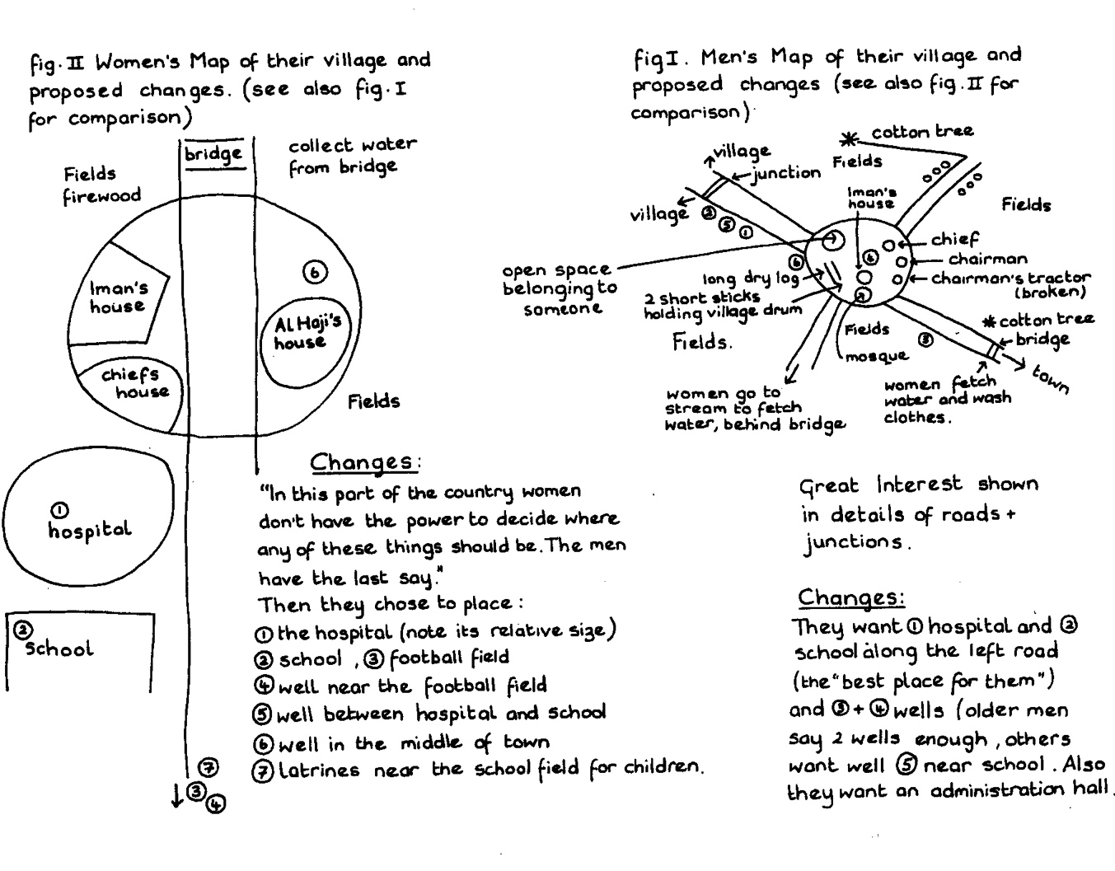
Photo 1
Source: 2010. Exercise No.3: Mental Map Analysis. Unit M08U01, Module M08: Ground and Sketch Mapping; in “Training Kit on Participatory Spatial Information Management and Communication”. CTA, The Netherlands and Ifad Italy, adapted from: Pretty N. J., Guijt I., Scoones I., Thomposon J., A trainer’s Guide for Participatory Learning and Action. IIED Participatory Methodology Series. Published by the International Institute for Environment and Development, London 1995. p. 237.

Unit 28

Exercise 3: SWOR analysis

Objective:
To identify strengths and opportunities of mapping and consider how to optimize these; to identify weaknesses and risks of mapping and discuss strategies to address these.

Time:
1 hour

Materials:
Pin boards or flat wall, two large sheets of craft paper (1.2 m x 1.2 m), twelve meta cards (A5) in four different colours for each participant, masking tape, scissors and pins.

Procedure:
- Distribute meta cards and marker pens to all participants.
- Define with the participants a topic to be analysed (e.g. mapping the ICH element they will focus on during the field practicum). This will be the group’s objective.
- Distribute the assignment below and explain that SWOR is an acronym of strengths, weaknesses, opportunities and risks.
- Display one large sheet of paper labelled with the table below drawn on it.
- Ask the participants to think of all the strengths and weaknesses related to mapping the ICH element and invite them to note these on the cards (one statement per card). Invite them to use one colour of card for ‘strengths’ and another for ‘weaknesses’.
- Gather the cards and stick them to the craft paper under the appropriate heading.
- Repeat steps 5 and 6 for opportunities and risks, using two different colours. Make sure that the issues are identified and clustered properly.
- Ask one participant to read the cards aloud one at a time and encourage discussion on every issue written on the card. While the group is discussing, cluster comparable statements. Make sure that everyone is given the opportunity to speak out and that there is a common understanding of the statements inscribed on the cards.
- Ask if the participants have any more points to add after they have heard everyone else's point of view.
- Facilitate an analysis of the results. Use the following questions to lead the discussion.
- How can strengths be employed to take advantage of the perceived opportunities?
- How can strengths be used to counteract risks?
- How can weaknesses be overcome to take advantage of opportunities?
- How can weaknesses be overcome to counteract risks?
- Give the participants enough time to think through their answers. Post their responses on a separate piece of a paper. These will form the basis for identifying various actions or strategies for mapping the ICH element.
- If two or more similar strategies/actions are identified, ask participants to rank them according to their feasibility, potential for benefit and urgency.
- Discuss the results with the participants and solicit their agreement.
 | Helpful to achieving the objective | Harmful to achieving the objective
Internal factors | S | W
External factors | O | R
Photo 2

Tips and options:
- A SWOR analysis can also be undertaken at different stages of an inventory to:
- plan strategies and action about how to inventory; and
- assess how an existing inventory could be improved.
- Strengths and weaknesses refer to the actual situation.
- Opportunities and risks assess possible future scenarios. Both may include developments within or beyond the control of the community.
- Strengths refer to actual conditions, qualities and resources that enhance inventorying.
- Weaknesses refer to actual conditions, qualities and inadequacies that constrain growth or serve as impediments to productive inventorying.
- Opportunities refer to positive scenarios with conditions favourable to the implementation of actions to achieve an inventory.
- Risks refer to negative scenarios within the social and physical environment that may prevent opportunities from being realized.
Source: Rambaldi G. 2010. Exercise No. 4: SWOT Analysis. Unit M08U01, Module M08: Ground and Sketch Mapping; in “Training Kit on Participatory Spatial Information Management and Communication”. CTA, The Netherlands and IFAD, Italy.

. Derek Elias, a consultant working with UNESCO’s Local and Indigenous Knowledge Systems (LINKS) project, has undertaken a PhD on the mythology of place in Warlpiri culture in the Tanami Desert, Australia. Here, landscape maps connect with songs, stories and dreams: ‘The knowledge of the spatial organization of sites is primarily coded in song cycles, and materially manifested in sacred paraphernalia and associated designs. This knowledge is also passed on through sand mapping and drawings.’

