CONVENTION FOR THE SAFEGUARDING OF THE
INTANGIBLE CULTURAL HERITAGE
INTERGOVERNMENTAL COMMITTEE FOR THE
SAFEGUARDING OF THE INTANGIBLE CULTURAL HERITAGE
Thirteenth session
Port Louis, Republic of Mauritius
26 November to 1 December 2018
Item 6 of the Provisional Agenda:
Intangible Cultural Heritage Fund:
voluntary supplementary contributions and other issues
Summary
In accordance with Article 25.5 of the Convention, the Committee may accept contributions to the Intangible Cultural Heritage Fund for specific purposes relating to specific projects, provided that those projects have been approved by the Committee. The present document (1) reports on such contributions received between the twelfth session of the Committee and September 2018 and (2) brings to the attention of the Committee the decision taken by the 204th session of the Executive Board regarding the revision of the Management Cost Rates.
Decision required: paragraph 14

- Chapter VI of the Convention, concerning the Fund for the Safeguarding of the Intangible Cultural Heritage (hereafter, the Intangible Cultural Heritage Fund), states that States Parties may wish to provide voluntary supplementary contributions (Article 27) in addition to their assessed contributions (Article 26). Such contributions may be made in favor of specific projects, ‘provided that those projects have been approved by the Committee’, according to Article 25.5.
- At its twelfth session, the Committee approved two new funding priorities for the period 2018-2021: (1) ‘Strengthening capacities to safeguard intangible cultural heritage and contribute to sustainable development’ to continue efforts to extend the reach and effectiveness of the global capacity-building strategy, and (2) ‘Safeguarding intangible cultural heritage in formal and non-formal education’, which is a new initiative established in response to Article 2 of the Convention that defines transmission through formal and non-formal education as a safeguarding measure (Decision 12.COM 6). These priorities were developed in line with UNESCO’s new Integrated Budget approach, included in the Programme and Budget (C/5), which sets out the organization’s overall funding requirements, providing Member States and donors with a holistic and realistic notion of the funding gap of each programme and thus of the resource mobilization targets for a given biennium. The resource mobilization targets set for the two new funding priorities were US$5 million and US$2 million, respectively, for the period 2018-2021.
- At the present session, the Secretariat is asked to report on the progress made in the implementation of any voluntary supplementary contributions it has received since the twelfth session. Furthermore, the Committee took note (Decision 7.COM 20.1) that States make use of different forms of support to the 2003 Convention, financial and in-kind, and not only of voluntary supplementary contributions to the Intangible Cultural Heritage Fund. It therefore requested that the Secretariat report at each session of the Committee on all forms of contributions received since the previous session. Accordingly, the list of contributions in support of the 2003 Convention received between the twelfth session of the Committee and September 2018 can be found in Annex I of the present document.
State of affairs
- While some contributions were made to the sub-fund to enhance the human resources of the Secretariat, from the last meeting of the Committee in December 2017 up to September 2018, no contribution has been received for earmarked activities. This situation confirms the decreasing trend in voluntary supplementary contributions that has been observed over recent years. This section provides an overview of the overall evolution of the funding received for the benefit of the 2003 Convention.
- Capacity-building programme: As shown in Figure 1, a general decline has marked the support for the global capacity-building programme since 2012. This is mainly explained by the drastic reduction in the earmarked contributions received for this purpose. During the last biennium (38C/5), only two new contributions were received specifically for capacity-building programme, while no contribution has been proposed in the current biennium – neither in support of ongoing projects, nor with the objective of initiating a new one. The contributions received in the last biennium were made by the same State Party (Netherlands) to finance the project ‘Strengthening the capacities of Suriname and Dutch Caribbean islands for implementing the 2003 Convention’. This situation calls into question the quadrennial target US$5M for the period 2018-2021 (see Decision 12.COM 6), which was set in line with UNESCO’s new Integrated Budget framework, and the chances of reaching the objectives of the global capacity-building programme.
- The severe decline in earmarked contributions towards the global capacity-building programme has been partially compensated by rising support through the Funds-in-Trust arrangements. Contributions through these arrangements, in the 38C/5, reached US$2,150,297 thanks to the generous contributions from Belgium (Flanders), the Iris Foundation, Switzerland and the Abu Dhabi Tourism & Culture Authority (the United Arab Emirates). Since the beginning of the current biennium, two new projects have been initiated thanks to the generous contributions made by Belgium (Flanders) to continue the project aimed at strengthening the sub-regional cooperation and national capacities in seven Southern African countries, and Japan to strengthen national capacities for the effective implementation of the 2003 Convention in Lebanon.
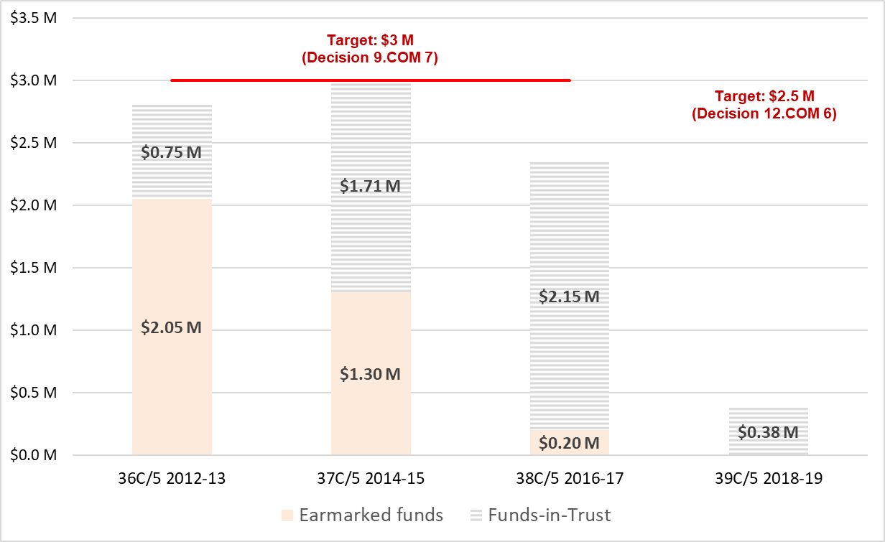
Figure 1: Evolution of resources mobilized in support of the global capacity-building programme
- Intangible cultural heritage in education: No contribution has been received to support the above-mentioned new funding priority, ‘Safeguarding intangible cultural heritage in formal and non-formal education’ since its approval by the Committee in December 2017. Following the advocacy of the Secretariat, some donors have expressed an informal interest, which so far did not translate into voluntary contributions. In this regard, the Secretariat will be intensifying its efforts to mobilize resources.
- The Committee may wish to encourage donors to support the achievement of the goals set out in the two funding priorities through earmarked voluntary contributions to the Fund. The modality of earmarked contributions allows the Committee to better coordinate international cooperation, as described in Article 19 of the Convention, while permitting the Secretariat to match needs and resources responsively and to deliver services effectively; it also provides high visibility to the donor. In keeping with the Organization’s principle of results-based management, the Secretariat has a responsibility towards the General Assembly – and towards donors – to achieve concrete results.
- Strengthening the human resources of the Secretariat: Recognizing that the Secretariat’s ability to provide quality services to Member States depends largely on its human resources, many and various donors have provided support by making use of several modalities over the years. However, Figure 2 shows a decrease in all kinds of contributions related to the strengthening of the human capacities of the Secretariat during the last biennia. In particular, support for the sub-fund of the Intangible Cultural Heritage Fund is again far from reaching the annual target of US$1.1 million set by the General Assembly (Resolution 3.GA 9). More precisely, it is worth noting that during the 38C/5, the sub-fund received voluntary contributions totalling only a third of the amount received during its preceding exercise. Between the last session of the Committee and September 2018, the sub-fund has received voluntary contributions for a consolidated amount of US$64,917, from the governments of the People’s Republic of China, Finland, Kazakhstan and Montenegro.
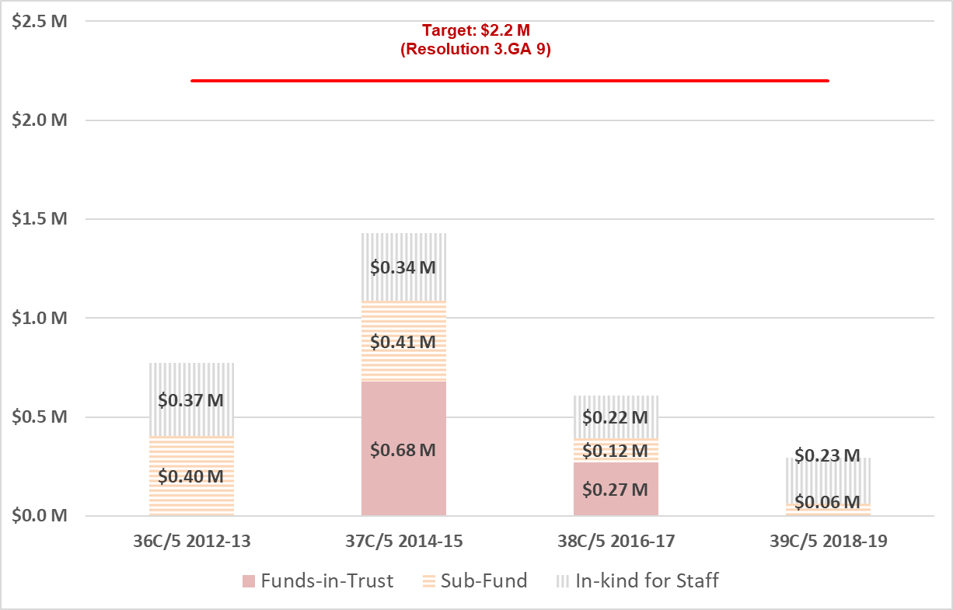
Figure 2: Evolution of resources mobilized in support of human resources
- Reflection on the listing mechanisms: In addition to the funds already received, the Government of Japan has expressed its wish to support the 2003 Convention by contributing to the Intangible Cultural Heritage Fund. At its twelfth session, the Committee acknowledged the need to convene an open-ended intergovernmental working group, ‘to reflect inter alia on the procedures for the removal of an element from a List and the transfer from one List to the other, on the nature and purposes of the Lists and the Register established under the Convention and on the relevance of the various criteria for each of these mechanisms’ (Decision 12.COM 14). The importance of undertaking such a reflection was also underlined most recently by the seventh session of the General Assembly of the States Parties to the Convention, held in June this year. The intention of the Government of Japan is to provide an earmarked contribution to the Fund to support this reflection process on the listing mechanisms of the 2003 Convention; the contribution is to be used, first of all, to organize a preliminary meeting of experts in 2019 and also to support the convening of a meeting of the open-ended intergovernmental working group (provisionally in 2021). Therefore, the Committee is asked at the present session to approve Japan’s offer, as set out in the letter from the Government of Japan presented in Annex II of this document.
- Finally, the implementation of the following earmarked activities, financed with voluntary supplementary contributions, continued during the reporting period:
Project | Contributors | Last report issued
Improvement of the periodic reporting mechanisms under the 2003 Convention | Republic of Korea | -
Strengthening the capacities of Eritrea for implementing the Convention for the Safeguarding of the Intangible Cultural Heritage | Norway | Progress report (11-2017)
Strengthening National Capacities for Safeguarding Intangible Cultural Heritage for Sustainable Development in Bangladesh | Azerbaijan | Progress report 2017
Strengthening the capacities of Suriname and Dutch Caribbean islands for implementing the Convention for the Safeguarding of the Intangible Cultural Heritage | Netherlands | Final report phase I  (10-2017)
Safeguarding intangible cultural heritage through strengthening national capacities in Morocco, Mauritania and Tunisia | Norway and Spain (Generalitat de Catalunya) | Progress report 2017
Strengthening national capacities for safeguarding intangible cultural heritage in Guatemala | Azerbaijan | Progress report 2017
Other issues: management cost rates
- At its 204th session (UNESCO, April 2018), the Executive Board examined documents 204 EX/5 Part II.E and 204 EX/5 Part II.E Corr., which contained three alternative proposals for differential Management Costs rates, out of which the Board decided to approve Option B (204 EX/Decision 5.II.E). According to this outcome, multi-donor special accounts should now be subject to a new rate of 7%, instead of the previous standard rate of 10%.
- The Intangible Cultural Heritage Fund, as well as other comparable multi-donor special accounts such as the World Heritage Fund, has benefitted from a special Management Cost Rate derogation (0%), granted by the Director-General with regard to their assessed contributions, while 10% was charged on voluntary contributions. The document presented to the 204th session of the Executive Board stated that ‘necessary consultations with the Governing Bodies of States Parties to the Intangible Cultural Heritage Convention and to the World Heritage Convention will take place between June 2018 and November 2019’ (see document 204 EX/5 Part II.E, paragraph 14). This means that the Committee should make a recommendation to the next session of the General Assembly, to be held in June 2020.
- The Committee may wish to adopt the following decision:
DRAFT DECISION 13.COM 6
The Committee,
- Having examined document ITH/18/13.COM/6,
- Recalling Article 25.5 of the Convention and Chapter II of the Operational Directives,
- Further recalling Decisions 8.COM 12, 9.COM 7, 10.COM 9, 11.COM 6, 12.COM 6 and 12.COM 14,
- Commends Japan for its generous offer of a voluntary supplementary contribution to the Intangible Cultural Heritage Fund to support the global reflection on the listing mechanisms of the 2003 Convention, notably to organize a preliminary meeting of experts in 2019 and support the convening of a meeting of the open-ended intergovernmental working group (provisionally in 2021);
- Accepts with gratitude the generous contribution of Japan, approves its specific purpose and requests that the Secretariat ensure its proper planning and implementation;
- Takes note that no supplementary voluntary contributions to the Intangible Cultural Heritage Fund have yet been received in line with the two funding priorities approved for the period 2018–2021, and expresses its concern in this regard;
- Thanks all the contributors that have generously supported the Convention and its Secretariat since its last session, namely Belgium (Flanders), the People’s Republic of China, Finland, Japan, Kazakhstan, Montenegro and Singapore;
- Encourages other contributors to consider the possibility of supporting the Convention, in particular within the scope of the two funding priorities set for the period 2018–2021 and the sub-fund for enhancing the human resources of the Secretariat;
- Also takes note of Executive Board Document 204 EX/5 Part II.E on ‘Cost recovery policy: Revised Proposal for a differential rate policy for Management Cost Rates’ and its related decision;
- Requests that the Secretariat report, at its fourteenth session, on the progress made in the implementation of any voluntary supplementary contributions it may have received since the thirteenth session.
ANNEX I
Financial/In-kind support to the 2003 Convention between
the twelfth session of the Committee (December 2017) and September 2018
Voluntary supplementary contributions to the Intangible Cultural Heritage Fund
Sub-fund for enhancing the human capacities of the Secretariat
China | US$50,000
Finland | US$2,628
Kazakhstan | US$10,000
Montenegro | US$2,288
Funds-in-trust
Belgium (Flanders) | US$117,467
Loans and Secondments
China | 10 months at P-2 level
Japan | 4 months at P-2 level
Singapore | 2 months at P-2 level

Annex II
