CONVENTION FOR THE SAFEGUARDING OF THE
INTANGIBLE CULTURAL HERITAGE
INTERGOVERNMENTAL COMMITTEE FOR THE
SAFEGUARDING OF THE INTANGIBLE CULTURAL HERITAGE
Thirteenth session
Port Louis, Republic of Mauritius
26 November to 1 December 2018
Financial Report of the Intangible Cultural Heritage Fund
for the Period 1 January 2018 to 30 June 2018
Summary
The present document includes the Financial Report for the Intangible Cultural Heritage Fund, issued by the Bureau of Financial Management, for the period 1 January 2018 to 30 June 2018, preceded by a brief explanatory note.

Explanatory Note
- The Financial Report below covers the period 1 January 2018 to 30 June 2018, during which the resources of the Fund for the Safeguarding of the Intangible Cultural Heritage (‘the Fund’) were used according to the ‘Plan for the use of the resources of the Fund’ that was approved by the sixth session of the General Assembly in June 2016, on a provisional basis for that period (Resolution 6.GA 9). This provisional budget for the first semester of 2018 was then superseded by the Plan adopted by the seventh session of the General Assembly (Resolution 7.GA 8).
Income (Statements I, II and III)
- In accordance with Article 25.3 of the Convention and with reference to the Financial Regulations of the Special Account for the Fund (Decision 1.EXT.COM 9), the income of the Fund, which is managed as a Special Account, consists of:
        - contributions made by States Parties to the Convention, in accordance with its Article 26;
        - funds appropriated for this purpose by the General Conference of UNESCO;
        - contributions, gifts or bequests that may be made by other States, organizations and programmes of the United Nations system, particularly the United Nations Development Programme, as well as other international organizations and public or private bodies or individuals;
        - any interest due on the resources of the Fund;
        - funds raised through collections and receipts from events organized for the benefit of the Fund;
        - any other resources authorized by the Committee.
- During the reporting period, the income to the Fund consisted of:
- Compulsory and voluntary assessed contributions by States Parties
Compulsory contributions by 172 States Parties to the Convention, as described in Article 26.1 of the Convention | US$1,791,754
Voluntary contributions of two of the five States Parties that, at the time of ratification, exercised Article 26.2 of the Convention | US$75,596
- Voluntary supplementary contributions
Sub-fund created within the Intangible Cultural Heritage Fund and intended exclusively to strengthen the human capacities of the Secretariat (Resolution 3.GA 9)
China, Finland and Montenegro | US$54,050
- Interest earned on the resources of the Fund | US$101,145
TOTAL | US$2,022,545
- The total income as at 30 June 2018 is only 2.9% higher than in the previous biennium for the period 1 January 2016 to 30 June 2016. This relative standstill contrasts with the 6% increase in the number of State Parties to the Convention in comparison with the same period of the last biennium (from 167 to 178). This situation can be explained by the decrease in the voluntary supplementary contributions received, especially those referring to earmarked activities, which dropped drastically as no contribution of this kind was received during the reporting period. At the same time, the fall in the voluntary supplementary contributions received is partially compensated by the increase in the interest generated, which grew from US$42,550 to US$101,145.
- The Statement of Compulsory and Voluntary Assessed Contributions, included in Annex 4 to this document, shows that as of 30 June 2018, the total assessed compulsory contributions that remained unpaid amount to US$1,228,441. Some US$826,391 correspond to contributions assessed for 2018, while the rest, US$402,050, are in arrears of compulsory contributions assessed for previous biennia. Out of the 172 States Parties whose compulsory obligations are described in Article 26.1 of the Convention, 85 are up-to-date with their compulsory assessed contributions, while 87 are in arrears, 42 of which were in arrears in relation to compulsory contributions assessed for previous biennia. The last payment for fourteen States Parties dates back to before 2016.
Schedule of appropriations and expenditure for the period 1 January 2018 to 30 June 2018 (Statement I.I)
- The total amount approved by the seventh session of the General Assembly for the operational budget in the schedule of appropriations and expenditure (US$8,590,922) corresponds to the balance of the Fund on 1 January 2018 (US$9,590,922) minus the accumulated Reserve Fund (US$1,000,000) at the same date. This Reserve Fund was created, in accordance with the Financial Regulations of the Fund, to grant International Assistance in cases of extreme urgency and in the event that the funds allocated to International Assistance (budget line 1) are exhausted.
- The Financial Report shows a total expenditure of US$1,384,940 as of 30 June 2018, that is, 16.1% of the operational budget approved by the seventh session of the General Assembly in its Resolution 7.GA 8. The total expenditure for the reporting period represents an increase of 119% in relation with the same period of the previous biennium (US$633,793) and confirms the positive trend already noted in previous reports. Explanations for each budget line of the schedule of appropriations and expenditure are provided below.
- The general increase in the level of expenditure comes mainly from the increase in the expenditure rate of budget line 1 (International Assistance), which as at 30 June 2018 represented 20.9% of the budget approved for that specific budget line, compared to 5.7% at the same period in the previous biennium. This expenditure corresponds only to International Assistance that has been materialized in a contract before the end of the reporting period. In this regard, ten International Assistance requests approved by the Bureau of the Committee during the first six months of 2018, for a total amount of US$968,482, are not reflected in the present Financial Report, as none of their contracts could be engaged before 30 June 2018. Therefore, a considerable increase in the expenditure rate of budget line 1 is expected by the time of the next Financial Report (31 December 2018). Finally, the report includes the new budget line 1.1, approved through the above-mentioned Resolution of the General Assembly, with the purpose of creating three extrabudgetary fixed-term posts to form a dedicated team to improve the implementation of the International Assistance mechanism, including its monitoring. As the General Assembly only approved the creation of this sub-line in June 2018 and the recruitments for these posts are ongoing, this budget line presents no expenditures during the reporting period.
- Concerning budget line 2 (Preparatory Assistance), only one Preparatory Assistance request for preparing a proposal to the Register of Good Safeguarding Practices was submitted and subsequently approved by the Bureau. This line was also used in the sense of the Committee’s decision at its eighth session in 2013 (Decision 8.COM 7.c), whereupon the Secretariat was requested to devise a mean to offer technical assistance to States Parties wishing to prepare requests for International Assistance. Such assistance was delivered through the provision of experts – either by undertaking missions or by offering services remotely – upon specific requests from States Parties. During the reporting period, such technical assistance was given to two requesting States.
- Based on specific proposals prepared by the Secretariat, the Bureau decided upon the utilization of resources in budget line 3, ‘other functions of the Committee’ (Decisions 12.COM 2.BUR 3 and 13.COM 2.BUR 3). These resources were dedicated to capacity building (36%), communication and outreach tools (27%), knowledge-management services (20%) and the integration of intangible cultural heritage into development plans, policies and programmes (17%). As at 30 June 2018, the expenditure rate of this budget line stood at 14.6%. This level of execution represents an increase of 1.3% compared to the previous biennium. More details on the progress made in the implementation of these funds can be found in the working document of the present session, ITH/18/13.COM/5, ‘Report of the Secretariat on its activities’.
- Since the meetings of the Committee are normally held at the end of the year, budget line 4, for financing the participation of experts representing developing States Members in the Committee and Bureau sessions, shows a modest expenditure rate (6.4%). Furthermore, budget lines 5 and 6, used to finance the participation of the members of the Evaluation Body eligible for such support, show expenditures relating to the two meetings of the Evaluation Body held during the reporting period: Budget line 5 financed the participation costs for three Evaluation Body members representing developing States Parties non-Members of the Committee while budget line 6 included the participation costs for the six accredited non-governmental organizations serving on the Evaluation Body.
- Lastly, budget line 7 (‘Cost of advisory services provided at the request of the Committee’) shows an expenditure rate of 21% corresponding to the fees of the nine eligible members of the Evaluation Body who evaluated the files for the 2018 cycle and were entitled to receive financial support. Since the evaluation work was still ongoing as at 30 June 2018, the amount of fees included in their contracts are reflected as ‘unliquidated obligations’ and not yet as ‘disbursements’.
Additional reports
- In Annex 1 of the Financial Report, the list of voluntary supplementary contributions paid for specific purposes, as specified by Article 25.5 of the Convention for the period 1 January 2018 to 30 June 2018, is included. As mentioned earlier, no voluntary contributions were received during the reporting period dedicated to specific activities approved by the Committee. As at 30 June 2018, three State Parties (China, Finland and Montenegro) had contributed to the Sub-fund for enhancing the human capacities of the Secretariat, for a total amount of $54,050.
- Contributions earmarked for specific projects are subject to the decisions of the Committee on whether to accept such contributions. The table in Annex 2 of the Financial Report shows the total expenditure incurred for each project since its beginning until 30 June 2018. Finally, Annex 3 shows the forecasts as of 30 June 2018, based on the Secretariat’s estimations, for the future use of the funds allocated to ongoing projects based on funds not committed at that date and budgets approved by the Committee. In cases where the donor has already confirmed that the outstanding contribution will not be paid (marked with an asterisk), forecasts are based on the actual funding received to date.

Statement I
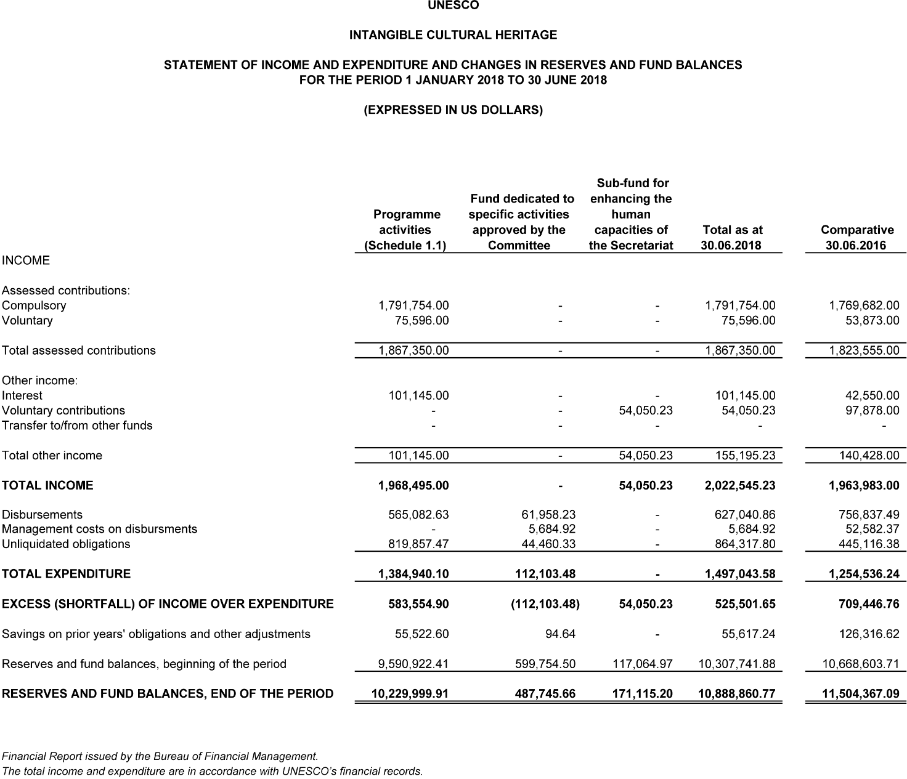
Schedule 1.1
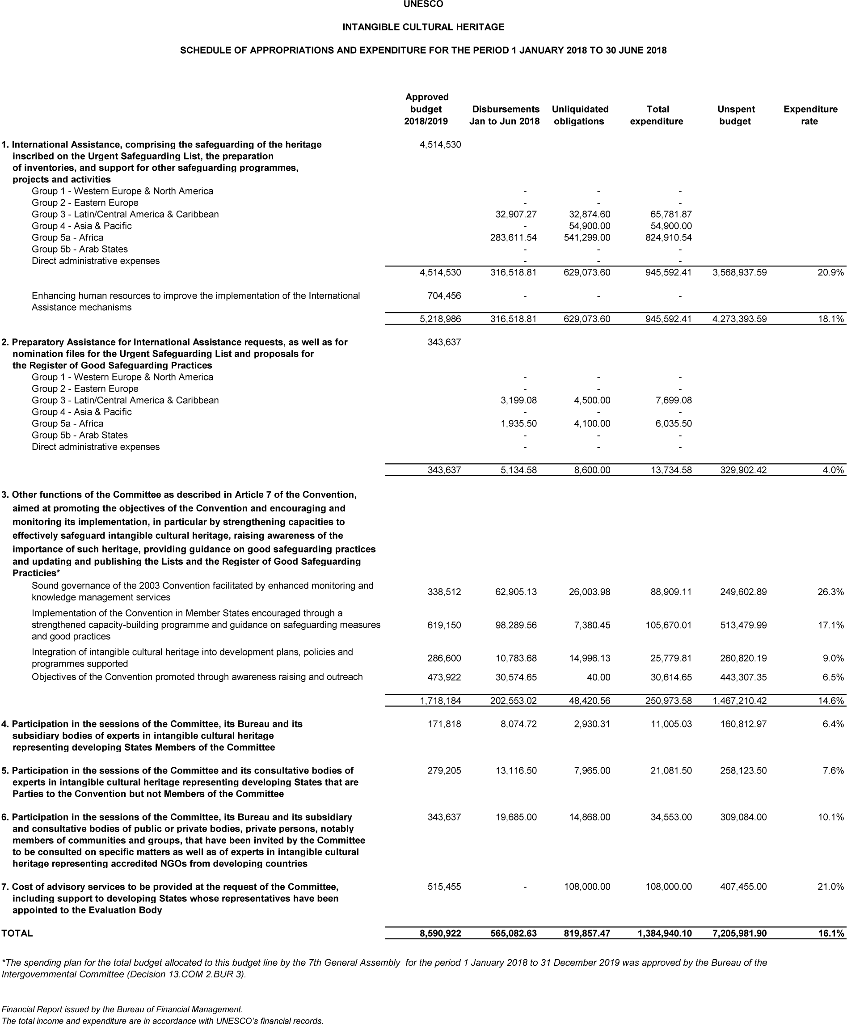
Statement II
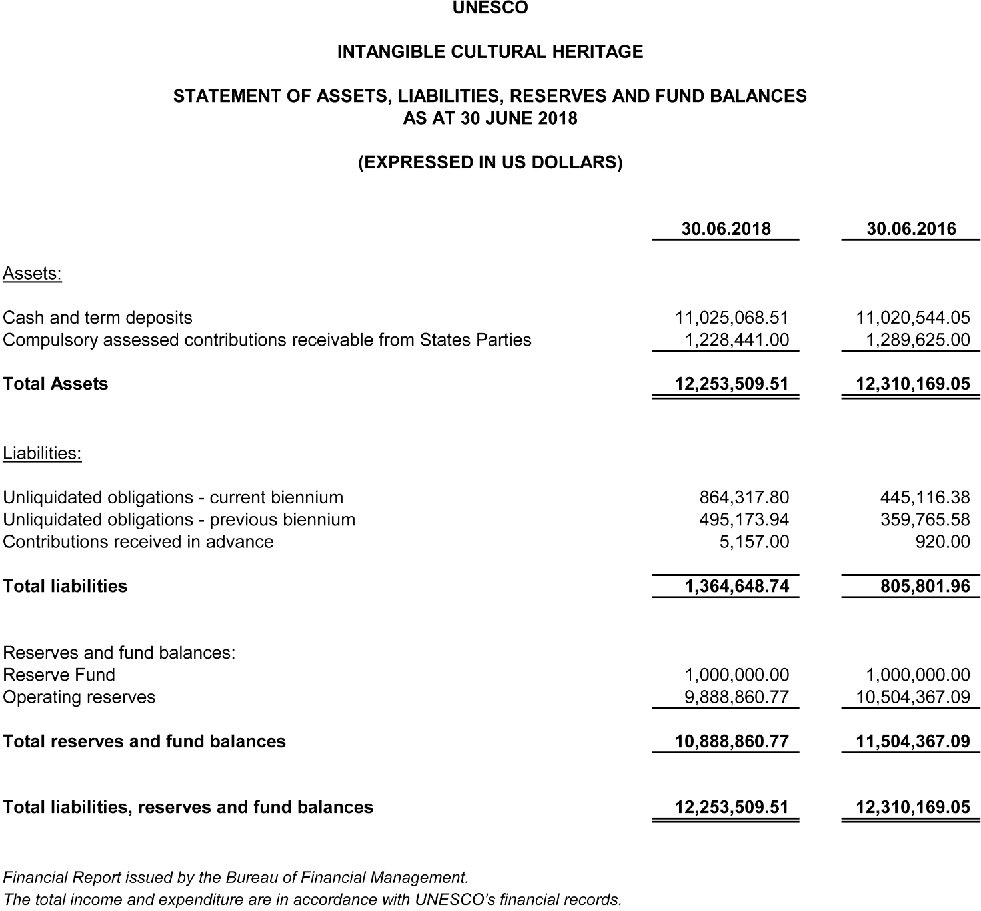
Statement III
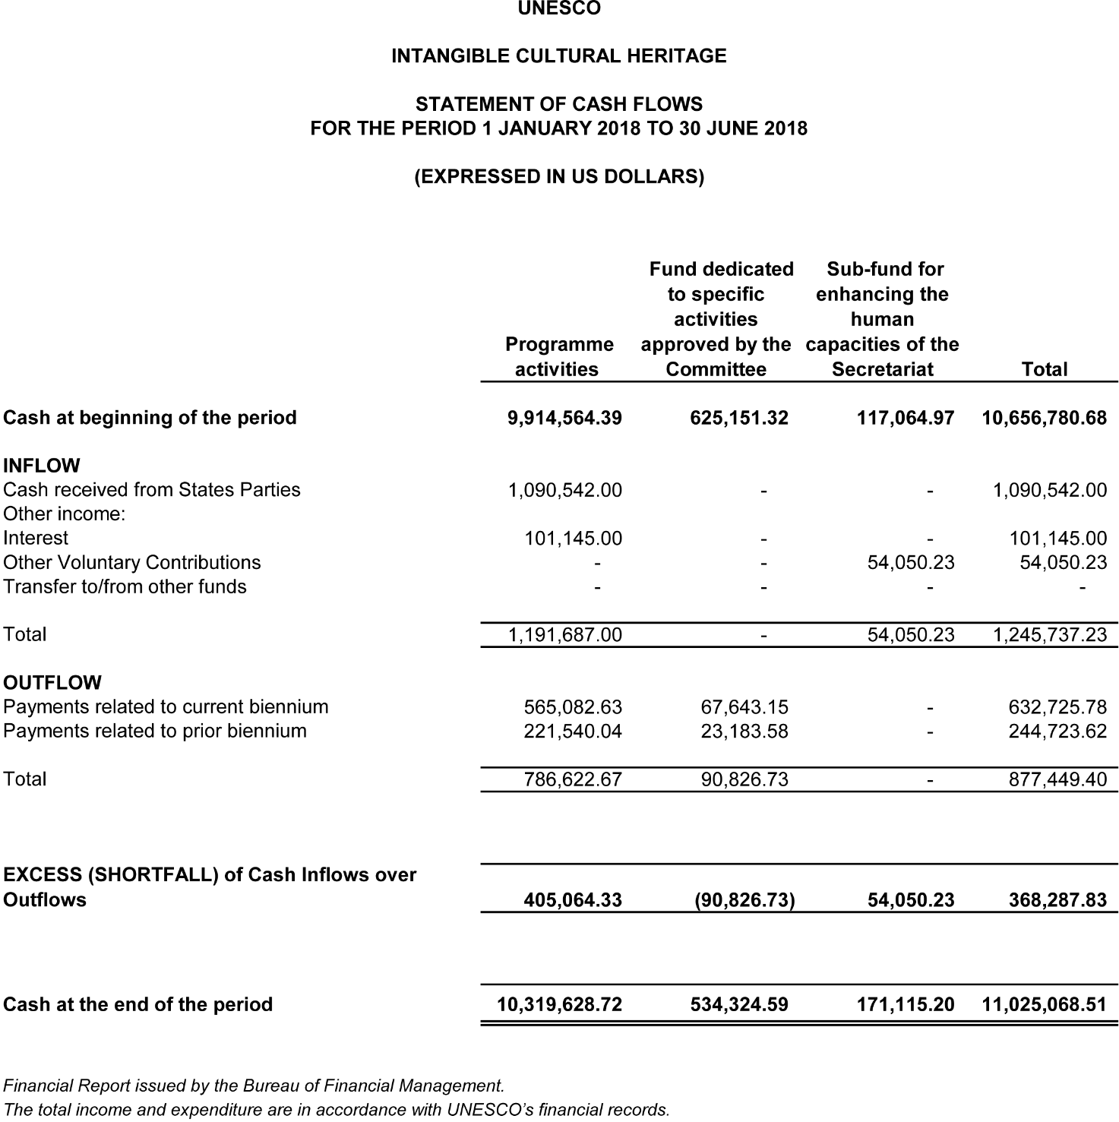
Annex 1
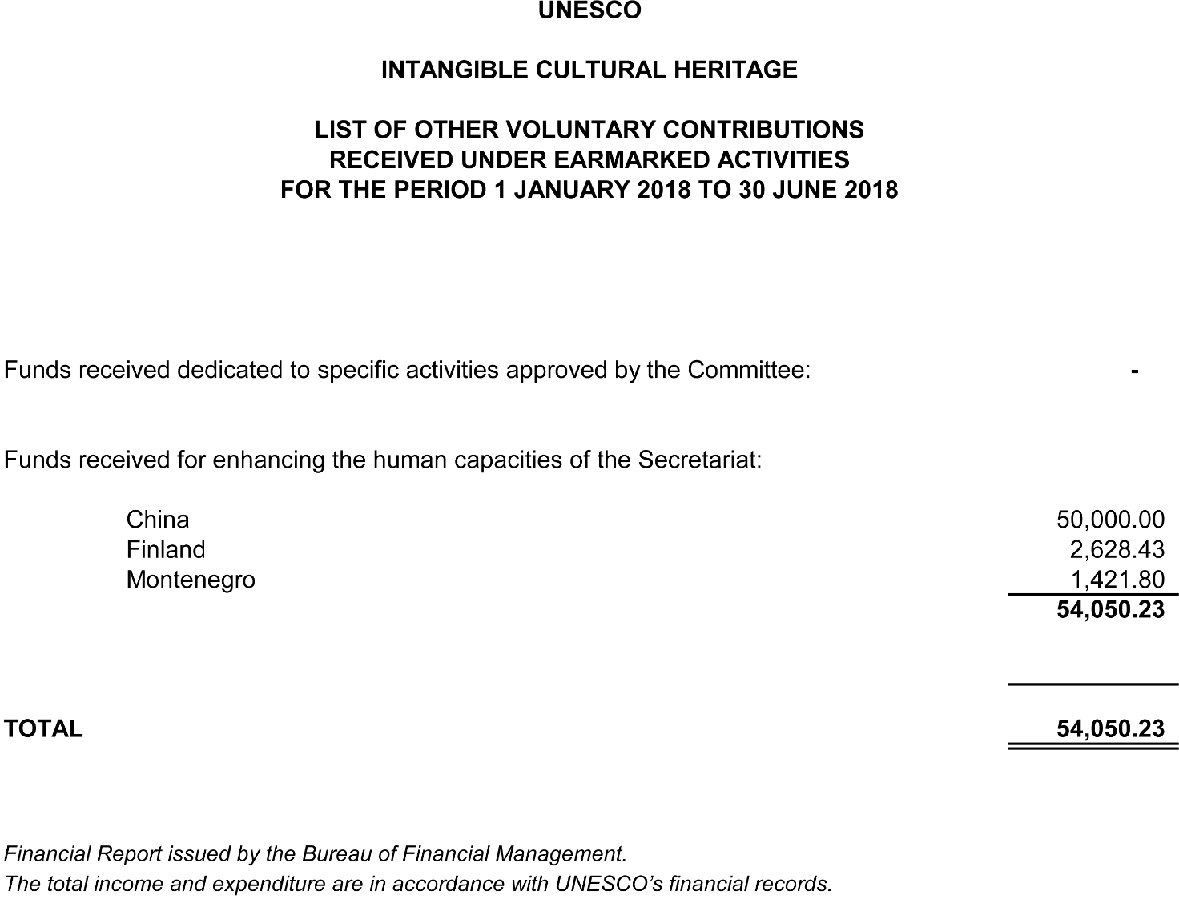

Annex 2
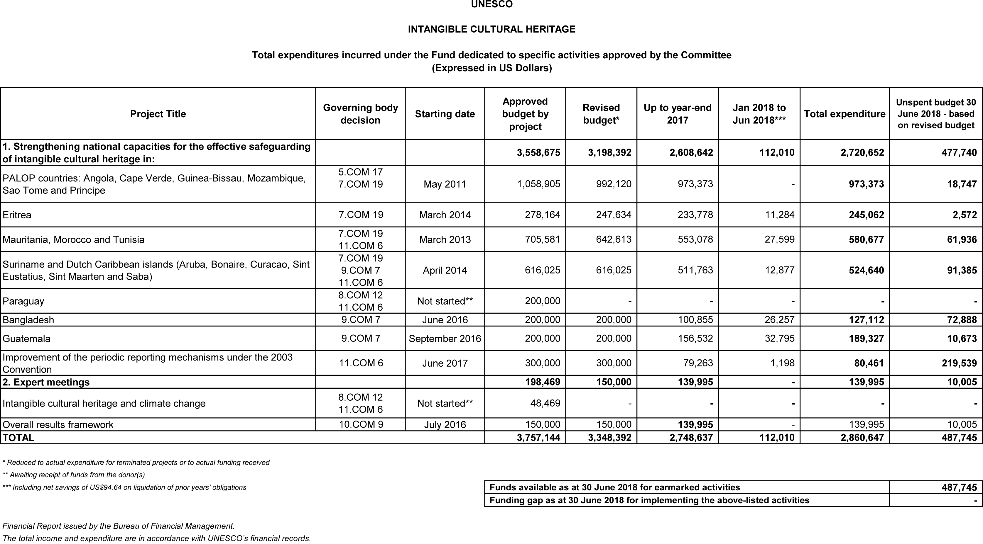
Annex 3
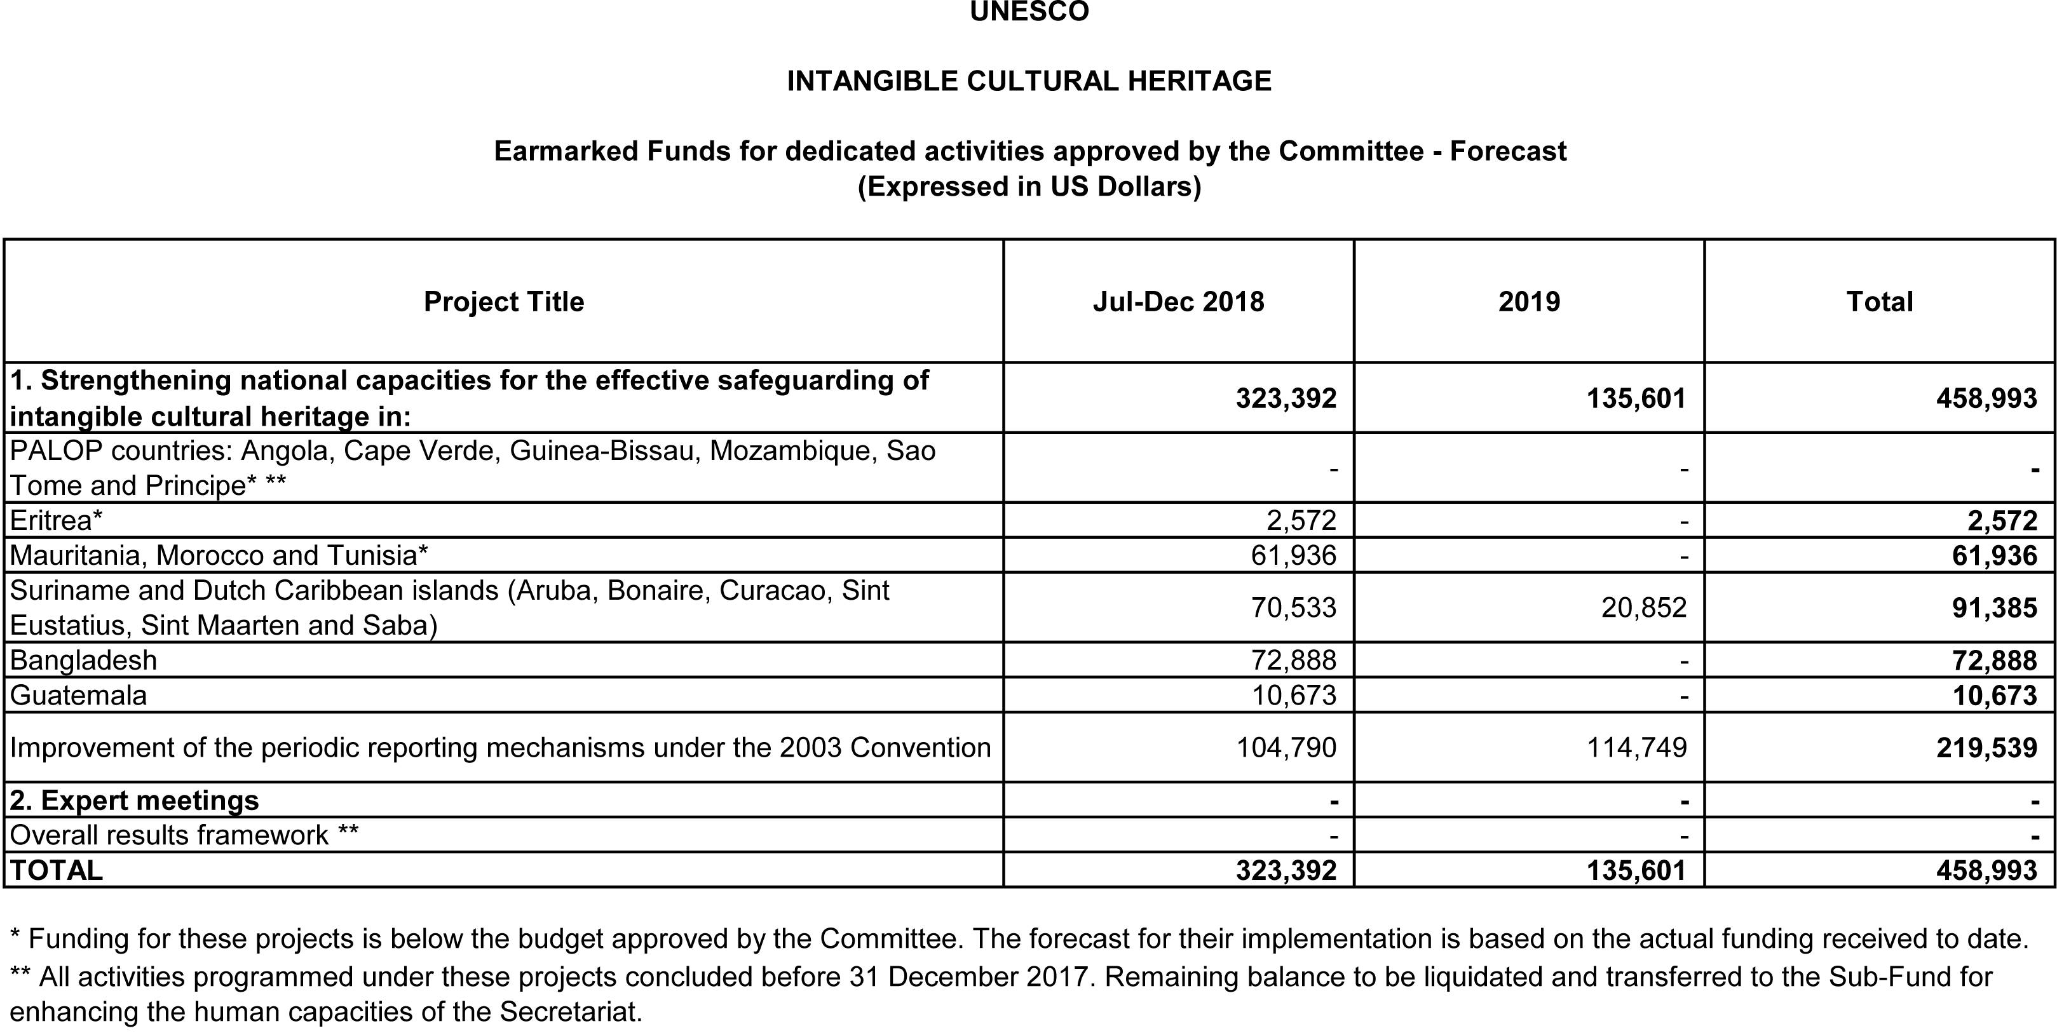
Annex 4
THE INTANGIBLE CULTURAL HERITAGE FUND / LE FONDS DU PATRIMOINE CULTUREL IMMATERIEL
Statement of compulsory contributions as at 30 June 2018 / État des contributions obligatoires au 30 juin 2018
(Expressed in US Dollars / Exprimé en Dollars EU)
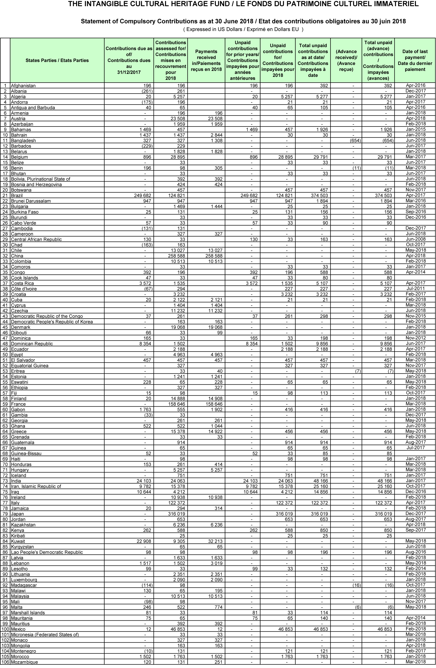
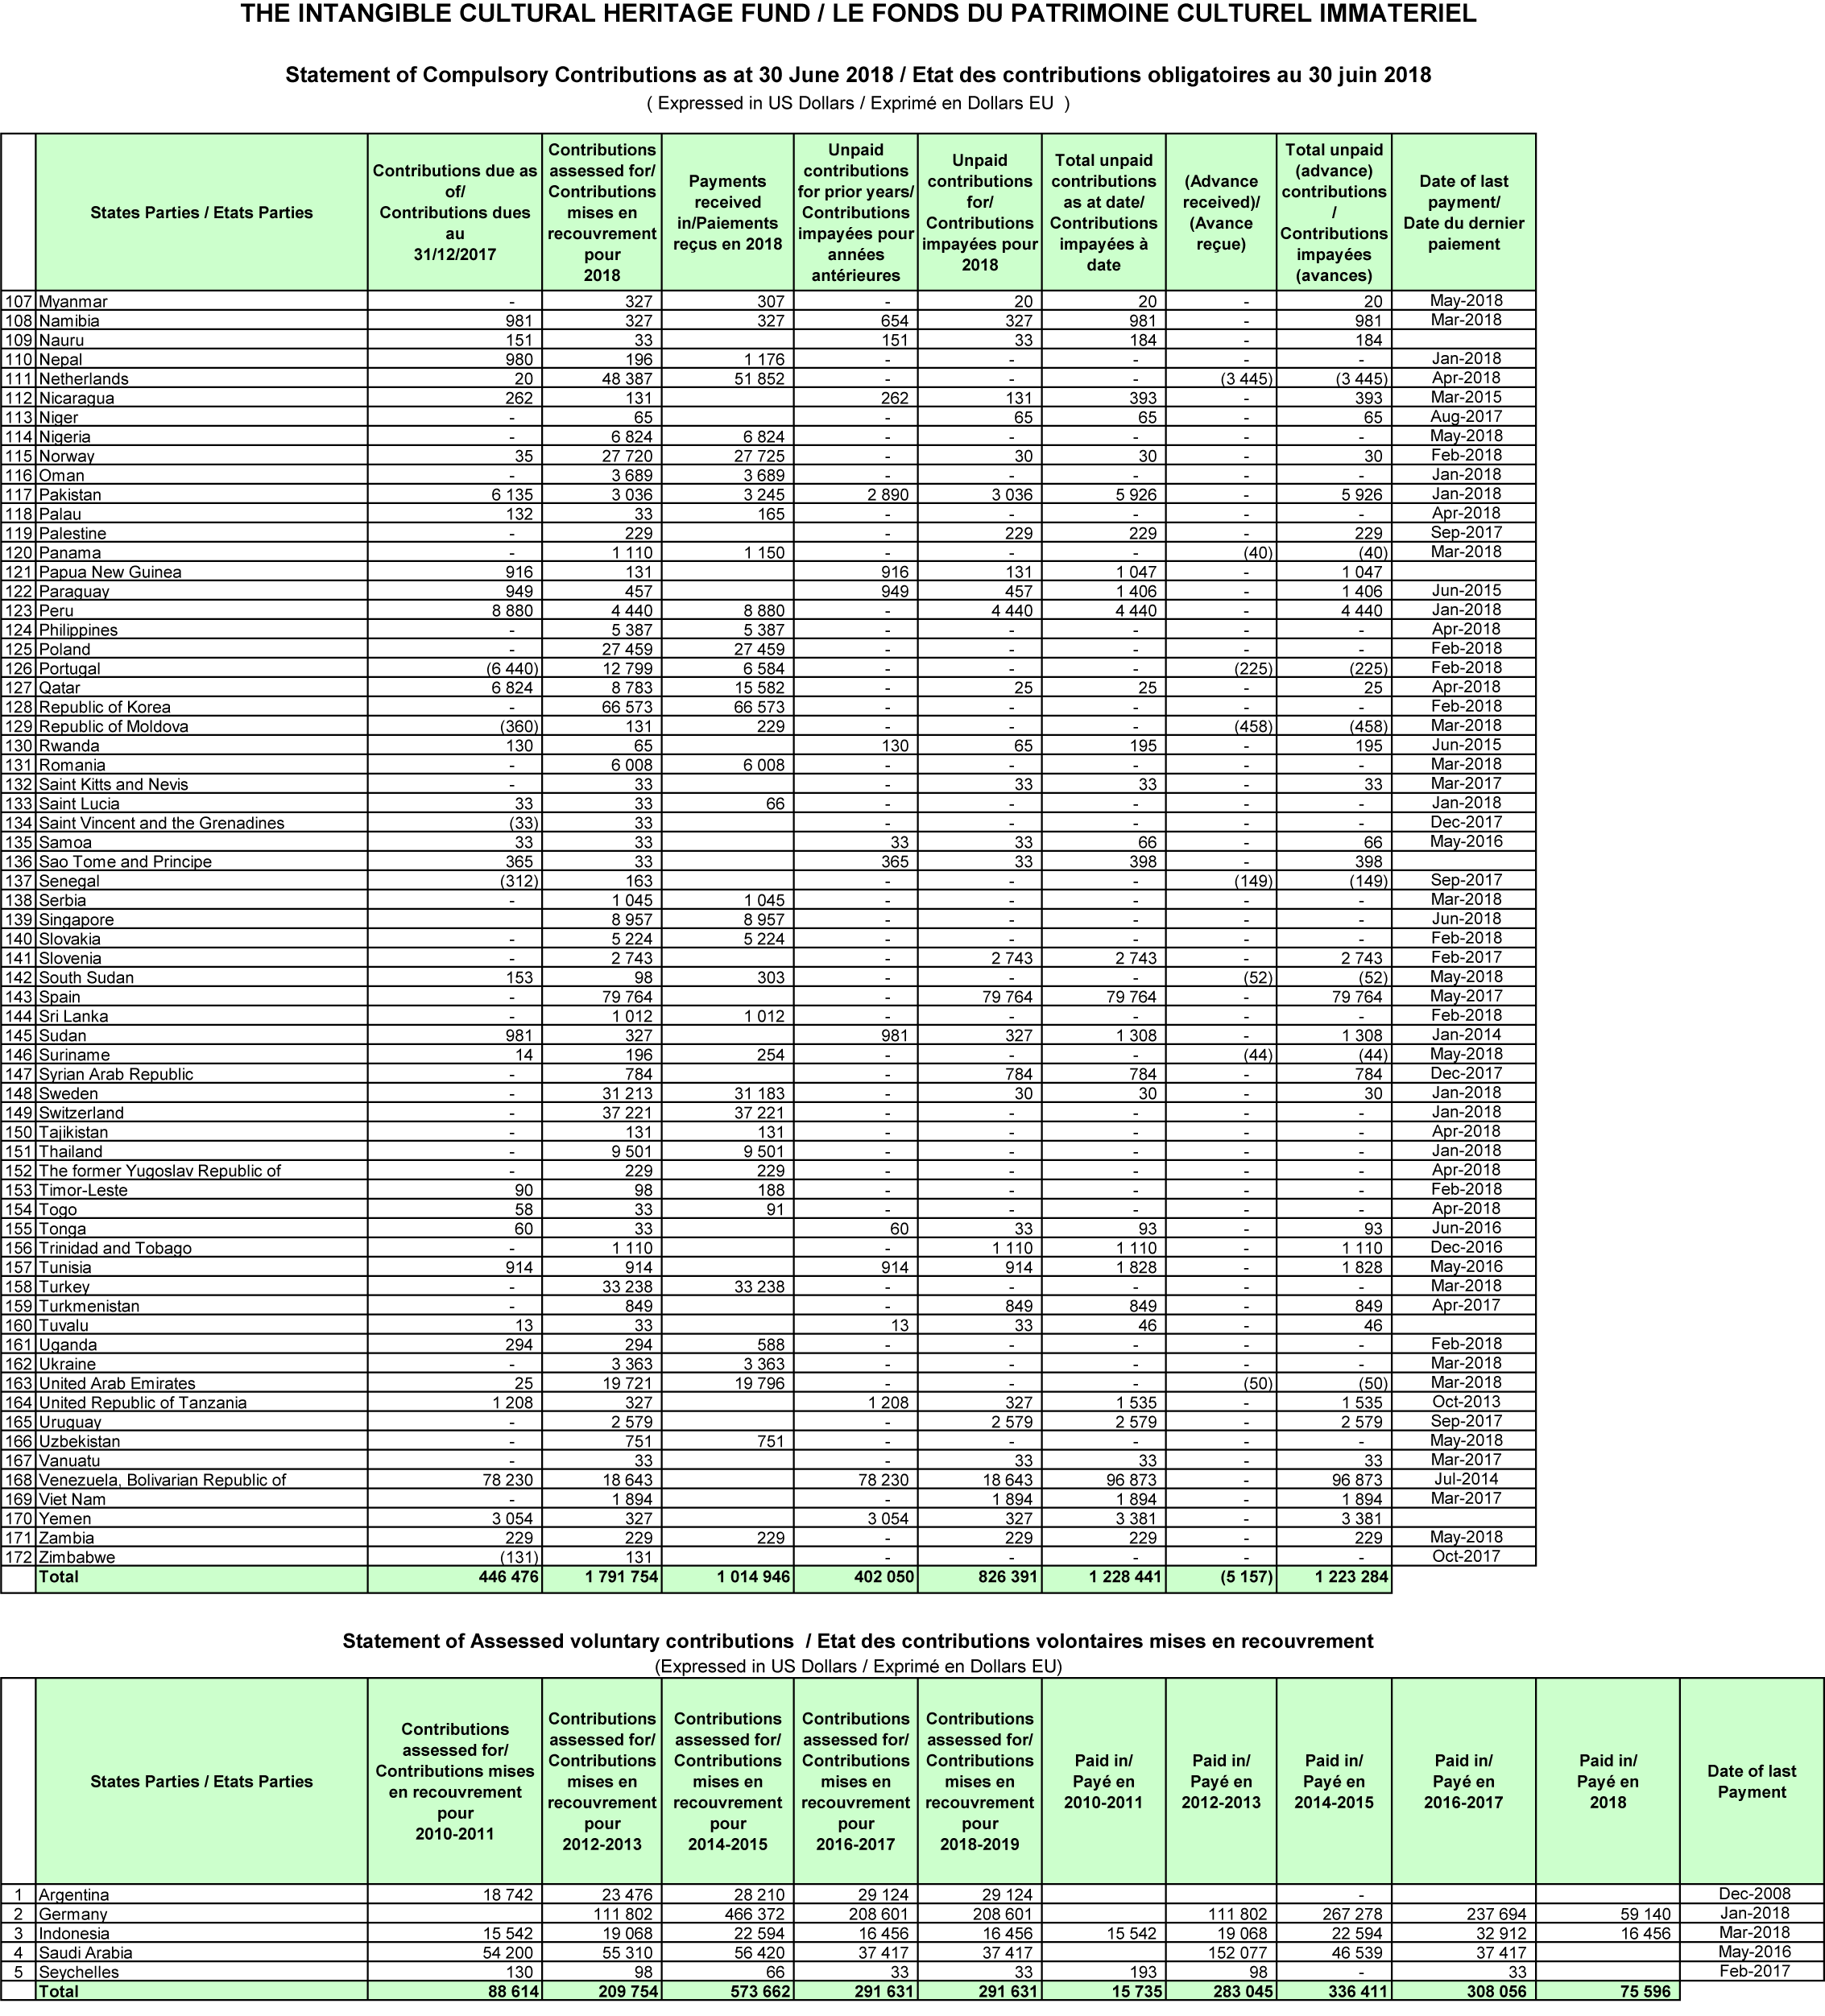
Statement of assessed voluntary contributions / État des contributions volontaires mises en recouvrement
(Expressed in US Dollars / Exprimé en Dollars EU)
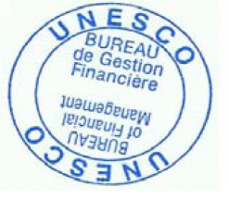

. Figures rounded to the next highest dollar compared to that in Financial Statement I.
. In Statement I, the compulsory assessed contributions for the period January 2018 – June 2018 are shown as income, whether or not they have been received; Statement II shows that the amount still unpaid and receivable from States Parties as at 30 June 2018 was US$1,228,441. Voluntary assessed contributions are shown as income only at the time cash is received.
. Article 26.1 of the 2003 Convention: ‘Without prejudice to any supplementary voluntary contributions, the State Parties to this Convention undertake to pay into the Fund, at least every two years, a contribution, the amount of which, in the form of a uniform percentage applicable to all States, shall be determined by the General Assembly’.

