ONLINE Training for the country Focal Points FOR Periodic Reporting under the 2003 Convention in Europe
10 March – 16 April 2021

Aims and objectives
Aim is to strengthen the capacities of the country focal points responsible for periodic reporting under the 2003 Convention, to set up and undertake the process of Periodic Reporting in their countries.
Objectives:
- Introduce the Convention’s new Periodic Reporting system and the related Overall Results Framework.
- Strengthen participants’ knowledge and skills to conduct results-based participatory reporting and use of the on-line reporting tool.
- Facilitate peer learning, networking and strategic discussion among participants.

Training modalities
The workshop will be composed by two introductory sessions, four weekly Modules with webinar in plenary session and forum in sub-groups, as well as two follow-up sessions. Each Module will include preparatory material (A), a plenary webinar for all participants (B) and a forum session for each of the five sub-regional groups (C) .
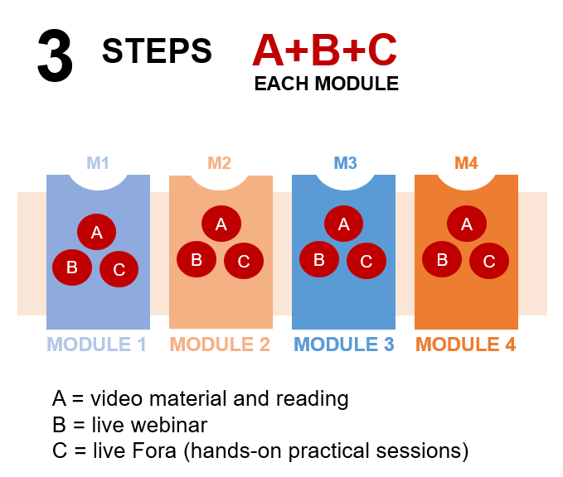
Training Schedule

