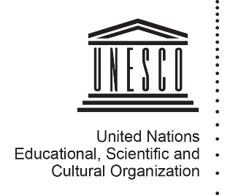

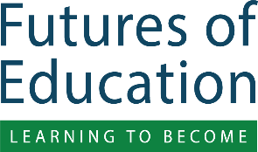

Debating the Futures of Education video series
Episode n°1: what needs to be learned at schools with teachers and other students?

SOCIAL MEDIA PACK

About
The radical changes in today’s complex and uncertain world are transforming our understanding of, and approaches to, education and learning. That is why it is crucial to rethink the nature of knowledge, the purpose of education, and the organization of learning. UNESCO has launched “Futures of Education”, a global initiative which aims to generate a global debate on how knowledge and learning can shape the future of humanity and the planet.

The collection of perspectives and ideas from a broad range of people across the globe is essential, that is why UNESCO has launched different engagement modalities. “Debating the Futures of Education” is an animated video series produced by UNESCO, posing one specific question and inviting viewers to share views through user-friendly features. First video invites viewers to think about what things are best learned in school alongside teachers and other students.

Key Message
What needs to be learned at schools with teachers and other students? Share your ideas by adding a comment in UNESCO’s forum and take part of the global conversation on the futures of education!

Assets and Links
- Hashtag: #FuturesOfEducation
- Link to download the animation video (English):
https://unesco.sharepoint.com/:v:/s/Education/EerkxKUqsXFIq1wMwNSTzuoB41FVZ1pKBaxDqQqCKGsgSw?e=25ggKI
- Youtube link to the video: https://youtu.be/fo_Q3ZJApXM
- Shortened redirect to UNESCO’s online forum (English): https://bit.ly/35eED56
- Link to download all the visuals of the Social Media Pack (GIFs) https://unesco.sharepoint.com/:f:/s/Education/Eo3TIGU6GhdIrW7WWWeLfsgBSq3Y1ywuoCZqDqMoprt3jQ?e=MIO53v
- Project Email: futuresofeducation@unesco.org
- Communications contact: Ms Stephanie Magalage, s.magalage@unesco.org

Images to accompany messages
Please use the video file and GIF images that are available through the links listed above.

Social Media Message #1

The global health crisis caused by COVID-19 affects us all, in multiple ways. This includes our education systems — where how people learn, where people learn and even what people learn has changed for students almost everywhere around the globe. What are the unique learning experiences that happen at school, alongside teachers and other students? We’re interested in YOUR view so share your ideas and become part of the global conversation on the #FuturesOfEducation: https://bit.ly/35eED56

Twitter adaptation:
COVID-19 affects our education systems: how, where and even what we learn. Yet, what are the unique learning experiences that happen at school, alongside teachers and other students? Share your ideas with @UNESCO by adding your comment: https://bit.ly/35eED56

Social Media Message #2

Sometimes schools have to close unexpectedly. In fact, right now COVID-19 school closures are affecting over a billion and a half students! But schools will reopen. And while studies can be continued in other ways, kids miss important lessons when schools are closed. Join UNESCO’s global debate on the #FuturesOfEducation – check out this video and tell us what needs to be learned at school with teachers and other students: https://bit.ly/35eED56

Twitter Adaptation:
COVID-19 school closures affect over 1.5 million students & while studies continue in other ways, many important lessons are missed. Join @UNESCO’s debate on the #FuturesOfEducation, share your ideas on what needs to be learned at school: https://bit.ly/35eED56

Social Media Message #3

In this time of global crisis, countries across the globe have mobilized to help students continue their studies. But not being at school means missing out on important learning experiences taking place there. In your view, what needs to be learned at schools with teachers and other students? Share your comment now and take part in the discussion on the #FuturesOfEducation: https://bit.ly/35eED56

Twitter Adaptation:
There are many distance learning solutions, but still a lot of important learning is being missed. What needs to be learned at schools with teachers and other students? Add your comment & join @UNESCO’s debate on the #FuturesOfEducation: https://bit.ly/35eED56

Social Media Message #4

Due to COVID-19, over 1,5 billion learners are out of school. A lot of distance learning solutions have been put in place but still, a lot of learning happens when one gets to interact with others #IRL “in real life”. In your view, what are the most important things that you learn when actually at school ? Share your ideas and make your voice heard in the conversation on the #FuturesOfEducation: https://bit.ly/35eED56

Twitter Adaptation
Solutions to study remotely are crucial but really powerful learning occurs with others #IRL “in real life”! What are the most important things that you learn when actually at school ? Share your ideas & join UNESCO’s #FuturesOfEducation initiative: https://bit.ly/35eED56

