CONVENTION FOR THE SAFEGUARDING OF THE
INTANGIBLE CULTURAL HERITAGE
INTERGOVERNMENTAL COMMITTEE FOR THE
SAFEGUARDING OF THE INTANGIBLE CULTURAL HERITAGE
Sixteenth session
Online
13 to 18 December 2021
Item 7.b of the Provisional Agenda:
Summary
This document presents the periodic reports of States Parties in Latin America and the Caribbean submitted for the first regional reporting cycle on the implementation of the Convention and on the current status of elements inscribed on the Representative List of the Intangible Cultural Heritage of Humanity, in accordance with paragraphs 151 to 159 of the Operational Directives. It includes background information (Part A), the launch and implementation of the new periodic reporting system (Part B) and the assessment of the reports (Part C with the annexes), as well as challenges, opportunities and the way forward, together with a draft overall decision (Part D).
Decision required: paragraph 25
Examination of the reports of the first regional cycle of periodic reporting on the implementation of the 2003 Convention and on the current status of elements inscribed on the Representative List of the Intangible Cultural Heritage of Humanity by States Parties in Latin America and the Caribbean

- At this session, the Committee is tasked to examine the first regional cycle of periodic reporting undertaken in the Latin America and Caribbean region, following the reform of the mechanism, on the implementation of the 2003 Convention and on the current status of elements inscribed on the Representative List. The implementation took place effectively despite the ongoing COVID-19 pandemic, with the support of the capacity-building activities. Most notably, the reporting exercise resulted in a considerably high rate of submission of reports by twenty-eight States Parties in the Latin America and Caribbean region (87.5 per cent out of a total of thirty-two reports expected). The present document presents an analytical overview of the periodic reports submitted for this cycle, together with some insights on the key challenges and opportunities related to periodic reporting.
A. Background information
- Article 29 of the Convention provides that States Parties ‘shall submit to the Committee, observing the forms and periodicity to be defined by the Committee, reports on the legislative, regulatory and other measures taken for the implementation of this Convention’. Article 7(f) stipulates that the Committee’s duties shall include to ‘examine […] the reports submitted by States Parties, and to summarize them for the General Assembly’. Based in part on those reports, the Committee then submits its own report to the General Assembly in compliance with Article 30 of the Convention. The relevant guidelines for the submission of such periodic reports are laid out in paragraphs 151–159 of the Operational Directives for the Implementation of the Convention, while paragraphs 165–166 describe their receipt and processing.
- Between 2017 and 2019, the Committee and the General Assembly took a set of decisions and resolutions to reform periodic reporting on the implementation of the Convention and on the elements inscribed on the Representative List (Decision 12.COM 10, Resolution 7.GA 10, Decision 13.COM 8 and Decision 14.COM 8; see also document LHE/19/14.COM/8 for a summary). The reform includes the establishment of the periodicity of the submission of periodic reports on the basis of a regional rotation system, and the revision of the periodic reporting Form ICH-10. The main objectives of the reform were to: (a) align the periodic reporting system with the overarching goals of the 2003 Convention, as identified in the Overall Results Framework; (b) enhance the pertinence of periodic reporting as a self-monitoring tool for States Parties on their implementation of the Convention, and its efficiency as a results-based reporting system; (c) allow for a more effective and coherent monitoring of periodic reports; and (d) address the severely low submission rate within the previous reporting cycles by fostering peer learning and exchange among States Parties in the same region. This reform, particularly the revisions to Form ICH-10 and the creation of the online reporting form, was made possible thanks to the generous financial support of the Republic of Korea.
B. Launch and implementation of the new periodic reporting system
- According to the calendar established for the first regional cycle of reporting (Decision 13. COM 8), which will be implemented between 2020 and 2025, States Parties belonging to the Latin America and the Caribbean region are the first to submit their periodic reports, to be followed by Europe, Arab States, Africa, Asia and the Pacific, and a separate year for reflection. Paragraph 152 of the Operational Directives was amended (Resolution 7.GA 10) so that States Parties may submit their reports on the implementation of the Convention every six years based on a system of regional rotation, instead of every six years after the year of ratification which was the case for the previous periodic reporting system. Regional reporting cycles were expected to improve the rate of submission of reports through the organization of targeted capacity-building activities at the regional level, which would represent an opportunity to foster dialogue and exchange among States Parties within a given sub-region and/or region.
- With the launch of the new periodic reporting system in 2020, the States Parties in Latin America and the Caribbean were informed of the deadline of 15 December 2020 for the submission of their periodic reports, which were scheduled to be examined by the Intergovernmental Committee at its sixteenth session in December 2021 (2021 cycle). The reporting exercise followed a three-phased implementation process:
- Phase 1. Introduction to the process – Initiate communication with the States Parties of the region concerned, informing them of the submission deadline for the report and requesting the designation of a focal point for periodic reporting in each country;
- Phase 2. Preparation and submission – Organize capacity-building activities to support the country focal points in their preparation of the periodic report, followed by the preparation and submission of the report by each State Party;
- Phase 3. Analysis of the reports and examination by the Committee.
- For the Latin American and Caribbean region and upon the request of the Committee at its fourteenth session (Decision 14.COM 8), the Secretariat developed a capacity-building approach and training materials for periodic reporting in English and Spanish. Several States Parties also made generous contributions to host regional training workshops for country focal points for periodic reporting and facilitators from the region. However, with the outbreak of the COVID-19 pandemic in early 2020, all in-person capacity-building activities initially planned had to be cancelled and the capacity-building material had to be substantially redesigned for an online format.
- To address these challenges, the Secretariat, in close collaboration with the Regional Centre for the Safeguarding of Intangible Cultural Heritage of Latin America (CRESPIAL), adapted the three-day physical workshop for national focal points into a six-week online course, which took place simultaneously in English and Spanish from 19 May to 23 June 2020, combining weekly webinars, videos, reading materials and online forum sessions. The course aimed to provide the skills and knowledge required for completing the periodic reporting process, covering topics such as results-based reporting, data generation, participatory methodology and hands-on exercises on filling out the online periodic reporting form. A total of 100 participants, of which forty-seven focal points from thirty-two States Parties, as well as senior facilitators and UNESCO culture officers from the region, participated in this training.
- The online participation in the training over a longer period of six weeks (instead of the initially planned three-day in presentia workshop) enabled the participants to develop solid relations with their counterparts in other countries. This has also evolved into some potential longer-term benefits, allowing ongoing peer learning and exchange on national experiences regarding safeguarding measures, which further led to enhanced networking and collaboration in the region. It is clear that these ongoing benefits would have been more difficult to realize if the workshops were of short duration.
- Following these capacity-building activities, each focal point was better equipped to prepare its country report. The Secretariat also provided additional support by organizing a wrap-up session for focal points on 25 September 2020, followed by help desk assistance for technical and content-related issues in filling in the periodic reporting form. Nevertheless, a high number of States Parties from the region requested an extension of the submission deadline (15 December 2020) as many of them were heavily impacted by the COVID-19 pandemic and facing difficulties to complete their reports by this deadline. In response to these challenges and in compliance with paragraph 152 of the Operational Directives, States concerned were asked to initially submit their report using the online periodic reporting Form ICH-10 by the set deadline and then were given the possibility to complete it by mid-March 2021.
- Assessment of the first regional cycle of periodic reports of States Parties in Latin America and the Caribbean
- In the reformed system, the periodic reporting form (online test version) has been aligned to the Overall Results Framework for the 2003 Convention. The form reflects its structure of the twenty-six core indicators and the eighty-six assessment factors, using them as a basis for formulating questions in order to trigger results-based reporting. In section B of the form, each State is asked to monitor and report on the existence (or absence) of these assessment factors by responding to each question. The responses to a set of these questions determine the extent to which the indicator is satisfied – either fully or to a lesser degree, creating a baseline for monitoring for all twenty-six indicators. With the new system, States are now able to establish their own target benchmarks against which progress can be measured in six years’ time. This also includes the possibility to focus on certain aspects of safeguarding they may wish to address and plan in advance on how they intend to achieve these targets.
- Twenty-eight States Parties (out of thirty-two) in the Latin America and the Caribbean region have submitted their periodic report on the implementation of the Convention and on the status of sixty-seven elements inscribed on the Representative List, as the first regional cycle. The reports ranged from fifty to 250 pages in length, reaching a total of around 3500 pages of reports. The majority were submitted in English, with only two in French, and in several cases accompanied by an original version in Spanish. The final reports are available at https://ich.unesco.org/en/7b-periodic-reporting-rl-01205 and the reporting countries are presented in the following table.
State Party | Date of ratification | Report
Argentina | 08/08/2006 | English
Bahamas | 15/05/2014 | English
Barbados | 02/10/2008 | English
Belize | 04/12/2007 | English
Bolivia (Plurinational State of) | 28/02/2006 | English
Brazil | 01/03/2006 | English
Chile | 10/12/2008 | English
Colombia | 19/03/2008 | English
Costa Rica | 23/02/2007 | English
Cuba | 29/05/2007 | French
Dominica | 05/09/2005 | English
Dominican Republic | 02/10/2006 | English
Ecuador | 13/02/2008 | English
El Salvador | 13/09/2012 | English
Guatemala | 25/10/2006 | English
Haiti | 17/09/2009 | French
Honduras | 24/07/2006 | English
Jamaica | 27/09/2010 | English
Mexico | 14/12/2005 | English
Nicaragua | 14/02/2006 | English
Panama | 20/08/2004 | English
Paraguay | 14/09/2006 | English
Peru | 23/09/2005 | English
Saint Kitts and Nevis | 15/04/2016 | English
Saint Lucia | 01/02/2007 | English
Saint Vincent and the Grenadines | 25/09/2009 | English
Uruguay | 18/01/2007 | English
Venezuela (Bolivarian Republic of) | 12/04/2007 | English

- With the novelty of reporting through an online form that is structured around indicators, a rich dimension of data has been generated through the reports. At first stage, a data specialist was engaged in May 2021 to undertake a thorough data processing and statistical analysis of the reports. Then, a public ‘call for expression of interest’ was launched and widely shared with the relevant networks of facilitators, UNESCO Chairs and accredited NGOs between May and June 2020, in order to identify the pertinent research team for the assessment of the reports, with the required qualifications of a strong research, monitoring and evaluation experience in the field of intangible cultural heritage. Consequently, a collaborative research team was selected to undertake the assignment of a qualitative and quantitative analysis of the periodic reports. The team was composed of Ms Harriet Deacon, an experienced UNESCO facilitator for the global capacity-building programme of the Convention who was also closely involved in the development of the Overall Results Framework of the Convention, and the UNESCO Chair ‘Universidad Nacional Autónoma de México – Centro Regional de Investigaciones Multidisciplinarias’.
- The analysis, which was initiated in July 2021, has taken both a quantitative and qualitative approach. During the first phase, the data processed from the reports were analysed quantitatively to better understand the answers from States according to each question and to illustrate the divergent and convergent trends and key issues related to intangible cultural heritage safeguarding in the different countries. The next phase of qualitative analysis aimed to identify key analytical areas of interest, analysing the specific and relevant country examples and incorporating a cross-cutting thematic analysis against priority areas of UNESCO, such as gender, youth, indigenous peoples, Small Island Developing States (SIDS) and sustainable development.
- An analytical overview of the reports can be found in Annex I of this document. It presents some general observations and key analytical findings from the periodic reports of the States Parties in Latin America and the Caribbean, which include the common trends, challenges and opportunities related to safeguarding intangible cultural heritage as reported by the countries. For example, many of the countries reported high levels of inclusive participation of communities in activities to safeguard living heritage, with specific attention paid to the rights and interests of indigenous communities, Afro-descendant, creole and other marginalized cultural communities. Several countries considered language as an important vehicle for intangible cultural heritage, and reported the adoption of policies integrating multicultural or intercultural bilingual education in school curricula, which helped to encourage the transmission of living heritage in primary and secondary education. In relation to intangible cultural heritage and sustainable development, two thirds of the reporting countries informed having policies, legal or administrative measures for inclusive economic development that include intangible cultural heritage safeguarding within policies and programmes for cultural tourism, income generation and sustainable livelihoods. A majority of the countries also reported cooperating at the regional level on the safeguarding of living heritage and, in some cases on specific intangible heritage at risk, either through the activities of the Category 2 Centre CRESPIAL, the Caribbean Community (CARICOM) or under regional agreements like MERCOSUR (Southern Common Market). While some countries are integrating intangible cultural heritage in policies across sectors beyond culture, such as education or other development sectors, there still remains further needs as well as opportunities for cross-sector engagement and inter-ministerial collaborations for implementing and monitoring broader policies related to living heritage.
- As one of the main challenges, many of the reports noted the negative impact of the COVID-19 pandemic on the transmission and safeguarding of living heritage practices in general, and on the livelihoods and health of the communities concerned, as well as for preparing the periodic report. Some of the counter measures, however, seemed to have broaden community engagement, and enhanced the transmission of skills through online workshops and income generation through virtual marketing platforms. Post-disaster recovery plans, in certain countries, have also incorporated living heritage as an essential component of resilience and recovery. In addition, many practitioners and communities have reported to experience serious economic challenges, which have been exacerbated by the COVID-19 pandemic. While culture agencies in governments are experiencing financial constraints in general, some countries are raising culture sector funding from private sector taxation and incentives, which alleviates certain financial difficulties. When it comes to cultural practices that have been negatively affected by commercial development projects and promotional activities, assessment and mediation services have been provided to communities in some countries for the resolution of conflicts with private sector investment.
- In Annex I, some specific findings from the reports are also shared according to the following eight thematic areas in the Overall Results Framework: (a) Institutional and human capacities; (b) Transmission and education; (c) Inventorying and research; (d) Policies as well as legal and administrative measures; (e) The role of intangible cultural heritage and its safeguarding in society; (f) Awareness-raising; (g) Engagement of communities, groups and individuals as well as other stakeholders; and (h) International engagement. In addition, a brief analysis is provided on key aspects related to the status of the elements on the Representative List in the region, such as the assessment of their viability and efforts to promote or reinforce the elements. Given the vast amount of data and content that has been extracted from the reports, further in-depth analyses of the reports will continue in order to support the longer-term reflection on the periodic reporting system in 2025. A detailed analytical report will also be presented to the Committee at its seventeenth session in November/December 2022.
- While the majority of the 26 indicators under the Overall Results Framework are related to measuring and monitoring the States Parties’ implementation at the national level, there are two indicators that require monitoring at the global level. These are indicators 23 ‘Number and geographic distribution of NGOs, public and private bodies, and private persons involved by the Committee in an advisory or consultative capacity’ and 26 ‘ICH Fund effectively supports safeguarding and international engagement’, which are both categorized under the thematic area ‘International engagement’. Annex II of this document therefore presents the monitoring data and information relevant to these two indicators and assessment factors.
- Challenges, opportunities and the way forward
- The new reporting system and its revised reporting form were devised in order to support States in developing a self-monitoring system on their implementation of the 2003 Convention and determining the appropriateness of their safeguarding measures, as well as revising their policies and safeguarding approaches as necessary. The new reporting mechanism is also expected to allow for more effective and coherent monitoring by the Committee and the General Assembly thanks to the use of an online reporting form which collects crucial information allowing for a strategic qualitative and quantitative analysis of the reports.
- The new system has already demonstrated promising results with the greatly improved submission rate of reports at 87.5 per cent (twenty-eight reports submitted out of a total of thirty-two expected) for the Latin America and the Caribbean region. This rate may be compared to the past reporting cycles, especially to the 2016 cycle which had a low submission rate of sixteen per cent with a similar number of expected reports, as presented in the following chart:
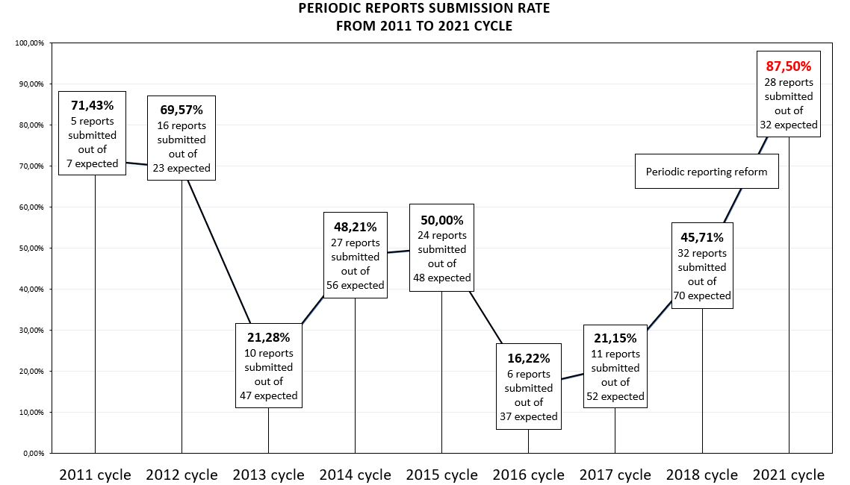
- In addition to the high submission rate, the implementation of the first regional cycle in Latin America and the Caribbean has raised other positive results, which were somewhat unexpected. One important point would be the adaptation and delivery of the online training on periodic reporting, which enabled the development of an extensive set of training materials using different participatory approaches and tools, as well as allowing a wider scope of participation. A forum of peer-to-peer exchange and learning among the country focal points was also created through the reporting exercise, which is expected to strengthen the cooperation in the area of intangible cultural heritage safeguarding within the region.
- Furthermore, the periodic reporting exercise has become an effective tool in raising awareness on the importance of broader consultation and collaboration with the relevant stakeholders for policy dialogue at the national level. These include governmental bodies within and beyond the culture sector, as well as bearers and practitioners, civil society and NGOs, researchers, and other competent bodies concerned in safeguarding. Wider consultation and participatory approaches seem to have been applied in many countries by conducting surveys and interviews with diverse groups of stakeholders.
- The first year of implementation of the regional cycle of reporting has also provided an opportunity to pre-assess the new system, based on the concrete experiences of reporting States and the analysis of the reports. The implementation process has been very challenging, not only due to the global health crisis of COVID-19, but also due to the diverse scope and depth of the exercise itself. Some of these challenges could already be identified. Certain are of a technical and procedural nature and others are related to difficulties of undertaking required activities for reporting at the national level. They can be described as follows:
- The short timeframe for States Parties to implement the reporting process from the moment they receive the training to the submission of the report. In the case of Latin America and the Caribbean, this period was even shorter as the training started later than foreseen due to the COVID-19 pandemic, and countries experienced considerable difficulty operating in the pandemic context;
- The density of the reporting form, which carries around 100 questions, requires an intense level of information across a wide range of thematic areas, and necessitates wide consultation and the cooperation of multiple stakeholders. The complex terminology used in the reporting form was also considered to be difficult to translate into the national and/or local languages for consultation purposes;
- The continuous support and follow-up that States Parties needed after the online training with the focal points. It was obvious that the new reporting process required more robust support and follow-up for the preparation of the reports from different actors, including the UNESCO Secretariat and Field Offices in the region, as well as adequate training on periodic reporting of facilitators from the region;
- The lack of continuity of focal points observed in a number of countries. For example, certain focal points who received training had to leave their functions, making it difficult for the newly arrived focal persons to assure the preparation of the report;
- The rigorous reporting process calls for broader outreach, consultation and cooperation with a wide range of actors in the field of living heritage and beyond, requiring sufficient human and financial resources to support that process. For example, reaching out to the different stakeholders and remote communities would require sufficiently trained and available personnel;
- The difficulty of convincing a wide range of actors on the importance of reporting on living heritage and receiving pertinent data and information from them. A certain level of awareness raising has been necessary, in most cases. For example, it has been essential to demonstrate how the reporting process could contribute to improving and monitoring policy areas related to safeguarding.
- Keeping in mind these challenges and based on the lessons learnt from the implementation of the first year of the regional cycle, the subsequent regions of Europe (2022 cycle) and the Arab States (2023 cycle) are undergoing various phases of implementation of the periodic reporting exercise. Currently, the States Parties in Europe have completed the capacity-building activities, with a working group session with facilitators from the region (22 January to 24 February 2021) and a five-week online training for focal points from all forty-four States Parties of the region (10 March to 16 April 2021), both of which took place online. They are now in full preparation and production of their periodic reports, aiming to submit them by the deadline of 15 December 2021 so that they may be examined by the Committee at its seventeenth session in November/December 2022. In the Arab region, States Parties have been informed of its regional cycle of reporting and submission deadline (15 December 2022), together with the request for their designation of a country focal point responsible for periodic reporting. The following figure presents the dynamic state of implementation of periodic reporting with three different regions simultaneously carrying out the reporting exercise at different stages:
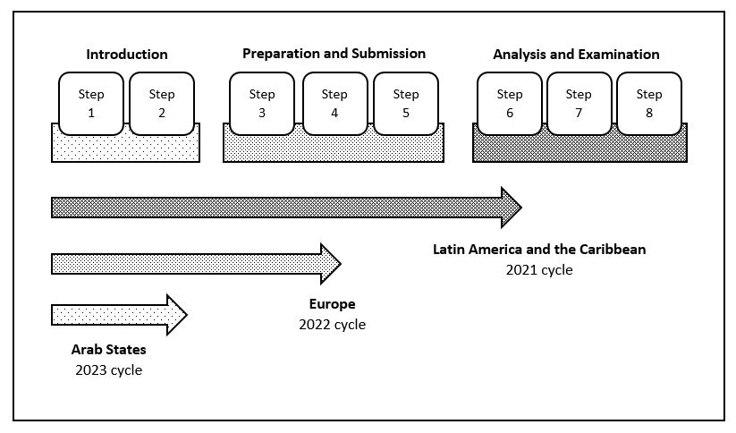
- As a way forward, it is also important to address some of the above-mentioned challenges, identify solutions and seek further improvements to the periodic reporting system. Certain aspects have already been adjusted for the implementation of the ongoing regions. For example, a separate training session of facilitators has been integrated in the implementation process of the Europe region (2022 cycle). This change has reinforced the support to country focal points and helped the training with focal points to be structured into smaller groups, enabling more interactive and participatory sessions. There has also been improvement in extending the time frame for the Arab States region (2023 cycle). The training of facilitators is planned in late October 2021, followed by the training of focal points in early 2022, giving States Parties more time to prepare and complete their report by the submission deadline of 15 December 2022. As the periodic reporting system completes its second year of implementation, further enhancements will be made so that States Parties may use it as an effective monitoring tool to assess current safeguarding measures and implementation approaches at the national level, customize future strategies and key actions according to the specific needs, contexts and conditions of safeguarding within each State, and track the progress of implementation from one reporting cycle to the next.
- The Committee may wish to adopt the following decision:
DRAFT DECISION 16.COM 7.b
The Committee,
- Having examined document LHE/21/16.COM/7.b,
- Recalling Articles 7, 29 and 30 of the Convention concerning reports by States Parties, and Chapter V of the Operational Directives,
- Further recalling Decision 12.COM 10, Resolution 7.GA 10, Decision 13.COM 8, Decision 14.COM 8, as well as document LHE/19/14.COM/8,
- Underlining the importance of periodic reporting on the implementation of the Convention and on the current status of elements inscribed on the Representative List, which serves as a key monitoring tool for the States Parties concerned to measure the progress of implementing safeguarding measures at the national level,
- Expresses its satisfaction with the implementation of the first regional cycle of periodic reporting in the Latin America and the Caribbean region and welcomes the positive results achieved from this cycle, especially the greatly increased rate of submission of the reports by States Parties;
- Congratulates the twenty-eight States Parties in the Latin America and the Caribbean region that have submitted their reports for the 2021 reporting cycle and commends them for their efforts to complete the periodic reporting exercise;
- Expresses its appreciation to the Secretariat for providing support to the States Parties concerned in their reporting process through capacity-building activities and ongoing follow-up;
- Takes note of the challenges, including those caused by the COVID-19 pandemic, during the implementation of the first regional cycle of reporting, and appreciates the Secretariat’s efforts to take necessary measures to ensure an effective implementation of the periodic reporting exercise;
- Acknowledges the quantitative and qualitative analysis that has been conducted for the reports, welcomes the key findings from the analytical overview of the reports, as presented in the annexes of document LHE/21/16.COM/7.b, notes with interest the common trends, challenges, opportunities and priority areas related to intangible cultural heritage as reported by the countries, and the different safeguarding approaches and methodologies adopted by States Parties to implement the 2003 Convention, and takes note that further detailed analyses of the reports will be presented to the seventeenth session of the Committee in 2022 and will contribute to the reflection year in 2025;
- Stresses the importance of the active involvement of the communities, groups and individuals concerned in the reporting process and encourages future reporting States Parties to involve a wide range of stakeholders, both civil society and national authorities, including those not directly working in the field of culture;
- Decides to submit to the General Assembly at its ninth session a summary of the reports of States Parties on the implementation of the Convention and on the current status of elements inscribed on the Representative List examined during the current session.

ANNEX I

Analytical overview of the periodic reports submitted by the States Parties in Latin America and the Caribbean region

Table of contents

Key analytical findings
Common trends across the thematic areas
Challenges and opportunities
Priority areas
Thematic areas
Institutional Capacities (Thematic area I)
Education, building human capacities and transmission (Thematic areas I and II)
Inventories (Thematic area III)
Research and Documentation (Thematic area III and VII)
Policies, legal and administrative measures (Thematic area IV)
The role of ICH in society (Thematic area V)
Awareness raising about the importance of ICH (Thematic area VI)
Safeguarding activities for ICH (Thematic area V and VII)
International cooperation and engagement (Thematic area VIII)
Status of elements on the Representative List

Key analytical findings

Common trends across the thematic areas

Participation of communities, groups and individuals concerned in ICH safeguarding
Participation of communities, groups and individuals concerned in ICH safeguarding is relatively strong in reporting countries. A large proportion of countries reported inclusive participation of communities, groups and individuals concerned in teaching and learning about their ICH, inventorying, research and documentation, and awareness-raising activities. About half of the countries reported high levels of inclusive participation of communities, groups and individuals concerned in ICH safeguarding, and about a third reported high levels of community participation in policy-making in the culture sector.

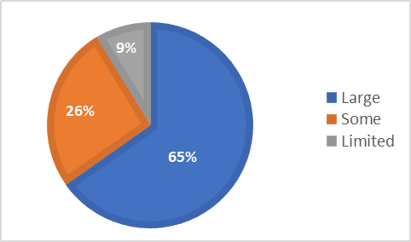
Figure 1. Number and percentage of countries reporting that communities, groups and relevant NGOs participate inclusively in inventorying, by extent of participation (n=23) (B8.1)

Community participation is generally well supported by States Parties through policy and programme planning. In Ecuador, for example, the participation of communities, groups and individuals in the preparation of inventories is considered a guiding principle for the safeguarding of intangible heritage. However, the State recognizes that ‘achieving systematic, broad and effective participation is a challenge that requires constant and permanent work’. Aside from government agencies, various stakeholders, such as NGOs (which are often community-run), Houses of Culture (state-supported local cultural institutions), universities and museums support community participation in ICH-related activities.
In many reporting countries, specific attention has been paid to supporting the participation, rights and interests of indigenous peoples, Afro-descendant, creole and other marginalized cultural communities in regard to ICH safeguarding. This will be discussed further below.

Language as a vehicle for ICH
States Parties, communities and research institutions in reporting countries pay particular attention to safeguarding language as a vehicle of the ICH, and to the soundscapes of ICH that link music, oral expressions and language. A number of ICH research or documentation, inventorying, educational and awareness-raising initiatives in reporting countries focus on language as a vehicle of ICH. ‘Argentina Sounds and Languages’, for example, is an inventory of ICH soundscapes and oral traditions in Argentina, established in 2020. In Saint Lucia, the Cultural Development Foundation (CDF) collaborates with sister agencies on the preservation and the development of the Kweyol language and culture.
Many countries have adopted policies of multicultural or intercultural bilingual education in schools, which has helped to encourage ICH transmission and awareness-raising about language as a vehicle of the ICH. Bilingual intercultural education is often linked to human rights provisions at the national level (for example in Ecuador and Brazil) and to citizenship education (for example in Argentina, Costa Rica and Peru). Around two thirds of countries reported including ICH in primary and secondary education curricula through mother tongue or multilingual education.

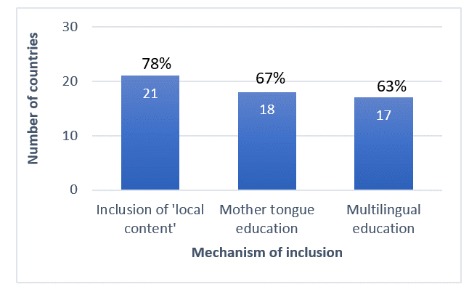
Figure 2. Number and percentage of countries that report including ICH in primary and secondary education curricula, by different mechanisms of inclusion (n=27) (B5.3)

Sustainable development
Reporting countries have paid particular attention to supporting ICH-related sustainable development through income generation and decent work based on cultural tourism, food heritage and traditional craft. Costa Rica’s National Strategy, ‘Creative and Cultural Costa Rica 2030’, for example, recognizes and promotes creative and cultural enterprises, as the engine of the economic, social and cultural development of the country. Twenty out of the reporting countries have policies, legal or administrative measures for inclusive economic development that give consideration to ICH and its safeguarding. Two thirds of these countries reported ICH-related policies and programmes for tourism, and the same number reported having policies and programmes for income generation and sustainable livelihoods.
Specific projects mentioned in the reports assist communities to expand opportunities for local cultural tourism, and support cooperative organizations, transmission and training programmes, environmentally-friendly production and direct marketing schemes for artisanal and food products based on ICH skills. In Paraguay, for example, the National Secretariat of Tourism (SENATUR) has established a programme of Tourist Inns, typical local houses adapted for lodging tourists that showcase the customs and traditions of the country, including cuisine and handicrafts. In some cases, environmental considerations have led to changes in traditional modes of production to increase sustainability.

Regional cooperation in ICH safeguarding
Reporting countries indicate high levels of regional cooperation for ICH safeguarding. Four fifths of the countries reported cooperating at the regional level on safeguarding of ICH in general. Nearly three quarters of countries were engaged in regional cooperation in regard to specific elements of ICH, particularly those in danger. Regional cooperation has been particularly well supported by the activities of the UNESCO Category 2 Centre, CRESPIAL, the Regional Centre for the Safeguarding of Intangible Cultural Heritage of Latin America. Cultural heritage activities (such as the Cultural Heritage List) under the regional agreement MERCOSUR also encourage regional cooperation, especially in Latin America. Regional cooperation among the countries of the Caribbean was supported by the Caribbean Community (CARICOM)’s Caribbean Festival of Arts (CARIFESTA) and initiatives such as the Organization of American States-supported project ‘Expanding the Socio-economic Potential of Cultural Heritage in the Caribbean’ which involved many Caribbean countries.

Challenges and opportunities

The impact of the COVID-19 pandemic
Many of the countries reporting in this cycle mentioned the negative impact of the COVID-19 pandemic on ICH practice, transmission and safeguarding activities, as well as on the livelihoods and health of the communities, groups and individuals concerned. Many festivals and events were cancelled or postponed. Community groups and practitioners were unable to gather and practice their ICH, transmission of skills was hampered by social isolation. The pandemic reduced government funding for culture in some cases, and affected the ability of government agencies to engage face-to-face with stakeholders in supporting safeguarding or indeed compiling the Periodic Report. Pandemic restrictions affected international engagement as well.
Communities, research institutions, civil society organizations and government agencies reported some success in moving activities and discussions online, however, using digital platforms much more extensively and in innovative ways. Online activities were sometimes found to be well suited to achieving broader community engagement, transmission of skills, awareness raising and income generation from ICH for example through online workshops, events and marketing platforms for ICH-related products and services. Although there were challenges in reaching older and marginalized communities without good digital access or expertise, young people have been attracted to ICH-related learning and activities online. Some countries also reported that specific funding such as subsidies for practitioners had been released by government to support communities concerned and their ICH safeguarding during the pandemic. Post-disaster recovery plans have incorporated ICH as an essential component of resilience and an engine of recovery in some countries.

Private sector support for ICH safeguarding
In reporting countries, much of the support for the culture sector comes from government funding. Nearly two thirds of the countries reported having favourable financial or fiscal measures or incentives in place to facilitate and/or encourage the practice and transmission of ICH. This included subsidizing carnivals or events, providing funds for bearers, and reducing fees and taxes associated with using land and property for sustainable ICH practice and transmission. However, culture agencies in governments also reported experiencing financial constraints, and ICH is seldom as well funded as the tangible heritage sector. Funding is thus a problem for institutions and civil society organizations working in ICH safeguarding. Many practitioners of ICH, and their communities, experience serious economic challenges in reporting countries. These challenges have been exacerbated by climate change, natural disasters and the COVID-19 pandemic.
Private institutions play a relatively small role in supporting ICH safeguarding in reporting countries, according to the reports.

Figure 3. Number and percentage of countries reporting private sector participation in ICH safeguarding activities, by extent (n=27) (B21.3)
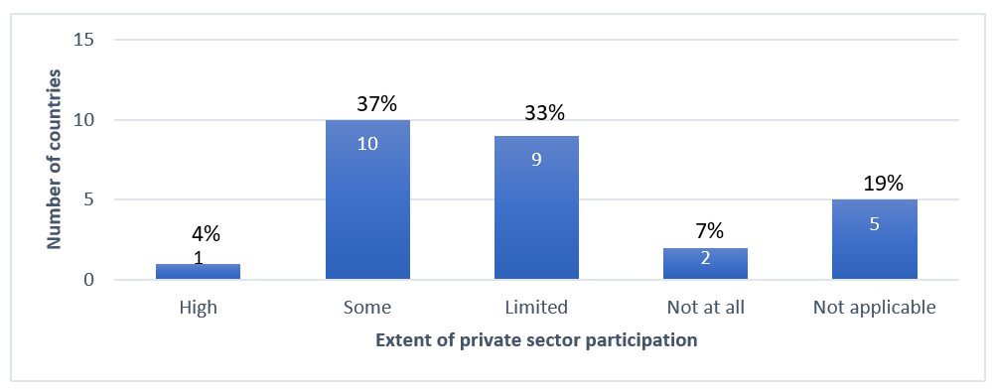
Where present, private sector involvement was often centred around tourism or events, which tends to be time-limited. Several countries noted that while some private sector actors promoted ICH or sponsored various projects as part of their social responsibility or marketing efforts, there was a need for more dialogue about the purposes and ethics of private sector support for ICH projects. It is often difficult for communities concerned to control the ways in which their ICH is used by private sector companies, and third party misappropriation of their ICH has occurred in a number of cases. Some communities have found that their cultural practices have been negatively affected by private sector development projects and promotional activities.
Some countries report successfully raising culture sector funding from private sector taxation and incentives. Examples include a 4% value added tax on mobile phone services in Colombia, and using public-private partnerships, for example partnerships with banks to support built heritage restoration projects that utilize ICH skills in Peru. Other countries have provided assessment and mediation services to communities for the resolution of conflicts related to private sector activities affecting sacred places. Government ICH agencies can play a role in both encouraging private sector investment and in monitoring compliance with the Ethical Principles for Safeguarding Intangible Cultural Heritage. Strong ethical frameworks in public policies, coupled with support to ensure implementation in a number of countries, have assisted communities to protect their rights and interests. These examples may have broader relevance in addressing the economic challenges experienced in different contexts.

Inclusion of ICH in development planning and policies beyond the culture sector
The reporting countries have designed and implemented many policies across a variety of sectors that support the implementation of the Convention in accordance with the Ethical Principles. Policies in the culture sector take ICH into account in all but two of the reporting countries. Nevertheless, only about half of these countries also have policies that take ICH into account across the full spectrum of both education and other development sectors. Ten of these countries take ICH into account in either education policies or development policies.
Only about a third of the countries report integrating ICH in policies relating to natural disaster or armed conflict. This is a concern given the rising number of natural disasters relating to climate change. In Peru, local Kechwa women have thus been involved in developing a plan for adaptation to climate change in the micro-basin of the Cumbaza River using measures based on ancestral knowledges and practices of the Kechwa indigenous population.
There may thus be opportunities to better integrate ICH into policies across a range of sectors at the national level in a number of countries. Some reports suggest ways of achieving better cross-sector engagement, for example through awareness-raising and inter-ministerial collaborations focused on common interests such as sustainable economic or environmental development, or by decentralizing planning to the local level. Cross-sectoral approaches may also present opportunities to create stronger mechanisms for monitoring the implementation of policies, and their impact on ICH safeguarding.

Priority areas
The reports indicate some trends in regard to ICH safeguarding activities that relate to the UNESCO priority areas on indigenous peoples, youth, gender, and Small Island Developing States (SIDS).
All but two countries reported involving people of different ages in ICH safeguarding plans and programmes. Four fifths of the countries reported involving people of different ethnic identities, and nearly three quarters also reported involving indigenous peoples in these plans and programmes.
About half the countries reported inclusivity of persons with disabilities, members of vulnerable groups and migrants, immigrants or refugees in ICH safeguarding plans and programmes. In countries like Chile and Venezuela, for example, efforts have been made to involve people with disabilities in ICH safeguarding activities through subtitling, audio description and use of sign language. In Cuba, cultural centers and municipal museums coordinate with disability organizations to promote the dissemination of ICH-related information.

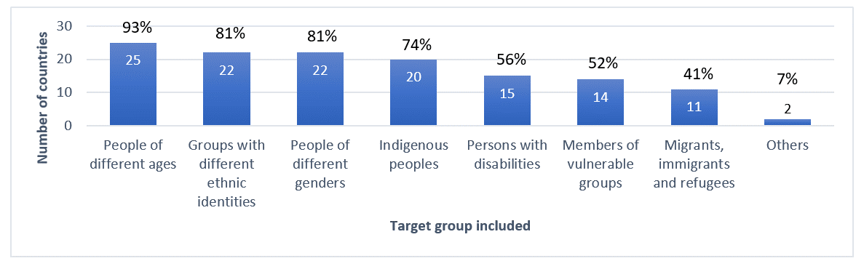
Figure 4. Number and percentage of countries reporting inclusivity of ICH safeguarding plans and programmes, by target group (n=27) (B16.1)
As already mentioned above in regard to language and education, significant attention is paid to supporting indigenous communities in safeguarding their ICH in reporting countries. Bilingual intercultural or multicultural education approaches provide children from indigenous communities with culturally relevant learning contexts in schools and encourage the use of indigenous languages. The broader policy environment frequently provides specific provisions for indigenous groups. The reports offer some examples of successful programmes promoting sustainable development based on culturally-appropriate health provision or artisanal craft for indigenous communities, or assisting them in exercising their rights and protecting their interests. In Mexico, for example, the Program for the Economic Strengthening of Indigenous Peoples and Communities (PROECI), implemented by the National Institute of Indigenous Peoples (INPI), uses participatory, territorial- and gender-inclusive approaches to promote integral, intercultural and sustainable development of indigenous and Afro-Mexican peoples and other communities located in the indigenous regions.
Research and inventorying help to raise awareness of the importance and value of indigenous ICH, which has historically been a focus for academic research in some countries. However, access to this information is not always available to communities concerned, and sometimes indigenous communities wish to manage public access to information about their ICH according to customary practices. Some countries reported challenges in implementing legal frameworks and ethical guidelines to protect the rights and interests of indigenous peoples, and efforts are made to address this. In Saint Vincent and the Grenadines, for example, the draft cultural policy aims to safeguard ICH as well as protect intellectual property rights associated with traditional knowledge.
Youth engagement in ICH safeguarding in the reporting countries was also a focus of the reports. Active community-led transmission of ICH is ongoing, but some ICH elements are nevertheless threatened by reduced youth interest. Nearly four fifths of countries reported that primary and secondary school curricula incorporate ICH as a way of teaching other subjects. A number of ICH safeguarding projects are specifically aimed at involving vulnerable youth and young people from indigenous, Afro-descendant or other ethnic communities. Countries reported youth engagement in awareness raising about ICH, inspired not just by activities in the culture sector, but also by environmental concerns and commercial opportunities. In Nicaragua, youth movements such as the Leonel Rugama Cultural Movement and the Guardabarranco Environmental Movement include raising awareness about ICH in their activities. The shift towards online access to research and documentation about ICH, and towards online activities during COVD-19 has particularly encouraged youth participation, as mentioned above.
The reports demonstrated keen awareness among various stakeholders of the need to achieve gender equality between men and women in ICH safeguarding activities. Some ICH practices do, however, remain gender-specific according to the wishes of the communities concerned. Threats to the viability of some traditions, or changes in social norms, have in a few cases resulted in communities or groups of practitioners choosing to break with traditional gender roles in the practice of the ICH and become more inclusive. Several countries reported successful efforts to achieve gender parity in educational programmes in ICH safeguarding and management, inventorying and safeguarding programmes. However, some of the reports acknowledged that further progress on gender issues and recognition of gender diversity was needed.
A few countries have initiated projects to address these issues, and to deal with broader questions such as gender-based violence and female economic empowerment. In 2020, a Gender Nucleus was created in the Sub-directorate of Intangible Cultural Heritage in Chile and given resources to do research and develop policy to address the link between gender and intangible cultural heritage. Initiatives promoting gender equality in regard to ICH may be effectively linked to broader development policies on this issue. Twelve out of the reporting countries already have development policies for gender equality in place that give consideration to ICH and its safeguarding.
An exhaustive analysis of ICH safeguarding activities in Small Island Developing States (SIDS) compared to other reporting countries has not been done for this report. A global comparison may be more useful at the end of the first reporting cycle in all regions with SIDS. Compared to other reporting countries in this cycle, SIDS reported a higher degree of inclusive media coverage of ICH, and of media coverage in line with the concepts and terminology of the Convention. The Barbados Government Information Service (GIS Barbados) has, for example, partnered with the Caribbean Broadcasting Corporation (CBC) to feature ICH activities in schools, create documentaries on ICH elements, and broadcast programmes to highlight Barbadian intangible heritage.
While SIDS have included ICH in cultural policies to a similar extent compared to other reporting countries, they have generally not included ICH in education and development policies as extensively. Many SIDS reported financial constraints in implementing culture sector programmes and policies, as did other reporting countries. Fewer SIDS have established ICH inventories compared to other countries reporting in this cycle, and a lower percentage of SIDS reported that communities, groups and individuals concerned had access to documentation and research findings on their ICH.
Given these similarities and differences, sharing of experiences between SIDS and other countries may thus promote ICH safeguarding and sustainable development. Among the SIDS only Cuba and the Dominican Republic are members of CRESPIAL, although many are members of CARICOM.

Thematic areas

Institutional Capacities (Thematic area I)
To assist in implementing the Convention and ICH safeguarding, in Article 13(b), State Parties are to ‘designate or establish one or more competent bodies for the safeguarding of the intangible cultural heritage present in [their] territory’. They are encouraged to establish consultative bodies or coordination mechanisms to promote the involvement of communities and other stakeholders in ICH safeguarding, in line with Article 15 and OD 80. The Periodic Report thus contains a number of questions about competent bodies and other institutions that support ICH safeguarding at the national or local level. These are as follows:

Core Indicators | Assessment According to the Following
B1. Extent to which competent bodies and institutions and consultative mechanisms support the continued practice and transmission of ICH | - One or more competent bodies for ICH safeguarding have been designated or established.
 | - Competent bodies exist for safeguarding specific elements of ICH, whether or not inscribed (on the Lists of the 2003 Convention).
 | - Broad and inclusive involvement in ICH safeguarding and management, particularly by the communities, groups and individuals concerned, is fostered through consultative bodies or other coordination mechanisms.
 | - Institutions, organizations and/or initiatives for ICH documentation are fostered, and their materials are utilized to support continued practice and transmission of ICH.
 | - Cultural centres, centres of expertise, research institutions, museums, archives, libraries, etc., contribute to ICH safeguarding and management.

In this report, although it is part of Thematic Area 1, the core indicator B2 has been included in the next section, as it closely relates to capacity development through education.

Summary of findings
In all the reporting countries, a total of 78 competent bodies have been established for ICH safeguarding in general, at least one in nearly every reporting country; 102 competent bodies have been established to support safeguarding of specific elements of ICH. This number is likely an underestimate, as additional bodies established at provincial or local levels were not always included in the tally. Consultative bodies or coordination mechanisms for supporting the continued practice and transmission of ICH, including Advisory Bodies or networks, have also been established in the majority of countries. Some of these, whether community-led or managed by government agencies, have made a significant contribution to increasing community engagement in safeguarding activities.
Many reporting countries have a long history of fostering and supporting institutions, organizations and/or initiatives for documenting ICH. ICH documentation has been used to support the continued practice and transmission of ICH in almost all reporting countries. This was generally done by promoting appropriate access to documentation materials, and using them to develop education and training materials for specific communities and the general public, specifically young people.
Overall, more than four fifths of the countries reported that museums and cultural centres played a role in supporting safeguarding and management, with research institutions close behind. ‘Houses of Culture’, which encourage local engagement and community projects including ICH safeguarding at the local level, play an important role in many reporting countries. This has helped in decentralizing government funding and linking it to local organizations, needs and initiatives. For example, in Cuba, Houses of Culture were involved in the ICH inventorying programme, which included awareness raising and capacity-building workshops for communities.

Table 1: Table showing the number of countries reporting the contribution of different kinds of institutions towards ICH safeguarding and management (n=27) (B1.5)
 | Cultural centres | Centres of expertise | Research institutions | Museums | Archives | Libraries | Others
Number of countries reporting contribution of this type of institution to ICH safeguarding and management | 23  (85%) | 17  (63%) | 22  (81%) | 23  (85%) | 20  (74%) | 15  (56%) | 15  (56%)

Nearly three quarters of reporting countries fully satisfied the core indicator B1 at the baseline, i.e. the extent to which competent bodies and institutions and consultative mechanisms support the continued practice and transmission of ICH. The significant and continuing investment in competent bodies and consultative mechanisms for safeguarding implies that these institutions are considered by reporting States to be effective mechanisms for implementing the Convention.

Education, building human capacities and transmission (Thematic areas I and II)
In the Convention, education is given a prominent place among a State’s safeguarding responsibilities at the national level. Article 14(a)(i) stresses the importance of educational programmes aimed at the general public, and youth in particular, while Article 14(a)(ii) concerns educational programmes within the communities and groups concerned. The relevance of non-formal means of transmitting knowledge is emphasized by Article 14(a)(iv). The Periodic Report thus contains a number of questions about how ICH is included in educational programmes and curricula, how communities and bearers of ICH (and other stakeholders) are involved in these efforts, and what the impact of these initiatives is on ICH safeguarding. These questions, under Thematic Areas I and II, are as follows:
Core Indicators | Assessment According to the Following
B2. Extent to which programmes support the strengthening of human capacities to promote safeguarding and management of ICH | - Tertiary education institutions offer curricula and degrees in ICH safeguarding and management, on an inclusive basis.
 | - Governmental institutions, centres and other bodies provide training in ICH safeguarding and management, on an inclusive basis.
 | - Community-based or NGO-based initiatives provide training in ICH safeguarding and management, on an inclusive basis.
B3. Extent to which training is operated by or addressed to communities, groups and individuals, as well as to those working in the fields of culture and heritage | - Training programmes, including those operated by communities themselves, provide capacity building in ICH addressed on an inclusive basis to communities, groups and individuals.
 | - Training programmes provide capacity building in ICH addressed on an inclusive basis to those working in the fields of culture and heritage.
B4 Extent to which both formal and non-formal education strengthen the transmission of ICH and promote respect for ICH | - Practitioners and bearers are involved inclusively in the design and development of ICH education programmes and/or in actively presenting and transmitting their heritage.
 | - Modes and methods of transmitting ICH that are recognized by communities, groups and individuals are learned and/or strengthened, and included in educational programmes, both formal and non-formal.
 | - Educational programmes and/or extra-curricular activities concerning ICH and strengthening its transmission, undertaken by communities, groups, NGOs or heritage institutions, are available and supported.
 | - Teacher training programmes and programmes for training providers of non-formal education include approaches to integrating ICH and its safeguarding into education.
B5. Extent to which ICH and its safeguarding are integrated into primary and secondary education, included in the content of relevant disciplines, and used to strengthen teaching and learning about and with ICH and respect for one’s own and others’ ICH | - ICH, in its diversity, is included in the content of relevant disciplines, as a contribution in its own right and/or as a means of explaining or demonstrating other subjects.
 | - School students learn to respect and reflect on the ICH of their own community or group as well as the ICH of others through educational programmes and curricula.
 | - The diversity of learners’ ICH is reflected through mother tongue or multilingual education and/or the inclusion of ‘local content’ within the educational curriculum.
 | - Educational programmes teach about the protection of natural and cultural spaces and places of memory whose existence is necessary for expressing ICH.
B6. Extent to which post-secondary education supports the practice and transmission of ICH as well as study of its social, cultural and other dimensions | - Post-secondary education institutions offer curricula and degrees (in fields such as music, arts, crafts, technical and vocational education and training, etc.) that strengthen the practice and transmission of ICH.
 | - Post-secondary education institutions offer curricula and degrees for the study of ICH and its social, cultural and other dimensions.

Summary of findings
Many reporting countries, especially those in Latin America, implement an educational approach based on bilingual intercultural education in schools, offering some local autonomy, especially for indigenous or Afro-descendant communities. Other educational systems in reporting countries, particularly in the Caribbean, teach directly about cultural diversity and mutual respect in schools, informed by multicultural education approaches. In primary and secondary education settings, over three quarters of the countries reported that students learned to respect and reflect on the ICH of their own community and others through educational programmes and curricula.
School curricula generally accommodate ICH-related content as a way of explaining other subjects, with only about half of the countries reporting it being included as a stand-alone subject. In Haiti, the association Ref-Culture, a private organization working in the field of safeguarding, has published two textbooks supporting the teaching of ICH in public schools using documentary evidence from the National Bureau of Ethnology (BNE). Teaching about ICH could be linked to local contexts. As mentioned above, over three quarters of countries reported ICH being included as part of ‘local content’, or in mother tongue or multilingual education. Just over three quarters of the countries reported having educational programmes teaching about the protection of natural and cultural spaces and places of memory whose existence is necessary for expressing ICH.
Over three quarters of countries reported that communities, groups, NGOs or heritage institutions offer educational programmes and/or extra-curricular activities concerning ICH and strengthening its transmission. Some communities preferred to limit the extent of knowledge diffusion outside their community in accordance with customary limitations on access.
A variety of educational approaches including formal curricula, informal workshops, online open access education, festivals or events and competitions are used to supplement usual transmission methods. All the countries reporting in this cycle stated that practitioners and bearers were involved in designing and developing formal or non-formal ICH education programmes and/or actively presenting and transmitting their heritage. Non-formal education is more frequently employed for encouraging transmission than formal education. Most reporting countries also stated that capacity building programmes on ICH were addressed to communities, groups and individuals concerned as participants.
Over three quarters of countries also reported specific educational programmes at the post-secondary level strengthening the practice and transmission of ICH in fields such as music and the arts, although not all such instruction would be specifically focused on ICH.

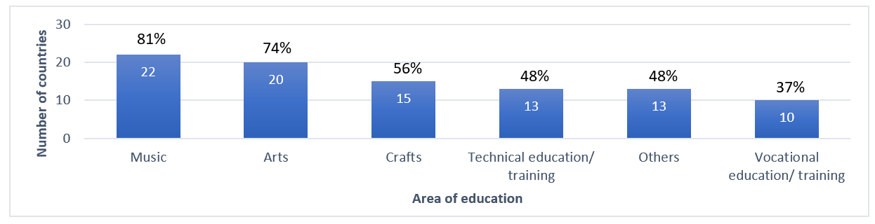
Figure 5. Number and percentage of countries reporting strengthening the practice and transmission of ICH in specific subject areas of post-secondary education curricula (n=27) (B6.1)
Just under two thirds of the countries reported vocational or technical training on ICH management being offered through tertiary institutions. Vocational or technical training on ICH management seems to be more commonly offered outside tertiary educational institutions. Almost all the reports stated that educational programmes in ICH safeguarding and management from different providers were inclusive. Inclusivity was understood in diverse ways across the reporting countries, embracing gender preference, social class, ethnic, cultural and geographical diversity, as well as diversity of institutional location and employment.
Almost all the reporting countries fully satisfied the core indicator B3 at the baseline, on the extent to which training is operated by or addressed to communities, groups and individuals, as well as to those working in the fields of culture and heritage. About half fully satisfied the core indicators B2 and B4 at the baseline, relating to educational programmes strengthening human capacities to promote safeguarding and management of ICH, and strengthening the transmission of ICH and promoting respect for ICH respectively. A lower proportion of countries fully satisfied the core indicators B5 and B6 at the baseline, relating to integration of ICH in primary and secondary education, and the role of post-secondary education in ICH safeguarding respectively.
Analysis of the reports indicates that greater emphasis may be placed on the inclusion of ICH in curricula of tertiary institutions and decentralization of decision-making on curricula in some countries. Further attention could also potentially be paid to inclusion of ICH as a subject in teacher training and in extra-curricular programmes offered by non-governmental institutions.

Inventories (Thematic area III)
In Article 11(b), the Convention requires that a State Party ‘identify and define the various elements of the intangible cultural heritage present in its territory, with the participation of communities, groups and relevant non-governmental organizations’. Article 12.1 specifies that the purpose of inventorying is ‘To ensure identification with a view to safeguarding’. It indicates that each State Party ‘shall draw up, in a manner geared to its own situation, one or more inventories of the intangible cultural heritage present in its territory. These inventories shall be regularly updated.’ The Periodic Report thus contains a number of questions about the design and format of inventories of ICH, how communities, groups and individuals and other stakeholders participate in inventorying and how inventories contribute to safeguarding, for example by recording ICH viability or being updated. These are as follows:
Core Indicators | Assessment According to the Following
B7. Extent to which inventories reflect the diversity of ICH and contribute to safeguarding | - One or more inventorying systems oriented towards safeguarding and reflecting the diversity of ICH have been established or revised since ratification.
 | - Specialized inventories and/or inventories of various scopes reflect diversity and contribute to safeguarding.
 | - Existing inventory or inventories have been updated during the reporting period, in particular to reflect the current viability of elements included.
 | - Access to ICH inventories is facilitated, while respecting customary practices governing access to specific aspects of ICH, and they are utilized to strengthen safeguarding.
B8. Extent to which the inventorying process is inclusive, respects the diversity of ICH and its practitioners, and supports safeguarding by communities, groups and individuals concerned | - Communities, groups and relevant NGOs participate inclusively in inventorying which informs and strengthens their safeguarding efforts.
 | - Inventorying process respects the diversity of ICH and its practitioners, including the practices and expressions of all sectors of society, all genders and all regions.

Section A6 of the Periodic Reporting form also contains a number of questions about individual inventories, so analysis of this section has been included here. Questions about research and documentation that are part of Thematic Area III have been included in the next section in this report.

Summary of findings
Most of the reporting countries have one or more inventories of ICH in their territory. A total of 40 inventories of ICH were reported on in this cycle, around two thirds of which have a specific scope. The inventories contain details of more than 11,000 ICH elements, which is likely an underestimate.
About three fifths of the countries stated that in general, their inventories fully or largely reflected the diversity of ICH present in their territory. Most of the general inventories follow the approach of the Convention in determining criteria for inclusion, and ICH domains. The Dominican Republic specifically requires the design and application of safeguarding measures that promote gender equality, the participation of young people and respect for ethnic identities as criteria for inclusion in their community ICH inventories.
Nearly two thirds of the countries reported that communities, groups and relevant NGOs participated to a large extent and inclusively in inventorying, thus informing and strengthening their safeguarding efforts. However, some countries reported challenges in ensuring gender equality and diversity across inventoried elements. Efforts were being made to address this problem.
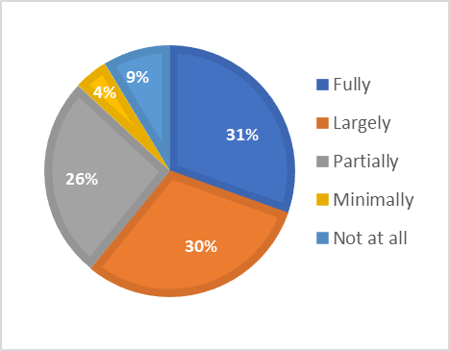
A third of inventories are reported to be fully accessible to relevant stakeholders, while respecting customary practices governing access.

Figure 6. Percentage of countries reporting that access to inventories in general is facilitated, respecting customary practices governing access, by extent of access (n=23) (B7.4a)

Providing online access has in some cases allowed communities, groups and individuals concerned not only to access, but also to update inventory entries. The importance of digital access for public participation has increased during the COVID-19 pandemic. However, not all communities and older individuals have access to digital tools. As already indicated above, adjustments for people with disabilities are needed to ensure equitable access for inclusive participation.
About two thirds of the inventories are reported to be fully or largely oriented towards safeguarding, for example by including information about viability, threats and safeguarding measures. Not all of the inventories update viability information when updating the inventory.
Only about a quarter of the reporting countries fully satisfied the core indicator B7 at the baseline on the extent to which inventories as such reflect the diversity of ICH and contribute to safeguarding. Considerably more countries, three fifths, fully satisfied the core indicator B8 at the baseline, on the extent to which the inventorying process is inclusive, respects the diversity of ICH and its practitioners, and supports safeguarding.
Thus, the process of inventorying is generally in line with the Convention, but inventories themselves are not yet fully developed, oriented towards safeguarding and made accessible. Challenges remain in some countries to reorient their inventories towards safeguarding, increase diversity and community participation, and improve the frequency of updating.

Research and Documentation (Thematic area III and VII)
The 2003 Convention encourages States Parties to ‘foster scientific, technical and artistic studies, as well as research methodologies, with a view to effective safeguarding of the intangible cultural heritage, in particular the intangible cultural heritage in danger’ (Article 13(c)). States Parties are also encouraged to ‘adopt appropriate legal, technical, administrative and financial measures aimed … ensuring access to the intangible cultural heritage while respecting customary practices governing access to specific aspects of such heritage’ (Article 13(d)(ii)). The Periodic Report thus contains a number of questions about support for research and documentation, community and other stakeholder participation in it, accessibility and utilization, as follows:
Core Indicators | Assessment According to the Following
B9. Extent to which research and documentation, including scientific, technical and artistic studies, contribute to safeguarding | - Financial and other forms of support foster research, scientific, technical and artistic studies, documentation and archiving, oriented towards safeguarding and carried out in conformity with relevant ethical principles.
 | - Research is fostered concerning approaches towards, and impacts of, safeguarding ICH in general and specific elements of ICH, whether or not inscribed.
 | - Practitioners and bearers of ICH participate in the management, implementation and dissemination of research findings and scientific, technical and artistic studies, all done with their free, prior, sustained and informed consent.
B10. Extent to which research findings and documentation are accessible and are utilized to strengthen policy-making and improve safeguarding | - Documentation and research findings are accessible to communities, groups and individuals, while respecting customary practices governing access to specific aspects of ICH.
 | - The results of research, documentation, and scientific, technical and artistic studies on ICH are utilized to strengthen policy-making across sectors.
 | - The results of research, documentation, and scientific, technical and artistic studies on ICH are utilized to improve safeguarding.
B22. Extent to which civil society contributes to monitoring of ICH safeguarding | - An enabling environment exists for communities, groups and individuals concerned to monitor and undertake scientific, technical and artistic studies on ICH safeguarding programmes and measures.
 | - An enabling environment exists for NGOs, and other civil society bodies to monitor and undertake scientific, technical and artistic studies on ICH safeguarding programmes and measures.
 | - An enabling environment exists for scholars, experts, research institutions and centres of expertise to monitor and undertake scientific, technical and artistic studies on ICH safeguarding programmes and measures.

Analysis of core indicator B22, which includes questions about creation of an enabling environment for research work, has been included under this heading.

Summary of findings
Over three quarters of reporting countries support research or documentation oriented towards safeguarding ICH. The level of support differs between reporting countries, however, and a number of countries indicated there were financial constraints in supporting ICH-related research and documentation. Much of the support for research within culture ministries is linked to inventorying processes, but funding for research is also available through institutional channels (mainly universities) and from national or regional development funding.
All but one of the countries reported involving ICH practitioners and bearers in research and documentation on ICH, with their free, prior, sustained and informed consent. Nevertheless, a number of reports commented that it was difficult to ascertain the actual extent of community participation and consent processes in research and documentation, and it was necessary to improve procedures to ensure this. All countries reported that communities, groups and individuals concerned had some access to documentation and research findings, although often this was just in line with general public access. In about a quarter of countries community access was considered limited.
Two thirds of countries reported that an enabling environment existed for communities, groups and individuals, as well as NGOs and other civil society actors to monitor and undertake scientific, technical and artistic studies on ICH safeguarding programmes and measures. An even higher proportion of countries (85%) reported that such an enabling environment existed for academic research. Some of the challenges identified in creating an enabling environment included insufficient focus on the need for monitoring, financial constraints (sometimes due to the COVID-19 pandemic), and lack of research capacity.
The reports demonstrate that community-led research and documentation, as part of the inventorying process, has been used in many cases for the development of safeguarding measures or plans for safeguarding specific elements of ICH. Research and documentation on ICH have also been used to inform more general safeguarding actions, such as education, and capacity-building for communities concerned. Community practitioners of ICH elements in Panama were, for example, able to use research findings to help develop training workshops, thus both generating income in some cases and enabling transmission. Direct use of ICH-related research and documentation in policy-making seems fairly limited across reporting countries, except where there were institutional links between policy-makers and research institutions and/or competent bodies for ICH safeguarding.

Figure 7. Number and percentage of countries reporting research, documentation, and scientific, technical and artistic studies on ICH being utilized in policy-making, by extent of use (n=27) (B10.2)
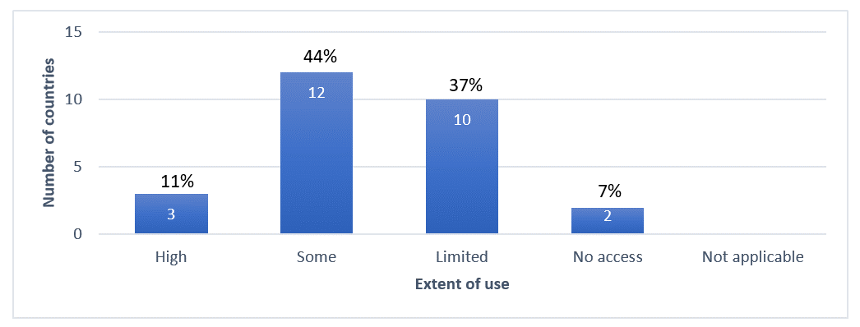
Some of the reports noted that State agencies could not always easily monitor the effects of research on the safeguarding of ICH elements where such research was independent of inventorying or policy-making, including research initiated by communities concerned and other actors, such as university researchers.
Over half of the reporting countries fully satisfied the core indicator B9 at the baseline in respect to the contribution of research and documentation to safeguarding, and on civil society contributions to monitoring of ICH safeguarding (B22). A small proportion of reporting countries (15%) fully satisfied the core indicator B10 at the baseline, regarding the accessibility of research and documentation findings.
Reports mentioned the need for further funding and planning for online access, focused on the needs of, and trusting relationships with, the communities, groups and individuals concerned.

Policies, legal and administrative measures (Thematic area IV)
Establishing a set of relevant policies and/or legal and administrative measures creates an important basis for supporting the design, development, delivery and implementation of effective and sustainable safeguarding programmes and activities in different sectors. Article 13(a) of the Convention encourages States Parties to ‘adopt a general policy aimed at promoting the function of the intangible cultural heritage in society, and at integrating the safeguarding of such heritage into planning programmes’ (see also OD 153(b)(i)), with more detailed guidance provided in Chapter VI of the Operational Directives. Article 14(a)(ii) of the Convention also emphasizes the desirability of ‘specific educational and training programmes within the communities and groups concerned’ as a means to ‘ensure recognition of, respect for, and enhancement of the intangible cultural heritage in society’. Policies in other development sectors include inclusive social or economic development, and environmental sustainability. The Periodic Report thus contains a number of questions about policies, legal and administrative measures that support ICH safeguarding and how communities, groups and individuals concerned are involved in policy-making, as follows:

Core Indicators | Assessment According to the Following
B11. Extent to which policies as well as legal and administrative measures in the field of culture reflect the diversity of ICH and the importance of its safeguarding and are implemented | - Cultural policies and/or legal and administrative measures integrating ICH and its safeguarding, and reflecting its diversity, have been established or revised and are being implemented.
 | - National or sub-national strategies and/or action plans for ICH safeguarding are established or revised and are being implemented, including safeguarding plans for specific elements, whether or not inscribed.
 | - Public financial and/or technical support for the safeguarding of ICH elements, whether or not inscribed, is provided on an equitable basis, in relation to the overall support for culture and heritage at large, while bearing in mind the priority for those identified as in need of urgent safeguarding.
 | - Cultural policies and/or legal and administrative measures integrating ICH and its safeguarding are informed by the active participation of communities, groups and individuals.
B12. Extent to which policies as well as legal and administrative measures in the field of education reflect the diversity of ICH and the importance of its safeguarding and are implemented | - Policies and/or legal and administrative measures for education are established or revised and implemented to ensure recognition of, respect for and enhancement of ICH.
 | - Policies and/or legal and administrative measures for education are established or revised and implemented to strengthen transmission and practice of ICH.
 | - Policies and/or legal and administrative measures promote mother tongue instruction and multilingual education.
B13. Extent to which policies as well as legal and administrative measures in fields other than culture and education reflect the diversity of ICH and the importance of its safeguarding and are implemented | - The Ethical Principles for Safeguarding Intangible Cultural Heritage are respected in development plans, policies and programmes.
 | - Policies and/or legal and administrative measures for inclusive social development and environmental sustainability are established or revised to consider ICH and its safeguarding.
 | - Policies and/or legal and administrative measures to respond to situations of natural disaster or armed conflict are established or revised to include the ICH affected and to recognize its importance for the resilience of the affected populations.
 | - Policies and/or legal and administrative measures for inclusive economic development are established or revised to consider ICH and its safeguarding.
 | - Favourable financial or fiscal measures or incentives are established or revised to facilitate and/or encourage practice and transmission of ICH and increase availability of natural and other resources required for its practice.
B14. Extent to which policies as well as legal and administrative measures respect customary rights, practices and expressions, particularly as regards the practice and transmission of ICH | - Forms of legal protection, such as intellectual property rights and privacy rights, are provided to ICH practitioners, bearers and their communities when their ICH is exploited by others for commercial or other purposes.
 | - The importance of customary rights of communities and groups to land, sea and forest ecosystems necessary for the practice and transmission of ICH is recognized in policies and/or legal and administrative measures.
 | - Policies and/or legal and administrative measures recognize expressions, practices and representations of intangible cultural heritage that contribute to dispute prevention and peaceful conflict resolution.

Summary of findings
Almost all the countries reported establishing or revising and implementing policies in the culture sector that incorporate ICH and its safeguarding and reflect its diversity. Some of these policies establish the competent bodies for implementing the Convention, or give new mandates to existing bodies, and set up inventories and associated processes. ICH and cultural heritage are also mentioned in a number of national constitutions, or specific legal frameworks protecting the culture and rights of indigenous peoples and Afro-descendant communities.
Three quarters of reporting countries had equitable public financial and/or technical support for ICH safeguarding, although only about two thirds of these prioritized ICH in need of urgent safeguarding. There is a continued imbalance between funding for tangible and intangible heritage. Many countries reported limitations in State support for ICH safeguarding, particularly under COVID-19, although there were a few COVID-19 support schemes for practitioners.
Nearly two thirds of the countries reported having favourable financial or fiscal measures or incentives in place to facilitate and/or encourage the practice and transmission of ICH. This included subsidizing carnivals or events, providing funds for bearers, and reducing fees and taxes associated with using land and property for sustainable ICH practice and transmission. Some countries used fines for infringements under the cultural heritage laws, legacies and donations, and specific taxation schemes, as mentioned above. Guatemala, for example, offers an incentive program for small holders of forest or agroforestry land, that provides community access to raw materials for ICH practices such as traditional ceramics and the practice of ancestral rituals.

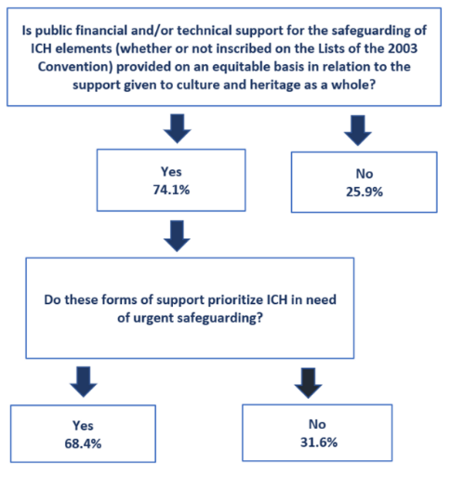
Figure 8. Percentage of countries providing public support for ICH safeguarding (n=27) (B11.3)

Just over four fifths of the reporting countries mentioned that national or sub-national strategies and/or action plans for ICH safeguarding had been established (or revised) and implemented. Safeguarding-related funding was usually directed towards inventoried elements, but some focused on specific groups, especially indigenous and afro-descendant communities.
Two thirds of the countries have established policies, legal or administrative measures in the education sector that ensure recognition of, respect for and enhancement of intangible cultural heritage, generally taking either multicultural or bilingual intercultural educational approaches. This proportion is somewhat lower among the SIDS, at two fifths. Not all of these policies specifically mention ICH or the Convention, but focus on culture, folklore, language and other related concepts. Cooperation agreements between ministries of culture and education, and the inclusion of ICH in the teacher training curricula, are considered useful mechanisms for enabling better implementation of these policies.
Nearly four fifths of the countries have also taken ICH into consideration in policies for inclusive social development and environmental sustainability and inclusive economic development. Examples of policies included protecting and promoting sustainable use of environmental resources in ICH practice; inclusion of ICH in land use planning; recognition and support for traditional agriculture, food products and handicrafts; provisions for protection, and access and benefit sharing agreements in regard to traditional knowledge; and support, recognition and regulation of traditional health care practices. In many cases, these policies were based on existing legal guarantees or recognition of the territorial, social, environmental, economic and cultural rights of indigenous and/or afro-descendant communities.
About half of the countries reported that their policies and/or legal and administrative measures recognize expressions, practices and representations of intangible cultural heritage that contribute to peaceful conflict prevention and resolution. Promoting specific ICH elements related to peace-building has helped in raising awareness about the role of ICH in conflict resolution. In a few countries with a history of recent conflict, special provisions have been made for revitalization and resilience. Colombia designed a legal framework for the Collective Reparation Program for victims of the armed conflict. This programme includes various actions for revitalization and safeguarding of ICH identified by affected communities.
About three quarters of countries reported that forms of legal protection, such as intellectual property rights and privacy rights, were available to communities, groups and individuals when their ICH is exploited by others for commercial or other purposes. Extensions of intellectual property rights protections to ICH are underway in some countries. Even where legal protection is provided, communities concerned, especially indigenous communities, may struggle to use them to the desired effect. Also, not all communities are covered by such protections. Some countries thus provide support for capacity building and mediation with third parties to assist communities concerned.
Four fifths of the countries stated that the Ethical Principles are respected in development plans, policies and programmes relating to ICH. Alignment of policies with ethical approaches in the field of ICH was not always specifically achieved by referencing the 2003 Convention’s Ethical Principles, but by following broader constitutional or development planning guidelines that referenced human and cultural rights.
About half of the reporting countries fully satisfied the core indicators B11 and B12 at the baseline, in regard to policies in culture and education sectors, with significant variation among countries. About a quarter of all reporting countries fully satisfied the core indicator B13 at the baseline, in regard to the integration of ICH in policies in other sectors. Two fifths of countries fully satisfied the core indicator B14 at the baseline in regard to respect for customary rights, practices and expressions in policies.
It is observed that SIDS may benefit from further attention to the development of ICH-related policies in the education sector. There may also be a need for better integration of ICH in broader development policies in some countries. Further efforts may be required in ensuring that formal policy provisions are made to ensure respect for customary rights, practices and expressions.

The role of ICH in society (Thematic area V)
The 2003 Convention suggests that ICH is of importance to communities, groups and individuals concerned, as it ‘provides them with a sense of identity and continuity, thus promoting respect for cultural diversity and human creativity’ (Article 2.1). The Convention’s purpose to ‘ensure respect for the intangible cultural heritage of the communities, groups and individuals concerned’ (Article 1(b)) implies respect for those people as well as their ICH. The Convention also recommends that States Parties adopt ‘a general policy aimed at promoting the function of the intangible cultural heritage in society, and at integrating the safeguarding of such heritage into planning programmes’ (Article 13(a)). The Periodic Report thus contains a number of questions about the role of ICH in society, particularly for bearer communities, and how it is being promoted and recognized, for example in development interventions. These are as follows:

Core Indicators | Assessment According to the Following
B15. Extent to which the importance of ICH and its safeguarding in society is recognized, both by the communities, groups and individuals concerned and by society at large | - Communities, groups and individuals use their ICH for their well-being, including in the context of sustainable development programmes.
 | - Communities, groups and individuals use their ICH for dialogue promoting mutual respect, conflict resolution and peace-building.
 | - Development interventions recognize the importance of ICH in society as a source of identity and continuity, and as a source of knowledge and skills, and strengthen its role as a resource to enable sustainable development.

Core indicator B16, which relates to the inclusiveness and impacts of safeguarding plans and programmes, is reported on more fully in the section below on Safeguarding Activities for ICH. However, some key findings from that indicator in relation to the impact of safeguarding activities under the Convention on the role of ICH in society (16.2) will also be mentioned here.

Summary of findings
Almost all countries reported that communities, groups and individuals used their ICH for promoting well-being. Acknowledging ICH as part of collective memory and identity fostered a sense of community, and ICH practice contributed to improving quality of life in some examples given. Recognition of the role of ICH in society served in some cases to highlight the importance of frequently undervalued actors in development, such as women, children and older adults. During the COVID-19 pandemic, certain aspects of ICH, such as mortuary practices and celebrations of social cohesion, were recognized as particularly important.
Community uses of ICH for wellbeing were frequently intertwined with maintaining livelihoods and encouraging environmental sustainability. Traditional medicines, sports and recreation and local foods promote health and wellbeing as well as maintaining social identity. Local tourism, festivals or artisanal events support livelihoods, bring local people and visitors together, educate the general public about the diversity and importance of ICH in society, and encourage the development of local community organizations.
Most countries reported that communities, groups and individuals used their ICH for dialogue promoting mutual respect, conflict resolution and peace-building. Some forms of ICH themselves promote conflict resolution and peace-building. The development of safeguarding plans and inventorying or inscription of ICH elements also sometimes helped to reduce historical conflicts and differences over cultural practices and values, both within and between communities.
Raising awareness about the diversity of ICH in a society, and especially the ICH of marginalized groups, helped to encourage mutual respect and integration. Teaching with ICH was used to develop mutual respect and peace-building approaches, for example in projects among vulnerable groups. ICH practices that regulate use of natural resources such as land or water, and allocate tasks for common benefit helped to support environmental sustainability as well as build community cohesion and reduce conflict. In Peru, for example, the ancestral ritual of the Peruvian altiplano called Pachatata Pachamama helps to renew the relationship between the sacred entities of the Amantani Island in the Titicaca Lake and the population of the ten communities settled in the area. In this ritual, community lands are redistributed and the relations of reciprocity among the communities are strengthened.
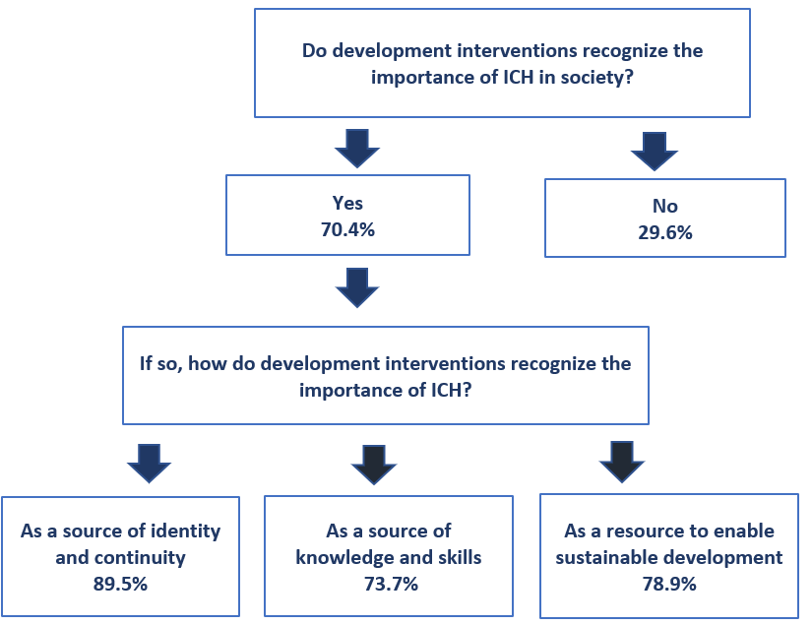
Over two thirds of countries noted that development interventions recognized the importance of ICH in society, whether as a source of identity and continuity, as a source of knowledge and skills and as a resource for sustainable development. Examples given in this section often combined these different aspects of the importance of ICH.

Figure 9. Percentage of countries recognizing the importance of ICH in society in development interventions (n=27) (B15.3)

Policies and legislation that take ICH into account and promote its safeguarding have encouraged some development programmes to be more attentive to the role of ICH in society. This has increased the consideration given to ICH in development interventions, especially in land use planning, tourism and environmental management. Greater recognition of the role of ICH in society as a consequence of implementing the Convention seems to have prompted some communities, groups and individuals concerned to organize themselves more effectively for safeguarding activities, and to lobby external stakeholders for support.
The reports indicated several ways in which ICH could be made more visible to development planning processes. Community lobbying, national policy and legislation can all help make ICH more visible to development planning agencies. Inventories of ICH can act as a repository of local knowledge about ICH. In many cases, communities cannot easily protect sacred spaces from development initiatives, such as mining and require the support of external stakeholders. Development planning does not always consider the potential negative impacts of development projects on ICH safeguarding from a community perspective.
About half of the reporting countries fully satisfied this core indicator B15 at the baseline. This indicator required considerable information about how communities, groups and individuals were using their ICH at the local level, which was likely challenging during COVID-19 and with limited resources for reporting. The reports suggested the need for more inter-institutional cross-sectoral communication on integration of ICH in development planning, including identification of good practices.

Awareness raising about the importance of ICH (Thematic area VI)
Awareness-raising of the importance of ICH is one of the Convention’s main four purposes (Article 1(c)) and can help ensure broad appreciation of it. To this end, States are encouraged to ‘ensure recognition of, respect for, and enhancement of the intangible cultural heritage in society, in particular through: (i) educational, awareness-raising and information programmes, aimed at the general public, in particular young people’ (Article 14(a), also ODs 100-117). Awareness-raising activities should be carried out with wide community participation in line with Article 15, and in conformity with relevant Ethical Principles. The Periodic Report thus contains a number of questions about awareness raising activities, community and youth participation in them, the role of media and public sector actors, and alignment with the Ethical Principles, as follows:

Core Indicators | Assessment According to the Following
B17. Extent to which communities, groups and individuals participate widely in raising awareness about the importance of ICH and its safeguarding | - Awareness-raising actions reflect the inclusive and widest possible participation of communities, groups and individuals concerned.
 | - The free, prior, sustained and informed consent of communities, groups and individuals concerned is secured for conducting awareness-raising activities concerning specific elements of their ICH.
 | - The rights of communities, groups and individuals and their moral and material interests are duly protected when raising awareness about their ICH.
 | - Youth are actively engaged in awareness-raising activities, including collecting and disseminating information about the ICH of their communities or groups.
 | - Communities, groups and individuals use information and communication technologies and all forms of media, in particular new media, for raising awareness of the importance of ICH and its safeguarding.
B18. Extent to which media are involved in raising awareness about the importance of ICH and its safeguarding and in promoting understanding and mutual respect | - Media coverage raises awareness of the importance of ICH and its safeguarding and promotes mutual respect among communities, groups and individuals.
 | - Specific cooperation activities or programmes concerning ICH are established and implemented between various ICH stakeholders and media organizations, including capacity-building activities.
 | - Media programming on ICH is inclusive, utilizes the languages of the communities and groups concerned, and/or addresses different target groups.
 | - Media coverage of ICH and its safeguarding is in line with the concepts and terminology of the Convention.
B19. Extent to which public information measures raise awareness about the importance of ICH and its safeguarding and promote understanding and mutual respect | - Practitioners and bearers of ICH are acknowledged publicly, on an inclusive basis, through policies and programmes.
 | - Public events concerning ICH, its importance and safeguarding, and the Convention, are organized for communities, groups and individuals, the general public, researchers, the media and other stakeholders.
 | - Programmes for promotion and dissemination of good safeguarding practices are fostered and supported.
 | - Public information on ICH promotes mutual respect and appreciation within and between communities and groups.
B20. Extent to which programmes raising awareness of ICH respect the relevant ethical principles | - The Ethical Principles for Safeguarding Intangible Cultural Heritage are respected in awareness-raising activities.
 | - Ethical principles, particularly as embodied in relevant professional codes or standards, are respected in awareness-raising activities.

Summary of findings
Almost all the countries reported the widest possible and inclusive participation of the communities, groups and individuals concerned in awareness raising about ICH. Awareness-raising activity, especially when coordinated by government agencies or NGOs, may extend across multiple geographical areas, ICH elements and communities, requiring targeted approaches to ensure community participation in each case.
Awareness raising activities are generally reported to conform with Ethical Principles, mainly because of strong government policies mentioned above. Where such policies are not in place, compliance is achieved informally. The need for community involvement in awareness raising is particularly highlighted in regard to ICH that has been previously ignored, denigrated or marginalized. The Salvadoran Indigenous Ancestral Rescue Institute (RAIS) in El Salvador involves older adults to help raise awareness about indigenous ICH, and thus acknowledge cultural bearers and foster local and national self-esteem in regard to culture. The network of Culture Guardians involves young people who undertake awareness-raising activities under the Cátedra Indígena Náhuat program in the same country.
Nearly all countries reported that communities, groups and individuals use information and communication technologies or any other form of media, in particular new media, for raising awareness of the importance of ICH and its safeguarding. In St. Kitts and Nevis, the ICH Secretariats for Living Heritage have implemented an ICH Awareness Campaign using television, radio, and internet, alongside special events. As already mentioned above, the countries report a high degree of youth engagement in awareness raising about ICH, which was encouraged by new media platforms. The shift towards online awareness raising in some cases reduced the participation of older groups, however.
Media coverage of ICH is not always in line with the Convention, and sometimes uses incorrect terminology or concepts. Press releases, briefings, information brochures and capacity-building workshops for media houses and journalists have helped to educate them on terminology and the concepts of the Convention in many countries.
The majority of ICH-related media coverage was reported to be inclusive, but only about half of the countries reported that it addressed different target groups and utilized the language(s) of the communities, groups and individuals concerned. One of the barriers to more targeted and language-inclusive media coverage of ICH may be financial, or even political.

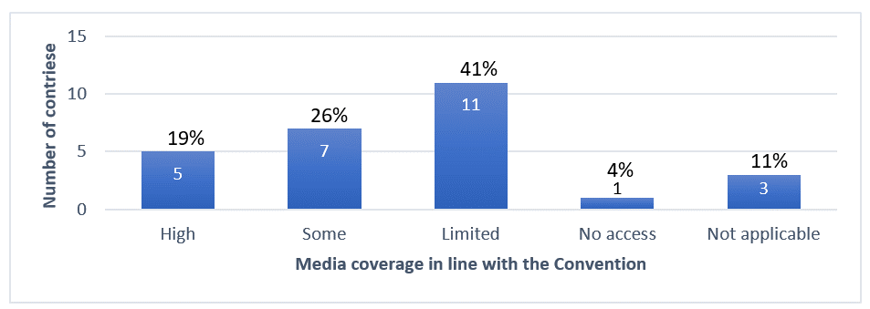
Figure 10. Number and percentage of countries providing media coverage of intangible cultural heritage and its safeguarding in line with the concepts and terminology of the Convention (n=27) (B18.4)
About half of the countries reported joint cooperation activities or programmes between the media and other ICH stakeholders concerning ICH, including capacity-building activities. Public broadcasting services work with government agencies and universities to publicize safeguarding and inventorying projects. In the Bahamas, for example, event organizers often partner with radio broadcasters to cover ICH events. Local or specialist media services are particularly interested in broadcasting local ICH content. Use of media channels such as radio for involving older and local or less advantaged audiences have demonstrated efficacy in some countries.
Almost all the countries reported that public events about ICH and the Convention were organized. Public institutions such as museums, schools and government initiatives for ICH safeguarding support many ICH awareness-raising activities. Tourism and marketing activities for artisanal crafts and other ICH-related products and services, some of which are publicly funded, also help to raise awareness about ICH. These activities generally acknowledge ICH bearers. Some bearers have been beneficiaries of pensions, awards and ongoing funding under Living Human Treasures-type schemes. Some inventorying systems also include records of bearers and practitioners of ICH.
Most countries fully satisfied the core indicators B17 and B20 at the baseline, regarding community participation and ethical principles in awareness raising. Nearly two thirds fully satisfied the core indicator B19 at the baseline in regard to public information measures raising awareness about ICH. However, only a third of the reporting countries fully satisfied the core indicator B18 at the baseline, regarding the extent of media involvement in raising awareness about ICH. Greater use of digital media for awareness raising about the Convention should pay attention to issues of equity and access.

Safeguarding activities for ICH (Thematic area V and VII)
Effectively involving a broad range of actors is essential to achieving the best safeguarding results, whether for ICH in general or for specific elements of ICH. Key among these are the communities, groups and, where appropriate, individuals concerned, whose widest possible participation in the safeguarding and management of their ICH is encouraged. In addition, the Operational Directives have also developed an important role in safeguarding for non-governmental organizations and other civil society actors (e.g. ODs 90, 108, 157(e), 158(b), 162(e), 163(b)), as well as the private sector (OD 187). The Periodic Report thus contains a number of questions about engagement of diverse actors in safeguarding activities. These are as follows:
Core Indicators | Assessment According to the Following
B16. Extent to which the importance of safeguarding ICH is recognized through inclusive plans and programmes that foster self-respect and mutual respect | - ICH safeguarding plans and programmes are inclusive of all sectors and strata of society, including but not limited to:  - indigenous peoples;  - groups with different ethnic identities;  - migrants, immigrants and refugees;  - people of different ages;  - people of different genders;  - persons with disabilities;  - members of vulnerable groups.
 | - Self-respect and mutual respect are fostered among communities, groups and individuals through safeguarding plans and programmes for ICH in general and/or for specific elements of ICH, whether or not inscribed.
B21. Extent to which engagement for safeguarding ICH is enhanced among stakeholders | - Communities, groups and individuals participate, on an inclusive basis and to the widest possible extent, in the safeguarding of ICH in general and of specific elements of ICH, whether or not inscribed.
 | - NGOs and other civil society actors participate in the safeguarding of ICH in general, and of specific elements of ICH, whether or not inscribed.
 | - Private sector entities participate in the safeguarding of ICH, and of specific elements of ICH, whether or not inscribed, respecting the Ethical Principles for Safeguarding ICH.

Core indicator B22 on the existence of enabling environments for the monitoring of safeguarding activities was covered above under Research and Documentation.

Summary of findings
About half of the countries reported high levels of the widest possible inclusive participation of communities, groups and individuals concerned in ICH safeguarding. To this end, many countries established guidelines, policies and practices requiring community participation, and used networks and consultative bodies to encourage it. Paraguay, for example, invites diverse community participation on Technical Tables of Culture, and has recently created Technical Tables for Community Living Culture. Members include representatives of the National Secretariat of Culture (NSC), the National Council of Culture (CONCULTURA) and non-profit associations, organizations or guilds; particular attention is paid to gender inclusivity.

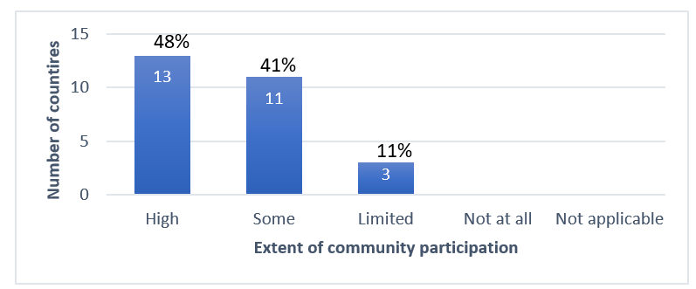
Figure 11. Number and percentage of countries reporting wide and inclusive community participation in ICH safeguarding activities, by extent (n=27) (B21.1)
In many cases, inclusivity or non-discrimination is mandated in national legislation or policy that applies to ICH safeguarding undertaken by government agencies or other organizations. Most of the countries reported involving people of different ages, ethnic identities, and genders in safeguarding plans and programmes. Nearly three quarters also involve indigenous peoples. However, inclusivity relating to people with disabilities and migrant or vulnerable groups was reported to be lower. The Caribbean Association of Cuba has involved migrant communities through awareness raising and capacity building about the Convention with communities of Anglophone and Francophone descent in some Cuban provinces. The Bateyes, a Haitian Dominican population, as well as migrant Haitians and Venezuelans, participate in ICH programmes in the Dominican Republic.
Although several countries reported having few NGOs dedicated to ICH, a third of the countries reported high levels of NGO and other civil society actor participation in ICH safeguarding. Many of these organizations were run by members of communities or groups concerned with specific ICH elements. Many NGOs and civil society organizations depended on some technical support and/or funding from government institutions. Few countries reported much private sector participation in safeguarding activities, as discussed above.
Nearly all countries reported that safeguarding plans and programmes for ICH foster self-respect within and mutual respect between communities, groups and individuals. Examples given in this section demonstrated the value of developing and publicizing guidelines and policies enabling the recognition of diverse ICH, and respectful interactions around it. The decentralization of ICH safeguarding activities allowed local communities to take control of them in some cases.
Over four fifths of reporting countries fully satisfied the core indicator B16 at the baseline, regarding the inclusivity of safeguarding plans and programmes that foster self-respect and mutual respect. However, only about a quarter fully satisfied the core indicator B21 at the baseline, regarding engagement for safeguarding ICH being enhanced among stakeholders. While engagement with communities, groups and individuals concerned is reportedly rather high, engagement with NGOs and private sector actors could be further developed.

International cooperation and engagement (Thematic area VIII)
One of the Convention’s four purposes is ‘to provide for international cooperation and assistance’ (Article 1(d)), and the Convention further defines international cooperation as including joint initiatives, among other things (Article 19). International mechanisms such as International Assistance, inscription on the Lists and Register of the Convention, enable collaboration, cooperation and communication between States Parties at the international level. Article 19 encourages States ‘to cooperate at the bilateral, sub-regional, regional and international levels,’ and such cooperation can be formalized through networking and institutional cooperation, including accreditation of NGOs. The Periodic Report thus contains a number of questions about international cooperation and engagement in safeguarding activities at the bilateral, sub-regional, regional and international levels, as follows:
Core Indicators | Assessment According to the Following
B24. Percentage of States Parties actively engaged with other States Parties in cooperation for safeguarding | - Bilateral, multilateral, regional or international cooperation is undertaken to implement safeguarding measures for ICH in general
 | - Bilateral, multilateral, regional or international cooperation is undertaken to implement safeguarding measures for specific elements of ICH, in particular those in danger, those present in the territories of more than one State, and cross-border elements.
 | - Information and experience about ICH and its safeguarding, including good safeguarding practices, is exchanged with other States Parties.
 | - Documentation concerning an element of ICH present on the territory of another State Party is shared with it.
B25. Percentage of States Parties actively engaged in international networking and institutional cooperation | - State Party engages, as host or beneficiary, in the activities of category 2 centres for ICH.
 | - International networking is fostered among communities, groups and individuals, NGOs, experts, centres of expertise and research institutes, active in the field of ICH.
 | - State Party participates in the ICH-related activities of international and regional bodies other than UNESCO.

Section A also contains some questions on accreditation of NGOs (A4), inscriptions on the Lists and programmes selected for the Register (A5), International assistance funding (A5), and synergies with other international frameworks (A7).

Summary of findings
Many reporting countries have engaged with the various international mechanisms of the Convention. From the countries reporting in this cycle, there were six elements inscribed on the Urgent Safeguarding List, 67 elements inscribed on the Representative List, and six Programmes selected for the Register of Good Safeguarding Practices. Multinational nominations included four on the Representative List, and one each on the Urgent Safeguarding List and Register of Good Safeguarding Practices. These multinational nominations have encouraged international cooperation at the multilateral and bilateral level supporting the safeguarding of the elements, for example among Belize, Guatemala, Honduras and Nicaragua in regard to the element ‘Language, dance and music of the Garifuna’. Experiences from the Good Safeguarding Practices have been shared internationally in other regions of the world.
Twelve projects in the reporting countries were financed through International Assistance (Intangible Cultural Heritage Fund), benefiting 14 countries. Saint Kitts and Nevis, for example, received funding to strengthen capacities for inventorying in the 2019-2021 period. The implementation of some of these projects indicates potential for sustainability. The project Aymara Cultural Universe, for example, originally funded for implementation in 2009, continues to inspire collaborative activity and technical exchange across the three partner countries, Bolivia, Chile and Peru.
Nine accredited NGOs are located in reporting countries: four in Mexico, two each in Colombia and Brazil, and one in Chile. Of these, two NGOs are active in more than one country. The Conservatory of Mexican Gastronomic Culture (Mexico) is active in Argentina, Bolivia, Brazil, Chile, Colombia, Ecuador, Mexico, Peru, and Venezuela. Three of these NGOs focus on activities relating to the safeguarding of traditional food and crafts that are supporting sustainable development of local communities. Two focus on safeguarding the ICH of indigenous peoples. The remaining NGOs – the majority - focus on research and documentation activities to support ICH safeguarding in diverse contexts, working in conjunction with the communities, groups and individuals concerned.
As discussed above, there is already significant regional cooperation among the reporting countries, facilitated by the presence of a Category 2 Centre and various regional initiatives such as MERCOSUR and CARICOM. There are also some bilateral and multilateral international initiatives, for example in connection with the Cultural Heritage Commission of the Community of Portuguese Speaking Countries.
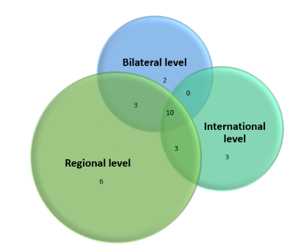
Most countries reported some level of cooperation with other countries on ICH safeguarding in general. Four fifths reported cooperating at the regional level, three fifths at the international level and just over half at the bilateral level. About a third reported cooperation at all three levels.

Figure 12. Number of countries reporting regional, bilateral and international cooperation on ICH safeguarding in general (n=27) (B24.1)

Somewhat fewer countries reported cooperation in regard to specific elements of ICH, particularly those in danger. Just under three quarters reported such cooperation at the regional level, two fifths at the international level and about half at the bilateral level.
Just over half of the countries reported synergies with other UNESCO frameworks, particularly the 1972 Convention Concerning the Protection of the World Cultural and Natural Heritage and the 2005 Convention on the Protection and Promotion of the Diversity of Cultural Expressions. About half of the countries also reported synergies with international frameworks other than UNESCO, particularly the World Intellectual Property Organization (WIPO), the Convention on Biological Diversity (CBD) and the Food and Agriculture Organization of the United Nations (FAO). Reporting in this section (A7) underestimated existing synergies that were included elsewhere in the reports.
Although regional cooperation is relatively strong, it is not evenly distributed, and initiatives for broader international cooperation could be strengthened. Only a quarter of the countries fully satisfied the core indicator B24 at the baseline, regarding active engagement with other States Parties in cooperation for safeguarding. Just over a third fully satisfied the core indicator B25 at the baseline, regarding active engagement in international networking and institutional cooperation. Additional platforms for engagement between Latin American and Caribbean countries may be an area for potential growth.

Status of elements on the Representative List
Article 16 of the Convention states that the aims of inscriptions on the Representative List of the Intangible Cultural Heritage of Humanity are ‘to ensure better visibility of the intangible cultural heritage and awareness of its significance, and to encourage dialogue which respects cultural diversity’. According to Article 29 of the Convention and ODs 156-158, States Parties shall submit reports to the Committee on currently inscribed elements, including those inscribed on the Representative List. Reporting on the status of elements inscribed on the Representative List can help to raise awareness about the significance of ICH, and assist in the monitoring and evaluation of the role of the List, the impact of inscription, and the safeguarding of inscribed elements.

Summary of findings
A total of 67 elements have been inscribed on the Representative List by 20 countries reporting in this cycle (this represents 74% of the reporting countries). Four of these elements are multinational nominations, involving between two and four countries. Among the SIDS, only 4 countries out of 10 (40%) have elements inscribed on the Representative List, totalling 11 inscriptions. The distribution of the elements by country can be seen in the figure below.

Figure 13. The number of elements inscribed on the Representative List from countries reporting in this cycle (A5, C)
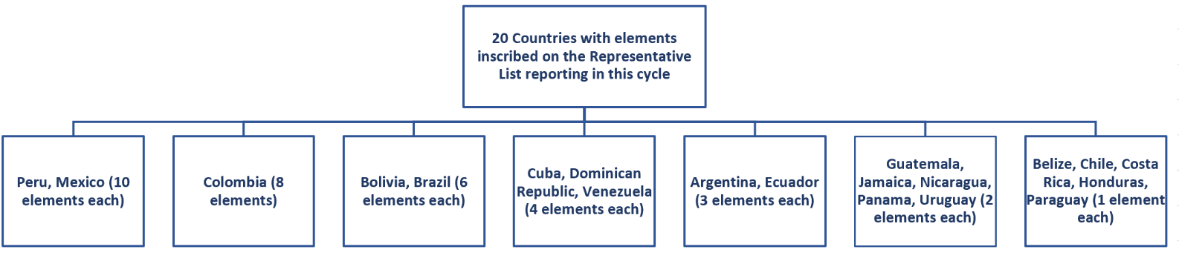
It is interesting to observe in the graph below, how many reporting countries had elements inscribed on the Representative List within a few years after ratification of the Convention. Inscriptions occurring before or at the same time as ratification in 2008 were linked to the ‘Masterpieces of the Oral and Intangible Heritage of Humanity’ (2001-2005) being incorporated into the Representative List.

Figure 14. The time elapsed between ratification of the Convention and inscription of the first element on the Representative List of the Intangible Cultural Heritage (A5)
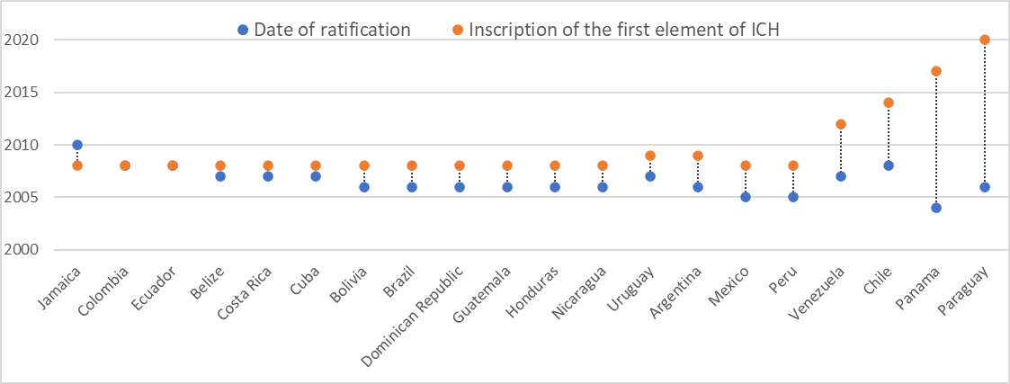

Social and cultural functions
Safeguarding of ICH depends on understanding and maintaining the social and cultural functions and meanings of the element for the communities, groups and individuals concerned. Section C1 of the Periodic Reporting form specifically requests information on changes to the information provided under inscription criterion R.1.
The reports noted innovations in ICH practice, such as the development of new forms of dance and music, and the incorporation of current themes around environment and social equity. Some reports mentioned gender-inclusive adjustments in ICH practice, for example to include more women and LGBTIQA+ groups practising Tango in Argentina. Women and gay men were also reported to be playing more active public roles in some of the ICH practices than they had in the past, for example in ‘The festival of the Santísima Trinidad del Señor Jesús del Gran Poder in the city of La Paz’ (Bolivia). Removing legal restrictions on certain ritual activities, as in the case of the ‘Ritual journeys in La Paz during Alasita’ (Bolivia), has helped communities, groups and individuals concerned to freely celebrate their social and cultural functions and meanings and take pride in their heritage.
ICH practices were also adapted to the COVID-19 pandemic. In Brazil, practitioners of the ‘Cultural Complex of Bumba-meu-boi from Maranhão’ adapted to pandemic conditions by using online broadcasts of Bois' baptism and death rituals, and car parades to celebrate the June saints.

Assessment of its viability and current risks
The development of ICH safeguarding strategies is based on an assessment of the current level of viability of the element, and threats or risks to this viability, if any. This may change over time, so Section C2 of the Periodic Reporting form specifically requests information on the current viability of inscribed elements, even those on the Representative List.
Most of the elements faced some threats and risks to viability, whether mild or serious. These threats and risks included lack of appropriate media coverage, inadequate remuneration for practitioners, and loss of interest among young people. Uncontrolled commercial exploitation or misrepresentation of ICH in tourism, product promotion, or in festivals and performance events was also mentioned as a threat to some elements. Commercialization has negatively impacted ICH in some cases because the use or sale of land for extraction of resources or infrastructure projects affect the use of sacred spaces by communities concerned.
A number of reports also mentioned general factors such as unemployment, out-migration of young people, hurricanes, floods and other natural disasters as risks or threats to the viability of ICH. Deforestation and land invasions affected the safeguarding of some ICH elements by disrupting community lives and use of their territory.
The COVID-19 pandemic negatively affected the practice and transmission of many ICH elements depending on face-to-face encounters, such as performances, festivals and events, as well as regular practice and training of apprentices. Many face-to-face encounters were cancelled, others were reduced in size and scope. This reduced opportunities for practice and transmission, changed social functions and meanings and negatively affected the livelihoods of communities, groups and individuals concerned. Not all ICH elements were badly affected in every way during the pandemic, however. Some reports noted increased membership of community associations, expanded geographical practice of ICH, and increased recognition of the value of ICH in society during COVID-19.

Contribution to the goals of the List
The goals of the Representative List include ensuring visibility of the ICH in general, raising awareness at the local, national and international levels of its importance, as well as promoting respect for cultural diversity and human creativity, and mutual respect among communities, groups and individuals. Section C3 of the Periodic Reporting form thus requests information on how inscription of the element has contributed to achieving these goals.
This is a difficult question for many communities to answer, and State Parties faced challenges in addressing it in the Periodic Reports, partly because it requires consideration of the impact of inscription from the perspective of the goals of the Convention.
The reports noted that many safeguarding activities raised awareness about inscribed elements, inspiring others to consider the importance of ICH in related domains or practices. Events linking several different elements of ICH in a specific area such as a city or a country also helped to promote increased visibility of ICH in general. Activities promoting the element ‘Language, dance and music of the Garifuna’ are for example integrated into the usual calendar of cultural heritage activities in Belize. Some of this inspiration went beyond national borders. For example, Jamaica’s report noted the emergence of several international festivals to celebrate and showcase Reggae Music.
Many elements of ICH inscribed on the Representative List involve practices that encourage mutual respect, as well as stimulating cultural diversity and human creativity, for example the ‘Wayuu Normative System’ in Colombia. Inscription of ICH elements on the Representative List have helped to highlight the need for respect, funding and redress for marginalized communities that have faced historical discrimination and disadvantage. The inscription of ‘Candombe and its socio-cultural space: a community practice’ (Uruguay) in 2009, for example, has encouraged targeted funding, greater awareness and the promulgation of a law in 2014 recognizing historical discrimination against Afro-descendant populations.

Efforts to promote or reinforce the element
Safeguarding ICH often involves the development and implementation of safeguarding measures. Section C4 of the Periodic Reporting form thus requests information on the measures that have been implemented to promote and reinforce the element, particularly detailing any measures that might have been necessary as a consequence of its inscription.
Many reports mentioned the importance of education in schools, and awareness raising about the element in the media, and through awards, competitions, establishing community museums, exhibitions and doing inventorying or research. Many of the reports emphasized the value of maintaining ICH practices and livelihoods by assisting practitioners with the transmission of skills and supporting them to benefit equitably from practice of their art. This was done in various ways, including direct financial support and training for artisans and performers, tourism promotion, sponsorship of festivals or handicraft fairs, and supporting practitioner access to markets. In Ecuador, the Center for Community and Craft Strengthening was established in Pile to support transmission of artisanal skills associated with the ‘Traditional weaving of the Ecuadorian toquilla straw hat’.
The COVID-19 pandemic, while presenting many challenges, also offered some opportunities for strengthening ICH safeguarding. Online meetings, performances, marketplaces, workshops and events helped to sustain the practice and transmission of ICH elements, and even broaden their reach to new audiences and new geographical areas. Greater use of digital media has facilitated stronger connections with diaspora communities interested in ICH practices of their countries of origin, and with new practitioners based abroad.

Community participation
The participation of communities, groups and individuals is essential in safeguarding ICH, assisted where relevant by non-governmental organizations. Section C5 of the Periodic Reporting form thus requests information on such participation and prospects for its continuation in the future.
The reports indicate that after the inscription of ICH elements on the Representative List, many communities experience a strengthening of cultural identity, and benefit from increased government support and social recognition. These factors can work together to encourage communities, groups, and individuals concerned to participate more actively in the work of ICH safeguarding. Structures set up for safeguarding also generally encouraged and expanded community participation. In several cases, community consultations held during the nomination process and the preparation of safeguarding activities empowered communities concerned to work together in safeguarding efforts, and to collaborate more effectively with other stakeholders.
Events, festivals and awareness raising activities encouraged broader community participation. In some contexts, for example among the Garifuna in Honduras, communities themselves were increasingly involved in doing research and documentation activities regarding their inscribed ICH elements.

Institutional context
Community organizations and other stakeholder agencies generally play an essential role in the safeguarding of inscribed ICH elements, and carry formal responsibilities for doing so in some contexts. Section C6 of the Periodic Reporting form thus requests information on the institutional context for the element inscribed on the Representative List, including competent body(ies) involved in its management and/or safeguarding and organization(s) of the community or group concerned with the element and its safeguarding.
Inscription of the element in some cases has resulted in the establishment of new community organizations, closer working relationships in community organizations, and more collaborations between them and other stakeholders.

Participation of communities in preparing the Periodic Report
Article 15 of the Convention encourages States Parties to ensure the widest possible participation of the communities, groups and, where applicable, individuals concerned as well as relevant non-governmental organizations in safeguarding activities. Section C7 of the Periodic Reporting form thus requests information on the extent of their participation during the process of preparation of this report.
The reports demonstrate that significant efforts were made to ensure participation of communities, groups and, where applicable, individuals concerned in preparation of the Periodic Report. This was sometimes hampered by the circumstances surrounding the COVID-19 pandemic. Communication was sometimes achieved through meetings and face-to-face interviews, but more frequently by using telephone, surveys, email, or other digital means. In Venezuela, practitioners of the ‘Traditional knowledge and technologies relating to the growing and processing of the curagua’ were invited to share experiences relating to the impact of COVID-19 through short audio-visual recordings. Community members were invited to review and comment on draft reports in some countries.
ANNEX II
Monitoring of the indicators 23 and 26 of the Overall Results Framework
- Under the thematic area of ‘International engagement’, the following two indicators within the Overall Results Framework require monitoring by the Secretariat at the global level: indicators 23 ‘Number and geographic distribution of NGOs, public and private bodies, and private persons involved by the Committee in an advisory or consultative capacity’ and 26 ‘ICH Fund effectively supports safeguarding and international engagement’. The current report therefore presents the monitoring data and information relevant to the set of indicators and assessment factors, as presented in the table below:
Core indicators | Assessment factors
23. Number and geographic distribution of NGOs, public and private bodies, and private persons involved by the Committee in an advisory or consultative capacity | - Number of NGOs accredited to provide advisory services, their geographic distribution and their representation of different domains.
 | - Percentage of accredited NGOs that participate in the sessions and working groups of the Convention’s governing bodies, and their geographic distribution.
 | - Number of occasions and activities in which accredited NGOs are involved by the Committee for consultative purposes, beyond the evaluation mechanisms.
26. ICH Fund effectively supports safeguarding and international engagement | - States Parties seek financial or technical assistance from the ICH Fund and implement safeguarding programmes resulting from such assistance.
 | - States Parties or other entities provide voluntary supplementary contributions to the ICH Fund, for general or specific purposes, in particular the global capacity-building programme.
 | - The ICH Fund is utilized to support costs of participation in the meetings of the governing bodies of the Convention by a wide range of stakeholders, including ICH experts and accredited NGOs from developing countries, public and private bodies, as well as members of communities and groups, invited to those meetings to act in an advisory capacity.

- This report focuses on presenting a broad outline and factual data on the performance of these indicators covering the reporting period between January 2020 and June 2021, which may be examined together with other relevant documents of the current session of the Committee providing more comprehensive and detailed information.

- Monitoring core indicator 23 ‘Number and geographic distribution of NGOs, public and private bodies, and private persons involved by the Committee in an advisory or consultative capacity’

23.1 Number of NGOs accredited to provide advisory services, their geographic distribution and their representation of different domains.
- There is currently a total of 193 NGOs accredited to perform advisory functions for the Intergovernmental Committee. The number of accredited NGOs distributed according to regions is as follows: Africa 24; Arab States 8; Asia and the Pacific 27; Europe and North America 122; Latin America and the Caribbean 12.

- Out of these 193 accredited NGOs, many of them operate in multiple fields of intangible cultural heritage. In this report, they are presented according to the domains of intangible cultural heritage broadly defined in Article 2 of the Convention: 154 NGOs are engaged in the field of Oral traditions and expressions; 128 in Performing arts; 159 in Social practices, rituals and festive events; 118 in Knowledge and practices concerning nature and the universe; 153 in Traditional craftsmanship, and fifty-three are working in specific domains defined by the States Parties themselves.

23.2 Percentage of accredited NGOs that participate in the sessions and working groups of the Convention’s governing bodies, and their geographic distribution.
- In 2020, the two following meetings of the governing bodies of the 2003 Convention were organized with the participation of the accredited NGOs; the eighth session of the General Assembly of the States Parties, which was held from 8 to 10 September 2020, and the fifteenth session of the Intergovernmental Committee for the Safeguarding of the Intangible Cultural Heritage, which took place online between 14 and 19 December 2020.
- At the eighth session of the General Assembly, 15% of the accredited NGOs (twenty-seven out of a total of 176) registered to participate in the meeting as observers. The geographical distribution of these twenty-seven accredited NGOs is as follows: Africa 2; Arab States 1; Asia and the Pacific 5; Europe and North America 15; Latin America and the Caribbean 4.

- For the fifteenth session of the Intergovernmental Committee (from 14 to 19 December 2020, online), 41% of the accredited NGOs (seventy-nine out of a total number 193) participated in the session as observers. The geographical representation of these seventy-nine accredited NGOs is as follows: Africa 11; Arab States 3; Asia and the Pacific 17; Europe and North America 46; Latin America and the Caribbean 2.

- In addition, between 2020 and 2021, seven accredited NGOs have served on the Evaluation Body, a consultative body of the Committee tasked with evaluating nominations for inscription on the Lists, proposals for the Register of Good Safeguarding Practices and requests for International Assistance greater than US$100,000. During the reporting period, the Body met three times in February (partially in presentia), June 2020 (online) and September 2020 (online), as well as twice online in March and June 2021. These members are as follows, representing each electoral group:
EG I: Workshop intangible heritage Flanders
EG II: European Association of Folklore Festivals
EG III: Erigaie Foundation
EG IV: Korea Cultural Heritage Foundation (CHF)
EG V(a): Association pour la sauvegarde des masques (ASAMA)
EG V(b): Egyptian Society for Folk Traditions (serving for the 2020 cycle) and Syria Trust for Development (serving for the 2021 cycle)

23.3 Number of occasions and activities in which accredited NGOs are involved by the Committee for consultative purposes, beyond the evaluation mechanisms.
- During the reporting period between January 2020 and June 2021, the accredited NGOs were involved by the Committee for consultative purposes on one occasion:
Upon the request of the Committee (Decision 14.COM 15), the ICH NGO Forum, composed of accredited NGOs, presented its first report to the Committee at its fifteenth session in 2020. This report highlighted the organizational issues and activities of the NGO Forum during 2019–2020, as well as its views on the role of accredited NGOs in the implementation of the Convention.
- More detailed information on the accredited NGOs is provided in the ‘Report of the non-governmental organizations forum’ (LHE/20/15.COM/6) and in the document on the ‘Accreditation of new non-governmental organizations and review of accredited non-governmental organizations’ (LHE/21/16.COM/9).

- Monitoring core indicator 26 ‘ICH Fund effectively supports safeguarding and international engagement’
26.1 States Parties seek financial or technical assistance from the ICH Fund and implement safeguarding programmes resulting from such assistance.
- From January 2020 to June 2021, a total of ten requests for International Assistance were examined by the Bureau of the fifteenth and sixteenth sessions of the Intergovernmental Committee, as well as the fifteenth session of the Committee (14–19 December 2021, online). Of these requests, four were referred and six were approved and granted funds from the Intangible Cultural Heritage Fund, as shown below:

- While the Bureau approved five out of the six submitted requests, granting financial assistance to Cook Islands, Grenada, Pakistan, Zambia and Zimbabwe, the Committee approved one out of the four submitted requests, granting financial assistance to Namibia.
- Further detailed information on the implementation of the International Assistance mechanism is provided in the ‘Reports of States Parties on the use of International Assistance from the Intangible Cultural Heritage Fund (LHE/21/16.COM/7.d).

26.2 States Parties or other entities provide voluntary supplementary contributions to the ICH Fund, for general or specific purposes, in particular the global capacity-building programme.
- During the reporting period between January 2020 and June 2021, voluntary supplementary contributions of a total amount of US$757,267.76 were provided to the Intangible Cultural Heritage Fund by eight States Parties, one category 2 centre and one foundation. They are Azerbaijan, France, Kuwait, Lithuania, Monaco, Palestine, Slovakia, Switzerland, ICHCAP (International Information and Networking Centre for Intangible Cultural Heritage in the Asia-Pacific Region, Republic of Korea) and Fondazione Museo del Violino Antonio Stradivari.
- Out of these ten contributors, the following four States Parties provided voluntary supplementary contributions of a total amount of US$536,445 to the Fund for the implementation of the global capacity-building programme: Azerbaijan (US$100,000), France (US$271,445), Kuwait (US$65,000) and Switzerland (US$100,000). This represents 71% of the total voluntary supplementary contributions to the Fund. More detailed information on voluntary supplementary contributions is provided in document LHE/21/16.COM/12 and the financial report for the period 1 January 2020 – 30 June 2021 (LHE/21/16.COM/INF.13.1).

26.3 The ICH Fund is utilized to support costs of participation in the meetings of the governing bodies of the Convention by a wide range of stakeholders, including ICH experts and accredited NGOs from developing countries, public and private bodies, as well as members of communities and groups, invited to those meetings to act in an advisory capacity.
- During the reporting period, due to the ongoing COVID-19 pandemic and the application of strict sanitary measures and travel restrictions, the majority of the meetings were organized online, with the exception of the following three meetings held in 2020: (a) the first Evaluation Body meeting in February 2020; (b) the eighth session of the General Assembly in June 2020; and (c) the second meeting of the Bureau of the fifteenth session in September 2020, which were all held at UNESCO Headquarters in Paris.
- Out of these three meetings, the Intangible Cultural Heritage Fund was utilized to support the participation costs of the Evaluation Body members in their meeting, which took place from 27 to 28 February 2020 in a hybrid format with nine members participating in presentia in Paris and two members connected online. A total amount of US$11,624 covered the costs of the participation of seven (out of twelve) Evaluation Body members in this meeting. They included two governmental experts from Ethiopia (EG V(a)) and Vietnam (EG IV), as well as representatives from the following five accredited NGOs serving on the Evaluation Body: Workshop intangible heritage Flanders in Belgium (EG I); European Association of Folklore Festivals in Bulgaria (EG II); Erigaie Foundation in Colombia (EG III); Association pour la sauvegarde des masques in Burkina Faso (EG V(a)); and Egyptian Society for Folk Traditions in Egypt (EG V(b)).

In conformity with Chapter VI of the Operational Directives, ‘inclusive social development’ comprises food security, health care, gender equality, access to clean and safe water and sustainable water use; quality education is included within core indicator B12.
In conformity with Chapter VI of the Operational Directives, ‘inclusive economic development’ comprises income generation and sustainable livelihoods, productive employment and decent work, and impact of tourism on the safeguarding of ICH and vice versa.
Note: In the case of Colombia and Ecuador, ratification coincided with the incorporation of the Masterpieces, so no blue dot appears for ratification of the Convention on the graph.
LGBTIQA+ includes lesbian, gay, bisexual, transgender, gender diverse, intersex, queer, asexual and questioning communities.

