**CONVENTION FOR THE SAFEGUARDING OF THE  
INTANGIBLE CULTURAL HERITAGE**

**INTERGOVERNMENTAL COMMITTEE FOR THE  
SAFEGUARDING OF THE INTANGIBLE CULTURAL HERITAGE**

**Sixteenth session**

**Online**

**13 to 18 December 2021**

**General Information**

# Sixteenth session of the Intergovernmental Committee

1. The sixteenth session (’16.COM’) of the Intergovernmental Committee for the Safeguarding of the Intangible Cultural Heritage (‘the Committee’) will be held fully online, from 13 to 18 December 2021 through the Zoom platform. The daily sessions will take place from 10.15 a.m. to 5:15 p.m., Paris time (including a one-hour break from 1.15 p.m. to 2.15 p.m.) from Monday to Saturday. The Bureau will convene prior to the Committee from Tuesday to Saturday from 9.30 a.m. to 10.00 a.m. (Paris time). Please note: Paris is one hour ahead of Greenwich Mean Time (GMT+1).
2. The Committee consists of twenty-four representatives of States Parties to the 2003 Convention for the Safeguarding of the Intangible Cultural Heritage, elected by the General Assembly of the States Parties to the Convention, with the current composition as follows:

|  |  |  |  |  |  |  |
| --- | --- | --- | --- | --- | --- | --- |
| **Mandate** | **Group I** | **Group II** | **Group III** | **Group IV** | **Group Va)** | **Group V)b** |
| 2018-2022 | Netherlands | Azerbaijan  Poland | Jamaica | China  Japan  Kazakhstan  Sri Lanka | Cameroon  Djibouti  Togo | Kuwait |
| 2020-2024 | Sweden  Switzerland | Czechia | Brazil  Panama  Peru | Republic of Korea | Botswana  Côte d’Ivoire  Rwanda | Morocco  Saudi Arabia |

1. The elected members of the Bureau of the 16.COM are: Chairperson (Mr Punchi Nilame Meegaswatte, Secretary-General of the Sri Lanka National Commission for UNESCO), Vice-Chairpersons (Sweden, Czechia, Brazil, Djibouti and Saudi Arabia) and Rapporteur (Ms Jun Takai, Japan).

## Webpage

1. All relevant information for the sixteenth session of the Committee, including the registration page, preliminary list of participants, provisional agenda and timetable as well as all working documents, can be found on the webpage of the 2003 Convention at: <https://ich.unesco.org/en/16com>.

## Documents

1. Documents corresponding to the items inscribed on this agenda were published on the Convention’s website in the two working languages of the Committee (English and French) between 15 November 2021 (statutory deadline) and 2 December 2021. If you are unable to download the documents, you may send an e-mail to the Secretariat of the Convention at: ichmeetings@unesco.org.

## Registration

1. In order to be included in the provisional list of participants, all participants, delegates, observers and those wishing to attend the sixteenth session of the Committee are advised to register through the following online registration form at: <https://ich.unesco.org/en/registration-01187>.

# Online modality

1. The sixteenth session of the meeting will take place online using the Zoom platform and will be simultaneously webcast on the webpage for the meeting (<https://ich.unesco.org/en/16com>).
2. Committee members and observers who wish to receive an active connection on Zoom are required to register by using the following link:

<https://unesco-org.zoom.us/meeting/register/tJIpdemuqDIrHNbQGaDLuYu2QbFddZ4PBP-j>

The Zoom system can accommodate up to 1,000 active participants, who may take the floor during the debate and intervene using camera/audio. Upon registration, a meeting link will be sent by email before the end of the day on 12 December 2021 (Paris time).

1. Delegations are invited to limit the number of persons simultaneously connected on Zoom according to the following recommendations:

* Committee members: a maximum of five persons connected simultaneously;
* States Parties non-members of the Committee: a maximum of three persons connected simultaneously;
* Other observers: a maximum of one person connected at any moment.

1. Should the number of connections surpass the limit of active connections (1,000 active participants), priority will be given to Committee members and States Parties non-members of the Committee. Kindly note that participants who do not need to actively take part in the debates may follow the webcast, which will be accessible on the following webpage: <https://ich.unesco.org/en/16com>.

## Technical set up and troubleshooting

1. It is suggested that participants check their technical setup in advance in order to ensure an optimal meeting experience. In this regard, participants should:
   1. Join the meeting on a laptop of desktop computer (not a phone or a tablet).
   2. Favour a wired connection to the internet.
   3. Use a headset with a microphone, if possible.
   4. Download Zoom (free) in advance of the meeting through the Zoom Download Centre at: <https://zoom.us/download>
   5. Login 60 minutes in advance on the first day of the meeting.
2. An automatic email will be sent to your email providing you with the link to access the meeting room (the same link can be used to access the meeting from 13 to 18 December, as well as for the meetings of the Bureau). Click on the link provided. When you first join the meeting, you should click ‘Test Speaker and Microphone’ and follow the instructions. Once you have joined the meeting, you will be in the ‘Waiting Room/Lobby’ until you are let into the meeting by the host. Please note this may take some time on the first day of the meeting due to the number of participants.
3. 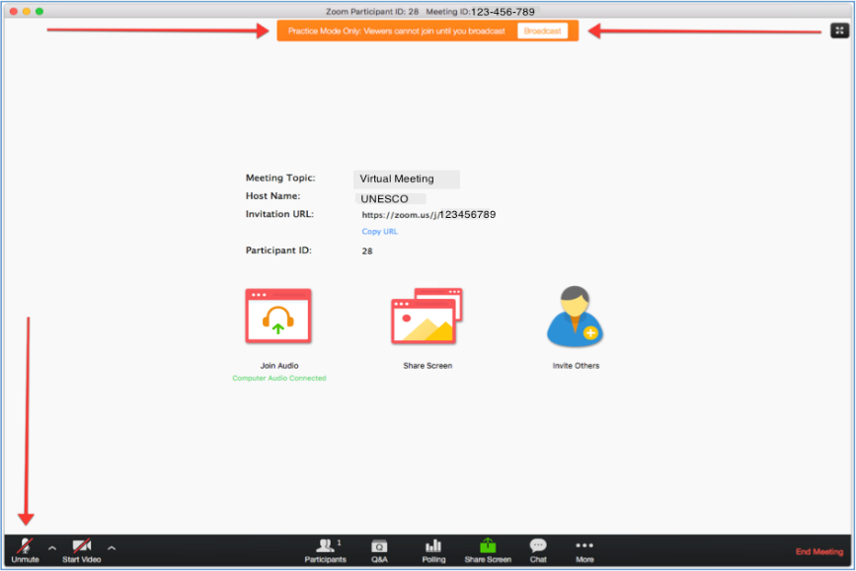You need to accept ‘Access the Microphone’ and ‘Access the Camera’. The microphone and video, which can be found in the bottom left corner are ‘on’ when there is no red line over them. Participants’ microphones should be kept on mute at all times except when called on by the Chairperson to give an intervention.
4. If you are encountering technical difficulties during the meeting, it is suggested that you first try exiting and re-entering the meeting or try connecting from a different browser. You may also contact the helpdesk whose contact details can be found below. Alternatively, you can send a message to [ICHmeetings@unesco.org](mailto:ICHmeetings@unesco.org).

**Helpdesk:** Ms Eléonore Barrat ([e.barrat@unesco.org](mailto:e.barrat@unesco.org)) ; +33145682052.

## Naming of speakers

1. All participants are required by the system to name themselves when they enter the meeting. It is suggested that participants use the format below for their names so that they can easily be identified by the Chairperson. Participants not using the following name formats will be asked to rename themselves by exiting and re-entering the meeting.

If you represent a Committee member:

**CM-Country (Last name)**

If you represent a State Party that is not a member of the Committee:

**SP-Country (Last name)**

If you represent a State not Party to the Convention:

**SNP-Country (Last name)**

If you represent an NGO:

**NGO- (Last name)**

If you represent a category 2 centre:

**C2C-Centre name (Last name)**

## Taking the floor

1. Participants who have an active connection are able to request to take the floor by pressing the ‘raise hand’ button, which will display a hand beside the participant’s name. This button can be found at the bottom of the screen, after pressing the icon ‘Reactions’.

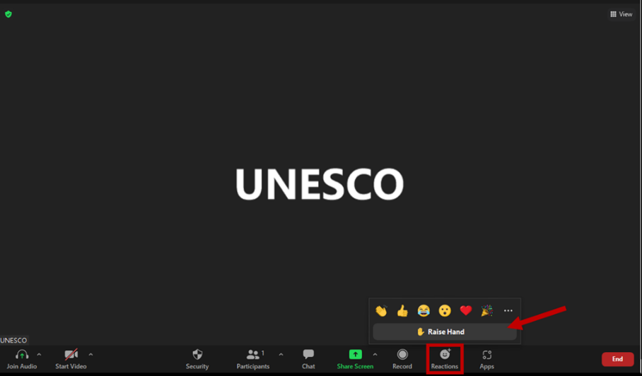

1. Once the hand is raised, it will signal to the Chairperson that the participant would like to take the floor and they will be added to the list of speakers. When the Chairperson calls on a participant to take the floor, they should unmute their microphone using the microphone button in the bottom left corner. Ideally, as long as the internet connection allows, participants should also use their video. After the participant has finished their intervention, they should put their microphone on mute again to avoid background noise.

## Chat box

1. The chat box is located at the bottom right-hand corner of your screen. It can be used to signal a technical problem to the Secretariat. It can also be used by participants wishing to signal a **point of order**. In this case, the participant should raise their hand to indicate they wish to speak and type ‘Point of order’ in the chat box. The chat box should not be used for submitting amendments. These should be submitted by email to: [ICH-amendments@unesco.org](mailto:ICH-amendments@unesco.org).

# Inscriptions to the Lists and register of the Convention and requests for International Assistance (items 8.a, 8.b, 8.c and 8.d)

## Schedule

1. In accordance with the [provisional timetable](https://ich.unesco.org/doc/src/LHE-21-16.COM-INF.2.1_Rev-EN.docx), the Committee is scheduled to examine the report of the Evaluation Body on its work in 2021 (item 8) and nominations to the Lists (items 8.a and 8.b), proposals to the Register of Good Safeguarding Practices (item 8.c) and requests for International Assistance greater than US$100,000 (item 8.d) from Tuesday, 14 December to Thursday, 16 December 2021.
2. In order to facilitate the participation of delegations concerned, a tentative schedule with estimated timeslots is available on the [16.COM webpage](https://ich.unesco.org/en/16com) under item 8, for informational and organizational purposes.

## Amendments and requests for debate

1. As for other items on the agenda of the sixteenth session, amendments to draft decisions can be submitted by Committee members to [ICH-amendments@unesco.org](mailto:ICH-amendments@unesco.org), using the appropriate form, which is available in English and French on the webpage of the meeting (<https://ich.unesco.org/en/16com>). As per the decision of the Bureau (Decision [16.COM 2.BUR 4](https://ich.unesco.org/doc/src/LHE-21-16.COM_2.BUR-4-EN.docx)), the Secretariat will circulate amendments to all Committee members as soon as possible upon their submissions in the language and format received, with a view to facilitating informal consultations among Committee members. To this end, Committee members are encouraged to submit amendments as early as possible. Please note at the same time that further discussions on the amendments should take place outside the mailing list.
2. In order to ensure efficient time management and facilitate the organization of debates on nomination files, the Committee may wish to apply the same working method as in previous years, according to which all decisions concerning nominations for inscription on the Lists, requests for International Assistance and proposals for inclusion in the Register of Good Safeguarding Practices would be adopted without debate, unless a Committee member wishes to raise a particular point. To this end, whilst recognizing that Committee members maintain the right to open a debate during the session,  in order to ensure a smooth conduct of the debates Committee members who wish to debate or propose amendments to a draft decision, are invited to inform the Secretariat  **by Tuesday, 14 December 8 a.m. (Paris time) by sending an email to** [ICH-amendments@unesco.org](mailto:ICH-amendments@unesco.org). The Bureau will draw up the list of nomination files to be debated and adapt the timetable accordingly.

## Interventions by submitting States

1. During the debates of the Committee on each nomination, proposal or request, submitting States may only take the floor to provide information in reply to questions raised by Committee members (Rule 22.4 of the Rules of the Procedures of the Committee).
2. After a decision has been made by the Committee, the submitting State(s) concerned may be invited by the Chairperson to give a speech, show a short video or a combination of both. Regardless of the format of the intervention, submitting States will be allotted a total of two minutes. In the case of multinational nominations, the duration of interventions (speech by one or more States and/or video) shall not exceed three minutes in total. The coordinating State of the nomination is asked to coordinate in advance the order and format of interventions that will be made. Due to the necessity to allocate a fair amount of time to all files, the cooperation of submitting States in respecting this time requirement would be appreciated.
3. In case submitting States would like to display a short video, please send it in mp4 format to the Secretariat **by 11 December 2021** via a file transfer system (UNESCO’s filedepot [www.unesco.org/tools/filedepot](http://www.unesco.org/tools/filedepot) or any alternative file transfer system) at [ichmeetings@unesco.org](mailto:ichmeetings@unesco.org), copying Mr Hugues Sicard ([h.sicard@unesco.org](mailto:h.sicard@unesco.org)).

# Voting by secret ballot

1. As part of Item 16 on the Establishment of the Evaluation Body for the 2022 cycle, the Committee is asked to elect three new members of the Evaluation Body in accordance with section B of Rule 39 of the Rules of Procedures of the Committee. While the 16.COM will be held fully online, the vote by secret ballot is required to be organized *in presentia*. Candidates have been proposed by States Parties through the Chairperson of each electoral group. The list of candidates can be found in Annex 2 of document [LHE/21/16.COM/16 Rev.3](https://ich.unesco.org/doc/src/LHE-21-16.COM-16_Rev.3-EN.docx)**.**

## Logistical arrangements

1. Based on the provisional timetable, Item 16 will be examined on Saturday, 18 December. However, as the session is held fully online, the voting will need to take place at an earlier date in order to allow sufficient time for the counting of ballots and the possible need for a second secret ballot if so required.
2. At its first meeting during the session on 14 December, the Bureau will determine the date of the voting, tentatively scheduled for Wednesday, 15 December. Prior to the voting, two volunteers who can be physically present in Paris to act as tellers will be identified. Voting will take place at UNESCO Headquarters (Room V) in Paris from 13:20 to 14:00, according to the following voting timetable:

|  |  |  |  |
| --- | --- | --- | --- |
| Voting time | Committee members | Voting time | Committee members |
| 13:20 – 13:25 | Azerbaijan | 13:40 – 13:45 | Morocco |
| Botswana | Netherlands |
| Brazil | Panama |
| 13:25 – 13:30 | Cameroon | 13:45 – 13:50 | Peru |
| China | Poland |
| Côte d’Ivoire | Republic of Korea |
| 13:30 – 13:35 | Czechia | 13:50 – 13:55 | Rwanda |
| Djibouti | Saudi Arabia |
| Jamaica | Sri Lanka |
| 13:35 – 13:40 | Japan | 13:55 – 14:00 | Sweden |
| Kazakhstan | Switzerland |
| Kuwait | Togo |

1. The two tellers and members of the Secretariat will be present during the voting period and counting of the ballots. At the time of voting, Committee members will receive an envelope and ballot papers, one for each vacant seat, bearing the names of all the candidates in that electoral group. Each Committee member should cast its vote by encircling the names of those candidates for which it desires to vote. The absence of any ballot paper in the envelope shall be considered an abstention.
2. If two or more candidates obtain the same number of votes, there shall be a second secret ballot restricted to those candidates who obtained the same number of votes. If ever this is the case, the date and time of the second vote will be announced during the session. While the provisional timetable foresees that the final results will be announced during Item 16 on Saturday, 18 December 2021, the Chairperson may decide, in consultation with the Bureau, to announce the results earlier, once the counting of the votes is finalized.

## Identification of representatives

1. As the election is taking place in Paris at UNESCO Headquarters, all delegations must have a representative who can be physically present to take part in the vote by secret ballot. At the time of voting, this person will be asked to present identification (i.e. UNESCO badge) that clearly identifies the delegation they represent and to sign the attendance list.
2. Those delegations who do not have a representative in France may designate as their representatives, with the right to vote conducted by secret ballot, individuals of their choice based in France (with the only exception of persons who are already representing another State Party). Accreditation letters should follow the normal practice at UNESCO, which is that they should be signed by the Head of State, Head of Government or Minister for Foreign Affairs. They should be submitted electronically by Monday, 13 December 2021 to ichmeetings@unesco.org. When voting, the representative should also bring a copy of this letter along with a piece of personal identification and sign the attendance list.

## Side events

1. A series of fully online side events are planned from 12 to 18 December 2021 when the 16.COM is not in plenary session. The updated list of side events is available through the dedicated webpage: <https://ich.unesco.org/en/calendar-of-events-01219>. All side events included in the calendar are endorsed by UNESCO.

## Press kit

1. A press kit is available from the webpage of the 16.COM (<https://ich.unesco.org/en/press-resources-01214>) which includes resources about the session that may be useful for journalists covering the session.
2. A press conference will also be held online on Monday 13 December 2021 at 5.30 p.m. (Paris time). For access, please contact Mr Thomas Mallard ([t.mallard@unesco.org](mailto:t.mallard@unesco.org)).