unit 61

Handout 1

QUESTION TYPES in PERIODIC REPORTING FORM

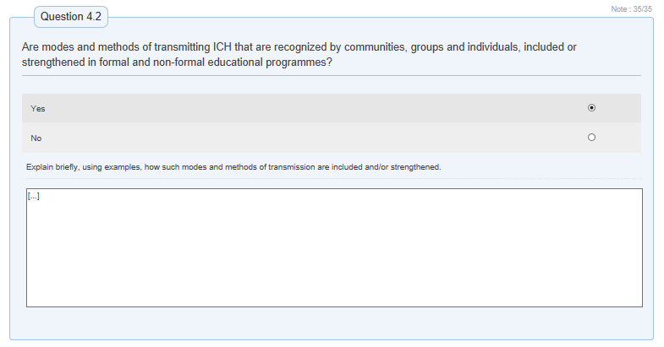
YES/NO QUESTIONS (SIMPLE)

YES/NO QUESTIONS (MORE COMPLEX)
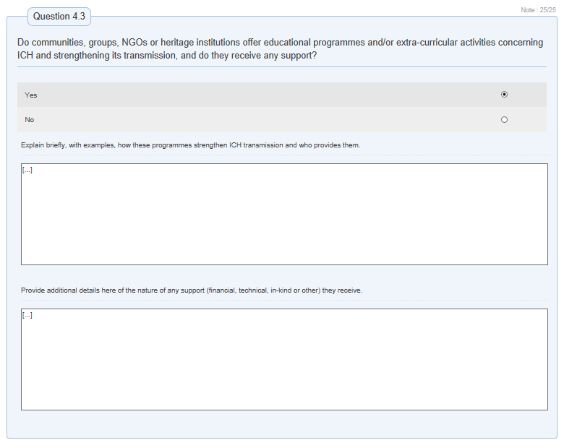

CHECK BOX QUESTIONS
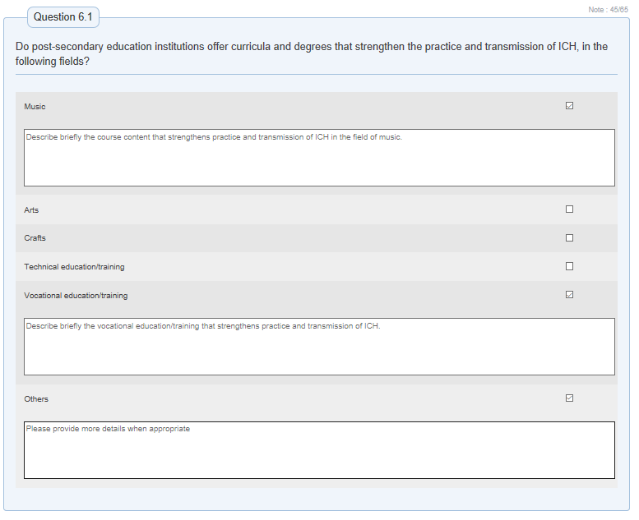

RATING SCALE QUESTIONS
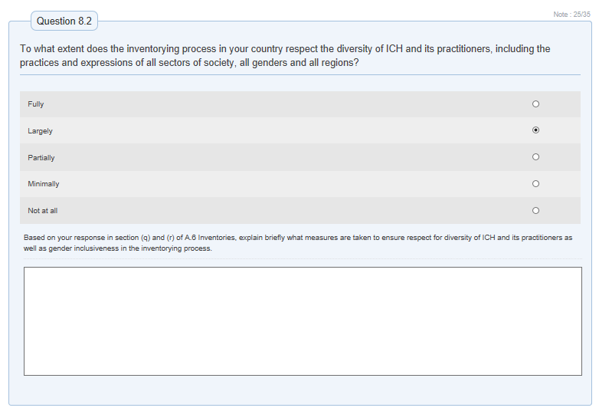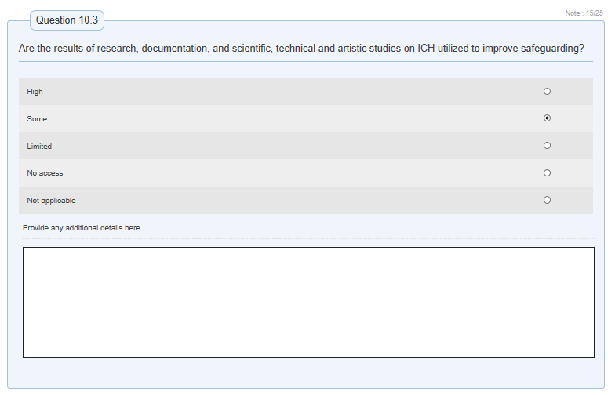

COMBINED QUESTIONS
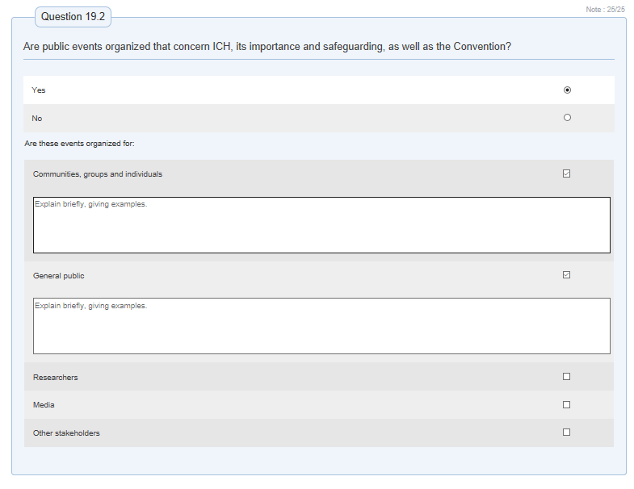
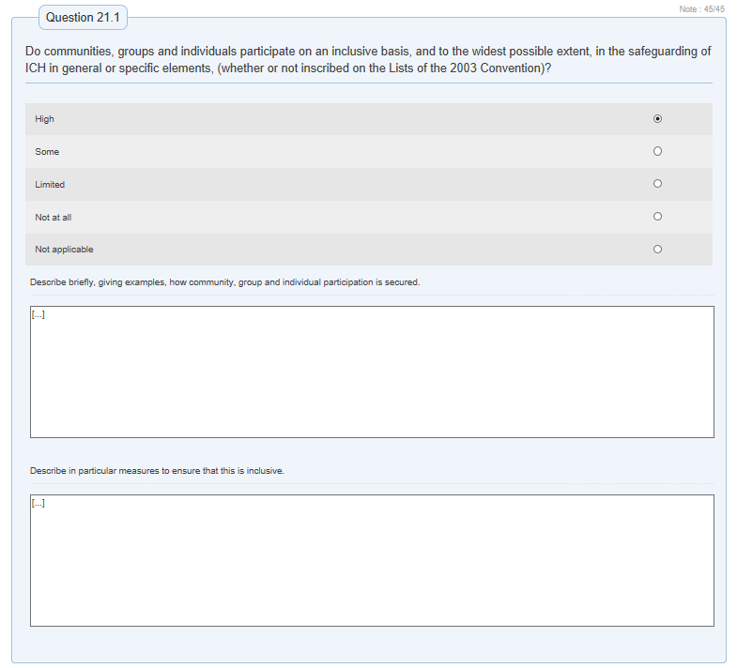

COMPLEX QUESTION FORMS
