UNESCO ASPnet x Futures of Education
Consultation Guidelines for Stakeholder Focus Groups

TABLE OF CONTENTS

TIMELINE 2
WHAT IS THE FUTURES OF EDUCATION INITIATIVE? 3
WHY ENGAGE THE ASPNET NETWORK THROUGH FOCUS-GROUP CONSULTATIONS? 3
HOW CAN YOU ORGANIZE A FOCUS GROUP DISCUSSION? 4
GENERAL CONTEXT | The concept of a focus group discussion 4
SCENARIOS | How to organise focus group discussions? 5
PARTICIPANTS | Who takes part in a focus group discussion? 5
SPACE/LOCATION | Where can you organize a focus group discussion? 6
LENGTH | How long does a focus group discussion last? 6
FREQUENCY | How many? 7
CONTENT | What would be discussed? 7
LANGUAGE | In what language can I hold a focus group discussion? 7
ANNOUNCEMENT | How to invite my community to a focus group discussion? 7
HOW TO SHARE THE INPUTS OF YOUR FOCUS GROUP DISCUSSION? 8
ADDITIONAL INFORMATION 8
ANNEX I – FACILITATOR’S GUIDE 9
ANNEX II – REPORTING TEMPLATE 14
ANNEX III – BACKGROUND MATERIALS 23
ANNEX IV – FREQUENTLY ASKED QUESTIONS 27
ANNEX V – WORD STIMULUS HAND-OUT 29

INTRODUCTION

UNESCO invites National Coordinators of the Associated Schools Network (ASPnet) to get involved in the Futures of Education initiative by organizing national focus group discussions with school leaders, teachers, student and, if possible, parents. The period of focus group discussions (September-November) will culminate in a series of regional webinars (December) which will be organized to share the deliberations from the focus group discussions with ASPnet members from other countries and engage with experts and commission members from the Futures of Education Initiative.

The objective is to engage the ASPnet community in a debate to rethink education and shape the future. Key questions, such as how education, learning and knowledge need to be re-imagined in a world of increasing complexity, uncertainty and precarity as well as ASPnet’s mission and work to foster global citizens for sustainable development will be central elements of discussion.

The insights gained through national and regional consultations will be synthesized for UNESCO’s International Commission on the Futures of Education and will help to shape the global debate.

This document and the accompanying annexes provide general guidelines and materials for the organizers and facilitators of national focus group discussions, as well as background information about the Futures of Education initiative. The guidelines are designed to provide a structure, including a PowerPoint template, for online and in-person focus group discussions. They also include a template for summarizing the results of focus group discussions and submitting them to UNESCO.

TIMELINE

WHAT IS THE FUTURES OF EDUCATION INITIATIVE?

UNESCO’s Futures of Education initiative is an ambitious attempt to rethink education and help shape the future. The initiative is catalyzing a global debate on how education, learning and knowledge need to be re-imagined in a world of increasing complexity, uncertainty, and precarity. As part of this initiative, UNESCO has appointed a high-level International Commission of thought leaders with diverse expertise and perspectives from the worlds of politics, academia, the arts, science and business. The International Commission will prepare a report, to be released in November 2021 that will provide an agenda for action and discussion for policymakers and practitioners.

When it comes to the futures of education, every voice counts, every perspective matters. This is why the forthcoming global report will emerge out of a range of work modalities that emphasize co-creation, a broad participatory and partnership structure, the inclusion of diverse perspectives, and the absence of pre-specified conclusions.

Towards this end, UNESCO is encouraging consultations around the globe, inputs from which will feed into to the Commission’s work and the preparation of the forthcoming report.

WHY ENGAGE THE ASPNET NETWORK THROUGH FOCUS-GROUP CONSULTATIONS?

A debate on the futures of education cannot take place without a strong involvement of school communities; collecting their voices and perspectives is crucial to nurture an inclusive global conversation:

- Students are the main beneficiaries of education and best placed to speak about their learning and related experiences. They can also bring fresh perspectives and original ideas. Inviting them to reflect about the futures of education means that they would be thinking about the education they want for their children and grandchildren.

- School principals and teachers play an instrumental role in students lives and are key stakeholders in shaping education systems and, therefore, can enact meaningful changes to address concerns and priorities to future-proof education.

- Parents play an important role in their children’s’ education; research has shown that parents involvement in their children’s school has many benefits for the entire school community. Parents’ involvement in their children’s learning has been given an additional emphasis during the COVID-19 crisis and lockdown of schools. Including parents in discussions on the futures of education can provide important additional insights and perspectives.

UNESCO highly encourages the ASPnet National Coordinators to ensure the participation of students and their parents, teachers and principals without connectivity to participate in consultations. This however may only be possible once schools have re-opened.

Leading a focus group consultation on the futures of education presents an important opportunity to:
- engage the ASPnet community in joint reflections, co-construction of ideas on the futures of education and, through a topic-centred approach on ESD and GCED, strengthen ASPnet members’ ongoing reflections and work in this regard.

- contribute to UNESCO's Futures of Education Initiative (i.e. feed into the global debate and the work of the High-level international commission and the 2021 report) by bringing school communities' perspectives, ideas and examples of good practices.

HOW CAN YOU ORGANIZE A FOCUS GROUP DISCUSSION?

We invite you to feed into UNESCO’s Futures of Education global debate and the work of the high-level International Commission through the organization of national focus group discussions with the different target groups you get to connect with (students, principals, teachers, parents).

Your work as part of this initiative – to bring school communities ideas and perspectives to the table through these consultations, and the following regional webinars – will represent an important contribution to the deliberations of the International Commission and feed into UNESCO’s next global report on the futures of education (to be published in 2021).

GENERAL CONTEXT | The concept of a focus group discussion

- A focus group consultation can be organized by anyone – it can be held within the same ASPnet school, or bring students, parents and teachers from different ASPnet schools across the country to engage in a discussion.

- Group interaction is key to the focus group methodology. Focus group discussions allow people to explore and clarify their views. Oftentimes, a focus group conversation can lead in new and unexpected directions as participants reflect on their own and others’ ideas. Focus group discussions also allow for participants to become an active part of the process of visioning the futures of education. They grant agency to individuals as well as the larger stakeholder group, thereby facilitating ownership and co-construction of ideas.

SCENARIOS | How to organise focus group discussions?

- NC invites a selected number of ASPnet members in her/his country to organise focus group discussions and to report back to UNESCO

- NC organises 4-6 (or more) focus group discussions and reports back to UNESCO
- Mix of 1 and 2: NC invites a selected number of ASPnet members in her/his country to organise focus group discussions and then organises national webinar(s) for all participants:
  - 1 webinar (for students, teachers, parents together), or
  - 3 webinars (one for each group), or
  - 4 webinars (one for each group and one altogether).

PARTICIPANTS | Who takes part in a focus group discussion?

- On one hand, the participants of the focus group discussion:
- They will be invited to share their views and ideas on the several questions raised by the discussion’s facilitator (prompts / questions will follow here below)
- In terms of number of participants, UNESCO recommends conducting focus group consultations with groups of 10-15 individuals, to allow for discussion and interaction among participants
- UNESCO recommends to conduct focus group discussions with:
  - Students (from secondary level)
  - Teachers and school principals (from all levels of education)
  - (Optional) Parents and their children/secondary level students
Whenever possible, UNESCO recommends that participants belong to the same stakeholder group (e.g. a focus group comprised of students only, or teachers only, or parents with their children, etc.) in order to capitalize on shared experiences

- On the other hand, the facilitators who will moderate the discussion:
- Facilitators should take a back-seat role as much as possible, steering and redirecting the conversation only minimally.
- UNESCO recommends that the facilitator be familiar with the local context in order to prompt dialogue and debate.
- In the case of ASPnet focus-group consultations, the facilitator can be the National Coordinators (or one of their colleagues, ideally with some experience in leading focus group discussions), the principal of the school in which the consultation is taking place, an association or NGO the ASPnet National Coordinator works closely with, etc.
- The facilitator should be accompanied by a note-taker who records significant comments to aid the preparation of the short summary report – preferably an observer who is not participating in the discussion.

SPACE/LOCATION | Where can you organize a focus group discussion?

- UNESCO recommends that focus group discussion sessions have a relaxed atmosphere and be conducted in a comfortable setting. The purpose is for participants to talk with one another.

- The focus group discussions can be held in a physical meeting space or online:
- If held in person, UNESCO recommends that participant sit in a circle in order to enable dialogue, while ensuring proper distancing measures considering the current COVID-19 pandemic.

- If the discussion is held online, UNESCO recommends the use of any online meeting platform such as Zoom, Skype, Teams, Google Meet – preferably which allows the use of video in order to better enhance dialogue. In case you do not have a platform at your disposition, please contact the ASPnet International Coordination Unit at aspnet@unesco.org for support.

- If it’s hard to organize a discussion with the audience you’d like to invite because:
- They live in another city/or in a remote area and cannot come to yours;
- They don’t have Internet access to connect to online discussions;
- There is a lockdown/schools are closed so no in-person discussions

- We encourage you to consider the following solutions:
  - Send hard copies of the facilitator’s guide to the local school’s team (the principal, a teacher) or to the community leaders who can organize a discussion in the location you cannot reach;
  - Partner up with some NGOs working on the ground to organize in-person consultations with small groups living in remote areas;
  - Create a WhatsApp group to open the discussion on mobile;
  - Organize phone calls with a few individuals in the form of interviews in order to have smaller, yet fascinating, discussions

LENGTH | How long does a focus group discussion last?

- 1h30 to 2h is the appropriate length of time for the focus group, but this can be contracted or expanded, depending on practical considerations.

FREQUENCY | How many?

- Ideally, National Coordinators should aim to organize four to six focus group discussions in the country:
  - With students: 1 on GCED and 1 on ESD
  - With school principals and teachers: 1 on GCED and 1 on ESD
  - (Optional) With students and their parents: 1 on GCED and 1 on ESD

CONTENT | What would be discussed?

- Focus group discussion prompts/questions:
- UNESCO has prepared a short series of prompts and additional guidelines for facilitators to follow - See section G. here below.

- Background materials:
- UNESCO offers some materials participants can consult to familiarize themselves with the Futures of Education initiative as well as with the thematic focus of discussions: Global Citizenship Education (GCED) and Education for Sustainable Development (ESD). Those are however not mandatory for the participation in a focus-group discussion - See ANNEX III to access the different background materials.

- Word Cloud
- UNESCO has prepared a word cloud for each of the two topics that will be discussed: 1. Global Citizenship Education; 2. Education for Sustainable Development. These can be shared with participants ahead of the focus group discussion (via Email or hand-out). The word clouds include key terminology associated with the main topics and intend to provide participants with food for thought and stimulation for reflection ahead of their participation. See Annex V for more information.

LANGUAGE | In what language can I hold a focus group discussion?

- A focus group discussions can be held in any language of choice. The PowerPoint for the facilitation of focus group discussions can be translated/adjusted according to your needs. Please note that reporting the outcomes and results of your focus group discussion to UNESCO would need to be in either English, French or Spanish.

ANNOUNCEMENT | How to invite my community to a focus group discussion?

- Once the facilitator of the focus group discussion has been identified (it can be the National Coordinator, the principal of the school in which the consultation is taking place, a teacher, a student), UNESCO suggests that participants receive an invitation to participate by email or in person.

HOW TO SHARE THE INPUTS OF YOUR FOCUS GROUP DISCUSSION?

The International Commission on the Futures of Education meets every six weeks; once the consultative process with ASPnet is complete, the inputs and findings from national and regional discussions will be brought to the attention of the commission.

The regional webinars (in English, French and Spanish) planned for December 2020 with all participants from these languages/regions will also provide an important opportunity for National Coordinators and participants to share and discuss the outcomes from national deliberations with experts, commission members and the UNESCO team from the Futures of Education Initiative.

In order to share the inputs of your focus group discussions, UNESCO suggests the use of the Reporting Form to summarize the deliberations, it is available in ANNEX II of this document – there are different reporting templates for the different groups.

ADDITIONAL INFORMATION

Acknowledgement. Kindly note that all focus-group discussion participants will be acknowledged. The facilitator must make sure that participants have registered, and if the event was held in person, that the information on the sign-up sheet (names, emails) are legible.

Pictures: Taking pictures during the focus group discussion is encouraged as they can be used to illustrate a web story about your discussion (on your website / social media platforms or on UNESCO’s digital platforms). Please make sure that people have agreed to appear in pictures, bearing in mind that they may be published online.

Consent. The national coordinators are also responsible for ensuring that consent is sought from the parents or guardians of those participating who are under the age of 18. For additional information do not hesitate to contact us at aspnet@unesco.org.

ANNEX I – FACILITATOR’S GUIDE

UNESCO ASPnet x Futures of Education
Consultation Guidelines for Stakeholder Focus Groups
FACILITATORS’ GUIDE

This facilitator’s guide aims to help the planning and moderation of Futures of Education focus group discussions, which typically will run between 1h30 and 2h. It describes the accompanying PowerPoint presentation, which is to be used in addressing the audience and for facilitating the discussion. The PowerPoint includes a detailed set of accompanying talking points to be used during the session. To view the notes, download the PowerPoint, go to the View tab, and select Notes under the sub-theme Show. In case of doubt, do not hesitate to contact UNESCO by writing a message to aspnet@unesco.org.

SLIDES 1 – 10 | WELCOME AND INTRODUCTIONS (15 minutes)

The facilitator uses these introductory slides to welcome the participants, introduce him/herself, the Futures of Education initiative as well as the purpose of the focus group discussion.

It is important to place the overall initiative within today’s uncertain and fragile context which are questioning the organisation of learning and schools; and to specify that joint reflections on the futures of education ought to be with students, teacher and parents who are both beneficiaries and enablers of more sustainable and peaceful societies.

If circumstances allow, the Futures of Education introductory video should be shown. It can be found on this Youtube link.

Advice to facilitator: The facilitator can take a few minutes to open the floor to questions on the initiative and purposes of the consultation. Supporting documentation is provided in these focus group guidelines.

SLIDE 11 | DISCUSSION AGENDA (5 minutes)
The facilitator should take a minute to present the agenda that is to follow which consists of two rounds of discussion – one general, and one more thematically focused. All participants will address the same question in round 1, reflecting on today’s world. Then in round 2, the facilitator will hone the discussion on a tailored set of questions developed for students, teachers and parents; and in one of two thematic areas: global citizenship or sustainable development.
Round 1: 30-40 minutes
Round 2: 1h-1h15
Advice to facilitator: Prepare the presentation by deleting the irrelevant slides before the focus group discussion [See slides 14-33 below].

SLIDES 12-13 | ROUND 1 (30-40 minutes)

The theme for this first round of reflection is “Our world in 2050”.

This is when the facilitator asks the participants to introduce themselves and reflect on the world around them by sharing (a) what they still want to see in our world in 30 years from now and (b) what they do not want to see in our world in 30 years from now.

Advice to facilitator: it is advisable to chart what participants are saying on the screen by drawing a mindmap in real-time to capture participants’ inputs and display them on screen to support the discussions. There are several options for “free online applications to draw mindmaps” which can be researched in any search engine. It is advisable to go around the room, in alphabetical order, or other, and give the floor to each person in the focus group to introduce themselves, and respond to the two questions at the same time. A time limit of 2-3 minutes per person is recommended.

SLIDES 14-33 | ROUND 2 (1h-1h15 minutes)

Based on the target group, and thematic focus, the facilitator can keep the slides as indicated in the table, and delete the rest. For example, if you are conducting a discussion with a group of parents on issues of sustainable development, delete slides 14-24; or with a group of teachers on issues of global citizenship, delete slides 23-33 and then slides 19-20.

 | GLOBAL CITIZENSHIP | SUSTAINABLE DEVELOPMENT
STUDENTS | 14 - 18 AND 19 - 20 | 25 - 27 AND 28 - 29
TEACHERS/SCHOOL PRINCIPALS | 14 - 18 AND 21 - 22 | 25 - 27 AND 30 – 31
PARENTS | 14 - 18 AND 23 - 24 | 25 - 27 AND 32 - 33

Regardless of the target group, round 2 start with an introduction of the concept, and is followed by a set of three questions. Q1 which is the same across all groups within the same theme; and Q2a and Q2b which are targeted to the thematic area and interest group. You can plan your time so that you spend about 20 minutes per question in round 2. In some cases, UNESCO has suggested some optional questions to use in lieu of the broader question in case participants require further prompts to engage in the discussion. These questions can be found in the talking points of the PowerPoint presentation. For ease of reference, the conceptual definitions of the concepts and respective questions are pasted below.

Advice to facilitator: While it may not be possible to hear all participants on all questions, the facilitator should make sure that each person as at least responded to 1-2 of the questions in this round. A list of the participants at hand is helpful, and can help ensure that the conversation is not being dominated by a handful of participants, by marking when a participant takes the floor. Participants can be reminded to add new perspectives rather than repeating what has already been said by others.

GLOBAL CITIZENSHIP

SLIDE 15 – Global Citizenship | Conceptual Clarification

The notion of “global citizenship” is described as common understanding of what it means to have a sense of belonging to a broader community, beyond national boundaries, that emphasizes our common humanity and draws on the interconnectedness between peoples as well as between the local and the global. Global citizenship is based on the universal values of human rights, democracy, non-discrimination and diversity. It is about civic actions that promote a better world and future.

STUDENTS | SLIDES 16, 17, 18, 19, 20
Q1. What makes a global citizen?
Q2. How can education foster global citizens?
- From your experience going to school, what has helped you in particular to becoming a global citizen?
- What ideas do you have to improve today’s education to allow you/ students to become global citizens?
TEACHERS/SCHOOL PRINCIPALS | SLIDES 16, 17, 18, 21, 22
Q1. What makes a global citizen?
Q2. How can education foster global citizens?
- Opportunities / What works well? Please share an example of how global citizenship is (or could be) successfully taught in your class/ school and that you would like to recommend for scale/i.e. to other teachers and/or school principals?
- Challenges / What does not work so well? How can education possibly exacerbate inequalities, injustices, racism and some of the other challenges we identified? What needs to change in our education system today to foster students’ knowledge, skills, attitudes and values to become global citizens and to counter these challenges?
PARENTS | SLIDES 16, 17, 18, 23, 24
Q1. What makes a global citizen?
Q2. How can education foster global citizens?
- Please share an example of how your children’s school effectively fosters global citizens. What could your children’s school do better?
- What role should parents play in their children’s education? What role should the wider community play in education/ schools?
SUSTAINABLE DEVELOPMENT

SLIDE 25 – Sustainable Development | Conceptual Clarification

Sustainable development can be understood as “development that meets the needs of the present without comprising the ability of future generations to meet their own needs.” (Brundtland Report, Our Common Future, Report of the World Commission on Environment and Development, 1987). The environment, economic issues and social issues are interlinked. This means that (economic and social) development need not be at the expense of the environment. In short, sustainable development is about balancing the demands of the environment, economy and society.

STUDENTS | SLIDES 26, 27, 28, 29
Q1. How can we live more sustainably on our planet?
Q2. How can education help us to live more sustainably on our planet?
- From your experience going to school, what has helped you in particular to live more sustainably?
- What ideas do you have to improve today’s education to allow you/ students to live more sustainably?
TEACHERS/SCHOOL PRINCIPALS | SLIDES 26, 27, 30, 31
Q1. How can we live more sustainably on our planet? (15-20min)
Q2. How can education help us to live more sustainably on our planet? (1h-1h15)
- Opportunities/What works well? Please share an example of how sustainability/ sustainable development is (or could be) successfully taught in your class/school and that you would like to recommend for scale/i.e. to other teachers/school principals?
- Challenges/What does not work so well? How can education possibly exacerbate unsustainable behaviours and systems? What needs to change in our education system today to foster the knowledge, skills, attitudes and values for current and future generations to live more sustainably?
PARENTS | SLIDES 26, 27, 32, 33
Q1. How can we live more sustainably on our planet? (15-20min)
Q2. How can education help us to live more sustainably on our planet?
- Please share an example of how your children’s school effectively fosters learnings associated with sustainable development. What could your children’s school do better?
- What role should parents play in their children’s education? What role should the wider community play in education/schools?

SLIDES 34 – 35 | THANK YOU AND WRAP UP (5 minutes)

Once the discussion is completed, the facilitator is encouraged to thank the participants again for their time and valuable ideas. He/she should mention that the participants will be acknowledged as contributors to the Futures of Education initiative.

The facilitator could also briefly encourage the participants to contribute further through one of the other consultation modalities, which include: (1) answering a 1-minute survey on the top 3 challenges ahead and the top 3 purposes of education; (2) sharing their ideas in writing on the major issue for the futures of education,; and (3) submitting original artwork to depict a vision of the futures of education.

ANNEX II – REPORTING TEMPLATE

UNESCO ASPnet x Futures of Education
Consultation Guidelines for Stakeholder Focus Groups
REPORTING TEMPLATE

Thank you for having undertaken national focus group discussions in your country as part of the ASPnet X Futures of Education collaboration and initiative.
The following reporting form is intended for UNESCO to learn about the reflections and ideas that took place in your country. Your inputs will be brought to the attention of the International Commission on the Futures of Education and inform the ongoing global debate and international report to be published in 2021. We would kindly ask you to be as concise as possible in your responses, whilst highlighting main ideas and observations from the discussions.
Please fill out ONE reporting form for EACH focus group discussion you organised (e.g. one reporting form for a focus group discussion with students on GCED, one reporting form for a focus group discussion with teachers on ESD, etc.).

You can complete this form and submit it to aspnet@unesco.org or you can complete the form via the following link online.
Thank you for your cooperation,
UNESCO ASPnet & Futures of Education Teams

Consultation

Country:
City:
Date of consultation:
Type of consultation: ☐ Face-to-face ☐ online ☐ Both ☐ Other (specify)
Language of consultation: ☐ English ☐ French ☐ Spanish
Consultation topic: ☐ GCED ☐ ESD BOTH
Facilitator

Title: ☐ Ms ☐ Mr
First Name:
Last Name:
Position:
Email:
Participants

Number of Participants:
Participants’ profiles: (please describe briefly the composition of the group):
(e.g. group of students from ASPnet school)
Stakeholder groups: (please tick or as appropriate) | ☐  Students | ☐  Parents | ☐  Teachers | ☐  Other (please specify):
Does the consultation involve children under the age of 18? |  |  | ☐ Yes | ☐ No
Kindly ensure that you have obtained the consent forms for consultations undertaken with children under the age of 18.

Synthesis of inputs

Please summarize your discussion in the boxes below.
Note that the questions for all three groups, and for the two thematic areas are reproduced below. Please choose the stakeholder group and the theme the focus group focused on.
Kindly limit your responses for each stakeholder group to two pages.
If you have taken pictures and got the approval of use from participants, don’t hesitate to share them with UNESCO.

DISCUSSION GROUP/TOPIC: STUDENTS | Global Citizenship Education

1st Round of Reflection: Our world in 2050
What do students from the focus group you undertook still want to see in our world in 30 years from now?

What do students from the focus group you undertook NOT want to see in our world in 30 years from now?

IF YOU COMPLETED A MINDMAP, PLEASE INSERT IT HERE

2nd Round of Reflection: How can education contribute to building more just, peaceful and sustainable societies?
What characteristics were identified by students in terms of what constitutes a global citizen?

From their experience going to school, what has helped students in particular to becoming global citizens?

What ideas do the students have to improve today's education to allow them to become global citizens?

DISCUSSION GROUP/TOPIC: TEACHERS/PRINCIPALS | Global Citizenship Education

1st Round of Reflection: Our world in 2050
What do teachers/school principals from the focus group you undertook still want to see in our world in 30 years from now?

What do teachers/school principals from the focus group you undertook NOT want to see in our world in 30 years from now?

IF YOU COMPLETED A MINDMAP, PLEASE INSERT IT HERE

2nd Round of Reflection: How can education contribute to building more just, peaceful and sustainable societies?
What characteristics were identified by teachers/school principals in terms of what constitutes a global citizen?

Please provide 3 key examples that were given by teachers/school principals on how global citizenship is (or could be) successfully taught in class/ a school and what they would like to recommend for scale/i.e. to other teachers and/or school principals.

Please put down key responses by teachers/school principals on 1) how education can possibly exacerbate inequalities, injustices, racism and some of the other challenges identified; 2) what needs to change in the education system today to foster students’ knowledge, skills, attitudes and values to become global citizens and to counter the identified challenges.

DISCUSSION GROUP/TOPIC: PARENTS | Global Citizenship Education

1st Round of Reflection: Our world in 2050
What do parents (and students) from the focus group you undertook still want to see in our world in 30 years from now?

What do parents (and students) from the focus group you undertook NOT want to see in our world in 30 years from now?

IF YOU COMPLETED A MINDMAP, PLEASE INSERT IT HERE

2st Round of Reflection: How can education contribute to building more just, peaceful and sustainable societies?
What characteristics were identified by parents (and students) in terms of what constitutes a global citizen?

Please share the examples provided by parents (and students) of how their children’s school effectively fosters global citizens and what the school could do better.

Please share the examples provided by parents (and students) in terms of the role that parents should play in their children’s education and what role the wider community should play in education/ schools.

DISCUSSION GROUP/TOPIC: STUDENTS | Education for Sustainable Development

1st Round of Reflection: Our world in 2050
What do students from the focus group you undertook still want to see in our world in 30 years from now?

What do students from the focus group you undertook NOT want to see in our world in 30 years from now?

IF YOU COMPLETED A MINDMAP, PLEASE INSERT IT HERE

2nd Round of Reflection: How can education contribute to building more just, peaceful and sustainable societies?
How can we live more sustainably on our planet? What knowledge, skills, attitudes and values are needed?

From their experience going to school, what has helped students in particular to live more sustainably?

What ideas do the students have to improve today’s education to allow them to live more sustainably?

DISCUSSION GROUP/TOPIC: TEACHERS/PRINCIPALS | Education for Sustainable Development

1st Round of Reflection: Our world in 2050
What do teachers/school principals from the focus group you undertook still want to see in our world in 30 years from now?

What do teachers/school principals from the focus group you undertook NOT want to see in our world in 30 years from now?

IF YOU COMPLETED A MINDMAP, PLEASE INSERT IT HERE

2nd Round of Reflection: How can education contribute to building more just, peaceful and sustainable societies?
How can we live more sustainably on our planet? What knowledge, skills, attitudes and values are needed?

Please provide 3 key examples that were given by teachers/school principals on how sustainability/ sustainable development is (or could be) successfully taught in class/ a school and what they would like to recommend for scale/i.e. to other teachers and/or school principals.

Please put down key responses by teachers/school principals on 1) how education can possibly exacerbate unsustainable behaviours and systems and some of the other challenges identified; 2) what needs to change in the education system today to foster students’ knowledge, skills, attitudes and values for current and future generations to live more sustainably.

DISCUSSION GROUP/TOPIC: PARENTS | Education for Sustainable Development

1st Round of Reflection: Our world in 2050
What do parents (and students) from the focus group you undertook still want to see in our world in 30 years from now?

What do parents (and students) from the focus group you undertook NOT want to see in our world in 30 years from now?

IF YOU COMPLETED A MINDMAP, PLEASE INSERT IT HERE

2nd Round of Reflection: How can education contribute to building more just, peaceful and sustainable societies?
How can we live more sustainably on our planet? What knowledge, skills, attitudes and values are needed?

Please share the examples provided by parents (and students) of how their children’s school effectively fosters learnings associated with sustainable development. What could your children’s school do better?

Please share the examples provided by parents (and students) in terms of the role that parents should play in their children’s education and what role the wider community should play in education/ schools.

Other questions
Are there any other questions that should be posed in the context of the Futures of Education consultations?
Is there anything else you wish to relay to UNESCO and/or the International Commission?

ANNEX III – BACKGROUND MATERIALS

UNESCO ASPnet x Futures of Education
Consultation Guidelines for Stakeholder Focus Groups
BACKGROUND MATERIALS

PUBLICATIONS

- “Education in a post-COVID world: Nine ideas for public action” (July 2020)
  - The Covid-19 crisis has revealed inequalities and vulnerabilities, but it has also surfaced extraordinary human resourcefulness and potential. Decisions made today in the context of Covid-19 will have long-term consequences for the futures of education. These decisions should be guided by shared principles and visions of desirable collective futures. In this new report, the International Commission on the Futures of Education proposes policy actions that can be taken today to advance education tomorrow. From the necessity of committing to strengthen education as a common good to the final call to advance global solidarity to end current levels of inequality all nine ideas for public action aim to invite debate, engagement and action at all levels.

  - The publication is available online in UNESCO’s Digital Library: https://bit.ly/2ZMI7tj

- “Visioning and Framing the Futures of Education” – Outcome document from the 1st meeting of the International Commission on the Futures of Education (February 2020)
  - Established by UNESCO, the Commission is charged with looking at 2050 and beyond to issue a report in 2021 to rethink how knowledge, learning and education may address the challenges and opportunities, both those foreseen for the future and those with us in the present. Following its first meeting in Paris in January 2020, the Commission published its first statement, outlining the core elements, principles and visions that will frame its work.

  - The publication is available online on the Futures of Education website: https://bit.ly/3iCbI1j

- “Humanistic Futures of Learning: Perspectives from UNESCO Chairs and UNITWIN Networks”
  - The UNESCO Chairs and UNITWIN Networks from all disciplines and scholarly fields, comprised of 800+ institutions and affiliates in over 110 countries, were invited to prepare think pieces to help advance a shared vision for the future. A selection of 48 independent think pieces are presented in this publication, each of them highlighting key dimensions to be considered in re-visioning and re-purposing education for the future of humanity and the planet. A humanistic approach to education and development is the common thread that weaves together the diversity of contributions into a rich tapestry on learning.µ

  - The publication is available online in UNESCO’s Digital Library: https://bit.ly/2ZMI7tj

- “Schools in action, global citizens for sustainable development: a guide for students” (2016)
  - This guide aims to introduce secondary school students to Global Citizenship Education (GCED) and Education for Sustainable Development (ESD) and provide them with ideas and activities to contribute proactively to a more peaceful and sustainable world. The guide draws on the discussions and activities of almost 1,100 participants from 104 countries, including ASPnet National Coordinators, school principals, teachers, students and experts who contributed to the ASPnet Online Collaborative Platform: Global Citizens Connected for Sustainable Development in 2014 and 2015.

  - The publication is available online in UNESCO’s Digital Library: https://bit.ly/2ZHa7P8

- “Schools in action, global citizens for sustainable development: a guide for teachers” (2016)
  - The teacher’s guide draws on the discussions and activities of almost 1,100 participants from 104 countries, including ASPnet National Coordinators, school principals, teachers, students and experts who contributed to the Online Collaborative Platform ASPnet in Action: Global Citizens Connected for Sustainable Development in 2014 and 2015 with associated activities and initiatives

  - The publication is available online in UNESCO’s Digital Library: https://bit.ly/2ZHa7P8

- “Global citizenship education: topics and learning objectives”
  - This publication is the first pedagogical guidance from UNESCO on global citizenship education. It is the result of an extensive research and consultation process with experts from different parts of the world. It was developed in response to the needs of Member States for overall guidance on integrating global citizenship education in their education systems. It presents suggestions for translating global citizenship education concepts into practical and age-specific topics and learning objectives in a way that allows for adaptation to local contexts. It is intended as a resource for educators, curriculum developers, trainers as well as policy-makers, but it will also be useful for other education stakeholders working in non-formal and informal settings.
  - The publication is available online in UNESCO’s Digital Library: https://unesdoc.unesco.org/ark:/48223/pf0000232993

- “Sustainable Development Goals: Resources for Educators”
  - This resource bank has been designed for educators, education planners and practitioners. It offers hundreds of pedagogical ideas for classroom activities and multimedia resources detailing how best to integrate ESD into teaching and learning, from early childhood care through secondary education.
  - The resources can be accessed via https://en.unesco.org/themes/education/sdgs/material
- “Education for Sustainable Development Goals: learning objectives”
  - This publication is intended to guide readers on how to use education, and in particular ESD, in achieving the SDGs. It identifies learning objectives, suggests topics and learning activities for each SDG, and describes implementation on different levels from course design to national strategies. The document aims to support policy-makers, curriculum developers, and educators in designing strategies, curricula, and courses to promote learning for the SDGs.
  - The publication is available online in UNESCO’s Digital Library: https://unesdoc.unesco.org/ark:/48223/pf0000247444

VIDEOS

- Official presentation video of the Futures of Education initiative:
  - Long version (recommended for offline/online presentations):
    - https://www.youtube.com/watch?v=7865y7hbehY
  - Short version (recommended for Social Media platforms)
    - https://www.youtube.com/watch?v=sdiFYOpWavI

- Statements from the members of the International Commission:
  - On the occasion of the first meeting of the International Commission on the Futures of Education in Paris (January 2020), each member shared views on how they see the future and what that means for learning and knowledge

Learn more: https://en.unesco.org/futuresofeducation/international-commission

- “Debating the Futures of Education” – An animated video series produced by UNESCO
  - Each episode will explore a single, important issue and invite users to offer their comments and ideas. The first video asks the audience the following question: what needs to be learned at school with teachers and other students?

  - Join the discussion: https://en.unesco.org/futuresofeducation/debates

- The Benefits of Global Citizenship Education – An animated video https://www.youtube.com/watch?v=23Jy2iPfVX8

IDEAS LAB – ORIGINAL SCHOLARSHIP AND OPINION PIECES

- The Futures of Education Ideas LAB space is designed to highlight original scholarship and opinion pieces that bear on issues being examined within UNESCO’s Futures of Education initiative. The ideas expressed here are those of the authors; they are not necessarily those of UNESCO and do not commit the Organization.

- Discover all pieces: https://en.unesco.org/futuresofeducation/ideas-lab

ANNEX IV – FREQUENTLY ASKED QUESTIONS

UNESCO ASPnet x Futures of Education
Consultation Guidelines for Stakeholder Focus Groups
FREQUENTLY ASKED QUESTIONS & ANSWERS

Why does the project use Futures (in the plural)?

The concept of futures in the plural is used to recognize that there is a rich diversity of ways of knowing and being around the world. The plural form also acknowledges that there are multiple dimensions to the future and that there will likely be various desirable and undesirable futures – all of which will vary greatly depending on who you are and where you stand. Rather than attempting to chart a single future, looking at futures in the plural validates multiple possible and desirable futures of humanity on our shared planet.

UNESCO’s Futures of Education initiative also approaches the future as a space for democratic design that is connected to, but not limited by, past and present. It builds on dedicated evidence-based trend analysis that can help shine light on anticipated challenges and opportunities. This is complemented by participatory mechanisms for envisioning new possible futures of education. Consultations across world regions will tap the visions and aspirations of a wide range of stakeholders under the understanding that innovation and ownership of the future need to be locally anchored as well as globally discussed.

The project embraces a fluid, iterative, and collective approach to futures-making. The goal is to generate discussion and action on the role of education, knowledge and learning in view of the predicted, possible and preferred futures of humanity and the planet.

Why ‘’Learning to become’’?

The concept of Learning to Become points to a philosophy of education and an approach to pedagogy that views learning as a process of continual unfolding that is ongoing and life-long. To think in terms of “becoming” is to invoke a line of thought that emphasizes potentials, rejects determinism and expresses a flexible openness to the new.

Learning to Become also invokes the need to develop the capacity to imagine a good and fulfilling life. Around the globe, for the many that live in conditions of poverty, exclusion, displacement and violence, the future can appear more as a set of shrinking possibilities than a world of hope and promise. When human aspiration is wasted, the world suffers.

As we come to terms with human-caused changes to the planet and face the possibilities of fundamental transformations in social organization, human consciousness and human identity, humanity needs to devote attention to the question: what do we want to become? Knowledge and learning are at the core of transformations in human minds and societies. Learning to Become invites us to become something we have not yet become.

Why look beyond the 2030 agenda?

Education is a key piece of the 2030 Agenda for Sustainable Development. Despite the scope of these global commitments and the expected achievements, there is still an urgent need to look beyond this fast-approaching horizon. While the Education 2030 Incheon Declaration and Framework for Action lays out a roadmap for the transformation of education systems and affirms a central commitment to inclusion and equity, we must still ask what education might yet become – and what education might
yet enable us to become. UNESCO’s Futures of Education initiative uses the horizon of 2050 and beyond in order to anticipate and shape both nearer and more distant futures.

Why should we participate in the consultation process and how will our perspectives be taken into account?

In the visioning and research phase of the consultation process, which will run through September 2020, the will focus on discussing the educational challenges and opportunities envisioned for 2050 and beyond. Consultations will center on three topics: (1) How do you view 2050?; (2) What should be the collective purposes of education in 2050?; (3) How will learning need to change in the future?
These inputs will be analyzed and synthesized for presentation to the International Commission on the Futures of Education and also publicly released (in a variety of ways) to help further the global debate on the futures of education. These channels and associated documents/webpages will be developed in all 6 official UN languages.
In a second phase of consultation between October 2020 and April 2021, deliberations on initial visions and strategies proposed by the International Commission will also be the subject of consultation.

Why should I participate in a focus group discussion when I can share my views through the online platforms provided on the Futures of Education website?

The open-ended nature of focus group consultation allows for people to explore and clarify their views. Group interaction is key to the focus group methodology. Oftentimes, a focus group conversation can lead in new and unexpected directions as participants reflect on their own and others’ ideas. Focus groups also allow for participants to become an active part of the process of visioning the futures of education. They will share ownership and be a part of co-construction the futures of education.

Participants of focus group discussions are also encouraged to undertake one or more of the online consultations which range from answering a short question, to providing a 1000 word essay with their views on a topic related to the futures of education, and even submitting a drawing, sketch or painting to illustrate their vision on the futures of education.

ANNEX V – WORD STIMULUS HAND-OUT

UNESCO ASPnet x Futures of Education
Consultation Guidelines for Stakeholder Focus Groups
WORD STIMULUS HAND-OUT

The following information can be shared with participants ahead of their participation in a focus group discussion (via Email or hand-out). The word clouds include key terminology associated with the two main topics for focus group discussions: 1. Global Citizenship Education; 2. Education for Sustainable Development. They intend to provide participants with food for thought and stimulation for reflection ahead of their participation in a focus group discussion.
The terms included in the word cloud are taken from the background materials enclosed in ANNEX III.
Message Template
Dear [participants the focus group discussion],
In preparation of your participation in the focus group discussion, I would like to share with you a word cloud to stimulate your reflections on the topics we will cover.
Please take a close look at the key terms included, select five that you find most relevant and connect a sentence of about 10-20 words with each:
Key Term | 1 Phrase Reflection

Best wishes,
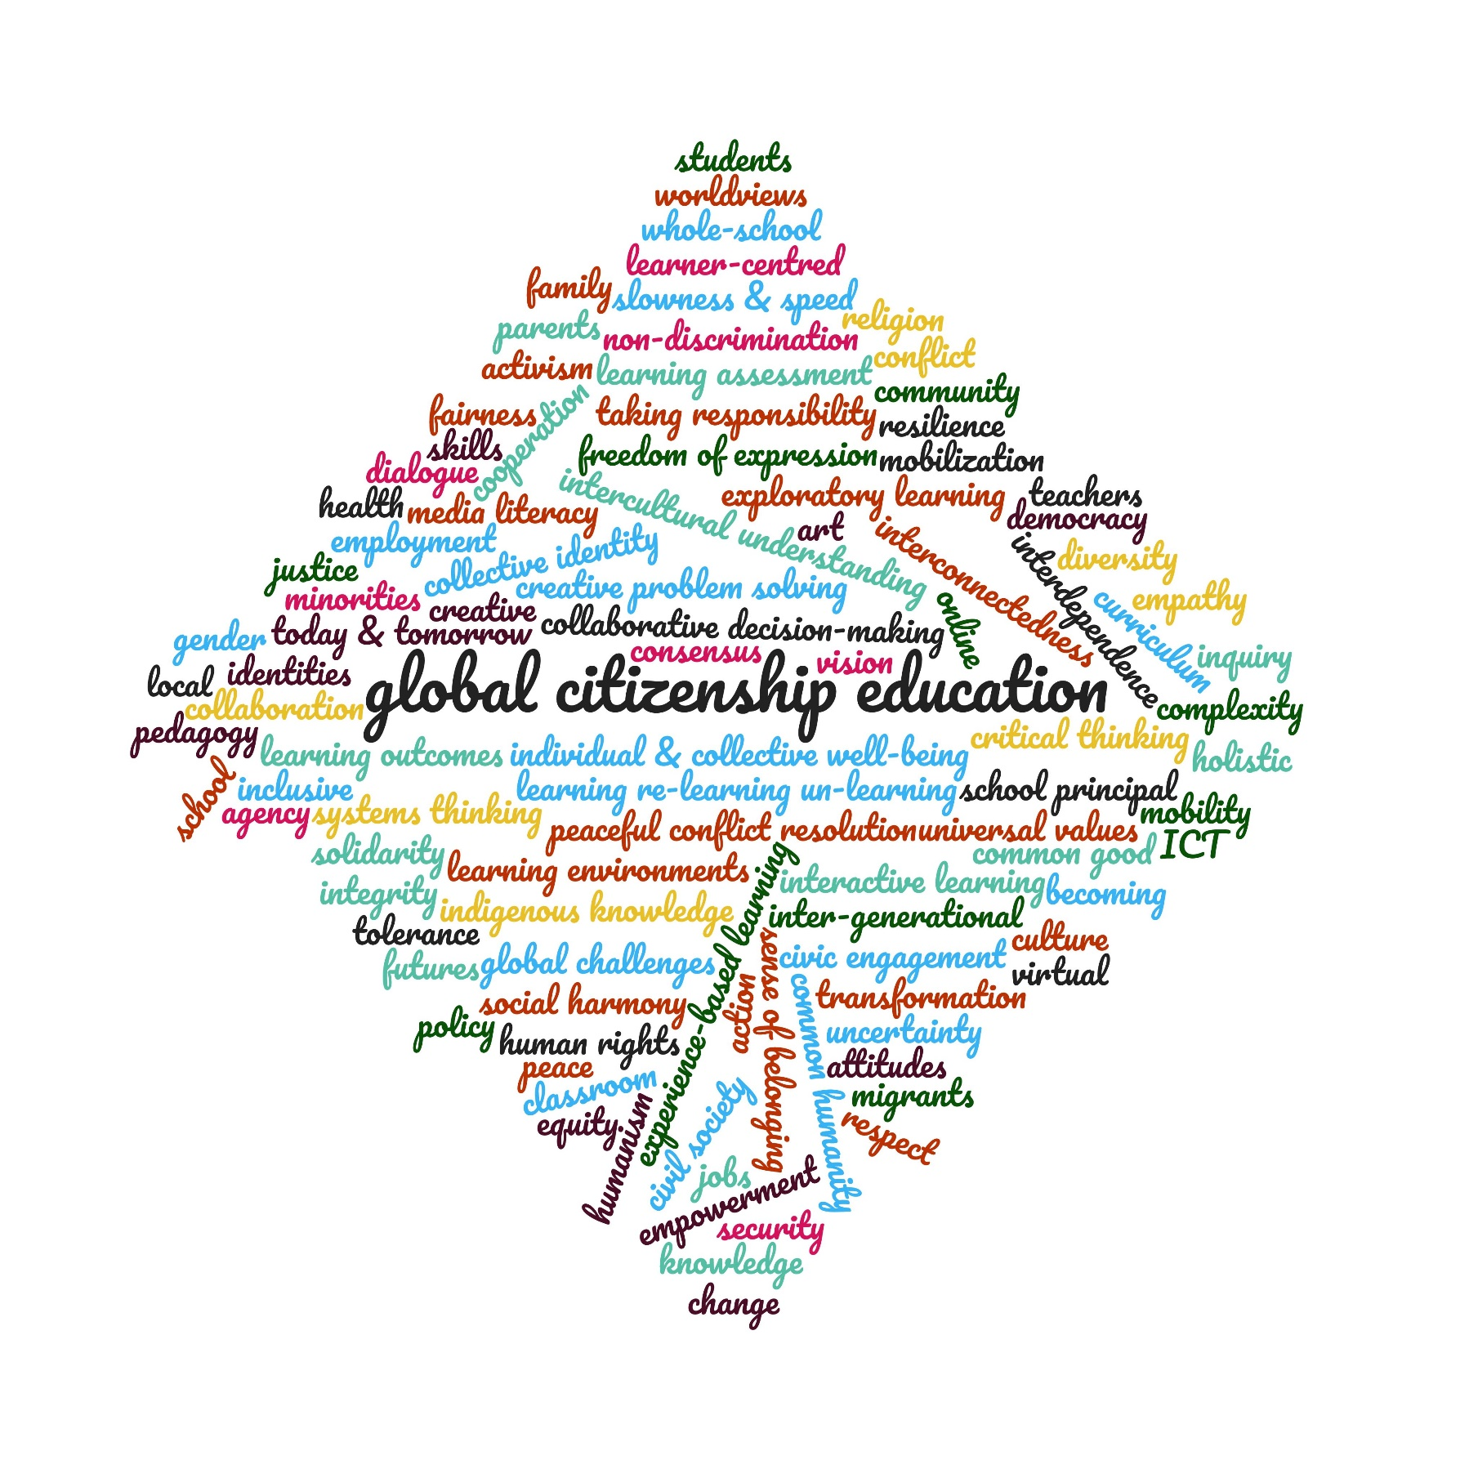

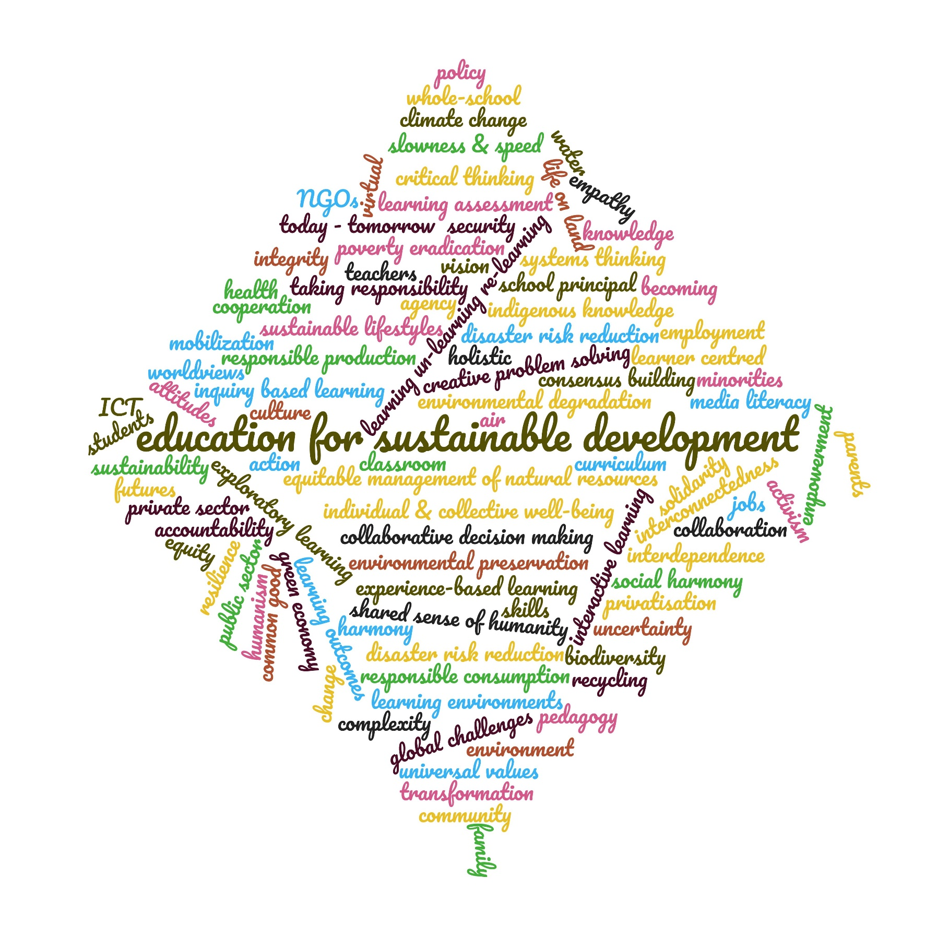

KEY WORDS
Futures
uncertainty
complexity
interconnectedness
interdependence
global challenges
destruction
change
transformation
global good
common good
school
family
community
humanism
empowerment
ICT
virtual
online
equity
slowness & speed
curriculum
pedagogy
assessment
learning outcomes
holistic
taking responsibility
agency
action
today
tomorrow
futures
whole-school
classroom
school
learning environments
school principal
teachers
students
parents
learning
un-learning
re-learning
interactive learning
exploratory learning
experience-based
learner centred
consensus building
becoming
worldviews
knowledge
attitudes
values
universal values
skills
systems thinking
critical inquiry
collaborative decision-making
creative problem solving
resilience
empathy
solidarity
cooperation
collaboration
vision
culture
art
policy
knowledge systems
indigenous knowledge
individual & collective well-being
political mobilization
activism
social harmony
security
health
employment
jobs
minorities

Education for Sustainable Development
environment
sustainability
green economy
sustainable lifestyles
climate
biodiversity
responsible production
responsible consumption
air
water
land
recycling
environmental preservation
equitable management of natural resources
disaster risk reduction
poverty eradication
integrity
private sector
public sector
NGOs
media
privatisation
accountability

Global Citizenship
intercultural understanding
dialogue
sense of belonging
global community
common humanity
collective identity
human rights
democracy
non-discrimination
tolerance
diversity
gender
religion
identities
peace
conflict resolution
global
local
citizenship
civic actions
inclusive
integrity
justice
fairness
respect
freedom of expression
inter-generational
migrants
mobility
media
civil society

