CONVENTION FOR THE SAFEGUARDING OF THE
INTANGIBLE CULTURAL HERITAGE
INTERGOVERNMENTAL COMMITTEE FOR THE
SAFEGUARDING OF THE INTANGIBLE CULTURAL HERITAGE
Meeting of the Bureau
UNESCO Headquarters, Room VIII
4 October 2022
10 a.m. – 1 p.m.
Item 5 of the provisional agenda:
Follow-up on elements inscribed on the Lists of the Convention
Summary
The present document aims to bring the attention of the Bureau to the removal requests made by third parties concerning the element ‘Processional giants and dragons in Belgium and France’ (Belgium and France) from the Representative List, with reference to Operational Directives’ paragraphs 40.1 to 40.3.
Decision required: paragraph 18

Introduction
- Taking note of the increasing number of cases that are brought to the attention of the Secretariat regarding the changing status of elements inscribed on the Lists of the Convention, the Committee at its thirteenth session in 2018 recognized the need to reflect on the follow up of inscribed elements and on ways for concerned communities, groups and where applicable, individuals and other stakeholders to participate in the monitoring of inscribed elements (Decision 13.COM 9).
- The global reflection on the listing mechanisms under the 2003 Convention, which took place between 2018 and 2022, consequently reflected on the establishment of a follow-up mechanism for inscribed elements that led to the revision of the Operational Directives of the 2003 Convention at the ninth session of the General Assembly in July 2022 (Resolution 9.GA 9). The listing mechanisms of the Convention now include a set of procedures for transferring elements between the Lists, inscribing elements on an extended or reduced basis, and removing elements. In parallel, the Committee has been taking note of cases that were the subject of correspondence received by the Secretariat concerning already inscribed elements (Decisions 14.COM 14 and 16.COM 11).
- The present document focuses on the case of the inscribed element ‘Processional giants and dragons in Belgium and France’, as a specific part of the element received removal requests from third parties due to alleged racism and discrimination. This element was incorporated on the Representative List of the Intangible Cultural Heritage of Humanity (Representative List) in 2008 by the third session of the Committee (Decision 3.COM 1) as a multinational inscription (Belgium and France). This element was previously proclaimed as a Masterpiece of the Oral and Intangible Heritage of Humanity in 2005 and was subsequently and automatically incorporated into the Representative List in 2008, pursuant to Article 31 of the Convention.
The inscribed element in question
- The nomination (file no. 00153) focuses on the traditional processions of large effigies of giants, animals or dragons which make up an ensemble of festive and popular manifestations. While similar traditions can be found in different parts of Western Europe, nine towns are covered by the file: five in Belgium (Ath, Brussels, Dendermonde, Mechelen and Mons) and four in France (Cassel, Douai, Pézenas and Tarascon). The performances often combine secular processions and religious ceremonies. They vary from town to town, but always follow specific rituals in which the giants and dragons relate to the history, legend or life of the town. They act out historical scenes and dance in the streets to the accompaniment of fanfares and people in costumes. The crowd follows the procession, and many participants help with the preparations at different stages of the festival.
- In the town of Ath, the festivity (known as the ‘Ducasse of Ath’) takes places each year on the fourth weekend of August to be the closest possible to the birth date of saint Julien, the patron of the town’s parish. While the main focus of the Ducasse of Ath is on the giants, animals or dragons, the procession includes the character of the ‘Sauvage’. The character was introduced to the Ducasse of Ath during the 19th century, according to the official website of the Ducasse of Ath, and represents a personality brought on a ship in chains, with a black painted face and other attributes to the costume, as he proceeds through the crowd acting out his character. The character is not mentioned in any part of the nomination file.
Issues raised by the public and concerned parties
- In 2019 and 2021, the Secretariat received several letters from non-governmental organizations and individuals in relation to the practice of the ‘Sauvage’. In both years the letters were transmitted to the national authorities of Belgium. The fourteenth session of the Committee in 2019 (Decision 14.COM 14) and the sixteenth session of the Committee (Decision 16.COM 11) also took note of the case. No festivities were held during 2020 and 2021, due to the COVID-19 pandemic, so that the 2022 edition was the first time the Ducasse of Ath took place since the initial correspondences received after the 2019 edition.
- The 2022 edition of the Ducasse of Ath took place from 26 to 28 August 2022. In August 2022, before the 2022 edition, the Secretariat started to receive once again a series of correspondence regarding the character of the ‘Sauvage’, including several letters from two non-governmental organizations or individuals (Annex I). A number of correspondences were also addressed to the Permanent Delegations of States Parties to the Convention which were members of the Committee at the time of the inscription of the element, with the Secretariat in copy.
- These letters describe that the ‘Sauvage’ is ‘a character dressed in black with a whole series of degrading signs attributed to black people by our racist societies throughout history: big nose, big red lips, “African” dress, nose ring, chains around the neck, wrists and ankles etc., plus agitated behaviour designed to frighten especially children’. All the correspondence received expresses serious concerns about the display of racist and discriminatory manifestations during the festivity, stating that the character of the ‘Sauvage’ and the use of the ‘blackface’ by white citizens, perpetuates negative and degrading stereotypes about black people and is a remnant of slavery. Out of 29 correspondences received at the time of issuing this document, 25 specifically request the removal of the Ducasse of Ath from the Representative List.
Procedures concerning the removal of an element
- Under the revised Operational Directives (2022 edition; see Annex II for an extract of relevant paragraphs), an element shall be removed from the List of Intangible Cultural Heritage in Need of Urgent Safeguarding or the Representative List by the Committee ‘when it determines that it no longer satisfies the required criteria, paying particular attention to criteria U.1/R.1 and U.4/R.4. The removal can be requested by the concerned State Party, communities, groups or, where appropriate, individuals, or any other third party […]’ (paragraph 40.1).
- The administrative steps entail the registration of a removal request (paragraph 40.2 (a)) and the transmission of the request to the concerned parties, so that a response and complementary information may be obtained (paragraph 40.2 (b) and (c)). The procedure then covers two main scenarios: a removal request submitted by the State Party (paragraph 40.2 (d)) and other cases (paragraph 40.2 (e)). In ‘other cases’, as is the case here, the request is transmitted first to the Bureau, whose role is to determine whether the removal request should be included in the agenda of the next session of the Committee. The Committee then has the option to either maintain the element on the List, or place it on ‘enhanced follow-up status’ to gather additional information for decision at a subsequent session of the Committee. (paragraphs 40.2 (e) and 40.3).
Reaction from the State Party concerned
- The correspondence received from the non-governmental organizations and individuals were transmitted to the national authorities of Belgium before the 2022 edition of the Ducasse of Ath on 16 August 2022 and once again on 28 September 2022. Since the issues raised concern exclusively the town of Ath, and no other towns in Belgium or France covered by the nomination, the national authorities of France have been informed but their reactions were not sought.
- In response to the first batch of correspondence, the State Party of Belgium responded with a letter on 14 September 2022, firmly condemning racism. The reply provided information on a set of initiatives undertaken by authorities to deal with the concerns raised (Annex III), which may be summarized as follows:
- In 2019, the municipal authorities of the town of Ath initiated a participative consultation process, gathering the town administration, representatives of bearers and practitioners of the Ducasse as well as the Unia (Belgium’s independent public institution that combats discrimination and promotes equal opportunities). The consultation took the form of a roundtable planned in June 2021 (the meeting was originally planned in November 2020 but postponed due to the COVID-19 pandemic), online forum and survey (March 2022), as well as a meeting between the town mayor, communities of the Ducasse of Ath and the regional authorities (13 April 2022). Furthermore, selected groups of primary school students were invited for three days in June 2022 to participate in awareness-raising activities about the Ducasse of Ath.
- The preliminary result of the above-mentioned consultation is that the communities’ opinions are divided, as reflected in the press release issued by the official website of the Ducasse of Ath on 24 August 2022, before the 2022 edition. In general, the communities concerned by the festivity are said to be strongly attached to the ‘Sauvage’ character and consider that its manifestation carries no intention of racism. At the same time, about 40% of the community responses said that they understand that the practice of the ‘Sauvage’ could offend some people and that they are not against seeing an evolution in the ways the Ducasse of Ath takes place.
- As announced by the above-mentioned press release, and following the consultations mentioned above, the town of Ath decided to maintain the character of the ‘Sauvage’ for the 2022 edition of the festivity. Nevertheless, in response to the reflection undertaken, certain attributes of the character were removed during the procession, so that in a deliberate and public act, on 28 August 2022, the ‘Sauvage’ rid himself of his chain and nose-ring. The town authorities also stated in the press, that reflections at the community level would continue, accompanied by authorities of Belgium, on the issue of whether the character would remain or be modified in the next edition of the festival.
- At the same time, the Belgian authorities stated that the legal framework applicable to the French community of Belgium concerning the safeguarding of intangible cultural heritage is scheduled to undergo a major reform, for adoption by Parliament in 2023. This reform is said to take into account various elements related to the requirements of mutual respect amongst communities.
Next steps
- Because the case at hand concerns a removal request submitted by entities other than the State Party, it is brought to the attention of the present Bureau, pursuant to paragraph 40.2 (e) of the Operational Directives. Since the revision of the Operational Directives by the ninth session of the General Assembly, this case represents the first application of the provisions related to the removal requests.
- The allegations of racism and discrimination raised in relation to the character of the ‘Sauvage’ are a serious matter, which must be addressed as they touch upon UNESCO’s founding principles of dignity, equality and mutual respect amongst peoples, which are also reflected in the very definition of intangible cultural heritage for the purposes of the Convention as stipulated in its Article 2.
- At the same time, the consultation and reflection process undertaken by the community, as well as the symbolic changes to the 2022 edition of the Ducasse, even if they appear minor and only partial, seem to indicate an openness by the community for a potential change in the character of the ‘Sauvage’ to address the concerns raised. This is in line with the dynamic and evolving nature of intangible cultural heritage, in the sense of Article 2 of the Convention, and appears to be reinforced by plans of the authorities to review and reform policies and legal frameworks concerning the safeguarding of intangible cultural heritage.
- It therefore seems appropriate that the Committee may wish to make use of the newly adopted provisions for ‘enhanced follow-up’ in order to encourage the community to resolve this serious matter, so that it may ultimately decide on whether or not this practice should be maintained on the Representative List.
- Following from the above, the Bureau may wish to recommend that the seventeenth session of the Committee examine the removal request, so that the Committee may decide whether to initiate an enhanced follow-up for this case. The issue may be included under the item already included in the provisional agenda related to the follow-up on inscribed elements that were subject to correspondence (document LHE/22/17.COM/2).
- The Bureau may wish to adopt the following decision:
DRAFT DECISION 17.COM 5.BUR 5
The Bureau,
- Having examined document LHE/22/17.COM 5.BUR/5 and its annexes (I to III),
- Recalling Decisions 3.COM 1, 13.COM 9, 14.COM 14, 16.COM 11, Resolution 9.GA 9 and paragraphs 40.1 to 40.3 of the Operational Directives,
- Further recalling that ‘Processional giants and dragons in Belgium and France’ (Belgium and France) was incorporated in 2008 in the Representative List of the Intangible Cultural Heritage of Humanity,
- Takes note that in 2022 the Secretariat registered a series of correspondence from the third parties condemning the ‘Sauvage’ character of the procession that takes place in the town of Ath (Belgium) as representing a form of racism and discrimination, and requesting the removal of the Ducasse of Ath from the Representative List, and that the Secretariat transmitted the removal requests to the State Party of Belgium;
- Further takes note that the State Party of Belgium replied in response to the removal requests and provided information on the reflection process initiated at the community level in order to address the concerns raised;
- Considers that the allegations of racism and discrimination are an extremely serious matter that touch upon UNESCO’s founding principles of dignity, equality and mutual respect amongst peoples as reflected in the preamble of the Organization’s Constitution, as well as the requirements of mutual respect among communities, groups and individuals as stipulated under Article 2 of the Convention;
- Recommends that, in accordance with paragraph 40.2 (e) of the Operational Directives, the removal requests concerning the Ducasse of Ath be included in the provisional agenda of the seventeenth session of the Committee.

ANNEX I
Correspondence received by the Secretariat concerning the element ‘Processional giants and dragons in Belgium and France’ from August 2022 to September 2022
 | Sending entity/individual | Type of correspondence | Date
Correspondence from institutions
1* | Bruxelles Panthères (Nordine S.) | Email to UNESCO | 2022-08-09
2* | Bruxelles Panthères (Mouhad R. & Nordine S.) | Email to UNESCO | 2022-09-10
3* | Bakushinta (Anne M. G. D. B.) | Email to UNESCO | 2022-08-16
4* | Jeunes Organisés et Combatifs Mons (Vic M.) | Email to UNESCO | 2022-08-17
5* | Jeunes Organisés et Combatifs Bruxelles (Sihame H.) | Email to UNESCO | 2022-08-26
Correspondence from individuals in support to Bruxelles Panthères
6* | Martin V. E. | Email to UNESCO | 2022-08-13
7* | Habiba B. | Email to UNESCO | 2022-08-16
8* | Anima E. | Email to UNESCO | 2022-08-16
9* | Lieven Miguel K. | Email to UNESCO | 2022-08-16
10* | Shashitu R. T. | Email to UNESCO | 2022-08-16
11* | Lotus L. | Email to UNESCO | 2022-08-16
12* | Marthe N. | Email to UNESCO | 2022-08-16
13* | Milady R. | Email to UNESCO | 2022-08-17
14* | Christelle B. K. | Email to UNESCO | 2022-08-17
15* | Jessica van Z. B. | Email to UNESCO | 2022-08-23
16* | Anna V. | Email to UNESCO | 2022-08-24
17* | Daniel V. | Email to UNESCO | 2022-08-25
18* | Timour S. | Email to UNESCO | 2022-08-25
19* | Luk V. | Email to UNESCO | 2022-08-26
20* | Juan C. B. | Email to UNESCO | 2022-08-26
21* | Khadija K. | Email to UNESCO | 2022-06-26
22* | Selma B. | Email to UNESCO | 2022-08-26
23* | Azhar R. | Email to UNESCO | 2022-08-26
24* | Latifa L. | Email to UNESCO | 2022-08-27
25* | Jennifer B. M. | Email to UNESCO | 2022-08-29
Correspondence from individuals
26/27 | Julien L. | Email to UNESCO | 2022-08-03  2022-08-25
28 | Karst van Z. | Email to UNESCO | 2022-08-17
29 | Ahmad N. | Email to UNESCO | 2022-09-10

Annex II
Extract concerning the removal procedure from the Operational Directives for the implementation of the Convention for the Safeguarding of the Intangible Cultural Heritage

I.11 | Transfer of an element from one List to the other and removal of an element from a List  […]
40.1 | An element shall be removed from the List of Intangible Cultural Heritage in Need of Urgent Safeguarding or from the Representative List of the Intangible Cultural Heritage of Humanity by the Committee when it determines that it no longer satisfies the required criteria, paying particular attention to criteria U.1/R.1 and U.4/R.4. The removal can be requested by the concerned State Party, communities, groups or, where appropriate, individuals, or any other third party and such a request shall be treated through the steps described below.
40.2 | - A removal request from the submitting entity (i.e. State Party concerned, communities, groups and/or where appropriate, individuals concerned or a third party) is registered by the Secretariat.  - The Secretariat transmits the removal request, as the case may be, to the State Party, the nomination contact person and representatives of communities, groups and/or where appropriate, individuals (as identified in the nomination file), who may provide a response and complementary information.  - If the submitting entity, other than States, wishes to remain anonymous, the Secretariat transmits an edited version of the original removal request.  - If the removal request is submitted by the State Party concerned as identified in the nomination file:  - The Secretariat gathers information in particular in relation to Article 2 of the Convention. The removal request is then directly transmitted to the Committee, together with a response, if any, from the State Party and/or communities, groups and, where appropriate, individuals concerned, as well as any information gathered.  - The Committee may then decide to:  - Place the element under ‘enhanced follow-up’ status as an interim measure if it considers that additional information is needed.  - Remove the element from the List if it considers that the information is complete and there is enough ground for removal, with the possibility of placing it in an Intangible Cultural Heritage Repository (end of the procedure).  - In other cases:  - The Secretariat may gather information in particular in relation to Article 2 of the Convention and share the results of that information with the concerned State Party and gather its response, if any. The removal request is then transmitted to the Bureau that recommends whether or not to include the case on the agenda of the next Committee session.  - The Committee may then decide to:  - Maintain the element on the List, if it considers that the information is complete and there is insufficient ground for removal (end of the procedure).  - Place the element under ‘enhanced follow-up’ status as an interim measure, if it considers that additional information is needed.
40.3 | - The Evaluation Body will evaluate the element placed under ‘enhanced follow-up' status, paying particular attention to Article 2 of the Convention, on the basis of additional information gathered through exchange and dialogue, as appropriate. The Evaluation Body shall transmit its report and recommendation to the Secretariat.  - On the basis of the recommendation from the Evaluation Body, and paying particular attention to criteria R.1/U.1 and R.4/U.4, the Committee may decide to:  - Continue to place the element under ‘follow-up’ for a period to be determined, if the issues persist. The Committee recommends the implementation of reconciliatory/mediatory measures and specifies a session of the Committee in which the issue will be reported back by the State Party for a final decision by the Committee.  - Remove the element from the List, if there is enough ground for removal, with the possibility of placing it in an Intangible Cultural Heritage Repository (end of the procedure).  - Maintain the element on the List, if there is insufficient ground for removal (end of procedure).

ANNEX III
Response from the State of Belgium to the correspondence received on the element ‘Processional giants and dragons in Belgium and France’ (14 September 2022)
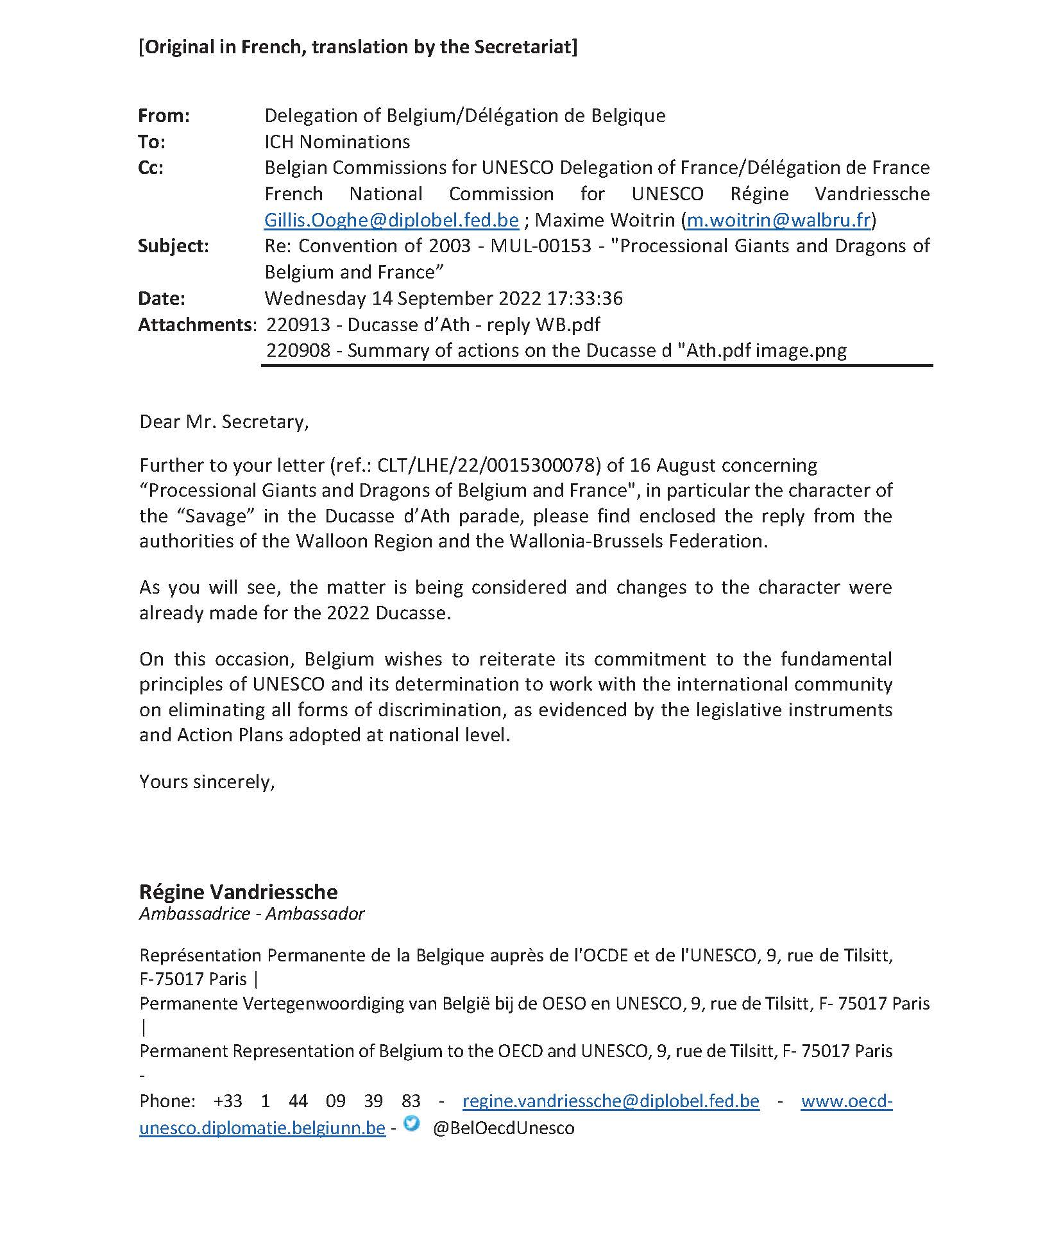

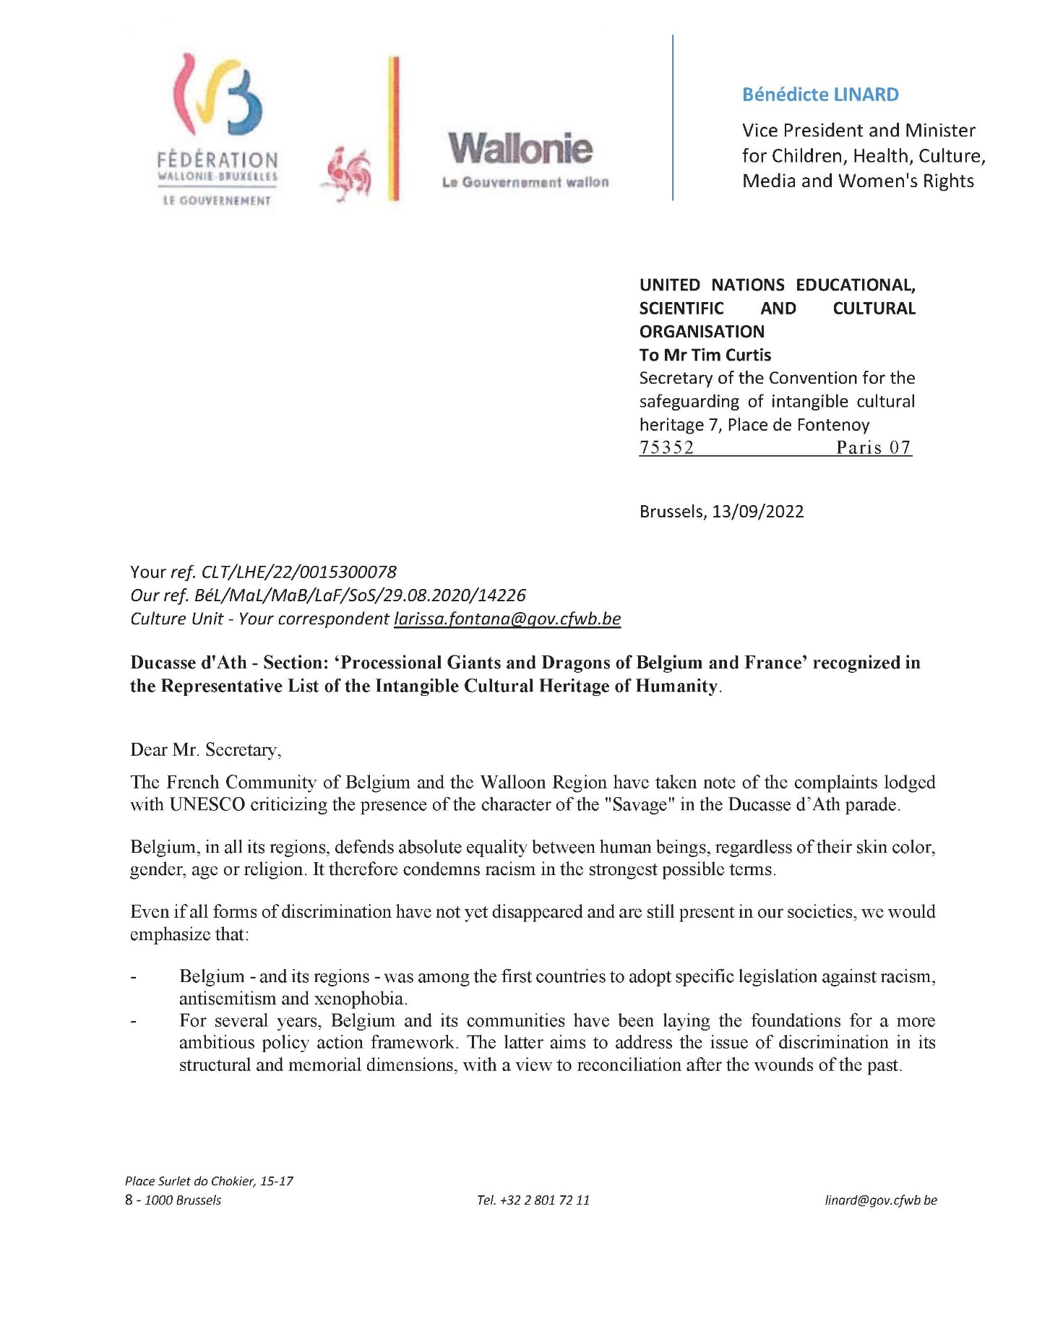

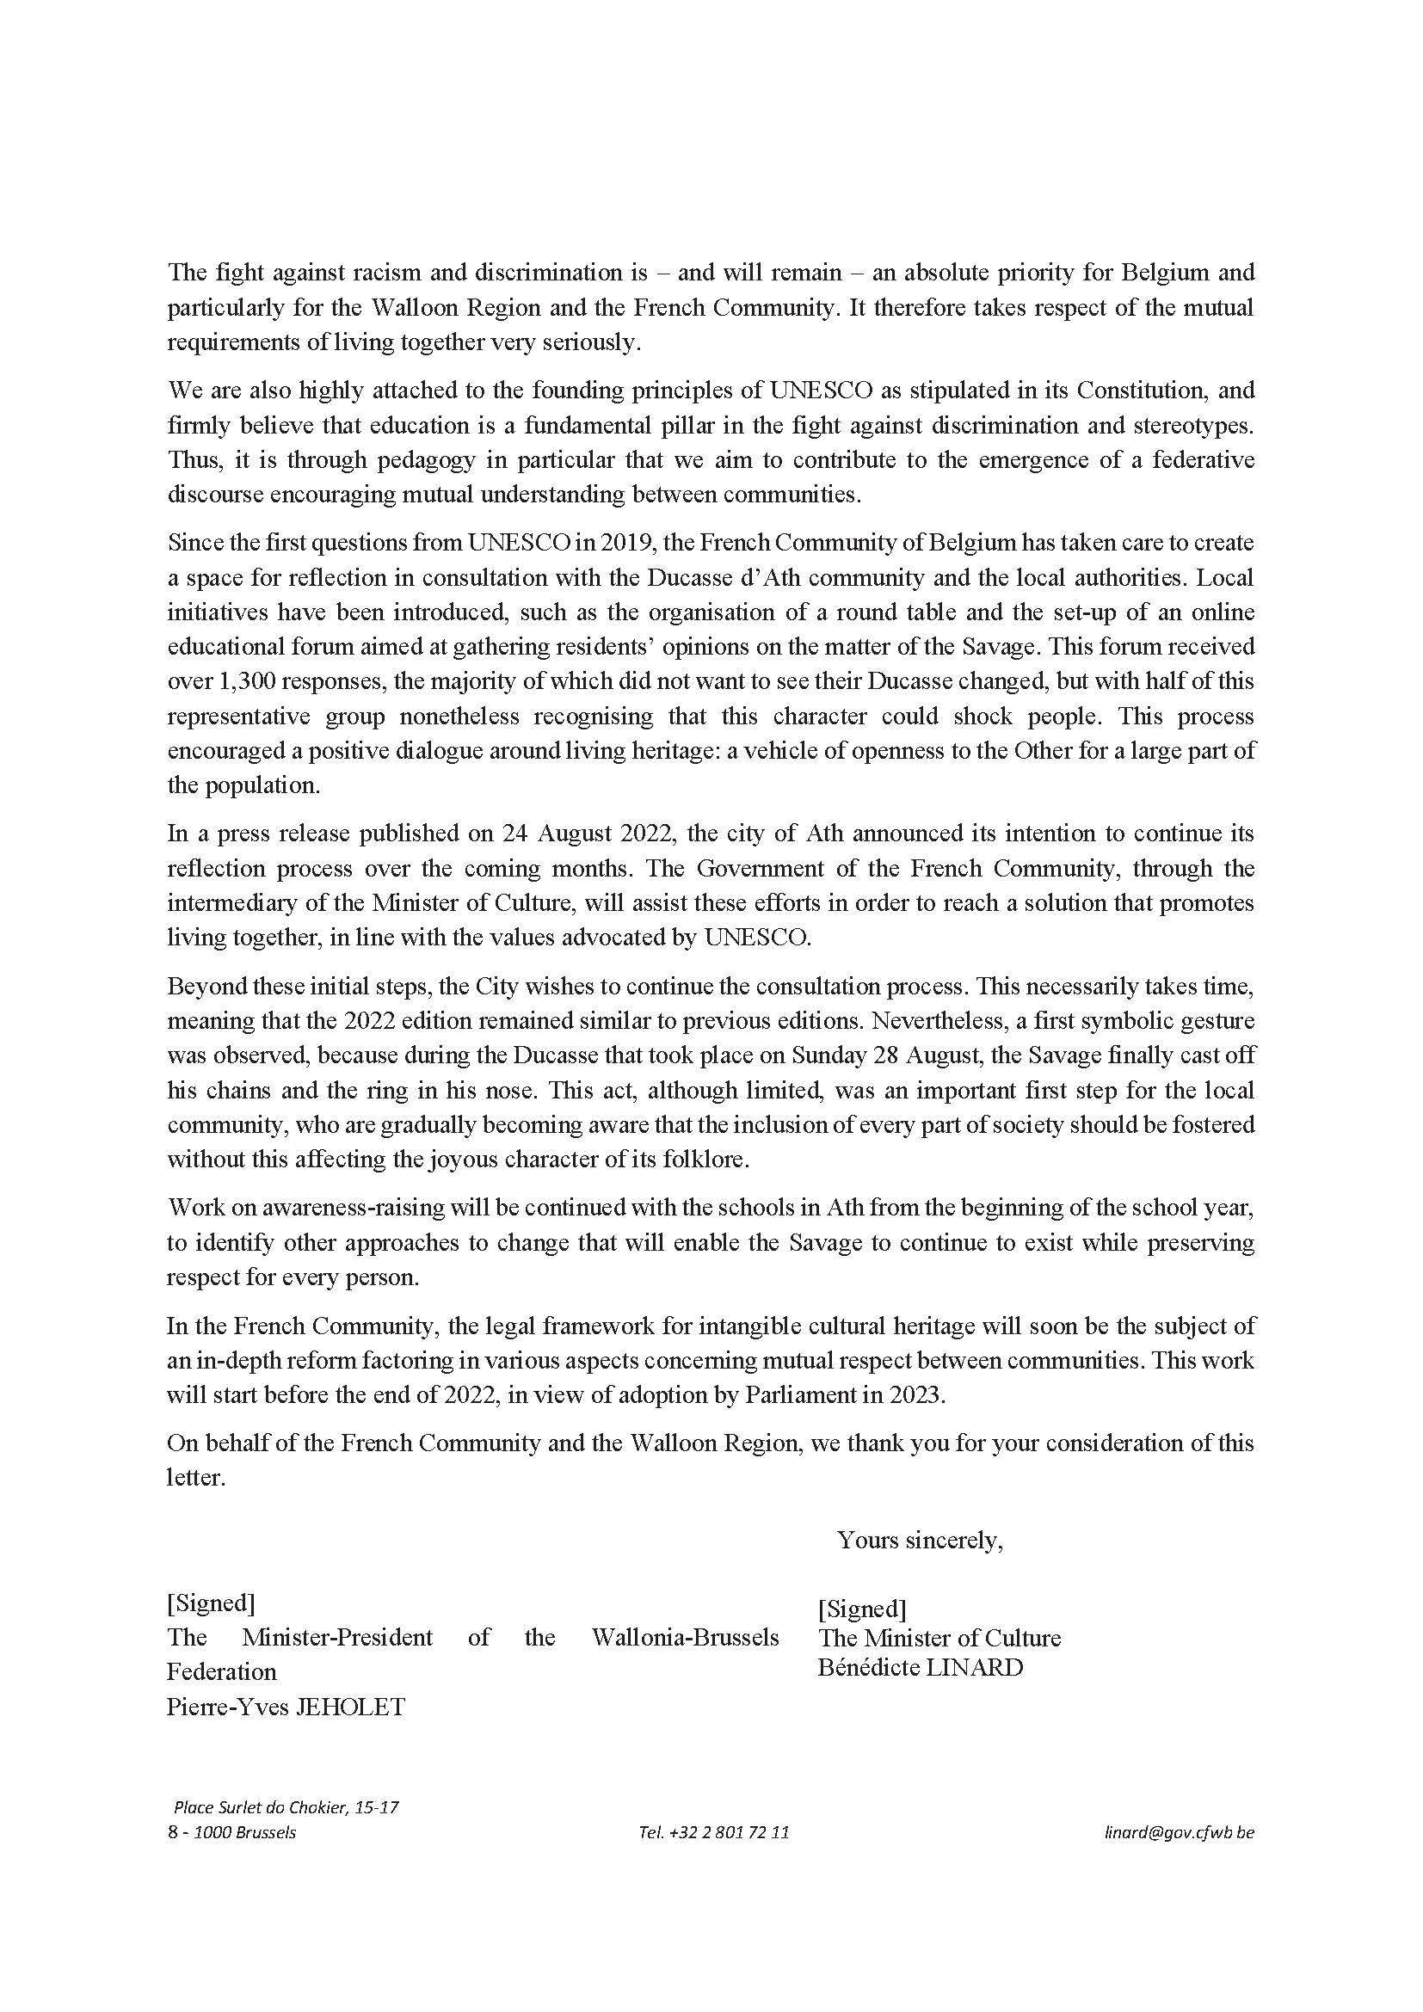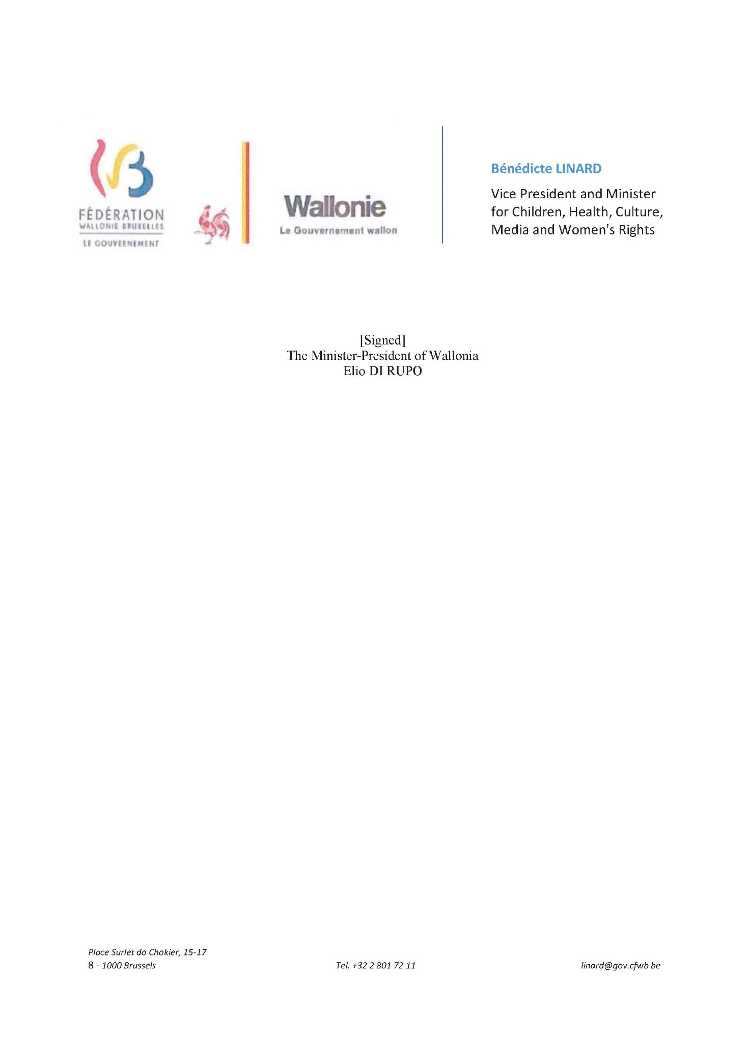

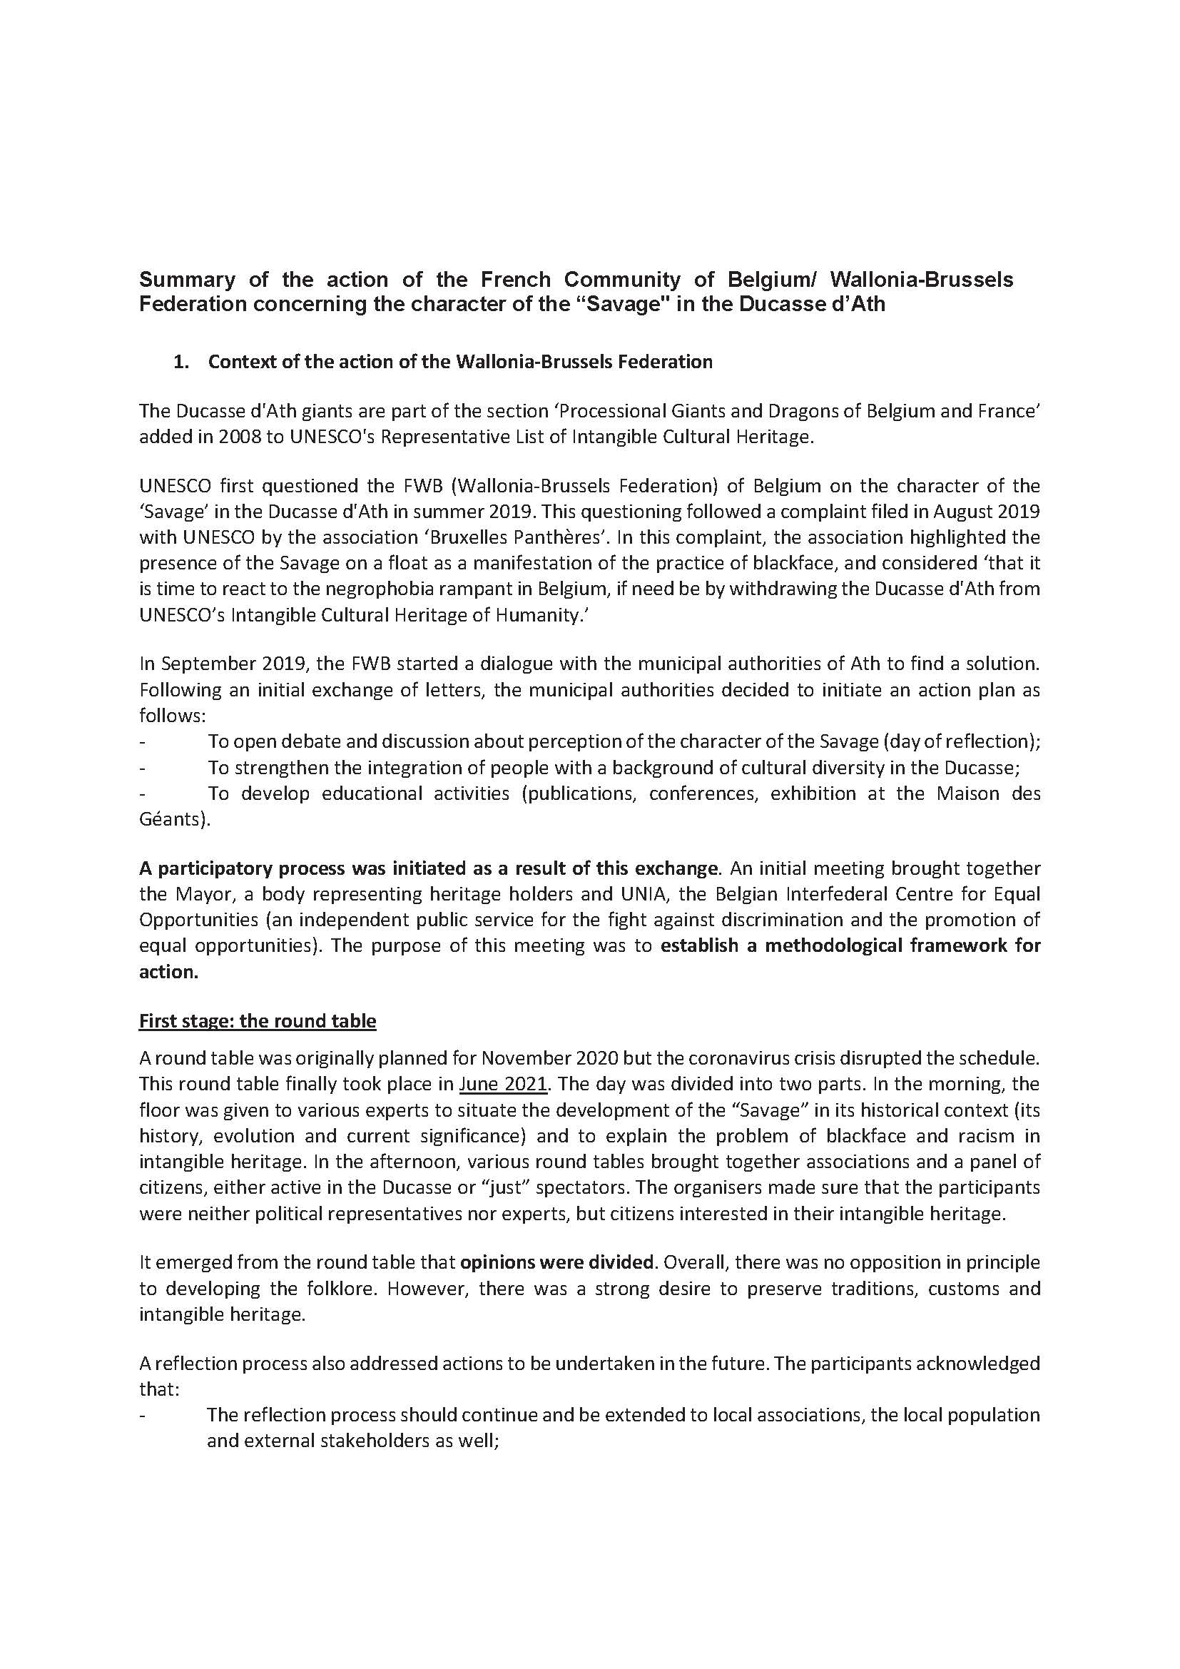

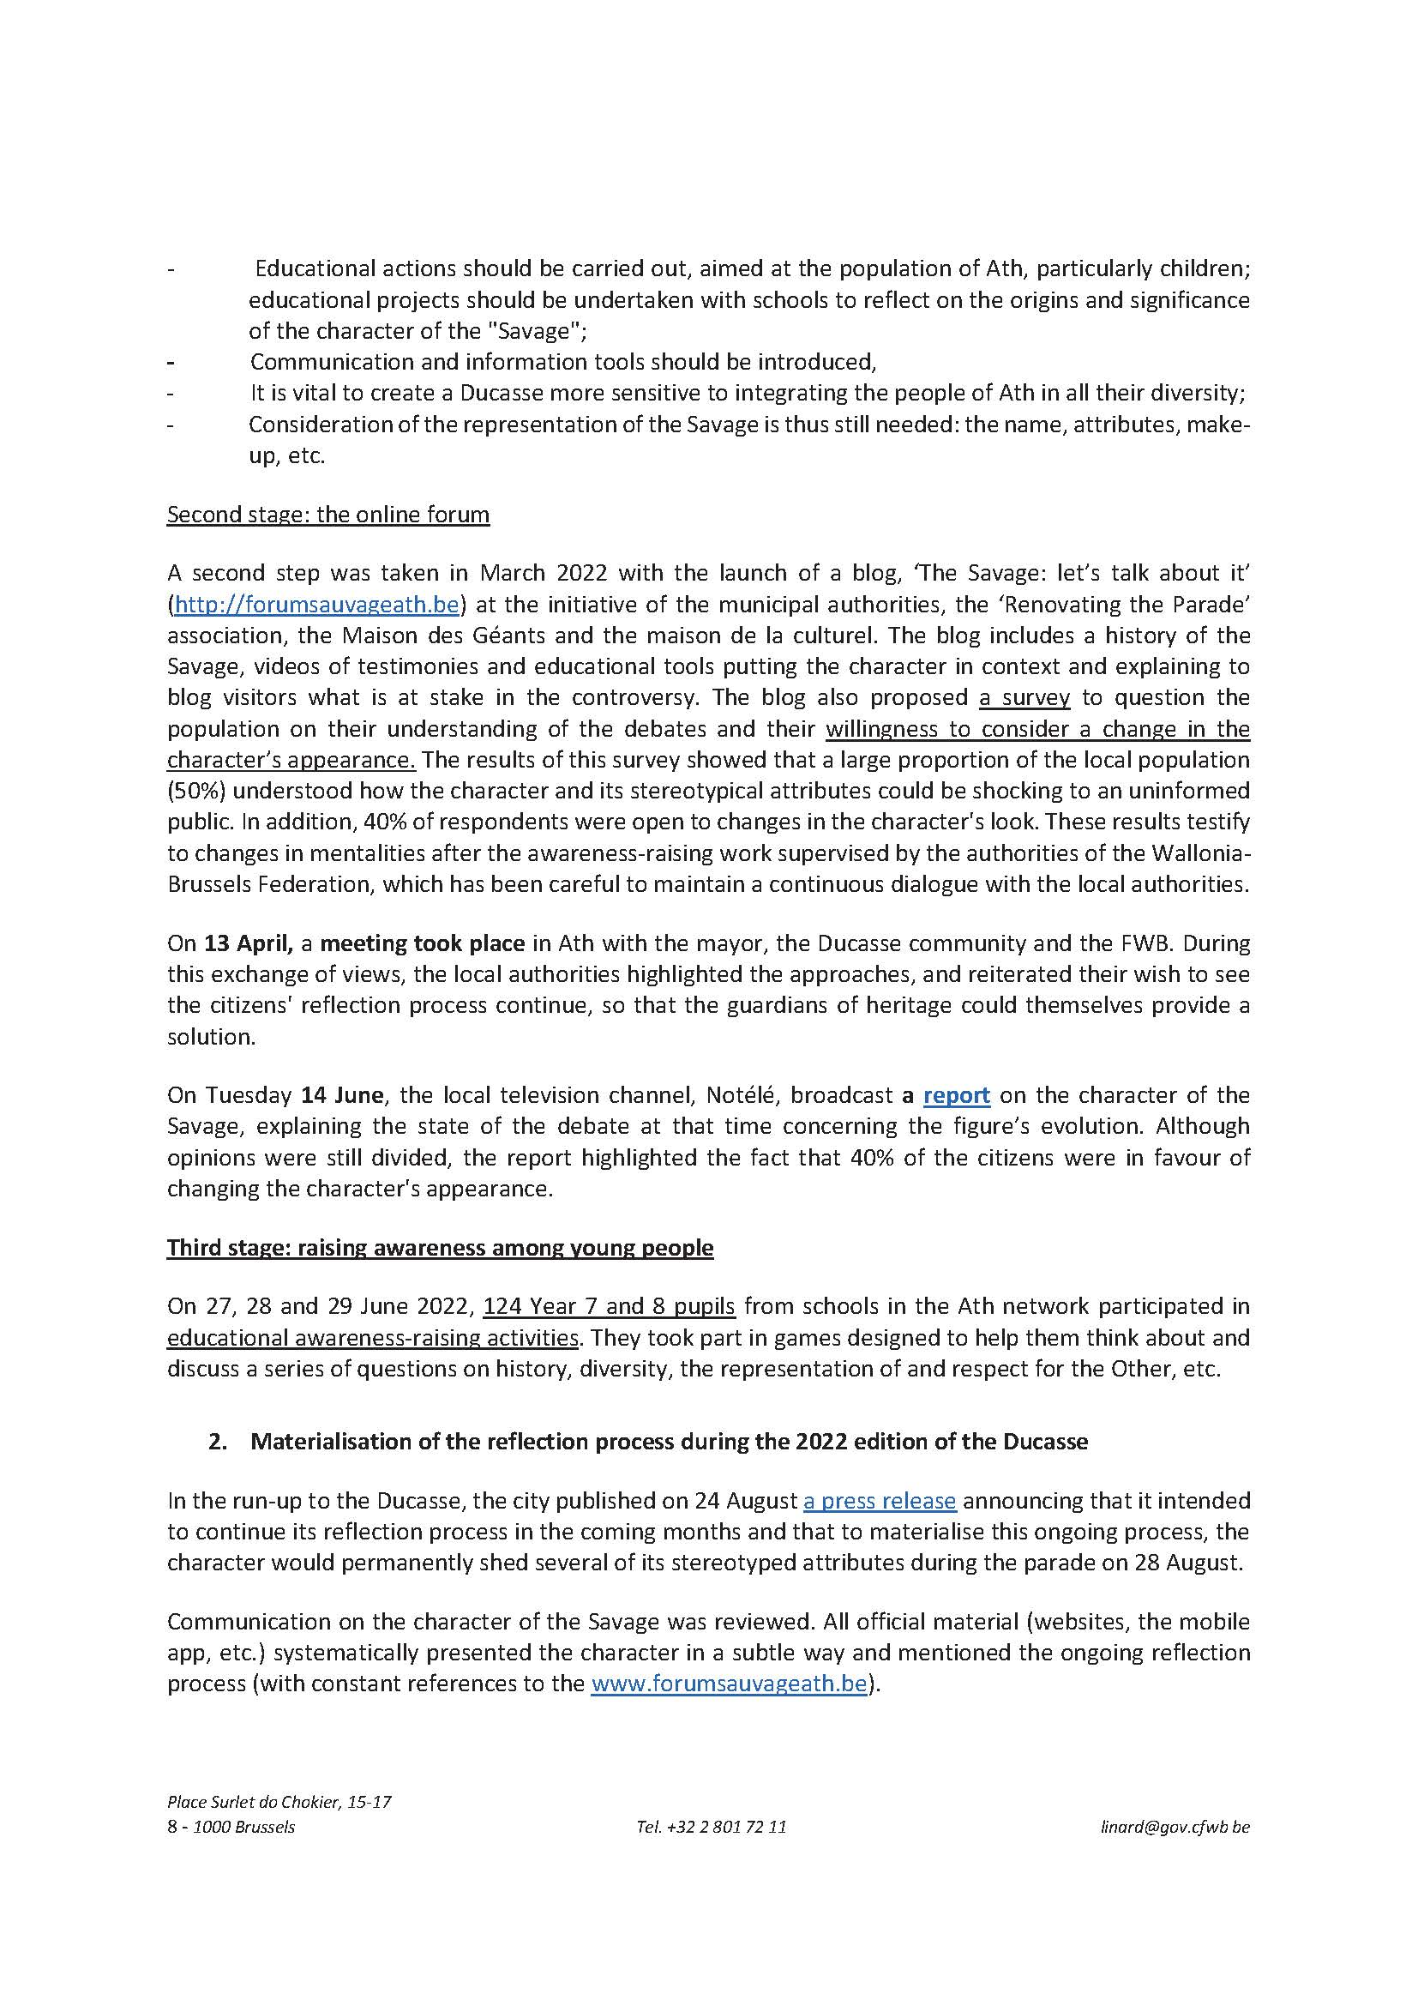

The nomination file is not accessible for public consultation on the webpage of the 2003 Convention since the authorization by the submitting States was not fully granted at the time of the element’s proclamation.

