Unit 26

Hand-out 2:
Working with exposure and focus
When taking a photograph, a certain amount of light is allowed in through the lens. If too much light is allowed in, the picture will be overexposed and the image will look washed out. If too little light is allowed in, the picture will be too dark and it will be difficult to discern the details in the image. This is why it is important to learn how to control the exposure settings on the camera.
Many cameras today can be programmed to automatic or manual settings. When using the automatic setting, the camera adjusts for light and focus. The downside to this is that the photographer may desire different results that emphasize focus or light on one particular part of the picture. To do this, it is important to learn how to use the camera manually.
Adjusting the shutter speed, the aperture and camera sensitivity are three ways to control how much light comes in (i.e. the exposure), how this light affects the look of the image, and what parts of the image are in or out of focus.
The amount of light allowed in is measured in ‘stops’. Stops are a relative measure of the lightness of a subject. When adding one stop of light, the amount of light that the camera records is doubled. It is not the brightness of the whole picture that matters, but the brightness of one object in the image compared with another (i.e. how many stops they are apart from each other). For example, if photographing or filming a snowy field at sunset, the exposure settings (the aperture, shutter speed and camera sensitivity) could be adjusted to ensure that the snow still looked white and that a rock sticking out of the snow looked dark.

Shutter speed
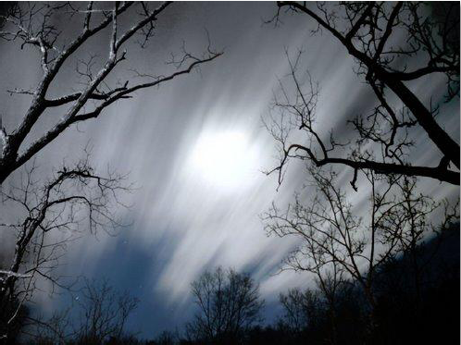
The shutter speed affects how much light is allowed into a picture because it controls how long the shutter stays open. The longer the shutter stays open, the more light is allowed in.
For example, when photographing a moonlit field at night, it is a good idea to place the camera on a tripod and adjust the camera to a high shutter speed (e.g. a 4-second exposure). This would allow sufficient time for the moonlight to fill the plate, which records the image in the camera. Keeping the camera absolutely still in this situation is important. If the camera is moved while the shutter is open, light will streak across the plate and the details in the photograph will be lost.
Photo 1
Shutter speed also helps to capture details in moving subjects. A faster shutter speed can freeze a fast-moving subject because it does not allow sufficient light in for long enough to blur the image.
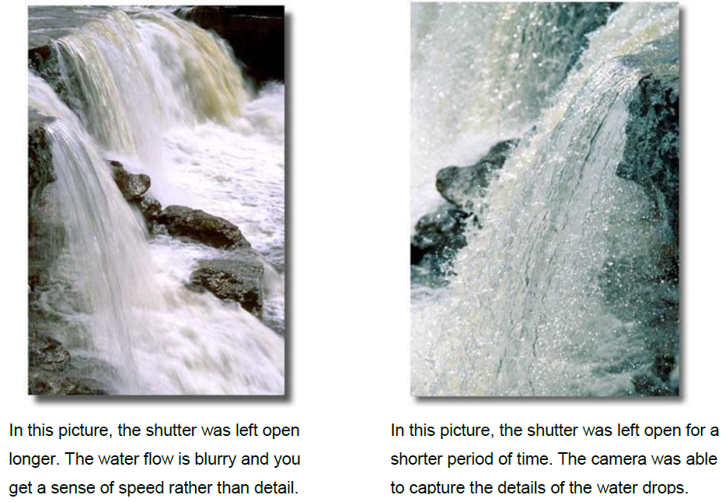
For example, if photographing running water with the aim of capturing the details of each droplet, a fast shutter speed such as a 1/800-second exposure could be used. A 4-second shutter speed could be used to get a photograph of running water that shows the whole stream of water, which would help convey the speed of the flowing water rather than focus on droplets. This would make the stream somewhat blurry, soft and flowing.
Photos 2 and 3

Aperture
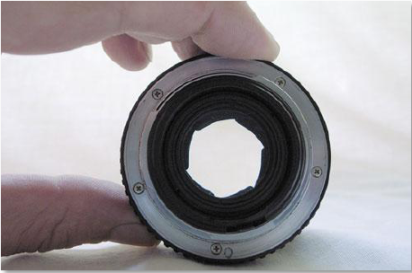
The aperture refers to the iris on a camera that opens and closes to allow in more or less light. It works in the same way as pupils, dilating when it is dark to let in more light or contracting on a sunny day to let in less. The aperture is measured in ‘f-numbers’, such as 1, 1.4, 2, 2.8, 4, 5.6, 8, 11, 16, 22 and 32. An f-number is the ratio width of the iris to the focal length of the shot. This can become quite complicated; for now, it is sufficient to know that an f-number is written like this: f/1 or f/2.8 or f/16 (i.e. f divided by 1, 2.8 or 16).
Photo 4
F/16 would be a lower f-number than f/1 because it represents a smaller ratio rather than a larger number.
Low f-numbers mean wide apertures, which allow in more light. Each f-number is 1.4 times the previous one and lets in half as much light. When someone says ‘close’, ‘reduce’ or ‘step down’ the aperture, they mean increase the f-number. By doing this, less light is allowed in. Like the shutter speed, the aperture affects the look of the photo, specifically the depth of field. Depth of field refers to what portions of the photo or image remain in focus.
At a small aperture (i.e. f/16), the whole scene is in focus. When the aperture is wider (i.e. f/1.4), only the part of the scene on which the photographer focuses is sharp, while the remainder is blurry. This technique helps an object to stand out from its background, as complicated backgrounds can sometimes be distracting for the viewer.
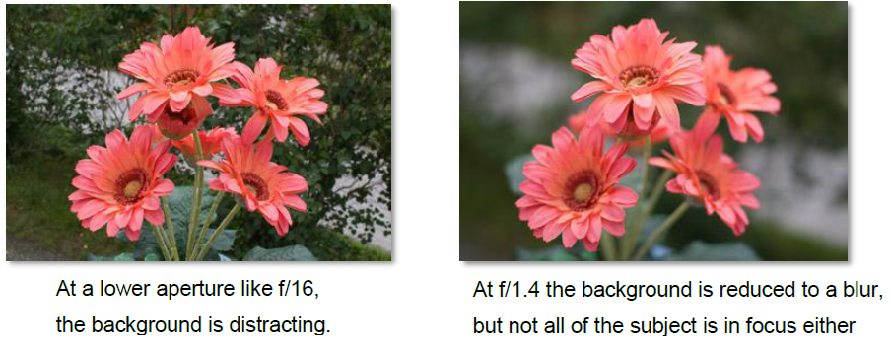
Photos 5 and 6

Camera sensitivity
The sensitivity of a camera’s plate is measured in ISO sensitivity units. Most digital cameras offer a range from 100 ISO to 1600 ISO, where 100 is the least sensitive. ISO tells the sensor in the camera how much light is present.
Sensitivity is a helpful exposure setting because it hardly ever affects the look of the final image. This means that it can be used to help achieve a combination of aperture and shutter speeds so as to get the desired look.
The higher the ISO, the more sensitive the image sensor; therefore, pictures can be taken in low-light situations. However, if too high of an ISO is used for the amount of light present, the picture can look ‘noisy’ (i.e. very pixilated).
The lower the ISO, the less noise or sharpness of detail is visible. When shooting in brighter situations, it might be a good idea to consider using a lower ISO setting.

Source: Corbett J. and White K., 2010. Handout for Trainee. Unit M14U05, Module M14: Documentation; in “Training Kit on Participatory Spatial Information Management and Communication”. CTA, The Netherlands and IFAD, Italy.

Copyright information:

Photo 1: from Handout on the Fundamentals of Photography from Module 14, Unit 5 of the Training Kit on Participatory Spatial Information Management and Communication by Jon Corbett and Kasondra White is licensed under CC BY-NC-SA 3.0.
Photos 2 and 3: from Handout on the Fundamentals of Photography from Module 14, Unit 5 of the Training Kit on Participatory Spatial Information Management and Communication by Jon Corbett and Kasondra White is licensed under CC BY-NC-SA 3.0.
Photo 4: from Handout on the Fundamentals of Photography from Module 14, Unit 5 of the Training Kit on Participatory Spatial Information Management and Communication by Jon Corbett and Kasondra White is licensed under CC BY-NC-SA 3.0.
Photos 5 and 6: from Handout on the Fundamentals of Photography from Module 14, Unit 5 of the Training Kit on Participatory Spatial Information Management and Communication by Jon Corbett and Kasondra White is licensed under CC BY-NC-SA 3.0.

