CONVENTION FOR THE SAFEGUARDING OF THE
INTANGIBLE CULTURAL HERITAGE
INTERGOVERNMENTAL COMMITTEE FOR THE
SAFEGUARDING OF THE INTANGIBLE CULTURAL HERITAGE
Seventeenth session
Rabat, Kingdom of Morocco
28 November to 3 December 2022
Item 6.c of the provisional agenda:
Update on the first cycle of periodic reporting
on the implementation of the Convention and on the current status of elements inscribed
on the Representative List of the Intangible Cultural Heritage of Humanity
by States Parties in Latin America and the Caribbean (2021 Cycle), in the Arab States
(2023 Cycle) and in Africa (2024 Cycle)
Summary
This document presents an update on the first cycle of periodic reporting on the implementation of the Convention and on the current status of elements inscribed on the Representative List of the Intangible Cultural Heritage of Humanity in Latin America and the Caribbean, in the Arab States and in Africa.
Decision required: paragraph 19

Introduction
- The periodic reporting mechanism under Article 29 of the 2003 Convention has been reformed with the aim of enhancing its quality, usefulness and timeliness, as well as to address the low submission rate, following the decision of the twelfth session of the Committee in 2017 (Decision 12.COM 10). The mechanism has been aligned with the overall results framework of the Convention in order to ensure the process was clearly in line with the overarching goals of implementing the Convention and to allow for more effective monitoring to achieve these goals (Resolution 7.GA 9 and Decision 14.COM 8). These reforms concerned the reporting process on the implementation of the Convention and on the current status of elements inscribed on the Representative List of the Intangible Cultural Heritage of Humanity (reporting on elements inscribed on the Urgent Safeguarding List was not concerned by the reform).
- The periodicity of the reporting process was also amended such that States Parties would submit their reports every six years on the basis of a system of regional rotation (Decision 13.COM 8). The calendar for the first cycle of reporting was defined as follows:
- Latin America and the Caribbean (2021 cycle): periodic reports submitted by 15 December 2020 for examination by the Committee at its sixteenth session in 2021.
- Europe (2022 cycle): periodic reports submitted by 15 December 2021 for examination by the Committee at its seventeenth session in 2022.
- Arab States (2023 cycle): periodic reports submitted by 15 December 2022 for examination by the Committee at its eighteenth session in 2023.
- Africa (2024 cycle): periodic reports submitted by 15 December 2023 for examination by the Committee at its nineteenth session in 2024.
- Asia and the Pacific (2025 cycle): periodic reports submitted by 15 December 2024 for examination by the Committee at its twentieth session in 2025.
- The first cycle will end with a reflection year in 2026.
- For each region, the periodic reporting exercise goes through a four-phase process over a period of four years: Phase 1 (first year) is the initiation of the exercise, involving the designation by States Parties of country focal points for the periodic reporting exercise and the training of facilitators to accompany the country focal points; Phase 2 (second year) involves the training of country focal points at the regional and/or sub-regional level as well as the preparation and online submission of reports; Phase 3 (third year) involves the preliminary analysis, by a team established by the Secretariat, of the reports submitted, presented as an ‘analytical overview’ for examination by the Committee in the year following the submission; and Phase 4 (fourth year) involves a comprehensive analysis of data extracted from the reports submitted, presented in the form of an ‘analytical report’ - two years after the submission of the country reports. In other words, the exercise consists of overlapping cycles, which are at different phases in respective regions, as shown below:
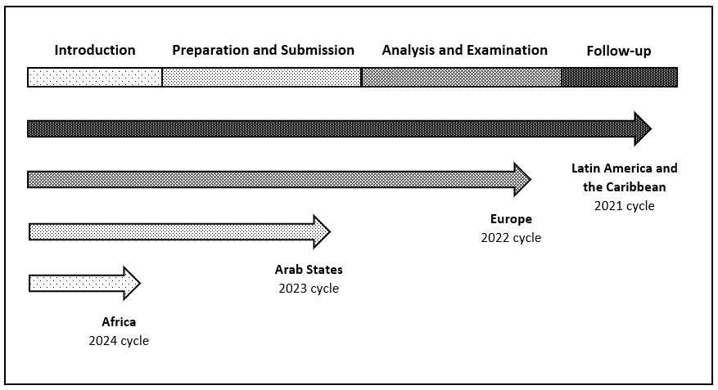
- The purpose of this document is to provide an update regarding the implementation of the cycles of the reformed periodic reporting system in Latin America and the Caribbean, in the Arab States and in Africa. The assessment of the periodic reporting exercise undertaken by Europe is covered under Item 6.b of the Provisional Agenda of the present session (document LHE/22/17.COM/6.b), as this session of the Committee is to examine the reports of the Europe region and the ‘analytical overview’ thereof.
2021 Cycle – Final analysis of the periodic reports from Latin America and the Caribbean
- The Latin America and the Caribbean region responded to the reformed periodic reporting exercise with enthusiasm, as twenty-eight (87.5 per cent out of a total of thirty-two reports expected) States Parties submitted their reports. This high submission rate – despite the COVID-19 pandemic, which impacted the region heavily – is a positive result of the reform, demonstrating the commitment of reporting States Parties who benefitted from the capacity-building approach developed by the Secretariat. The active role played by the Regional Centre for the Safeguarding of Intangible Cultural Heritage in Latin America (CRESPIAL) was also a determining factor for this positive experience.
- An ‘analytical overview’ of these reports was examined by the sixteenth session of the Committee (Decision 16.COM 7.b and Annex I of document LHE/21/16.COM 7.b). The Committee welcomed the key findings from the overview and noted the common trends, challenges, opportunities and priority areas related to intangible cultural heritage reported by the countries with interest, as well as the different safeguarding approaches and methodologies adopted by the reporting States Parties. The research team set up by the Secretariat which prepared the ‘analytical overview’ continued its work after the sixteenth session of the Committee in 2022 to draft the ‘analytical report on the first cycle of periodic reporting under the 2003 Convention by States Parties in Latin America and the Caribbean’, presented at the present session of the Committee (document LHE/22/17.COM/INF.6.c). This report follows the main structure of the analytical overview, as it is developed around the eight thematic areas of the Overall Results Framework of the 2003 Convention.
- In addition to detailed information on the extent to which reporting States Parties have met the core indicators as well as on the targets set for the next round of reports, the analysis highlighted, amongst other points:
- Challenges encountered by States Parties and potential ways to enhance intangible cultural heritage safeguarding in their different spheres of action.
- Inclusive policymaking privileged in the culture sector, often with a specific focus on cultural diversity and on safeguarding languages as an expression and vehicle of intangible cultural heritage.
- Impact of policies and activities undertaken under the 2003 Convention to achieve the global Sustainable Development Goals (SDGs) and for sustainable development in general beyond the culture sector.
- Common trends demonstrating a high level of participation by communities, groups and individuals in education, research and documentation, as well as in awareness-raising activities.
- Enhanced regional cooperation, for instance through the implementation of activities aiming at safeguarding specific elements, particularly those in need of urgent safeguarding.
- The abovementioned research team provided the Secretariat with specific recommendations on the effectiveness of the periodic reporting mechanism as a monitoring and reporting tool for the 2003 Convention, as well as lessons learnt from this cycle.
- With reference to Recommendation 2 of the 2021 evaluation by the Division of Internal Oversight Services of UNESCO’s actions in the framework of the 2003 Convention, it is important to make the results of the data collected widely available, in an easily digestible, visual manner. In the first instance, the Secretariat intends to issue the ‘analytical report’ on the reports by States Parties in Latin America and the Caribbean as a UNESCO publication in English, French and Spanish. The information submitted is also planned to be made available to each reporting State in the form of a ‘country data sheet’, with the aim of facilitating safeguarding efforts and following up of the periodic reporting exercise at the national level.
2022 Cycle – Post-submission analysis in Europe
- As the second region to go through the reformed periodic reporting exercise, forty-two States Parties out of forty-four in the Europe region submitted their periodic reports by the extended deadline of 15 February 2022. The Regional Centre for the Safeguarding of the Intangible Cultural Heritage in South-Eastern Europe supported the capacity-building activities. An analytical overview of these reports is provided to the present session of the Committee under Item 6.b of its provisional agenda (document LHE/22/17.COM 6.b).
2023 Cycle – Capacity-building support in the Arab States
- Under the 2023 cycle, eighteen States Parties in the Arab States region are getting ready to submit their reports by the deadline of 15 December 2022. To support the process, the Secretariat designed a nine-month capacity-building process (running from February to October 2022), as demonstrated below:
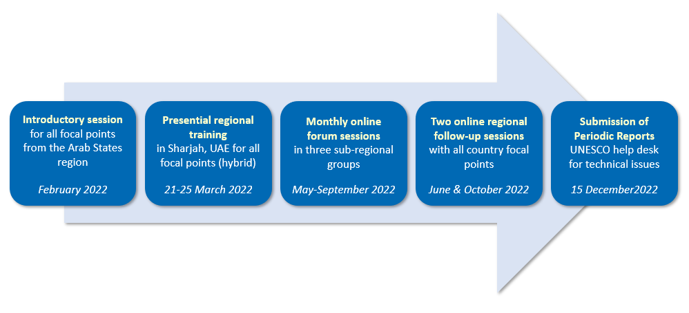
- Following an online introductory session (15 February 2022), a five-day training session brought together eighteen country focal points, representing all the States Parties of Electoral Group V (b). The training was made possible thanks to the generous support and hospitality of the Sharjah Institute for Heritage. Given the ongoing COVID-19 pandemic, the meeting was conducted in a hybrid format (Sharjah, the United Arab Emirates, from 21 to 25 March 2022). Supported by training materials available in Arabic, French and English, the training session combined lectures and interactive exchange sessions on core knowledge and concepts, complemented by hands-on exercises using the online periodic reporting form. Furthermore, there was an emphasis on peer learning in three sub-regional groups. The participants of the training session included twenty observer officials from ministries, National Commissions for UNESCO and other regional organizations, together with six culture specialists from UNESCO field offices in the region.
- After the training at the regional level, the sub-regional groups continued their exchanges through monthly follow-up sessions (April to September 2022). These sessions allowed focal points to work together closely, contributing significantly to strengthening the exchange of knowledge and experience across the region. The Secretariat provided additional support by organizing two online follow-up sessions bringing together all the focal points and their teams from the entire region to facilitate further exchanges and peer-learning (June and October 2022). For the final phase of the preparation of the reports, a help desk has been put in place to ensure assistance on technical issues related to filling in the periodic reporting form.
2024 Cycle – Launch of the periodic reporting exercise in Africa
- Preparations are underway for the roll-out of the periodic reporting exercise to support States Parties in the Africa region to submit their reports by the deadline of 15 December 2023. The capacity-building approach for the Africa region comprises a training programme for facilitators and the regional training of country focal points for periodic reporting:
- As a first stage, an online training session was/will be provided (26 October as well as 2 and 9 November 2022) for twelve facilitators from the global capacity-building network in Africa. The facilitators will be introduced to the reformed periodic reporting mechanism and the Overall results framework of the Convention in order to strengthen their knowledge and skills to design and implement results-based participatory reporting; the training will also help the facilitators to familiarize themselves with the online reporting tool.
- The second stage of the capacity-building process, planned for early 2023, would focus on preparing the forty-four country focal points from the region to undertake the periodic reporting process, depending on the availability of extrabudgetary funds. It is expected that the group of facilitators trained through the abovementioned online training session would then offer advice on how best to contextualize the training for country focal points for the Africa context. Facilitators who were involved in previous reporting cycles will be invited to the training session to share their experiences and lessons learnt, facilitating peer learning and cross-regional exchanges.
- The implementation of the capacity-building process for the Africa region would be ensured by UNESCO and its network of field offices in the region and in collaboration with the Category 2 Centre the Regional Centre for the Safeguarding of Intangible Cultural Heritage in Africa (CRESPIAF). The comprehensive capacity-building approach in the region will help ensure that African States are fully supported in the preparation of their periodic reports, in line with UNESCO’s Operational Strategy for Priority Africa 2022-2029.
Ways forward
- While it is a challenge to support four regions undertaking the periodic reporting exercise, the situation allows the Secretariat to apply lessons learnt from one region to another. Numerous experiences and observations from the first cycle in Latin America and the Caribbean could be described, but the key recommendations that are immediately relevant for the regions who are preparing or will be preparing their reports may be summarized as follows:
- Although the submission of a report is a statutory obligation, it is important to include the perspectives of all the stakeholders involved, particularly communities, rather than focusing exclusively on State actions.
- Similarly, reports should not only cover actions related to inventoried or inscribed elements; rather, they should relate to intangible cultural heritage in general, so as to showcase a greater variety of examples of safeguarding activities.
- It could be helpful if reporting countries clearly differentiated between the notions of actions, outcomes and impacts, instead of focusing primarily on the safeguarding activities undertaken. States should also be encouraged to provide evidence supporting any claims made in the reports.
- The experiences gained so far have also pointed to technical or structural issues that require attention in order to improve the periodic reporting mechanism. For example, the questions in the forms need to be streamlined as there are over a hundred questions and some questions request similar information. In addition, certain questions were interpreted in different ways by the reporting countries, as were terms such as ‘element’, ‘diversity’ and ‘inclusivity’. The Secretariat will strive to deal with issues of a technical nature (particularly on data collection and analysis-related questions) that can be dealt with quickly; any issues that require structural solutions will be considered carefully during the reflection year to be conducted at the end of the first reporting cycle in 2026.
- Finally, it must be recalled that the Final Declaration of the recently held UNESCO World Conference on Cultural Policies and Sustainable Development (Mondiacult meeting) calls upon UNESCO to produce a comprehensive Global Report on Cultural Policies on a quadrennial basis; this report is meant to build on information, data and existing indicators provided by its Member States notably in the framework of the periodic reports of the complete set of UNESCO normative instruments in the field of culture. It will be important therefore, as the Convention finalizes its first cycle of reformed periodic reporting to start exploring how best to adjust the process also so that the information it produces may also effectively contribute to this initiative.
- The Committee may wish to adopt the following decision:
DRAFT DECISION 17.COM 6.c
The Committee,
- Having examined document LHE/22/17.COM/6.c,
- Recalling Articles 7, 29 and 30 of the Convention concerning reports by States Parties, as well as Chapter V of the Operational Directives,
- Further recalling Resolution 7.GA 9 and Decisions 12.COM 10, 13.COM 8, 14.COM 8 and 16.COM 7.b,
- Expresses its satisfaction that the first cycle of periodic reporting is progressing well in the regions that have undertaken it and thanks those involved for their engagement and commitment, in particular country focal points for periodic reporting, national authorities, facilitators and Category 2 Centres under the auspices of UNESCO that are active in the field of intangible cultural heritage;
- Takes note with interest the ‘Analytical report of the first cycle of periodic reporting on the implementation of the Convention and on the current status of elements inscribed on the Representative List of the Intangible Cultural Heritage of Humanity by States Parties in Latin America and the Caribbean’ as contained in document LHE/22/17.COM/INF/6.c, and welcomes the key findings highlighted in the report together with detailed information on the extent to which reporting States Parties have met the core indicators as well as on the targets set for the next round of reports;
- Appreciates the work of the Secretariat in providing continuous and pertinent support to the States Parties concerned with their reporting process through capacity-building and ongoing follow-up activities;
- Encourages States Parties which are preparing their reports to benefit from the experiences, observations and lessons learnt from States Parties which have already submitted their reports;
- Invites States Parties, Category 2 Centres and other stakeholders to consider the possibility of providing financial contributions, through the modality of their choice, to support the implementation of the first cycle of periodic reporting in the Africa region, including the capacity-building activities;
- Requests that the Secretariat report on the progress with the periodic reporting exercise on the implementation of the Convention and on the current status of elements inscribed on the Representative List of the Intangible Cultural Heritage of Humanity, for examination by the eighteenth session of the Committee.

. A research team was established to undertake the assignment of a qualitative and quantitative analysis of the periodic reports. The team was composed of Ms Cristina Amescua, the UNESCO Chair ‘Universidad Nacional Autónoma de México – Centro Regional de Investigaciones Multidisciplinarias’ with research assistant Mr Jesús Mendoza Mejía, and Ms Harriet Deacon, an experienced UNESCO facilitator for the global capacity-building programme of the Convention who was also involved in the development of the Overall Results Framework of the Convention; the team collaborated closely with a data specialist from Stat sans limites, Ms Ioulia Sementchouk.
Documents LHE/21/16.COM/10 Rev. and LHE/21/16.COM/INF.10 Rev.

