**CONVENTION FOR THE SAFEGUARDING OF THE  
INTANGIBLE CULTURAL HERITAGE**

**Open-ended intergovernmental working group  
in the framework of the global reflection on the listing mechanisms**

**Online  
25 and 26 April 2022 (Part III)**

**General Information**

1. **Open-ended intergovernmental working group in the framework of the global reflection on the listing mechanisms under the 2003 Convention**
2. The Open-ended intergovernmental working group in the framework of the global reflection on the listing mechanisms under the 2003 Convention (thereafter the ‘working group’) convened with a Part I meeting held on 8 and 9 July 2021 and a Part II meeting held on 9 and 10 September 2021. Following the decision of the sixteenth session of the Committee (Decision [16.COM 14](https://ich.unesco.org/en/Decisions/16.COM/14)), a Part III meeting will take place online on 25 and 26 April 2022.
3. This meeting will comprise four ninety-minute sessions each day. The morning sessions will be held from 9:30 a.m. to 11:00 a.m. and 11:30 a.m. to 1:00 p.m., and the afternoon sessions will be held from 2:00 p.m. to 3:30 p.m. and 4:00 p.m. to 5:30 p.m. (Paris time).

***Webpage***

1. All relevant information for the working group, including the registration page and preliminary list of participants can be found on the corresponding webpage at: <https://ich.unesco.org/en/open-ended-intergovernmental-working-group-01167>.

***Agenda and documents***

1. The agenda and documents corresponding to the items inscribed on this agenda are made available on the abovementioned webpage in the two working languages of the Convention (English and French). If you are unable to download the documents, you may send an e-mail to the Secretariat of the Convention at: [ichmeetings@unesco.org](mailto:ichmeetings@unesco.org).

***Registration***

1. All participants, delegates, observers, and those wishing to attend the working group are strongly advised to register as soon as possible. This is to allow enough time to process all the relevant information and to ensure that all online arrangements are in place before the opening of the meeting. Please complete the **online** **registration form** at: <https://ich.unesco.org/en/registration-part-iii-01226>. When registering, participants should indicate whether they are to be granted an active connection to the meeting (see paragraph 11 below).

***Amendments***

1. Amendments to the Recommendations of the working group can be sent to [ICH-amendments@unesco.org](mailto:ICH-amendments@unesco.org), with the names of the co-sponsors. Please do not submit amendments via the chat box during the meeting.
2. **Online modality**
3. The working group will take place online using the Zoom platform and will be simultaneously webcast, in both English and French, on the webpage for the meeting (<https://ich.unesco.org/en/open-ended-intergovernmental-working-group-01167>).

***Technical set up and troubleshooting***

1. It is recommended that participants check their technical setup in advance in order to ensure an optimal meeting experience. In this regard, participants should:
   1. Join the meeting on a laptop or desktop computer (not a phone or a tablet).
   2. Favour a wired connection to the internet.
   3. Use a headset with a microphone, if possible.
   4. Download Zoom (free) in advance of the meeting through the Zoom Download Centre at: <https://zoom.us/download>.
   5. Login at least 30 minutes in advance on the first day of the meeting.
2. An automatic email will be sent to your email providing you with the link to access the meeting by 22 April 2022 (the same link can be used to access the meeting from 25 to 26 April, as well as for the meetings of the Bureau). Click on the link provided. When you first join the meeting, you should click ‘Test Speaker and Microphone’ and follow the instructions. Once you have joined the meeting, you will be in the ‘Waiting Room/Lobby’ until you are let into the meeting by the host. Please note this may take some time on the first day of the meeting due to the number of participants.
3. 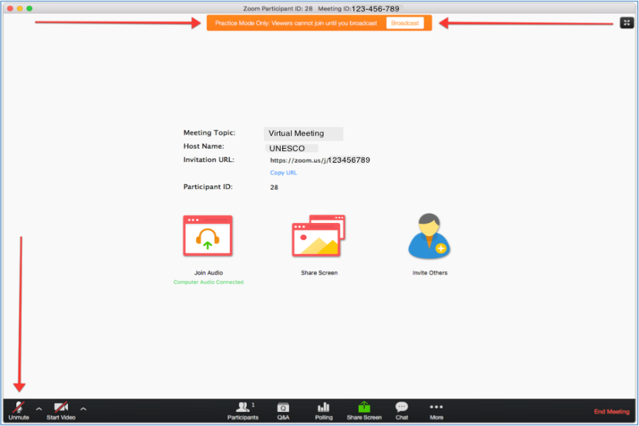You need to accept ‘Access the Microphone’ and ‘Access the Camera’. The microphone and video, which can be found in the bottom left corner are ‘on’ when there is no red line over them. Participants’ microphones should be kept on mute at all times except when called on by the Chairperson to give an intervention.
4. If you are encountering technical difficulties during the meeting, it is suggested that you first try exiting and re-entering the meeting or try connecting from a different browser. You may also contact the helpdesk whose contact details can be found below. Alternatively, you can send a message to [ICHmeetings@unesco.org](mailto:ICHmeetings@unesco.org).

**Helpdesk:** Ms Axoum Ho-kong-ciat ([al.ho-kong-ciat@unesco.org](mailto:al.ho-kong-ciat@unesco.org)); +33 1 45 68 21 40.

***Active participants***

1. The Zoom system can accommodate up to 500 active participants. Active participants may take the floor during the debate and intervene using camera/audio. All other participants may follow the online webcast on the event webpage. Delegations are invited to limit the number of simultaneous active connections on Zoom according to the following recommendations:

* States Parties: a maximum of two simultaneous active connections;
* States not party: a maximum of one simultaneous active connection;
* Category 2 Centres: a maximum of one simultaneous active connection;
* Accredited non-governmental organizations: each member of the Steering Committee of the ICH NGO Forum may receive one active connection. Other accredited NGOs may receive an active connection subject to availability.

***Naming of speakers***

1. All participants are required by the system to name themselves when they enter the meeting. It is suggested that participants use the format below for their names so that they can easily be identified by the Chairperson. Participants not using the following name formats will be asked to rename themselves by exiting and re-entering the meeting.

If you represent a State Party:

**SP-Country (Last name)**

If you represent a State not Party to the Convention:

**SNP-Country (Last name)**

If you represent an NGO:

**NGO-NGO Name (Last name)**

If you represent a category 2 centre:

**C2C-Centre Name (Last name)**

***Taking the floor***

1. Participants who have an active connection are able to request to take the floor by pressing the ‘raise hand’ button, which will display a hand beside the participant’s name. This button can be found at the bottom of the screen, after pressing the icon ‘Reactions’.

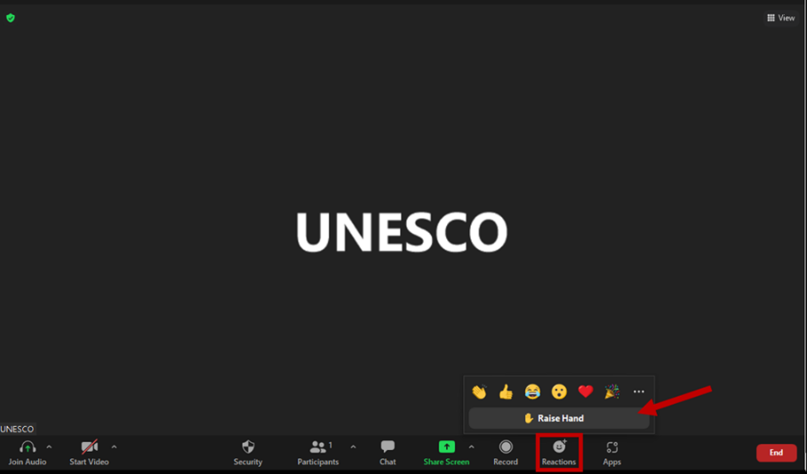

Once the hand raised, it will signal to the Chairperson that the participant would like to take the floor and they will be added to the list of speakers. When the Chairperson calls on a participant to take the floor, they should unmute their microphone using the microphone button in the bottom left corner. Ideally, as long as the internet connection allows, participants should also use their video. After the participant has finished their intervention, they should put their microphone on mute again to avoid background noise.

***Chat box***

1. The chat box is located at the bottom right hand corner of your screen. It can be used to signal a technical problem to the Secretariat. It can also be used by participants wishing to signal a **point of order**. In this case, the participant should raise their hand to indicate they wish to speak and type ‘Point of order’ in the chat box. The chat box should not be used for submitting amendments. These should be submitted by email to: ICH-amendments@unesco.org.