CONVENTION FOR THE SAFEGUARDING OF THE
INTANGIBLE CULTURAL HERITAGE
INTERGOVERNMENTAL COMMITTEE FOR THE
SAFEGUARDING OF THE INTANGIBLE CULTURAL HERITAGE
Sixteenth session
Online
13 to 18 December 2021
Item 13 of the Provisional Agenda:
Draft plan for the use of the resources of the
Intangible Cultural Heritage Fund in 2022 – 2023
Summary
Part I of this document examines the use of the Intangible Cultural Heritage Fund during the 2020–2021 period. Part II presents a draft plan for the use of the resources of the Intangible Cultural Heritage Fund for the period 1 January 2022 to 31 December 2023 and the first semester of 2024, to be submitted to the General Assembly for its approval.
Decision required: paragraph 35

- Article 7(c) of the Convention requests that the Committee ‘prepare and submit to the General Assembly for approval a draft plan for the use of the resources of the [Intangible Cultural Heritage] Fund [Special Account]’ (hereafter ‘the Fund’). Article 25.4 of the Convention further provides that the use of the resources of the Fund by the Committee ‘shall be decided on the basis of guidelines laid down by the General Assembly’. Those guidelines were adopted by the General Assembly of the States Parties in its second session in 2008 and can be found in Chapter II.1 of the Operational Directives for the implementation of the Convention. The draft plan proposed as annexed to this document was prepared in conformity with those guidelines on the basis of the 2020–2021 plan.
- The General Assembly of the States Parties to the Convention meets in ordinary session in even years, about six months after the start of UNESCO’s financial period. At its ninth session in June 2022, the General Assembly will therefore be requested to approve a draft plan for the use of the resources of the Fund that covers twenty-four months, from 1 January 2022 to 31 December 2023, and, on a provisional basis, the first six months of the following financial period, i.e. from 1 January 2024 to 30 June 2024, preceding the tenth session of the General Assembly. The provisional budget for the first semester of 2022 that was adopted by the eighth session of the General Assembly (Resolution 8.GA 7) will in turn be superseded by the present plan once it has been adopted by the ninth session of the General Assembly.
- The total amount of funds available for the next financial period cannot be known until early 2022, after the closure of the 2021 accounts. The budget presented in the draft plan (Annex) is thus expressed in percentages of the total amount that will be available. The document to be submitted to the General Assembly will specify the amounts allocated for each purpose. As was the case in the current plan, the Committee may wish to propose provisionally allocating to the first semester of 2024 one fourth of the amount established for the two-year period from 1 January 2022 to 31 December 2023. It is therefore proposed that the Committee submit to the General Assembly an expenditure plan based on the total amount of unrestricted and unencumbered funds available as of 31 December 2021, which is estimated to be approximately US$7.7 million.
- The present document first provides an overview of the status of the Fund and of current trends (Part I). In the second part (Part II), the document presents the proposed draft plan for the use of the resources of the Fund for the period 2022–2023.

STATUS AND TRENDS
- Based on the financial report included in document LHE/21/16.COM/INF.13.1 for the period 1 January 2020 to 30 June 2021 and following the analysis of trends outlined in document LHE/19/14.COM/7 Rev.2, this section describes the evolution of the income and expenditures of the Fund until 30 June 2021.
- During the 2020–2021 biennium, income increased by 16% compared to the previous biennium for the same period. While the interest credited to the Fund has decreased from US$372,949 to US$184,853, voluntary supplementary contributions increased, representing a total amount of US$757,268 (against US$77,772 in the previous biennium for the same period).
- Meanwhile, the expenditure rate of the latest plan approved by the General Assembly is on the decrease (32.4% as of 30 June 2021) with another six months still remaining in the current biennium. According to the latest forecast, the expenditure rate at the end of the biennium should reach 61% despite the impact of the COVID-19 pandemic. While this would represent a slight decrease compared with the previous biennium (63% expenditure rate in the 2018-2019 biennium) this forecast rate remains higher than the average expenditure rate of the Fund since 2010 (47% on average between 2010 and 2019).
- The graph below (Figure 1) shows that during the current biennium, the expenditures have decreased compared to the previous biennium 2018–2019, which is largely linked to the effects of the COVID-19 pandemic, the operations of the Secretariat, as well as those of the States Parties worldwide, having been significantly impacted during the reporting period. The global health crisis led to the delay or postponement of several activities initially planned under budget line 3 (‘other functions of the Committee’) and the switch to an online format of all statutory meetings of the Committee (15.COM) and the Evaluation Body between March 2020 and October 2021, which means that budget lines allocated to cover the travel costs of participants (budget lines 4, 5 and 6) remained almost untouched.
- The Secretariat’s forecast indicates that the expenditure rate should surpass 60% by the end of the biennium with the establishment of new contracts covering the implementation of International Assistance projects, the reprogramming of several activities under the ‘other functions of the Committee’ and the planned organization of an in presentia sixteenth session of the Committee in December 2021. As a result, the overall approved budget is expected to remain relatively stable for the 41 C/5 biennium (2022–2023) with a planned budget of US$7.7 million (against US$7.8 million for the present biennium).
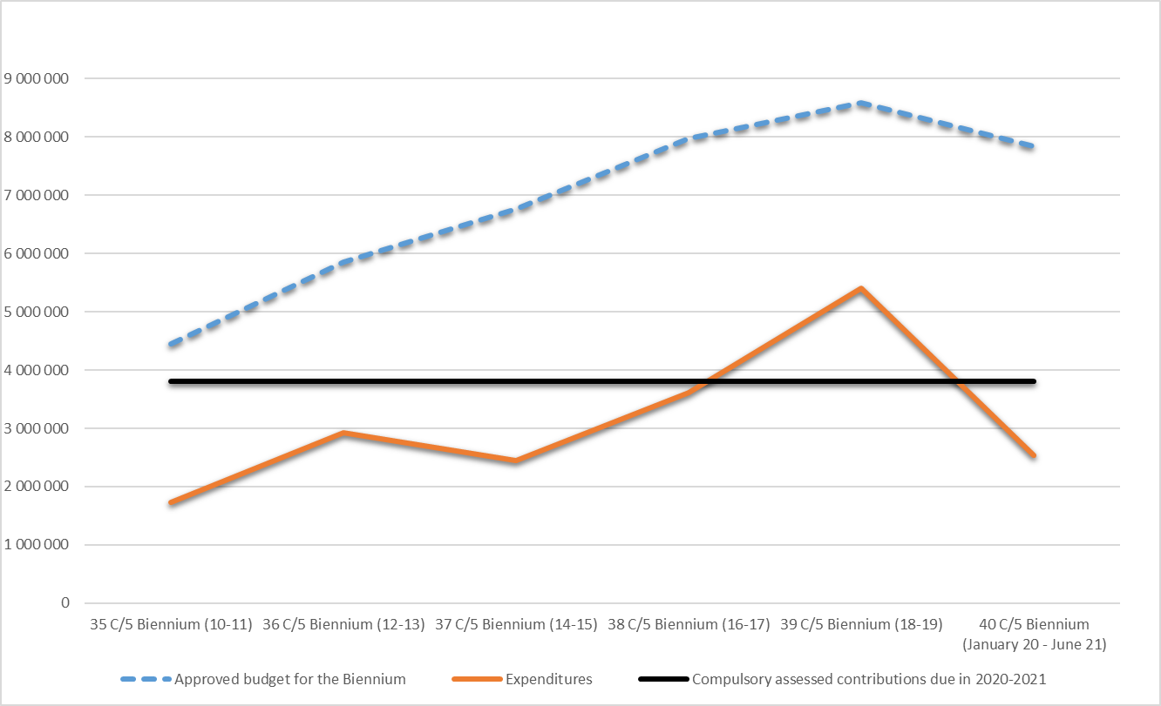
Figure 1: Evolution of expenditures of the Fund
- It should be recalled that the payment of contributions is an obligation incumbent on all States Parties that have ratified the Convention, in accordance with Article 26 of the Convention. As States Parties exercise rights and enjoy benefits conferred on them under the Convention, they are also expected to fulfil their corresponding commitments in return. It is worth noting that the lack of cash availability caused by late payments of assessed contributions might delay and thus jeopardize the implementation of activities foreseen in the budget.
- With regards to the compulsory assessed contributions by States Parties to be paid in accordance with Article 26.1 of the Convention, the evolution of the payment of assessed compulsory contributions in the past six years shows a continuous trend of unpaid contributions representing the equivalent of around 19% of the amount assessed each year. As of 30 June 2021, the unpaid contributions represent US$1.40 million (against US$1.43 million on 30 June 2019), US$355,509 of which correspond to unpaid contributions of previous years. As of 30 June 2021, 115 States Parties (66%) have not yet paid their contribution for 2021. Amongst them, 56 States Parties (32%) have also not paid their contribution for 2020 and preceding years (see Statement of Assessed contributions as at 30 June 2021).
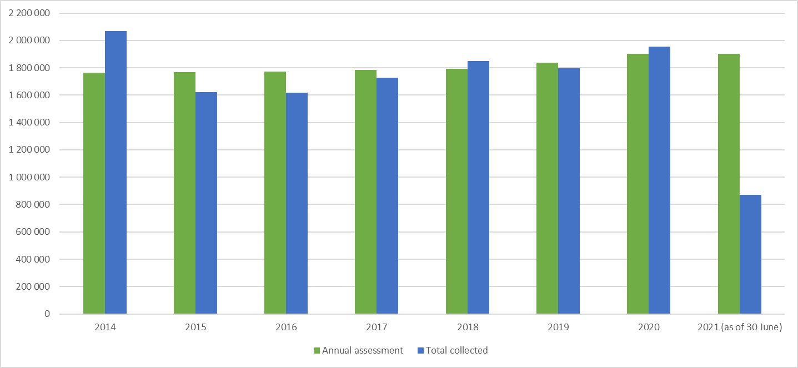
Figure 2: Evolution of assessed compulsory contributions
- The payments of voluntary assessed contributions by States Parties in accordance with Article 26.2 of the Convention, for the 18 months of the biennium 2020-2021 was 73%, which is higher in comparison to the past three full biennia (63% on average).
- Figure 3 (below) shows a decrease in the use of funds dedicated to International Assistance, corresponding to budget lines 1, 1.1 and 2 compared to the same period in the previous biennium. During the 40 C/5 biennium (2020-2021), the expenditure rate for these lines represents 32% compared to 43% for the period from 1 January 2018 to 30 June 2019 and 52% for the entire 2018–2019 biennium. This decrease is largely due to the lower number of International Assistance requests submitted by States Parties since January 2020 (twenty-seven requests registered and treated by the Secretariat during the reporting period against forty-eight in the 2018–2019 biennium). As of 30 June 2021, the expenditure rate for International Assistance reached 25.4% and is expected to rise to 57% by the end of the present biennium, with the establishment of thirteen contracts associated with requests already approved by the Committee and the Bureau. This is comparable to the average expenditure rate in previous years (around 61%). A detailed report on the progress of the implementation of the funds dedicated to International Assistance can be found in document LHE/20/16.COM/7.d.
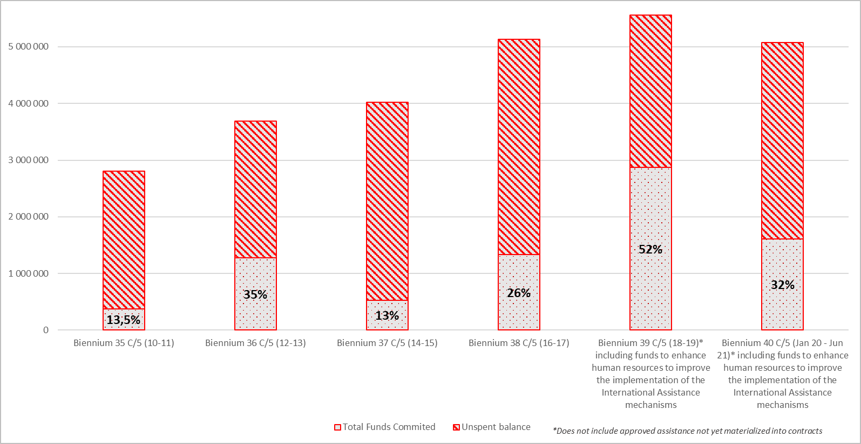
Figure 3: Expenditure rate: International and Preparatory Assistance

PROPOSED DRAFT PLAN FOR THE USE OF THE RESOURCES OF THE INTANGIBLE CULTURAL HERITAGE FUND FOR THE PERIOD 2022–2023
- The draft plan proposed below is based on an estimated total budget of approximately US$7.7 million corresponding to the amount forecasted as available as of 31 December 2021. As the overall budget of the Plan is expected to remain stable, only a few adjustments are proposed in the use of funds and its distribution between the different budget lines as follows:
- An increase of budget lines 2 (Preparatory Assistance) from 2% to 2.6% and 7 (Advisory services to the Committee) from 6% to 7.7% in order to foresee the potential additional costs that may be incurred in the implementation of the outcomes from the global reflection on the listing mechanisms of the 2003 Convention (document LHE/21/16.COM/14), should the newly proposed procedures for the transfer, removal and inscriptions on an extended/reduced basis of inscribed elements be endorsed by the Committee at the present session and the General Assembly in 2022 (see paragraphs 19 and 33). This increase is offset by a 1.96% decrease of budget line 1 (International Assistance) and a 0.79% decrease of budget line 1.1 (Human resources to improve the International Assistance mechanisms);
- Taking into account the findings from the evaluation by the Internal Oversight Service (IOS) of UNESCO’s action in the framework of the 2003 Convention for the Safeguarding of the Intangible Cultural Heritage (document LHE/21/16.COM/INF.10, hereafter referred to as the ‘IOS evaluation’), it is proposed to use part of the funds under budget line 1 to cover the monitoring and evaluation costs of projects, in order to better support States Parties in the implementation of safeguarding programmes and to measure the contribution of International Assistance projects to national safeguarding efforts.
International Assistance
- In line with the priorities set by the Guidelines for the use of the resources of the Fund in Chapter II.1 of the Operational Directives, it is proposed that the majority of the resources (62.6%) be allocated to providing International Assistance to States Parties to supplement their national efforts to safeguard intangible cultural heritage (budget lines 1, 1.1 and 2).
- Funds allocated to budget line 1 (50%) are foreseen for the support to States, through the International Assistance mechanisms, in the safeguarding of heritage inscribed on the List of Intangible Cultural Heritage in Need of Urgent Safeguarding, the preparation of inventories and other safeguarding programmes and projects. Although the number of requests has decreased during the previous biennium (see paragraph 13), it is important to maintain the allocation of budget line 1 at a high level to enable States Parties to strengthen their safeguarding efforts. Emphasis will be placed during the next biennium on promoting the International Assistance mechanisms and improving access to the Fund.
- Noting that the projects supported by the Intangible Cultural Heritage Fund through the International Assistance mechanisms benefit from ‘a relatively low level of monitoring and evaluation overall’, the IOS evaluation recommended strengthening the quality of project design, monitoring and outcomes reporting (IOS Recommendation 6) and promoting the ‘provision of relevant guidelines and tools for the design, implementation and reporting on projects’ (IOS Recommendation 5). While the creation of the Safeguarding Implementation and Monitoring team in 2018 provided human resources to manage the International Assistance mechanisms, monitoring and evaluating individual projects require significant resources for the Secretariat and the Field Offices involved in the implementation of projects concerned and would benefit in some cases from the assistance of external experts, in particular to provide an independent evaluation of projects. To this end, the Committee may wish to authorize, on an experimental basis, the use of funds under budget line 1 in an amount not exceeding 10% of the approved budget of each approved International Assistance project, to finance the provision of expertise, as described in Article 21 of the Convention, for monitoring and evaluating ongoing and recently completed International Assistance projects. These additional funds, separate from the grants allocated to the beneficiaries, would be dedicated to the evaluation and monitoring of projects and would be managed directly by the Secretariat. Monitoring and evaluation actions will be carried out using the methodologies that will be developed in the framework of the International Assistance monitoring strategy and may take the form of monitoring missions and contracts with individual experts to be planned in cooperation with the State Party concerned and according to the needs and requirements of each project.
- At its seventh session in June 2018, the General Assembly approved the creation of three extra-budgetary fixed-term posts (Resolution 7.GA 8) to form a dedicated team to operationalize the implementation of the International Assistance mechanisms (Safeguarding Implementation and Monitoring team). Some 10% of the resources of the Fund are proposed to be allocated to cover the costs of these three posts (budget line 1.1).
- Furthermore, it is proposed that 2.6% of the funds be budgeted for granting preparatory assistance (budget line 2), which represents a slight increase compared with the present biennium (2%). In addition to preparatory assistance for nomination files, this budget line covers the costs incurred for the provision of technical assistance to States Parties for preparing International Assistance requests. Through the present Plan, it is proposed that budget line 2 also be used to grant preparatory assistance for requests for the transfer of inscribed elements between the two Lists of the Convention, as well as for inscriptions of elements on an extended or reduced basis.
- This relates to the recommendation of the Open-ended intergovernmental working group in the framework of the global reflection on the listing mechanisms of the 2003 Convention as regards the introduction of specific procedures for the transfer of inscribed elements between the two Lists of the Convention, as well as for inscriptions of elements on an extended or reduced basis (see paragraphs 5, 7 and 8 in document LHE/21/16.COM WG/Recommendations). As part of the proposed procedures which the present session of the Committee is asked to examine (document LHE/21/16.COM/14), States Parties and the communities concerned would be offered the possibility to request expert advice prior to the possible submission of a request for transfer or for an inscription on an extended/reduced basis (‘pre-submission actions’). On the basis of a letter from the State Party seeking assistance, the Secretariat could arrange for the provision of expertise, as described in Article 21 of the Convention, to assist the State and communities in developing such a request. Should the Committee and the General Assembly endorse this possibility for ‘assistance to pre-submission actions’, the proposed increased allocation from 2% to 2.6% would allow the provision of such an assistance for an initial number of requests that the Secretariat may receive during the 2022–2023 biennium, after the ninth session of the General Assembly.
‘Other functions of the Committee’
- Budget line 3 (‘other functions of the Committee’) will be maintained at 20% in order to strengthen the work initiated during the current biennium, taking into consideration the recommendations made by the IOS evaluation. Such functions are listed under Article 7 of the Convention, and the Secretariat makes use of these funds to assist the Committee in performing these functions, as required by Article 10 of the Convention. In other words, these funds will primarily be used for upstream and cross-cutting actions aiming to promote the objectives of the Convention and encourage and monitor its implementation (Article 7[a]), as well as provide guidance on measures for the safeguarding of intangible cultural heritage (Article 7[b]).
- At its fourteenth session in 2019, the Committee introduced a new approval procedure for the spending plan under budget line 3 (Decision 14.COM 7). In accordance with this Decision, the proposed Plan presented to the Committee includes a percentage breakdown under budget line 3 in terms of Expected Results (ERs) as per the approved C/5, with a view to presenting it for approval by the following session of the General Assembly. Continuing with the approach of the previous biennium, the proposed Expected Results are aligned with the performance indicators defined in the approved 40 C/5 for the Major Programme IV Culture, Main Line of Action 2, Expected Result 6 ‘Intangible cultural heritage identified and safeguarded by Member States and communities, in particular through the effective implementation of the 2003 Convention’. The budget proposed for the current biennium aims to balance the allocation between the different ERs:
Expected Result | 2020−2021 | 2022−2023
ER 1: Sound governance of the 2003 Convention facilitated by enhanced monitoring and knowledge management services | 27% | 25%
ER 2: Implementation of the Convention in Member States encouraged through a strengthened capacity-building programme | 33% | 33%
ER 3: Integration of intangible cultural heritage into development plans, policies and programmes supported | 13% | 19%
ER 4: Objectives of the Convention promoted through awareness-raising and outreach | 27% | 23%

- In line with the previous decisions of the Committee (most recently Decision 14.COM 7), it is proposed that the Committee authorize the Secretariat to make transfers between Expected Results within budget line 3. In accordance with 40 C/Resolution 101 adopted by the General Conference at its fortieth session in November 2019, authorizing the Director-General to make transfers between appropriation lines of UNESCO’s regular programme up to an amount of 5% of the initial appropriation under the 40 C/5, the draft decision proposes correspondingly that such transfers may be made up to a cumulative amount equivalent to 5% of the initial total allocation likely to be proposed for this purpose to the General Assembly. The Secretariat would inform the Committee in writing, at the session following such action, of the details and reasons for these transfers; any transfers larger than that amount would require the Committee’s prior approval of a revised spending plan.
Expected Result 1: Sound governance of the 2003 Convention facilitated by enhanced monitoring and knowledge management services
- Providing adequate support to the Convention’s governing bodies and Member States remains key for the good governance of the Convention. In this regard, the IOS Evaluation underlined the importance of a solid knowledge strategy to leverage abundant quantities of information and recommended facilitating knowledge management on intangible cultural heritage and safeguarding measures (IOS Recommendation 10). Since the establishment of the Convention, a critical mass of information has been collected and the amount of data is increasing at a growing pace and intensity, due to the introduction of the Overall Results Framework and the reform of the periodic reporting mechanism, the increasing number of stakeholders involved, the high number of nominations submitted, the enhanced monitoring and evaluation of International Assistance projects or the initial results from the work on new thematic areas. In line with the IOS evaluation, the Secretariat will redefine its knowledge management strategy to streamline data production, improve its data analysis tools, ensure the usefulness of the information collected for safeguarding and facilitate access to such information through user-friendly and open formats. This new strategy could also provide more space for information emanating from partners such as category 2 centres, accredited NGOs, UNESCO Chairs and national institutions, in particular about their operational activities, safeguarding practices and research.
- Responding to the recommendation from IOS to tackle priority thematic areas (IOS Recommendation 3), the Secretariat intends to continue its work on the economic aspects of living heritage based on the ongoing work initiated during the present biennium on the safeguarding measures and good practices that address the risk of decontextualization and over-commercialization of elements. Thematic work will be extended to other areas such as climate change or intangible cultural heritage in urban planning. Furthermore, building on the increased operationalization of the International Assistance mechanisms over the past few years, the Secretariat will enhance the monitoring of the projects funded by the Fund and gather lessons learned from ongoing and completed projects. This will be achieved with the development of a monitoring strategy aiming at assessing the outcomes of International Assistance projects and their impacts on the safeguarding of living heritage. Efforts will also focus on developing communication tools to promote International Assistance, so as to encourage the submission of requests.
Expected Result 2: Implementation of the Convention in Member States encouraged through a strengthened capacity-building programme
- The success and central role of the global capacity-building programme for the implementation of the Convention was positively highlighted in the IOS evaluation, noting that while demand continues to grow, the context and needs are evolving, which requires strategic adaptation and programme development. The COVID-19 pandemic, in particular, created challenges for programme delivery, but also provided new opportunities for digital learning, consultation, and networking. At the same time, an increased awareness of the important role of intangible cultural heritage safeguarding in responding to socio-development challenges has resulted in evolving capacity-building needs in a wider range of policy and thematic areas with new audiences.
- The Secretariat will focus on strengthening the regional scope and thematic expertise of its facilitators’ network, while adapting its programme approach to new online and hybrid modalities and reaching out to new audiences (IOS Recommendations 8 and 9). It will map the existing capacities and needs of the network, utilize technology and social media platforms to support networking, and provide opportunities for new membership. The Secretariat will pursue reorienting the Programme, combining online learning, in-person training and self-learning. This will involve materials adaptation and updating in core action areas of the Convention, tools development, and broadening the programme’s thematic scope in areas such as intangible cultural heritage and commercialization and intangible cultural heritage and urban planning. The Secretariat will notably establish a Learning management system in close collaboration with the facilitators’ network and other partners, to allow users to easily create, manage and deliver training content for different modalities and contexts. Partnerships with category 2 centres, UNESCO Chairs, universities, NGOs and organizations active in the fields of culture and heritage will be strengthened.
Expected Result 3: Integration of intangible cultural heritage into development plans, policies and programmes supported⁷
- Some inroads have been made in developing methods and projects to incorporate living heritage in a wide range of formal and non-formal education programmes and settings since the establishment of the programme ‘Safeguarding intangible cultural heritage in formal and non-formal education’ in 2017, resulting in stronger appreciation of cultural diversity among participating youth, more confidence in teachers and a better understanding of the important role of intangible cultural heritage for quality education (SDG 4). Now it is time to scale up through a combined approach of strengthening inter-ministerial collaboration at all levels and bottom-up initiatives. This is the conclusion of the IOS evaluation which recommended that, as a next step, the Secretariat and UNESCO’s Education sector sharpen and reflect on the scope of the programme by using the proposed Theory of Change (IOS Recommendation 4).
- The Secretariat will organize this intersectoral reflection process jointly with the Education Sector, develop a common framework for the second phase of this programme and facilitate its utilization for project design, monitoring and reporting. Moreover, the Secretariat will develop relevant capacities, tools and methodologies with experts and actors that can be utilized in supporting countries in scaling up the programme at country level. Particular attention will be given to the development of innovative assessment methods to evaluate learning achievement in this new area and generate more robust data and analysis, which are required to advocate for the further integration of living heritage in education systems. Collaboration with relevant research and education institutions will be established for this purpose. The Secretariat will also facilitate knowledge-sharing and networking by further developing the online clearinghouse on living heritage and education to allow peer learning and the effective dissemination of the knowledge and tools generated. In addition, the Secretariat will continue strengthening intersectoral and inter-institutional collaboration for safeguarding living heritage in other development programmes, notably in the context of the International Decade on Indigenous Languages.
Expected Result 4: Objectives of the Convention promoted through awareness-raising and outreach⁶
- As defined in its Article 1, one of the main purposes of the Convention is to raise awareness about the importance of intangible cultural heritage and ensuring mutual appreciation thereof, while Article 14 highlights the role of awareness-raising as a safeguarding measure in itself. The Convention’s website is the backbone for disseminating information on the Convention and its implementation, from the work of governing bodies to projects and activities implemented at the national level. While it is a key repository of information for States representatives and experts, its current format and content focuses on statutory mechanisms and the website does not currently constitute the engaging communication tool it could be. Actions planned for the coming biennium will contribute to exploring new avenues for communication and outreach targeting the general public and youth in particular, as recommended by the IOS evaluation (IOS Recommendation 11). Beyond its alignment with UNESCO’s new graphic charter, the website will be restructured to better tell stories, provide thematic approaches, offer transversal navigations – in particular around Sustainable Development Goals – and highlight striking content such as data-visualization, high-quality photos and audio-visual materials depicting living heritage in action.
- Building on the successful experience of the platform on living heritage experiences and the COVID-19 pandemic launched in May 2020, the Secretariat will also reinforce the capacity of its website to serve as an exchange and communication platform, in particular building on the communication and outreach potential of its partners (category 2 centres, accredited NGOs, UNESCO Chairs and national institutions). To better reach out to youth, the Secretariat will also elaborate and implement a communication plan intensifying the usage of social media, using all possible channels and relays. Guidance tools will be developed to help States Parties establish communication strategies at the national level. Already envisaged for last biennium but delayed because of the pandemic, new initiatives will be undertaken to reach out beyond the usual audiences of the Convention and promote the presentation of living heritage within other major relevant international events linked to priority thematic areas (cities, climate change, environment). The transversal potential of ‘Dive into intangible cultural heritage!’ interfaces will be further exploited through physical and virtual exhibitions and electronic brochures will be prepared and organized around strategic themes.
Participation of experts in the meetings of the governing bodies
- The participation of experts in intangible cultural heritage representing developing States Parties in statutory meetings is covered either by budget line 4 when they are members of the Committee or by budget line 5 when they are not. The participation of experts representing accredited NGOs from developing countries in the sessions of the Committee is covered by budget line 6. It is proposed that 3.1%, 3.3% and 3.3%, respectively, be dedicated to the above-mentioned lines. While budget lines 5 and 6 remain unchanged, it is proposed that budget line 4 be slightly increased, to support the participation costs of experts in intangible cultural heritage representing developing States that are Members of the Committee in a potential extraordinary session of the Committee in the first half of 2022, as a result of the recommendations from the Open-ended intergovernmental working group in the framework of the global reflection on the listing mechanisms (see document LHE/21/16.COM/14).
Advisory services to the Committee
- Budget line 7 is proposed to be increased from 6% to 7.7% to cover the cost of the advisory services provided at the request of the Committee from January 2022 to December 2023, in particular those associated with the work of the Evaluation Body and of accredited NGOs. The 1.7% increase is proposed in light of the potential additional costs that may result from the global reflection on the listing mechanisms of the 2003 Convention based on the recommendations of the Open-ended intergovernmental working group (see paragraphs 5 to 8 in document LHE/21/16.COM WG/Recommendations), including the treatment, evaluation and examination of transfer requests of elements between the Lists and Register of the Convention, the inscription of elements on an extended or reduced basis and the follow-up of elements inscribed on the Lists of the Convention. Should the Committee and the General Assembly approve the abovementioned procedures, the proposed increased allocation would allow the treatment, evaluation and examination of an initial number of requests that the Secretariat may receive during the 2022–2023 biennium, after the ninth session of the General Assembly.
- At its eighth session, the General Assembly recommended that the Secretariat be authorized to make transfers between budget lines 4, 5, 6 and 7, for up to 30% of their initial total allocation (Resolution 8.GA 7). While no transfer has been necessary during the reporting period, since travel costs have been reduced dramatically due to the pandemic, the intention remains to make efficient use of the funds in accordance with the necessities of each cycle. Therefore, in order to be able to respond to as many requests for financial assistance as possible across the different categories of participants, it is proposed that the Committee recommend to the General Assembly to continue authorizing the Secretariat to make transfers between budget lines 4, 5, 6 and 7, up to an equivalent of 30% of their initial total. Should such a transfer be necessary, the Secretariat would be requested to inform the Committee and the General Assembly in writing, at the session following such action, of the details of and reasons for these transfers.
- The Committee may wish to adopt the following decision:
DRAFT DECISION 16.COM 13
The Committee,
- Having examined documents LHE/21/16.COM/13, LHE/21/16.COM/INF.13.1 and their respective annexes,
- Recalling Article 7(c) of the Convention, Resolution 8.GA 7 of the General Assembly and Decision 14.COM 7,
- Further recalling the UNESCO’s General Conference’s Appropriation resolution for 2020–2021 40 C/Resolution 101,
- Takes note of the statement of accounts of the Fund for 2020–2021 as of 30 June 2021, recalls that the payment of compulsory and assessed voluntary contributions is, per Article 26 of the Convention, an obligation incumbent on all States Parties which have ratified the Convention, and calls upon all States Parties which have not yet paid the totality of their assessed contributions for 2021 or previous years, including voluntary contributions, to ensure that their contributions are paid at the earliest opportunity;
- Further takes note that the draft plan for the use of the resources of the Fund takes into account the potential additional costs that may result from the global reflection on the listing mechanisms of the Convention;
- Decides to base the draft plan for the use of the resources of the Fund for the periods 1 January 2022 to 31 December 2023 and 1 January 2024 to 30 June 2024 on the total unrestricted operating reserves available as of 31 December 2021;
- Submits for approval to the ninth session of the General Assembly the draft plan for the use of the resources of the Fund, as included in the Annex of document LHE/21/16.COM/13, and proposes to the General Assembly that one fourth of the amount established for the two-year period from 1 January 2022 to 31 December 2023 be provisionally allocated to the first semester of 2024;
- Welcomes the proposed strengthening of the monitoring and evaluation of International Assistance projects in line with the IOS evaluation of UNESCO’s action in the framework of the Convention, authorizes the Secretariat, to this end, to use on an experimental basis an amount not exceeding 10% of the approved budget of each International Assistance project, in addition to the amount granted by the Committee or its Bureau for each project, to monitor and assess the impact of projects supported by the Fund, and requests the Secretariat to report on the use of funds for this purpose at its eighteenth session;
- Further authorizes the Secretariat, when utilizing the funds allocated under budget line 3 of the Plan, to make transfers between activities included within the specific proposals for budget line 3 up to a cumulative amount equivalent to 5% of the initial total allocation proposed to the General Assembly for this purpose, and further requests that, in such cases, the Secretariat inform the Committee in writing, at the session following such action, of the details of and reasons for these transfers;
- Recommends that the General Assembly authorize the Secretariat to make transfers between budget lines 4, 5, 6 and 7, up to an equivalent of 30% of their initial total allocation, and also requests that the Secretariat inform the Committee and the General Assembly in writing, at the session following such action, of the details of and reasons for these transfers.

ANNEX
Draft plan for the use of the resources of the Fund
For the period 1 January 2022 to 31 December 2023, as well as for the period 1 January to 30 June 2024, the resources of the Intangible Cultural Heritage Fund may be used for the following purposes: |  | % of the total amount proposed | 2020-2021  Plan
1. | International Assistance, comprising the safeguarding of the heritage inscribed on the List of Intangible Cultural Heritage in Need of Urgent Safeguarding, the preparation of inventories and support for other safeguarding programmes, projects and activities, including the monitoring and evaluation of requests approved; | 50.0% | 51.96%
1.1 | Enhancing human resources to improve the implementation of the International Assistance mechanisms through three extra-budgetary fixed-term posts (one P3, one P2 and one G5); | 10.0% | 10.79%
2. | Preparatory assistance for International Assistance requests, as well as for nomination files for the Urgent Safeguarding List, for proposals for the Register of Good Safeguarding Practices, for the transfer of elements between the Lists and Register of the Convention and for the inscription of elements on an extended or reduced basis; | 2.6% | 2.00%
3. | Other functions of the Committee, as described in Article 7 of the Convention, aimed at promoting the objectives of the Convention and encouraging and monitoring its implementation, in particular by strengthening capacities to effectively safeguard intangible cultural heritage, raising awareness of the importance of such heritage, providing guidance on good safeguarding practices and updating and publishing the Lists and the Register of Good Safeguarding Practices: | 20.0% | 20.00%
 | ER 1: Sound governance of the 2003 Convention facilitated by enhanced monitoring and knowledge management services; | 5.0% | 5.4%
 |  | (25% of line 3) | (27% of line 3)
 | ER 2: Implementation of the Convention in Member States encouraged through a strengthened capacity-building programme; | 6.6% | 6.6%
 |  | (33% of line 3) | (33% of line 3)
 | ER 3: Integration of intangible cultural heritage into development plans, policies and programmes supported; | 3.7% | 2.6%
 |  | (19% of line 3) | (13% of line 3)
 | ER 4: Objectives of the Convention promoted through awareness-raising and outreach; | 4.7% | 5.4%
 |  | (23% of line 3) | (27% of line 3)
4. | Participation in the sessions of the Committee, its Bureau and subsidiary bodies of experts in intangible cultural heritage representing developing States that are Members of the Committee; | 3.1% | 2.63%
5. | Participation in the sessions of the Committee and its consultative bodies of experts in intangible cultural heritage representing developing States that are Parties to the Convention but not Members of the Committee; | 3.3% | 3.31%
6. | Participation in the sessions of the Committee, its Bureau and consultative bodies of public or private bodies, private persons, notably members of communities and groups, that have been invited by the Committee to advise it on specific matters, as well as experts in intangible cultural heritage representing accredited NGOs from developing countries; | 3.3% | 3.31%
7. | The costs of advisory services to be provided at the request of the Committee, including support to developing States whose representatives have been appointed to the Evaluation Body, the transfer of elements between the Lists and Register of the Convention, the inscription of elements on an extended or reduced basis and the follow-up of elements inscribed on the Lists of the Convention. | 7.7% | 6.00%
 | TOTAL | 100% | 100%
Funds that have not been committed at the end of the period of this Plan are carried over to the next financial period and shall be allocated in accordance with the Plan approved by the General Assembly at that time.

. This estimate is based on the Fund balance as of 30 June 2021 (excluding the Reserve Fund of US$1,000,000) and does not take into account assessed contributions due for the 41 C/5.
. The latest Statement of compulsory contributions is available on the following webpage: https://ich.unesco.org/en/ich-fund-00816.
The UNESCO Evaluation Policy recommends that 5% of programme expenditure be earmarked for evaluation. The cost of an evaluation may vary from US$5,000 to US$10,000 for each project, depending on its scale (up to or higher than US$100,000) and duration. Based on this guidance, it is estimated that monitoring actions may also correspond to 5% of a project budget.
. ‘Preparatory assistance’ corresponds to the assistance that States Parties can request for developing nominations to the List of Intangible Cultural Heritage in Need of Urgent Safeguarding or proposals for the Register of Good Safeguarding Practices (paragraph 21 of the Operational Directives). ‘Technical assistance’ refers to the provision of experts, as described in Article 21 of the Convention, to States Parties wishing to develop requests for International Assistance (Decision 8.COM 7.c).
. The breakdown by expected result for 2020-2021 was approved by the General Assembly in 2020 (Resolution 8.GA 7).
. The proposed Expected Results 1 and 4 are aligned with the proposed performance indicator 2 entitled ‘Number of Member States sustainably safeguarding living heritage through enhanced international cooperation and assistance mechanisms of the 2003 Convention for the Safeguarding of the Intangible Cultural Heritage’ as defined in the Draft 41 C/5 for OUTPUT 5.CLT4 ‘Member States and communities capacities strengthened to identify, safeguard and promote living heritage’.
. The proposed Expected Results 2 and 3 are aligned with the proposed performance indicator 1 entitled ‘Number of Member States with new or revised policies, strategies and programmes to safeguard living heritage, including within sustainable development plans and frameworks, in line with the 2003 Convention for the Safeguarding of the Intangible Cultural Heritage’ as defined in the Draft 41 C/5 for OUTPUT 5.CLT4 ‘Member States and communities capacities strengthened to identify, safeguard and promote living heritage’.
. In the event that no extraordinary session of the Committee is held during the biennium, funds remaining on budget line 4 could be transferred to budget lines 5 and/or 6 as required, if the General Assembly maintains its authorization to make transfers between budget lines 4, 5, 6 and 7 (see paragraph 34).

