CONVENTION FOR THE SAFEGUARDING OF THE
INTANGIBLE CULTURAL HERITAGE
INTERGOVERNMENTAL COMMITTEE FOR THE
SAFEGUARDING OF THE INTANGIBLE CULTURAL HERITAGE
Sixteenth session
Online
13 to 18 December 2021
Item 5.b of the Provisional Agenda:
Report by the Secretariat on its activities
(January 2020 to June 2021)
Summary
This document provides an overview of the activities undertaken by the Secretariat of the 2003 Convention from 1 January 2020 to 30 June 2021, including the response to the COVID-19 pandemic.
Decision required: paragraph 42

- Introduction
- The present report focuses on the work of the Secretariat of the 2003 Convention from January 2020 to June 2021 and follows the report presented by the Secretariat to the eighth session of the General Assembly in September 2020, which covered the period from January 2018 to December 2019. The reporting period corresponds to the timeframe of the 40C/5 Approved programme and budget and would be aligned with UNESCO’s other main statutory reporting processes – namely the Director-General’s reports to the Executive Board on the execution of the programme adopted by the General Conference (EX/4) – as endorsed by UNESCO’s Executive Board at its 212th session (212 EX/SR.4).The report seeks to highlight a strategic overview of the Secretariat’s activities, its key achievements and challenges encountered. Annex I further demonstrates the contribution of the Secretariat’s work to the 40C/5 results framework and, more specifically, to the performance indicators of Expected Result 6 within Major Programme IV.
- The Living Heritage Entity serves as the Secretariat of the Convention. It is structured around two units and two teams: the Programme Management Unit (including the Statutory Support Team) and the Capacity Building and Heritage Policy Unit, as well as the Safeguarding, Implementation and Monitoring Team and the Knowledge Management and Outreach Team.
- As the outbreak and propagation of the COVID-19 pandemic marked the reporting period, the Secretariat strived to bring an adequate response to new challenges posed by the pandemic (see section II). In this context, the Secretariat’s core activities focused on four main axes: Governance of the 2003 Convention (see section III), the implementation of operational priorities on capacity building and intangible cultural heritage and education (see section IV), as well as communication and outreach (section V). In addition, the Secretariat endeavoured to initiate and reinforce thematic initiatives linking living heritage with sustainable development (section VI) and to strengthen synergies with UNESCO’s other normative instruments in the field of culture (section VII).
- Impact of and response to the COVID-19 pandemic
- Impact on the work of the Secretariat: The operations of the Secretariat for the implementation of the Convention have been and still remain significantly impacted by the pandemic. An interim report on measures taken by the Secretariat was presented to the General Assembly in 2020 (see document LHE/20/8.GA/6+Add.). This involved increasing technological support, developing new content, tools and interfaces adapted to online meetings and changing meeting modalities (in presentia, online, hybrid) at short notice. Also, most of the capacity-building events were scheduled to be cost-shared with host states, who quite naturally cancelled their planned cost sharing when events were no longer held in their country. This means that, overall, the adaptations due to the crisis and rescheduling of events did not result in any significant cost savings and in fact brought with them a significant increase in the workload of the Secretariat. Nevertheless, the Secretariat’s actions demonstrated that it is possible to adapt modalities and working methods, if planned carefully, and that new ways of working can point to new and interesting opportunities for carrying out activities under the Convention. The impact of the pandemic on specific meetings, activities and mechanisms, as well as remedial actions taken, are detailed in the appropriate sections of this report.
- Response to the pandemic: Across the organization, UNESCO mobilized the international community in promoting global solidarity through education, science, culture and communication and information in response to the world-wide COVID-19 crisis. The Living Heritage Entity actively participated in the Culture Sector task force that was formed and contributed to the immediate communication campaign launched and to the open access initiative, with the public release of all its capacity-building materials on the safeguarding of intangible cultural heritage.
- In April 2020, the Secretariat launched the online survey ‘Living heritage experiences in the context of the COVID-19 pandemic’, targeting practitioners and communities in line with the Convention’s emphasis on community participation. The aim was to look at the impact of the crisis on living heritage and its role in helping communities during the pandemic, by providing a platform for people to speak about their experiences, thus bringing community voices to the forefront. A wide range of cultural actors contributed, with more than 230 testimonies from seventy-eight countries, all accessible from a dedicated interface. As part of the UNESCO-wide response to COVID-19, preliminary findings from the survey were published in a ‘Spotlight on living heritage’ in the Culture & COVID: Impact & Response Tracker (Issue 4, 6 May 2020) and an article in World Heritage (no. 95); an online ResiliArt dialogue on the pandemic was organized during the eighth session of the General Assembly in September 2020.
- Published in May 2021, the UNESCO report ‘Living Heritage in the face of COVID-19’ presents in detail the outcomes of this survey. It demonstrates that the pandemic greatly impacted the living heritage of communities around the world. In many cases, communities adapted their practice of living heritage to specific contexts, highlighting the resilience of many forms of living heritage in complex situations. The practice of living heritage also proved to be an important means of resilience for people to overcome the social and psychological challenges they faced in the context of the pandemic and to maintain social interconnectedness. The report recommends to governments, civil society, the private sector and bearers three broad areas of action to prepare for the recovery phase and beyond: (a) strengthen direct support mechanisms to living heritage bearers; (b) leverage opportunities offered by digital technologies to support resilience and safeguarding; (c) integrate living heritage safeguarding into emergency preparedness, response and recovery plans (see Annex II).
- After consultation with Field Offices and national authorities, UNESCO decided to dedicate US$80,000 from UNESCO’s regular programme to pilot these recommendations through eight activities in Barbados, Plurinational State of Bolivia, Bosnia and Herzegovina, Colombia, Ecuador, Gambia, Indonesia, Jamaica, Saint Vincent and the Grenadines and Sint Maarten. Started in June 2021, these projects are already bringing concrete outputs, from the production of audio-visual materials explaining the impacts of the crisis in Bolivia, Colombia, Ecuador, and Sint Maarten, to workshops and virtual discussions between authorities and communities in Barbados and Bosnia and Herzegovina, to inventory fieldwork with communities in the Gambia to identify knowledge and know-how that could contribute to disaster risk reduction and crisis recovery.
- Governance of the Convention: Statutory support
- Meetings and mechanisms of the 2003 Convention: As noted by the IOS Evaluation (2021) of UNESCO’s action in the framework of the 2003 Convention for the Safeguarding of the Intangible Cultural Heritage (hereafter the ‘IOS Evaluation’), the Secretariat has provided substantial support for the work of the governing bodies of the Convention in taking a set of key decisions during fourteen statutory meetings organized notably for the General Assembly, the Committee, the Bureau of the Committee and the Evaluation Body, as well as information-sharing meetings on statutory matters and preparatory meetings organized specifically to discuss the organization of statutory meetings through online means. Adapting to the evolving health situation, statutory meetings were held through various modalities, thanks to which the statutory life of the Convention remained uninterrupted despite adverse circumstances: two in presentia meetings with social distancing measures (including the eighth session of the General Assembly), one in presentia meeting before the outbreak of the pandemic and eleven online meetings (including the fifteenth session of the Committee).
- The eighth session of the General Assembly in September 2020 and the fifteenth session of the Committee in December 2020 were instrumental in defining directions for the future development of the Convention. The General Assembly adopted Operational principles and modalities for safeguarding intangible cultural heritage in emergencies and introduced a dialogue process between the Evaluation Body and submitting States as part of the evaluation process. Meanwhile, the fifteenth session of the Committee, which examined a reduced number of items due to the online modality of the session, inscribed the highest number of multinational elements – fourteen – testifying to the ability of intangible cultural heritage to bring people together and promote international cooperation.
- Importantly, the biennium was marked by the continuation of the global reflection on the listing mechanisms of the Convention, initiated by the twelfth session of the Committee in 2017 with the support from Japan, with the organization of an online category VI meeting of experts in May 2021 and a two-part online meeting of the Open-ended intergovernmental working group in July and September 2021. Based on a survey addressed to more than 200 experts, recommendations from the thirty-four experts laid the ground for the Open-ended intergovernmental working group, which reflected on the nature and purposes of the listing mechanisms, the inscription criteria, the follow-up of inscribed elements and the methodology of evaluation. Recommendations from the Open-ended intergovernmental working group, which will be examined at the present session, constitute a landmark for the Convention, reinforcing the credibility of its listing mechanisms while underlining the continued importance of community participation throughout the process.
- In addition, the Secretariat undertook administrative tasks for the Evaluation Body to support it in its evaluation of the nomination files under the 2020 and 2021 cycles, while checking the technical completeness of nominations under the 2022 cycle. Furthermore, periodic reports, and accreditation and renewal requests from non-governmental organizations (NGOs) were processed during the given period. All these tasks were performed within the statutory requirements defined by the text of the Convention and its Operational Directives, while allowing some leniency given the circumstances surrounding the pandemic.
- Non-governmental organizations: Pursuant to the two-year reflection on the role of accredited non-governmental organizations, which was concluded by the General Assembly in 2020, the ICH NGO Forum and the Secretariat strengthened their collaboration by planning a mapping of the domains of competencies of accredited non-governmental organizations. Expected results from this exercise will contribute to identifying ways through which accredited NGOs would be in a position to provide advisory services to the Committee, while facilitating potential cooperation between accredited NGOs and States Parties at the national level.
- Knowledge management: Knowledge management services had a critical role to play to ensure the ‘business continuity’ of the Secretariat, but also for online mechanisms such as the evaluation of nominations or the completion of periodic reports. In 2020 and 2021, the Evaluation Body members were not able to meet in presentia, as they usually do, to confront their opinions and reach consensus over five days (six hours a day) which could have jeopardized their capacity to perform their tasks. A new online monitoring interface was developed to compensate for the reduced time and limited interactivity imposed by virtual meetings. Given its usefulness, this tool will be used for future cycles even if Evaluation Body members are able to meet in person. Furthermore, the ever-growing usage of the knowledge management system caused a strong pressure on the server and degraded performances at the end of 2020 and in early 2021. The application has since been optimized and was migrated to new servers in June 2021.
- International Assistance: The General Assembly approved, at its seventh session in June 2018, the creation of three fixed-term extrabudgetary posts, allowing for the creation of the Safeguarding Implementation and Monitoring team within the Secretariat, dedicated to the implementation of the International Assistance mechanisms. The team has been operational since October 2019. It aims to manage the mechanism holistically, facilitating access to the Fund for States Parties, assisting them in the submission of requests, supporting the implementation of projects and providing improved monitoring and impact assessment.
- Between January 2020 and June 2021, expenditures linked to International Assistance have reached US$1.6 million, while taking into account that the planned expenditure for the last semester of the biennium will bring expenditures up to the same level as in the previous biennium (around US$2.8 million). Eleven new projects were approved by the Committee and its Bureau, including five in Africa and three in Small Island Developing States (SIDS). It should however be noted that the number of requests submitted by States Parties decreased, from forty-eight requests registered and treated by the Secretariat in the 2018–2019 biennium to twenty-seven during the eighteen-month reporting period (see document LHE/21/16.COM/7.d). Taking into account the recently decreasing number of requests which is no doubt largely due to the impact of the pandemic, the Secretariat focused on analysing the current implementation of the International Assistance mechanisms and identifying challenges encountered by States and communities in the preparation of requests and the implementation of projects.
- Operational priorities on capacity-building and the integration of intangible cultural heritage in formal and non-formal education
- Capacity building: The Secretariat has undertaken capacity-building interventions in the widest sense since its inception in 2009, in 138 countries, including forty-five in Africa and thirty in Small Island Developing States (SIDS). Of these, fifty-two countries (eighteen in Africa) have benefited from long-term projects, and 114 countries have benefitted from short-term projects under the global capacity-building programme. Category 2 centres have supported forty-one countries. During the reporting period, the Programme initiated a strategic reorientation to include multi-modal delivery approaches to broaden access and delivery, particularly in response to the COVID-19 pandemic. This reorientation is in line with the IOS evaluation, which confirmed the centrality of the Programme and highlighted the need to adapt to evolving demands.
- The Secretariat furthermore strengthened its global network of facilitators, with fifty-five new trained members (54% women) from Asia and the Pacific, Africa, Europe and the Arab States, increasing the total to 103 facilitators (61% women). Other highlights include the creation of an interregional working group, the launch of a webinar series and an improved network’s webpage. Over 140 universities engaged in intangible cultural heritage were identified through regional surveys leading to network development in three regions. To offer effective training on gender-responsive approaches in the field of living heritage, materials were developed including a video animation and a policy note on gender equality and intangible cultural heritage. These tools, together with an online toolbox on living heritage and sustainable development and the ongoing development of a first massive online open course (MOOC) on the topic, further contribute to the 2030 Agenda for Sustainable Development.
- Following the reform of the periodic reporting mechanism adopted by the General Assembly in 2018, Latin America and the Caribbean was the first region to submit periodic reports under the new system. The move to a regional cycle of periodic reporting allowed enhanced and concerted efforts for capacity-building in the region. A comprehensive online training course on periodic reporting tailored to the needs of the region was implemented by the Secretariat, together with the Regional Centre for the Safeguarding of Intangible Cultural Heritage of Latin America (CRESPIAL) and facilitators from the global network of the Convention, in two languages (English and Spanish). This took the form of a series of online events over six weeks, from 19 May to 23 June 2020, combining weekly webinars, videos, reading materials and online forum sessions. A total of 100 participants, of which forty-seven focal points from thirty-two States Parties, as well as senior facilitators and UNESCO culture officers from the region, participated in this training. The Secretariat also provided additional support by organizing a wrap-up session for focal points in September 2020, followed by help desk assistance for technical and content-related issues in filling in the periodic reporting form. Nevertheless, taking into account the impact of the COVID-19 pandemic and in compliance with paragraph 152 of the Operational Directives, the Secretariat asked States concerned to initially submit their report using the online periodic reporting Form ICH-10 by the set statutory deadline and then gave the possibility to complete it by mid-March 2021. Twenty-eight out of thirty-two States Parties in the Latin America and Caribbean region (87.5 %) submitted their report, which represents the highest submission rate since the creation of the Convention.
- While the Programme has concentrated on strengthening capacity-building in the core areas of the Convention, it has further broadened its thematic expertise, such as disaster risk reduction, in line with the Operational principles and modalities for safeguarding intangible cultural heritage in emergencies. Since their adoption by the General Assembly in September 2020, the Secretariat has focused its activities on building capacities and raising awareness of their importance among relevant stakeholders. Online training workshops were undertaken in Honduras and the Philippines, thanks to support from Switzerland, to enhance the capacities of communities, national authorities and civil society organizations in the safeguarding of their living heritage in disaster-prone contexts. A capacity-building approach tailored to conflict situations, including forced displacement, is furthermore under development, with consultations ongoing to assess training needs.
- Intangible cultural heritage and education: Four years ago, the Secretariat, developed the programme on Safeguarding intangible cultural heritage in formal and non-formal education through consultation with the Education Sector, which the Committee adopted as a second funding priority for 2018–2021. Both sectors saw clear strategic advantages of promoting a broader approach to safeguarding that has the potential to reach communities while helping States meet their commitments under Sustainable Development Goal 4 (SDG 4). Since then, the Secretariat has successfully steered intersectoral cooperation at Headquarters and in field offices through joint projects and a global meeting (2019), and anchored the living heritage and education programme as an intersectoral priority area in UNESCO’s programme (40C/5 and draft 41C/5). Today, the role of living heritage and its importance for achieving SDG 4 for quality education is better understood and illustrated.
- Sixteen field offices have spearheaded projects and activities in more than fifty countries, integrating living heritage in school-based and non-formal education and building capacities of teachers and teacher educators. Three regions (Europe, Asia and the Pacific, Latin America and the Caribbean) generated knowledge about existing experiences through surveys. Fifteen projects were evaluated in the IOS evaluation with promising results: increased awareness of and respect for living heritage amongst youth and the wider community together with fostered identity, pride and appreciation for cultural diversity. Participating teachers developed capacities and confidence to integrate intangible cultural heritage in their teaching across all subjects, and the partnerships developed between communities, bearers and schools were considered one of the most rewarding features of the projects. There is now a need to scale up the projects to anchor them in education systems.
- At the global level, the Secretariat built new knowledge, in collaboration with the Education Sector, on the education-related indicators of the Overall Results Framework for the Convention and their relationship with SDG 4 (2020) through an expert meeting and a public webinar (2021). Furthermore, it developed an online training course on living heritage and education, resulting in a global learning network of forty resource persons equipped to provide training and advisory services on demand. Finally, to facilitate knowledge-sharing, cooperation and innovation, the Secretariat developed a clearinghouse on living heritage and education, which contains documentation of all the innovative projects carried out so far under the programme.
- Communication and outreach
- Building on the positive feedback – especially from youth – to the project ‘Dive into intangible cultural heritage’ launched at the end of 2019 with the support from the Netherlands, the Secretariat further improved the interface demonstrating the wide-ranging ways in which living heritage echoes sustainable development, and how more than 500 inscribed elements connect to Sustainable Development Goals. Released during the fifteenth session of the Committee in December 2020, this interface was featured on 21 May 2021 during the High-level event on Culture and Sustainable Development convened in New York by the President of the United Nations General Assembly.
- An effort was engaged in 2021 to provide more frequent, diversified and engaging content on the portal of the Convention. Initiatives were taken to better highlight thematic content, with the creation in 2020 of thematic pages dedicated to living heritage in emergency situations and living heritage and education. A series of news items related to International Days has been published to better connect living heritage initiatives to UN-wide communication efforts. The exhibition ‘Sounds of living heritage, a journey through indigenous languages,’ initially launched in 2019, is displayed in the halls of UNESCO Headquarters, ahead of the 2022–2032 International Decade of Indigenous Languages.
- Thematic initiatives
- In line with UNESCO’s Draft Medium-Term Strategy for 2022–2029 (41C/4), the Operational Directives of the Convention (Chapter VI) and the Committee’s Decision underlining the importance of highlighting the contributions of living heritage to sustainable development, the Secretariat initiated efforts in specific thematic areas to contribute to a holistic approach to heritage safeguarding and sustainable development. These efforts also respond to the concerns raised by stakeholders interviewed as part of the IOS evaluation and to IOS Recommendation 3 to intensify efforts in priority thematic areas.
- Intangible cultural heritage and climate change: An emerging area of concern is the relationship between intangible cultural heritage and climate change, including climate-induced disasters. To this end and in response to the Committee’s request to better highlight the links between intangible cultural heritage and environmental sustainability,⁹ the Secretariat initiated work with experts on the development of a concept note to consolidate existing knowledge with a view to developing a position paper on strengthening safeguarding practices in the context of climate change. The work is planned to be finalized in 2022 and will provide a basis for future work in this area.
- Intangible cultural heritage and commercialization: Pursuant to the Committee’s request to develop a guidance note on safeguarding measures and good practices addressing the risk of decontextualization and over-commercialization of intangible cultural heritage, the Secretariat started the analysis of related recommendations from the Evaluation Body, which will be included in the guidance note. Beyond the preparation of the guidance note for States and communities, work in this area will include literature research, the identification of experts, the development of case studies and the launch of a survey addressed to ‘focal points’ of the Convention at the national level and to contact persons associated with elements inscribed on the Lists of the Convention, so as to gather insights on the positive and negative effects of commercialization on the viability of living heritage, as well as identify measures to address these, in view of sharing good practices.
- Intangible cultural heritage in urban contexts: A third area of interest concerns the safeguarding of living heritage in urban planning and its contribution to the development of sustainable cities, in line with Sustainable Development Goal 11, and the impact of urbanization on its viability. In this regard, the Secretariat is currently developing a position paper based on the implementation of an extrabudgetary project funded by the private sector in China since 2018. As part of its second phase, two pilot projects were successfully implemented in the reporting period in Ayacucho (Peru) and Tbilisi (Georgia). Due to the health restrictions imposed by the COVID-19 pandemic, capacity-building workshops, community-based inventorying and awareness raising activities were adapted and implemented using hybrid formats. Concrete outputs include a Methodological guide for the preparation of inventories of intangible heritage in urban contexts (Peru) and the production of twenty-one short videos on living heritage in Old Tbilisi, which were disseminated through a dedicated online film festival (Georgia). From 2021 to 2022, two additional pilot projects are planned in Irbid (Jordan) and in China (city to be confirmed) before a wrap-up workshop in the first half of 2022.
- Synergies with other cultural conventions
- The Secretariat collaborated with the Secretariat of the 1954 Hague Convention and its two Protocols to prepare a reflection document on synergies in safeguarding intangible cultural heritage in emergency situations. The information document is brought to the attention of the Committee for the Protection of Cultural Property in the Event of Armed Conflict at its sixteenth meeting in December 2021. A proposed way forward in the immediate future is to build the capacities of these actors to operationalize the Operational principles and modalities for safeguarding intangible cultural heritage in emergencies and build awareness of their importance among relevant stakeholders.
- Linkages with the 1972 World Heritage Convention are particularly highlighted in operational projects implemented in the field. While only a partial overview can be provided given the large scope of projects, UNESCO initiatives, for instance, aim at promoting living heritage and developing cultural tourism at World Heritage properties (India, Delhi Office), inventorying intangible cultural heritage in urban contexts (Malaysia, Headquarters and Bangkok Office), sensitizing and training young professionals on tangible and intangible cultural heritage safeguarding in a project jointly implemented in Europe with the World Heritage Centre (Headquarters and Venice Office).
- The synergies with the 2005 Convention on the protection and promotion of the diversity of cultural expressions are similarly strengthened in the field, through projects focusing on the safeguarding of craftsmanship in the context of climate change (Morocco, Rabat Office), the development of rural craft and cultural hubs in West Bengal (India, Delhi Office) or in support of the transmission of musical know-how among young people (Morocco, Rabat Office).
- In 2021, the Secretariat participated in the sector-wide Working group on the establishment of model rules of procedure for the assemblies/conferences of parties to the UNESCO cultural conventions/protocol. Outcomes from these meetings were presented to the forty-first session of UNESCO’s General Conference.
- Key challenges and ways forward
- The eighteen-month reporting period has largely been marked by the COVID-19 pandemic, which put in stark relief the value of intangible cultural heritage and the importance communities attach to its continued practice and expression. The impact of the pandemic has been far-reaching, challenging communities in many ways and in virtually all regions of the world. While this impact has often and at first been negative, the crisis also demonstrated both the capacities of communities to adapt their practice of living heritage and to mobilize their heritage for their own resilience. Against this backdrop, the work of the governing bodies and of the Secretariat has been affected by the uncertainties around the various modalities through which stakeholders of the Convention could interact. While the crisis is still ongoing, it should be noted that the governing bodies of the Convention, statutory mechanisms and key operational initiatives of the Convention, supported by the Secretariat, continued without any interruption, preserving equity among decision-makers and the regional distribution of stakeholders involved, in line with the provisions of the Operational Directives. This proved that the statutory structure put in place was simultaneously solid enough to withstand the impact of the crisis and flexible enough to adapt to adverse circumstances. Innovative ways to maintain the possibility of working collaboratively were introduced and digital tools were developed, some of which offered new possibilities that could remain in place in a post-pandemic environment.
- The Convention continues developing and expanding its reach. As pointed out by the IOS evaluation, the implementation of the Convention ‘has gone through many reforms and transformations that have significantly strengthened the Organization’s support to Member States, partners and communities.’ However, while the development of the Convention is of course a positive sign for the increased awareness of intangible cultural heritage in different arenas, it also translates into an increased demand for UNESCO support to States Parties. Given the limited resources of the Secretariat, it is important to maintain a high-quality level of support to the governing bodies, States, and communities, in line with IOS Recommendation 1, ‘Strategic decisions on priorities, particularly on the need to focus on programme support versus statutory requirements and on use of its limited resources will need to be made in the near future.’
- Going forward, the follow-up to the global reflection on the listing mechanisms will constitute important interventions by the Secretariat. While the revisions to the Operational Directives that will be examined by the Committee at the present session (Item 14) are expected to reinforce the credibility of the listing mechanisms, the introduction of new procedures does not come without challenges for States, communities, the Evaluation Body and the Secretariat. One of the interesting outcomes of the reflection process also pertains to the recommendation of the Open-ended intergovernmental working group to reflect further on a broader application of Article 18 of the Convention and for which the support from Sweden has already been received. In addition, the continued operationalization of International Assistance mechanisms with a reinforced monitoring and evaluation system (Item 13) is also foreseen as a priority area of action in the next biennia.
- Demands for the capacity-building programme are still high and continue to exceed the delivery capacity. The emergence of the COVID-19 crisis and the related restrictions made particularly clear that the capacity-building programme needs to adapt, calling for creative and innovative ways for programme delivery in an online environment. The programme has successfully piloted new online and hybrid delivery formats. Building on the lessons learnt, the Secretariat intends to continue reorienting the programme to include a multimodal delivery approach, thus providing opportunities for expanding programme outreach to new audiences and harnessing innovative pedagogy, while ensuring cost-effectiveness. These efforts to support the capacity-building programme will be carried out in complement to actions aiming to facilitate the access of States Parties to the International Assistance from the Intangible Cultural Heritage Fund.
- Regarding the second funding priority on intangible cultural heritage and education, the IOS evaluation emphasized that, while some progress has been achieved through projects, it tends to be isolated and local. Scaling up with a more strategic focus on education systems is needed to promote a pedagogical shift and effectively feed results into the national discourse and advance the 2030 Agenda through education and culture. Based on the assessment and insights gained from substantive work carried out in related fields, such as intercultural education, indigenous education, education for sustainable development, and others, UNESCO will centre its efforts on further expanding and scaling up the intersectoral Programme for greater impact and sustainability.
- Planned communication and outreach activities were deeply affected by the COVID-19 pandemic, with efforts focusing on the dissemination of materials and the development of tools and interfaces to gather information and data, while facilitating communication among stakeholders. Moving forward, the Secretariat plans to explore new avenues for communication and outreach targeting the general public and youth in particular, as recommended by the IOS evaluation. Beyond its alignment with UNESCO’s new graphic charter, the website will be restructured to better tell stories, provide thematic approaches and reinforce the capacity of its website to serve as an exchange and communication platform, in particular building on the communication and outreach potential of its partners (category 2 centres, accredited NGOs, UNESCO Chairs and national institutions).
- Building on forays made into new thematic initiatives during the last biennium, in particular on the safeguarding of intangible cultural heritage and emergencies and on the integration of intangible cultural heritage into education, the Secretariat will intensify its efforts with the implementation of pilot operational activities, the development of capacity-building materials, and the strengthening of partnerships with the wider network of institutions and individuals associated with the Convention. Beyond these two themes, the work initiated during the reporting period on the economic aspects of intangible cultural heritage and on intangible cultural heritage in urban contexts will be continued and deepened, also calling upon the inputs from States Parties and communities associated with elements inscribed on the Lists of the Convention, with the idea to strengthen cooperation and information-sharing among communities facing similar issues. In all these endeavours, the Secretariat will be mindful of existing initiatives both within the Organization and outside, in order to bring intangible cultural heritage to the forefront of these cross-cutting issues in an effective and concerted manner.
- Notwithstanding the potential that these new developments and thematic initiatives represent, it is vital for the further development of the Convention that – as noted by the IOS evaluation in its Recommendation 1 – a decision be made on the priority areas in which the Secretariat should focus its efforts. Given the perduring constraints in terms of human and financial resources, the governing bodies of the Convention may find it timely to take stock of this situation, provide guidance and establish priorities for the coming years.
***
- The Committee may wish to adopt the following decision:
DRAFT DECISION 16.COM 5.b
The Committee,
- Having examined document LHE/21/16.COM/5.b Rev. and its annexes,
- Takes note of the far-reaching impacts of the COVID-19 pandemic on living heritage and on its bearers and practitioners, welcomes the recommendations to prepare for the recovery phase as described in the UNESCO report ‘Living Heritage in the face of COVID-19’, and encourages their implementation by States and communities, including through the International Assistance mechanisms of the Intangible Cultural Heritage Fund;
- Further takes note of the challenges posed by the global health crisis on the statutory mechanisms and programmes of the Convention, commends the Secretariat for taking the necessary measures to ensure that the governance of the Convention could be maintained, in line with the Convention and its Operational Directives and appreciates the implementation of the various outreach and communications initiatives, in particular those launched in the context of the wider response to the COVID-19 pandemic;
- Highlights the achievements made in the geographical and thematic expansion of the global capacity-building programme since its inception and welcomes its ongoing reorientation to adapt to the need for multi-modal delivery approaches and to strengthen partnerships in the delivery and management of the programme;
- Further appreciates the progress made in the implementation of the funding priority ‘safeguarding and transmission of intangible cultural heritage through formal and non-formal education’ and underlines the importance of strengthening intersectoral collaboration for greater impact;
- Further commends the Secretariat for initiating and continuing thematic initiatives such as intangible cultural heritage and climate change, commercialization, education and urban contexts, underlines the importance of ensuring synergies with UNESCO’s cultural conventions and other relevant programmes in that regard, and invites the Secretariat to pursue its efforts;
- Requests that the Secretariat prepares information on its main activities, with cost implications and workload-related issues, for examination by the seventeenth session of the Committee, who may take stock of the situation, provide guidance and establish priorities.
Annex I
Assessment by performance indicator
40C/5 Performance Indicator 1 | Sound governance exercised through the adoption and implementation of strategic resolutions/decisions of the governing bodies of the 2003 Convention.
Assessed according to the following: | Baselines | Targets 2020-2021 | Assessment of progress:  01/01/2020 to 30/06/2021
- Strengthened ability to provide strategic guidance to States Parties for the implementation and monitoring of the Convention, including through examination of submitted periodic reports  - Working methods of the governing bodies improved  - Level of funding to the implementation of decisions adopted by the governing bodies  - Level of contribution of non-governmental organizations with recognized competence in the field of intangible cultural heritage to the Convention’s governance | - Yes | - Yes | - Working methods and tools of the Convention’s governing bodies and evaluation bodies adapted to online modalities, and knowledge management services optimized to ensure the continuity of statutory mechanisms and meetings.  - Operational principles and modalities for the safeguarding of intangible cultural heritage in emergencies adopted.  - Dialogue process between the Evaluation Body and submitting States – in the form of a short question-and-answer – introduced in the evaluation procedure and timetable of nominations, proposals and requests and related revisions to the Operational Directives adopted. The dialogue process was carried out for 11 files in 2020 and 15 files in 2021.  - 62 nomination files from 62 States were newly submitted for the 2020 cycle; 74 files from 81 States were newly submitted for the 2021 cycle; and 59 nomination files from 64 States were newly submitted for the 2022 cycle.  - 14 statutory meetings organized.  - First regional cycle in the reformed periodic reporting mechanism initiated for States Parties in Latin America and the Caribbean (87.5% of periodic reports submitted in 2020). 9 reports examined on the status of elements inscribed on the Urgent Safeguarding List in 2020.  - Standalone item on the ‘Report of the non-governmental organizations forum’ included for the first time in the agenda of the Committee in 2020 (15.COM).  - 46 new accreditation requests processed for non-governmental organizations and 65 reports registered for renewal of accreditation.  - 8 proposals processed for the establishment or renewal of UNESCO Chairs in the field of intangible cultural heritage.
40C/5 Performance Indicator 2 | Number of supported Member States utilizing strengthened human and institutional resources for the safeguarding of intangible cultural heritage
Assessed according to the following: | Baselines | Targets 2020–2021 | Assessment of progress:  01/01/2020 to 30/06/2021
- Strengthened or newly established institutional frameworks for the safeguarding of intangible cultural heritage  - Community-based approaches adopted or strengthened for inventorying intangible cultural heritage or developing safeguarding plans, including those reflecting a gender-sensitive approach | - 95, of which 34 in Africa and 18 Small Island Developing States (SIDS) | - 100, of which 34 in Africa and 18 SIDS | - 138 Member States supported through general capacity-building interventions, including 45 in Africa and 30 SIDS. 52 Member States supported through multi-year capacity-building projects (18 in Africa). 114 countries (38 in Africa) benefitted from short-term capacity-building projects.  - 3 regional training-of-trainers’ workshops organized in cooperation with 3 category 2 centres, training 94 network members (68% women). In addition, 27 facilitators trained in safeguarding intangible cultural heritage in formal and non-formal education and a learning network established.  - Specific capacity-building approach developed and implemented for the roll-out of the reformed periodic reporting mechanism for the first two regional cycles of reporting (Latin America and the Caribbean in 2020, Europe in 2021).  - 78 national focal points for periodic reporting in Latin America and the Caribbean and Europe trained through online courses on periodic reporting.  - More than 140 universities engaged in networking activities, including 39 universities in the Arab States (following similar activities in Africa, Asia and the Pacific and Latin America and the Caribbean).  - International Assistance from the Intangible Cultural Heritage Fund supported capacity-building on community-based inventorying and safeguarding in 26 States Parties.
40C/5 Performance Indicator 3 | Number of supported Member States which have integrated intangible cultural heritage into their plans, policies, and programmes, in particular as a contribution towards the achievement of SDGs in a gender-responsive manner
Assessed according to the following: | Baselines | Targets 2020–2021 | Assessment of progress:  01/01/2020 to 30/06/2021
- Convention-related reports address plans, policies and programmes aimed at integrating the safeguarding of intangible cultural heritage with a gender-sensitive approach, including in emergency contexts, and provide evidence towards the attainment of SDG targets  - Partnerships established, within and outside the culture sector, with a view to strengthening the role of intangible cultural heritage as an enabler and guarantee of sustainable development and supporting national plans to achieve the SDGs  - Initiatives designed and implemented, resulting in the incorporation of intangible cultural heritage in formal and non-formal education (SDG 4.7) | - 41, of which 22 in Africa and 8 SIDS | - 45, of which 15 in Africa and 10 SIDS | - 51 Member States supported in the field of intangible cultural heritage and education, including 26 in Africa and 9 SIDS.  - Global learning network of 40 resource persons established to provide training and advisory services on safeguarding intangible cultural heritage in formal and non-formal education.  - Clearing house for knowledge sharing, cooperation and innovation in the field of intangible cultural heritage and education created, made available in two languages (English and French) and launched in the context of the World Conference on Education for Sustainable Development in May 2021.  - UNESCO Report on ‘Living Heritage in the face of COVID-19’ published in May 2021 in two languages (English and French), with key recommendations for building back better.
40C/5 Performance Indicator 4 | Number of States Parties which have effectively implemented International Assistance, including from the Intangible Cultural Heritage Fund, complementing their national safeguarding efforts
Assessed according to the following | Baselines | Targets 2020-2021 | Assessment of progress:  01/01/2020 to 30/06/2021
- Intangible Cultural Heritage Fund used by States Parties to effectively complement their national safeguarding efforts  - Preparatory/technical assistance from the Intangible Cultural Heritage Fund used by States Parties to elaborate International Assistance requests to effectively complement their national safeguarding efforts | - 9, of which 7 in Africa and 2 SIDS | - 16, of which 12 in Africa and 2 SIDS | - 7 States Parties completed the implementation of an International Assistance project, of which 4 in Africa and 1 SIDS.  - 27 International Assistance requests for up to US$100,000 treated by the Secretariat, of which twelve were submitted to the Bureau of the Intergovernmental Committee of the Convention. 10 requests were approved, including 5 for Africa and 3 SIDS.  - 4 States Parties received technical assistance for the development or revision of a request, including 2 from Africa and 1 SIDS.
40C/5 Performance Indicator 5 | Number of initiatives undertaken by supported Member States which have enhanced knowledge and understanding of intangible cultural heritage safeguarding and of the 2003 Convention
Assessed according to the following: | Baselines | Targets 2020-2021 | Assessment of progress:  01/01/2020 to 30/06/2021
- Evidence of programmes, projects or initiatives for the safeguarding of heritage reflecting the principles and objectives of the 2003 Convention with proven effectiveness to contribute to the viability of the intangible cultural heritage concerned  - Communication and/or awareness-raising initiatives developed in line with the Convention’s communications and outreach strategy  - Level of engagement of all actors (governmental and non-governmental) concerned with the safeguarding of intangible cultural heritage in related initiatives | - 15, of which 5 in Africa and 1 SIDS | - 20, of which 5 in Africa and 5 SIDS | - 30 initiatives undertaken by supported Member States, of which 8 in Africa and 8 SIDS.  - Communication initiatives launched in the context of the UNESCO response to the COVID-19 pandemic, including an online platform and survey on ‘Living heritage experiences in the context of the COVID-19 pandemic’, with more than 230 testimonies from practitioners and communities accessible.  - One thematic exhibition – a reproduction of a sound exhibition of Indigenous Languages – reconfigured and installed at UNESCO Headquarters.  - ‘Dive into Intangible Cultural Heritage’: update of existing visualizations (addressing cultural diversity, environment and threats) with 2020 inscriptions; release in December 2020 of a new set of visualizations dedicated to the relationships between Living Heritage and Sustainable Development (interface displayed on 21 May 2021 during the High-Level event on Culture and Sustainable Development convened in New York by the President of the United Nations General Assembly).  - More frequent, diversified and engaging content published on the portal of the Convention (thematic pages, news on international days).  - Ongoing mapping of the domains of competencies of accredited non-governmental organizations in cooperation with the ICH NGO Forum.

Annex II
Report on ‘Living Heritage in the face of COVID-19’ (May 2021)

Download : English|French
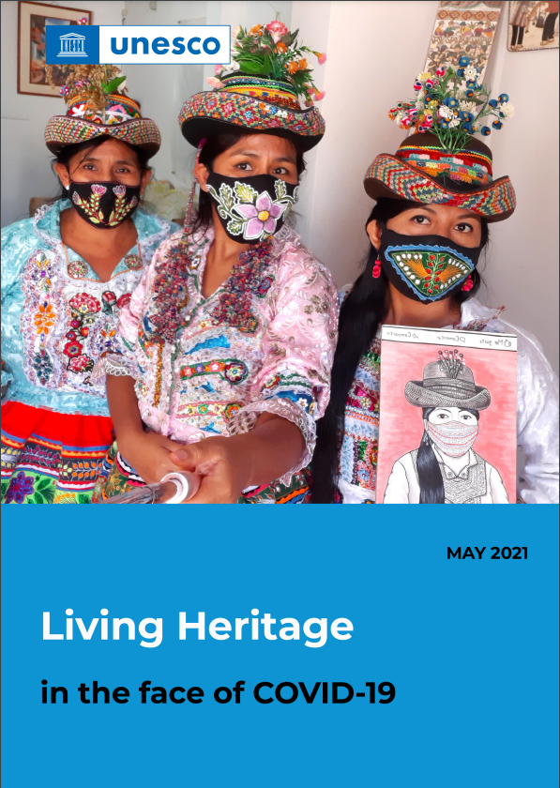
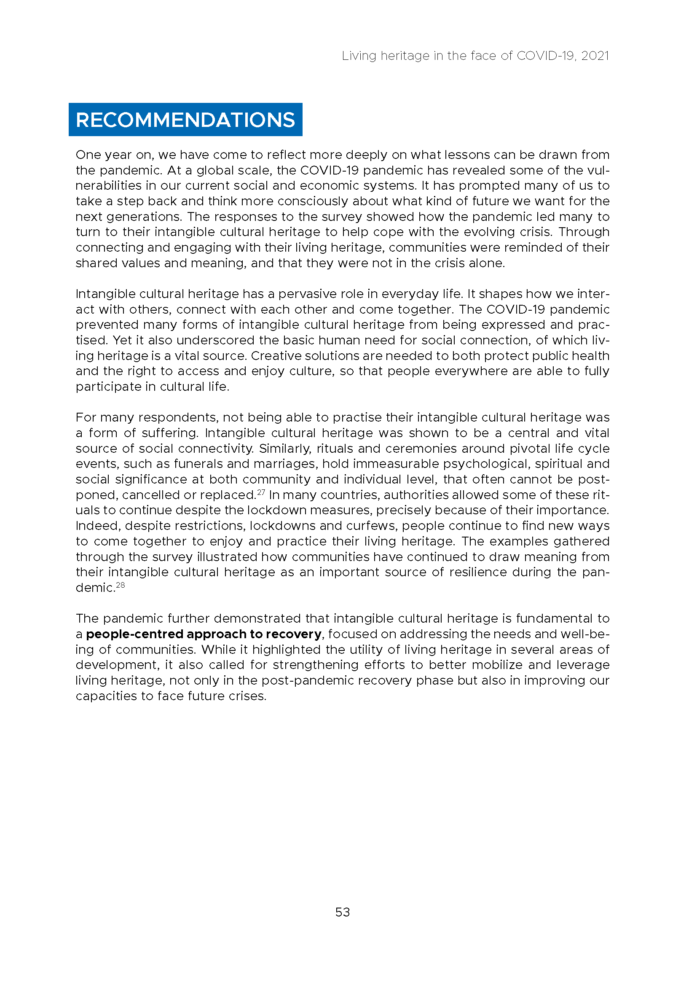
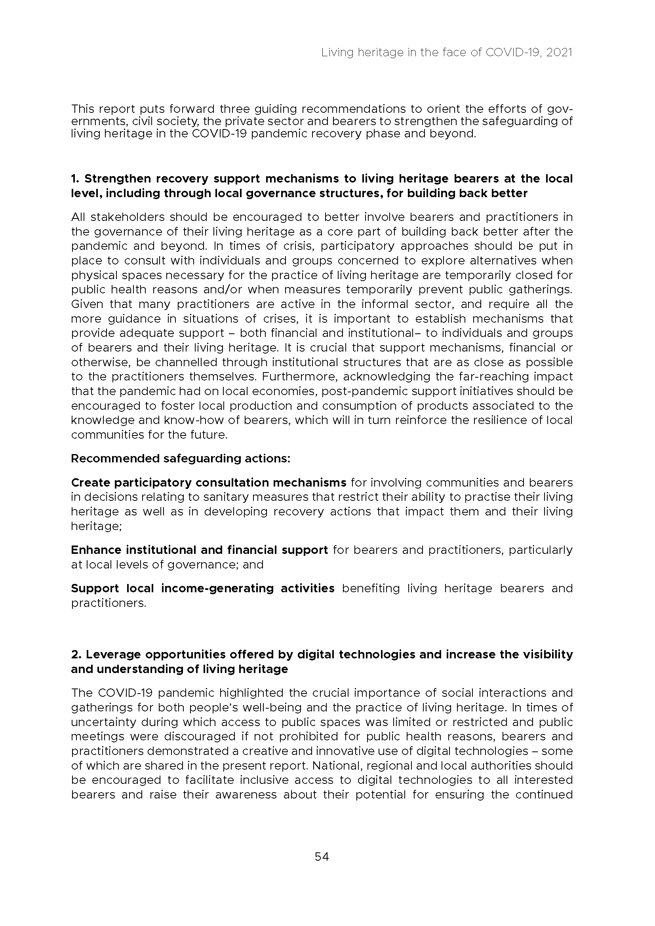

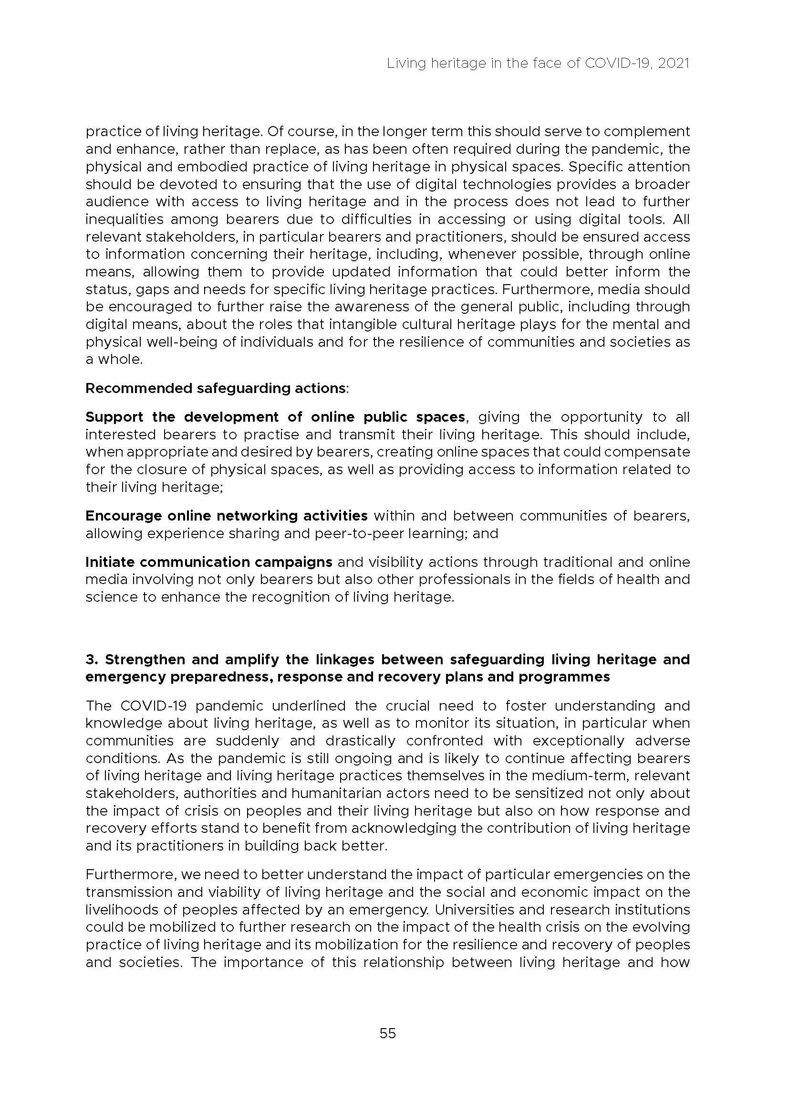

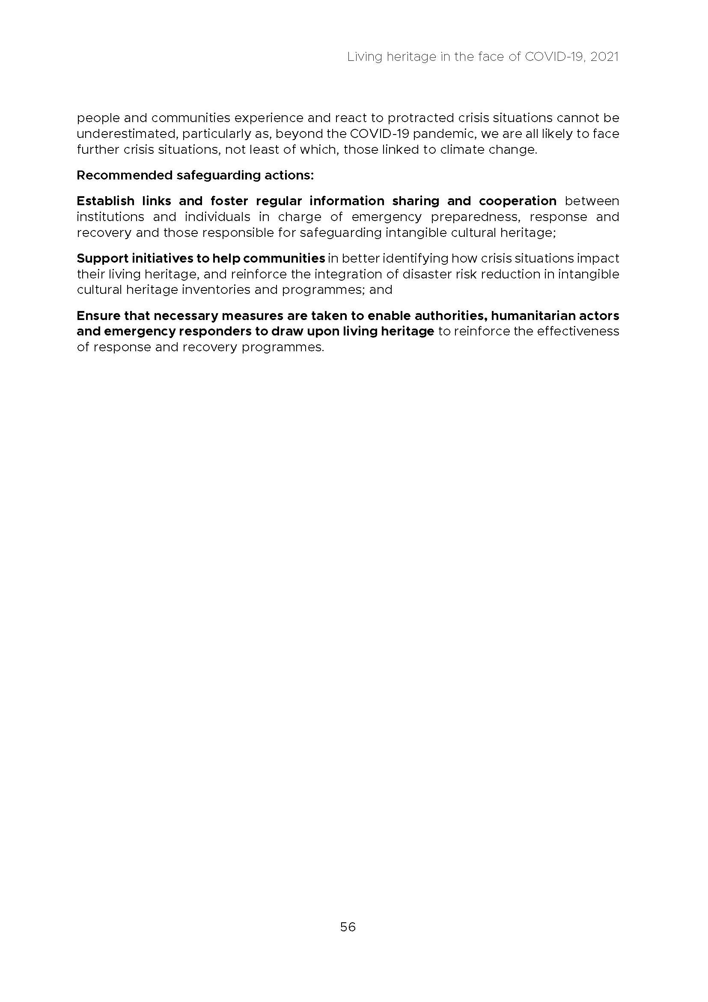

. The report should be read together with the financial report of the Convention’s Fund for the Safeguarding of the Intangible Cultural Heritage (document LHE/21/16.COM/INF.13.1) and the latest implementation report of the spending plan for the utilization of the funds for the ‘Other Functions of the Committee’ which is presented to the present session of the Committee (document LHE/21/16.COM/INF.13.2). In addition, the IOS Evaluation (2021) of UNESCO’s action in the framework of the 2003 Convention (document LHE/21/16.COM/INF.10) provides further insights into the activities of the Secretariat since 2018.
. The IOS Evaluation of UNESCO’s action in the framework of the 2003 Convention for the Safeguarding of the Intangible Cultural Heritage provides a detailed description of the composition and structure of the Secretariat (document LHE/21/16.COM/INF.10, paragraphs 33–34).
. See Document LHE/21/16.COM/14
. See Decision 14.COM 15
. See Resolution 7.GA 8.f
. See Document LHE/21/16.COM/INF.13.1
. See Document LHE/21/16.COM/7.b
8. See Decision 12.COM 6
. See Decision 15.COM 8
. See Decision 14.COM 10 (paragraph 14)
. See Document C54/21/16.COM/INF.5.III
. See Document LHE/21/16.COM/INF.10 (paragraph 181)
. See Document LHE/21/16.COM/INF.10 (paragraph 182)
. See document LHE/21/16.COM/INF.10 (IOS Recommendation 11)
. Resolution 8.GA 9.
. Resolution 8.GA 10.
. During the reporting period, the Secretariat organized five meetings of the Evaluation Body to evaluate fifty-two nomination files for the 2020 cycle as well as sixty files for the 2021 cycle. The Secretariat also administered technical completeness for fifty-nine nomination files for the 2022 cycle.
. Meetings in 2020: 4 meetings of the 15.COM Bureau; 8th session of the General Assembly of the States Parties to the Convention, UNESCO HQ, 8–10 September 2020; 3 meetings of the Evaluation Body for the 2020 cycle; and 15th session of the Intergovernmental Committee, Online, 14–19 December 2020. Meetings in 2021 (01/01/2021 to 30/06/2021): 2 meetings of the 16.COM Bureau; 2 meetings of the Evaluation Body for the 2021 cycle; Meeting of experts (Category VI) in the framework of the global reflection on the listing mechanisms of the 2003 Convention, Online, 7–27 May 2021.
. Training of National focal points for the reformed periodic reporting process in Latin America and the Caribbean – Online (19 May–23 June 2020), ICH Training of Trainers for Central Asia – Online (24–28 August 2020), Training of National focal points for the reformed periodic reporting process in the Europe Region – Online (19 March–16 April 2021).
. Regional Centre for the Safeguarding of Intangible Cultural Heritage in Latin America (CRESPIAL), International Training Centre for Intangible Cultural Heritage in the Asia-Pacific Region (CRIHAP).

