CONVENTION FOR THE SAFEGUARDING OF THE
INTANGIBLE CULTURAL HERITAGE
INTERGOVERNMENTAL COMMITTEE FOR THE
SAFEGUARDING OF THE INTANGIBLE CULTURAL HERITAGE
Eighteenth session
Kasane, Republic of Botswana
4 to 9 December 2023
Item 7.b of the provisional agenda:
Examination of the reports of the regional cycle of periodic reporting on the implementation of the Convention and on the current status of elements inscribed on the Representative List of the Intangible Cultural Heritage of Humanity by States Parties in the Arab States
Summary
This document presents the reports of States Parties in Arab States submitted for the ongoing cycle of periodic reporting on the implementation of the Convention and on the current status of elements inscribed on the Representative List.
Decision required: paragraph 14

Background
- Pursuant to Article 29 of the Convention as well as the relevant provisions in the Operational Directives (paragraphs 151-159 and 165-166, notably), the present session of the Committee is asked to examine the ongoing cycle of periodic reports on the implementation of the Convention and on the current status of elements inscribed on the Representative List submitted by States Parties in the Arab States. This follows the amendment to the Operational Directives undertaken to reform the periodic reporting mechanism to align itself to the Overall Results Framework of the Convention, as amended by the ninth session of the General Assembly (Resolution 7.GA 10) and the revised reporting calendar based on a system of regional rotation covering a six-year period established by the thirteenth session of the Committee (Decisions 13.COM 8 and 14.COM 8).
- The present document covers the implementation of the new periodic reporting system in the Arab States (Section A), includes an assessment of the reports (Section B with Annex I and Annex II), and highlight challenges, opportunities and ways forward (Section C).
- Implementation of the reformed periodic reporting system in the Arab States
- The Secretariat organized capacity-building activities to support the implementation of the periodic reporting exercise in the region, in collaboration with the Sharjah Institute for Heritage in the United Arab Emirates, as follows:
Phase 1: A three-day online training of trainers (25 to 27 October 2021) for twenty-five facilitators from the Arab States to prepare them to deliver the capacity-building activities on periodic reporting to the countries of the region the following year.
Phase 2: An online information session for country focal points (15 February 2022) to explain the capacity-building process and the task ahead, also providing an overview of the online periodic reporting form.
Phase 3: A presential five-day workshop (21 to 25 March 2022) bringing together eighteen focal points from the region (with half of the officials being women and half of them men) in Sharjah, United Arab Emirates as well as staff from the UNESCO network of field offices in the region, and observers from National Commissions, Ministries, and other regional organizations.
Phase 4: Monthly sub-regional meetings (May to September 2022) as well as two regional exchange sessions (28 June 2022 and 3 October 2022).
- Assessment of the first cycle of periodic reports of States Parties in the Arab States
- Eighteen States Parties (100 per cent) in the Arab States submitted their periodic reports, against the deadline of 15 December 2023, on the implementation of the Convention and on the status of 46 elements inscribed on the Representative List. The submitted reports ranged from fifty-one to 174 pages each in length, reaching a total of around 1800 pages of reports. The majority were submitted in English and five in French. The periodic reports are available at https://ich.unesco.org/en/01322 and the reporting countries are presented in the following table:
State Party | Date of ratification | Report (language(s) of submission)
Algeria | 15/03/2004 | French
Bahrain | 07/03/2014 | English
Egypt | 03/08/2005 | English
Iraq | 06/01/2010 | English
Jordan | 24/03/2006 | English
Kuwait | 09/04/2015 | English
Lebanon | 08/01/2007 | French
Mauritania | 15/11/2006 | French
Morocco | 06/07/2006 | French
Oman | 04/08/2005 | English
Palestine | 08/12/2011 | English
Qatar | 01/09/2008 | English
Saudi Arabia | 10/01/2008 | English
Sudan | 19/06/2008 | English
Syrian Arab Republic | 11/03/2005 | English
Tunisia | 24/07/2006 | French
United Arab Emirates | 02/05/2005 | English
Yemen | 08/10/2007 | English

- The analysis of the periodic reports in the Arab States was initiated with a thorough data processing and statistical analysis of the reports in June 2023, in collaboration with a data specialist from the agency ‘Stat sans Limites’. Based on the experience with the Latin America and the Caribbean region (2021 cycle) and Europe (2022 cycle), the data output models used for the Arab States cycle were updated so that the data and comments from the reports, which were structured around the twenty-six core indicators and the eighty-six assessment factors of the Overall Results Framework, could be visualized for qualitative analysis in a user-friendly way. Following this step, the qualitative content analysis was undertaken by a group of experts from the region who identified key issues, trends and progresses made by States Parties related to intangible cultural heritage safeguarding. A cross-cutting thematic analysis method was also applied in order to highlight some key analytical areas, which are illustrated by specific and relevant country examples in line with the priority areas of UNESCO, such as gender, youth, indigenous peoples, and sustainable development.
- The analytical overview of the reports, which can be found in Annex I of this document, presents some general observations and key analytical findings from the periodic reports of the States Parties in the Arab States. Further in-depth analysis of the submitted reports, which started in mid-2023, will continue throughout 2024, so that it will be examined by the Committee at its nineteenth session in November/December 2024.
- In Annex I, the specific findings from the reports are shared according to the following eight thematic areas in the Overall Results Framework: (a) Institutional and human capacities; (b) Transmission and education; (c) Inventorying and research; (d) Policies as well as legal and administrative measures; (e) The role of intangible cultural heritage and its safeguarding in society; (f) Awareness-raising; (g) Engagement of communities, groups and individuals as well as other stakeholders; and (h) International engagement. In addition, a brief analysis is provided on key aspects related to the status of the elements on the Representative List in the region, such as the assessment of their viability and efforts to promote or reinforce the elements.
- In summary, periodic reports show significant evidence of state support for intangible cultural heritage safeguarding through funding competent bodies and cultural institutions, support to research and capacity development activities, outreach and awareness raising events. In many countries, support for intangible cultural heritage safeguarding was linked to state investment in the tourism, agriculture and handicrafts sectors. Strong engagement with the international mechanisms of the Convention, and in particular multinational nominations to the Representative List, have encouraged regional and international cooperation in the region. States Parties from the region underscored the crucial role of living heritage for social cohesion, mutual and self-respect, conflict resolution, and peacebuilding, as communities in a number of countries have suffered substantial economic and social disruption. In volatile contexts, the majority of reporting countries have mobilized living heritage in policy response to natural disasters and armed conflicts. Youth engagement in intangible cultural heritage transmission and safeguarding has received considerable attention in the region, including through the greater integration of living heritage in primary, secondary and post-secondary education, as well as in non-formal learning environments. Reporting countries from the Arab States acknowledged gendered roles in living heritage practice and transmission. At the same time, State Parties have encouraged gender equality in intangible cultural heritage policies and programmes, and some elements threatened by reduced transmission have been revitalized by promoting broader gender inclusiveness among bearers and practitioners.
- While the majority of the 26 indicators under the Overall Results Framework are related to measuring and monitoring the States Parties’ implementation at the national level, there are two indicators that require monitoring at the global level. These are indicator 23 ‘Number and geographic distribution of NGOs, public and private bodies, and private persons involved by the Committee in an advisory or consultative capacity’ and indicator 26 ‘ICH Fund effectively supports safeguarding and international engagement’, which are both categorized under the thematic area ‘International engagement’. Annex II of this document therefore presents the monitoring data and information relevant to these two indicators and assessment factors.
- Challenges, opportunities and the way forward
- Following the first and second experience with the periodic reporting exercise in Latin America and the Caribbean (2021 cycle) and Europe (2022 cycle), the implementation of the reformed system of periodic reporting continues to show favourable results in the 2023 cycle with the submission rate of reports at 100 per cent (eighteen reports submitted) in the Arab States. The submission rate may be compared to the past reporting cycles in the following charts:
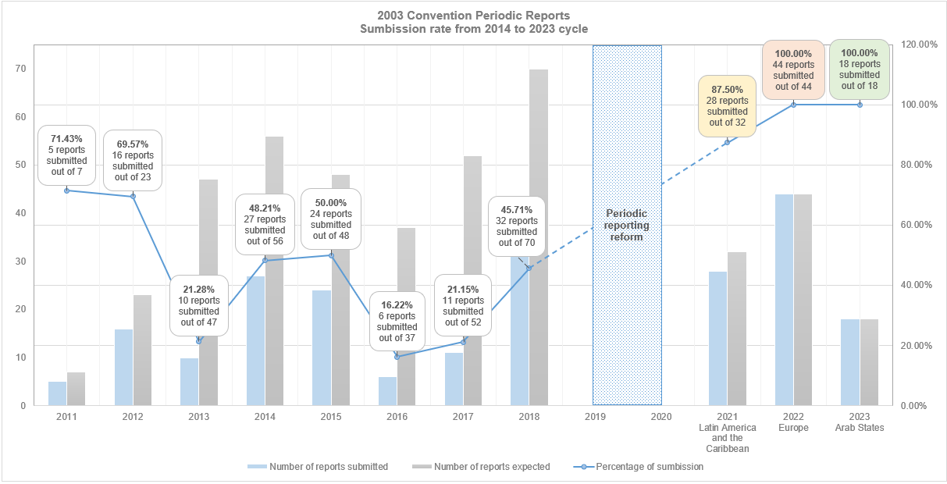
- As observed in previous cycles, the implementation of periodic reporting in the Arab States has considerably raised awareness among States Parties for the importance of broader participation in the reporting process of key stakeholders at the national level, including living heritage bearers and practitioners, national institutions, NGOs, and academia. The periodic reporting exercise greatly encouraged cross-cutting collaboration within and beyond the culture sector, allowing for inter-ministerial cooperation to better positioning living heritage safeguarding in national development plans and strategies. Furthermore, at the regional level, periodic reporting has shown to be a meaningful platform for inter- and intra-regional dialogue and peer-to-peer exchange among countries on living heritage safeguarding.
- While much has been achieved through the implementation of periodic reporting in the Arab States region, the implementation process has also been assessed to be challenging. Some of the challenges have already been identified through the reporting experience in previous cycles, and reiterated by countries in the Arab States:
- Limited resources (human and financial) and short timeframe available for States Parties to fully understand and undertake the reporting process.
- Limited pertinent data and information in the relevant areas of safeguarding, readily available for review and analysis.
- Difficulties in conducting an exhaustive identification of, and broad consultations with, the varied stakeholders working in the field of intangible cultural heritage.
- Challenges related with information gathering among communities that do not speak Arabic, where focal points faced difficulties for translating key terms into local languages.
- As the ongoing periodic reporting cycle completes its third year of implementation, the mechanism is in the process of gaining further experience as an effective and dynamic self-monitoring tool, allowing each States to assess current safeguarding measures and to customize future strategies and key actions for safeguarding intangible cultural heritage elements practiced in its territory. The capacity building programme developed by the Secretariat has not only equipped States Parties with the skills to prepare their periodic reports and facilitated knowledge sharing and peer-to-peer learning between States Parties from the same reporting region, but it has also created opportunities for interregional exchange; the testimonies of focal points from regions that have already submitted their reports are passed through the capacity-building process to focal points from the region that is preparing the reports. Also, the challenges that each region has faced while undertaking the periodic reporting exercise will help seek further improvements and identify short- and mid-term solutions to improve the periodic reporting system.
- The Committee may wish to adopt the following decision:
DRAFT DECISION 18.COM 7.b
The Committee,
- Having examined document LHE/23/18.COM/7.b Rev. and its annexes,
- Recalling Articles 7, 29 and 30 of the Convention concerning reports by States Parties, and Chapter V of the Operational Directives,
- Further recalling Resolution 7.GA 10 as well as Decisions 13.COM 8 and 14.COM 8,
- Congratulates the eighteen States Parties in the Arab States that have submitted their reports for the 2023 reporting cycle and commends them for their efforts to complete the periodic reporting exercise;
- Expresses its appreciation to the Secretariat for ensuring an effective implementation of the periodic reporting exercise for the third consecutive year by providing concrete and comprehensive support to the States Parties concerned in their reporting process through capacity-building activities and ongoing follow-up;
- Acknowledging the quantitative and qualitative analysis that has been conducted for the reports from the Arab States region, welcomes the key findings from the analytical overview of the reports, as presented in the annexes of document LHE/23/18.COM/7.b Rev.;
- Takes note with interest the common trends, challenges, opportunities and priority areas related to intangible cultural heritage as reported by States Parties, as well as the different safeguarding approaches and methodologies adopted by them to implement the Convention, and looks forward to further detailed analyses of the reports, which will be presented to the nineteenth session of the Committee in 2024;
- Recalls that the designations employed in the reports presented by the States Parties do not imply the expression of any opinion whatsoever on the part of the Committee nor UNESCO concerning a) the legal status of any country, territory, city or area, b) the legal status of its authorities or c) the delimitation of its frontiers or boundaries;
- Decides to submit to the General Assembly at its tenth session a summary of the reports of States Parties on the implementation of the Convention and on the current status of elements inscribed on the Representative List examined during the current session in accordance with Article 30 of the Convention.

ANNEX I

Key analytical findings
This section provides some key analytical findings on common trends and progress or challenges in the UNESCO priority areas on indigenous peoples, youth and gender, as well as on sustainable development.

Common trends across the thematic areas

State support for intangible cultural heritage safeguarding
Reporting countries in this cycle provided significant evidence of state support for intangible cultural heritage safeguarding, calibrated to the resources available in different contexts. This support took various forms, including state funding for competent bodies, cultural institutions and research, capacity building, events, festivals and prizes. All but one of the reporting countries had designated at least one competent body for intangible cultural heritage safeguarding (B1.1), generally affiliated to the ministry responsible for culture.
In many countries, support for intangible cultural heritage safeguarding was linked to state investment in the tourism, agriculture and handicrafts sectors. For example, tourism was one of five priority sectors identified in Qatar’s development planning, according to the National Strategy for the Tourism Sector 2030. Restoration of the marketplace at Souq Waqif in 2008 as part of a tourism initiative provided a space for the marketing of local seasonal foods and handicrafts, giving visibility to local intangible cultural heritage.

International and regional cooperation, especially in regard to multinational nominations
Reporting countries engaged extensively with the various international mechanisms of the Convention, particularly in respect of multinational nominations. In this cycle (i.e. up to but not including inscriptions at 17.COM (2022)), reporting countries participated in nominating 14 multinational elements inscribed on the Representative List. Bilateral initiatives and regional bodies such as the Arab League Organization for Education, Science, and Culture (ALECSO) played a role in coordinating meetings to discuss the development of multinational nominations in the region and agreed strategies for elaborating these files. Multinational nominations promoted cooperation within the region, for example in the case of ‘Al-Taghrooda, traditional Bedouin chanted poetry in the United Arab Emirates and the Sultanate of Oman’, and beyond the region, for example in the case of ‘Mediterranean diet’, nominated by Morocco alongside six countries from southern Europe.
Ten international assistance projects or programmes financed through the ICH Fund benefited five of the reporting countries (Egypt, Mauritania, Morocco, and Sudan) up to but not including 17.COM in 2022. These projects largely focused on documentation and inventorying of intangible cultural heritage. Aside from inventorying, three of the international assistance projects supported the preparation of nomination files and two projects provided capacity building to local stakeholders implementing the Convention, including non-governmental organizations (NGOs) and civil society. For example, Mauritania benefited from an international assistance project called “Strengthening the capacities of NGOs active in the field of intangible cultural heritage in Mauritania” (2019-2021), totaling 94,300 USD and assistance to inscribe the ‘Moorish epic T’Heydinn’ on the Urgent Safeguarding List, totaling 9,800 USD (2009-2010).

Challenges and opportunities

Managing social and economic disruption
Communities in a number of reporting countries have suffered significant social and economic disruption over the reporting period, although the effects have not been evenly distributed. In those contexts where forced migration and economic crisis have negatively affected community cohesion and heritage practice and transmission, intangible cultural heritage has also been a mechanism for recovery and survival. Half of the reporting countries noted that intangible cultural heritage safeguarding plans involved migrants and refugees, and about two fifths included members of vulnerable groups, see Figure 1 below (B16.1).

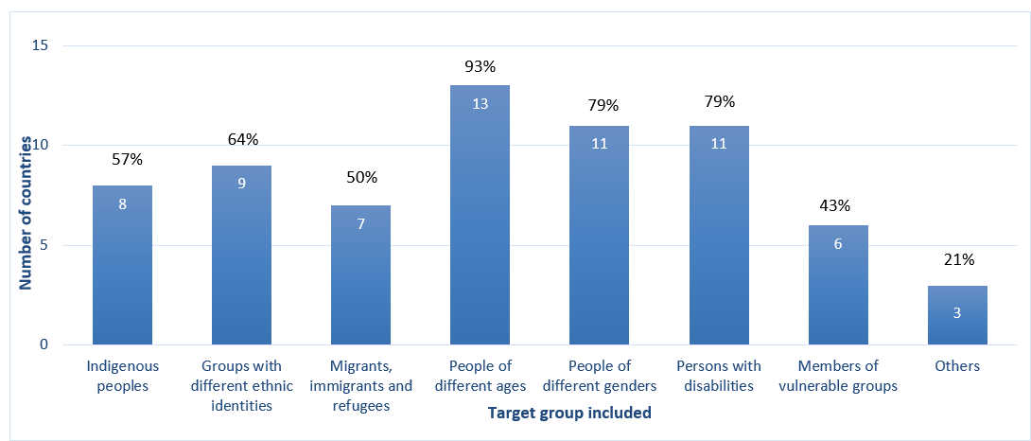
Figure 1: Inclusivity of intangible cultural heritage safeguarding plans and programmes in reporting countries, by target group (n=14) (B16.1)
Various intangible cultural heritage projects have been implemented to try and improve livelihoods for refugees and local people experiencing challenging economic conditions, while safeguarding the heritage. In Egypt, for example, the NilFurat Project created a safe space for refugee and Egyptian women to give each other psychosocial support, share different cultural perspectives, create high-quality artisan products and thereby generate income.

Promoting peace and conflict resolution
In this reporting cycle, countries paid specific attention to the role of intangible cultural heritage in peace and conflict resolution. Four fifths of the countries had policies that recognized intangible cultural heritage contributions to peaceful conflict prevention and resolution (B14.3). Most countries reported that communities, groups and individuals used their intangible cultural heritage for dialogue promoting mutual respect, conflict resolution and peace-building (B15.2), and that safeguarding promoted mutual respect (B16.2). Village committees of wise men (Tadjmaat) performed dispute-resolution functions in Algeria, aside from providing advice, organizing community activities and mobilizing action in times of crisis.
About three quarters of the countries took intangible cultural heritage into consideration in policies responding to situations of natural disaster or armed conflict (B13.3). In Iraq, for example, researchers at the College of Law at the University of Mosul have investigated the use of various mechanisms for safeguarding intangible cultural heritage during armed conflicts. These mechanisms included UNESCO inscriptions, reference to international agreements relating to human rights and armed conflict, and prosecutions in national and international criminal courts.

Responding to the Covid pandemic
The COVID-19 pandemic, starting in March 2020, affected both the practice of intangible cultural heritage and safeguarding activities in reporting countries. Use of the cultural and social spaces of Majlis (an element nominated by the United Arab Emirates, Saudi Arabia, Oman and Qatar) to discuss local events and issues, for example, was negatively affected by the pandemic, although the practice revived afterwards. Some states were able to support communities during the pandemic. Palestine’s Ministry of Culture provided financial support, in addition to its regular cultural fund, through an emergency budget of USD 250,000 supporting individuals and organizations in the cultural sector including intangible cultural heritage. The Ministry of National Economy also exempted the private sector, including craft workers, from certain registration fees upon request.
In many countries, intangible cultural heritage festivals, events and safeguarding activities moved online during the pandemic. Since the livelihoods of practitioners were badly affected by the pandemic, marketing of intangible cultural heritage-related products (such as handicrafts) and services (such as tourism and workshops) also benefited from use of online platforms in some countries.

Priority areas

Indigenous communities
Nearly three fifths of reporting countries mentioned including indigenous peoples in safeguarding plans and programmes (B16.1, see Figure 1 above).
Attention to the intangible cultural heritage of indigenous peoples was sometimes formalized in government institutions and policy. In Sudan, the intangible cultural heritage safeguarding policy of the National Council for Cultural Heritage and Promotion of National Languages stipulated that safeguarding plans and programs for intangible cultural heritage elements should include indigenous peoples. This was relevant to elements such as Nubian wrestling practised by the indigenous people of Sibr al Lūba in the Nuba Mountains; as well as the practice of Jad’ an-Nar among the indigenous people of the Anqasana Mountains in the Blue Nile region.

Youth
Youth engagement in intangible cultural heritage safeguarding received considerable attention in reporting countries. Primary and secondary school curricula incorporated intangible cultural heritage as a way of teaching other subjects in about four fifths of reporting countries, and as a stand-alone subject in over two thirds of them (B5.1, see Figure 2 below). Post-secondary education also incorporated intangible cultural heritage, mainly through music, arts and crafts disciplines (B6.1) in most reporting countries.]
Integration of intangible cultural heritage in formal education was achieved in various ways. In Jordan, for example, school students were introduced to the Al-Mansaf and its preparation (a traditional Jordanian dish inscribed on the Representative List in 2022) as part of their French and English language curricula. In the Kingdom of Saudi Arabia, the Ministry of Culture launched a competition for school and university students that targeted three age groups (10-13, 14-17, and 18-24) and encouraged the practice of Arabic Calligraphy among the youth.
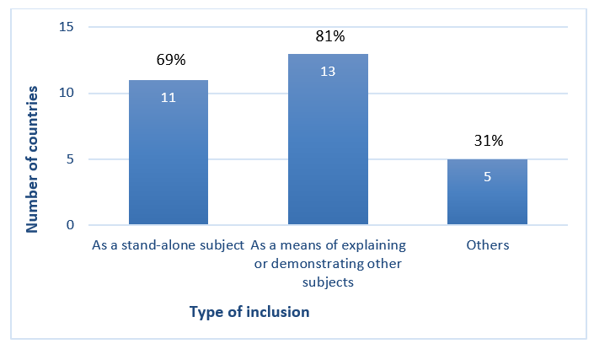

Figure 2: Means of inclusion of intangible cultural heritage in primary and secondary education curricula in reporting countries (n=16) (B5.1)

In informal educational contexts, different mechanisms were adopted to encourage youth engagement with intangible cultural heritage. In Tunisia, an NGO called ‘The Voice of the Rural Child’ (‘la voix de l’enfant rural’), piloted the project “Puppets on the way II”, to promote children’s access to culture and safeguard intangible cultural heritage in the regions of Médenine and Tataouine, supported by a bilateral cultural project called Tfanen-Tunisie Créative.

Gender
One of UNESCO’s global priorities is gender equality. UNESCO believes that all forms of discrimination based on gender are violations of human rights, as well as posing a significant barrier to the achievement of the 2030 Agenda for Sustainable Development. Reporting countries noted efforts towards achieving gender equality and inclusion in policies and programs, both in general and those relating to intangible cultural heritage safeguarding. Many reports commented on gendered roles in intangible cultural heritage practice while, at the same time, some countries reported on changing gender norms, which could aid in transmission. In the United Arab Emirates, gender equity was promoted through policies such as the 2015-2021 National Strategy on Women's Empowerment and Active Participation in Society. The Department of Culture and Tourism - Abu Dhabi encouraged women to practice Al Sadu weaving by giving craftswomen monthly salaries, and by involving them in local and international events and festivals. The Abu Dhabi Falconers’ Club allocated a special section in the club to teach women falconry skills, and enable their easier participation in the practice.
Women may need specific support to benefit equitably from their intangible cultural heritage practice, even in areas where they form the majority of practitioners. In Bahrain, the Awal Women’s Association established a project in the city of Muharraq as far back as 1996, training women in a traditional silver embroidery handicraft called ‘al naqda’. Supported by the Ministry of Development and Industry, the project has continued to create job opportunities for young women and generated a stable income for them, while raising the value of handicraft work in society. At the time of reporting, the project hosted visits from school students, local citizens and tourists.

Contributions to sustainable development
The current United Nations framework for sustainable development is Agenda 2030, monitored through 17 Sustainable Development Goals (SDGs). UNESCO’s Culture 2030 framework assists culture sector actors in linking their work to Agenda 2030. The Overall Results Framework for the 2003 Convention includes the contribution of safeguarding activities to sustainable development as one of the impacts of implementing the Convention. The Operational Directives’ Chapter VI contains guidance for States Parties on encouraging synergy between intangible cultural heritage safeguarding and sustainable development objectives.
Within the framework of these initiatives, some reporting countries mentioned the link between intangible cultural heritage and sustainable development in policies and programs across different sectors. For example, the strategic plan “Syria 2030” Framework Program on Healthcare emphasized the use of traditional medicine associated with bathing in sulfuric waters in hospitalization and medical tourism, for example at the Afqa Spring at Palmyra, a World Heritage property in danger.
The reports provided some evidence demonstrating the contributions of safeguarding activities to sustainable development. Some of these examples are presented below, organized according to the themes outlined in the Operational Directives: inclusive social development, inclusive economic development, environmental sustainability, and social cohesion and peace. Many of the examples address major themes across reporting countries, such as the promotion of livelihoods and reduction of social conflicts.
Regarding inclusive social development, country reports indicated how the implementation of the Convention contributed to gender equality, quality education, food security, access to clean and safe water, and health. In the Kingdom of Saudi Arabia, for example, the Culinary Arts Commission developed an inventory of traditional culinary practices across the country and established the country’s first professional association in the culinary arts to support practitioners and promote safeguarding. The inventory was used as the basis for awareness raising activities such as the Saudi Feast Food Festival, held in December 2021, where practitioners shared their experience, knowledge and skills with local communities and younger generations, and promoted healthy eating. In Lebanon, NGOs helped families in rural areas to respond to the economic crisis in 2019 by resuming and expanding production of traditional winter provisions known as mûné. This encouraged more women and young people to learn the making of mûné, and created jobs. These activities supported SDG Targets 2.1 (access to safe, nutritious and sufficient food), 4.7 (education on culture and sustainable development), 5.4 (valuing domestic work), 5.c (gender equality and women’s empowerment) and 8.5 (productive employment and decent work).
With regard to inclusive economic development, reporting countries provided multiple examples of promotion of cultural tourism and craft training programmes aiming to support income generation and provide decent jobs. In Iraq, the NGO Nature Iraq worked with the Ministry of Water Resources and the Centre for the Rehabilitation of Iraqi Marshlands and Wetlands to enhance transmission of skills in traditional textiles and reed house construction methods among local men and women living around the Ahwar of Southern Iraq World Heritage property, also known as the Iraqi Marshlands. The education programme contributed to several SDG Targets for Goal 4 on education and training and helped to maintain livelihoods and intangible cultural heritage practices, contributing to SDG Targets 8.5 (productive employment and decent work) and 11.4 (protect heritage) among others. Promoting traditional building skills enabled the sustainable reuse of existing buildings and agricultural structures and thus contributed to SDG Target 11.c.
Regarding environmental sustainability, reporting countries were well aware that culture and environmental issues are intertwined so that safeguarding intangible cultural heritage also means maintaining and reinvigorating ecosystems. In Palestine, the Institute for biodiversity and sustainability at Bethlehem University provided practical training for 80 farmers (50 males and 30 females aged between 30 and 60), in four villages in Bethlehem governorate over a period of 3 years. As a result, the farmers favoured traditional eco-friendly farming methods over use of chemical fertilizers, increased their production by 40% and reduced their costs, supporting the realization of SDG Target 15.1 (sustainable use of terrestrial ecosystems) as well as Target 8.5 (productive employment and decent work).
Regarding social cohesion and peace, some countries have used intangible heritage for resolving local disputes or to bring together different groups in the local community. Some intangible cultural heritage elements became more focused on peace and conflict resolution over time. Sudan reported changes in the practice of Al-Hakamat (wise women singing poetry) in Darfur, for example. After practitioners were brought together by the government to reflect on the harms experienced by widows and orphaned children in times of war, the content of the songs included concepts advocating for peace. This provided a positive atmosphere for dialogue and peace, supporting the achievement of SDG Target 16.1 (reducing violence).

Thematic areas

Thematic area I - Institutional Capacities
To assist in implementing the Convention and intangible cultural heritage safeguarding, the Convention strongly recommends in Article 13(b) that State Parties “designate or establish one or more competent bodies for the safeguarding of the intangible cultural heritage present in [their] territory”. Some bodies have functions relating to intangible cultural heritage in general (see OD 154(a)), others are focused on specific intangible cultural heritage elements (see ODs 158(a) and 163(a)). States are encouraged to establish consultative bodies or coordination mechanisms to promote the involvement of communities and other stakeholders in intangible cultural heritage safeguarding, in line with Article 15 and OD 80. The Convention also encourages States Parties to support other institutions such as cultural centres, centres of expertise, research and documentation institutions, museums, archives and libraries that can contribute to intangible cultural heritage safeguarding (ODs 80 and 109, Article 13(d)(iii)).
The Periodic Report thus contains a number of questions about competent bodies and other institutions that support intangible cultural heritage safeguarding at the national or local level. These are as follows:

List of core indicators and assessment factors on institutional capacities (B1)
Core Indicators | Assessment according to the following
B1. Extent to which competent bodies and institutions and consultative mechanisms support the continued practice and transmission of intangible cultural heritage | - One or more competent bodies for intangible cultural heritage safeguarding have been designated or established.
 | - Competent bodies exist for safeguarding specific elements of intangible cultural heritage, whether or not inscribed.
 | - Broad and inclusive involvement in intangible cultural heritage safeguarding and management, particularly by the communities, groups and individuals concerned, is fostered through consultative bodies or other coordination mechanisms.
 | - Institutions, organizations and/or initiatives for intangible cultural heritage documentation are fostered, and their materials are utilized to support continued practice and transmission of intangible cultural heritage.
 | - Cultural centres, centres of expertise, research institutions, museums, archives, libraries, etc., contribute to intangible cultural heritage safeguarding and management.

Summary of analytical findings
As already mentioned above, all but one of the reporting countries designated at least one competent body for intangible cultural heritage safeguarding in general (B1.1). Most of the competent bodies mentioned in the reports, numbering 52 in total, were government bodies affiliated to ministries responsible for culture. Most countries reported between one and three competent bodies, but a few, such as Egypt, reported many such bodies at national and sub-national levels. NGOs designated as competent bodies included the Mauritanian Association for Popular Traditions (AMTP). The AMTP documented oral traditions and enabled transmission to future generations through cultural centers, youth centers and cultural festivals. In Algeria, the competent body for implementation of the Convention, the National Center for Prehistoric, Anthropological and Historical Research (CNRPAH), collaborated with several other institutions dedicated to intangible cultural heritage safeguarding across the country, including the UNESCO Category 2 Regional Centre for the Safeguarding of Intangible Cultural Heritage in Africa (CRESPIAF).
The main safeguarding activity of the competent bodies mentioned in the reports was inventorying, which will be discussed further below under Thematic Area III. Other tasks undertaken by these bodies included policy-making or strategic planning for intangible cultural heritage safeguarding, the preparation of nomination files, documentation and awareness raising, for example by organizing events and festivals. For example, the Qatar Department of Heritage and Identity was appointed as the competent body for intangible cultural heritage safeguarding, with duties relating to cultural heritage documentation and inventorying, archiving, research and publications, and arranging workshops and seminars to build capacity for safeguarding. Not all of the competent bodies mentioned in the reports were entirely dedicated to intangible cultural heritage or one of its specific domains: some had mandates across several areas of heritage, culture or tourism.
All but three of the reporting countries mentioned having competent bodies for safeguarding specific elements or domains of intangible cultural heritage (B1.2). In total, 57 such bodies were named in the reports, covering elements such as falconry and palm tree culture, and domains such as traditional music, folk dance, popular poetry, handicrafts, popular games and festivals. These bodies included associations, clubs, museums and research centers organizing safeguarding activities such as transmission, awareness-raising and promotion. Consultative bodies or coordination mechanisms for supporting the continued practice and transmission of intangible cultural heritage, including advisory or consultative bodies and networks, were established in all but three of the reporting countries (B1.3). These included the Lebanese Network for Intangible Cultural Heritage Safeguarding, a community organization representing various socio-religious communities and ethnic groups across the country.
Reporting countries made substantial investments in institutions, organizations and/or initiatives for documenting intangible cultural heritage (B1.4). The level of support was tailored according to available budgets and financial constraints, and ranged from direct financing and subsidies to in-kind support and logistical or administrative assistance. For example, the Sudanese Ministry of Culture, the National Council for Cultural Heritage and Language Development and the Sudanese Life Documentation Center provided high-quality video cameras and digital audio recorders to documentation initiatives, and helped to archive the resulting data. The Bahrain Authority for Culture and Antiquities provided a monthly allowance to cultural associations registered in the Associations Register in the Authority. This enabled the associations to document intangible cultural heritage and participate in the activities of the Authority.
All of the countries reported that cultural centres contributed towards intangible cultural heritage safeguarding and management, and over four fifths reported that museums and libraries did so. Research institutions and archives were also mentioned by about two thirds of reporting countries, alongside centres of expertise mentioned by just under half (B1.5, see Figure 3 below).

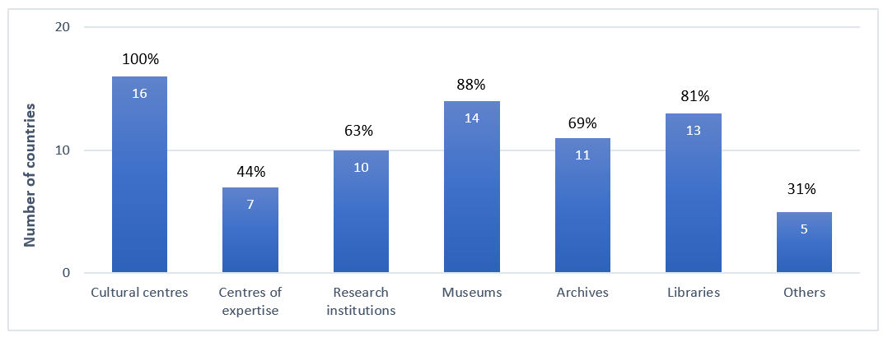
Figure 3: Contribution of different kinds of institutions towards intangible cultural heritage safeguarding and management in reporting countries (n=16) (B1.5)
The role of cultural centres in intangible cultural heritage safeguarding and management was highlighted in the reports. All but two reporting countries also emphasized the role of museums for the safeguarding of intangible cultural heritage. For example, Al-Mukalla Museum in Yemen organized the annual Al-Baldah Festival to raise awareness about local traditions and hosted permanent exhibitions on traditional industries such as the craft of traditional shipbuilding.
Nearly seventy percent of reporting countries thus fully satisfied the core indicator B1 at the baseline, on the extent to which competent bodies and consultative mechanisms support the continued practice and transmission of intangible cultural heritage.
The significant and continuing investment in competent and consultative bodies as well as in coordinating mechanisms for safeguarding implies that these institutions and organizations were considered by reporting countries to be effective mechanisms for implementing the Convention. More attention might be paid to developing mechanisms for community consultation and involvement for implementation of the Convention.

Thematic areas I and II - Education, building human capacities and transmission
In the Convention, education is given a prominent place among a State’s safeguarding responsibilities at the national level. Article 14(a)(i) stresses the importance of educational programmes aimed at the general public, and youth in particular, while Article 14(a)(ii) concerns educational programmes within the communities and groups concerned. The relevance of non-formal means of transmitting knowledge is emphasized in Article 14(a)(iv). Education can raise awareness and strengthen transmission mechanisms for intangible cultural heritage, especially where communities, groups and individuals concerned are involved in designing and delivering educational programmes, in line with Article 15, which refers to their “widest possible participation” in safeguarding activities. The principles of inclusiveness and non-discrimination are fundamental values of the United Nations, as of UNESCO, and are reiterated in the Operational Directives and Ethical Principles.
The Periodic Report thus contains a number of questions about how intangible cultural heritage is included in educational programmes and curricula, how communities and bearers of intangible cultural heritage (and other stakeholders) are involved in these efforts, and what the impact of these initiatives is on intangible cultural heritage safeguarding. These questions, under Thematic Areas I and II, are as follows:

List of core indicators and assessment factors on education, building human capacities and transmission (B2-B6)
Core Indicators | Assessment according to the following
B2. Extent to which programmes support the strengthening of human capacities to promote safeguarding and management of intangible cultural heritage | - Tertiary education institutions offer curricula and degrees in intangible cultural heritage safeguarding and management, on an inclusive basis.
 | - Governmental institutions, centres and other bodies provide training in intangible cultural heritage safeguarding and management, on an inclusive basis.
 | - Community-based or NGO-based initiatives provide training in intangible cultural heritage safeguarding and management, on an inclusive basis.
B3. Extent to which training is operated by or addressed to communities, groups and individuals, as well as to those working in the fields of culture and heritage | - Training programmes, including those operated by communities themselves, provide capacity building in intangible cultural heritage addressed on an inclusive basis to communities, groups and individuals.
 | - Training programmes provide capacity building in intangible cultural heritage addressed on an inclusive basis to those working in the fields of culture and heritage.
B4 Extent to which both formal and non-formal education strengthen the transmission of intangible cultural heritage and promote respect for intangible cultural heritage | - Practitioners and bearers are involved inclusively in the design and development of intangible cultural heritage education programmes and/or in actively presenting and transmitting their heritage.
 | - Modes and methods of transmitting intangible cultural heritage that are recognized by communities, groups and individuals are learned and/or strengthened, and included in educational programmes, both formal and non-formal.
 | - Educational programmes and/or extra-curricular activities concerning intangible cultural heritage and strengthening its transmission, undertaken by communities, groups, NGOs or heritage institutions, are available and supported.
 | - Teacher training programmes and programmes for training providers of non-formal education include approaches to integrating intangible cultural heritage and its safeguarding into education.
B5. Extent to which intangible cultural heritage and its safeguarding are integrated into primary and secondary education, included in the content of relevant disciplines, and used to strengthen teaching and learning about and with intangible cultural heritage and respect for one’s own and others’ intangible cultural heritage | - Intangible cultural heritage, in its diversity, is included in the content of relevant disciplines, as a contribution in its own right and/or as a means of explaining or demonstrating other subjects.
 | - School students learn to respect and reflect on the intangible cultural heritage of their own community or group as well as the intangible cultural heritage of others through educational programmes and curricula.
 | - The diversity of learners’ intangible cultural heritage is reflected through mother tongue or multilingual education and/or the inclusion of ‘local content’ within the educational curriculum.
 | - Educational programmes teach about the protection of natural and cultural spaces and places of memory whose existence is necessary for expressing intangible cultural heritage.
B6. Extent to which post-secondary education supports the practice and transmission of intangible cultural heritage as well as study of its social, cultural and other dimensions | - Post-secondary education institutions offer curricula and degrees (in fields such as music, arts, crafts, technical and vocational education and training, etc.) that strengthen the practice and transmission of intangible cultural heritage.
 | - Post-secondary education institutions offer curricula and degrees for the study of intangible cultural heritage and its social, cultural and other dimensions.

Summary of analytical findings
Almost all of the countries reported that formal educational programmes strengthened the transmission of intangible cultural heritage during this reporting cycle (B4, B4.2), and nearly four fifths reported transmission through non-formal education programmes (B4). A variety of educational approaches were mentioned including formal curricula, extra-curricular activities, online open-access education, informal workshops, educational trips, festivals, exhibitions and competitions. Examples have been provided under the Priority Area on youth above.
At the post-secondary level, most countries reported providing training contributing to the practice and transmission of intangible cultural heritage (B6.1, see Figure 4 below). A large proportion of the countries reported specific post-secondary educational programmes strengthening the practice and transmission of intangible cultural heritage in the fields of music, arts and craft. The reports also mentioned well-established systems of professional training for adults. The Yemeni Turkish Institute of Crafts affiliated to the Ministry of Technical Education and Vocational Training granted diploma certificates in traditional gold and silver smithing, and offered special courses in carpet weaving and knot making.

Figure 4: Educational programmes at the post-secondary level in specific subject areas strengthening the practice and transmission of intangible cultural heritage in reporting countries (n=14) (B6.1)
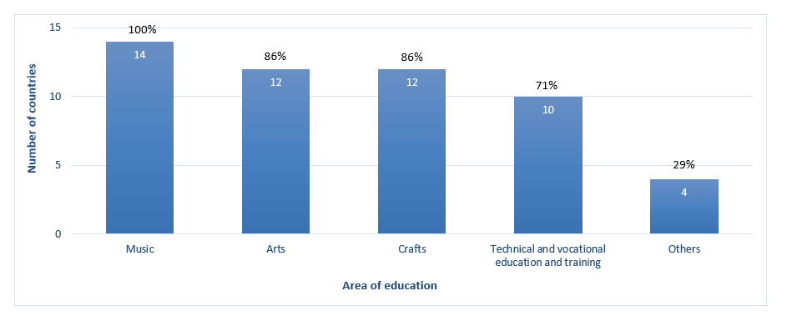
At the tertiary level, programmes supporting the strengthening of human capacities to promote safeguarding and management of intangible cultural heritage were offered in just over two thirds of reporting countries (B2.1). Programmes on selected intangible cultural heritage elements or domains like orality, traditional music, traditional crafts or handicrafts were offered at tertiary level in Algeria, Iraq and Yemen. In Jordan, many of the universities offered degrees in music, including folk music and the use of musical instruments such as the Oud (stringed musical instrument, or lute), the Rabbah (single-stringed musical instrument), the Mijwiz (short bamboo flute). While universities in some reporting countries offered intangible cultural heritage modules, Masters and PhD research programs, others offered relevant study modules. The anthropology department of the National Institute of Archeology and Heritage Sciences in Morocco offered training for Bachelors and Masters students in the framework of a partnership with the city of Casablanca for local ICH inventorying, thereafter integrating study findings into the national inventory.
Government institutions, centres and other bodies offered training on intangible cultural heritage safeguarding and management in all but three of the reporting countries (B2.2). A government institution, the Sharjah Institute for Heritage in the United Arab Emirates, awarded professional diplomas on heritage and folk arts, including one on intangible cultural heritage. The Mohamed bin Zayed Falconry and Desert Physiognomy School offered both theoretical and practical programmes to educate people about the heritage of falconry. In Tunisia, the Technical Center for Creation, Innovation and Supervision in the Carpet and Weaving Sector, a body under the Tunisian Ministry of Tourism and Handicrafts, provided training in hand-weaving, spinning, and traditional dyeing of carpets, wall tapestries and wool blankets.
Community- and/or NGO-based initiatives offered training on intangible cultural heritage safeguarding and management in just over two thirds of reporting countries (B2.3), often focusing on transmission of knowledge and traditional know-how in specific domains of intangible cultural heritage. All but one country reported that capacity building in intangible cultural heritage safeguarding was also addressed to communities, groups and individuals concerned (B3.1). In Najran (Gatten) in the Kingdom of Saudi Arabia, the non-profit organizations ‘Association of Antiquities and History of Najran’ and the ‘Culture and Arts Association’ worked with expert practitioners in the local community to promote transmission of traditional crafts through a workshop and training programs, the Najrani Cooking Festival and “Shibana”, a project to document and safeguard traditional games.
Over three fifths of reporting countries fully satisfied the core indicators B2 and B4 at the baseline, on the extent to which programmes in intangible cultural heritage safeguarding and management and formal and non-formal educational programmes help safeguard intangible cultural heritage by building capacities and promoting transmission respectively. Three quarters of reporting countries fully satisfied the core indicator B3, on the extent to which educational programmes are operated by or addressed to communities, groups and individuals, as well as to those working in the fields of culture and heritage. Less than a third of the countries fully satisfied core indicator B5 at the baseline, on the extent to which intangible cultural heritage and its safeguarding are integrated into primary and secondary education. Most of the remaining countries largely satisfied that indicator at the baseline, however. About half of the countries fully satisfied the core indicator B6 at the baseline, relating to the role of post-secondary education in supporting intangible cultural heritage safeguarding.
The reports demonstrated a significant and increasing number of educational programmes and professional training opportunities supporting intangible cultural heritage safeguarding. Better integration of intangible cultural heritage across school curricula could help to raise awareness among teachers and students of its diversity and richness, as well as the importance of safeguarding it, thus contributing to achieving SDG 4 on quality education. Further attention might be paid to ways to support NGOs working on non-formal education programmes, and to encourage them, and government agencies, to involve practitioners and bearers more extensively in intangible cultural heritage safeguarding programs.

Thematic area III - Inventories
In Article 11(b), the Convention requires that a State Party ‘identify and define the various elements of the intangible cultural heritage present in its territory, with the participation of communities, groups and relevant non-governmental organizations’. Article 12.1 specifies that the purpose of inventorying is “To ensure identification with a view to safeguarding”. It indicates that each State Party “shall draw up, in a manner geared to its own situation, one or more inventories of the intangible cultural heritage present in its territory. These inventories shall be regularly updated.” The Convention encourages States Parties to endeavour to ensure access to information about the intangible cultural heritage in such inventories, while respecting customary practices governing such access (Article 13(d)(ii)). In order for elements to be inscribed on one of the Lists of the Convention, they need to be included on an inventory of intangible cultural heritage.
The Periodic Report contains a number of questions about the design and format of inventories of intangible cultural heritage, how communities, groups and individuals and other stakeholders participate in inventorying and how inventories contribute to safeguarding, for example by recording intangible cultural heritage viability or being updated. These are as follows:

List of core indicators and assessment factors on inventories (B7-B8)
Core indicators | Assessment according to the following
B7. Extent to which inventories reflect the diversity of intangible cultural heritage and contribute to safeguarding | - One or more inventorying systems oriented towards safeguarding and reflecting the diversity of intangible cultural heritage have been established or revised since ratification.
 | - Specialized inventories and/or inventories of various scopes reflect diversity and contribute to safeguarding.
 | - Existing inventory or inventories have been updated during the reporting period, in particular to reflect the current viability of elements included.
 | - Access to intangible cultural heritage inventories is facilitated, while respecting customary practices governing access to specific aspects of intangible cultural heritage, and they are utilized to strengthen safeguarding.
B8. Extent to which the inventorying process is inclusive, respects the diversity of intangible cultural heritage and its practitioners, and supports safeguarding by communities, groups and individuals concerned | - Communities, groups and relevant NGOs participate inclusively in inventorying which informs and strengthens their safeguarding efforts.
 | - Inventorying process respects the diversity of intangible cultural heritage and its practitioners, including the practices and expressions of all sectors of society, all genders and all regions.

Summary of analytical findings
In this cycle, all countries reported having at least one intangible cultural heritage inventory on their territory. The 16 countries reported on 26 intangible cultural heritage inventories with 3744 inscribed elements in total (A6). Most of these inventories were national inventories overseen by ministries responsible for culture, and as such, were general in scope. Five countries had more than one intangible cultural heritage inventory, including the Kingdom of Saudi Arabia (8 inventories), the Syrian Arab Republic (3), Egypt, Morocco and Mauritania (2 each). The largest inventorying projects were reported by the Kingdom of Saudi Arabia (1418 elements altogether) and the United Arab Emirates (714 elements). A few of the inventories mentioned in the reports were created or managed by NGOs. In Mauritania, the government agency “National Conservation of Heritage and Culture” and national NGOs working on intangible cultural heritage supervised the pilot inventory conducted in 2018 and the national inventory of ICH elements carried out between 2019 and 2022.
Overall, just over three quarters of the countries stated that inventories in their territory were fully or largely oriented towards safeguarding (B7.1a). For example, over four fifths of inventories included information about the viability of the element (A6.l) although only about half of the inventories were regularly updated (A6.e). Almost all inventories included information about threats to the viability of intangible cultural heritage elements (A6.m), including wars and civil conflicts, globalization and climate change. Countries experiencing conflict in some cases created intangible cultural heritage inventories specifically in order to obtain comprehensive documentation of heritage threatened by the war. For example, in the Syrian Arab Republic, inventories of intangible cultural heritage were established for communities of the Tartous and Sarouja governorates in 2022. Key threats posed by the conflict to the viability of elements included the displacement of practitioners, damage to cultural spaces, as well as economic sanctions, which contributed to both a shortage of and increased prices of raw materials used in some crafts. The consequences of the earthquakes in the Syrian Arab Republic were yet to be evaluated.
Most countries reported that inventorying involved the inclusive participation of communities, groups and relevant NGOs (B8.1). Although not many specific examples were provided, community members were involved in presenting information, collecting data, and occasionally assisting with writing the texts. Their involvement supported safeguarding and raised awareness at local and national levels. Practitioners and community members, for example, participated in inventorying and the identification of elements in need of urgent safeguarding in Qatar. They assisted a team of heritage researchers, and university student volunteers, appointed in 2009 by the Department of Heritage and Identity to inventory the national cultural heritage. The team had inventoried 44 elements by the end of the reporting cycle.
Most countries reported that their inventories fully or largely reflected the diversity of intangible cultural heritage in their territory (B7.1b), representing different origins, genders, religious and cultural communities and rural, coastal, and urban locations, for example. Just over two-fifths of the countries reported that the inventorying process itself respected the diversity of intangible cultural heritage and its practitioners, including the practices and expressions of all sectors of society, all genders and all regions (B8.2). The Heritage Department at the Ministry of Culture, for example, was in charge of the process of inventorying in Palestine. During inventorying of the first 22 elements, they made sure to include different practitioners of both genders and all ages, as well as different ICH genres, different locations and sectors.

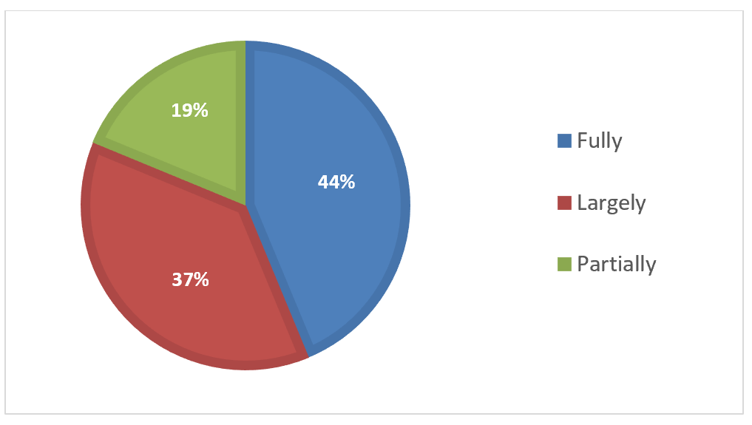
Figure 5: Extent to which inventories reflect the diversity of intangible cultural heritage present in the territory of reporting countries (n=16) (B7.1b)
Inventories were used for various reasons, including preparing international nomination files, development of safeguarding plans, dissemination of information, and transmission of an element. Entries on national inventories were used to guide preparation of festivals, workshops, and local development projects. Language is an important vehicle of the intangible cultural heritage. In Yemen, an international seminar on safeguarding the intangible cultural heritage, held in 2019, thus recommended establishing an inventory of ancient Yemeni languages, especially the largely unwritten Mahri and Socotri languages, as a safeguarding measure. However, only one fifth of the countries reported that access to inventories was fully facilitated (B7.4a) and only about half of the countries stated that inventories were fully or largely used to strengthen safeguarding (B7.4b). A few of the inventories, such as the Sudanese National Inventory, were made available online; some, such as the United Arab Emirates Electronic Register of Intangible Cultural Heritage, were in the process of being digitized.
Only a fifth of the reporting countries thus fully satisfied the core indicator B7 at the baseline on the extent to which inventories reflect the diversity of intangible cultural heritage and contribute to safeguarding. A further half largely satisfied the indicator. Over four fifths of countries fully satisfied the core indicator B8 at the baseline, on the extent to which the inventorying process is inclusive, respects the diversity of intangible cultural heritage and its practitioners and supports safeguarding.
Across reporting countries, the process of inventorying was diverse, but broadly in line with the principles of the Convention, and largely oriented to safeguarding. Political, technical and financial challenges hampered the creation or updating of inventories in some cases. Analysis of the reports highlighted the need for active efforts to enable better access to inventories, for example by making them available online.

Thematic area III - Research and Documentation
The Convention encourages States Parties to ‘foster scientific, technical and artistic studies, as well as research methodologies, with a view to effective safeguarding of the intangible cultural heritage, in particular the intangible cultural heritage in danger’ (Article 13(c)). States Parties are also encouraged to adopt appropriate legal, technical, administrative and financial measures aimed at “ensuring access to the intangible cultural heritage while respecting customary practices governing access to specific aspects of such heritage” (Article 13(d)(ii)). Of course, under Article 15 and the Ethical Principles, communities, groups and individuals concerned are central to the safeguarding process, they should be involved in undertaking or guiding research and documentation and be able to use its results.
The Periodic Report thus contains a number of questions about support for research and documentation, community and other stakeholder participation in it, accessibility and utilization. These are as follows:

List of core indicators and assessment factors on research and documentation (B9-B10)
Core indicators | Assessment according to the following
B9. Extent to which research and documentation, including scientific, technical and artistic studies, contribute to safeguarding | - Financial and other forms of support foster research, scientific, technical and artistic studies, documentation and archiving, oriented towards safeguarding and carried out in conformity with relevant ethical principles.
 | - Research is fostered concerning approaches towards, and impacts of, safeguarding intangible cultural heritage in general and specific elements of intangible cultural heritage, whether or not inscribed.
 | - Practitioners and bearers of intangible cultural heritage participate in the management, implementation and dissemination of research findings and scientific, technical and artistic studies, all done with their free, prior, sustained and informed consent.
B10. Extent to which research findings and documentation are accessible and are utilized to strengthen policy-making and improve safeguarding | - Documentation and research findings are accessible to communities, groups and individuals, while respecting customary practices governing access to specific aspects of intangible cultural heritage.
 | - The results of research, documentation, and scientific, technical and artistic studies on intangible cultural heritage are utilized to strengthen policy-making across sectors.
 | - The results of research, documentation, and scientific, technical and artistic studies on intangible cultural heritage are utilized to improve safeguarding.

Summary of analytical findings
All countries reported the existence of some financial or other forms of support for research or documentation oriented towards safeguarding intangible cultural heritage (B9.1). Most of the support mentioned in the reports was government funding for scientific research in general, which was in some cases used for research on intangible cultural heritage. Aside from government support, countries reported other funding sources for intangible cultural heritage research projects. For instance, in Lebanon, NGOs and international agencies such as the Francophone University Agency (AUF), the British Council and the National Commission for UNESCO provided funding for intangible cultural heritage research projects implemented by universities. Funding for the project ‘El-Midan Market and Fish Market/Halaa’ in Alexandria (Egypt), undertaken by the Raquda Foundation for Art and Heritage was provided by the Egypt Exploration Society, a registered charity based in the UK. This project enabled surveying and monitoring of the El-Manshya Area, and the safeguarding and conservation of its tangible and intangible heritage.
Four fifths of countries reported that intangible cultural heritage practitioners and bearers participated with their free, prior, sustained and informed consent in the management, implementation and dissemination of research findings (B9.3). Community consent was often ensured through existing research ethics frameworks in university and inventorying frameworks. In Morocco, for example, the art of making Fez brocade could only be documented, inventoried and transmitted to apprentices after the consent of the last remaining master practitioner was obtained. He was subsequently designated as a Living Human Treasure (THV).
The majority of countries reported that documentation and research findings were made available to some extent to communities, groups, and individuals while respecting customary practices governing access. However, only about a third said that this was true to a ‘high’ extent (B10.1). As one report pointed out, the Convention was not always a reference point for institutions conducting research on intangible cultural heritage. Various mechanisms were used to provide public access to research. In Jordan, the Directorate of Intangible Cultural Heritage created a specific website to share information on intangible cultural heritage and provided further access to researchers, academics and students through a specialized Heritage Library with books, studies and magazines related to intangible cultural heritage. Another mechanism for access was publication by scientific research institutions. In Algeria, scientific research undertaken at the Algerian Research Centre on Scientific and Technical Information (CERIST), including on intangible cultural heritage, was made publicly available through the CERIST Digital Library, its institutional repository.
Participatory research and documentation was used for safeguarding to some extent in most countries, whether in strengthening policy-making or designing safeguarding measures (B10.2, B10.3, see Figure 6 below), although only a few countries reported that this was true to a ‘high’ extent.

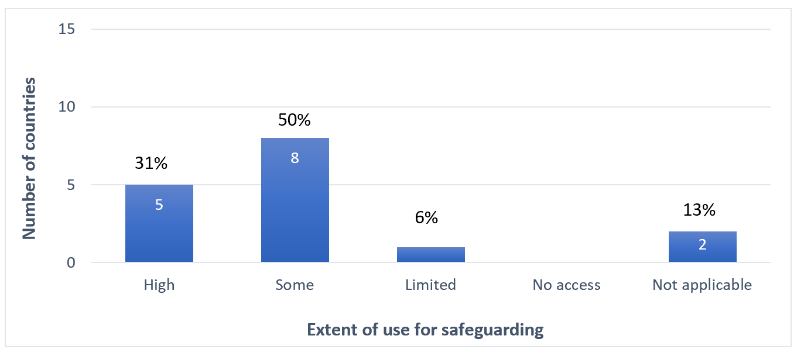
Figure 6. Extent to which the results of research, documentation, and scientific, technical and artistic studies on intangible cultural heritage are utilized to improve safeguarding (n=16) (B10.3)
Just over two thirds of reporting countries fully satisfied the core indicator B9 at the baseline in respect to the contribution of research and documentation to safeguarding. Just over a third of reporting countries fully or largely satisfied the core indicator B10 at the baseline, regarding the accessibility of research and documentation findings and their utilization to strengthen policy-making and improve safeguarding.
Most countries invested in research relating to intangible cultural heritage safeguarding, but the reports did not provide many details about the content of the research and how it was related to safeguarding. Some countries faced political or economic challenges that limited the financial resources available for research support. Stronger support for research may be needed to enable broader interdisciplinary studies on a wider variety of intangible cultural heritage domains. Research by communities, groups and individuals concerned, as well as civil society institutions and NGOs may also need further encouragement.

Thematic area IV - Policies, legal and administrative measures
Establishing a set of relevant policies and/or legal and administrative measures creates an important basis for supporting the design, development, delivery and implementation of effective and sustainable programmes and activities for safeguarding intangible cultural heritage in different sectors. Article 13(a) of the Convention encourages States Parties to ‘adopt a general policy aimed at promoting the function of the intangible cultural heritage in society, and at integrating the safeguarding of such heritage into planning programmes’ (see also OD 153(b)(i)). A primary area of such policy-making and planning is likely to be the culture sector, where action plans and strategies for intangible cultural heritage safeguarding may also be developed (see ODs 1, 2 and 171(d)) with the involvement of communities, groups and individuals concerned, in line with Article 15.
In the Convention, education is given particular attention as a means of ensuring respect for intangible cultural heritage and raising awareness of its importance (Article 1) as well as an important means for safeguarding intangible cultural heritage through supporting its transmission (Article 2.3). Article 14(a)(ii) of the Convention also emphasizes the desirability of ‘specific educational and training programmes within the communities and groups concerned’ as a means to ‘ensure recognition of, respect for, and enhancement of the intangible cultural heritage in societ’ (Article 14(a)). Policies in other development sectors, including inclusive social or economic development, and environmental sustainability, can be established or revised to consider intangible cultural heritage and its safeguarding in line with the Ethical Principles. The Convention’s Article 13(a) refers to the importance of ‘integrating the safeguarding of [intangible cultural heritage] into planning programmes’, and more detailed guidance is given in Chapter VI of the Operational Directives.
The Periodic Report thus contains a number of questions about policies, legal and administrative measures that support intangible cultural heritage safeguarding and how communities, groups and individuals concerned are involved in policy-making. These questions are as follows:

List of core indicators and assessment factors on policies, legal and administrative measures (B11-B14)
Core indicators | Assessment according to the following
B11. Extent to which policies as well as legal and administrative measures in the field of culture reflect the diversity of intangible cultural heritage and the importance of its safeguarding and are implemented | - Cultural policies and/or legal and administrative measures integrating intangible cultural heritage and its safeguarding, and reflecting its diversity, have been established or revised and are being implemented.
 | - National or sub-national strategies and/or action plans for intangible cultural heritage safeguarding are established or revised and are being implemented, including safeguarding plans for specific elements, whether or not inscribed.
 | - Public financial and/or technical support for the safeguarding of intangible cultural heritage elements, whether or not inscribed, is provided on an equitable basis, in relation to the overall support for culture and heritage at large, while bearing in mind the priority for those identified as in need of urgent safeguarding.
 | - Cultural policies and/or legal and administrative measures integrating intangible cultural heritage and its safeguarding are informed by the active participation of communities, groups and individuals.
B12. Extent to which policies as well as legal and administrative measures in the field of education reflect the diversity of intangible cultural heritage and the importance of its safeguarding and are implemented | - Policies and/or legal and administrative measures for education are established or revised and implemented to ensure recognition of, respect for and enhancement of intangible cultural heritage.
 | - Policies and/or legal and administrative measures for education are established or revised and implemented to strengthen transmission and practice of intangible cultural heritage.
 | - Policies and/or legal and administrative measures promote mother tongue instruction and multilingual education.
B13. Extent to which policies as well as legal and administrative measures in fields other than culture and education reflect the diversity of intangible cultural heritage and the importance of its safeguarding and are implemented | - The Ethical Principles for Safeguarding Intangible Cultural Heritage are respected in development plans, policies and programmes.
 | - Policies and/or legal and administrative measures for inclusive social development and environmental sustainability are established or revised to consider intangible cultural heritage and its safeguarding.
 | - Policies and/or legal and administrative measures to respond to situations of natural disaster or armed conflict are established or revised to include the intangible cultural heritage affected and to recognize its importance for the resilience of the affected populations.
 | - Policies and/or legal and administrative measures for inclusive economic development are established or revised to consider intangible cultural heritage and its safeguarding.
 | - Favourable financial or fiscal measures or incentives are established or revised to facilitate and/or encourage practice and transmission of intangible cultural heritage and increase availability of natural and other resources required for its practice.
B14. Extent to which policies as well as legal and administrative measures respect customary rights, practices and expressions, particularly as regards the practice and transmission of intangible cultural heritage | - Forms of legal protection, such as intellectual property rights and privacy rights, are provided to intangible cultural heritage practitioners, bearers and their communities when their intangible cultural heritage is exploited by others for commercial or other purposes.
 | - The importance of customary rights of communities and groups to land, sea and forest ecosystems necessary for the practice and transmission of intangible cultural heritage is recognized in policies and/or legal and administrative measures.
 | - Policies and/or legal and administrative measures recognize expressions, practices and representations of intangible cultural heritage that contribute to dispute prevention and peaceful conflict resolution.

Summary of analytical findings
Policies in the culture sector that incorporated intangible cultural heritage and its safeguarding and reflected its diversity were reported by all but three countries (B11.1). Some of the culture and heritage policies mentioned in the reports established competent bodies for implementing the Convention while others set up frameworks for inventorying and safeguarding. In the United Arab Emirates, for example, aside from inventorying and safeguarding mechanisms, the Abu Dhabi Cultural Heritage Law set up mechanisms integrating intangible cultural heritage safeguarding in sectors other than culture by including it in school curricula, and by licensing practitioners of intangible cultural heritage and certain crafts. Other policies integrated intangible cultural heritage safeguarding into broader development strategies. Iraq’s National Strategy for Biological Diversity (2015-2020) incorporated a study on the traditional knowledge of indigenous and local communities and aimed to respect and promote relevant local practices in the conservation of biological diversity.
Publicly-funded financial or technical support for intangible cultural heritage safeguarding was provided in all but three of the reporting countries, that were affected by economic crisis or war (B11.3). Support for research and documentation has been discussed above. Some reporting countries allocated a regular budget for relevant institutions and NGOs. Others funded specific activities such as competitions, festivals or events, capacity building and safeguarding projects. In Tunisia, the Literary and Artistic Creation Incentive Fund sponsored 152 festivals and other events relating to intangible cultural heritage in 2016, spanning 20 governorates. Some reporting states offered loans to ensure sustainability of intangible cultural practices. In the Syrian Arab Republic, the National Microfinance Company granted small tax-free loans for projects supporting practitioners in securing the necessary materials and access to spaces for their intangible cultural heritage practices.
Few reporting countries prioritized support for elements of intangible cultural heritage in need of urgent safeguarding, but the Kingdom of Saudi Arabia’s Cultural Development Fund has supported the endangered practice ‘Al-besht Alhasawi’ (the weaving of ‘bisht’ Saudi attire). The Ministry of Culture maintained an open communication channel for NGOs in the field of cultural heritage, through which they could raise concerns about elements in need of urgent safeguarding. In Mauritania, the national plan to conserve historic towns and their immediate surroundings contributed to the safeguarding of cultural spaces needed for the performance of the ‘Moorish epic T’heydinn’, inscribed on the Urgent Safeguarding List.

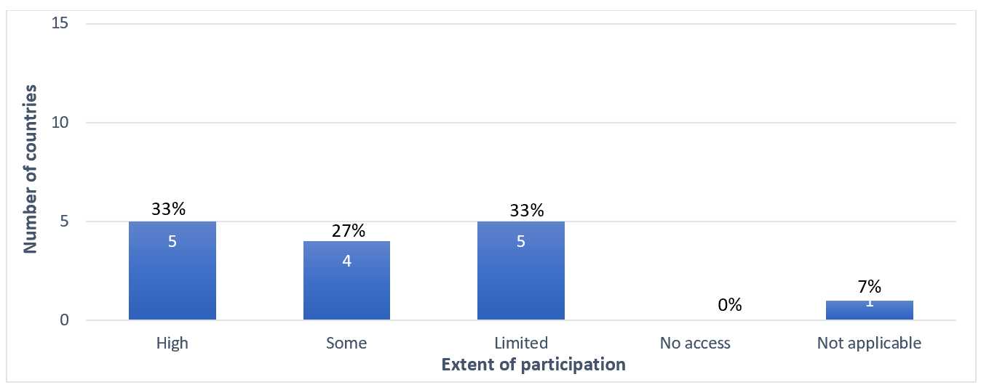
Figure 7: Extent of participation of communities, groups and individuals in cultural policy-making and implementation in reporting countries (n=15) (B11.4)

Around three quarters of reporting countries established policies in the education sector that ensured recognition of, respect for and enhancement of intangible cultural heritage (B12.1) or strengthened its transmission (B12.2). Four countries had not yet established policies regarding intangible cultural heritage in the education sector. While a few such policies included measures for transmission of specific intangible cultural heritage elements in formal education, others focused more broadly on national culture, heritage and cultural diversity. Three quarters of reporting countries established policies to promote mother tongue instruction and multilingual education (B12.3). In most reporting countries, Arabic was designated as the official language of education, or as one of two official languages, such as Amazigh in Algeria and Morocco and Kurdish in Iraq.
Policies for inclusive social development and environmental sustainability took intangible cultural heritage into consideration in two thirds of reporting countries (B13.2). For example, Palestine’s National Policy Agenda 2017-2022 stated that national identity and cultural heritage were part of its sustainable development pillar. In Sudan, the Dams Construction Unit funded the documentation, dissemination and safeguarding of intangible cultural heritage elements in northern Sudan (during the construction of the Merowe Dam), eastern Sudan (construction of the Upper Atbara and Setit dams) and the Blue Nile region (raising of the Roseires Reservoir). Policies on inclusive economic development took intangible cultural heritage into consideration in all but one of the reporting countries that responded to this question (B13.4), usually in the context of cultural tourism, festivals, traditional agriculture or foodways and handicrafts.
Almost all countries reported that forms of legal protection, such as intellectual property rights and privacy rights, were being developed or already available to communities, groups and individuals when their intangible cultural heritage was exploited by others for commercial or other purposes (B14.1). In the Syrian Arab Republic, for example, copyright protection was provided for collections of works and expressions of folklore as national public property. In Yemen, a license issued by the government was required to exploit folk traditions or folklore expressions commercially.
Policies in over four fifths of reporting countries recognized the importance of protecting the customary rights of communities and groups to land, sea and forest ecosystems necessary for the practice and transmission of intangible cultural heritage (B14.2). In Tunisia, the Forestry Code recognized local populations' rights to use resources such as dead wood and brushwood of secondary species, certain forest products, grazing and the cultivation of some plots of land. In return, beneficiaries were called upon to respect certain obligations and restrictions and held liable for any damage caused to the forest in that area. In Morocco, the customary rights of communities and groups over land and forest ecosystems were respected in a national policy for the protection of nature and the environment. This environmental policy provided for the protection of cultural heritage insofar as it is of national interest, and included a specific liability regime guaranteeing the repair of damage caused to the environment and compensation for victims.
Half of the reporting countries fully satisfied the core indicator B11 at the baseline, in regard to policies in the culture sector. With regard to the integration of intangible cultural heritage in policies in the education sector, just over half of countries satisfied the core indicator B12 at the baseline. About two fifths of all reporting countries fully satisfied the core indicator B13 at the baseline, in regard to the integration of intangible cultural heritage in policies in other sectors. Three quarters of the countries fully satisfied the core indicator B14 at the baseline in regard to respect for customary rights, practices and expressions in policies.
Heritage, cultural and educational policies dealing with intangible cultural heritage were implemented or being developed in most reporting countries. Apart from culture and to a lesser extent education, considerable attention was paid to intangible cultural heritage in policies and programmes on the small business, tourism and environmental sectors. The reports highlighted the benefits of developing policies on intellectual property protection to support communities to safeguard and benefit from their intangible cultural heritage. Communities may require special assistance to access legal protection and to protect their rights, especially in a commercial context.

Thematic area V - The role of intangible cultural heritage in society
The Convention suggests that intangible cultural heritage is of importance to communities, groups and individuals concerned, as it ‘provides them with a sense of identity and continuity, thus promoting respect for cultural diversity and human creativity’ (Article 2.1). Of course, specific elements of intangible cultural heritage have particular meaning and value to bearer communities, including as a means of dialogue, a source of knowledge and skills, and a resource for sustainable development. The requirement of ‘mutual respect among communities, groups and individuals” figures into the Convention’s definition of intangible cultural heritage (Article 2.1), and the Convention’s aim to “ensure respect for the intangible cultural heritage of the communities, groups and individuals concerned’ (Article 1(b)) implies respect for those people as well as their intangible cultural heritage.
The Convention also recommends that States Parties adopt ‘a general policy aimed at promoting the function of the intangible cultural heritage in society, and at integrating the safeguarding of such heritage into planning programmes’ (Article 13(a)). These policies should be inclusive and non-discriminatory, in accordance with the emphasis on cultural diversity in the Convention’s Preamble, Article 2.1, Article 11 and related texts. The Operational Directive paragraph 174, for example, says that ‘States Parties shall endeavour to ensure that their safeguarding plans and programmes are fully inclusive of all sectors and strata of society, including indigenous peoples, migrants, immigrants and refugees, people of different ages and genders, persons with disabilities and members of vulnerable groups, in conformity with Article 11 of the Convention’.
The Periodic Report thus contains a number of questions about the role of intangible cultural heritage in society, particularly for bearer communities, and how it is being promoted and recognized, for example in development interventions. These are as follows:

List of core indicators and assessment factors on the role of intangible cultural heritage in society (B15-B16)
Core indicators | Assessment according to the following
B15. Extent to which the importance of intangible cultural heritage and its safeguarding in society is recognized, both by the communities, groups and individuals concerned and by society at large | - Communities, groups and individuals use their intangible cultural heritage for their well-being, including in the context of sustainable development programmes.
 | - Communities, groups and individuals use their intangible cultural heritage for dialogue promoting mutual respect, conflict resolution and peace-building.
 | - Development interventions recognize the importance of intangible cultural heritage in society as a source of identity and continuity, and as a source of knowledge and skills, and strengthen its role as a resource to enable sustainable development.
B16. Extent to which the importance of safeguarding intangible cultural heritage is recognized through inclusive plans and programmes that foster self-respect and mutual respect | - Intangible cultural heritage safeguarding plans and programmes are inclusive of all sectors and strata of society, including, but not limited to:  - indigenous peoples;  - groups with different ethnic identities;  - migrants, immigrants and refugees;  - people of different ages;  - people of different genders;  - persons with disabilities;  - members of vulnerable groups.
 | - Self-respect and mutual respect are fostered among communities, groups and individuals through safeguarding plans and programmes for intangible cultural heritage in general and/or for specific elements of intangible cultural heritage, whether or not inscribed.

Summary of analytical findings
Communities, groups and individuals concerned were reported by all countries in this cycle to have used their intangible cultural heritage for promoting well-being (B15.1). Community uses of intangible cultural heritage for wellbeing were frequently intertwined with maintaining health, livelihoods and environmental sustainability. In Jordan, for example, folk healers still used medicinal plants and cupping therapies to provide affordable treatment in both rural and urban areas. Local communities also used traditional knowledge to manage water resources and engage in agriculture.
Almost all countries reported that communities, groups and individuals used their intangible cultural heritage for dialogue promoting mutual respect, conflict resolution and peace-building (B15.2), and that safeguarding also promoted self-respect and mutual respect (B16.2), as mentioned above. In Tunisia, customs of conflict resolution (arbitration by the zaouïas) were used to resolve conflicts around ownership of a hot spring in 2020 among the inhabitants of Béni Khedache and Douz. Various forms of intangible cultural heritage promoted communal activity in a way that fostered dialogue and mutual respect, including the customs and traditions of serving Arabic coffee to guests or the culture of gathering at a Majlis, as reported by the Kingdom of Saudi Arabia.
Most countries reported involving diverse groups in safeguarding plans and programmes to some extent. As mentioned above, half of the reporting countries (B16.1, see Figure 1) mentioned involving migrants, immigrants and refugees in safeguarding plans and programmes. Involvement of people of different ages, genders and those with disabilities was mentioned by about four fifths or more of reporting countries (B16.1). In Egypt, for example, the UN Women Egypt - UNIDO Joint Programme ‘Rabeha’ aimed to support a thousand women from underprivileged and rural areas to start their own handicraft businesses. Specific provision was made in most reporting countries to increase the participation of people with disabilities in the practice and transmission of intangible cultural heritage, frequently through provision of training opportunities linked to livelihoods, and by improving the access of people with disabilities to cultural heritage institutions and events, such as those promoting wellbeing and social participation through the arts. In Mauritania, state policies extended positive discrimination to vulnerable people and those with disabilities who were active in the intangible cultural heritage field.
Development interventions recognized the importance of intangible cultural heritage in society in nearly all countries, whether as a source of identity and continuity, as a source of knowledge and skills and as a resource for sustainable development, as Figure 8 below demonstrates (B15.3). Across reporting countries, development initiatives at the national level frequently referenced intangible cultural heritage, particularly in relation to handicrafts projects. In Iraq, the Marketing Centre of the Heritage Directorate and the Crafts Institute of the Ministry of Culture, Tourism and Antiquities set up a market for traditional craft products including carpets, wooden and metal goods, which contributed to safeguarding these skills as well as promoting sustainable livelihoods for practitioners.

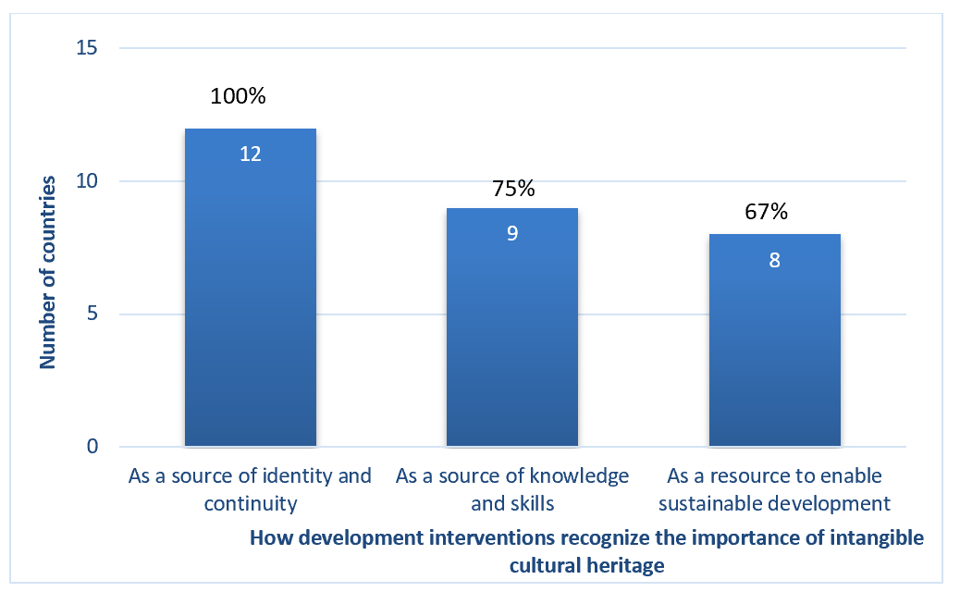
Figure 8: Recognition of the importance of intangible cultural heritage in society, in development interventions in reporting countries (n=15) (B15.3)
About half of the reporting countries fully satisfied the core indicator B15 at the baseline regarding the importance of intangible cultural heritage and its safeguarding in society. Just over half of reporting countries fully satisfied the core indicator B16 at the baseline, regarding the inclusivity of safeguarding plans and programmes that foster self-respect and mutual respect.
Intangible cultural heritage was well recognized in reporting countries as a source of national or ethnic identity, and a contributor to well-being, peace and conflict reduction, as well as to environmental and economic development. This was particularly the case in regard to handicrafts, as well as traditional medicine, agriculture and water management. Intangible cultural heritage safeguarding was integrated into some national development strategies. However, little systematic evidence was provided in the reports to enable assessment of the impact of intangible cultural heritage safeguarding on society and its development.

Thematic area VI – Awareness raising about the importance of intangible cultural heritage
Awareness raising about the importance of intangible cultural heritage is one of the Convention’s main four purposes (Article 1(c)) and can help ensure broad appreciation of it. To this end, States are encouraged to “ensure recognition of, respect for, and enhancement of the intangible cultural heritage in society, in particular through: (i) educational, awareness-raising and information programmes, aimed at the general public, in particular young people” (Article 14(a), see also ODs 100-117). Awareness-raising activities should be carried out with wide community participation in line with Article 15, and in conformity with relevant Ethical Principles.
The Periodic Report thus contains a number of questions about awareness-raising activities, community and youth participation in them, the role of media and public sector actors, and alignment with the Ethical Principles. These are as follows:

List of core indicators and assessment factors on awareness raising about the importance of intangible cultural heritage (B17-B20)
Core indicators | Assessment according to the following
B17. Extent to which communities, groups and individuals participate widely in raising awareness about the importance of intangible cultural heritage and its safeguarding | - Awareness-raising actions reflect the inclusive and widest possible participation of communities, groups and individuals concerned.
 | - The free, prior, sustained and informed consent of communities, groups and individuals concerned is secured for conducting awareness-raising activities concerning specific elements of their intangible cultural heritage.
 | - The rights of communities, groups and individuals and their moral and material interests are duly protected when raising awareness about their intangible cultural heritage.
 | - Youth are actively engaged in awareness-raising activities, including collecting and disseminating information about the intangible cultural heritage of their communities or groups.
 | - Communities, groups and individuals use information and communication technologies and all forms of media, in particular new media, for raising awareness of the importance of intangible cultural heritage and its safeguarding.
B18. Extent to which media are involved in raising awareness about the importance of intangible cultural heritage and its safeguarding and in promoting understanding and mutual respect | - Media coverage raises awareness of the importance of intangible cultural heritage and its safeguarding and promotes mutual respect among communities, groups and individuals.
 | - Specific cooperation activities or programmes concerning intangible cultural heritage are established and implemented between various intangible cultural heritage stakeholders and media organizations, including capacity-building activities.
 | - Media programming on intangible cultural heritage is inclusive, utilizes the languages of the communities and groups concerned, and/or addresses different target groups.
 | - Media coverage of intangible cultural heritage and its safeguarding is in line with the concepts and terminology of the Convention.
B19. Extent to which public information measures raise awareness about the importance of intangible cultural heritage and its safeguarding and promote understanding and mutual respect | - Practitioners and bearers of intangible cultural heritage are acknowledged publicly, on an inclusive basis, through policies and programmes.
 | - Public events concerning intangible cultural heritage, its importance and safeguarding, and the Convention, are organized for communities, groups and individuals, the general public, researchers, the media and other stakeholders.
 | - Programmes for promotion and dissemination of good safeguarding practices are fostered and supported.
 | - Public information on intangible cultural heritage promotes mutual respect and appreciation within and between communities and groups.
B20. Extent to which programmes raising awareness of intangible cultural heritage respect the relevant ethical principles | - The Ethical Principles for Safeguarding Intangible Cultural Heritage are respected in awareness-raising activities.
 | - Ethical principles, particularly as embodied in relevant professional codes or standards, are respected in awareness-raising activities.

Summary of analytical findings
The reports provided examples of awareness-raising activities, generally managed by a wide range of public institutions, in which many stakeholders, including communities, groups and individuals concerned, were involved. All but one of the reporting countries stated that public events were organized regarding intangible cultural heritage, its importance and safeguarding, as well as the Convention (B19.2). These activities included intangible cultural heritage inventorying, preparation of nominations to the Lists of the Convention, and broad cultural activities such as festivals, exhibitions, symposia, conferences, seminars, workshops, and media programs. In Lebanon, for example, an annual festival of Dabkeh dancing (a combination of circle and line dancing styles) was organized in the village of Maasser el Chouf, Jabalna region in collaboration with the Chouf Cedar Reserve and under the patronage of the Ministry of Tourism. The festival provided a venue for competitions between Dabkeh troupes and workshops introducing children and adults to the dance.
All reporting countries stated that media coverage on intangible cultural heritage raised awareness about its importance and promoted community understanding and mutual respect (B18.1). Qatar's report mentioned a number of different media programmes on topics such as folklore, history (‘Shea Men Al-Maadi’), heritage sites and local inhabitants (‘Cashat’), mysteries, popular proverbs and the heritage of the desert (‘Ramah’) and popular memory (‘Men Al-Zakera Al-Shabeya’). These programmes also documented craft practices in the country. However, media coverage of intangible cultural heritage and its safeguarding was not always in line with the concepts and terminology of the Convention (B18.4, see Figure 9 below). Less than a third of countries reported that media coverage was highly aligned in this way to the Convention. In some countries, a focal point was appointed to liaise between the media and government agencies responsible for culture.

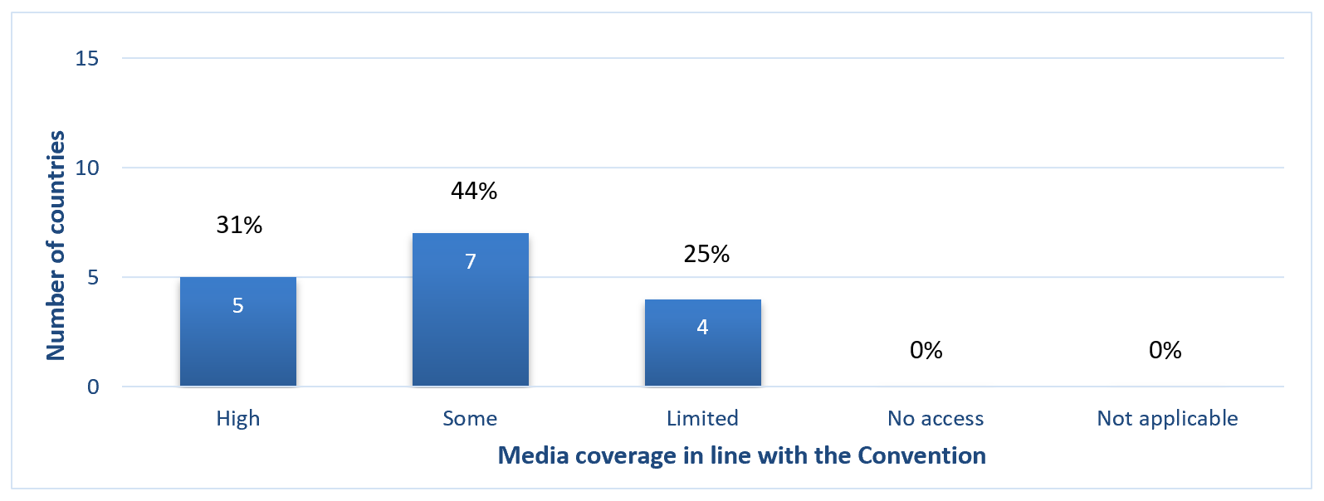
Figure 9: Extent of media coverage in reporting countries about intangible cultural heritage and its safeguarding, in line with the concepts and terminology of the Convention (n=16) (B18.4)
Over four fifths of reporting countries noted that there was community participation in awareness raising about their intangible cultural heritage (B17.1), with their free, prior, sustained and informed consent (B17.2). Most countries stated that media programming was inclusive, used the languages of the communities and groups concerned, and addressed different target groups (B18.3). Classical and local Arabic dialects were used in all the States Parties, alongside other locally-spoken languages and dialects. Almost all countries reported that programmes raising awareness of intangible cultural heritage respected the relevant ethical principles (B20.1), but often without specific reference to the specific Ethical Principles of the Convention. This was also true of relevant professional codes or standards, which were generally also respected in awareness-raising activities (B20.2).
Protection of community rights during awareness-raising activities, reported by all but two countries (B17.3), was ensured in various ways including adherence to constitutional rights protections and other general legal measures, financial compensation for artisans, and imposition of publication restrictions at community request.
Nearly three quarters of reporting countries fully satisfied the core indicators B17 and B20 at the baseline regarding community participation in awareness raising and the extent to which programmes raising awareness of intangible cultural heritage respected the relevant ethical principles. Just over three fifths fully satisfied the core indicators at the baseline for B18, regarding media involvement, and B19 in regard to public information measures.
The reports gave examples of various awareness-raising and public information activities, generally funded by the state as part of public broadcasting, inventorying and nomination processes or culture sector programming. More support might be needed for community- or civil society-led awareness-raising projects, and to develop capacity within media organizations on the concepts and terminology of the Convention.

Thematic area VII - Safeguarding activities for intangible cultural heritage
Effectively involving a broad range of actors is essential to achieving the best safeguarding results, whether for intangible cultural heritage in general or for specific elements of intangible cultural heritage. Key among these actors are the communities, groups and, where appropriate, individuals concerned, whose widest possible participation in the safeguarding and management of their intangible cultural heritage is encouraged in Article 15, the Operational Directives and Ethical Principles. This does not simply imply a two-way partnership between the State and such communities; rather, the Operational Directives have also developed an important role in safeguarding for NGOs and other civil society actors (e.g. ODs 90, 108, 157(e), 158(b), 162(e), 163(b)), as well as the private sector (OD 187). The effectiveness of intangible cultural heritage safeguarding programmes and measures can be increased and improved through regular monitoring and through scientific, technical and artistic studies to provide feedback about positive or negative impacts. Such monitoring studies can be done by communities concerned, NGOs and other civil society bodies, research institutions and centres of expertise, scholars and experts.
The Periodic Report thus contains a number of questions about engagement of diverse actors in safeguarding activities. These are as follows:

List of core indicators and assessment factors on safeguarding activities for intangible cultural heritage (B21-B22)
Core indicators | Assessment according to the following
B21. Extent to which engagement for safeguarding intangible cultural heritage is enhanced among stakeholders | - Communities, groups and individuals participate, on an inclusive basis and to the widest possible extent, in the safeguarding of intangible cultural heritage in general and of specific elements of intangible cultural heritage, whether or not inscribed.
 | - NGOs and other civil society actors participate in the safeguarding of intangible cultural heritage in general, and of specific elements of intangible cultural heritage, whether or not inscribed.
 | - Private sector entities participate in the safeguarding of intangible cultural heritage, and of specific elements of intangible cultural heritage, whether or not inscribed, respecting the Ethical Principles for Safeguarding intangible cultural heritage.
B22. Extent to which civil society contributes to monitoring of intangible cultural heritage safeguarding | - An enabling environment exists for communities, groups and individuals concerned to monitor and undertake scientific, technical and artistic studies on intangible cultural heritage safeguarding programmes and measures.
 | - An enabling environment exists for NGOs and other civil society bodies to monitor and undertake scientific, technical and artistic studies on intangible cultural heritage safeguarding programmes and measures.
 | - An enabling environment exists for scholars, experts, research institutions and centres of expertise to monitor and undertake scientific, technical and artistic studies on intangible cultural heritage safeguarding programmes and measures.

Summary of analytical findings
Just over half of the reporting countries reported inclusive community and civil society or NGO participation in intangible cultural heritage safeguarding (B21.1 and B21.2). Lebanon noted that communities, groups and individuals concerned organized their own safeguarding activities. The Poets Union of Zajal, for example, launched a program for the teaching of Zajal called ‘your heritage is your identity’ (turathak hawitak) in two schools and a university. Groups of 30 to 40 registered students learned to improvise texts on defined themes, and some of them received a diploma. This program was interrupted by the COVID-19 pandemic.

Figure 10: Extent of participation by communities, groups and individuals concerned in intangible cultural heritage safeguarding activities in reporting countries (n=16) (B21.1)
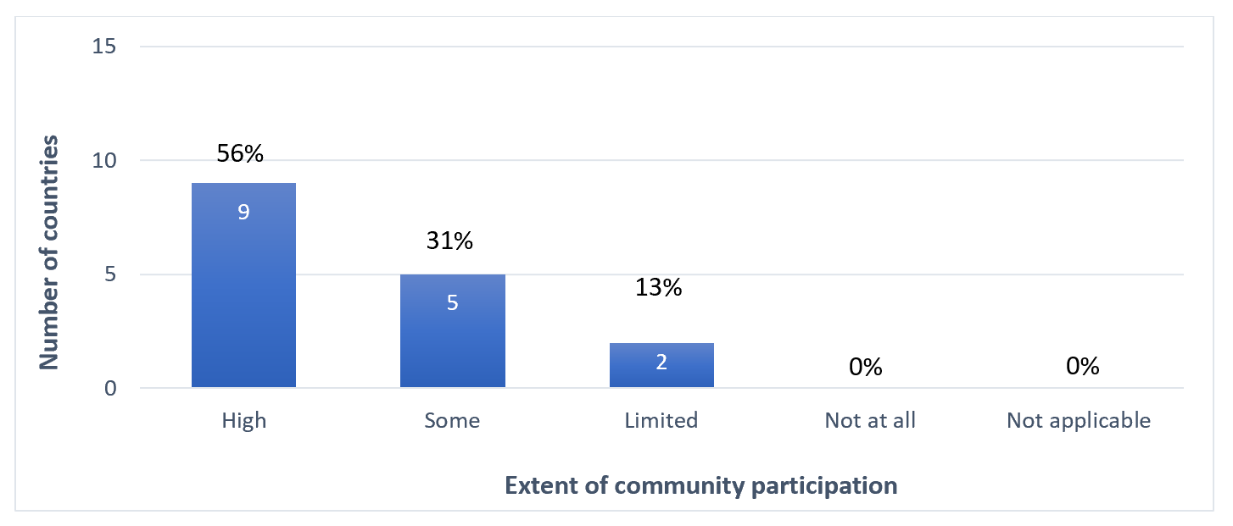
Some reports mentioned the contribution of ratification of the Convention in highlighting the need for broad community and stakeholder participation, and the need to develop legal, administrative and awareness-raising activities.
Ministries responsible for culture cooperated with civil society organizations and NGOs to assist with safeguarding actions in some cases. In Bahrain, the Enki Center for the Performing Arts, an NGO established in 2012, documented traditional women’s performing arts in Bahrain, such as Al Muradah (lyrical dance performance) and Layali Al Hazawi (storytelling). Sudan’s report highlighted the relative lack of interest shown by NGOs in working on intangible cultural heritage safeguarding in the country, a challenge evident elsewhere. Nevertheless, the Heritage House Foundation in Sudan, a civil society organization, was active in capacity building, inventorying and documentation, preparing nomination files, policy development and organizing cultural events. NGOs played a particularly important role assisting affected communities in conflict zones with intangible cultural heritage safeguarding activities, for example in the Syrian Arab Republic and Yemen.
About half of the countries reported that the private sector played some role in intangible cultural heritage safeguarding; only one country (Morocco) noted high levels of private sector engagement in this regard (B21.3). Private sector initiatives included promoting tourism-related events (internal or external), festivals and artisanal fairs. In Morocco, private companies in the tourism, logistics, music and production sectors helped safeguard the Sufi therapeutic and musical practices and rituals of ‘Gnawa’, through events such as the Gnawa Festival held in Essaouira. In Egypt, a company established by jewellery designer Azza Fahmy, its Design Studio and Azza Fahmy Foundation, a non-profit organization, have undertaken various initiatives to help safeguard the heritage of traditional jewellery-making in the country. These included programmes to train young craftspeople, provide jobs and support small craft businesses. The company also organized local and international exhibitions. In Mauritania, private museums also played an important role in safeguarding.
Just under three quarters of countries reported that communities, groups, and individuals, as well as NGOs enjoyed an enabling environment to monitor and undertake intangible cultural heritage safeguarding studies (B22.1 and B22.2). Examples provided in the reports included networking and collaboration between various stakeholders, support for publications and other kinds of funding from government agencies, such as the ministries responsible for culture. In Tunisia, community practitioners from the mountain oasis of El Guettar in the governorate of Gafsa and farmers from the oases of Kébili, Tozeur and Gabès worked with Masters and Doctoral students to document knowledge and practices for natural resource management and develop safeguarding methods for palm tree culture.
Some countries highlighted the difficulties faced in undertaking intangible cultural heritage-related studies on safeguarding. Palestine’s report noted that expertise and human and financial resources to undertake such studies were not evenly distributed among NGOs and other civil society organizations, community groups and academic experts. Cooperation between different stakeholders was thus essential in creating an enabling environment for this work. For example, Khazaaen, a Palestinian NGO, worked with folk storytellers to make their archive of people’s personal documents and daily newspapers or photographs come alive. This archive was intended also to serve as a resource for researchers.
Three quarters of countries reported that researchers and academic institutions enjoyed an enabling environment to monitor and undertake intangible cultural heritage safeguarding studies (B22.3). In Jordan, for example, the Princess Basma Centre for Intangible Cultural Heritage at Al-Hussein Bin Talal University documented intangible cultural heritage, sponsored studies and research on intangible cultural heritage, and published the information on its website. The Centre contributed to the completion of the Expanded Jordanian Folk Heritage Thesaurus (Al-Maknaz) in the south of the country.
About two thirds of reporting countries fully or largely satisfied the core indicator B21 at the baseline, regarding engagement of different kinds of stakeholders for safeguarding intangible cultural heritage. Just over half fully satisfied the core indicator B22 at the baseline, regarding an enabling environment for research on intangible cultural heritage safeguarding by different kinds of stakeholders.
Reporting countries provided considerable support to communities, researchers and NGOs undertaking safeguarding actions and monitoring and undertaking intangible cultural heritage safeguarding studies. However, stakeholder capacities and access to resources to undertake this work differed widely across reporting countries. Better collaboration between stakeholders, and strong community involvement (reported by only about half the countries) may be needed. Private sector involvement in safeguarding could also be more actively linked to safeguarding, rather than just to promotional events.

Thematic area VIII - International cooperation and engagement
One of the Convention’s four purposes is “to provide for international cooperation and assistance” (Article 1(d)), and the Convention further defines international cooperation as including joint initiatives, among other things (Article 19). International mechanisms such as International Assistance, inscription on the Lists and Register of the Convention (especially mechanisms allowing multinational nominations), enable collaboration, cooperation and communication between States Parties at the international level. Article 19 encourages States “to cooperate at the bilateral, sub-regional, regional and international levels,” and such cooperation can be formalized through networking and institutional cooperation, including accreditation of NGOs.
The Periodic Report thus contains a number of questions about international cooperation and engagement in safeguarding activities at the bilateral, sub-regional, regional and international levels. These are as follows:

List of core indicators and assessment factors on international cooperation and engagement (B24-B25)
Core indicators | Assessment according to the following
B24. Percentage of States Parties actively engaged with other States Parties in cooperation for safeguarding | - Bilateral, multilateral, regional or international cooperation is undertaken to implement safeguarding measures for intangible cultural heritage in general.
 | - Bilateral, multilateral, regional or international cooperation is undertaken to implement safeguarding measures for specific elements of intangible cultural heritage, in particular those in danger, those present in the territories of more than one State, and cross-border elements.
 | - Information and experience about intangible cultural heritage and its safeguarding, including good safeguarding practices, is exchanged with other States Parties.
 | - Documentation concerning an element of intangible cultural heritage present on the territory of another State Party is shared with it.
B25. Percentage of States Parties actively engaged in international networking and institutional cooperation | - State Party engages, as host or beneficiary, in the activities of category 2 centres for intangible cultural heritage.
 | - International networking is fostered among communities, groups and individuals, NGOs, experts, centres of expertise and research institutes, active in the field of intangible cultural heritage.
 | - State Party participates in the intangible cultural heritage-related activities of international and regional bodies other than UNESCO.

Section A also contains some questions on accreditation of NGOs (A4), inscriptions on the Lists and programmes selected for the Register (A5), International Assistance funding (A5) and synergies with other international frameworks (A7). These relate partly to core indicators B23 and B26 that will be reported only at the global level; nevertheless, some information will be included here for completeness.

Summary of analytical findings
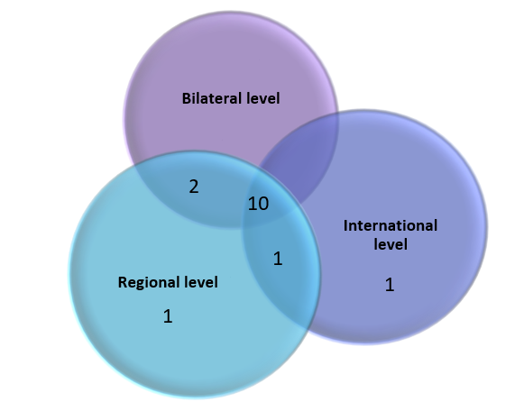
Most countries reported high levels of international cooperation on intangible cultural heritage safeguarding in general (B24.1, see Figure 11 below), most frequently at the regional level. International cooperation for the safeguarding of specific elements of intangible cultural heritage was reported by fewer countries, with a slightly greater emphasis on bilateral cooperation.

Figure 11: Number of countries reporting regional (n=14), bilateral (n=12) and international cooperation (n=12) on intangible cultural heritage safeguarding in general (B24.1)
As already mentioned above, reporting countries participated very actively in international mechanisms such as multinational nominations. Individual reporting countries also had eight elements inscribed on the Urgent Safeguarding List, and 32 elements inscribed on the Representative List (excluding the 14 multinational nominations), as will be discussed further below. Across reporting countries, there were seven NGOs accredited under the Convention. Some of these performed roles at the international level. The Egyptian Society for Folk Traditions served on the Evaluation Body from 2017-2020, assessing nomination files.
International cooperation for safeguarding intangible cultural heritage, whether in general or specific elements thereof, included developing multinational nomination files and related activities, organizing or participating in capacity building training and events such as conferences, expositions, exhibitions, festivals and bookfairs. For example, in the Kingdom of Saudi Arabia, the Expert Program hosted by the Ministry of Culture in 2021-2022 involved international intangible cultural heritage experts to build capacities among people from countries in the Gulf and Yemen. The Syrian Arab Republic, the Kingdom of Saudi Arabia and Bahrain were among the countries that participated in Dubai Expo 2020, which contributed to raising awareness about their intangible cultural heritage. The theme of Bahrain's pavilion was entitled ‘Density Weaves Opportunity’, where craftspeople, designers and trainees participated in a series of experimental technical laboratories. This promoted traditional and contemporary weaving crafts, and launched a youth training program in Bahraini handicrafts.
Reporting countries were involved in activities of three UNESCO Category 2 centers with a regional focus on intangible cultural heritage safeguarding. These were the Regional Centre for the Safeguarding of Intangible Cultural Heritage in Africa (CRESPIAF, Algeria), the Regional Research Centre for Safeguarding Intangible Cultural Heritage in West and Central Asia (Iran) and the International Centre for Capacity Building in Intangible Cultural Heritage in the Arab States (Sharjah Institute for Heritage, the United Arab Emirates). Activities of these institutions mentioned in the reports included exhibitions and publications, capacity-building and assistance with the development of multinational nomination files. The Sharjah Institute for Heritage hosted capacity building on periodic reporting in 2022, for example. Capacity building programmes like this performed an important role in building cooperation around intangible cultural heritage in the region. Regional bodies such as the Islamic World Educational, Scientific, and Cultural Organization (ISESCO) and the Arab League Organization for Education, Science, and Culture (ALECSO) also facilitated regional cooperation.
Activities that contributed to intangible cultural heritage safeguarding under UNESCO frameworks other than the Convention were shared in the reports (A7). These activities particularly related to the 1972 Convention Concerning the Protection of the World Cultural and Natural Heritage and the 2005 Convention on the Protection and Promotion of the Diversity of Cultural Expressions. For example, for safeguarding purposes, Morocco inventoried intangible cultural heritage associated with the World Heritage inscriptions of Moroccan properties, including Marrakech and Rabat. To support implementation of the 2005 Convention, Qatar participated in the cultural strategy of the Cooperation Council for the Arab States of the Gulf, a regional intergovernmental, political, and economic union comprising Bahrain, Kuwait, Oman, Qatar, the Kingdom of Saudi Arabia, and the United Arab Emirates.
Most countries also reported synergies with international frameworks other than UNESCO (B25.3, A7), particularly the Food and Agriculture Organization (FAO) and the World Intellectual Property Organization (WIPO). In 2011, the Ghout Oasis system El Oued in the Oued Souf region of Algeria was recognized as a Globally Important Agricultural Heritage System (GIAHS) under the FAO. It was set up to safeguard the complex oasis agricultural system based on management of the date palm, fruit trees, market gardening, growing of fodder and keeping of small livestock.
Just over a third of the countries fully satisfied the core indicator B24 at the baseline, regarding active engagement with other States Parties in cooperation for safeguarding. Half of them fully satisfied the core indicator B25 at the baseline, regarding active engagement in international networking and institutional cooperation.
Countries shared examples of international, regional and bilateral cooperation, often implemented by government agencies. From the reports, it seems that such cooperation was focused to a large extent on awareness-raising events, capacity building-activities organized in the UNESCO framework and the development of multinational nomination files. Some reports noted the importance of further deepening regional cooperation, for example through further capacity building on safeguarding, identification of good safeguarding practices and use of international assistance mechanisms.

Status of elements on the Representative List
Article 16 of the Convention states that the aims of inscriptions on the Representative List are “to ensure better visibility of the intangible cultural heritage and awareness of its significance, and to encourage dialogue which respects cultural diversity”. According to Article 29 of the Convention and ODs 151-152, States Parties shall submit reports to the Committee on currently inscribed elements, including those inscribed on the Representative List. Reporting on the status of elements inscribed on the Representative List can help to raise awareness about the significance of intangible cultural heritage. It can assist in the monitoring and evaluation of the role of the List, the impact of inscription, and contribute to the safeguarding of inscribed elements. The Periodic Report thus contains a number of questions about elements inscribed on the Representative List.

Overview
Before the inscriptions at 17.COM (2022), 46 elements from reporting countries were inscribed on the Representative List of the Intangible Cultural Heritage of Humanity. They included 14 multinational elements; of which four were inscribed with States Parties in other UNESCO regional groups (Imzad, Falconry, Novruz and the Mediterranean Diet). Individual reporting countries also had eight elements inscribed on the Urgent Safeguarding List, but no programmes were selected for the Register of Good Safeguarding Practices among reporting countries during the reporting period.
Figure 12 below shows how many reporting countries had elements inscribed on the Representative List within a few years after ratification of the Convention. Inscriptions in 2008, some of which happened before ratification, were linked to the incorporation of “Masterpieces of the Oral and Intangible Heritage of Humanity” (2001-2005) into the Representative List.

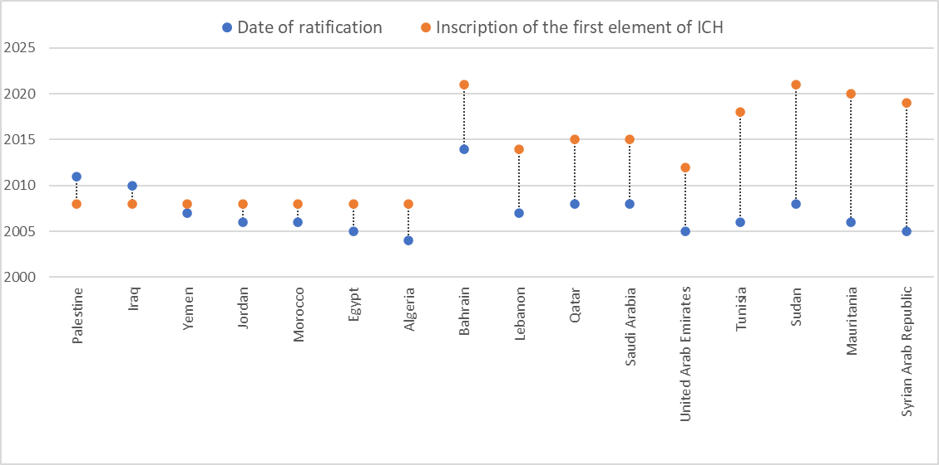
Figure 12: The time elapsed between ratification of the Convention and inscription of the first element on the Representative List of the Intangible Cultural Heritage of Humanity

A sample of 17 elements out of the 46 Representative List inscriptions was analyzed for this analytical overview, covering (i) at least one element per reporting country; (ii) different intangible cultural heritage domains; and (iii) both national and multinational elements.

Social and cultural functions
Safeguarding of intangible cultural heritage depends on understanding and maintaining the social and cultural functions and meanings of the element for the communities, groups and individuals concerned. Section C1 of the Periodic Reporting form specifically requests information on changes to the information provided under inscription criterion R.1.
Most of the social functions of the elements analyzed for this first analytical overview were reported as stable. The practices continued to express shared cultural meanings for the communities, groups and individuals concerned, as well as for wider society. The social functions originally listed in the nomination files and mentioned in the reports varied according to the nature of the elements and their domains. Many related to concepts such as identity, memory and social cohesion, combining ideas such as social solidarity, socializing and sharing. Other social functions included leisure and entertainment, pride and self-esteem, mutual respect and reconciliation, conflict resolution and making a living. In Palestine, for example, the art of embroidery remained an important social and political symbol. Women still wore embroidered dresses on official occasions, representing the cities from which they originally came, even when they had been forced to leave these places. Brides and female guests also continued to wear the dresses to celebrate “henna night”, the day before a wedding.
Some of the reports noted that social functions of the element remained stable even if the context was changing. For example, in Bahrain, the Fjiri musical performance have remained anchored in the memory of traditional pearl diving even after the emergence of cultured artificial pearls, the decline of pearl diving and changes in the religious and political context in the 1970s. However, the decline in the number of venues in famous historical houses and migration of Muharraq experts to other cities in the 1970s and 1980s have created risks to its sustainability.

Assessment of viability and current risks
The development of intangible cultural heritage safeguarding strategies is based on an assessment of the current level of viability of the element, and threats or risks to this viability, if any. This may change over time, so Section C2 of the Periodic Reporting form specifically requests information on the current viability of inscribed elements, even those on the Representative List.
Most of the elements analyzed for this analytical overview maintained their viability, especially where they were practised very broadly by communities or the whole society. While older transmission mechanisms were retained, new and sometimes more formal modalities were introduced. Mauritania’s report noted that competitions between cooperatives to win the prize for the best quality couscous maintained high local interest in the regional specificity of the practice, central to daily life and festive occasions. In some cases, the viability of an element was strengthened by its inscription on the Representative List. In Egypt, ‘Tahteeb, stick game’ benefited from greater visibility in social and national events after inscription in 2016 and became more widely popular, beyond the region of Upper Egypt. More practitioners were encouraged to attend the Tahteeb festival and it became a means of transmitting skills. Publications about the art also increased after inscription.
Risks to the viability of inscribed elements were mentioned in some reports. They included changing ways of life, reduced availability of raw materials, and decline in revenue, as well as the COVID-19 pandemic, unstable political situations, conflicts, disasters and natural hazards or environmental degradation. For example, although community interest in the practice remained high, the viability of the ‘Rites and craftsmanship associated with the wedding costume tradition of Tlemcen’ in Algeria was possibly threatened by the rising price of high quality materials to make bespoke costumes, and competition from ready-to-wear products. The ‘Song of Sana’a’, Yemen, was endangered by the dearth of young practitioners willing to undergo training to replace ageing masters, loss of skills to perform old song repertoires, and the destruction of one of the only remaining Yemeni lute maker’s workshops in one of the raids at Sanaa airport. The audio library at the Music Heritage Centre was also subjected to looting, affecting hundreds of song recordings. The work and livelihoods of poets practising ’Al-Zajal, recited or sung poetry’ in Lebanon were badly affected by the COVID-19 pandemic, the economic crisis, and the destruction of the building of the Union of Poets of Zajal in the Beirut Port explosion in 2020, which housed their archives.

Contribution to the goals of the List
The goals of the Representative List include ensuring visibility of the intangible cultural heritage in general, raising awareness at the local, national and international levels of its importance, as well as promoting respect for cultural diversity and human creativity, and mutual respect among communities, groups and individuals. Section C3 of the Periodic Reporting form thus requests information on how inscription of the element has contributed to achieving these goals. Answering this question requires consideration of the impact of inscription from the perspective of the goals of the Convention, and not just specific safeguarding goals relating to an inscribed element.
Most of the reports found that inscription of intangible cultural heritage elements contributed to the goals of the Representative List. Announcement of inscriptions, coupled with reporting on social and traditional media, in particular encouraged visibility and awareness of intangible cultural heritage and the Convention. Inscriptions of some elements, such as ‘Charfia fishing in the Kerkennah Islands’ of Tunisia and the art of embroidery in Palestine encouraged other communities to want to have their own intangible cultural heritage inscribed.
The reports also mentioned the contribution of inscriptions to promotion of respect for cultural diversity and human creativity. The inscription of the equestrian performing art of the ‘Tbourida’, which is practised in rural areas in all regions of Morocco to celebrate national and religious holidays, encouraged local teams to express their cultural diversity through the initial salute, handling of weapons, or the type of clothing or harness, reflecting local history and environmental contexts.

Efforts to reinforce and promote the element
Safeguarding intangible cultural heritage often involves the development and implementation of safeguarding measures. Section C4 of the Periodic Reporting form thus requests information on the measures that have been implemented to promote and reinforce the element, particularly detailing any measures that might have been necessary as a consequence of its inscription.
A wide variety of safeguarding measures was implemented to promote the practice and transmission of inscribed elements. These measures included consultative meetings with stakeholders, awareness-raising activities such as festivals, exhibitions, cultural events and media campaigns, training and capacity-building, documentation and integration in school curricula. In the case of Arabic calligraphy in Sudan, the National Council for Cultural Heritage and Promotion of National Languages held several brainstorming workshops on safeguarding measures with experts and stakeholders, including practitioners belonging to the Sudanese Calligraphers Association. A committee of stakeholders was then established to follow up and implement safeguarding plans and measures. These measures included providing writing materials for schools, documenting and collecting examples of current work, giving prizes to outstanding students, organizing exhibitions and supporting or expanding training programmes. In Jordan, the art of As-Samer, a dancing and singing tradition, was safeguarded through inclusion in school music and singing competitions and national celebrations and festivals. The Ministry of Culture supported an annual Al-Samer Festival, alongside other events and projects promoting the element. The Al-Ma'ani/Al-Samer Wedding Project in Ma’an Governorate encouraged youth to engage with artistic images of the social ritual.
The reports also highlighted the importance of protecting spaces and places necessary for the practice of the intangible cultural heritage. In the United Arab Emirates, for example, camel racing was promoted by taking care of the camel breeding places, inclusion of camel racing in school curricula and extra-curricular activities, or through local and regional radio and television programs, and encouraging community participation in the practice by financing NGOs dedicated to camel races.

Community participation in safeguarding
The participation of communities, groups and individuals is essential in safeguarding intangible cultural heritage, assisted where relevant by NGOs. Section C5 of the Periodic Reporting form thus requests information on such participation and prospects for its continuation in the future.
Communities, groups and individuals concerned participated in safeguarding the inscribed elements in various ways, alongside normal practice and transmission. Al-Zajal poets in Lebanon, for example, actively participated in a project launched by the Lebanese National Commission for UNESCO providing training in popular Zajal poetry in ten Lebanese schools and a center for children with special needs in 2015.
Community organizations were active in some countries. In Algeria, practitioner associations such as Al-Assala and Bab El Zir have contributed significantly to the safeguarding of the ‘Rites and craftsmanship associated with the wedding costume tradition of Tlemcen’. They brought together different kinds of practitioners engaged in the making of the ‘Chedda’ (wedding dress), organized holiday workshops for school children and training activities for artisans in collaboration with local vocational institutions and the Chamber of Crafts and Trades of Tlemcen. In Qatar, however, despite the efforts of the Department of Heritage and Identity at the Ministry of Culture, community participation in safeguarding inscribed elements was hampered by declining numbers of practitioners and the shortage of community organizations.

Institutional context
Community organizations and other stakeholder agencies generally play an essential role in the safeguarding of inscribed intangible cultural heritage elements, and carry formal responsibilities for doing so in some contexts. Section C6 of the Periodic Reporting form thus requests information on the institutional context for the element inscribed on the Representative List, including competent bodies involved in its management and/or safeguarding, and organizations of the community or group concerned with the element and its safeguarding.
Community organizations provided critical institutional support to safeguarding inscribed elements in certain cases, as indicated above. Government agencies with responsibilities for safeguarding also played an important role (see Thematic Area I above). Civil society bodies and NGOs sometimes assisted in this process. The competent body for safeguarding falconry in Qatar, for example, was the Qatari Society of Al Gannas (or Al Qannas), a cultural association established in 2008 to support traditional Arab hunting, raise public awareness and encourage young people to take up the sport. In Palestine, civil society organizations such as the Dar Attifel and Palestinian Museums held workshops, published three books and organized three exhibitions on the art of embroidery. A lack of strong community and civil society organizations was remarked on in some reports.

Participation of communities in preparing the Periodic Report
Article 15 of the Convention encourages States Parties to ensure the widest possible participation of the communities, groups and, where applicable, individuals concerned as well as relevant NGOs in safeguarding activities. Section C7 of the Periodic Reporting form thus requests information on the extent of their participation during the process of preparation of this report.
Most of the periodic reports in this cycle, as in previous cycles, were compiled by appointed persons in competent bodies, ministries responsible for culture or National Commissions for UNESCO. In many cases, the reports focused on participation of communities, groups and individuals concerned as well as NGOs in preparing the report on a specific element, but some also mentioned processes for involving a wide variety of stakeholders in writing the report as a whole. The Syrian Arab Republic’s report noted that as a result of strong community involvement in preparing and approving the report on the “Practices and craftsmanship associated with the Damascene rose in Al-Mrah”, community members had developed proposals for further safeguarding activities in line with the Convention.
A number of mechanisms were used to collect data, including establishing databases of relevant organizations, setting up workshops and meetings (online and in person), sending out surveys or questionnaires, and arranging individual contacts and field visits. In Yemen, a questionnaire was published online to gather information for the periodic reporting process: sixteen organizations and institutions responded. Meetings were then held online to get further information on specific topics. In Bahrain, the Authority for Culture and Antiquities National Heritage Directorate Team contacted more than 30 NGOs in the register of cultural associations and other related music and cultural societies to provide information on “Fjiri” for the periodic report. The periodic reporting team also prepared a questionnaire to collect data from individual community members and NGOs. A media campaign about the questionnaire was distributed on social media platforms.

ANNEX II
Monitoring of the indicators 23 and 26 of the Overall Results Framework
- Under the thematic area of ‘International engagement’, the following two indicators within the Overall Results Framework require monitoring by the Secretariat at the global level: indicator 23 “Number and geographic distribution of NGOs, public and private bodies, and private persons involved by the Committee in an advisory or consultative capacity” and indicator 26 “ICH Fund effectively supports safeguarding and international engagement”. The current report therefore presents the monitoring data and information relevant to the set of indicators and assessment factors, as presented in the table below:
Core indicators | Assessment factors
23. Number and geographic distribution of NGOs, public and private bodies, and private persons involved by the Committee in an advisory or consultative capacity | - Number of NGOs accredited to provide advisory services, their geographic distribution and their representation of different domains.
 | - Percentage of accredited NGOs that participate in the sessions and working groups of the Convention’s governing bodies, and their geographic distribution.
 | - Number of occasions and activities in which accredited NGOs are involved by the Committee for consultative purposes, beyond the evaluation mechanisms.
26. ICH Fund effectively supports safeguarding and international engagement | - States Parties seek financial or technical assistance from the ICH Fund and implement safeguarding programmes resulting from such assistance.
 | - States Parties or other entities provide voluntary supplementary contributions to the ICH Fund, for general or specific purposes, in particular the global capacity-building programme.
 | - The ICH Fund is utilized to support costs of participation in the meetings of the governing bodies of the Convention by a wide range of stakeholders, including ICH experts and accredited NGOs from developing countries, public and private bodies, as well as members of communities and groups, invited to those meetings to act in an advisory capacity.
- This annex focuses on presenting a broad outline and factual data on the performance of these indicators covering the reporting period between July 2022 and June 2023, which may be examined together with other relevant documents of the current session of the Committee providing more comprehensive and detailed information.
- Monitoring core indicator 23 ‘Number and geographic distribution of NGOs, public and private bodies, and private persons involved by the Committee in an advisory or consultative capacity’
23.1 Number of NGOs accredited to provide advisory services, their geographic distribution and their representation of different domains.
- There is currently a total of 217 NGOs accredited to perform advisory functions for the Intergovernmental Committee. The number of accredited NGOs distributed according to regions is as follows: Africa 27; Arab States 10; Asia and the Pacific 28; Europe and North America 138; Latin America and the Caribbean 14.

- Out of these 217 accredited NGOs, many of them operate in multiple fields of intangible cultural heritage. In this report, they are presented according to the domains of intangible cultural heritage broadly defined in Article 2 of the Convention: n the basis of the information provided at the time of the accredited requests, 170 NGOs are engaged in the field of Oral traditions and expressions; 142 in Performing arts; 177 in Social practices, rituals and festive events; 131 in Knowledge and practices concerning nature and the universe; 177 in Traditional craftsmanship, and 59 are working in specific domains defined by the States Parties themselves.

23.2 Percentage of accredited NGOs that participate in the sessions and working groups of the Convention’s governing bodies, and their geographic distribution.
- At the seventeenth session of the Intergovernmental Committee (28 November to 3 December 2022, Rabat, Kingdom of Morocco), 51% of the accredited NGOs (111 out of a total number 217) participated as observers, with the following geographical representation: Africa 20; Arab States 9; Asia and the Pacific 23; Europe and North America 48; Latin America and the Caribbean 11.

- In addition, between 2022 and 2023, six accredited NGOs served on the Evaluation Body, a consultative body of the Committee tasked with evaluating nominations for inscription on the Lists, proposals for the Register of Good Safeguarding Practices and requests for International Assistance greater than US$100,000. These members are as follows, representing each electoral group:
EG I: Workshop intangible heritage Flanders.
EG II: European Association of Folklore Festivals
EG III: Daniel Rubin de la Borbolla Center
EG IV: Aigine Cultural Research Center – Aigine CRC
EG V(a): The Cross-Cultural Foundation of Uganda (CCFU)
EG V(b): Syria Trust for Development
23.3 Number of occasions and activities in which accredited NGOs are involved by the Committee for consultative purposes, beyond the evaluation mechanisms.
- During the reporting period between July 2022 and June 2023, the accredited NGOs were involved by the Committee for consultative purposes in four occasions:
- Upon the request of the Committee (Decision 16.COM 9), the ICH NGO Forum, composed of accredited NGOs, presented its third report to the seventeenth session Committee (28 November to 3 December 2023, Rabat, Kingdom of Morocco).
- Accredited NGOs participated in the expert meeting that took place in Stockholm, Sweden, from 19 to 21 April 2023, as well as in the Open-ended intergovernmental working group in the framework of the global reflection for a broader implementation of Article 18 of the Convention (4 to 5 July 2023, UNESCO Headquarters).
- The ICH NGO Forum presented an oral report during the ninth session of the General Assembly (5 to 7 July 2022, UNESCO Headquarters).
- Monitoring core indicator 26 ‘ICH Fund effectively supports safeguarding and international engagement’
26.1 States Parties seek financial or technical assistance from the ICH Fund and implement safeguarding programmes resulting from such assistance.
From July 2022 to June 2023, a total of eighteen requests for International Assistance were examined by the Bureau of the seventeenth and eighteenth sessions of the Intergovernmental Committee. All eighteen requests were approved and granted funds from the Intangible Cultural Heritage Fund. The Bureau granted financial assistance to Belize, Botswana, Central African Republic, Costa Rica, Cuba, Dominican Republic, El Salvador, Ethiopia, Guatemala, Haiti, Honduras, Kyrgyzstan, Mauritania, Mongolia, Nicaragua, Panama, Peru, Romania, Slovakia, Thailand, The Bahamas, Togo, Rwanda, South Sudan, and Uzbekistan. Among these requests, four were emergency International Assistance requests, while one was a request for preparatory assistance to the inscription of an intangible cultural heritage element to the Register of Good Safeguarding Practices. On another hand, the Committee approved two submitted requests, granting financial assistance to Albania and Malawi.
26.2 States Parties or other entities provide voluntary supplementary contributions to the ICH Fund, for general or specific purposes, in particular the global capacity-building programme.
- During the reporting period between July 2022 and June 2023, voluntary supplementary contributions of a total amount of US$140,971.86 were provided to the Intangible Cultural Heritage Fund by five States Parties and one category 2 centre. They are Lithuania, Monaco, Netherlands, Slovakia, Slovenia and ICHCAP (International Information and Networking Centre for Intangible Cultural Heritage in the Asia-Pacific Region, Republic of Korea).
- Out of these six contributors, the following State Party and category 2 centre provided voluntary supplementary contributions of a total amount of US$114,775.67 to the Fund for the implementation of the global capacity-building programme: Netherlands (US$74,775.67), and ICHCAP (US$121,271.13). This represents 81% of the total voluntary supplementary contributions to the Fund.
26.3 The ICH Fund is utilized to support costs of participation in the meetings of the governing bodies of the Convention by a wide range of stakeholders, including ICH experts and accredited NGOs from developing countries, public and private bodies, as well as members of communities and groups, invited to those meetings to act in an advisory capacity.
- The Intangible Cultural Heritage Fund was utilized to support the participation costs of the Evaluation Body members in their meeting, which took place from 12 to 16 June 2023 in presence. A total amount of US$63,354 covered the costs of the participation of ten (out of twelve) Evaluation Body members in this meeting. They included four States experts from Türkiye (EG I), Belize (EG III), Madagascar (EG V(a)), and Egypt (EG V(b)) as well as six representatives from the following accredited NGOs serving on the Evaluation Body: Workshop Intangible Heritage Flanders in Belgium (EG I); European Association of Folklore Festivals in Bulgaria (EG II); Daniel Rubin de la Borbolla Center (EG III), Aigine Cultural Research Centre (EG IV); The Cross-Cultural Foundation of Uganda (CCFU) (EG V(a)); and Syria Trust for Development (EG V(b)).

. Sixteenth States Parties submitted their reports before the deadline of 15 December 2022; the submission from two reporting States received after the deadline was incorporated in the reporting cycle.
. States Parties reported on the status of 46 elements that were inscribed on the Representative List up to the sixteenth session of the Committee.
. A research team was established to undertake the periodic reports quantitative and qualitative analysis. The team was formed by Ms Maissoun Sharkawi, Associate Researcher at the French Institute for the Near East (IFPO) in Jerusalem; Ms Annie Tabet, Professor in the Department of Sociology and Anthropology at Saint-Joseph University of Beirut; Mr Ahmed Skounti, Anthropologist at the National Institute of Science, Archaeology and Cultural Heritage (INSAP) of Morocco; and Ms Harriet Deacon an experienced UNESCO facilitator for the global capacity-building programme of the Convention who was also involved in the development of the Overall Results Framework of the Convention. The team was assisted by Mr Jesús Mendoza Mejía and Ms Elizabeth Matilda Mantebeah, and collaborated closely with a data specialist from ‘Stat sans Limites’, Ms Ioulia Sementchouk.
Two reports (Kuwait and Oman) have not been included in the statistical analysis for section B because they were submitted after the completion of the analysis.
See https://www.unesco.org/en/gender-equality
In this report, although it is formally part of Thematic Area I, the core indicator B2 has been included in the following section, as it closely relates to capacity development through education.
References to “whether or not inscribed” should be understood to mean ‘inscribed on the List of Intangible Cultural Heritage in Need of Urgent Safeguarding or the Representative List of the Intangible Cultural Heritage of Humanity”.
References to ‘inclusive’, ‘inclusively’ or ‘on an inclusive basis’ should be understood to mean “inclusive of all sectors and strata of society, including indigenous peoples, migrants, immigrants and refugees, people of different ages and genders, persons with disabilities and members of vulnerable groups” (cf. Operational Directives 174 and 194). When these actions and outcomes are reported, States Parties will be encouraged to provide disaggregated data or to explain how such inclusiveness is ensured.
In this report, although it is part of Thematic Area I, the core indicator B2 has been included in the current section, as it closely relates to capacity development through education.
Although the Convention consistently utilizes the expression, “communities, groups and individuals”, several assessment factors, like some Operational Directives, choose to refer to “practitioners and bearers” to better identify certain of their members who play a specific role with regards to their intangible cultural heritage.
As section A6 of the Periodic Reporting form also contains a number of questions about individual inventories, the analysis of that section has been included here. Questions about research and documentation that are part of thematic area III have been included in the following section of this report.
In conformity with Chapter VI of the Operational Directives, ‘inclusive social development’ comprises food security, health care, gender equality, access to clean and safe water and sustainable water use; quality education is included within core indicator B12.
In conformity with Chapter VI of the Operational Directives, ‘inclusive economic development’ comprises income generation and sustainable livelihoods, productive employment and decent work, and impact of tourism on the safeguarding of intangible cultural heritage and vice versa.
Law issued in the Emirate of Abu Dhabi as part of the Executive Regulation No. 4 of 2016, articles 22, 47, 53 and 55.
Law Protecting Copyright and Related Rights in the Legislative Decree No. 62 of 9/16/2013, articles 3 and 89.
Law No.15 of 2012 regarding the protection of the copyright and neighboring rights, article 58.
Law n°11-03, relating to the protection and enhancement of the environment.
Further information on the activities undertaken by the ICH NGO Forum and accredited NGOs is provided in document LHE/23/18.COM/15).
Further information on the implementation of the International Assistance mechanism is provided in document LHE/23/18.COM/10.
Further information on the voluntary supplementary contributions received during the reporting period for this document is provided in document LHE/23/18.COM/INF.14.

