unit 64
CASE STUDY 1 – Cyclones and ICH in Northern Vanuatu

Case Study 1 is based on the study of a long history of the impact of cyclones on the intangible cultural heritage (ICH) of the Banks Islands in the Pacific Ocean Republic of Vanuatu (which is usually identified by the World Risk Index as the country most at risk of disaster in the world). The case study provides participants with a deeper understanding of the range of social, environmental, economic and political processes that can transform the ICH of a region over time. The case study demonstrates that the extent to which ICH ‘survives’ a cyclone or other natural hazard depends upon its ‘resilience’ leading into and emerging from the disaster.

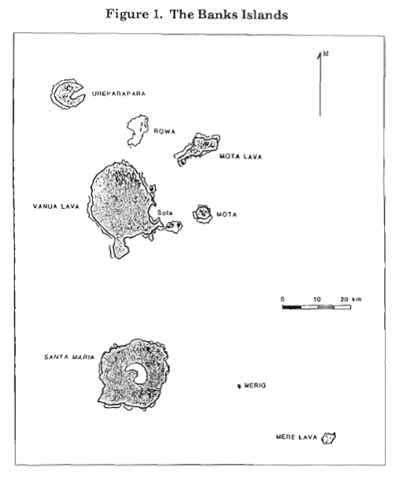

Shell Money from the British Museum Collection, acquired in 1976, coll. no. Oc1976,11.49, 20th century, Vanuatu (Photo: Trustees of the British Museum)

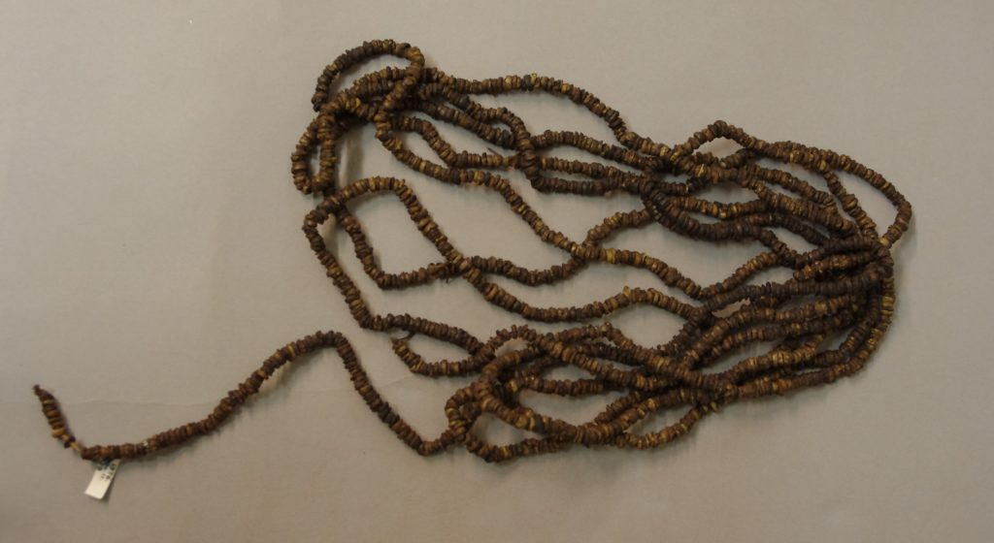

Transformations in the social, political and economic life of the island of Mota Lava (Banks Islands, Vanuatu) accelerated with the arrival of Christian missionaries in the mid-1800s. Previously, economic exchange amongst Banks Island communities had involved a complex web of inter-island interaction and movement of people, goods, food and shell money which supported marriage, a system of grade-taking for senior men and women, known as the suqe, and other regional social structures and networks. These inter-island networks and transactions were personalised around formal individual pulsala friendships. Each island specialised in the production of particular foods, goods or shell money that supported these activities. In times of disaster, this established inter-island network effectively spread risk over a wider region, and provided essential avenues for support.
The post-contact period saw sweeping changes to these inter-island networks as a result of missionisation, epidemics and population decline, and participation in the market economy. Beads began to replace shell money in transactions; the suqe grade system and traditional forms of marriage were impacted by the expansion of missionary influence; and colonial authorities sought to control movement between islands. Without the demand for the inter-island goods and food surpluses required to support these ICH practices, the need for shell money dwindled, and the inter-island and inter-personal connections fractured. With the expansion of industrial coconut plantations, the Banks Islands became increasingly engaged in the cash economy. The earlier decline in population as a result of disease, and the shift away from traditional subsistence practices, led to a desire for less labour-intensive and more productive crops, such as cassava. Neither coconuts nor cassava fare as well in cyclones as the traditional staples, further exacerbating food shortages after more recent cyclones.
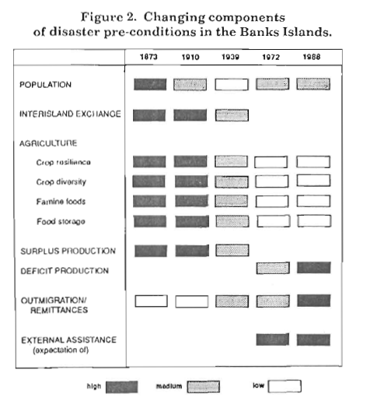
This background of historical transformations in people, place and story, allows for a detailed analysis of responses to a series of major cyclones, which took place in 1873, 1910, 1939, 1972 and 1988. From the 1873 cyclone onwards, with the decline in diversity of food crops, food scarcity became commonplace in the Banks, and the first non-traditional and external food relief was provided. From 1910, traditional famine foods such as sago disappeared. Although traditional networks were still being activated in 1939, by 1972 they had been replaced by links to government agencies and migrant kin in the capital, Port Vila. Each of these historical changes, brought on by the effects of globalisation, reshaped the pre-disaster conditions, which in turn re-defined the impact of the disaster on ICH and simultaneous shifts in resilience as cultural diversity and livelihood diversity dwindled over time.

Points to be raised by the facilitator after introducing the Case Study:
- An historical framework such as this is essential for understanding the way that challenges for ICH safeguarding evolve over time, particularly in cases where cultural practices have been impacted under the conditions of colonialism or environmental transformation. We can refer to this longer frame for understanding as an ‘ICH Disaster Biography’.
- We need to understand disasters in these broader social contexts for disaster knowledge, and broader historical contexts for individual events, as a baseline for assessing and understanding the impact of disasters on ICH, and the role of ICH in supporting disaster resilience.
- The ICH Disaster Biography shows the ways in which the modalities of people, place and story are individually and collectively transformed over time, generating a different set of pre-conditions for each new disaster.
- The source for this case study and the figures is: Campbell, John R. ‘Disasters and development in historical context: Tropical cyclone response in the Banks Islands, Northern Vanuatu.’ International Journal of Mass Emergencies and Disasters 8, no. 3 (1990): 401-424.; note that Campbell’s ‘biography’ was written before the 2003 Convention, and thus makes no reference to ICH.

